Data code:

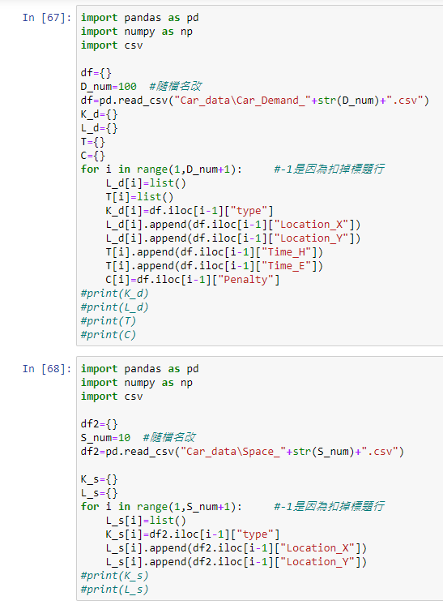

Original: Car_demand = 5, Space=8

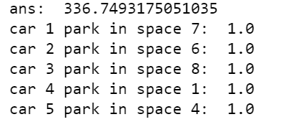

以下例子的座標區間為(1,50) R=20

Car_demand = 5, Space=1

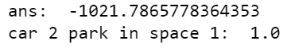

Car_demand = 10, Space=1

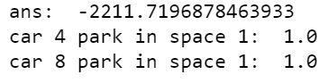

Car_demand = 20 , Space=1

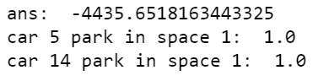

Car_demand = 5 , Space=10

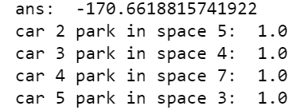

Car_demand = 10, Space=10

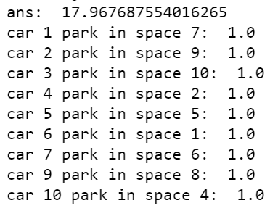

Car_demand = 20, Space=10

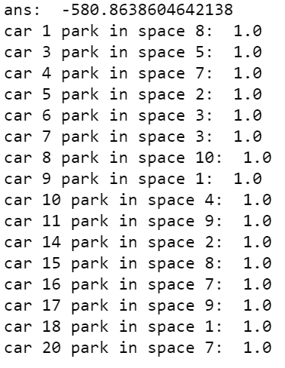

Car_demand = 100 , Space=10

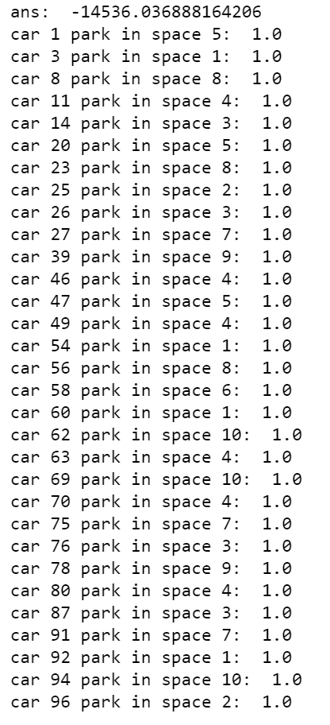

Car_demand = 200 , Space=10

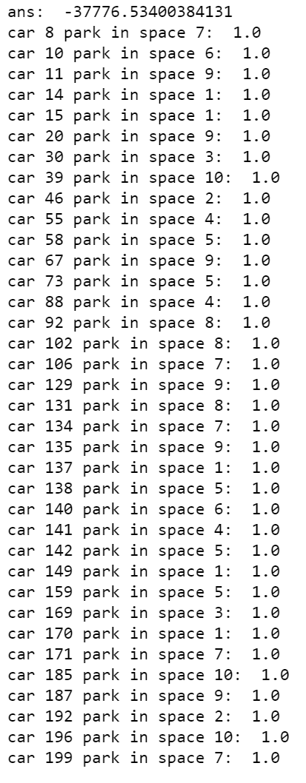

Car_demand = 100 , Space=200

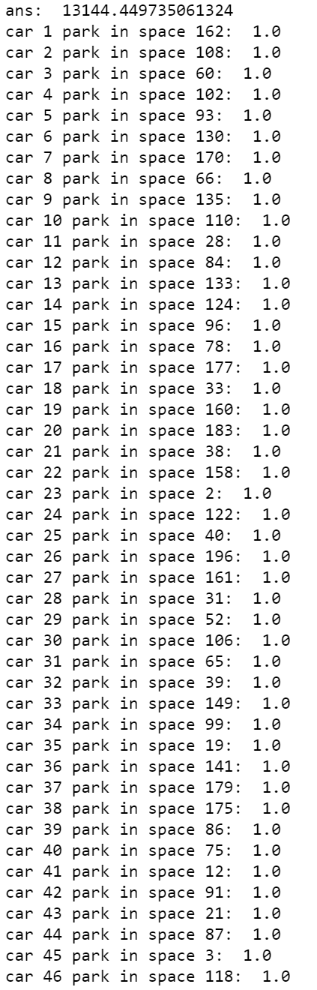

Car_demand = 200 , Space=200

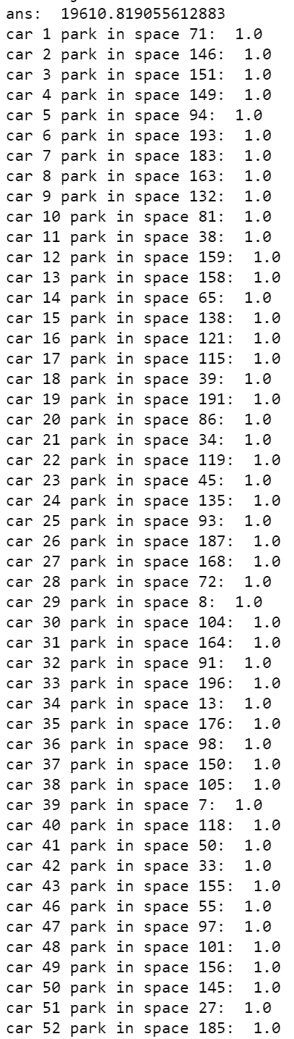

Car_demand = 1000 , Space=200

