**How to Build a Java Application with Jenkins in Docker**

**June 11, 2021**

**https://www.section.io/engineering-education/building-a-java-application-with-jenkins-in-docker/**

[My comments and notes appear in red]

We can automate building, testing, and deployment of software by running Jenkins in a Docker container. This facilitates continuous integration and delivery. Including Jenkins in Docker also solves several incompatibility issues.

Docker does this by simplifying the task of running Jenkins to as little as two commands; docker pull and docker run.

**Goal**

In this tutorial, we will set up Jenkins in a Docker container. We will also build and dockerize a Java application.

**Prerequisites**

* Basic knowledge of Java, Maven, Git, and the command line.
* Understanding of Docker and its commands.
* A Java IDE - In this tutorial, we will use [IntelliJ Idea](https://www.jetbrains.com/idea/), but you can use any IDE of your choice

[Using Eclipse]

**Creating a demo Java application**

We will create a simple Java console application and unit test it. This demo application will only check if an input is even or odd.

To start, let’s create a new Maven project with IntelliJ IDEA.

We will use the following IntelliJ settings:

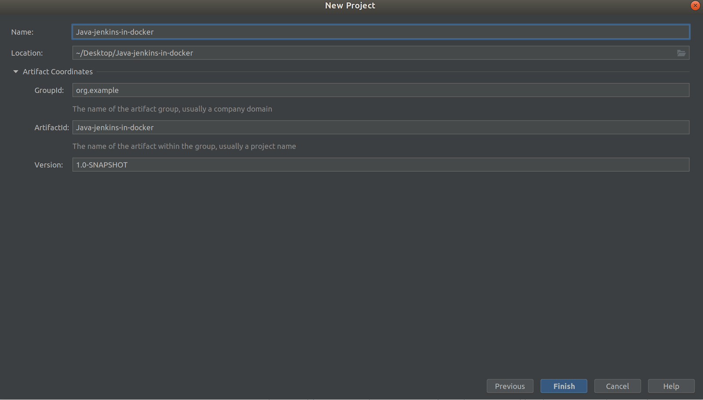

*** start section

Prior to creating eclipse maven project create a github repository and clone repository into the folder where Maven project will be created.



WSL2 Ubuntu project - U:\home\bobp\projects\bob_peressini_github\java-jenkins-in-docker

From file --> import

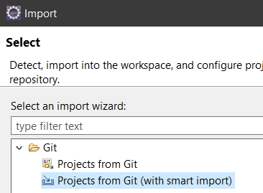

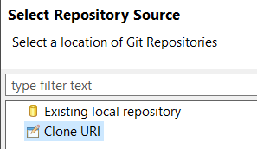

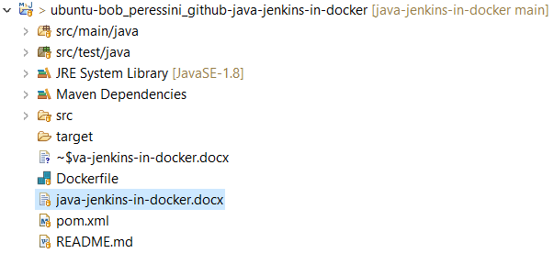

*** end section

We can also create a Maven project via the command line using the [Maven standard directory layout](https://maven.apache.org/guides/introduction/introduction-to-the-standard-directory-layout.html).

Eclipse will create Maven folder structure and default pom.xml

To create the Maven project directory layout, run:

$ mkdir -p src/main/java

Add a pom.xml file:

$ touch pom.xml

In our pom.xml file, we will add the code below:

<?xml version="1.0" encoding="UTF-8"?>

<project xmlns="http://maven.apache.org/POM/4.0.0"

xmlns:xsi="http://www.w3.org/2001/XMLSchema-instance"

xsi:schemaLocation="http://maven.apache.org/POM/4.0.0 http://maven.apache.org/xsd/maven-4.0.0.xsd">

<modelVersion>4.0.0</modelVersion>

<groupId>org.example</groupId>

<artifactId>Java-jenkins-in-docker</artifactId>

<version>1.0-SNAPSHOT</version>

<properties>

<java.version>1.8</java.version>

</properties>

</project>

To finish up our application configuration, we need to add JUnit 5 dependency for writing tests.

Let’s update the pom.xml file to make sure that this dependency is present:

<dependencies>

<!-- junit 5, unit test -->

<dependency>

<groupId>org.junit.jupiter</groupId>

<artifactId>junit-jupiter-engine</artifactId>

<version>5.3.1</version>

<scope>test</scope>

</dependency>

</dependencies>

The following lines are required to run TestMain

<properties>

<java.version>1.8</java.version>

<maven.compiler.source>1.8</maven.compiler.source>

<maven.compiler.target>1.8</maven.compiler.target>

</properties>

**On to the code**

In src/main/java path, let’s create a class called Main. It will contain the code for our simple console application.

In the Main class, let’s add the main method to run our code.

Note that some IDEs such as [NetBeans](https://netbeans.apache.org/download/index.html) usually autogenerate this code:

public class Main {

public static void main(String[] args) {

//code will go in here

}

}

Next, let’s create a simple static method called checkIfInputIsAnEvenNumber.

It will check if an input is even or odd:

public static boolean checkIfInputIsAnEvenNumber(int number){

return number % 2 == 0;

}

* In the code snippet above, we are creating a static method so that we can write unit tests. We want to see how Jenkins will automate testing.
* If the input int is even or odd, the method will return true or false respectively.

Here is the final code for the Main class:

public class Main {

public static void main(String[] args) {

System.out.println(checkIfInputIsAnEvenNumber(122)); // Testing in the main method

}

public static boolean checkIfInputIsAnEvenNumber(int number){

return number % 2 == 0;

}

}

If you run the above code, the output will be true.

Now, let’s write a unit test to test our checkIfInputIsAnEvenNumber method. First, in the src/test/java path, let’s create a test class TestMain to test the method.

import org.junit.jupiter.api.Test;

import static org.junit.jupiter.api.Assertions.assertTrue;

public class TestMain {

@Test

public void testInputIsEven(){

assertTrue(Main.checkIfInputIsAnEvenNumber(23)); // Assertion

}

}

You can run the test above in your IDE.

Alternatively, we can use a Maven command to run all our unit tests in the command line, as shown below:

$ mvn test

When we use 23 as our input data, the test fails:

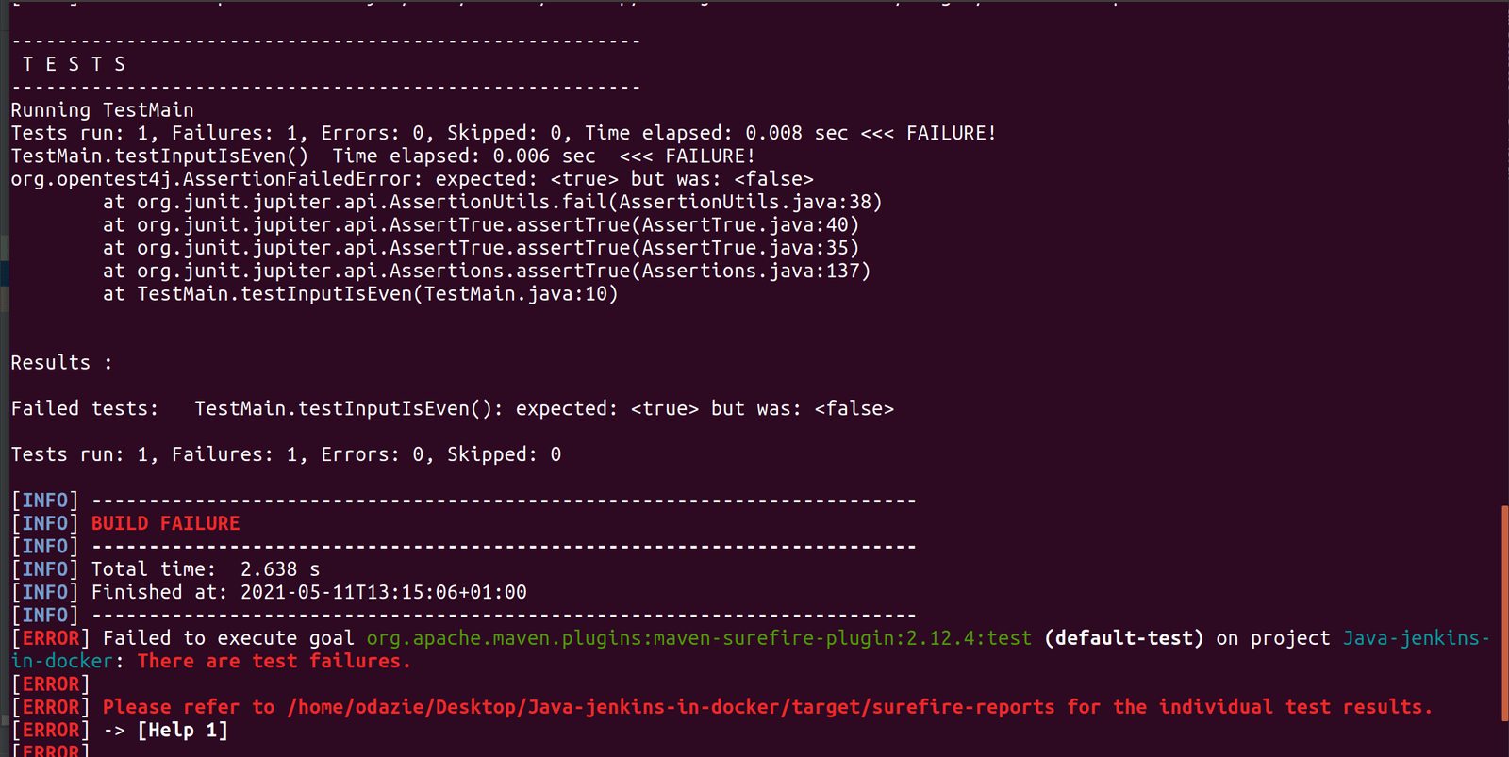

Let’s change the test input data to 22 and run the Maven command:

assertTrue(Main.checkIfInputIsAnEvenNumber(22)); // Assertion

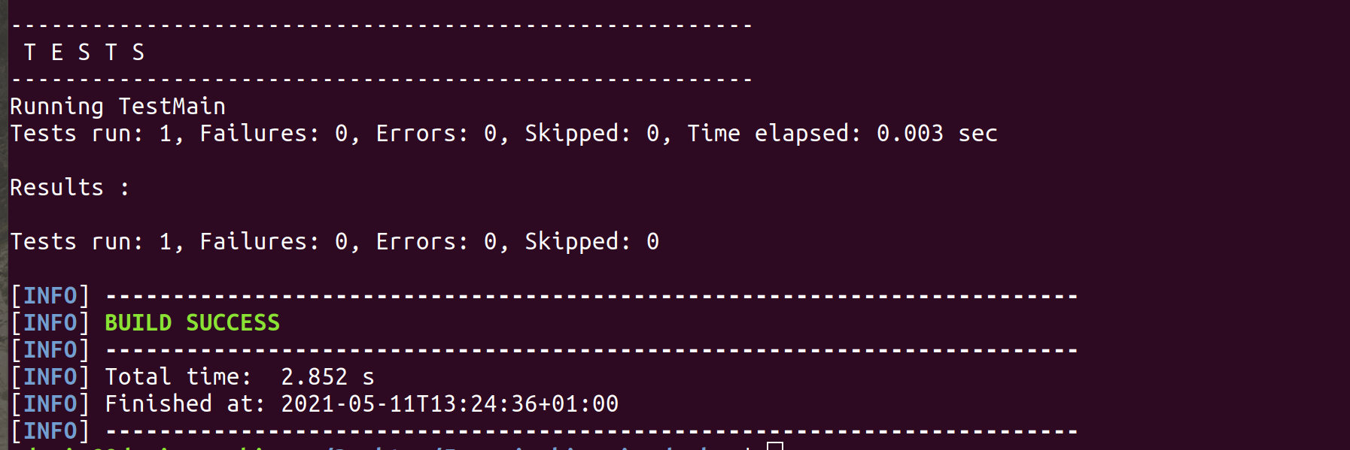

The test passes. In a few steps, we will see how Jenkins can automate this process.

**Hosting the demo application on GitHub**

We are going to push our Java application code to GitHub. When we make any change (commit) to our application on GitHub, Jenkins will trigger a post-commit build process remotely.

* To start, [create a new GitHub repository](https://docs.github.com/en/github/creating-cloning-and-archiving-repositories/creating-a-new-repository). This should be done before creating Eclipse Maven project.

Eclipse Staging plugin used for adding/updating files so the cmd line steps shown below can be skipped..

Then open up the terminal.

* Navigate to the directory of our demo application and run:

$ git init -b main //To initialize the local repository

* We will add all our application files using the command below:

$ git add .

* We can now commit our files:

$ git commit -m "Added java demo application files"

* Copy the created repository clone URL on GitHub.
* Then add the remote URL where we will push the local repository:

$ git remote add origin <REMOTE_URL>

Verify the remote URL and push the changes of our local repository to Github:

$ git remote -v

$ git push origin main

For more detailed instructions on adding our existing application to GitHub, you can visit [here](https://docs.github.com/en/github/importing-your-projects-to-github/adding-an-existing-project-to-github-using-the-command-line).

************************************

**Setting up Jenkins in Docker**

**Docker-in-Docker**

As we set up Jenkins in Docker, we need to remember the goal of our setup: dockerizing of an application. For this to happen, we need to execute docker commands, as well as access other containers.

To achieve this functionality, we need a Dockerfile that configures a Jenkins environment. It will be capable of running Docker commands and managing docker containers.

Installed Eclipse Docker Tooling

Create a Dockerfile in any directory, and in the Dockerfile add:

from jenkins/jenkins:lts

USER root

RUN apt-get update -qq \

&& apt-get install -qqy apt-transport-https ca-certificates curl gnupg2 software-properties-common

RUN curl -fsSL https://download.docker.com/linux/debian/gpg | apt-key add -

RUN add-apt-repository \

"deb [arch=amd64] https://download.docker.com/linux/debian \

$(lsb_release -cs) \

stable"

RUN apt-get update -qq \

&& apt-get install docker-ce=17.12.1~ce-0~debian -y

RUN usermod -aG docker jenkins

Now let’s create a jenkins-docker image using the above Dockerfile :

$ docker image build -t jenkins-docker .

To run our Jenkins-docker container in the command line, we use the code below:

$ docker run -it -p 8080:8080 -p 50000:50000 -v jenkins_home:/var/jenkins_home -v /var/run/docker.sock:/var/run/docker.sock --restart unless-stopped jenkins-docker

* The above command runs our pre-built jenkins-docker image. The -p command publishes the container’s ports 8080 and 50000 to the host machine.
* We should run Docker commands in our Jenkins container. However, there is only one Docker daemon running in our machine at a time. So what we need to do is to [bind mount](https://docs.docker.com/storage/bind-mounts/) our container to our host machine daemon while we run the container using this argument: -v /var/run/docker.sock:/var/run/docker.sock
* -v jenkins_home:/var/jenkins_home argument creates an explicit volume on our host machine. Why? During our initial setup, we will configure Jenkins and download plugins. When we stop/restart/delete our container, we need to have our initial setup configuration intact. We wouldn’t want to be doing those set ups every time we stop/restart/delete our container.
* --restart unless-stopped ensures that the container always restarts unless stopped using the docker stop <container_name/container_id> command.

After running the above command, visit localhost localhost:8080 to set up Jenkins.

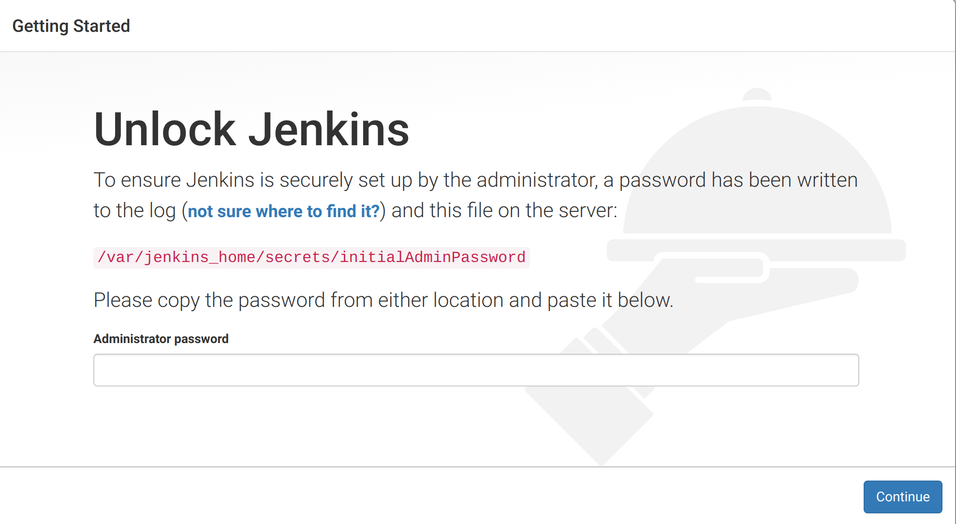

We can get the admin password from what command returns.

See what is looks like:

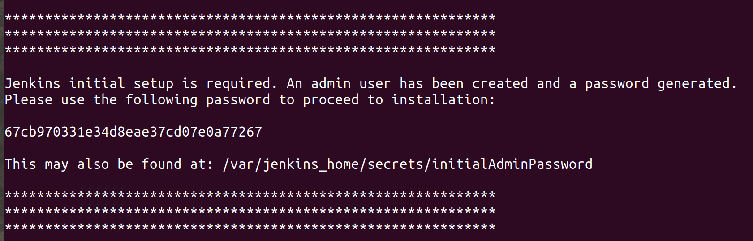

We can also get the initial admin password from /var/jenkins_home/secrets/initialAdminPassword directory using the following command:

$ docker exec -it <container_name/container_id> /bin/bash

And to get the password:

$ cat /var/jenkins_home/secrets/initialAdminPassword

Next, we select Install suggested plugins.

Jenkins will automatically download essential plugins:

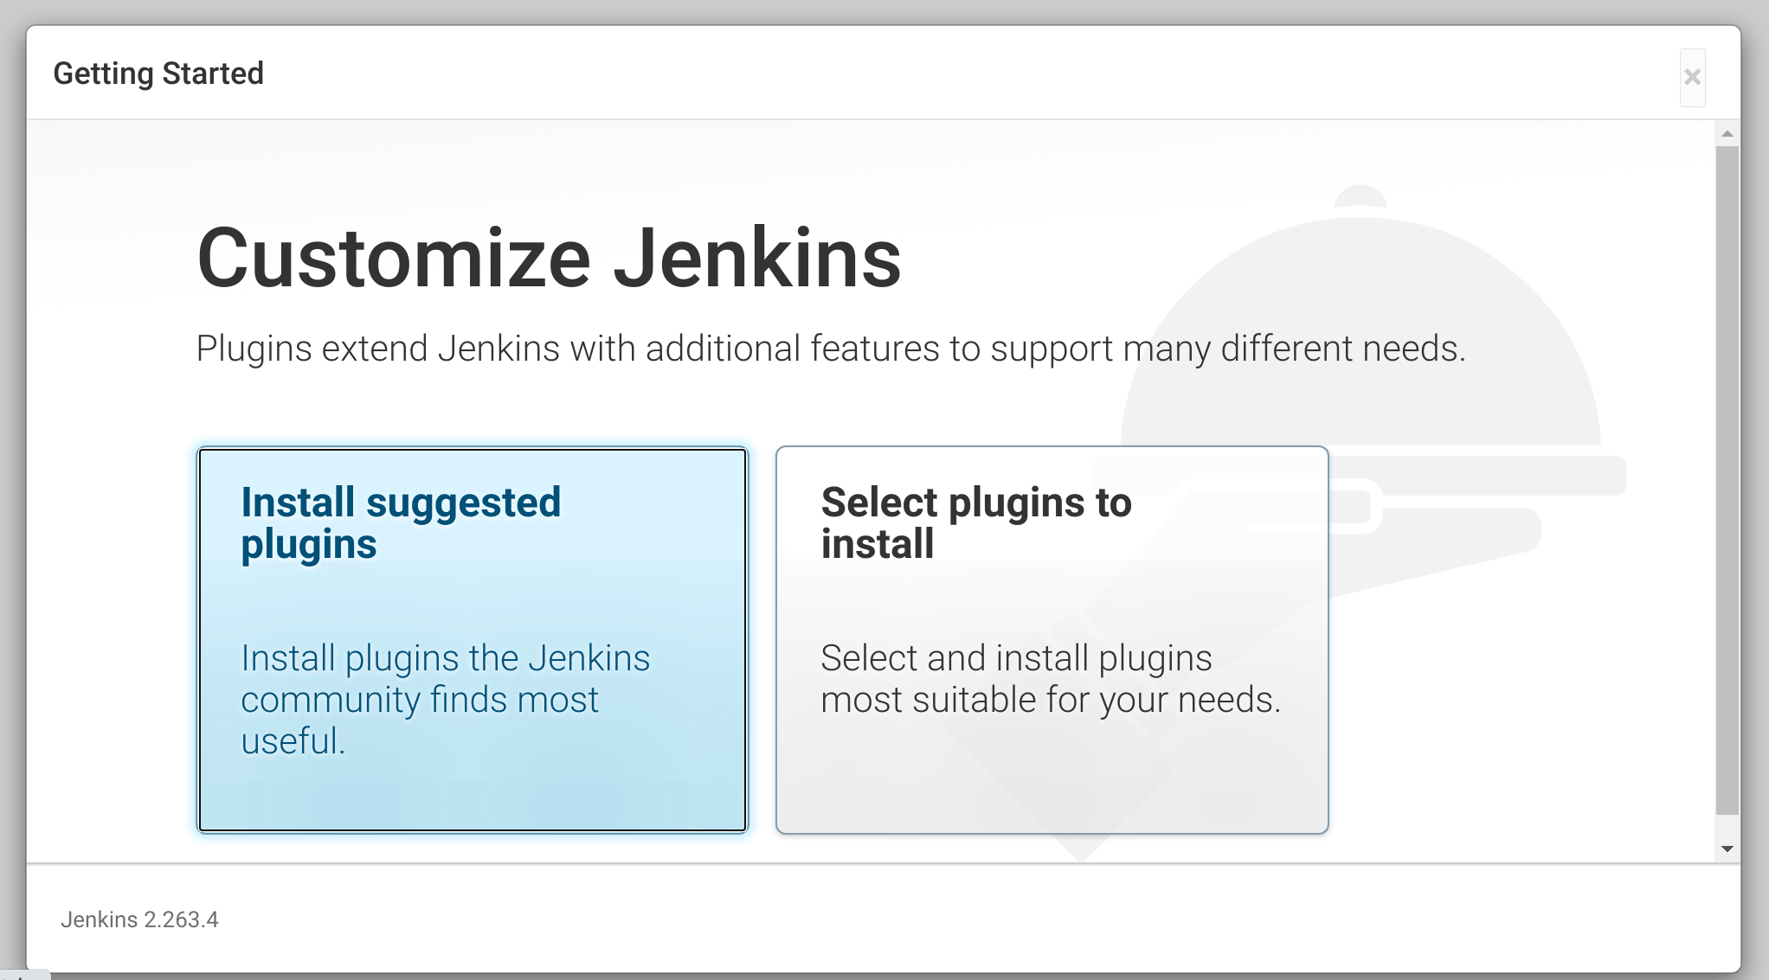

**Jenkins global configurations**

First, we will configure the JDK, Maven, and Git on our Jenkins console to enable Jenkins to clone our repository and build our application.

In our Jenkins console, go to Manage Jenkins.

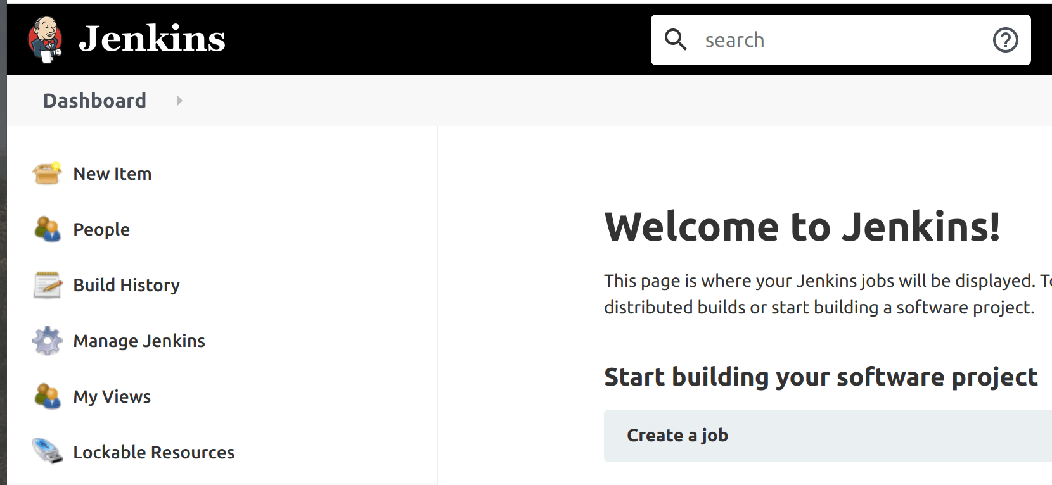

Under System Configurations, click on Global Tool Configuration.

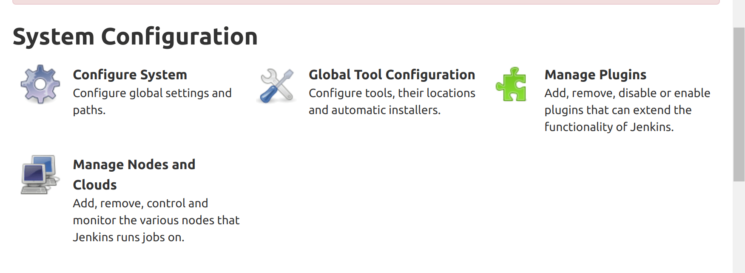

**JDK config**

Our Jenkins container comes with an OpenJDK. To find it, we need to enter into the container’s bash shell to get the JAVA_HOME path.

To get the bash shell of the container run:

$ docker exec -it <container_name/container_id> /bin/bash

Then if we’re using either macOS or Linux, we run:

echo $JAVA_HOME

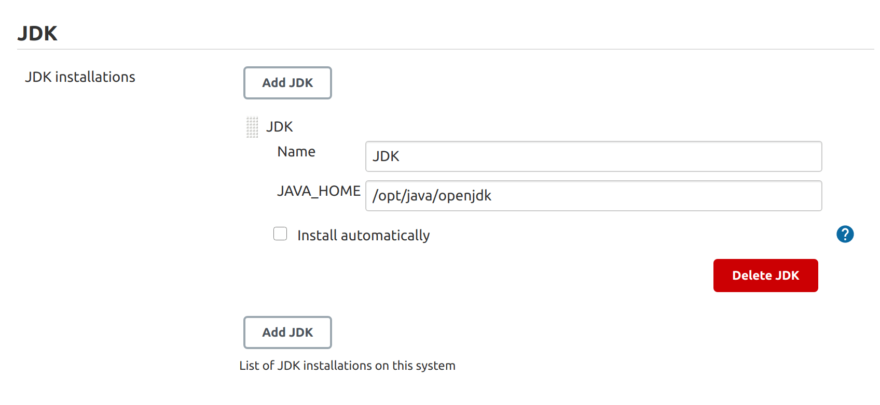

Check out this [article](https://www.baeldung.com/find-java-home) on finding JAVA_HOME.

**Maven config**

We can direct Jenkins to download Maven from Apache servers instead of the Maven directory on our system.

Follow the guideline shown in the image below:

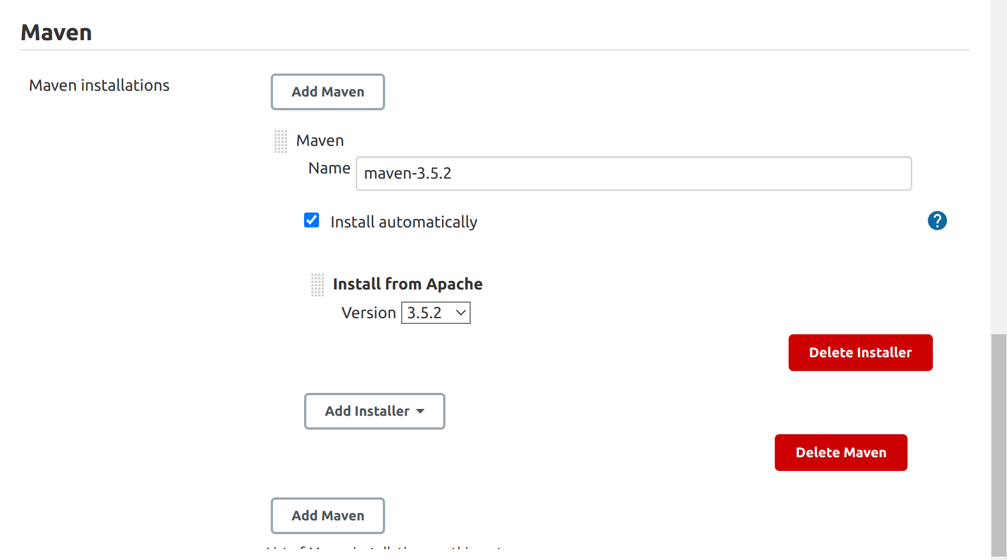

Make sure to save the configurations before exiting the page.

While building with Docker-in-Docker, we may run into problems. Therefore, having a fundamental understanding of Docker-in-Docker can allow us to debug applications easily.

For more details on Docker-in-Docker, read this article on [Quickstart CI with Jenkins and Docker-in-Docker](https://medium.com/swlh/quickstart-ci-with-jenkins-and-docker-in-docker-c3f7174ee9ff).

**Putting it all together**

So far, we’ve built a simple demo Java console application, hosted our application code on Github, and set up Jenkins in Docker.

Now let’s put it all together by using Jenkins to automate the building, testing, dockerizing, and deploying our application Docker image to Docker Hub after every commit made to our application repository hosted on GitHub.

To start, let’s create a new Jenkins item:

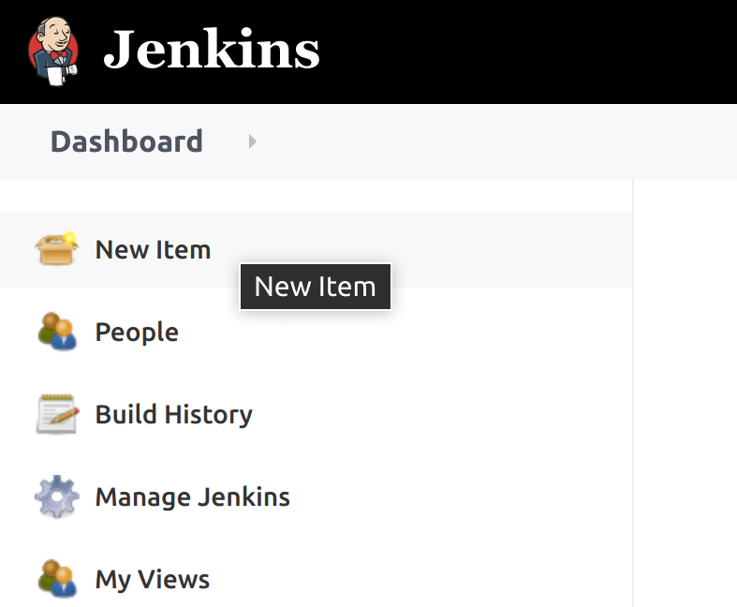

Then select Freestyle project:

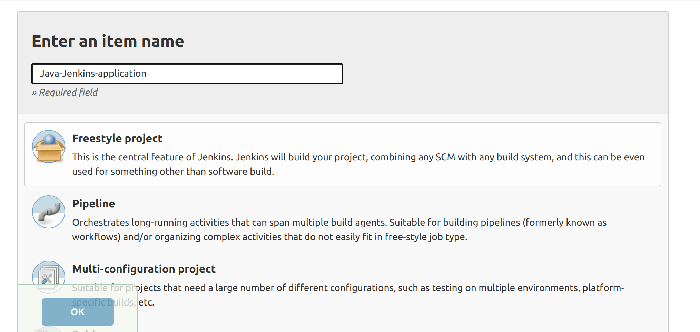

To configure our Freestyle project, select GitHub project and add the project URL:

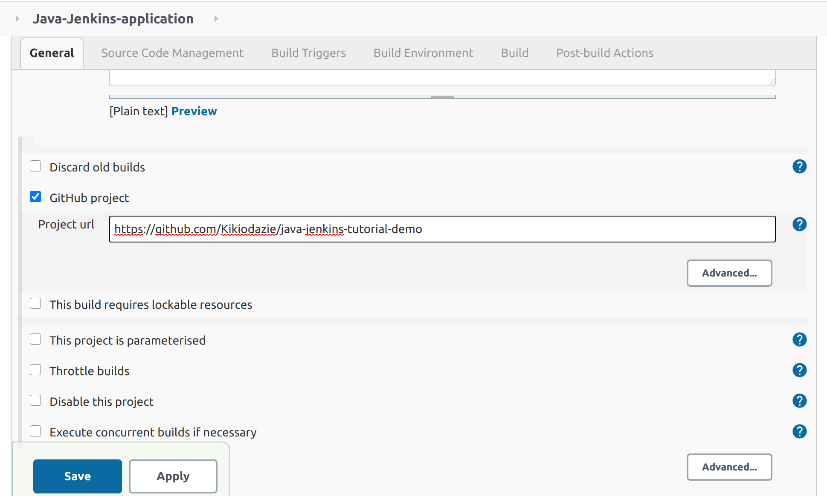

For our Source Code Management (or **SCM** for short), select Git, add the remote Git repository URL of the project and leave the branch field empty so any commit made to any branch triggers our entire Jenkins process:

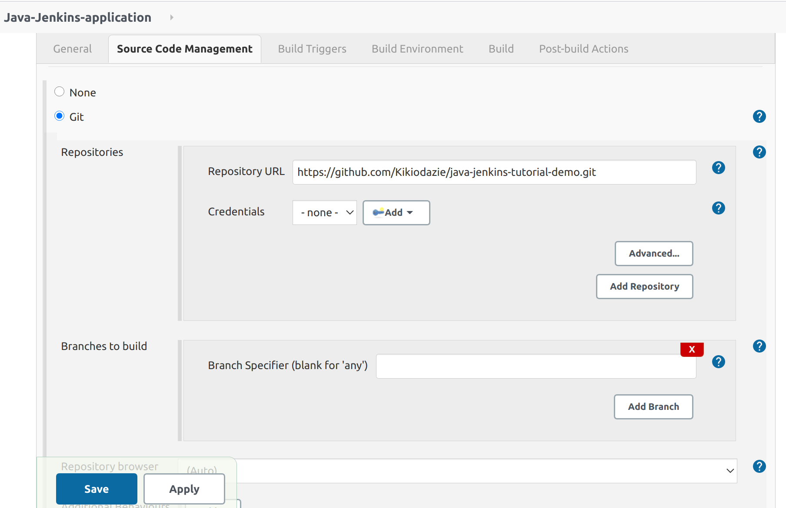

For Build Triggers, select Poll SCM, which checks whether we made changes (i.e. new commits) and then rebuilds our project. Poll SCM periodically checks the SCM even if nothing has changed in the repository.

We will give the Schedule five stars with this demo application, which is the [cron expression](https://en.wikipedia.org/wiki/Cron) to poll every minute.

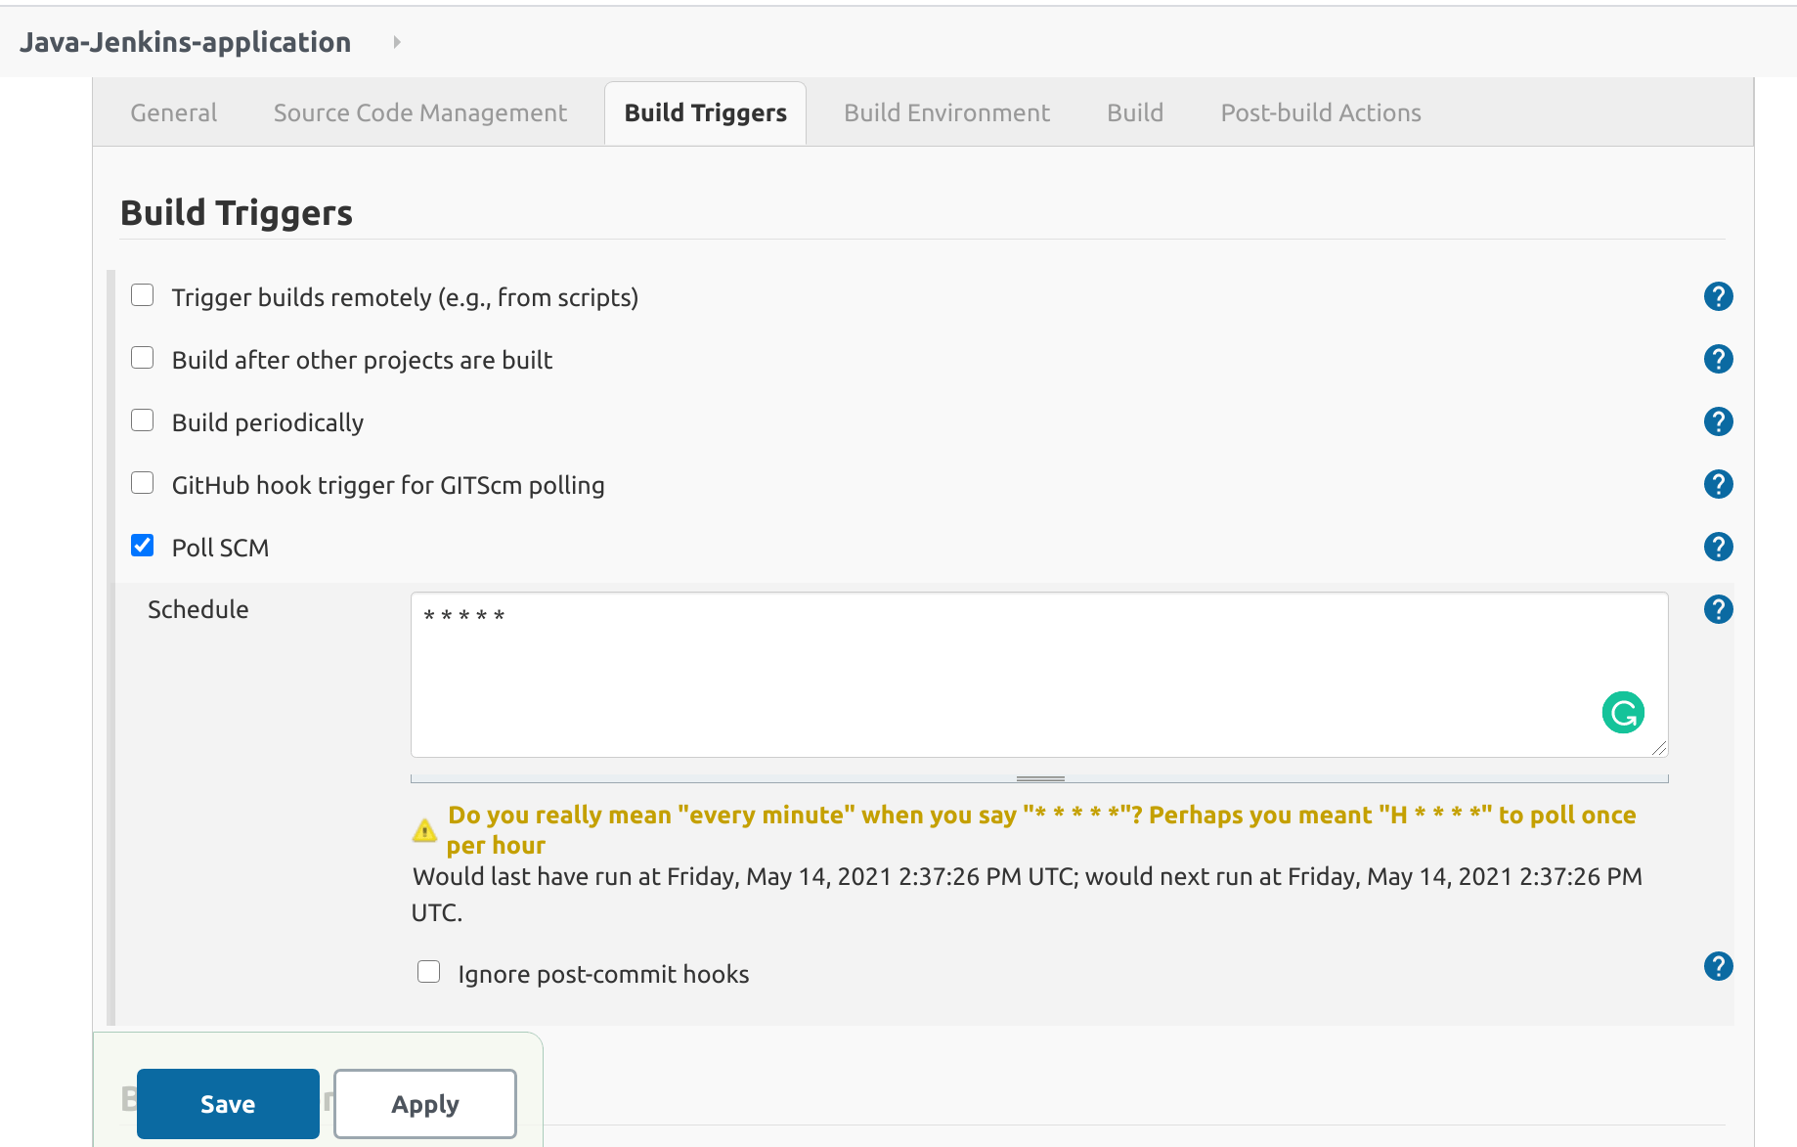

To learn more on polling SCM, check out this article [What is poll SCM in Jenkins?](https://askinglot.com/what-is-poll-scm-in-jenkins)

Next, we skip the Build Environment tab. In the Build window, we will add two Invoke top-level Maven targets steps.

Finally, we click on apply and save our Freestyle project configuration.

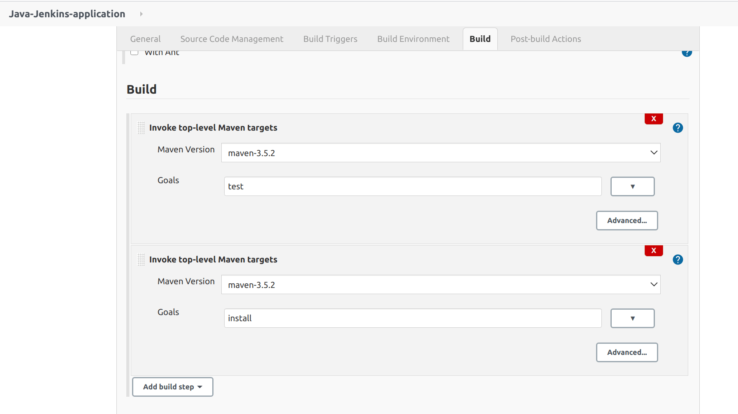

The above build steps run $ mvn test and $ mvn install commands automatically. If you recall our previous steps, we manually ran the test command for our unit test.

For testing purposes, let’s build our project to see if the current configuration works. Click on Build Now.



We can view the console output in the Build History:

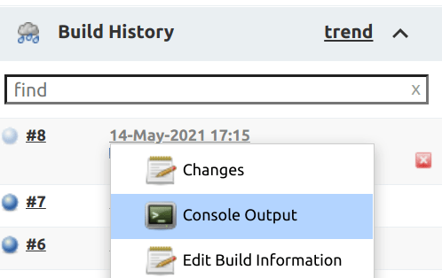

Our console output should look a lot like the image below:

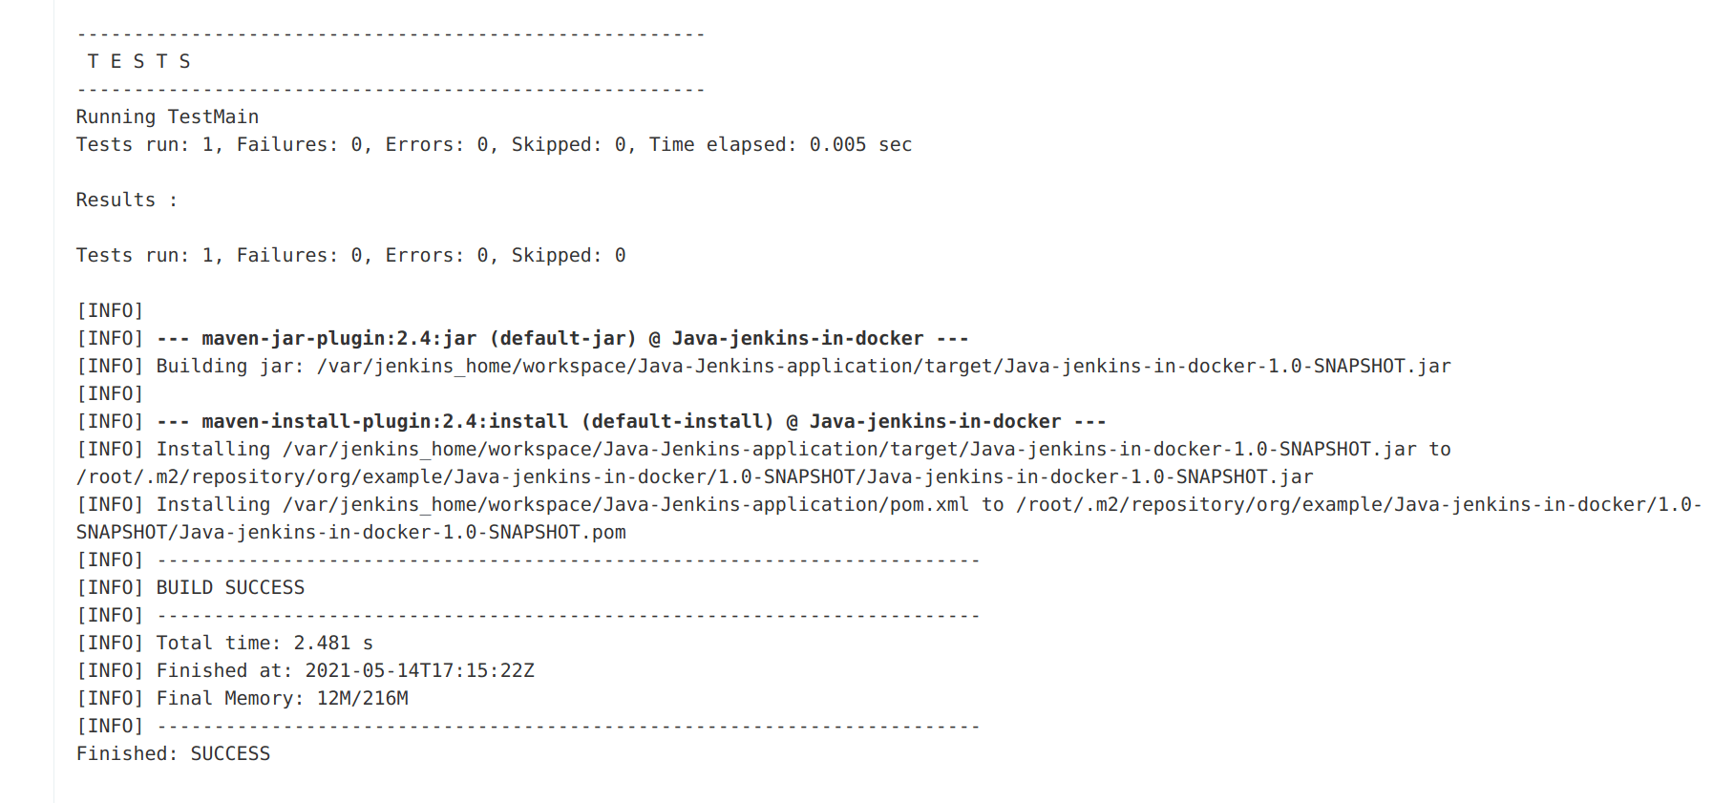

If we commit changes, we don’t need to manually click Build Now. Jenkins will automatically build our Freestyle project.

**Building and deploying our Docker image to Docker Hub**

We are almost there. What’s left is for us to configure Jenkins to build the Docker image of our Java application and deploy that image to Docker Hub.

To achieve this, we need a few Jenkins plugins installed.

In Manage Jenkins, select Manage Plugins under System Configurations, search and install the following plugins:

* docker-build-step
* CloudBees Docker Build and Publish

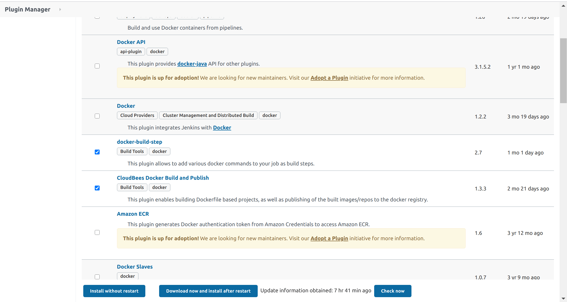

To check if the plugins have been installed, let’s go back to our Freestyle project configuration and in the Build tab, click on Add build step.

We will see the Docker Build and Publish option:

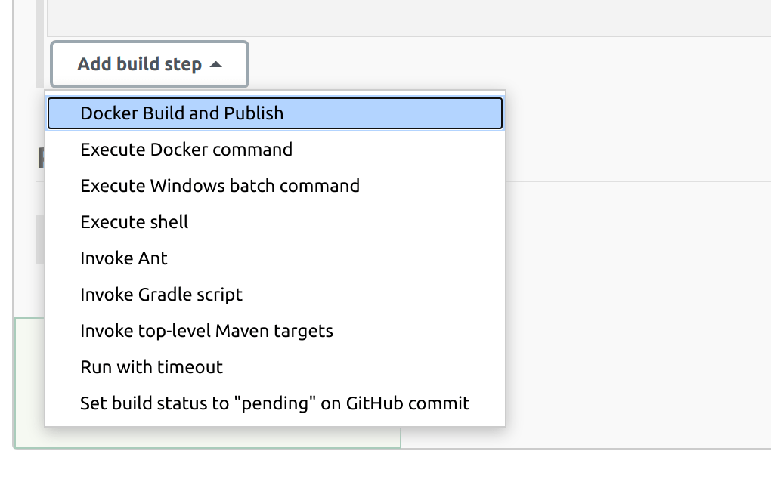

To build a Docker image, we need a Dockerfile to notify docker which base image to build our image from and other Java-related configurations. We also need to generate a JAR (Java ARchive) file.

In the build profile, navigate to the pom.xml file and add a [finalName](https://kb.novaordis.com/index.php/Maven_pom.xml#:~:text=finalName%20modifies%20the%20name%20of,named%20artifacts%20in%20the%20repository.).

This finalname will be our JAR name:

<build>

<finalName>java-jenkins-docker</finalName>

</build>

To generate our JAR run:

$ mvn install

We can find our JAR in the target/ directory of the project.

Now let’s create our Dockerfile.

Open the terminal and navigate to our Java application directory:

$ touch Dockerfile

And in our Dockerfile:

FROM openjdk:8

ADD target/java-jenkins-docker.jar java-jenkins-docker.jar

ENTRYPOINT ["java", "-jar","java-jenkins-docker.jar"]

EXPOSE 8080

Add the new files and then commit the changes to the GitHub repository. This will trigger a Jenkins post-commit build process as we configured.

Now we can add our build steps to build and deploy our Java application’s Docker image. For this, we will need a Docker Hub account. You can create one [here](https://hub.docker.com/signup).

Then, in the build step set:

* Repository name: Docker_id/jar_name example kikiodazie/java-jenkins-docker
* For this demo, we will leave the rest of the fields empty then Apply and save.

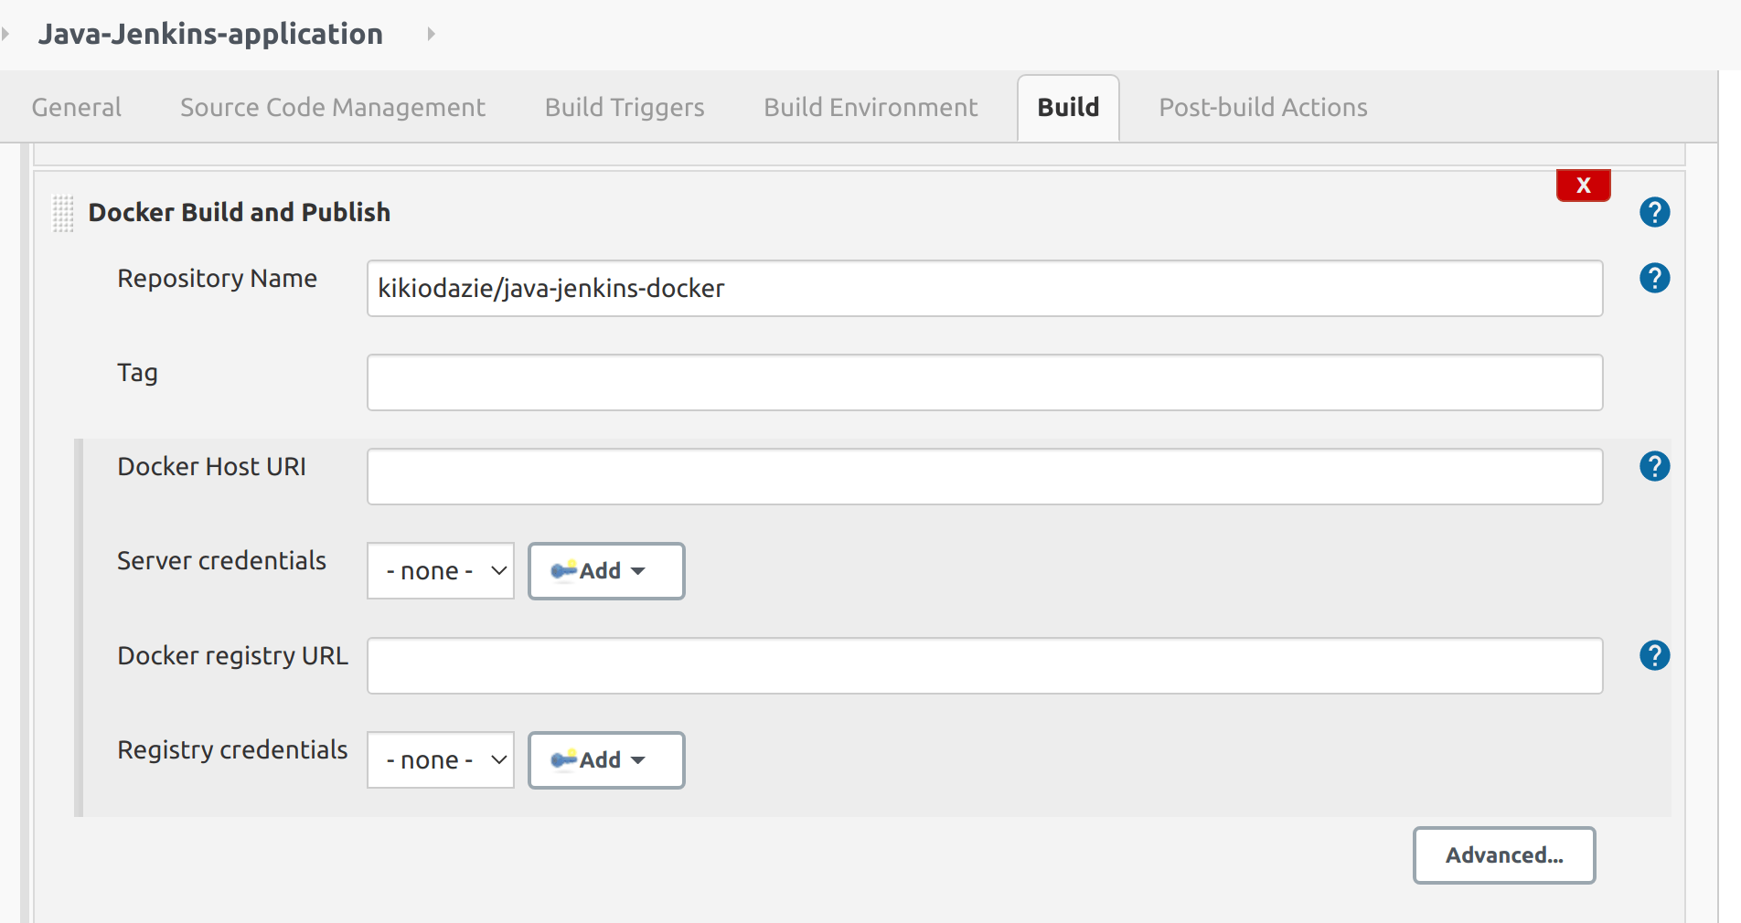

To give Jenkins access, we need to login to our Docker Hub account inside our Jenkins container through the command line, as shown below:

$ docker exec -it <container_name/container_id> /bin/bash

Then inside the container, run the Docker login command:

$ docker login

To complete this process, input your login credentials:

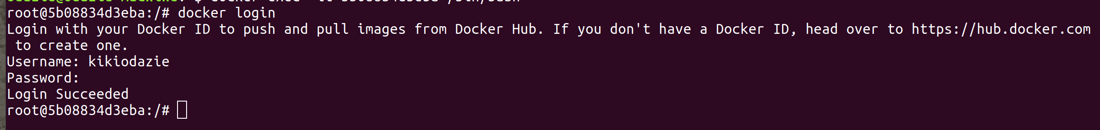

Go back to your project and click Build Now, then navigate to the console output. The output should look, as shown in the image below.

This means that our image has been successfully built and pushed to Docker Hub:

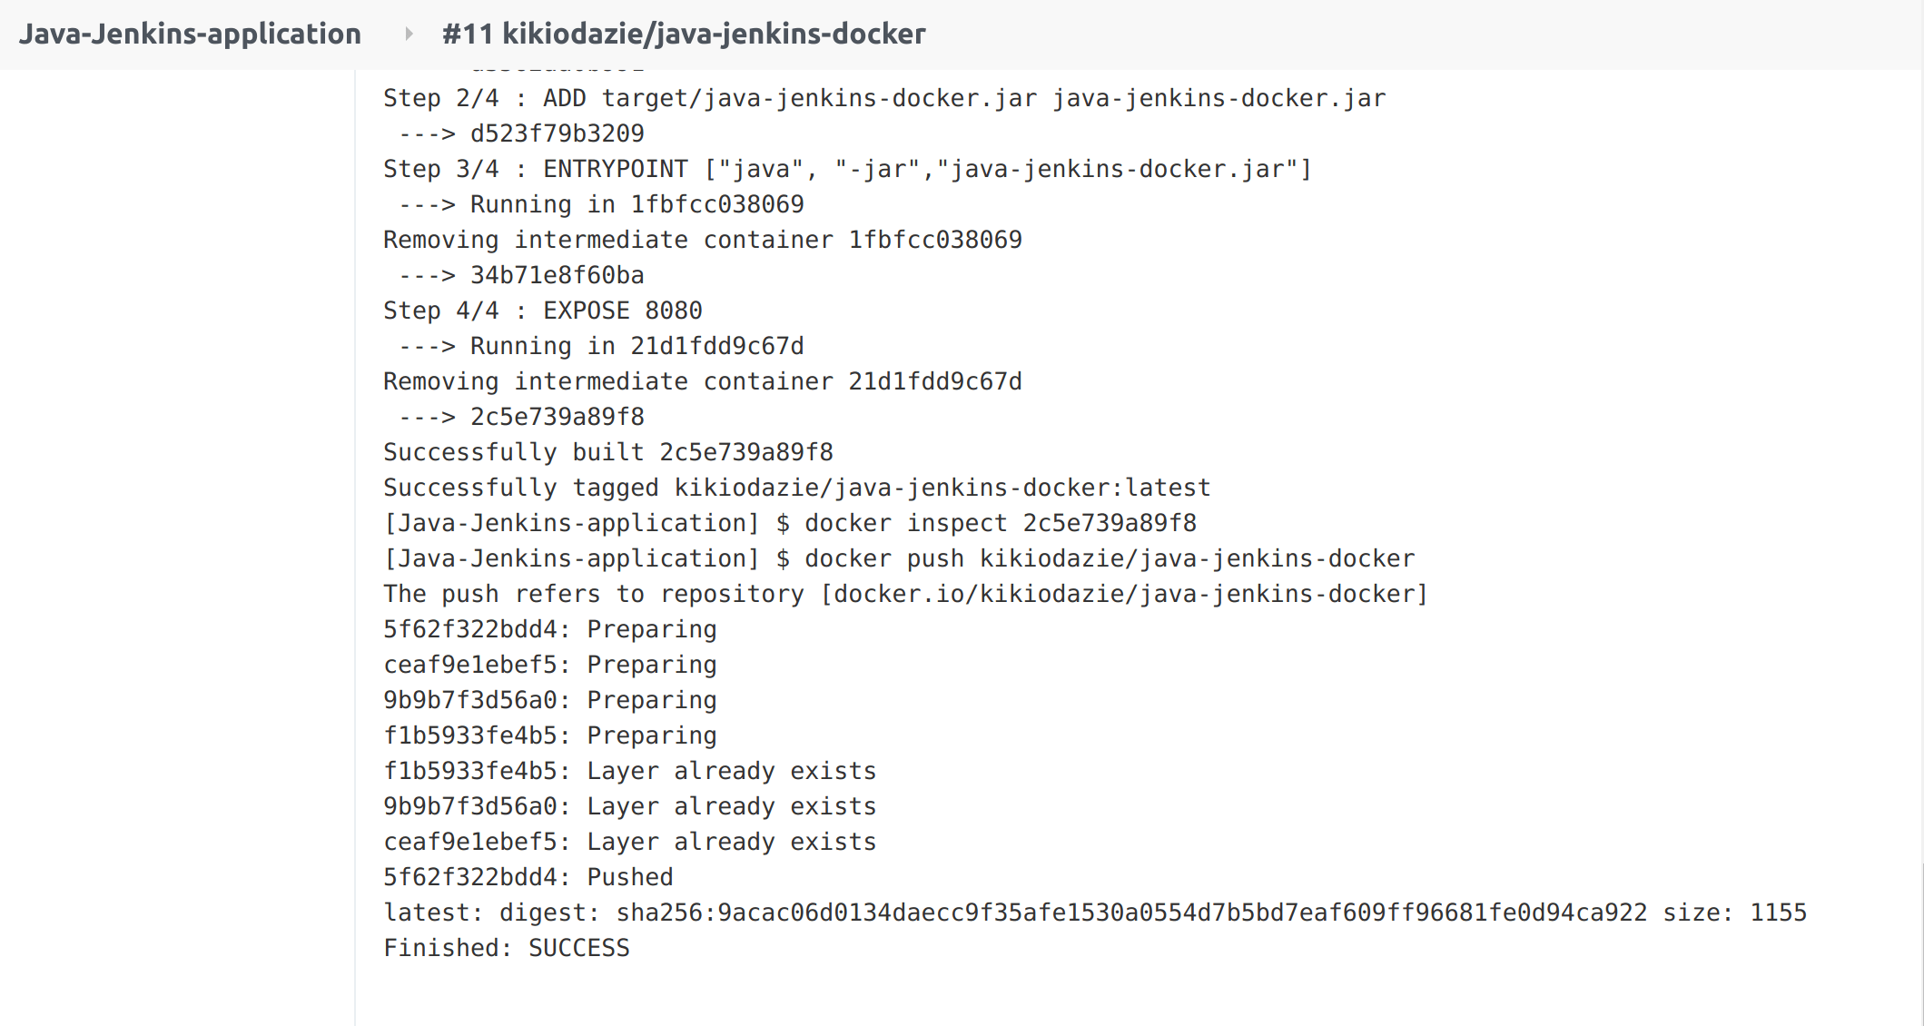

**Conclusion**

In this tutorial, we have learned how to set up and configure Jenkins in Docker. We also built and tested a Java application code and hosted it on Github.

We gave Jenkins access to our Docker Hub account to perform post-commit build triggers. Finally, we learned about Docker-in-Docker and how to build Docker images in a Docker container.

Happy coding!

**References**

* [Building CI/CD pipelines with Jenkins](https://opensource.com/article/19/9/intro-building-cicd-pipelines-jenkins)
* [A simple guide to DevOps - CI/CD with Jenkins Pipelines and Docker](https://www.linkedin.com/pulse/simple-guide-devops-cicd-jenkins-pipelines-docker-ramos-da-silva/)
* [Jenkins Full Course | Jenkins Tutorial For Beginner](https://www.youtube.com/watch?v=FX322RVNGj4)

Peer Review Contributions by: [Wanja Mike](https://www.section.io/engineering-education/content/authors/michael-barasa/)

**About the author**

[Divine Odazie](https://www.section.io/engineering-education/authors/divine-odazie/)

Consistency is key. That’s what Divine believes in and he says he benefits from that fact which is why he tries to be consistent in whatever he does in gaining permission-less leverage through accountability. Divine is currently a software engineer and technical writer who spends his days’ building software and writing about it.

Aside from the world of software he enjoys watching football (soccer), listening to good music, traveling and having fun in his own way.

* [Follow @_Odazie](https://twitter.com/_Odazie)
* [Connect on LinkedIn](https://www.linkedin.com/in/divine-odazie/)

This article was contributed by a student member of Section's Engineering Education Program. Please report any errors or innaccuracies to [enged@section.io](mailto:enged@section.io).

**[Want to learn more about the EngEd Program?](https://www.section.io/engineering-education)**

[Discover Section's community-generated pool of resources from the next generation of engineers.](https://www.section.io/engineering-education)

[Learn more](https://www.section.io/engineering-education)

**QUICK LINKS // More Section offerings**

**Join our Slack community**

[Add to Slack](https://sectionio-community.slack.com/)

**Company**

* [About](https://www.section.io/about)
* [Careers](https://www.section.io/about/careers)
* [Legals](https://www.section.io/legal-stuff)

**Resources**

* [Blog](https://www.section.io/blog)
* [Case Studies](https://www.section.io/blog/tag/case-study)
* [Content Library](https://www.section.io/edge-compute-content-resources)
* [Solution Briefs](https://www.section.io/solution-briefs)
* [Partners](https://www.section.io/solutions-partners)
* [Changelog](https://www.section.io/changelog)

**Support**

* [Docs](https://www.section.io/docs/)
* [Community Slack](https://sectionio-community.slack.com/)
* [Help & Support](https://support.section.io/hc/en-us)
* [Platform Status](https://status.section.io/)

Section supports many open source projects including:

* © 2021 Section
* [Privacy Policy](https://www.section.io/legal-stuff/privacy-policy)
* [Terms of Service](https://www.section.io/legal-stuff/terms-and-conditions)