Into the UFC: The Greatest Striker, Grappler, and Entertainer

Stanley Go1

1 Rutgers University

Author note

Add complete departmental affiliations for each author here. Each new line herein must be indented, like this line.

Enter author note here.

The authors made the following contributions. Stanley Go: Conceptualization, Writing - Original Draft Preparation, Writing - Review & Editing.

Correspondence concerning this article should be addressed to Stanley Go, 123 Rutgers University. E-mail: [smg421@scarletmail.rutgers.edu](mailto:smg421@scarletmail.rutgers.edu)

Abstract

One or two sentences providing a **basic introduction** to the field, comprehensible to a scientist in any discipline. Two to three sentences of **more detailed background**, comprehensible to scientists in related disciplines. One sentence clearly stating the **general problem** being addressed by this particular study. One sentence summarizing the main result (with the words “**here we show**” or their equivalent). Two or three sentences explaining what the **main result** reveals in direct comparison to what was thought to be the case previously, or how the main result adds to previous knowledge. One or two sentences to put the results into a more **general context**. Two or three sentences to provide a **broader perspective**, readily comprehensible to a scientist in any discipline.

*Keywords:* keywords

*Word count:* X

Into the UFC: The Greatest Striker, Grappler, and Entertainer

**monkey**

*monkey*

# Methods

We report how we determined our sample size, all data exclusions (if any), all manipulations, and all measures in the study.

## Participants

## Material

## Procedure

## Data analysis

We used R (Version 4.3.1; R Core Team, 2023) and the R-packages *dplyr* (Version 1.1.3; Wickham, François, Henry, Müller, & Vaughan, 2023), *forcats* (Version 1.0.0; Wickham, 2023), *ggplot2* (Version 3.4.3; Wickham, 2016), *lubridate* (Version 1.9.2; Grolemund & Wickham, 2011), *papaja* (Version 0.1.2; Aust & Barth, 2023), *purrr* (Version 1.0.2; Wickham & Henry, 2023), *readr* (Version 2.1.4; Wickham, Hester, & Bryan, 2023), *stringr* (Version 1.5.0; Wickham, 2022), *tibble* (Version 3.2.1; Müller & Wickham, 2023), *tidyr* (Version 1.3.0; Wickham, Vaughan, & Girlich, 2023), *tidyverse* (Version 2.0.0; Wickham et al., 2019), and *tinylabels* (Version 0.2.4; Barth, 2023) for all our analyses.

# Results

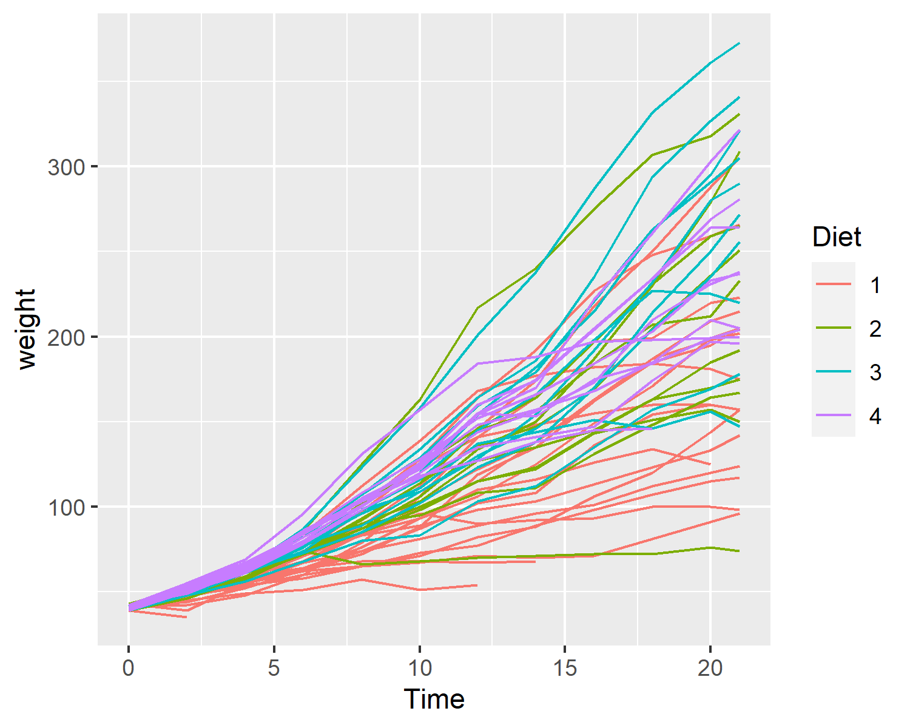

Figure 1: Each Chick’s weight in grams (y-axis) over time (x-axis), with each chick a separate line

# Discussion

# References

Aust, F., & Barth, M. (2023). *papaja: Prepare reproducible APA journal articles with R Markdown*. Retrieved from <https://github.com/crsh/papaja>

Barth, M. (2023). *tinylabels: Lightweight variable labels*. Retrieved from <https://cran.r-project.org/package=tinylabels>

Grolemund, G., & Wickham, H. (2011). Dates and times made easy with lubridate. *Journal of Statistical Software*, *40*(3), 1–25. Retrieved from <https://www.jstatsoft.org/v40/i03/>

Müller, K., & Wickham, H. (2023). *Tibble: Simple data frames*. Retrieved from <https://CRAN.R-project.org/package=tibble>

R Core Team. (2023). *R: A language and environment for statistical computing*. Vienna, Austria: R Foundation for Statistical Computing. Retrieved from <https://www.R-project.org/>

Wickham, H. (2016). *ggplot2: Elegant graphics for data analysis*. Springer-Verlag New York. Retrieved from <https://ggplot2.tidyverse.org>

Wickham, H. (2022). *Stringr: Simple, consistent wrappers for common string operations*. Retrieved from <https://CRAN.R-project.org/package=stringr>

Wickham, H. (2023). *Forcats: Tools for working with categorical variables (factors)*. Retrieved from <https://CRAN.R-project.org/package=forcats>

Wickham, H., Averick, M., Bryan, J., Chang, W., McGowan, L. D., François, R., … Yutani, H. (2019). Welcome to the tidyverse. *Journal of Open Source Software*, *4*(43), 1686. <https://doi.org/10.21105/joss.01686>

Wickham, H., François, R., Henry, L., Müller, K., & Vaughan, D. (2023). *Dplyr: A grammar of data manipulation*. Retrieved from <https://CRAN.R-project.org/package=dplyr>

Wickham, H., & Henry, L. (2023). *Purrr: Functional programming tools*. Retrieved from <https://CRAN.R-project.org/package=purrr>

Wickham, H., Hester, J., & Bryan, J. (2023). *Readr: Read rectangular text data*. Retrieved from <https://CRAN.R-project.org/package=readr>

Wickham, H., Vaughan, D., & Girlich, M. (2023). *Tidyr: Tidy messy data*. Retrieved from <https://CRAN.R-project.org/package=tidyr>