ANALYTICS REPORT & INSIGHTS DOCUMENTATION
Business Performance Analysis | Task 5
Prepared as a demonstration using illustrative sample data

1. Executive Summary
This report demonstrates a structured business analytics workflow using an illustrative sales dataset covering 12 months, four regions, and three product categories. The dataset contains 144 aggregated observations. Total recorded revenue is $1,716,328.63, total profit is $307,489.77, and total orders are 10,128. The weighted profit margin is 17.92%. Technology is the largest revenue category, while West is the leading region by revenue. These results are examples from synthetic data and should not be interpreted as actual company performance.

2. Business Objectives and Key Questions
- Measure overall revenue, profit, order volume, and profit margin.
- Identify monthly trends, seasonal patterns, and unusually strong or weak periods.
- Compare category and regional performance to identify growth opportunities.
- Translate findings into practical, measurable recommendations for stakeholders.
- Document assumptions, limitations, and reproducible steps so the analysis can be reviewed.

3. Dataset and Methodology
The demonstration dataset is generated for this task; it is not collected from a real business. Each row represents one month–region–category combination. Fields include Month, Region, Category, Orders, Revenue_USD, Profit_USD, and Profit_Margin_Pct. The dataset has 144 rows and covers January–December 2025.
Methodology:
- Load the CSV using pandas and validate column names and data types.
- Check for missing values, duplicate records, negative sales values, and invalid order counts.
- Aggregate revenue, profit, and orders by month, category, and region.
- Calculate weighted profit margin as total profit divided by total revenue multiplied by 100.
- Create line and bar charts to compare time trends, categories, and regions.
- Interpret patterns cautiously and separate observed results from hypotheses that require further testing.

4. Key Performance Indicators
KPI | Result | Interpretation
Total Revenue | $1,716,328.63 | Overall sales value in the illustrative dataset.
Total Profit | $307,489.77 | Revenue remaining after the modeled costs represented in profit.
Total Orders | 10,128 | Sum of order counts across all groups.
Weighted Profit Margin | 17.92% | Profit divided by revenue; weighted across all records.
Top Revenue Category | Technology | $849,113.37 revenue.
Top Revenue Region | West | $473,871.23 revenue.

5. Findings and Visualizations

5.1 Monthly performance
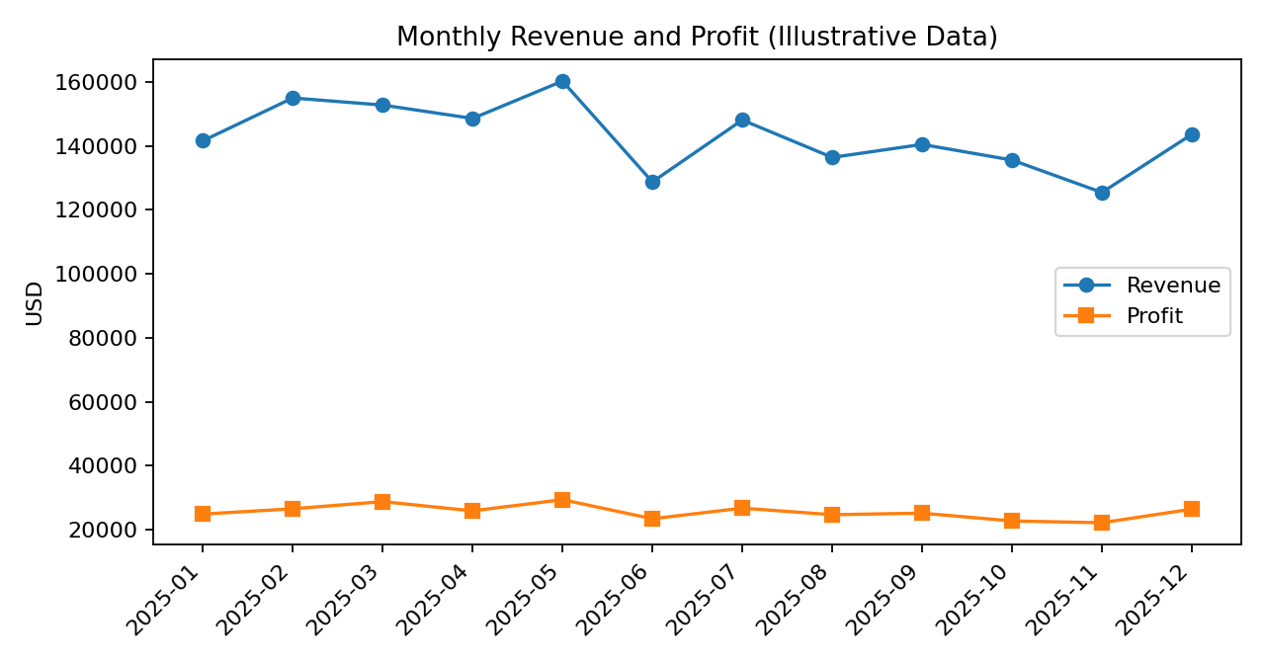
The highest-revenue month in this sample is 2025-05 ($160,231.66); the lowest is 2025-11 ($125,437.89). The line chart helps stakeholders compare month-to-month movement. Before acting on a peak or dip, a real business should check promotions, stock availability, pricing changes, holidays, and one-off orders.

5.2 Category performance
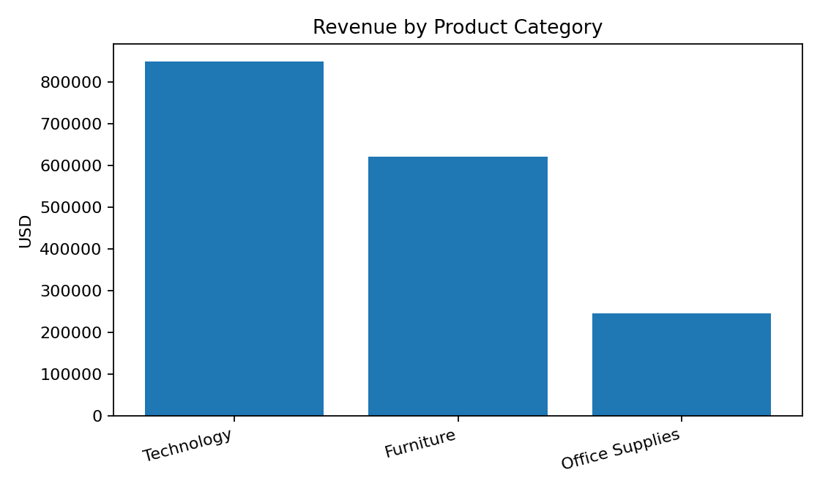
Technology ranks first by revenue in this sample. Revenue alone is not enough to determine the best category: decision-makers should also review margin, returns, inventory carrying cost, and customer acquisition cost. The lowest category-level weighted margin in the sample is Furniture.

5.3 Regional performance
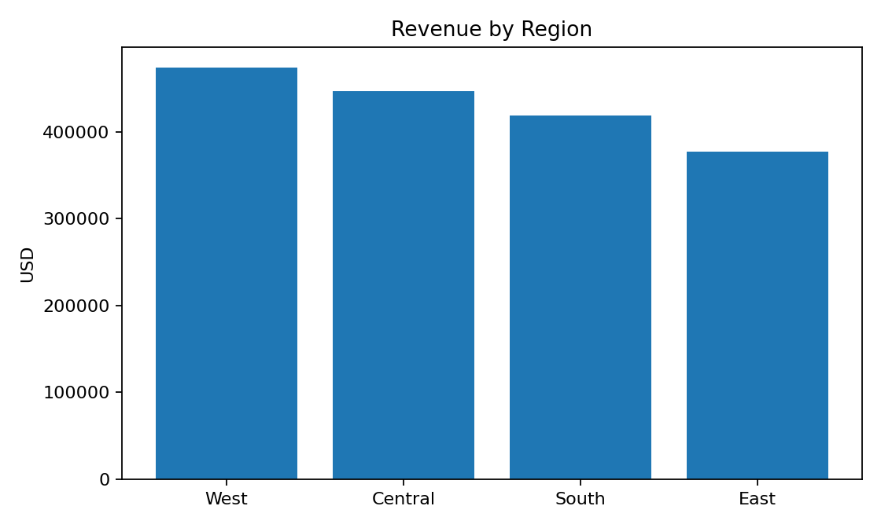
West has the highest recorded revenue among the four regions. Regional differences may reflect customer demand, distribution coverage, marketing spend, or account mix. A follow-up analysis should compare revenue per order and profit margin by region before reallocating budgets.

6. Business Insights
- Revenue concentration: Technology is the largest category by revenue in this sample; it may deserve a closer look for stock planning and cross-selling.
- Regional opportunity: West leads in revenue. Investigate the practices, customer segments, and product mix that may explain the difference.
- Profitability must accompany growth: the overall weighted margin is 17.92%, but category-level margins differ. High sales with low margin can reduce business value.
- Monthly monitoring is useful: regular trend reporting can reveal deviations earlier than an annual summary, especially when paired with inventory and campaign data.
- These are descriptive findings only. The synthetic data cannot establish causal relationships or prove that a specific marketing or pricing action caused a result.

7. Actionable Recommendations
- Create a monthly KPI dashboard — Track revenue, profit, orders, weighted margin, average order value, and month-over-month change. Review it with stakeholders each month.
- Investigate the leading category — Review Technology inventory availability, product-level margin, return rate, and repeat purchases before increasing its budget.
- Review regional differences — Benchmark West against other regions using revenue per order, margin, customer count, and marketing spend.
- Set margin guardrails — Require margin impact to be included in promotion and discount approvals; measure profit as well as sales uplift.
- Improve data quality controls — Validate missing values, duplicates, currency, date formats, and outliers before every report refresh.
- Run controlled experiments — Test campaigns or pricing changes using A/B tests or matched comparisons; document the hypothesis, success metric, sample size, and review period.

8. Limitations and Assumptions
- All records are synthetic and were generated only to demonstrate analysis; findings do not describe a real organization.
- Revenue and profit values are modeled in USD. Currency conversion, taxes, shipping, refunds, and accounting definitions are not modeled separately.
- The dataset is aggregated by month, region, and category, so customer-level or product-level behavior cannot be assessed.
- No causal inference is possible from these descriptive summaries.
- Recommendations should be validated using verified business data, stakeholder input, and relevant operational constraints.

9. Conclusion
This task demonstrates how business objectives can be translated into measurable KPIs, grouped summaries, visualizations, insights, and action plans. A good analytics report does more than display numbers: it explains what the numbers may mean, states the limits of the evidence, and recommends next steps that can be measured. For an actual organization, the next step is to replace the illustrative dataset with approved, validated business data and refresh the analysis on a regular schedule.

10. Reproducibility and Project Files
The accompanying project package includes the sample CSV, Python analysis script, chart images, and README instructions. Run the script in Python 3.10+ after installing pandas and matplotlib. The script reads sample_sales_data.csv, prints summary KPIs, and saves charts. All outputs are intended for learning and task demonstration.

Appendix A — Description of Analysis Steps
The workflow begins with defining business questions and identifying metrics. The data is then loaded and checked for structure, missing values, duplicates, and plausible values. Grouped summaries are calculated with pandas. Matplotlib is used to create a monthly trend chart and comparisons by category and region. The report translates those summaries into findings and recommendations. A production version should add automated tests, data lineage, access controls, scheduled refreshes, and review/approval steps.

