HANDS-ON DATA LAB IMPLEMENTATION
Task 2 — Data Science Consultant
Prepared by: Gauri Bobade
Dataset: Synthetic retail sales practice data
Submission note: This report includes reproducible Python code, computed summary tables, data-quality evidence, six visualizations and interpretations. The dataset is synthetic and intended for learning.

1. Objectives
The objectives are to inspect a dataset, identify data quality problems, clean and standardize records, manipulate data with Pandas, calculate descriptive statistics, analyze relationships, create useful visualizations, and document findings with reproducible code.

2. Dataset and Business Context
The raw file contains 243 rows and seven fields: Order_ID, Order_Date, Product, Region, Quantity, Unit_Price and Sales. Each record represents a practice order line. The exercise simulates a small retail dataset and deliberately includes missing cells, duplicated rows, inconsistent text and one non-numeric price value. The data is synthetic; it does not represent an actual business.

3. Tools and Method
Python, Pandas, NumPy and Matplotlib were used. The workflow is: load and inspect → normalize data types/text → remove exact duplicates → impute missing values → recalculate sales → create derived features → compute tables and correlations → plot and interpret results.

4. Dataset Inspection and Data Quality
The following code checks dataset dimensions, types, missing values and duplicates before any cleaning.
df = pd.read_csv("retail_sales_raw.csv")\nprint(df.shape)\nprint(df.dtypes)\nprint(df.isna().sum())\nprint("Duplicates:", df.duplicated().sum())
The raw dataset contains intentionally introduced issues. The summary below compares data quality before and after the cleaning steps.
Metric | Before cleaning | After cleaning
Rows | 243 | 240
Duplicate rows | 3 | 0
Missing cells | 8 | 0

5. Data Cleaning and Transformation
Dates and numeric fields are converted to appropriate types. Text values are stripped and standardized to title case. Exact duplicates are dropped. Missing Quantity and Unit_Price values are filled with their column medians; missing Product and Region values are filled with their modes. Sales is recalculated from Quantity × Unit_Price. Month and Revenue_Band are added for additional analysis.
df["Order_Date"] = pd.to_datetime(df["Order_Date"], errors="coerce")\ndf["Product"] = df["Product"].astype("string").str.strip().str.title()\ndf["Region"] = df["Region"].astype("string").str.strip().str.title()\nfor c in ["Quantity", "Unit_Price", "Sales"]:\n df[c] = pd.to_numeric(df[c], errors="coerce")\ndf = df.drop_duplicates()\nfor c in ["Quantity", "Unit_Price"]:\n df[c] = df[c].fillna(df[c].median())\ndf["Sales"] = (df["Quantity"] * df["Unit_Price"]).round(2)
After cleaning, the analysis contains 240 rows. The exact duplicate count fell from 3 to 0. The remaining missing-cell count is 0; missing values in key analysis fields were addressed using the documented median/mode rules.

6. Descriptive Statistics
The table reports count, mean, median, standard deviation, variance, minimum and maximum for quantity, unit price and sales. These measures describe typical order size and the spread of prices and sales.
Variable | count | mean | median | std | var | min | max
Quantity | 240.00 | 4.51 | 4.00 | 2.32 | 5.39 | 1.00 | 8.00
Unit_Price | 240.00 | 154.86 | 45.00 | 210.55 | 44,332.04 | 9.00 | 715.00
Sales | 240.00 | 685.35 | 200.00 | 1,125.03 | 1,265,698.93 | 9.00 | 5,200.00

7. Product and Region Analysis
Product summary is sorted by total sales so the strongest sales contributor appears first.
Product | Orders | Units_Sold | Total_Sales | Average_Order_Sales
Backpack | 29 | 130.00 | 85,800.00 | 2,958.62
Calculator | 25 | 105.00 | 36,540.00 | 1,461.60
Bottle | 53 | 227.00 | 27,240.00 | 513.96
Notebook | 37 | 174.00 | 7,749.00 | 209.43
Folder | 36 | 173.00 | 4,412.50 | 122.57
Pen | 60 | 274.00 | 2,743.00 | 45.72
Finding: Backpack is the largest product contributor in this synthetic dataset, with total sales of 85,800.00, approximately 52.2% of all recorded sales. This is a result of this generated sample and should not be generalized to real retail.
Region summary supports a comparable view across regions.
Region | Orders | Units_Sold | Total_Sales | Average_Order_Sales
West | 73 | 327.00 | 54,216.00 | 742.68
East | 61 | 269.00 | 40,540.50 | 664.60
North | 50 | 239.00 | 36,567.00 | 731.34
South | 56 | 248.00 | 33,161.00 | 592.16
Finding: West is the leading region in this sample, contributing 54,216.00 in sales (approximately 33.0% of total). Regional rankings can vary if the random seed or dataset changes.

8. Correlation Analysis
Variable | Quantity | Unit_Price | Sales
Quantity | 1.00 | -0.03 | 0.29
Unit_Price | -0.03 | 1.00 | 0.84
Sales | 0.29 | 0.84 | 1.00
Sales is expected to relate positively to Quantity and Unit_Price because it is calculated as Quantity × Unit_Price. Correlation describes linear association, not causation. Because Sales is mathematically derived from the other two fields, its correlations are partly built into the formula and should not be interpreted as independent evidence of a business effect.

9. Visualizations and Interpretation

Figure 1. Total Sales by Product
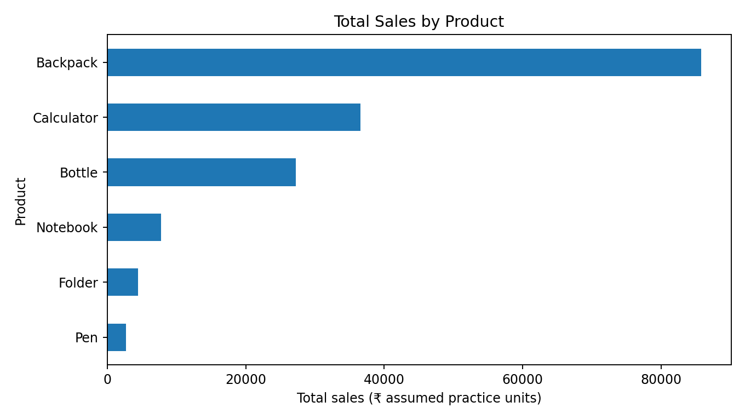
Interpretation: The bars compare total sales across product categories. The top category in this generated sample is Backpack. This chart helps prioritize further investigation but does not explain profit, costs or demand.

Figure 2. Total Sales by Region
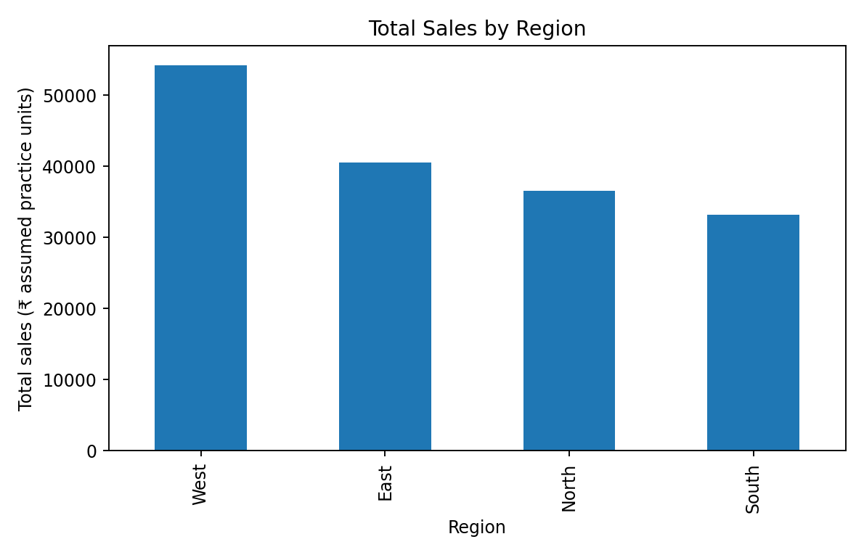
Interpretation: The chart compares regional sales; West ranks highest in this sample. Differences may reflect the random order mix and should be verified with real business data.

Figure 3. Daily Sales Trend
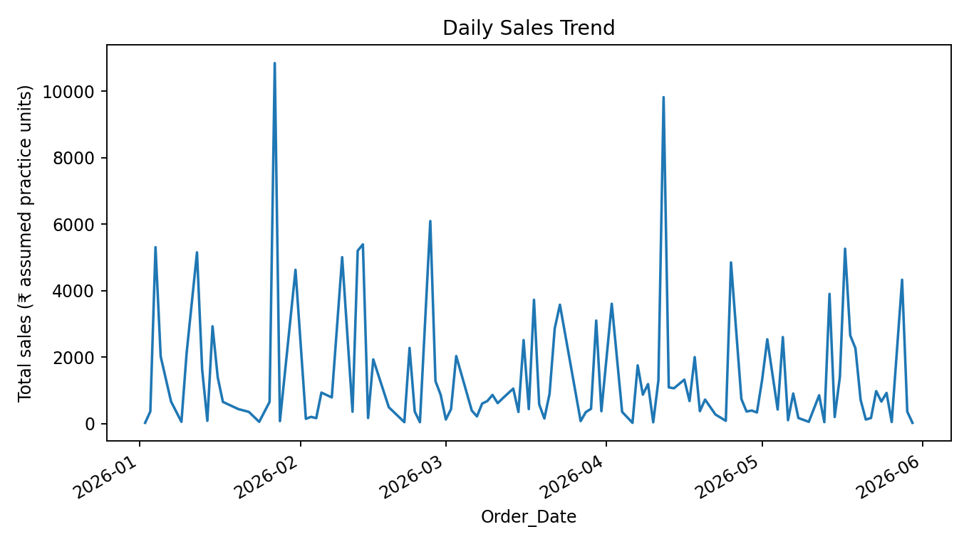
Interpretation: Daily totals fluctuate across the observation period. A short synthetic sample is not enough to claim a stable trend or seasonality.

Figure 4. Distribution of Order Sales
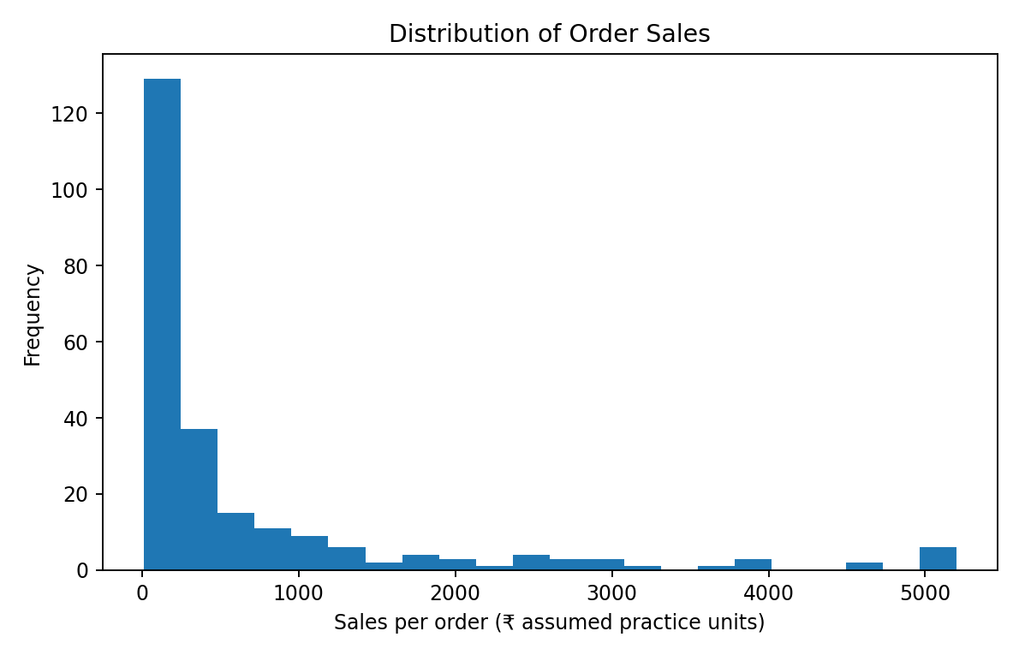
Interpretation: The histogram shows the spread of order-level sales. Higher-priced items can create a right-skewed distribution, so the mean (685.35) may differ from the median (200.00).

Figure 5. Correlation Matrix
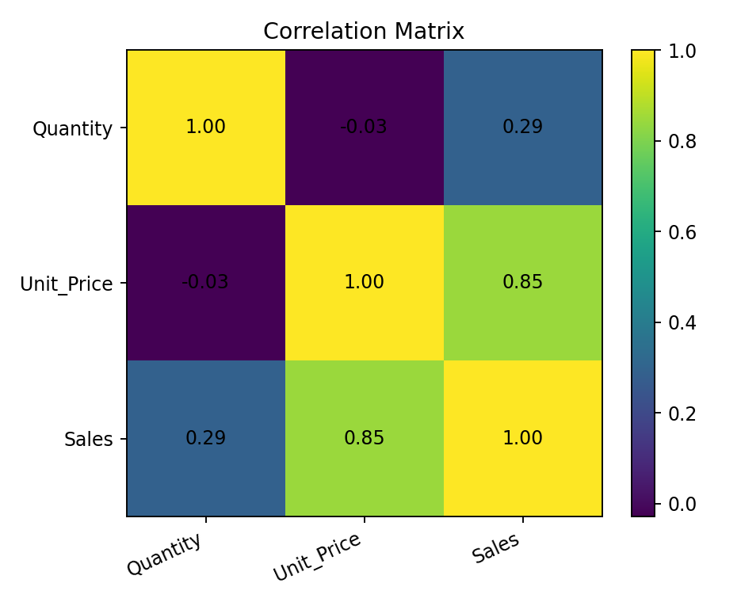
Interpretation: The matrix summarizes pairwise linear correlations among Quantity, Unit_Price and Sales. Interpret the Sales relationships cautiously because Sales is calculated from Quantity and Unit_Price.

Figure 6. Sales by Revenue Band
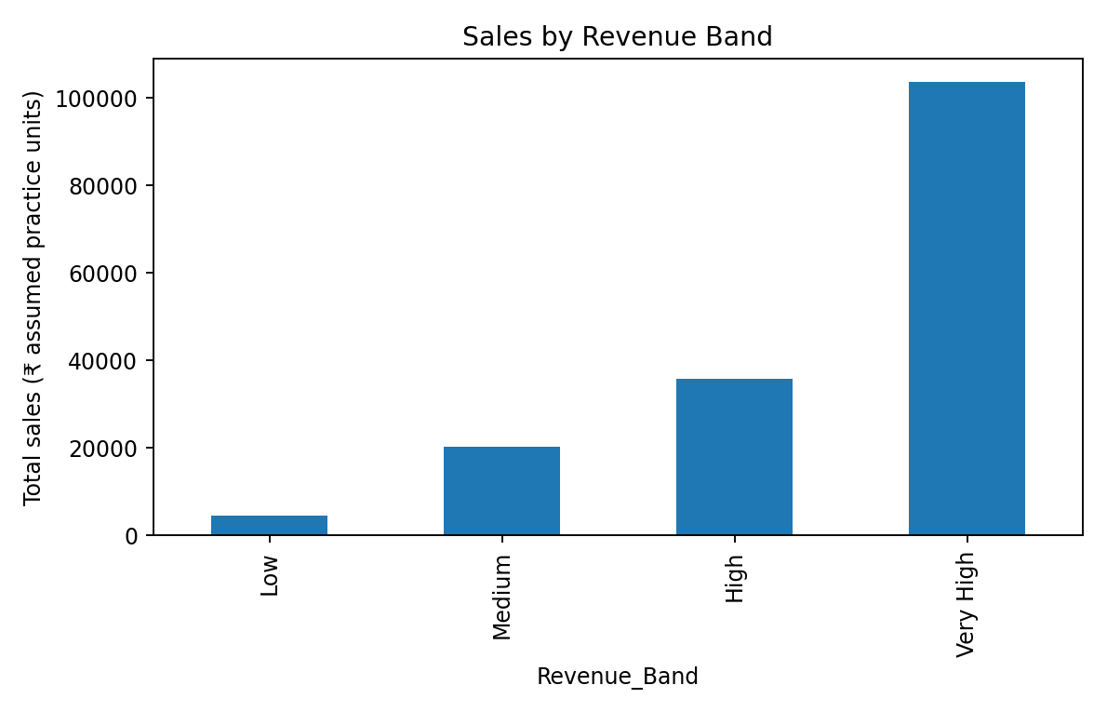
Interpretation: Revenue bands group order values into Low, Medium, High and Very High categories. This can simplify comparisons, but band thresholds are chosen for demonstration rather than derived from a business policy.

10. Reproducibility and Execution
Install the required libraries with: pip install pandas numpy matplotlib. Keep task2_data_lab.py and retail_sales_raw.csv in the same folder, then run: python task2_data_lab.py. The script prints summary results and saves cleaned data and analysis tables under outputs/ and charts under plots/.

11. Limitations
The dataset is synthetic, the product prices are illustrative, and the results are not evidence about a real company. Median/mode imputation can affect distributions. Sales is derived from quantity and unit price, so correlations involving Sales are partly mathematical. The daily series is short and random, so it should not be used for forecasting.

12. Conclusion
This task demonstrates a reproducible data science workflow from inspection to interpretation. It records 243 raw rows, identifies data quality problems, cleans the data, produces descriptive and category-level tables, computes correlations, and creates six visualizations. The main learning outcome is that clear cleaning rules, code, computed outputs and cautious interpretation make an analysis more transparent and verifiable.

