Task 3: Real-World Dataset Analysis Project
Dataset: Diabetes disease-progression dataset (scikit-learn)
Prepared as a reproducible educational data-analysis project

1. Executive Summary
This project demonstrates a complete data-analysis workflow using the diabetes dataset distributed with scikit-learn. The source dataset contains 442 observations, ten baseline variables, and a quantitative measure of disease progression one year after baseline. The analysis includes data inspection, quality checks, cleaning, descriptive statistics, correlation analysis, and visualizations. To make cleaning methods demonstrable, the included raw working copy intentionally contains a small number of missing cells and duplicate observations. These issues were introduced for this educational exercise; they are not claims about the untouched source dataset.

2. Objective
- Understand the structure and meaning of a real-world dataset.
- Inspect data types, missing values, duplicate records, distributions, and relationships.
- Apply repeatable cleaning and preprocessing techniques.
- Use descriptive statistics and correlation analysis to identify patterns.
- Create visualizations and explain findings, limitations, and appropriate use.

3. Dataset Description and Source
The dataset is the diabetes dataset packaged with the Python scikit-learn library (sklearn.datasets.load_diabetes). It is based on a study of diabetes patients and is commonly used for regression demonstrations. The target is a quantitative measure of disease progression one year after baseline, not a diagnosis or probability of having diabetes. Features include age, sex, body-mass-index (bmi), blood pressure (bp), and six serum measurements (s1–s6). The feature values are standardized in the distributed version, so they should not be read as original physical units.
Source reference: scikit-learn documentation, “Diabetes dataset” — https://scikit-learn.org/stable/datasets/toy_dataset.html#diabetes-dataset
Project files: diabetes_raw.csv is a deliberately modified working copy used to demonstrate cleaning; diabetes_cleaned.csv is the cleaned analysis dataset. task3_analysis.py contains the reproducible cleaning and analysis workflow.

4. Tools and Methodology
Python was used with Pandas and NumPy for data handling and numerical operations, Matplotlib for charts, and scikit-learn to identify the source dataset. The workflow was:
- Load and inspect the raw CSV; check dimensions, column names, data types, and summary statistics.
- Count missing values and duplicate observations.
- Remove duplicate observations using the feature values and target, rather than the unique record identifier.
- Convert analysis columns to numeric values and impute missing feature values using each feature’s median.
- Save the cleaned dataset and quality summary so the result can be audited.
- Calculate descriptive statistics and Pearson correlations, then generate charts for distribution and relationships.

5. Data Quality and Cleaning
The raw working copy has 445 rows because three duplicate observations were added to the 442 source observations. A small set of missing feature values was also deliberately inserted. Duplicate detection excludes record_id because the ID is unique by design and would otherwise prevent duplicate rows from matching. The duplicated observations were removed. Missing numeric feature values were filled with the median of the corresponding feature, a robust choice for a small number of missing cells. The target was also given a median fallback in code, although the supplied working copy does not intentionally insert missing target values.
Observed cleaning results: raw rows = 445; duplicate observations removed = 3; missing cells before imputation (after duplicate removal) = 12; cleaned rows = 442; missing cells after cleaning = 0.
Quality check | Result
Rows in raw file | 445
Columns in raw file | 12
Duplicate observations removed | 3
Missing cells before imputation (after duplicate removal) | 12
Missing cells after cleaning | 0
Rows in cleaned file | 442

6. Exploratory Data Analysis
Descriptive statistics were calculated for every feature and the target. Because the features are standardized, their means and ranges are on a transformed scale. The target remains a quantitative outcome on the dataset’s scale. Correlation is used as an exploratory measure of linear association only; it does not establish causation.

6.1 Target distribution
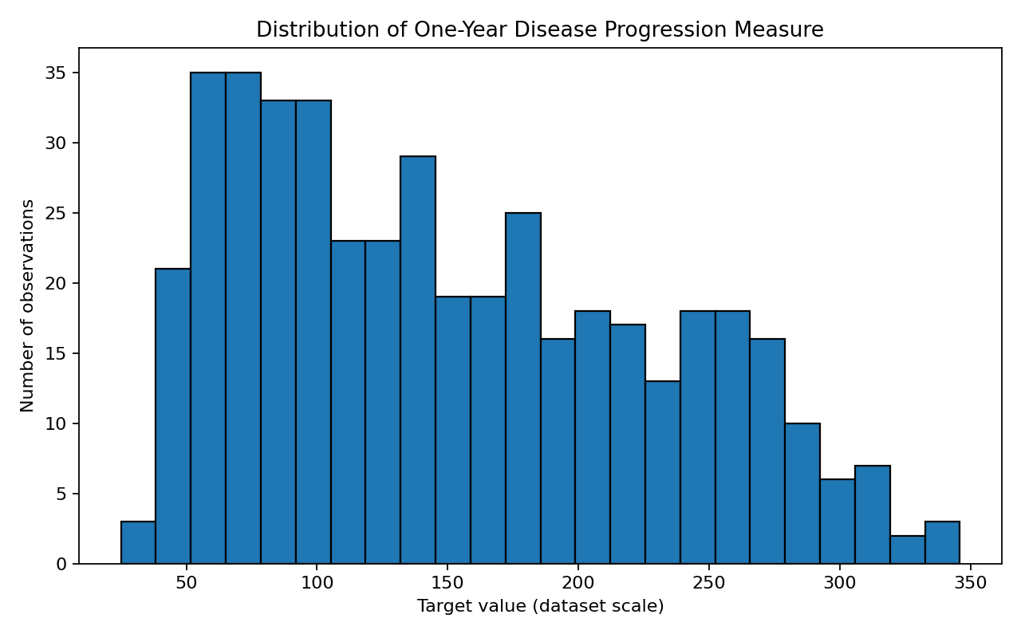
The histogram shows the spread of one-year disease-progression values. The distribution helps identify the central range, variation, and any unusually high or low observations. These values describe this dataset and should not be used to assess an individual patient.

6.2 BMI feature and target
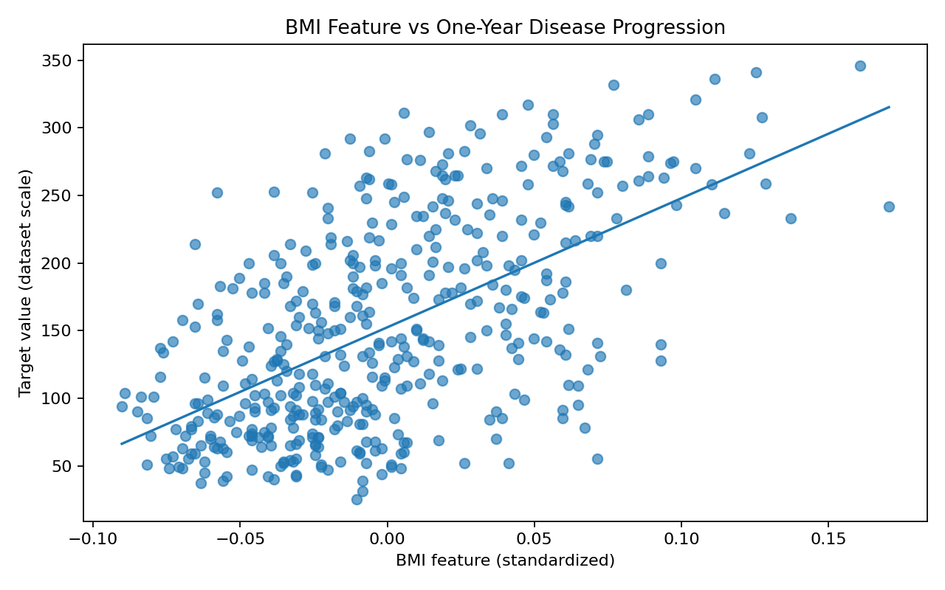
The BMI feature has a Pearson correlation of 0.588 with the target in the cleaned dataset. The scatter plot indicates the direction and spread of the linear association. A wide spread around the fitted line shows that BMI alone does not explain all variation in the target.

6.3 Blood-pressure feature and target
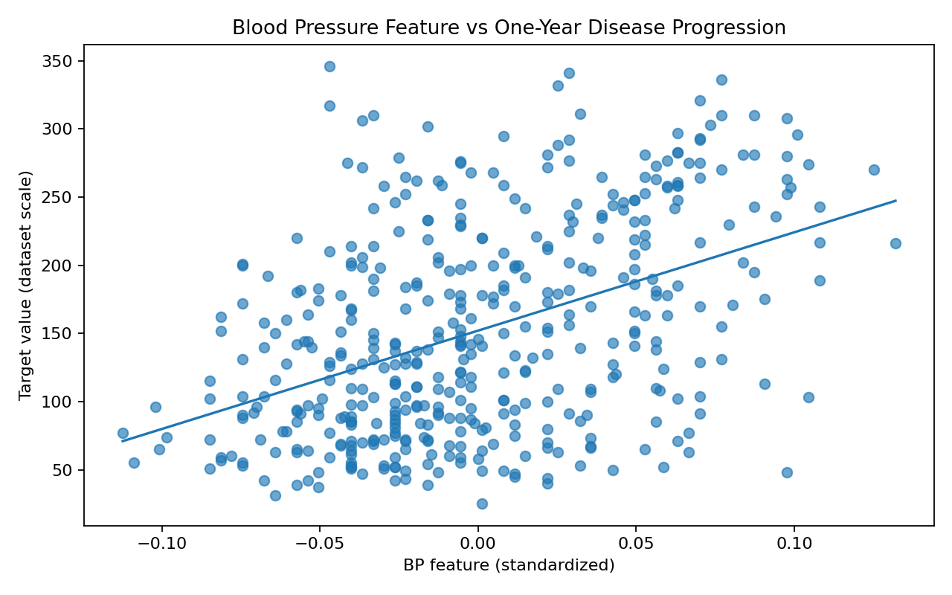
The BP feature has a Pearson correlation of 0.445 with the target. This is an exploratory relationship on standardized feature values, not a clinical threshold or causal effect.

6.4 Correlation matrix
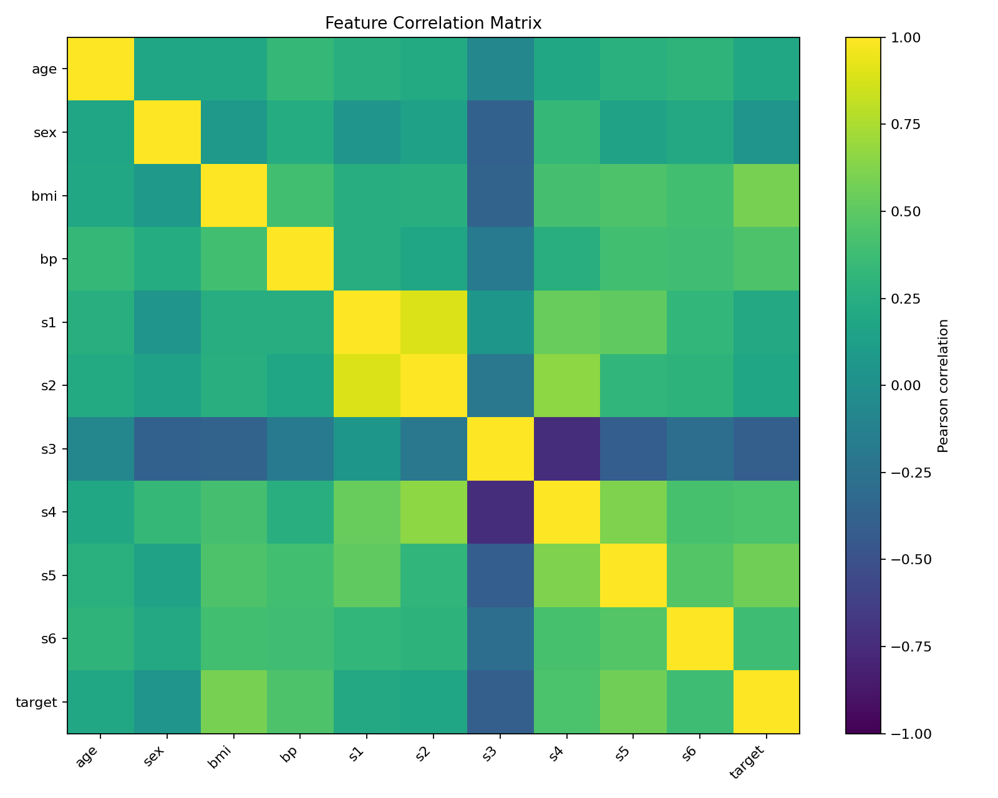
The heatmap summarizes pairwise Pearson correlations. It can help identify features that move together and features with stronger linear association with the target. Correlated predictors may carry overlapping information, so a future predictive model should check multicollinearity and validate performance on held-out data.

6.5 Mean target by BMI feature quartile
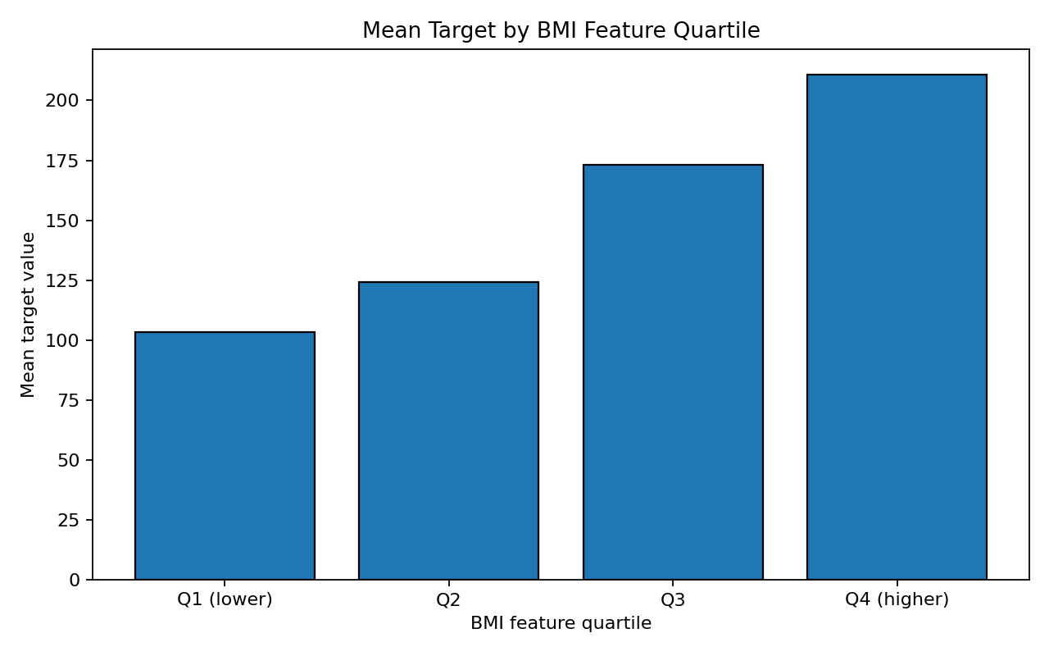
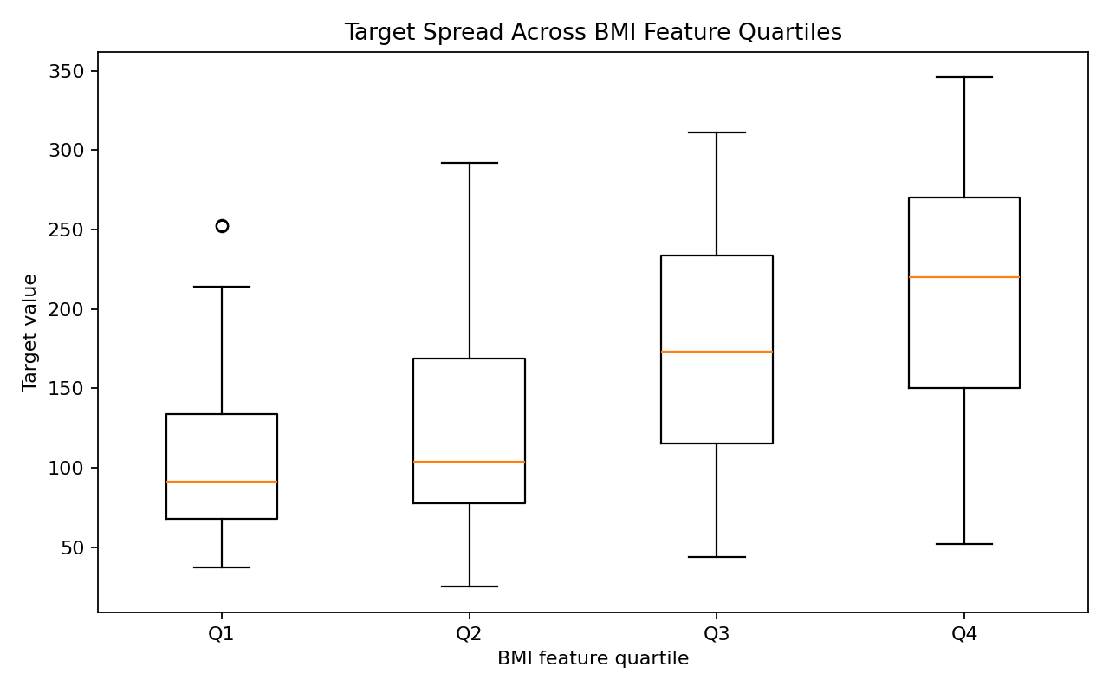
Grouping the standardized BMI feature into quartiles offers a simple comparison of target averages and spread across lower-to-higher feature groups. Quartile analysis is descriptive: the groups are not medical categories and do not imply that changing one feature would cause a change in the target.

7. Key Findings
- bmi: Pearson correlation with target = 0.588.
- s5: Pearson correlation with target = 0.566.
- bp: Pearson correlation with target = 0.445.
- s4: Pearson correlation with target = 0.430.
- s3: Pearson correlation with target = -0.395.
The strongest correlations above are selected by absolute correlation magnitude. Positive values indicate that higher standardized feature values tend to accompany higher target values; negative values indicate the opposite linear pattern. The magnitude should be interpreted cautiously, and relationships among variables may confound simple pairwise comparisons.

8. Limitations and Responsible Interpretation
- The dataset is relatively small (442 unique observations) and should not be treated as representative of all populations.
- The features are standardized, so they are not directly interpretable as original clinical measurements.
- The target is a historical disease-progression measure, not a diagnosis, clinical recommendation, or current medical outcome.
- Correlation does not prove causation. No predictive model or clinical validation is claimed in this report.
- Missing values and duplicates were intentionally introduced into the working copy for demonstration; they are not presented as source-dataset defects.
- Median imputation is practical for this exercise, but a real deployment should evaluate the missingness mechanism and compare preprocessing choices.

9. Conclusion
This project demonstrates how a real-world dataset can be inspected, cleaned, summarized, visualized, and interpreted using Python. The final cleaned dataset contains 442 unique observations with no missing cells. Summary tables and charts make the analysis easier to review and reproduce. The main lesson is that data cleaning and visualization provide useful exploratory evidence, while conclusions must remain proportional to the dataset, its limitations, and the analysis performed.

10. Reproducibility and Deliverables
- diabetes_raw.csv — raw working copy with deliberately introduced missing values and duplicate observations.
- diabetes_cleaned.csv — cleaned dataset used for analysis.
- task3_analysis.py — Python script showing data inspection, cleaning, summary statistics, and correlation analysis.
- outputs/ — quality summary, descriptive statistics, correlation matrix, target correlations, and quartile summary.
- plots/ — six generated charts used in the report.
- README.md — project overview, run instructions, and file guide.

