DATA SCIENCE FUNDAMENTALS ASSESSMENT
Data Science Consultant – Task 1
Submitted as part of Data Science Internship
Prepared by: Gauri Bobade

1. Introduction
This report presents a practical data science workflow using the Breast Cancer Wisconsin (Diagnostic) dataset available through scikit-learn. The objective is to demonstrate the complete fundamentals of data analysis: understanding a real-world dataset, applying Python programming and data science libraries, checking data quality, calculating descriptive statistics, studying correlations, performing exploratory data analysis (EDA), and communicating meaningful findings through visualizations.
The dataset is relevant to a real-world healthcare analytics context because the observations contain measurements computed from digitized images of breast mass samples. The target variable indicates whether a sample is classified as malignant or benign. This report is strictly educational and is not intended for clinical decision-making or medical diagnosis.

2. Dataset Understanding
The dataset contains 569 records and 30 numeric diagnostic features. The target variable is binary: 0 represents malignant and 1 represents benign in the original encoding. A target_name column was created with readable labels. Features include measurements such as radius, texture, perimeter, area, smoothness, compactness, concavity and symmetry.

3. Python Fundamentals and Libraries
Python was used as the main programming language. Pandas was used for DataFrame-based data manipulation, NumPy for numerical operations, Matplotlib for visualizations, and scikit-learn for loading the public dataset. Basic programming concepts including variables, column selection, aggregation, conditional logic and statistical calculations were applied.

4. Data Cleaning and Preparation
The dataset was checked for missing values, duplicate records and data types. The analysis found 0 missing values and 0 duplicate rows. The variables are numeric and suitable for statistical calculations and correlation analysis. A readable categorical target label was created. Since no missing observations were identified, imputation was not required.

5. Statistical Analysis
Descriptive statistics were calculated using mean, median, mode, standard deviation and variance. These measures help understand central tendency and spread. Radius, perimeter and area-related variables show substantial variation because they capture different physical characteristics of the samples.

6. Exploratory Data Analysis
EDA was performed to identify class balance, relationships between variables and potentially important measurements. Visualizations make patterns easier to detect than summary statistics alone.

7. Correlation Analysis
Pearson correlation was used to quantify linear relationships among numeric variables. Several radius, perimeter and area measurements are strongly related because they describe connected geometric characteristics. The target correlation ranking also indicates that some diagnostic measurements have a stronger association with the classification label than others.

8. Outlier Analysis
The interquartile range (IQR) rule was used to identify potential outliers. A value below Q1 − 1.5×IQR or above Q3 + 1.5×IQR was counted as a potential outlier. Outliers are not automatically errors; they should be investigated before removal.

9. Key Insights
The dataset contains 569 observations with 30 numeric diagnostic features. There are no missing values. The dataset contains both benign and malignant observations, allowing class-wise comparison. Radius, perimeter and area measurements are strongly related. The strongest target correlation in this analysis is associated with 'worst concave points'. Visualizations show measurable differences between the target classes.

10. Conclusion
This assessment demonstrates a complete introductory data science workflow. Python was used to load and inspect a real-world dataset, Pandas and NumPy supported data preparation and statistical analysis, and Matplotlib communicated patterns visually. The analysis demonstrates how descriptive statistics, class comparisons, correlations and outlier detection can turn raw data into useful insights. Future work could include feature engineering, hypothesis testing, machine learning classification and model evaluation.

Dataset Summary
Property | Value
Records | 569
Numeric features | 30
Missing values | 0
Duplicate rows | 0
Benign records | 357
Malignant records | 212

Statistical Summary of Selected Features
Measure | mean radius | mean texture | mean perimeter | mean area
mean | 14.13 | 19.29 | 91.97 | 654.89
std | 3.52 | 4.3 | 24.3 | 351.91
min | 6.98 | 9.71 | 43.79 | 143.5
max | 28.11 | 39.28 | 188.5 | 2501.0

EDA Visualizations
Figure 1: Class Distribution
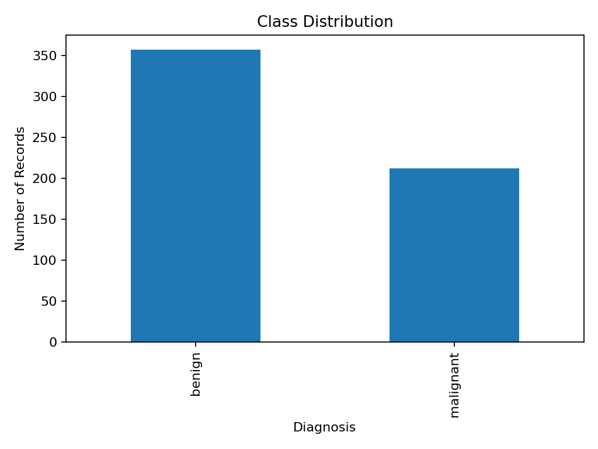
The chart shows the number of benign and malignant observations.
Figure 2: Average Mean Radius by Diagnosis
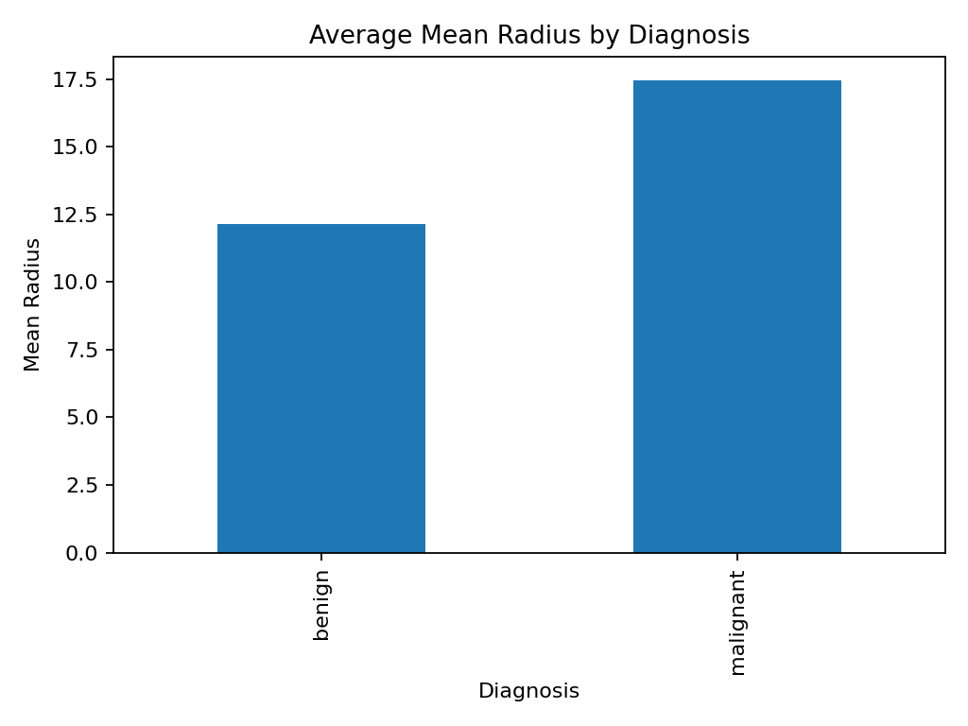
Average mean radius differs between the two target classes.
Figure 3: Mean Radius vs Mean Texture
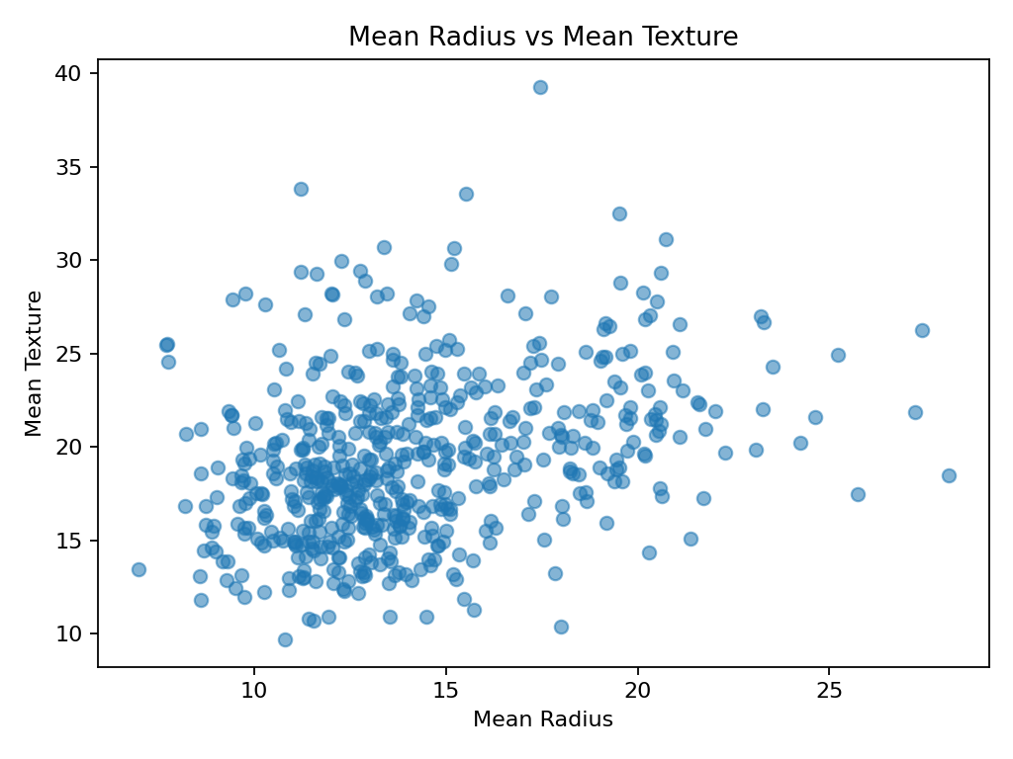
The scatter plot shows the relationship between two numeric features.
Figure 4: Top Correlations with Target
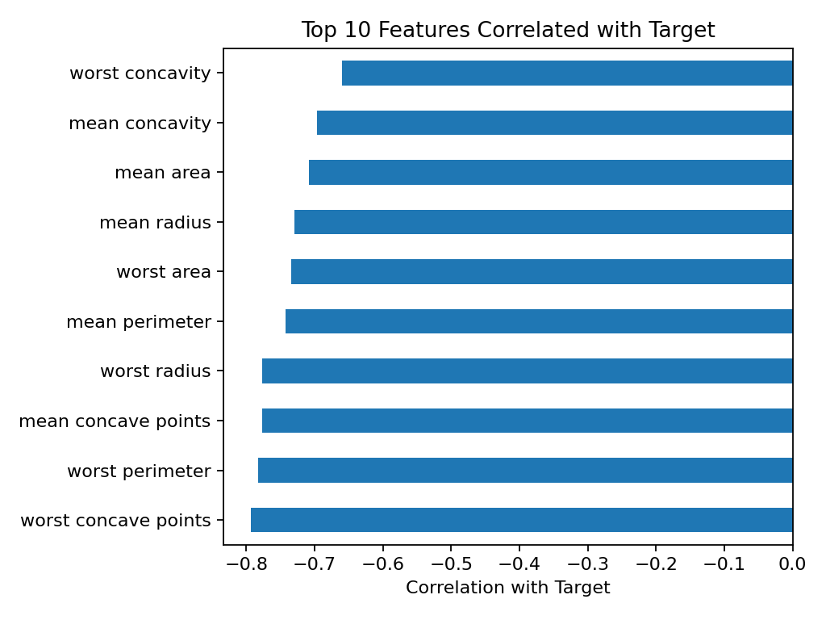
The chart highlights features with stronger linear association with the target encoding.

Top Correlations with Target
- worst concave points: -0.794
- worst perimeter: -0.783
- mean concave points: -0.777
- worst radius: -0.776
- mean perimeter: -0.743
- worst area: -0.734
- mean radius: -0.730
- mean area: -0.709

Potential Outliers (Top 5 by IQR Count)
- area error: 65
- radius error: 38
- perimeter error: 38
- worst area: 35
- smoothness error: 30

Tools and Technologies
- Python 3
- Pandas
- NumPy
- Matplotlib
- Scikit-learn
- Microsoft Word
- Git/GitHub

Project Structure
Data_Science_Fundamentals_Assessment.docx
breast_cancer_dataset.csv
task1_analysis.py
README.md
plots/

