ICAO Annex 9, Appendix 1

GENERAL DECLARATION

(Outward / Inward)

Owner or Operator: Prince Aviation
Marks of Nationality and Registration: Flight No: Date:

FLIGHT ROUTING
(“Place” column always to list origin, every en-route stop and destination)

Departure from: Arrival at:
(Place and country) (Place and country)

RANK | NAME | DATE, PLACE OF BIRTH | PASSP. NO | NUMBER OF PAX  ON THIS STAGE | CARGO
 |  |  |  | Departure place:  Embarking:  Through on  same flight: ________  Arrival place:  Disembarking:  Through on  same flight: ________ | NIL  …….. CARGO  Manifest  Attached

DECLARATION OF HEALTH  Persons on board with illness other then sickness of the effects of accidents (including persons with symptoms or signs of illness such as rash, fever, chills, and diarrhea) as those cases of illness disembarked during the flight:  NIL | FOR OFFICIAL USE ONLY
Any other condition on board which may lead t spread of disease:  NIL | FOR OFFICIAL USE ONLY
Details of each disinfecting or sanitary treatment (place, date, time, method) during the flight.  If no disinfecting has been carried out during the flight, give details of most recent disinfecting:  NIL | FOR OFFICIAL USE ONLY
Signed, if required __________________________________  Crew member concerned | FOR OFFICIAL USE ONLY
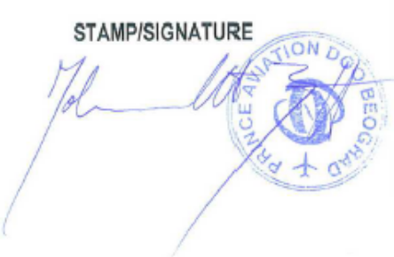
I declare that all statements and particulars contained in this General Declaration and any supplementary forms required to be presented with this General Declaration, are complete, exact and true to the best of my knowledge and that all though passengers will continue/have continued on the flight.

___________________________________
Authorized Agent or Pilot in Command

(1) Not to be completed when pass. Manifests are presented and to be completed only when required by the State.

