Module 10A – The Exploration of Space: The Formative Years
Sputnik and Telstar
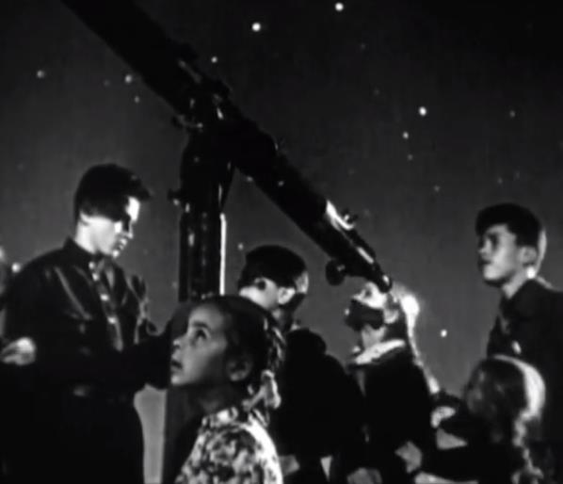 | In this module, we will study the formative years of space exploration, from Sputnik 1 to Apollo 11.  Later, we will look at the exploits of early pioneers of earthbound flight, as well as the science of flight itself.  [Click here to see a mesmerizing video on American media's reaction to the Soviet Union's launch of Sputnik 1, the first artificial satellite in space.]

It was on October 4, 1957, that Americans (and the whole world) woke up to find that the Soviets (the USSR) had launched an artificial satellite into near-Earth orbit for the very first time in human history.
Its orbit ranged from about 135 to 585 miles above the Earth. The satellite was moving at about 18,000 mph, and took about 96 minutes to circumnavigate the Earth.
There was no doubt that the Soviets had done this: any amateur (ham) radio operator could easily pick up Sputnik's radio signals broadcasting at 20 MHz and 40 MHz.
The space age had started, and the space race had begun.
Launched from Baikonur Cosmodrome, the Soviet space mecca in what today is called Kazakhstan, Sputnik 1 was quite small by today's satellite standards, being only 23 inches in diameter. Nevertheless, it certainly made a big splash in the worldwide press, as indicated by the above video.
The satellite made only 1440 revolutions of the Earth before reentering Earth's atmosphere and burning up in January of 1958.
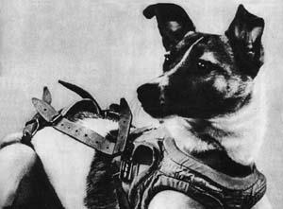 | For geopolitical reasons, the Soviets launched a second satellite, Sputnik 2 (the word originally meant “fellow traveler” in Russian, but now means “satellite” in Russian) a mere 30 days later. It had a living occupant on a one-way ticket to space, a mongrel dog named Laika.

The United States had intended to launch a satellite around this time, but concerns about the Soviet Union’s intentions regarding the possible militarization of space accelerated the United States response to Sputnik.
The first attempt by the United States, the Vanguard TV-3, unfortunately failed, the rocket exploding on the launch pad at Cape Canaveral.
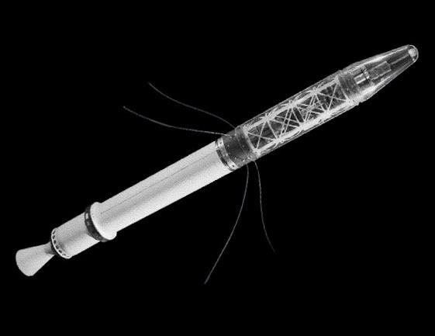 | The United States had much better success with its second attempt at an orbiting satellite, Explorer 1, which launched on January 31, 1958, also from Cape Canaveral. The satellite, a science instrument, discovered the Van Allen Belts, zones of charged particles trapped by the Earth’s magnetic field.

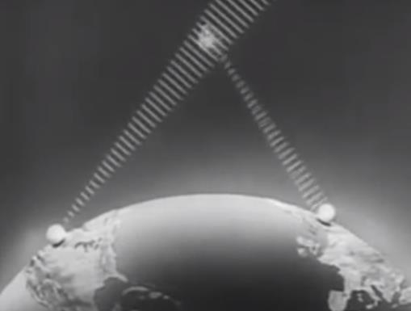 | It would take the United States an additional five years to “leapfrog” over the Soviets by launching the first transatlantic telecommunication satellite, Telstar 1, in July of 1962 from Cape Canaveral.  [Click here to see a video on, and learn more about, the Telstar program.]

 | Launched on a Thor-Delta rocket, the satellite occupied a highly elliptical orbit, with perigee at about 590 miles, and apogee at about 3500 miles. It weighed 170 pounds, was 3 feet in diameter, and ran on a mere 14 Watts of solar-assisted power.  Telstar 1 was the first satellite to relay television images across the Atlantic Ocean.

The first image sent from the US was that of an American flag flying over the transmission station in Andover, Maine.
Subsequent images from the US included part of a Chicago Cubs and Philadelphia Phillies baseball game, as well as a press conference by then President John Kennedy.
France returned the favor by transmitting a singing performance of the French vocal legend Yves Montand (shown here with movie costar Marilyn Monroe).
Unfortunately, Telstar 1 suffered radiation damage while traveling through the Van Allen Belts (previously mentioned), because of radiation deposited there by a US high-altitude nuclear bomb detonation the day before Telstar’s launch.
Telstar 1 first failed in November of 1962, a mere four months later. Engineers revived it in January of 1963, but it failed for good in February of 1963.
Yuri Gagarin – First Man in Space
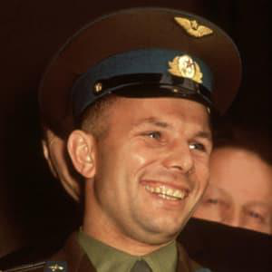 | The space race was in full stride when the Soviets decided to take a chance with their less than reliable Vostok program, and try to put a man in orbit.  On April 12, 1961, Soviet cosmonaut Yuri Gagarin became the first human to orbit the Earth.  It was not a routine journey. Gagarin had only a 50 percent chance of returning safely to Earth. He would orbit the Earth only once, traveling 25,000 miles, in 108 minutes, at an average speed of nearly 14,000 miles per hour.  [Click here to learn more about Gagarin's harrowing mission.]

Gagarin was chosen to be the first human in space in part because of his short stature, but also because he was athletic and a very level-headed person.
On a personal note, he had grown up in Nazi-occupied Russia, and had to live for a while in a mud hut, while his older brother and sister were shipped off to a Nazi slave labor camp.
His capsule, the Vostok 1, did not fare as well as he did. Part of the spacecraft was supposed to detach before reentry, but it failed to do so, sending his capsule tumbling violently as it reentered.
Fortunately, the unwanted part ultimately detached from his capsule because the cables connecting it burned through during reentry. Gagarin was able to eject from the Vostok 1, as planned, at 23,000 feet, and parachuted down near the town of Engels, in the Saratov region of European Russia, near the Volga River. The capsule landed nearby under its own parachute, and is now on display in a museum near Moscow.
Unfortunately, Gagarin did not live very long after his successful orbiting of the Earth. Just seven years later, on March 27, 1968, Gagarin died in a MiG-15 military jet aircraft training accident.
He was only 34 years old.
Alan Shepard – First American in Space
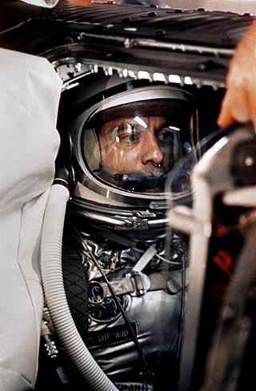 | President John F. Kennedy was not happy that the Soviets had beaten the US in putting a man in orbit around the Earth, but he knew it would be a while before the US could duplicate that feat.  The original “right stuff” US astronaut crew had been chosen (the Mercury 7), and it was up to NASA to respond in some fashion as soon as possible.  It was decided to send one astronaut up into a suborbital flight aboard a Redstone rocket, and Alan Shepard was selected for that task.  A navy test pilot of the highest caliber, Shepard, in his capsule Freedom 7, blasted off from Cape Canaveral on May 5, 1961, flying to a height of 116 miles, while traversing a horizontal distance of 302 miles.

Shepard's triumph was celebrated with a ticker tape parade in New York City.
Shepard would soon be grounded because of an inner ear disease, but that disease was corrected by surgery, and he was able to command Apollo 14, which he landed on the Moon on February 5, 1971.
While Shepard was on the Moon, he managed to squeeze in a bit of golf, hitting one ball, as he described it, “miles and miles.”
Shepard died of leukemia at the relatively young age of 74. His wife of 53 years, Louise, died about five weeks after him, apparently of a broken heart.
[Click here to see a video of Shepard's first space flight.]
Gus Grissom – Second American in Space
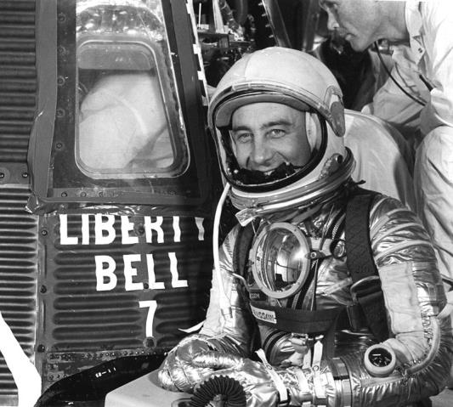 | No review of the early days of space flight would be complete without a sincere remembrance of Gus Grissom, perhaps the second best-known member of the Mercury Seven astronauts after John Glenn.  A bit of a maverick but extremely popular, Grissom was the second American to go into space, after Alan Shepard, flying a suborbital arc on July 21, 1961, for a mere 15 minutes and 37 seconds in the Liberty Bell 7 capsule.

Unfortunately, after splashing down, the capsule hatch inadvertently blew open, and the capsule took on substantial water.
Rescue helicopter pilots were able to fish Grissom from the turbulent Atlantic, but the capsule was too heavy for the helicopter, and it sank.
[The capsule would be retrieved much later, in 1999, by a private salvage firm.]
Grissom went on to successfully command the two-man Earth-orbiting Gemini 3 mission, in a capsule playfully dubbed the Molly Brown (in honor of the unfortunate sinking of the Liberty Bell 7 capsule).
The mission was the first time astronauts were able to change the characteristics of their orbital motion using small rockets on the capsule.
Grissom and fellow Gemini 3 astronaut John Young were honored on March 29, 1965, with a ticker tape parade in New York City.
Unfortunately, Grissom's next mission, Apollo 1, was to be his last. He was to fly with fellow astronauts Ed White and Roger Chaffee, but during a launch pad test for the flight, a fire occurred in their oxygen-rich capsule.
The capsule filled with smoke, and all three astronauts were asphyxiated when they inhaled carbon monoxide from the fire. The air tubes to their suits, as well as parts of their suits, had melted from the intense heat and flames of the fire.
Grissom was only 40 years old.
[Click here to view a biography of Gus Grissom.]
Kennedy's Speeches
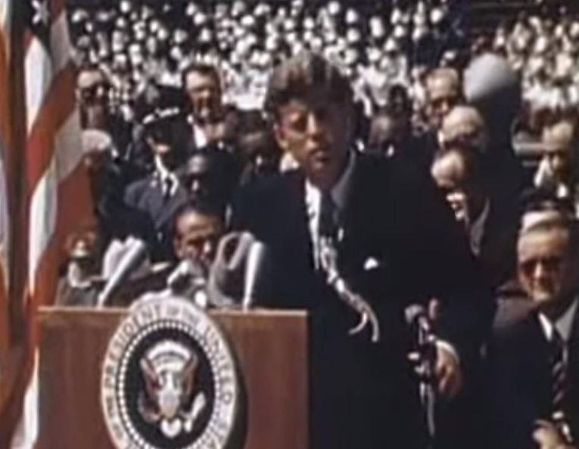 | The United States would probably not have gone to the Moon, if not for the single-mindedness of President Kennedy.  President Kennedy made two speeches about going to the Moon, the first in front of a joint session of Congress on May 25, 1961, and the second at Rice University on September 12, 1962.  The second of the speeches is the better known of the two, where Kennedy invoked a countrywide mandate.

Here in part is what President Kennedy said:
We choose to go to the Moon. We choose to go to the Moon in this decade and do the other things, not because they are easy, but because they are hard; because that goal will serve to organize and measure the best of our energies and skills, because that challenge is one that we are willing to accept, one we are unwilling to postpone, and one which we intend to win, and the others, too.
[Click here to see Kennedy give this riveting speech.]
John Glenn – First American to Orbit the Earth
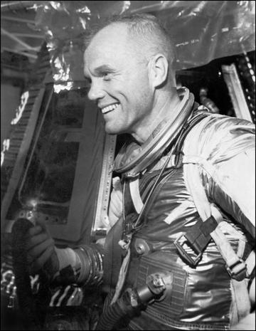 | Although Yuri Gagarin was the first person to orbit the Earth (and fellow cosmonaut Gherman Titov the second), John Glenn was the first American, and third person, to do so, and he did it in spectacular fashion.  Born in 1921, Glenn was already a distinguished fighter pilot, having served in World War II, China and the Korean War.  Partly because of his stature, but mostly because of his flight record, Glenn became one of a select number of astronauts first called Astronaut Group 1.

These astronauts would later be called the Mercury Seven: they would fly the Project Mercury missions, America’s first human spaceflights, designed to put an American in orbit and bring him home safely.
Glenn's orbital mission lasted a mere 5 hours as he completed three orbits around the Earth. His capsule did not fly very high: at perigee, he was only 100 miles off the surface of the Earth.
Glenn's mission was not without concern and worry. After insertion into orbit, ground control received a signal from his space capsule, Friendship Seven, indicating that his re-entry heat shield was perhaps not firmly attached. He was instructed to re-enter Earth's atmosphere manually and with the retrorocket package still attached. The retrorocket package burned up on re-entry, but the heat shield stayed firmly attached, and Glenn splashed down on mother Earth unscathed.
Glenn would go on to a distinguished career as a US Senator from Ohio, serving 24 years. In 1998, while still a Senator, he returned to space aboard the Space Shuttle Discovery.
Glenn also achieved the status of 32nd degree mason. Glenn died in late 2016 at the ripe old age of 95, the last remaining member of the Mercury Seven.
[Click here to see a video on Glenn's historic Friendship Seven mission.]
Apollo 11 – Man on the Moon
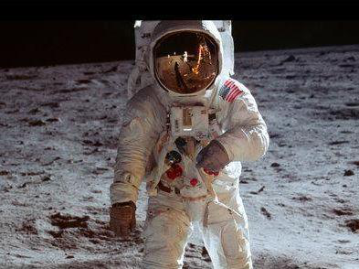 | There would be more preparatory missions to fulfill Kennedy's admonition that the US land men on the Moon, and bring them home safely, but one day it finally happened.  That day is now well over fifty years ago.  On July 20th of 1969, an event of epic proportions took place.

Two American astronauts, Neil Armstrong and Buzz Aldrin, landed their lunar excursion module (LEM) Eagle on the Moon, fulfilling the first part of President Kennedy’s challenge in 1961 that the United States “should commit itself to achieving the goal, before this decade is out, of landing a man on the Moon and returning him safely.”
A third astronaut, Michael Collins, stayed in orbit around the Moon in the command module Columbia, their return ticket to Earth.
It had taken them a little over 4 days to get to the Moon, leaving on July 16th. Armstrong and Aldrin would stay on the Moon less than a day. They would return to Earth in less than 3 days, successfully splashing down in the Pacific Ocean about 800 miles southwest of Hawaii, thus fulfilling the second part of President Kennedy's challenge.
[Click here to see a truly wonderful video about Apollo 11's landing, and the world's reaction to it.]
Even now, over 50 years later, it is hard to conceive of the courage these three men must have summoned up, to sit on top of the Saturn V, the largest rocket ever to carry humans, and blast off to the Moon. They were still attached to the final stage of the rocket when it ignited for the translunar injection (TLI) burn, sending them on the translunar trajectory they needed to rendezvous with the Moon 3 days later.
When they first orbited the Moon, and were out of radio communication with Earth, the entire world held its collective breath. Would the astronauts make it around the Moon and return to radio communication, or would they die on the far side of the Moon, which never presents itself visually to Earth?
When Armstrong and Aldrin landed on the Moon, in the Sea of Tranquility, between 500 and 600 million people on Earth watched from every corner of our planet. It was a truly mesmerizing moment.
Although their stay was quite short, Armstrong and Aldrin planted the American flag there, set up a moonquake seismograph, and installed a mirror to reflect laser beams from Earth so that scientists could later measure the Earth-Moon distance very precisely.
Both the landing and the blastoff of the LEM from the Moon were not without difficulty. On landing, Armstrong could see that the computer-driven LEM landing was going to miss its ideal landing spot, and place their craft in a rock-strewn area. He took semiautomatic control of the LEM and landed it safely.
On departure, one of the switches needed for the LEM blastoff was broken, but the astronauts fixed the problem with a pen. The blastoff knocked over the flag they had carefully positioned on the Moon.
Once docked with Columbia, the LEM was detached and left in orbit around the Moon. What became of it is unknown; a 2021 study suggested it may still be orbiting the Moon today.
Columbia splashed down upside down, but inflatable balloons quickly righted the capsule. The Apollo 11 astronauts had managed to bring back a little less than 50 pounds of lunar rocks.
 | After being quarantined for a good three weeks, the Apollo 11 astronauts returned to civilization with great acclaim, enjoying ticker tape parades in New York and Chicago.  [Click here to see a video montage of those parades.]

Of the Apollo 11 crew, only Aldrin is still alive. Armstrong died in 2012, and Collins in April of 2021.
Seven Apollo missions attempted a Moon landing, resulting in six successful landings. Only Apollo 13 had to turn back, because of an explosion that damaged its service module.
All in all, 12 men landed on the Moon, all returning successfully to Earth. As of 2026, four survive.
First Extended Study: In order to walk, we must first learn to crawl. In order to reach for the stars, we must first learn to fly close to Earth.
In this extended study, we will learn about early pioneers of earthbound human flight, including the Wright Brothers, Bessie Coleman, Charles Lindbergh, and Amelia Earhart.
The Wright Brothers
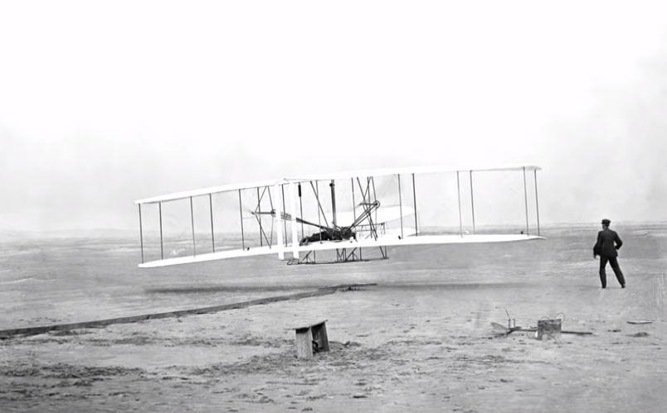 | Most of us are familiar with the immense and courageous achievements of Orville and Wilbur Wright, brothers who owned a bicycle shop in Dayton, Ohio, and who shared an inextinguishable passion for manned flight.  While there were many pioneers in manned flight, no one now doubts that the Wright brothers achieved the first heavier-than-air, fixed-wing, controlled and powered human flight at Kitty Hawk, North Carolina, on December 17, 1903.

At first ignored by the press and the US government, the brothers would go on to become world celebrities, showing off their latest aircraft design in Europe and the US in 1908.
[Click here to see a short but reverential biography of the Wright brothers and their indispensable sister and business partner Katharine.]
Wilbur died at the relatively young age of 45 years, of typhoid fever. Orville was more fortunate, living to the ripe old age of 76, when he succumbed to his second heart attack.
Bessie Coleman
Anyone who lives in the Chicagoland area and has visited O’Hare Airport has driven by or on Bessie Coleman Drive, named after Bessie Coleman, the first African-American and Native-American woman to earn a pilot’s license.
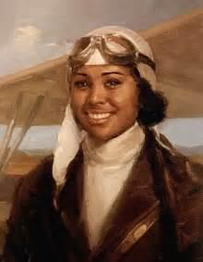 | Born the 10th of 13 children to George Coleman, a Texas sharecropper, and his wife Susan, Bessie distinguished herself in school, but soon grew restless, wanting to make something of her life.  She moved to Chicago, saving her money as she worked both as a manicurist and in a chili restaurant.  Wanting badly to be a licensed pilot, but denied that opportunity in her home country (for reasons of race and gender), she set sail for France, where she soon learned how to fly.

She returned to the States with her pilot’s license and much fanfare, but soon realized that she would need additional flight training to make a living as a barnstormer (aerial acrobatic pilot), and so she returned to Europe for additional advanced training.
She came back to the US and to a successful career as a barnstormer, but died unexpectedly in a plane crash in 1926.
[Click here to see a reverential biography of Bessie Coleman.]
Charles Lindbergh
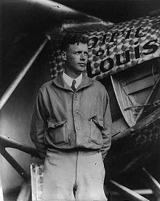 | No other pilot from the 1920s is better known than the American Charles Lindbergh, who flew his Ryan Monoplane, the Spirit of St. Louis, from Long Island, New York, to Paris, France, in May of 1927.  Lindbergh, also known as “Lucky Lindy”, was the first person to fly solo and nonstop across the Atlantic, from New York to Paris, but not the first person to fly a fixed-wing aircraft nonstop from North America to Europe.  That honor goes to the team of Alcock and Brown, who in 1919 flew from Newfoundland (not yet part of Canada) to County Galway, Ireland in a mere 16 hours, traversing about 1900 miles at an average speed of 115 mph.

Lindbergh learned how to fly the “old-fashioned” way, first as a post–World War I barnstormer, then as a cadet in the US Army Air Service Reserve, where he graduated first in his class, and finally as a US airmail pilot.
Lindbergh’s transatlantic flight was long and arduous, flying a little more than 33 hours and 3600 miles through icy storms and fog, and without a front window, landing finally at Le Bourget Field just outside Paris, to the acclaim of 150,000 witnesses.
For Lindbergh’s efforts, he won the Orteig Prize of $25,000 (in today’s money, about $460,000), and received two US military medals, the Distinguished Flying Cross, and the Medal of Honor, from President Calvin Coolidge.
The remainder of Lindbergh’s life was no less exciting. His first son and namesake was kidnapped and murdered, with much notoriety. Lindbergh was an avowed isolationist prior to World War II, only seeing the error of his ways after Pearl Harbor.
During World War II, Lindbergh flew 50 combat missions in the Pacific theater, as a private consultant.
Lindbergh died in Maui, Hawaii, in 1974.
Le Bourget Airport is no longer used for commercial flights, but is home to the world-famous Paris Air Show, held every other year.
[Click here to view a retrospective of Lindbergh's historic flight.]
Amelia Earhart
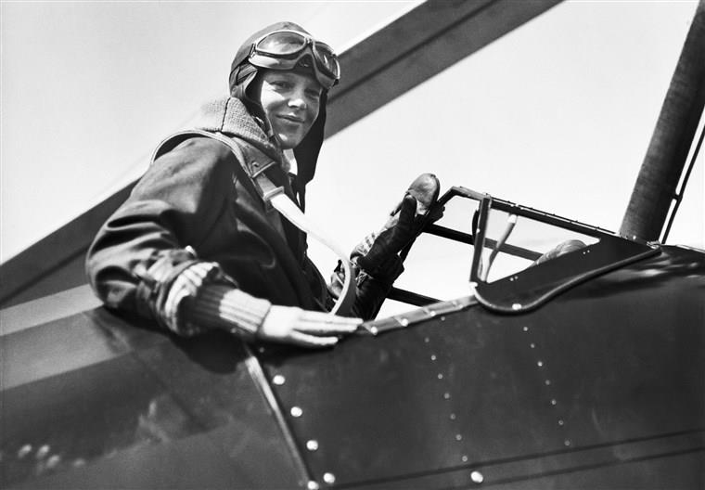 | Perhaps the best-known female pilot of all time is the aviatrix Amelia Earhart.  Earhart lived only 39 years, but in that time she accomplished many aerial feats, including being the first woman to fly solo nonstop across the Atlantic, flying from Newfoundland to Derry, Northern Ireland, in May of 1932, in a single-engine Lockheed Vega 5B. For this feat, she received the Distinguished Flying Cross from Congress.

Married to promoter and publicist G. P. Putnam, Earhart bounced from one record flight to another, until in 1937 she decided to aerially circumnavigate the globe. Her first attempt, from east to west, failed when she accidentally damaged her plane in Hawaii.
Her second attempt, flying from west to east, was initially more successful. She had traveled an astounding 22,000 miles when she and her navigator Fred Noonan departed Lae, New Guinea, on July 2, 1937. Their destination was the American territory of Howland Island, situated near the Equator and the International Date Line.
The date of their departure was no coincidence: they intended to be back in the States just in time for the Fourth of July. But that was not to be, because Earhart and Noonan disappeared somewhere between Lae and Howland Island.
There continues to be controversy as to whether Earhart and Noonan perished at sea, or whether they ended up on some other island, possibly even a Japanese possession. No one knows for sure what happened to them.
We should remember Earhart not only for her aerial derring-do, but also for her service as a nurse’s aide in Toronto helping returning World War I veterans, and her work teaching English to immigrant children.
[Click here to learn more about Amelia Earhart.]

Second Extended Study: How do airplanes fly?
There are four forces acting on any plane in flight, and in dynamic equilibrium (steady, level flight), these forces are balanced.
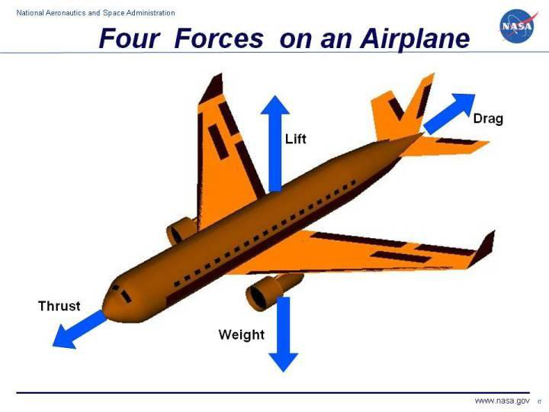
Thrust comes from the plane’s jets or propellers, and is a third law effect: as the air is pushed to the rear, it pushes back, causing the plane to go forward.
Weight of course is the Earth’s attraction of the plane to it, and is universally downward.
Drag is air resistance, which includes air friction along the plane’s surfaces.
Lift is what causes the airplane to go up and stay up. It is caused by the flow of air over the plane’s wings.
Lift happens because of the cross-sectional shape of the wings (called the airfoil) and the wing’s angle of attack:
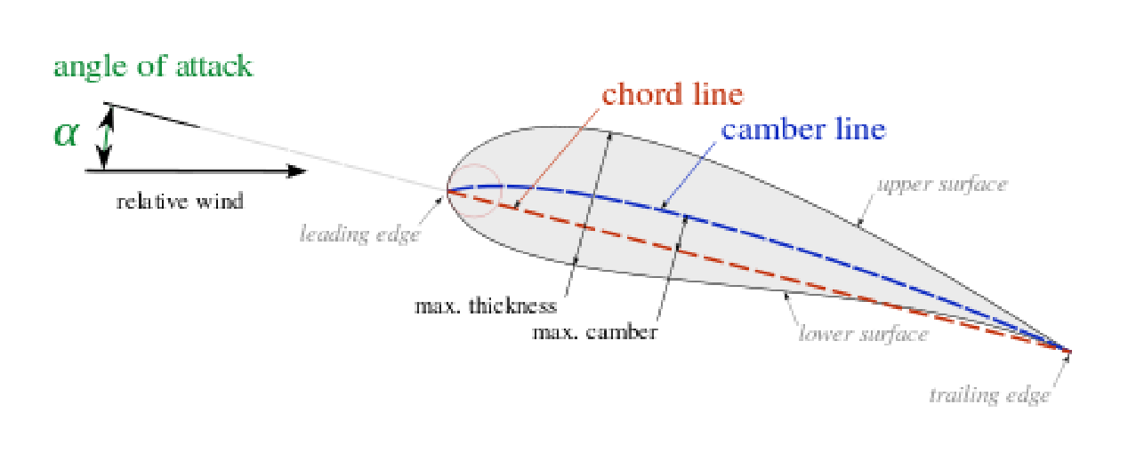
The airfoil, the shape of which can change on takeoff and landing, creates a difference in pressure between the top and bottom of the plane’s wings. This difference in pressure can be explained two ways: Bernoulli's Principle and Newton’s Third Law.
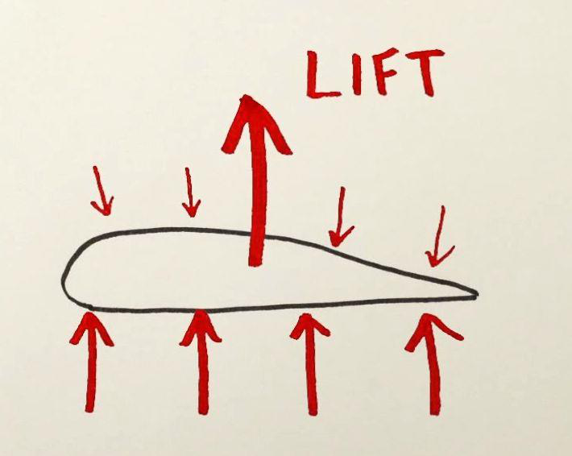 | According to Bernoulli, air traveling faster over a surface exhibits less pressure on that surface than air traveling slower over that surface.  Air travels faster over the top of the wing than the bottom of the wing, so there is a pressure difference between the bottom of the wing (higher pressure) and the top of the wing (lower pressure).  That pressure difference pushes up on the wing, and the plane is lifted up, once the lift force exceeds the plane’s weight.

Lift can also be explained as Third Law action-reaction pairs between the air flowing under and over the wing and the wing itself.
[Because there is much confusion about whether the Bernoulli explanation or the Third Law explanation is dominantly correct in explaining lift, click here for further clarification of this “dispute.”]
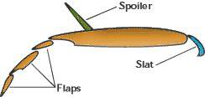 | When a plane is taking off, the pilot raises the plane’s nose using the elevator (described below), increasing the angle of attack. To create the extra lift needed to get the plane off the ground at low speed, the wing’s flaps and slats are also extended:

Flaps (at the back of the wing) and slats (at the front of the wing) increase the wing’s curvature and surface area, which increases lift.
[The spoiler shown in the illustration above is located on the top and back of the wing, and is used to decrease lift on landing, or to aid in slowing down the plane once it has landed.]
Lift is also enhanced because air flowing over the curved top of the wing tends to follow (hug) that surface, an effect often called the Coanda Effect. On the top of the wing (with flaps and slats extended, or not), the air flow over the wing follows the wing’s curve and leaves it heading downward. By Newton's Third Law, the air pushed downward by the wing reacts by pushing back upward on the wing, causing lift. (It also induces some additional drag.) [Note that some aerodynamicists object to using the term Coanda Effect here, since it originally describes fluid jets.]
[Of course air flowing under the wing is also directed downward, because of the angle of attack. So Newton's Third Law will result in additional lift here as well.]
Notice the separation between successive flaps in the illustration above. Air flowing below the flap is redirected to above the flap, where it hugs the top of the flap so as to redirect that air downward.
The overall lift enhancement is shown here:
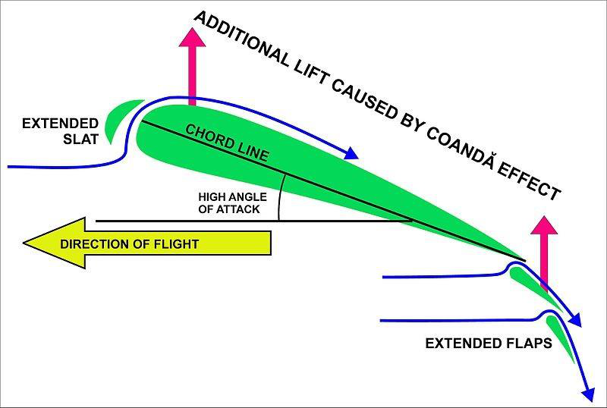
Here we see that the slats also enhance lift by redirecting air flow to above the wing.
Note that flaps and slats are normally retracted during steady flight.
Of course, once airborne, it is necessary to control the airplane as to its direction and its altitude (collectively called flight control). This is done using three devices: the ailerons, the rudder and the elevator.
The ailerons are near the wing tips and work in opposition: when one aileron goes up, the other goes down. The aileron that is up causes its wing to go down (because it has less lift). The aileron that is down causes its wing to go up (because it has more lift).
When ailerons are used, the plane rolls (banks) around its front-to-back axis of rotation. This tilts the wings’ lift force to one side, which turns the plane, changing its direction of travel and its pointing direction. (Unless the pilot compensates, the plane also tends to lose some altitude in the turn.)
The rudder is on the vertical stabilizer at the tail of the plane. When it is used, the plane will yaw around its top-to-bottom axis of rotation, and this causes a change in the plane’s pointing direction but not its altitude. The rudder is also used to counteract an unwanted yawing motion (called adverse yaw) that occurs when the ailerons are used to turn the plane.
The elevator is on the horizontal stabilizer at the tail of the plane. When it is used, the plane’s pitch will change, meaning it will rotate around the horizontal axis going through the plane’s wings. This changes the plane’s altitude (up if the elevator is up, and down if the elevator is down) without changing the plane’s direction.

Here is a nice illustration of the three axes of rotation of a plane in flight:
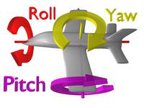
Here also is a nice illustration of the three in-flight control devices just described, and their purposes:
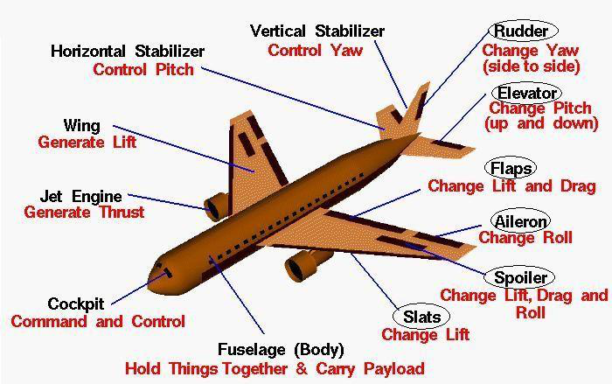
Notice that a plane has to maintain a minimum speed in normal straight-line flight to keep the lift force equal to the plane’s weight. With this in mind, when a plane is landing, the flaps and slats are extended to increase wing curvature and area (and therefore lift) to compensate for the slower plane speed.
Note: A plane also needs to avoid too great an angle of attack, because then the air flow separates from the top of the wing, and the plane will stall due to insufficient lift.
One final comment worth noting: in June of 2017, some commercial jets were grounded in Phoenix because it was too hot to fly. It turns out that lift force is affected by air density. If the air is too hot, the air density will be too low for safe flight.
You can read about this density issue here.
Third Extended Study: Besides Telstar 1, there were many other important unmanned missions to solar system locations (and beyond) in the formative years of the space age during and after the Apollo missions.
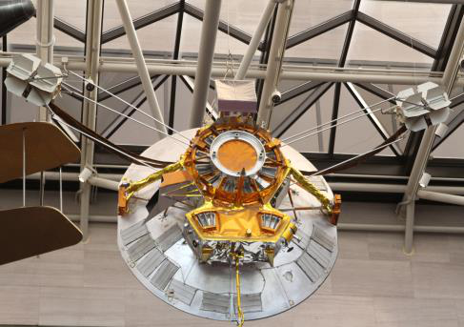 | About two and a half years after the Apollo 11 landing, the first of the two outer-planet Pioneer probes was launched, Pioneer 10. It left Cape Canaveral in 1972, and passed through the asteroid belt.  It flew by Jupiter late the following year, obtaining for the first time closeup images of that planet.

Pioneer 10 continued onward, to the outer reaches of the Solar System (80 AU) for a total mission time of about 30 years, before its power source weakened and communication with NASA on Earth ceased.
[The image above is that of Pioneer H, a backup craft for Pioneer 10 and Pioneer 11. It is located in the National Air and Space Museum in Washington, DC.]
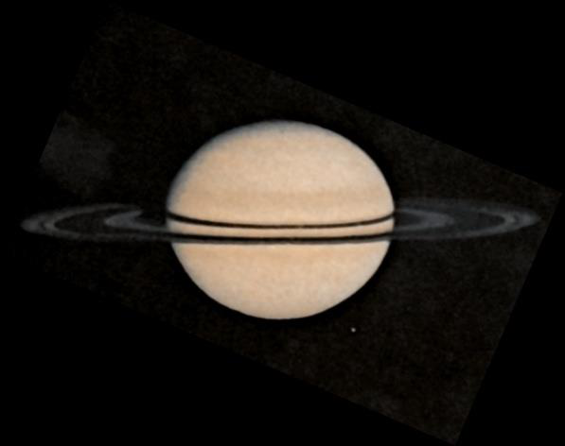 | Pioneer 11, the "twin" of Pioneer 10, launched one year after Pioneer 10, and also passed through the asteroid belt, passing by Jupiter on its way to Saturn, returning the first close-up images of that planet.  Like Pioneer 10, Pioneer 11 continued on its way to the outer edges of the Solar System. NASA lost contact with the craft in 1995, ending its 22-year-long mission to explore the Solar System.

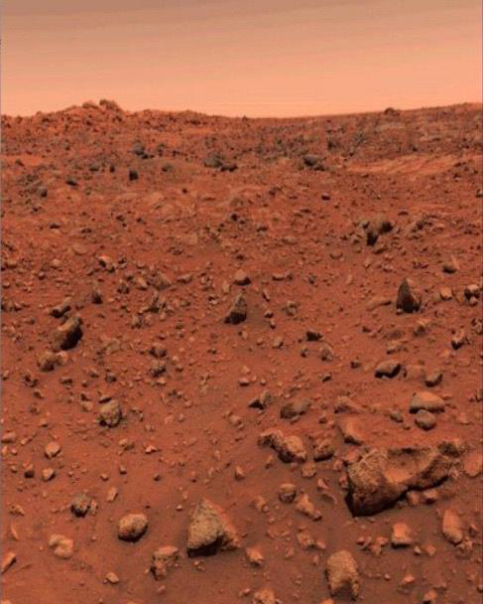 | The Pioneer missions were quickly followed by the two Viking missions, both launched from Cape Canaveral in 1975, designed to soft land on Mars, send back images of the red planet, and conduct science experiments on the planet.  Each mission consisted of an orbiter and lander. Both missions successfully soft landed on Mars in 1976. One of the landers’ experiments gave results that a few scientists read as a sign of living microorganisms, but most scientists think ordinary soil chemistry explains them.

The two landers far outlived their expected mission lifetimes, with Viking Lander 1 sending its last transmission in 1982, and Viking Lander 2 sending its last transmission in 1980.
[The image above, transmitted from Viking Lander 1 in July of 1976, is the first clear image ever seen from the Martian surface.]
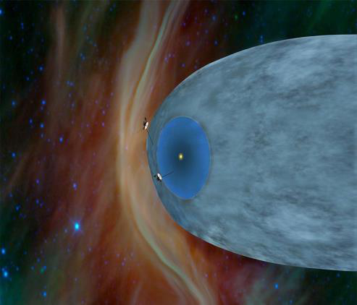 | Twin Voyager spacecraft, Voyager 1 and Voyager 2, were launched in 1977, shortly after the twin Viking spacecraft. The Voyagers' joint mission was to explore Jupiter, Saturn, and the interstellar medium.  Both missions went by Jupiter and Saturn, but Voyager 2 also visited Uranus and Neptune  Both spacecraft are still in service nearly 50 years later, though running on very low power.

Both spacecraft are still in service nearly 50 years later, though running on very low power.
[Click here to see the actual current distances to the two spacecraft.]
NASA has overseen more than 1000 unmanned missions into Earth orbit and beyond. A list of all the major unmanned missions can be found here.

