This is an example of a battle:

(1) This is a 14-frame battlefield, with two players representing red and blue.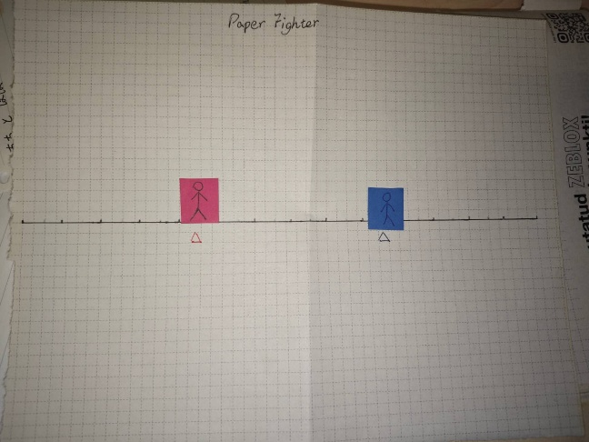

1. At the beginning of the round, both players place their Action Card Covers on the table and turn them over in turn and settle in order.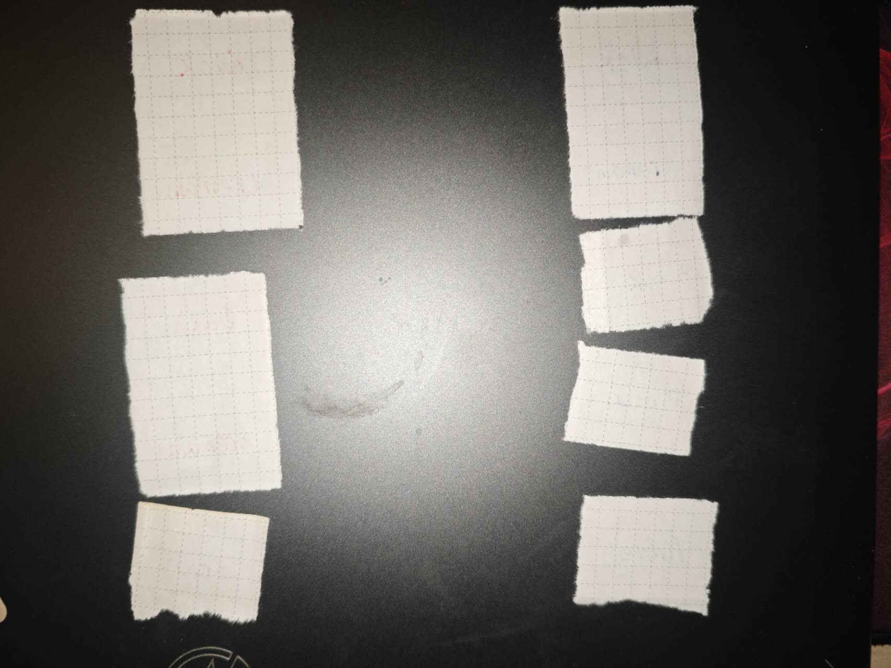 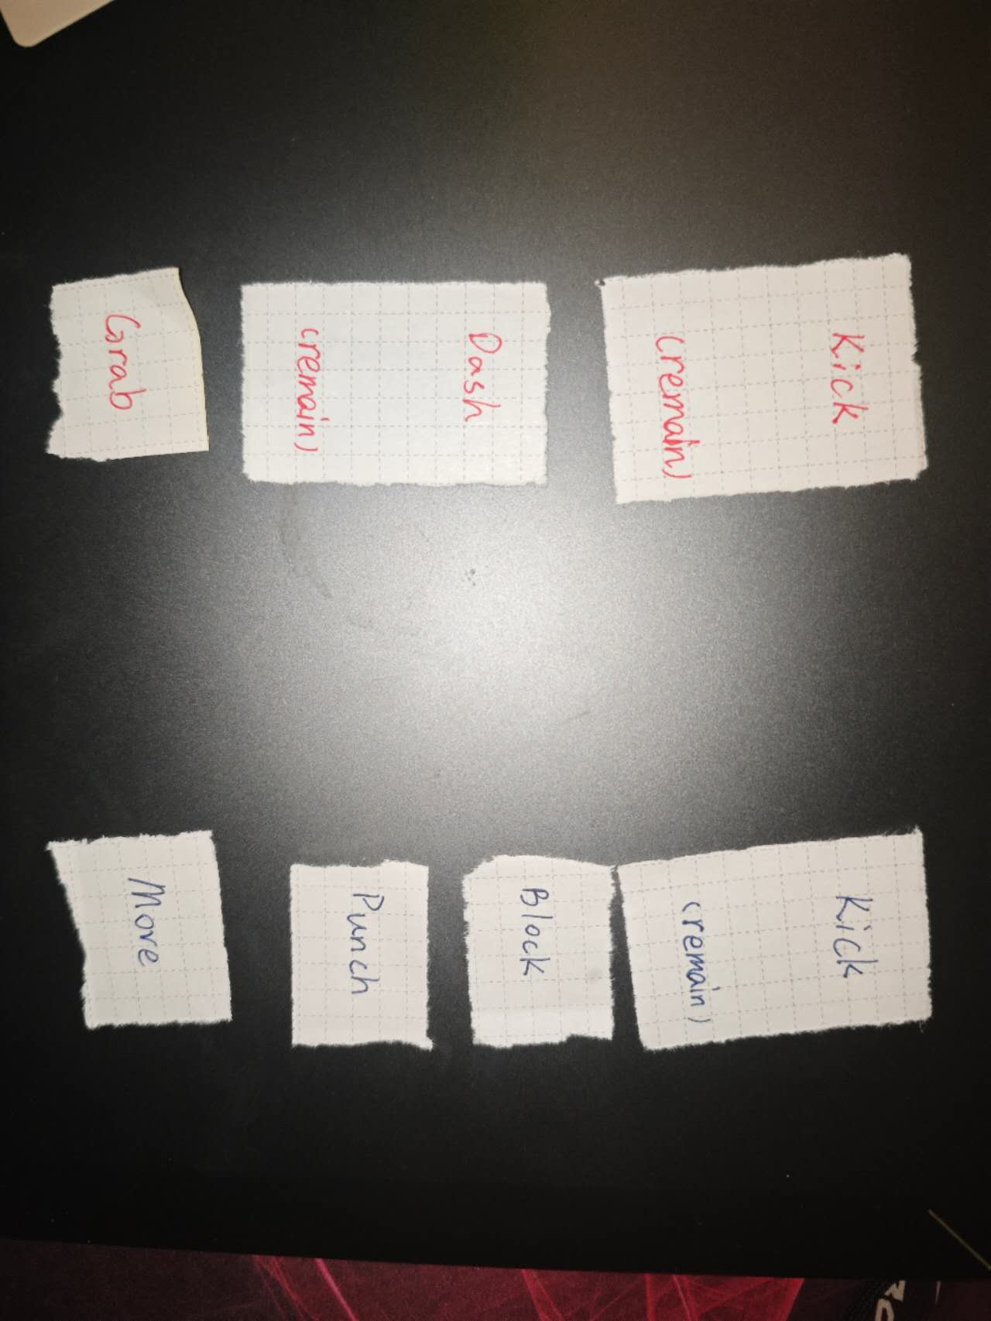

I In the situation depicted above, the two sides commence by kicking each other, but as they are beyond striking range, neither inflicts damage. Subsequently, the red player dashes to close the distance, while the blue player defends and lands a punch, dealing 1 point of damage to the red player.

Finally, the red player attempts to execute a grab on the blue player, but the blue player's last action is to move, evading the grab. 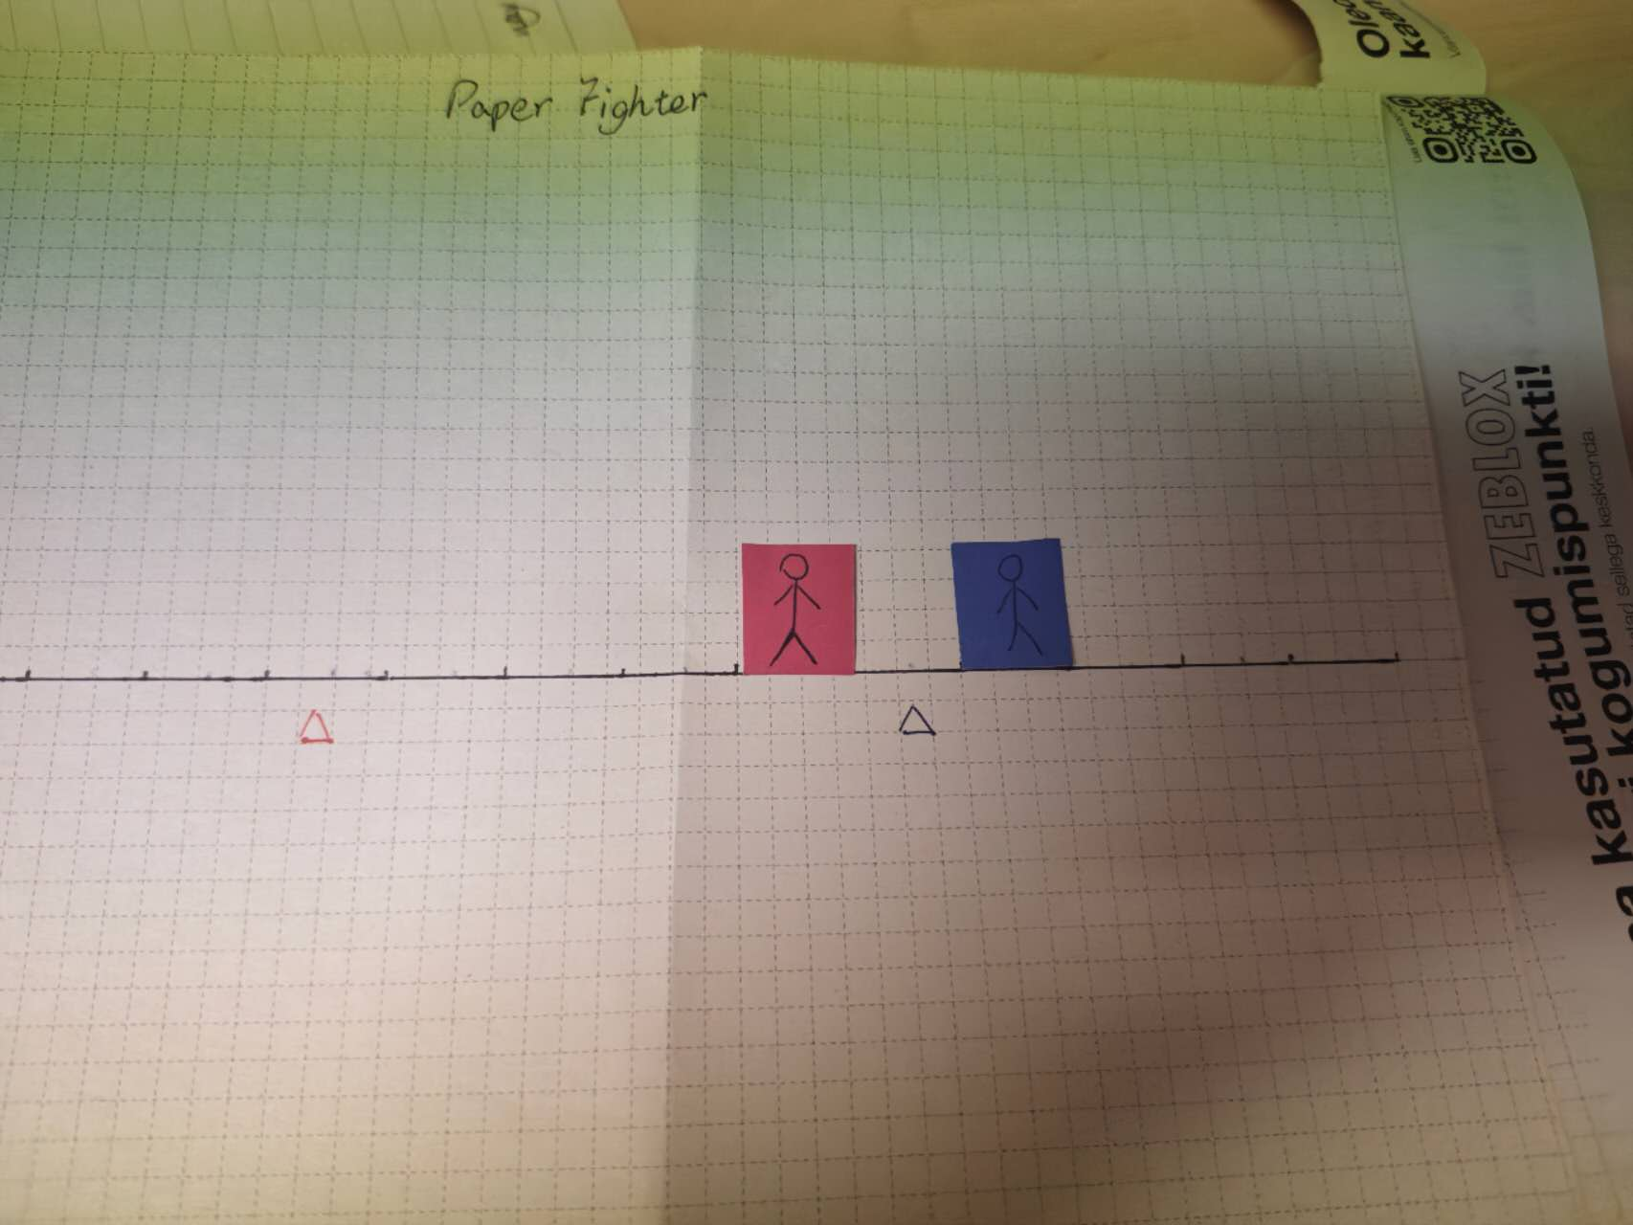

（4）Eventually the field position adjusts to this situation and continues next turn