A.L.P.H.A.
Automated and Lightweight Plant Habitation Assistant

Final Product

Problem
The cultivation of indoor flora breathes life into our living quarters and improves the human physche, especially for those residing in urban areas (Spano et al., 2020). However, busy work prevents some from partaking in horticulture activities.

Solution
By delegating the task of cultivating plants to an automated system, the user will be able to enjoy the benefits of in-house gardening without investing too much time and effort into plant care. The system logs data onto an SD card for monitoring.

Functionalities
Description | Designed | Implemented | Verified
Water plants with configurable time periods and water quantity depending on temperature and humidity
Log plant growth, temperature and humidity onto an external storage and display on OLED
Detect light levels throughout the day and use LED to supplement plant growth
Display soil, temperature, humidity and any relevant stats onto the OLED module
Use motors to carry sensor and watering tool from pot to pot to monitor multiple plants

Project Duration:
2021-07-24 → present

Prepared by:
Milky
Electrical Components
STM32 microcontroller
SD card and reader
4x4 Keypad
Photoresistor
Humidity sensor
Thermometer
Water level sensor
Red and Blue LED
OLED Module
Active buzzer
Stepper- and servo-motors
(ELEGOO 37 SENSOR KIT TUTORIAL FOR UNO V2.0)
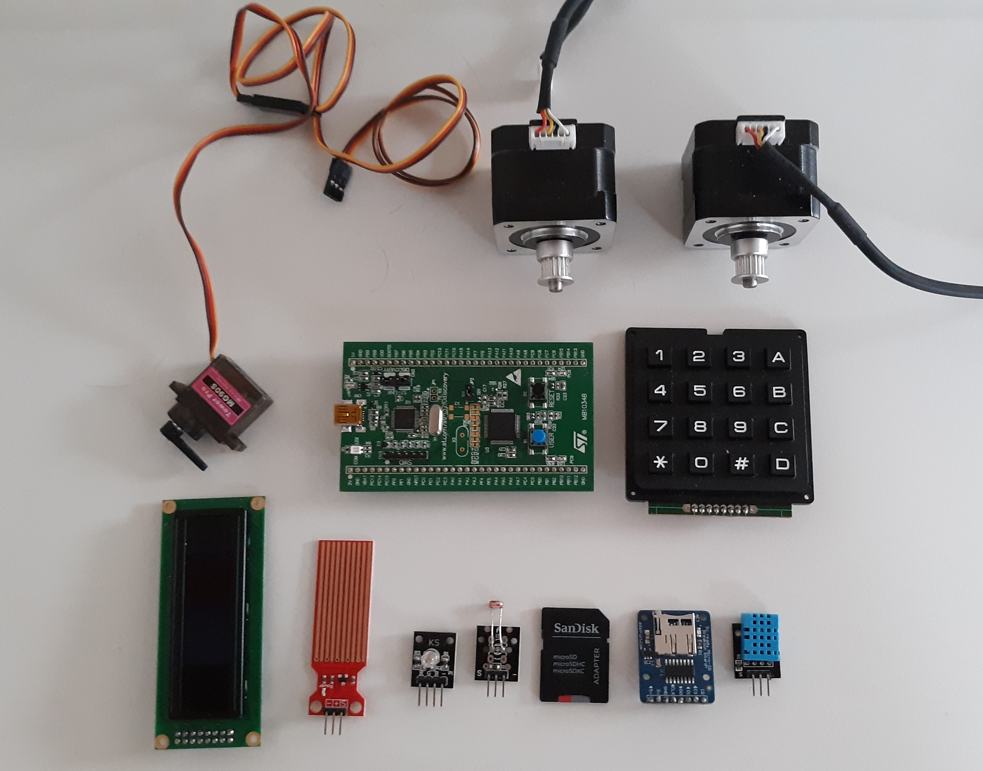
Software Components
STM32 System Workbench (IDE)
CubeMX (Hardware Abstraction Layer)

Cloud service set up

Miscellaneous Components
water storage
water flow switch (connected to servomotor)
plant of choice
flower pot of choice

Timeline
https://docs.google.com/spreadsheets/d/1D-ZyrKnIMRHGlNYRvxcjqJI7CP4GUzHoVvOjKRtuSOY/edit?usp=sharing

System Design for Function I
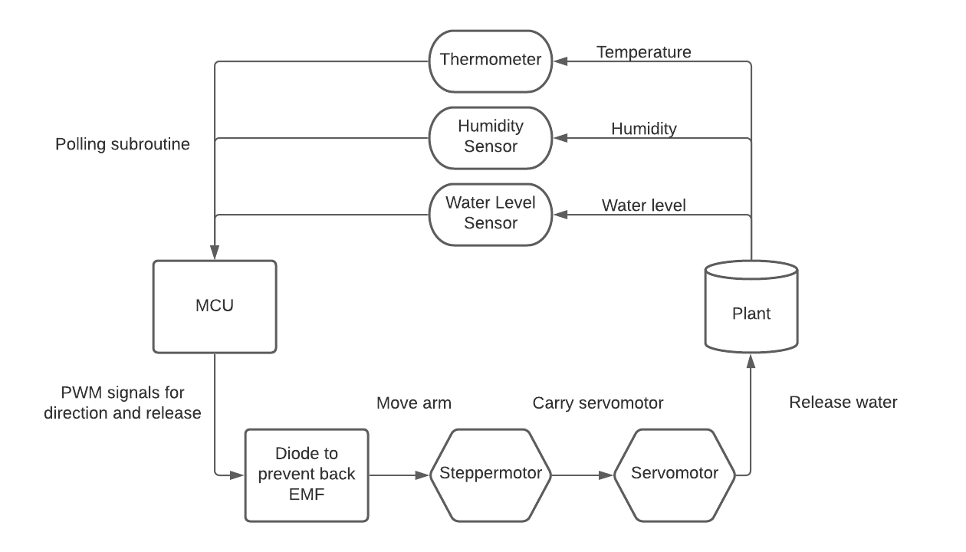
Algorithmic Design for Function I
- release water when temperature is low to prevent evaporation
- release greater quantities of water when humidity is low
- alert user when water level in tank is low
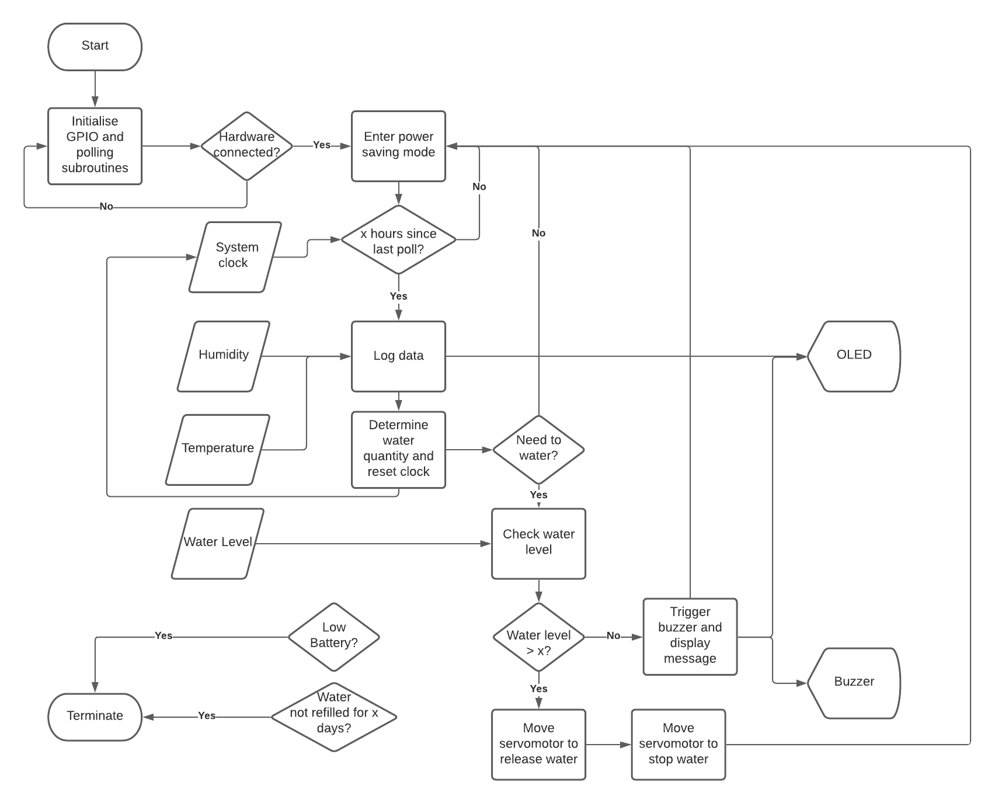

System Design for Function II
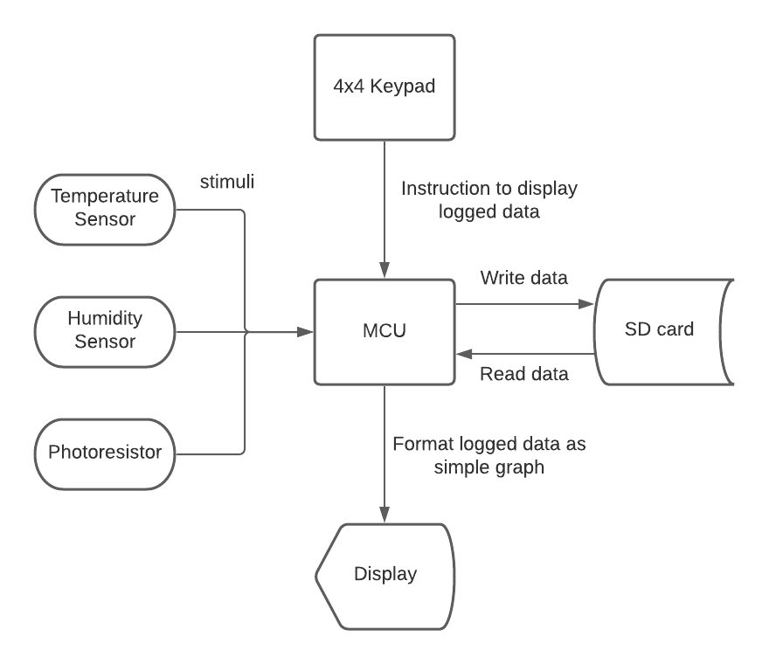
Algorithmic Design for Function II
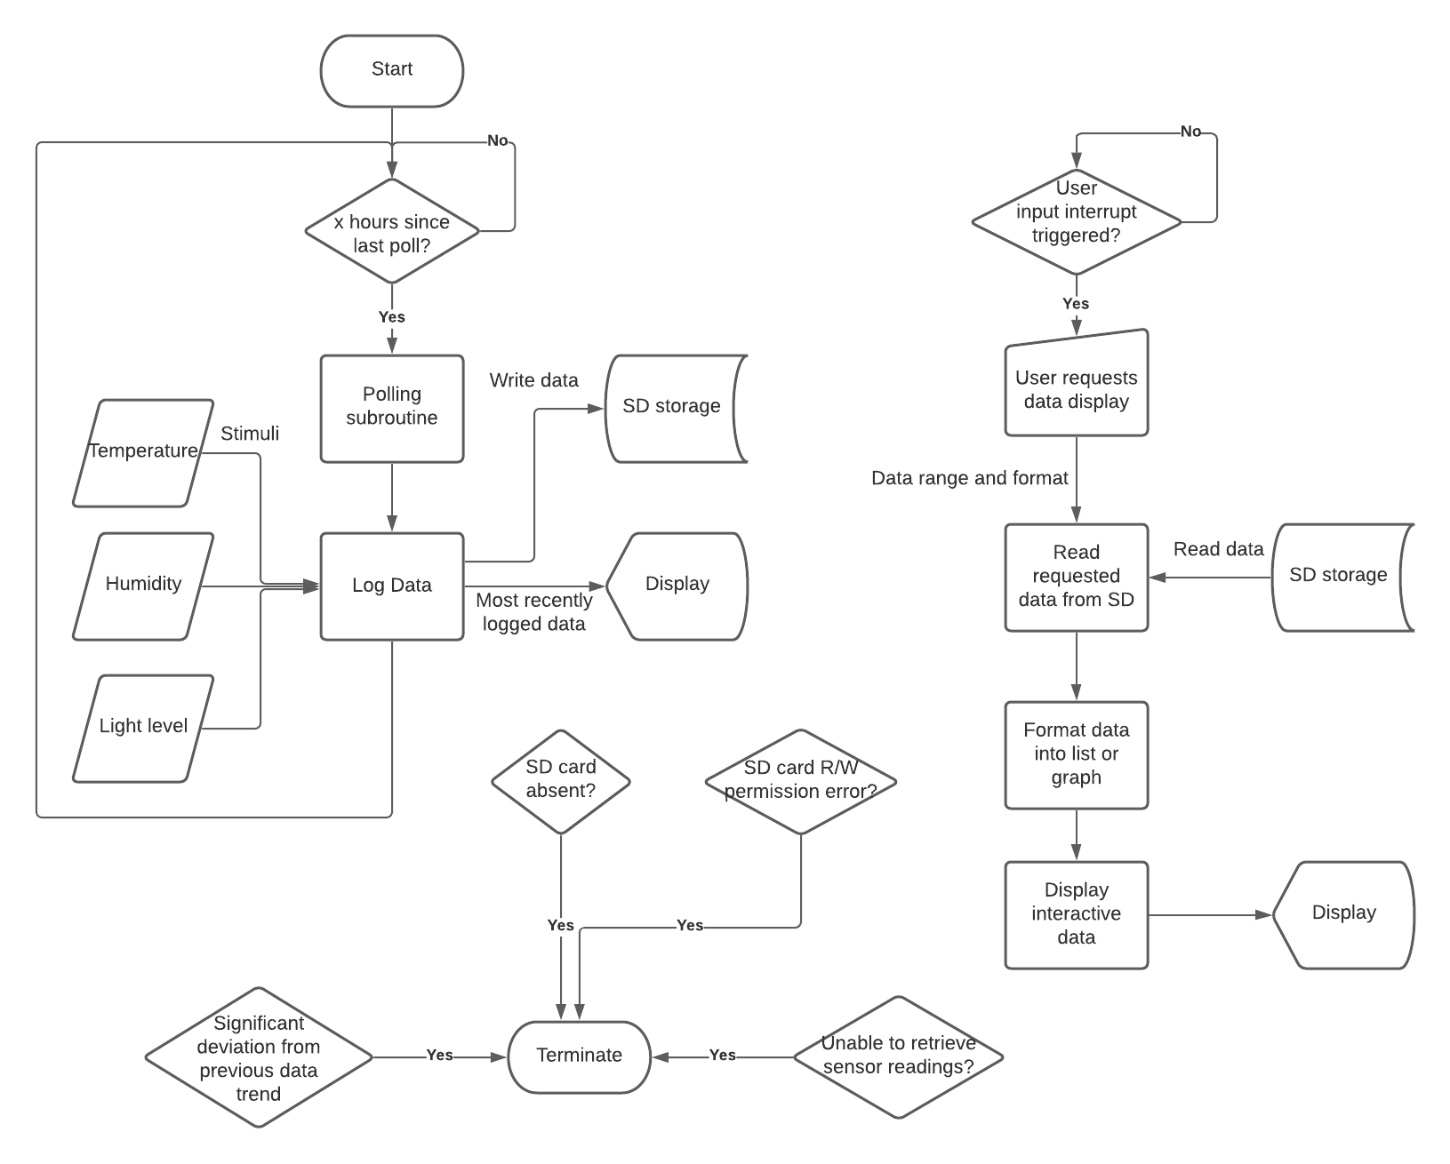
Schematic Layout

PCB Design

Test Plan
- unit testing
- integration testing
- behaviourial testing

References / Citation
[1] G. Spano, M. D’Este, V. Giannico, et al., Are Community Gardening and Horticultural Interventions Beneficial for Psychosocial Well-Being? A Meta-Analysis , 20-May-2020. [Online]. Available: https://www.mdpi.com/1660-4601/17/10/3584/htm. [Accessed: 24-Jul-2021].

[2] “ELEGOO 37 SENSOR KIT TUTORIAL FOR UNO V2.0.” Elegoo, Shenzhen. Available: https://www.elegoo.com/pages/arduino-kits-support-files. [Accessed July 24, 2021].

[3] H. Silva, S. Sagardia, and M. Ortiz, “Relationships between leaf anatomy, morphology,and water use efficiency inAloe vera(L) Burm f.as a function of water availability,” Revista Chilena de Historia Natural, 24-Jul-2014. [Online]. Available: https://revchilhistnat.biomedcentral.com/track/pdf/10.1186/s40693-014-0013-3.pdf. [Accessed: 24-Jul-2021].

