

- Game Design Document (GDD) -

**Project name:** Color Quest

**Team name:** Team Quest

**Team members:**

* **Vaduva Mihnea –** Project Manager
* **Vaduva Mihnea –** Game Designer
* **Vaduva Mihnea –** Lead Programmer
* **Stefan Mihai –** Lead Artist
* **Stefan Mihai –** Animator
* **Stefan Mihai –** Audio Engineer

Table of contents

1. Game Description
   1. Introduction
   2. Goals
2. Gameplay
   1. First minute
   2. Game flow
   3. Rewards and scoring
   4. Mechanics
   5. Controls
3. Art
   1. Look & feel
   2. 2D Art & Animation
   3. GUI
   4. Sounds & Music
4. Game Design
   1. Story
   2. Characters
   3. Level structure
   4. User Experience
5. Technical Specifications
   1. Game engine
   2. Platform
6. Marketing
   1. Demographics
   2. Competitors
   3. Strategy
7. Management
8. Risks

# Game Description

## Introduction

## You are Cray, a student at the Royal Colormancy Academy in Creato City. It’s been your dream since birth to join the Color Wizards Corps, the protectors of Creato City and the country of Imagina. When you wake up on Graduation Day, you realize that everything and everyone around you has lost its color, and the rest of your peers can’t be found. It’s your goal to find out what caused this disaster!

## The game will be a mix between a platformer and a turn-based RPG. The main sections of the game will be the platformer levels, where the player must find clues as to what happened, and find the encounters for each level. After finding an encounter, the turn-based RPG part of the game will come into play, the player having to defeat the enemy to return the colors of Imagina bit by bit, and find out the truth.

## The player will go through various levels, ranging from city scapes, to caves, forests, the countryside, and other more exotic locations.

## Goals

The 2D game has the goal of creating an interesting and gripping world for all ages, while offering an entertaining environment and ultimately a creative outlet in the final implementation of the game, when we will attempt to implement a “draw-your-own-Cray” system.

Important aspects which must be taken into account:

* + - Gripping storyline
    - Interesting, fresh gameplay loop
    - Emotional connection
    - Attractive, cartoonish graphics
    - Simple game controls, on both PC and mobile devices
    - Increasing levels of difficulty, as the player progresses
    - Stat development system based on what colours the player character is using

# Gameplay

## First minute

## The first minute of gameplay is that of a traditional 2D platformer, in which the player must explore his surroundings to piece together what has happened, and advance through the level towards the final challenge. Different paths are available to the player, offering several choices and ultimately leading to the final encounter of the area. Obstacles must be avoided to arrive safe and sound at the destination, and pick-ups offer customization to the player. Once the ending part is reached, the game’s turn-based battle system comes into play, Cray having to beat the encounter to progress.

**2.2 Game flow**

The game is a mix of platformer and turn-based RPG. For most of the level, Cray’s movement is determined by the user’s input. The speed is initially constant, but can be upgraded by discovering certain colors that change the stats of the player character. The stat system is simple to understand and intuitive, based around what colors the player character is sporting. These colors affect both the combat and the movement of the player through the stages.

The player must perform several actions to get through the platforming sections of the levels, such as running, crouching, jumping and double jumping, as well as interacting with various items and solving puzzles thru ought the level. Once the final area is reached, Cray must face the final encounter of the level, at which point the turn-based RPG battle system comes into play, where the player must choose from different actions available, such as attacking, defending, using skills, or running away to further complete the level and be better prepared for the final challenge.

As of 20/10/2019, 2 main levels are planned and thought out, comprising the beginning of the game. They function on the principles detailed above. The levels thought out so far are:

* Level 1: taking place in the city of Creato, Cray must venture through the streets and find out what has happened and what can he do.
* Level 2: taking place in the surrounding forest, Cray learns to use his powers better, and the stat and equipment system is introduced, along with the concept of colors affecting stats

The levels are designed to offer a clear path to the end goal, with the possibility of going off the beaten path to collect better items and learn more about the lore and what has happened in the game world. While it is perfectly fine for players to just follow the main path, they are encouraged to explore the game world and find out its secrets. Players are giving the freedom of choosing how they want Cray’s adventure to shape up, and how they want to tackle the challenges they are facing.

**2.3 Rewards and scoring**

In each level, players must reach and defeat the end encounter in order to pass the level. Scoring is calculated based on three main categories: time needed to complete the level, collectibles found and battle performance.

Each level will have a “par” time that, if beaten, will award the player with extra points based on how fast the platforming part of the level was completed. The standard level completion awards 1000 points, and each second under the par time awards a certain percentage increase in the score, depending on how far in the game the player is.

Collectibles offer a flat increase in the player’s score, increasing as the game goes one. Thus, a collectible in the first level of the game offers 200 points, in the next level 300, and so on and so forth.

Battle performance is the last part of the scoring system. The performance is based on how many moves it took to win, did the player have to escape from battle and come back, how long it took to finish the battle, and how much HP the player was left with at the end.

**2.4 Game mechanics**

The game blends platforming mechanics with standard turn-based RPG fare. The player can:

* Jump / Double jump
* Find collectibles
* Explore the world
* Improve their character
* Battle enemies in a turn-based manner
* Solve puzzles in the game world

**2.5 Controls**

The controls are standard 2D Platformer fare, with the player controlling the character’s movement with the navigation keys (W/A/S/D). Crouching is done using the “left CTRL” button, and jumping is done using the “spacebar”. Double pressing the spacebar will do a double jump. In the eventual mobile port, the controls will be presented on screen.

Once combat starts, the player is presented with a menu containing the combat options. Selecting an option is done with the W and S keys, and confirming the selected option is done by pressing the spacebar.

**3.Art**

**3.1. Look and feel**

Color Quest has a vibrant, cartoonish, warm and inviting vibe. The general aesthetic is reminiscent to the doodles all students do in their spare time or when bored, and the color palette was chosen to reinforce the light, airy, dream-like feel of the game. This extends to all parts of the game, including the menu screens.

The backgrounds reflect the different stages Cray has to go through, and evolve through the game, as the player advances more and more towards the end of their quest. This is easily evidenced by the colour pallet shifting.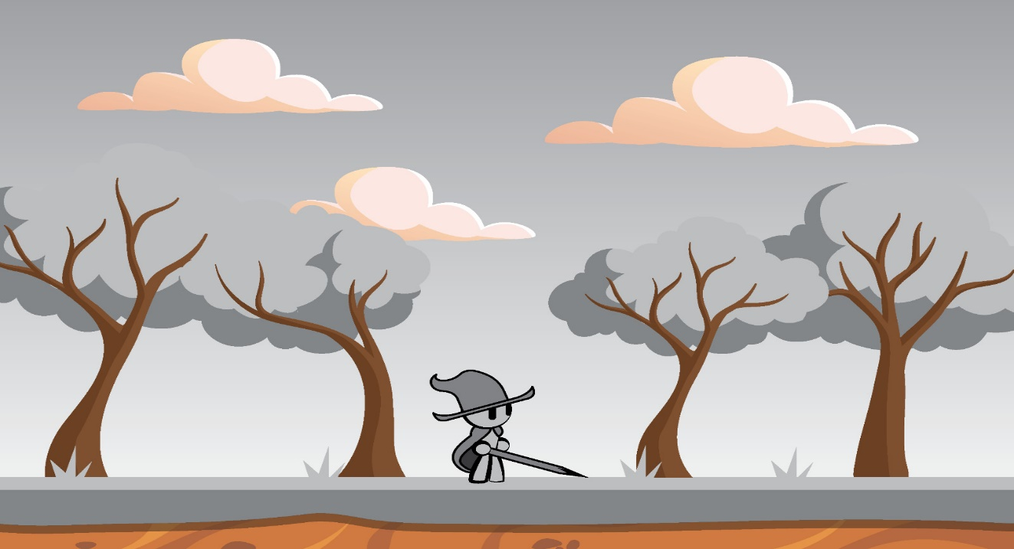

*Figure 1: Cray in one of the beginning part of the first level*

**3.2. 2D Art & Animation**

Different art assets are used in each scene of the game. Particular interest is to be put on the background and the evolution of the player character, as well as the evolution of the background. Thus, progression is shown by how the vibrancy of the scenes increases, as well as that of the character.

***Main Character***

Cray, the main character of Color Quest, is animated in the iconic South Park style. His movements are designed to be choppy and amusing, to endear him even more to the player.

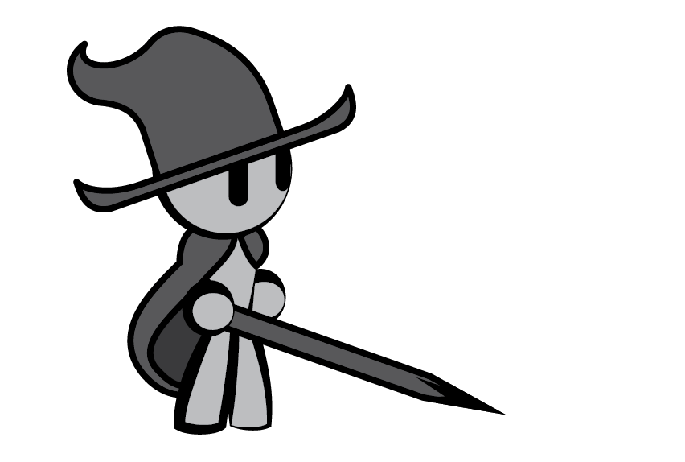

***Figure 2: Cray looking cute***

The player character evolves through the course of the game, gaining new stats and powers based on how he is colored. In the image below, we can see two models for Cray after the first level, having gained some colors back, and equipping them to gain more power.

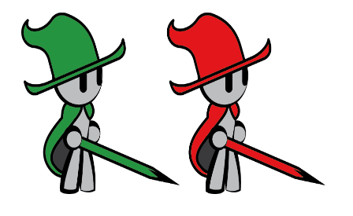

***Figure 3: Cray later on***

***Example Levels***

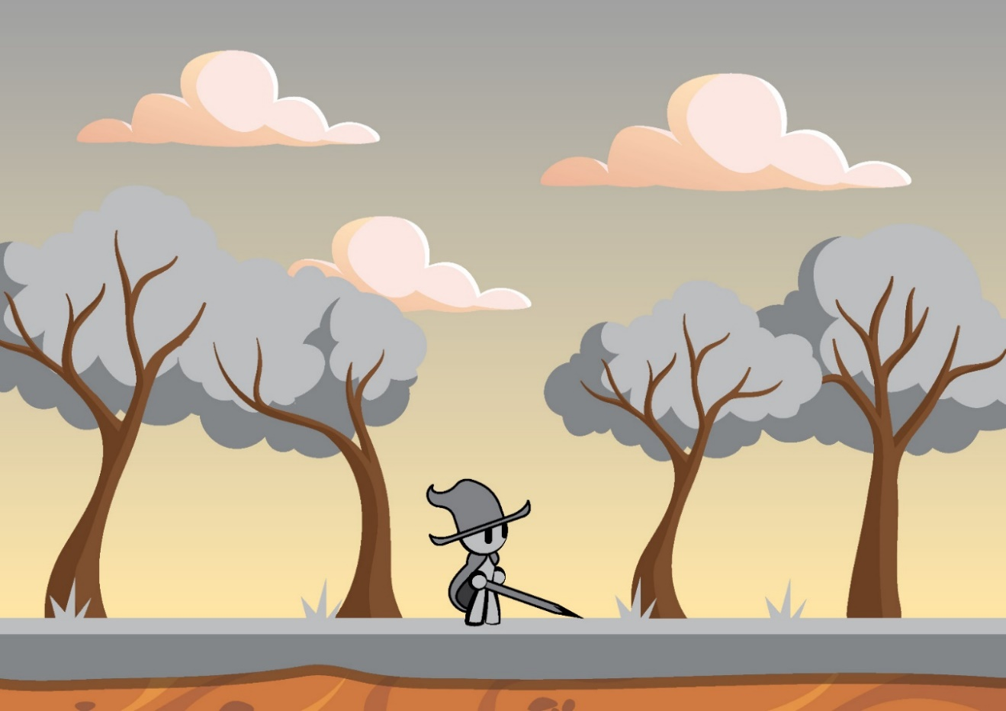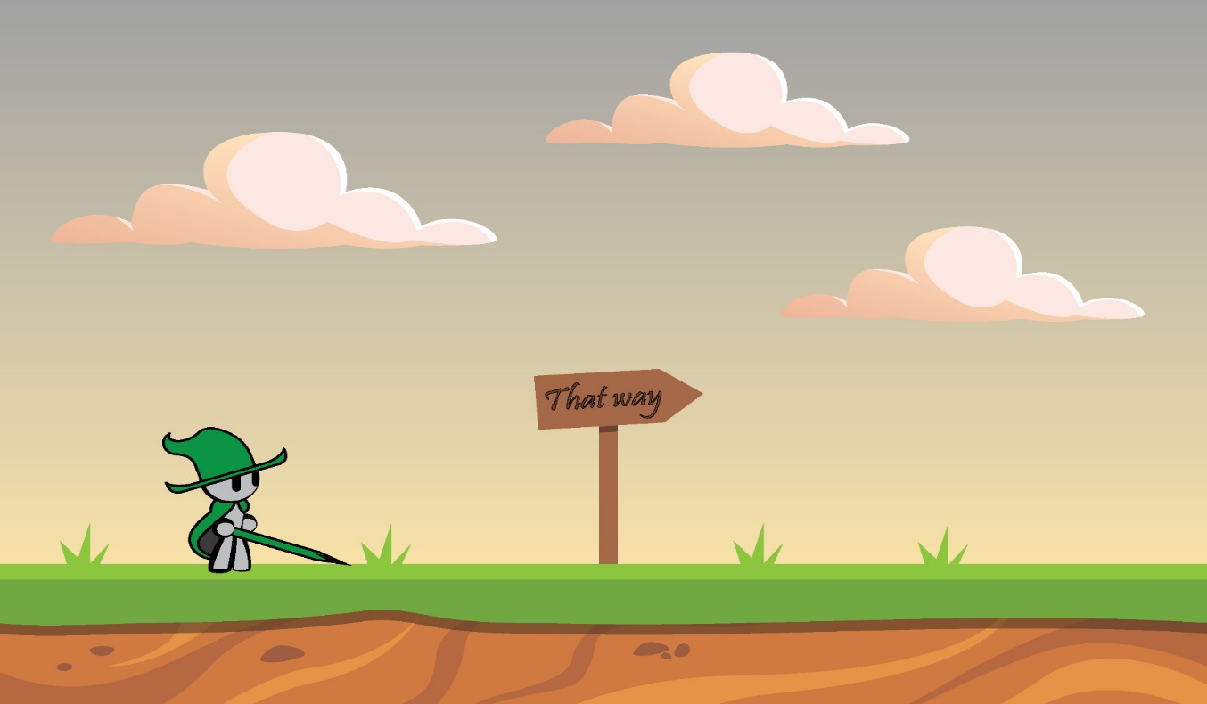

## 

## 

## Enemy examples:

## 

## *Buckrab variations*

## 

## *Rubbolem*

## Many more art-based mobs and enemies are meant to be implemented, along with final-bosses for some levels.

## 3.3 GUI

## The GUI will be minimalistic and reminiscent of old-school video game design, but with a cartoonish, dreamy style and vibe.

## *Main Menu*

## Color Quest has a simple main menu, with multiple buttons, for choosing specific options:

## Continue: To continue from the last save point

## New Game: To start a new adventure

## Load Game: Continue Cray’s adventure from a certain point

## Exit: Abandon Cray and his quest (for the time being at least)

## 

## *Levels*

## As seen in the Example Levels section, the level UI is uncluttered, containing only the background, interactible content, and the player character

## *Combat screens*

## Once an encounter is reached, the game enters its combat screen, where the player is given several options to use to defeat the enemies.

## *Level Complete*

## After winning the final encounter, the player is sent to the Level Complete screen, where they are given information on how well they performed. They are offered the option to continue, save their progress, or quit the game and return to the main menu.

## More screens, such as an equipment screen and a party screen will be added in later versions.

## 3.4 Sounds & Music

## During the initial levels, the music is somewhat eerie and ominous, to give the sense that something is off about the situation in which the player character is. As the levels progress, the music starts getting cheerier and more vibrant, to reflect the increase in colour of the world. The combat stages have a separate soundtrack, with a more alert vibe to them, to sell to the player the urgency and danger of the encounter they are faced with.

## Collectibles will also have a particular sound, to impart their importance to the player.

## 4 . Game Design

## 4.1 Story

## You are Cray, a young student at the Royal Colormancy Academy in Creato City, the capital of Imagina. Ever since you can remember, your dream was to graduate and become part of the Color Wizards Corps, protectors of the realm and advisors to the king and state. Finally, graduation day has come, and it’s time to wake up and face the most important day of your life!

## All is not well, though. The moment you wake up, you start noticing that the world around you seems to have gone dull, and lost all of its colour. Looking in the mirror, you realize this has happened to yourself as well. You race out of your house and rush towards the Academy, to hopefully find some answers.

## Along the way, you realize that everything is awfully quiet, and the streets seem to be devoid of all life. As you reach the Academy, you are faced with a frightening sight: all of your fellow students and teachers are being sucked into a portal. Bravely, you try to follow them, jumping through the portal, and waking up alone in a forest.

## All is not lost, though! When searching the area, you find a journal belonging to the headmaster. As you touch it, the book seems to come alive, and starts communicating with Cray. From it, you learn of the mysterious portals that opened up, and how they affected the world and its inhabitants. Resolute, you set out to find other survivors, developing your colormancy skills along the way, and restoring the world to its former vibrance, one color at a time!

## 4.2 Characters

## *Cray*

## The main character is Cray, a young student at the Royal Colormancy Academy of Creato City, who wishes to one day join the Color Wizards Corps, and become a hero!

## *The Headmaster*

## A mysterious figure, who acts as your mentor in the game, through his talking journal, which acts as a copy of his personality. It offers advice and horrible, horrible puns along the way.

## *Unknown enemies*

## Strange figures who seem to follow Cray around and try to hinder his search for answers. Their motives are unknown.

## *Other survivors*

## Characters who have seemingly avoided the disaster, much like Cray. They can join you in your quest, or offer collectibles and gear to help you.

## *Buckrab, Minor Annoyance*

## An animated bucket, and common familiar of many colormancers. The cataclysm seems to have turned the normally helpful assistants into enemies.

## *Rubbolem, Gentle Giant*

## Roaming sentinels and law enforcers, these animated golems enjoy “rubbing” away any problem in the world. The player encounters this particular example at the end of the first level, and must face him to pass. It would seem that he mistakes Cray for an enemy.

## 4.3 Level Structure

## Currently, we have one level with numerous battle scenes, with more planned and under construction. Each one has a different general theme, and the overall progress is shown by how the background evolves and changes with each color regained.

## In the first level, Cray will walk through the forest surrounding Creato, trying to find survivors and piece together more about what has happened. At the end of the level, Cray will have his first boss combat encounter, and regain some colours.

## The second level will take place in the Easel Fields, where Cray experiments with his powers and learns new tricks under the guidance of the Headmaster’s Journal.

## More levels are planned, but require extensive work on the art assets, and thus are not yet completely detailed.

## 4.4 User Experience (UX)

## Color Quest has the goal of offering an interesting, gripping story with new ideas and a fresh take on the standard RPG gameplay loop, The levels are designed to be easy to complete, but requiring careful observation to find all the collectibles and solve all the puzzles.

## The controls are simple to understand and use, so the game is easy to pick-up, regardless of prior experience in both genres of the game. We believe that the mesh of game mechanics we offer will lead to an interesting and engaging experience.

## As the story progresses, the levels will become more and more difficult. And the user will have to show a better understanding of game mechanics to progress properly. The gripping story, interesting characters, customization options and fresh gameplay loop should offer users countless hours of entertainment, and fan their interest for our game.

# 5. Technical Specifications

## Game Engine

The game will be developed using Unity3D, version 5.6.0f3. In addition, Adobe Illustrator and various online editors were used for creating or modifying existing sprites.

Unity3D allows the access to a big asset database, the asset store, where thousands of free assets are available for download. Therefore, we will take advantage of the packages available on the platform, and modify the scripts to suit our needs.

Currently, we have scripts for the battle system, with prefabs for the player and several of the enemies Cray might face in his journey. Scene transitions are employed to pass through each part of the game, as well as return the player to the menu. The code will be uploaded to a github page.

## Platform

Color Quest was envisioned to work on PC (Windows Standalone game). As Unity3D offers the possibility of exporting the game to multiple platforms, a mobile version is within the realms of possibility.

# Marketing

## Demographics

## Our target demographic consists of teenagers and young adults, passionate about gaming in general, and fresh takes on old concepts in particular. The preferred user must also enjoy new takes on ideas, as well as have at least a passing knowledge of art, to fully enjoy the references spread through the game.

## Art based media has seen a resurgence in recent years, especially on the internet. Experimental games such as Passpartou: The Starving Artist and Scribblenauts have proven that there is a market for games that tackle this subject matter, and we seek to tap into that market.

## 6.2 Competitors

Platformers and Turn Based RPGs are time-proven classic genres on which the gaming industry is built. The merging of these two genres has been attempted before, with varying degrees of success. The “Paper Mario” series by Nintendo has a number of installments in it, but while they are lauded for their story and ideas, they are quite obviously carried by their IP more than their gameplay. We aim to inject some much needed fresh air into the formula, and put our own spin on it to offer a new experience to our players.

**6.3 Strategy**

As mentioned before, our game seeks to tap into the market created by Paper Mario and Scribblenauts, and inject a dose of fresh air and ideas into the mix, to offer players a new entry in a woefully under-developed genre. Our direct competitors have not released a game in years, thus the market is free and ready to be cornered by us. By using an attractive story and a refreshing gameplay loop, we plan to attract a larger age group, in spite of the seemingly childish look of the game.

A market research will be conducted to see if the public would actually enjoy such a game, and if any changes should be made to the story or gameplay to better tap into the collective mindset of the market. By running ads on social environments such as YouTube, Facebookm Instagram etc we make sure that our product reaches as many potential users as possible

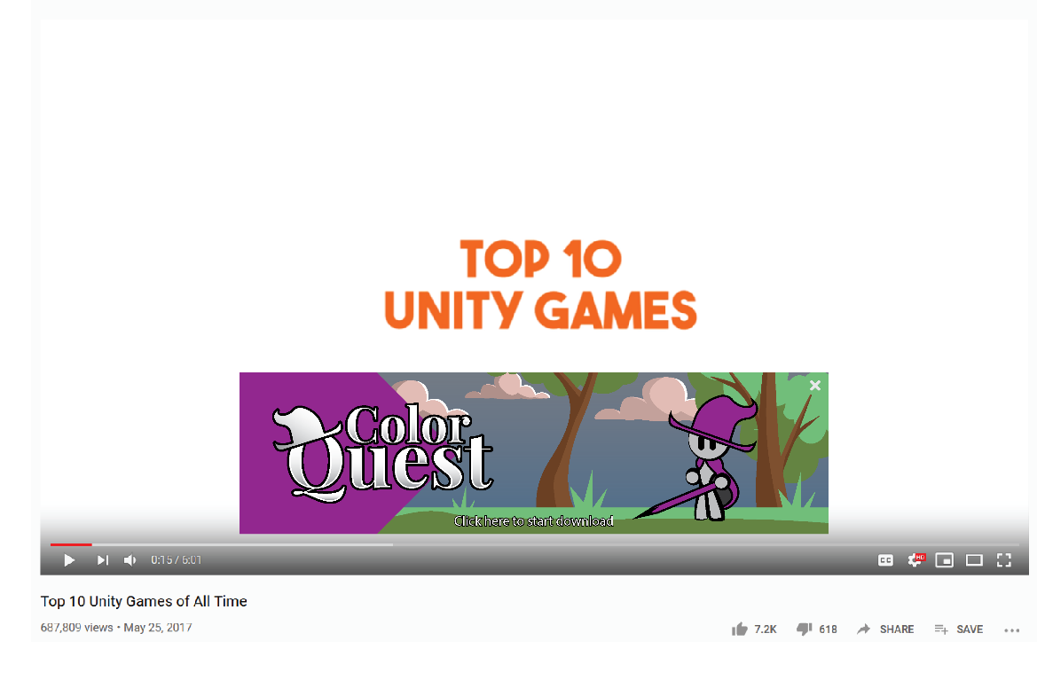

*YouTube advertisment mock-up*

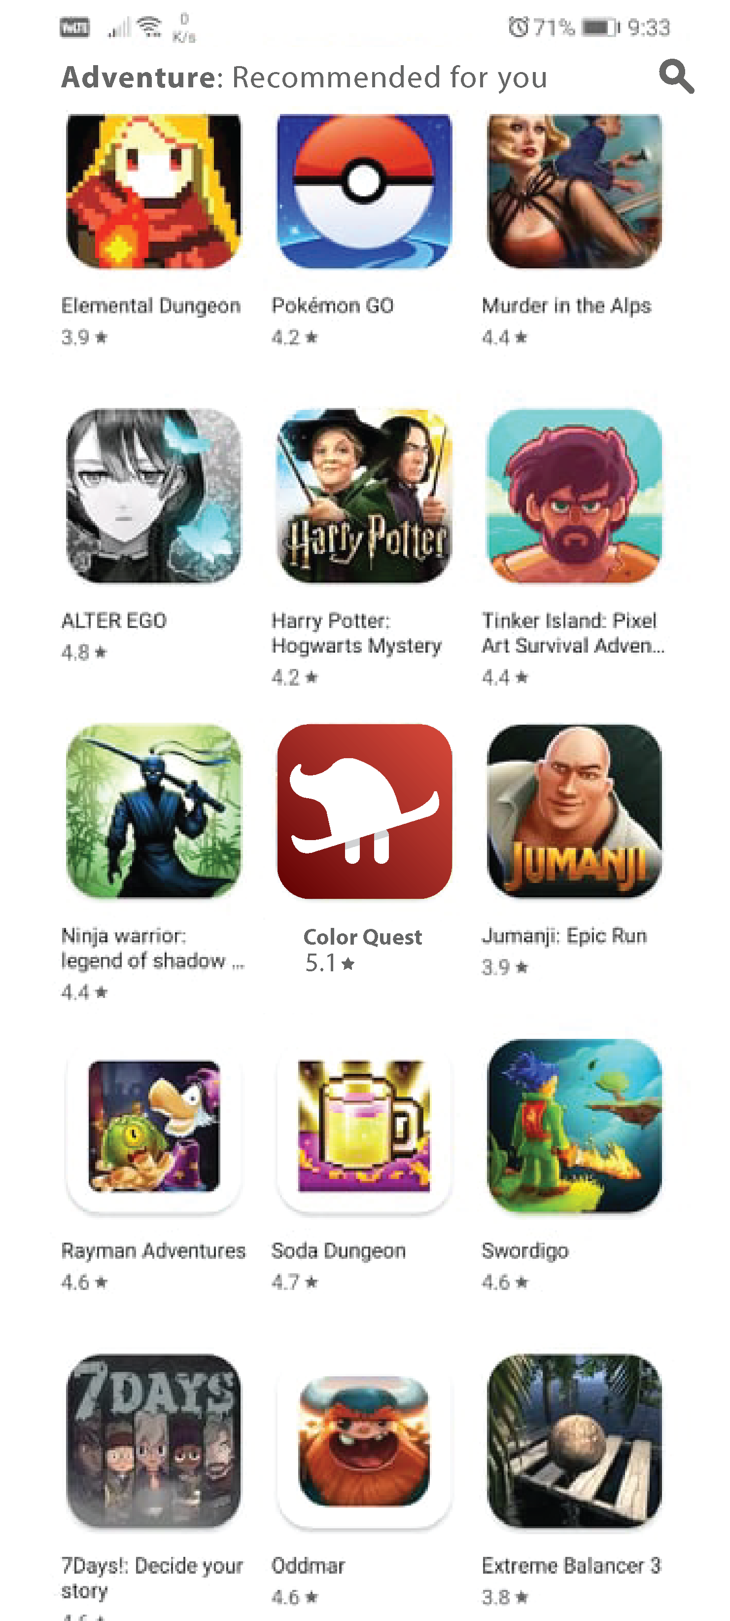On the monetization side of things, there are a number of ways we could go through the process. The easiest way would be to simply use the Steam Early Access system, offering the first chapters of the game for a low price, like many other indie titles, and offer constant updates to the story and gameplay, thus also doing the market research without any further investment.

If the launch proves to be successful on PC, the Android version will be released. The monetization will not be under any means predatory. We will either offer the game at a flat price, or include in game ads if we release a free version on Android. Microtransactions will ideally be nonexistent, especially if the game is released at a flat price.

If the Android version is to be released free on the Play Store, we shall employ adds and an unlock system for the story, where players can either spend points they gain in the levels to unlock the next chapters in the story, or simply buy them.

*Play Store mock-up*

# 8.Risks

* Fail to meet the launch deadline;
* Receive irrelevant info from the market research;
* Create a game too similar to the ones of the competitors;
* Older users might think that the game is designed for children and avoid it;
* Create a game which is too difficult and cause frustration;
* Might become monotonous after playing it extensively;
* User experience not so pleasant on mobile devices with small resolution.