Enemy Nations™

Colony Commander Notes


License

1. LICENSE. Windward Studios Inc. (WSI) grants to you a nontransferable, right to use the copy of the software program identified above (the "Software"). You may not copy the Software or any accompanying materials (the "Documentation"), except that you may make one copy for backup purposes. You may not place the Software on a computer that would allow multiple users to access it. You may not reverse engineer, disassemble, decompile, modify, adapt, translate, or create derivative works of the Software or Documentation. WSI retains all rights, title, and ownership in the Software. WSI may terminate this license immediately if you fail to comply with its terms.
2. WARRANTY. WSI warrants that the Software will perform substantially in accordance with the Documentation for a period of ninety (90) days from the date of purchase. WSI's entire liability and your sole and exclusive remedy is the return of the Software for a refund of the amounts paid by you or a replacement copy of the Software, so long as the Software is returned to WSI in the original packaging with a copy of your receipt and has not been subject to misuse, neglect, improper installation, repair, alteration, or damage by you. Any replacement Software will be warranted for the remainder of the original warranty period. EXCEPT FOR THE EXPRESS WARRANTIES ABOVE, WSI DISCLAIMS ALL OTHER WARRANTIES, EXPRESS OR IMPLIED, INCLUDING WITHOUT LIMITATION, THE IMPLIED WARRANTIES OF MERCHANTABILITY AND FITNESS FOR A PARTICULAR PURPOSE AND NON-INFRINGEMENT OF THIRD PARTY RIGHTS.
3. LIMITATION OF LIABILITY. IN NO EVENT WILL WSI OR ITS SUPPLIERS BE LIABLE FOR ANY INCIDENTAL, INDIRECT, SPECIAL OR CONSEQUENTIAL DAMAGES ARISING OUT OF OR IN CONNECTION WITH THIS AGREEMENT, EVEN IF WSI HAS BEEN ADVISED OF THE POSSIBILITY OF SUCH DAMAGES. IN NO EVENT SHALL LIABILITY OF WSI FOR DAMAGES HEREUNDER EXCEED THE AMOUNT PAID BY YOU FOR THE SOFTWARE.
SOME JURISDICTIONS DO NOT ALLOW THE LIMITATION OF IMPLIED WARRANTIES OF LIABILITY FOR INCIDENTAL, INDIRECT, SPECIAL, OR CONSEQUENTIAL DAMAGES, SO THE ABOVE LIMITATIONS MAY NOT ALWAYS APPLY.

©copyright 1995 - 1997 by Windward Studios, Inc. All Rights Reserved
Table of Contents
INTRODUCTION 6
INSTALLATION 6
INTRODUCTION 6
GOAL 6
THIS MANUAL 6
HISTORY 7
A Quick Guide 8
Starting a game 9
THE MAIN SCREEN 9
Training Grounds 9
Choose Race 11
Mission Objectives 12
Create Single Player Game 13
Create Network Game 13
Join Network Game 13
Load Single Player Game 14
Load Network Game 14
View Credits 14
Replay Introduction 14
Options 14
Exit 14
Minimize 15
PLAYING THE GAME 16
LANDING 16
HARVESTING MATERIALS 16
SCREEN LAYOUT 17
Toolbar 17
Resource Management 17
Main Maps 19
World Map 21
Radar Map 22
Build a Building 23
Build a Vehicle (or Infantry) 24
Research 25
Flags 25
GAME CONTROLS 26
Selecting a Unit 26
Commanding Units 26
SHORT-CUT KEYS 27
Use at any time 27
If World Map or Radar is selected 27
If a Main Map is selected 27
ADVANCED CONCEPTS 29
THE ROCKET 29
TRUCKS AND FREIGHTERS 29
A Single Trip 29
Routes 31
Roads and Bridges 31
Exiting Buildings 32
Building Spacing 32
Freighters 32
Landing Craft 32
Building on an Island 32
A SUCCESSFUL ECONOMY 33
THE COMBAT MODEL 33
POPULATION 34
PLAYER RELATIONS 35
Give Unit(s) 36
TRAINING GROUNDS 37
A WALK-THROUGH 37
Landing 37
Construction of a Building 37
MULTI-PLAYER GAMES 40
CREATING A MULTI-PLAYER GAME 41
Create Network Game 41
Publish a Game 41
Game Players 43
Choose Race & Chat 44
JOINING A MULTI-PLAYER GAME 44
Connect to the Net 44
Join a Game 45
Choose Race & Chat 45
E-Mail and Chat 45
Quitting Multi-Player Games 47
IServe 47
Network Protocols 48
TCP/IP 48
IPX 49
NETBIOS 50
DirectPlay 50
MODEM, TAPI, and Serial (Direct Connect) 51
MODEM 51
TAPI 53
OPTIONS 54
OPTIONS 54
ADVANCED OPTIONS 54
EVEN MORE ADVANCED… 55
RACES 56
BUILDINGS 59
VEHICLES 65
TERRAIN 68
SUPPORT 69
CREDITS 70

INTRODUCTION

INSTALLATION
Windows® '95, Windows® NT
Insert the Enemy Nations CD into your CD-ROM drive. The Enemy Nations™ Autoplay screen will appear. Click SETUP, and follow instructions. If the autoplay screen does not appear, follow the instructions for Windows 3.1 below.
Windows® 3.1
Insert the Enemy Nations™ CD into your CD-ROM drive. Double-click on your CD-ROM drive icon (for example, "D: Enemy Nations"). Click the SETUP icon, and follow instructions.
Enemy Nations™ will install approximately 4Meg of files onto your hard drive. All other files will remain on the CD-ROM.

INTRODUCTION
Enemy Nations™ is unlike any strategy game you have played. As commander of your colony, you must manage an economy as well as a military, making sure, as in real life, that things go as well at home as they do abroad. Luckily, Enemy Nations™ can be as intricate or as superficial as you like, offering a wide variety of options to suit your particular taste as a gamer. Your colony's economy is designed to automate, leaving you free to press military claims; but the variables that make an economy strong are diverse enough to allow you to get inside of it and perfect it to your liking.

GOAL
The goal of Enemy Nations™ is to dominate the planet by destroying any trace of opponent colonies. But this goal can be achieved in many ways, and it is up to you to develop your own style of play.

THIS MANUAL
This document is designed to help you understand the many unique and exciting features of Enemy Nations™. We recommend that you read it before playing the game, and use it as reference material as well. The manual is divided into three sections:
- The first section will help you get started by taking you through the various screens of Enemy Nations™, explaining the functions of each piece of interface.
- The second section takes you through the first mission of the Training Grounds, after which you will be able to play the game without further reading.
- The third section takes you through all the game elements and features one by one. This third section should serve as a reference to you while you play the game.

HISTORY
On September 26, 2005 the human race finally achieved interstellar flight with the first successful implementation of the Clawson-Hyperdrive developed by Dr. Tanya Clawson.
Various governments immediately sent out scout ships to explore the nearby stars. No longer limited to one planet in one solar system, the human race would at last realize its destiny and expand to fill the galaxy.
The first scout ships found nothing but inhospitable planets. But the search continued until the exciting news was received: A habitable planet had been found. More stunning, however, was the discovery that it supported an advanced civilization that had also achieved interstellar flight. The euphoria of finding another race of sentient beings precluded any doubts.
But as the reports from the scout ships continued to arrive, the truth dawned: Intelligent life was not a rare occurrence. Every planet capable of sustaining life supported advanced life forms, many of which were fiercely competitive.
The early evolving races had already traveled outward and colonized unoccupied planets and the last habitable planet had been found over 20,000 years ago. There was nothing left for the human race.
But dreams die hard and there are always those fools who continue striving no matter how impossible the odds. And so, a handful of ships continued to explore looking for a planet to colonize.
And then it happened. A habitable planet with no intelligent life was discovered.
Earth hastily dispatched a fleet of ships to colonize the newly discovered planet. But when they arrived they were greeted by warships from various other races. An available planet was a unique treasure. No race was willing to relinquish the planet to any other and those who tried to run the blockade were annihilated. No single race had a chance against all of the others and there was nothing to offer in exchange for a rare planet.
Negotiations ensued and years later, a compromise is announced. Each race will send one colony ship of a predetermined mass down to the surface of the planet. You will lead the expedition for Earth.
Your orders are simple: Do whatever it takes to be the dominant race on the new planet. There is no second chance. This is the one opportunity to establish the human race on another planet and your leadership will determine the future of our colony.

A Quick Guide
Ok, you’re a god at playing Red Alert™, Warcraft II®, and tiddlywinks. You don’t want to have to wade through the rest of this manual. You are ready to go out and kill. This section will attempt to give you a quick overview so you can get started immediately.
Winning at Enemy Nations rests on several key concepts:
First, you need to have the most efficient economy. This requires not only mining the most materials but getting those materials through the system to build tanks. A road can be more valuable than a second mine.
Second, you need to keep up on research. If you can only build infantry and your opponent is attacking with medium tanks, your chances are not good no matter how many infantry you can build.
Third, you need to attack your opponents’ weak points (and protect your own). In an evenly matched game an attacking force will be able to destroy maybe two buildings before being destroyed. Destroying Refineries, Power Plants, or Smelters can be extremely damaging blows.
Fourth, attack with combined arms. You will find that your attacks are much more effective if you attack with a combination of tanks and artillery. And infantry are deadly if they can get next to the object they are attacking.
You should first build, in order, a Lumber Mill, Farm, Iron Mine, Coal Mine, and Smelter. Once these buildings are built they will generate additional lumber and steel for more buildings.
All materials except food, gas, and electricity are local. This means they have to travel to the building that needs them. Coal and Iron are trucked from the mines to the Smelter. Steel is then trucked to the factory to build tanks.
Cranes build and repair buildings. A crane is sent to a location to build a building. It can build the foundation with no materials. However, the rest of the building cannot be completed until a truck brings the materials.
Trucks carry materials from building to building. You can take over control of the trucks. DON’T DO IT. Leave the trucks on auto. When you become an advanced player you will occasionally take over a truck for a short period but when you first play leave them alone.
Roads are essential to a strong economy. Build roads between all buildings that trucks regularly visit, including the Rocket Ship. Note, building roads requires gas and if you are out of gas you cannot build roads.
Population and Power affect building productivity. If your power is at 99% of what is needed, it will have a negligible effect. If it’s at 10% your factories will take forever. You need to keep these at or above 100% most of the time but occasional slight drops are not a cause for alarm. A full population requires enough food, Apartments, and Offices.
When the game starts you have to first place your Rocket Ship. You left click on the location you wish to place it in. You must place it in the lighted part of the map and all other players will start outside that lighted area.
Try to pick a location near trees, coal, iron, and oil. This is generally impossible (by design) but at least try to minimize the distances.
The door of the Spaceship is the single square sticking off of the pattern showing the base of where the rocket will be placed. If you want to rotate the rocket, press CTRL-RMB to rotate. This can be done for all buildings and is sometimes critical for good traffic flow.
Once you have found the location and rotation you want, press LMB and your rocket will land.
As you move the mouse over the screen watch the text in the lower right hand corner of the screen. That will give you information about whatever the mouse is over. This is a fast way to learn the function of the various buttons, the status of buildings and vehicles, and the mineral resources at that location in the ground. You can also move the mouse over status bars to get more detail on a unit’s status.
You now need to build your economy. Double click on a crane and you can then pick the building for it to build. Pick the building and then choose it’s location as you did for the Rocket Ship. Remember; Lumber Mill, Farm, Iron Mine, Coal Mine, Smelter!
Read the chapter titled Short-Cut Keys and then you’re ready to play.

Starting a game

THE MAIN SCREEN
After the introductory movie you will be at the main screen.
Note: You can skip the introductory movie by clicking the mouse or pressing any key.
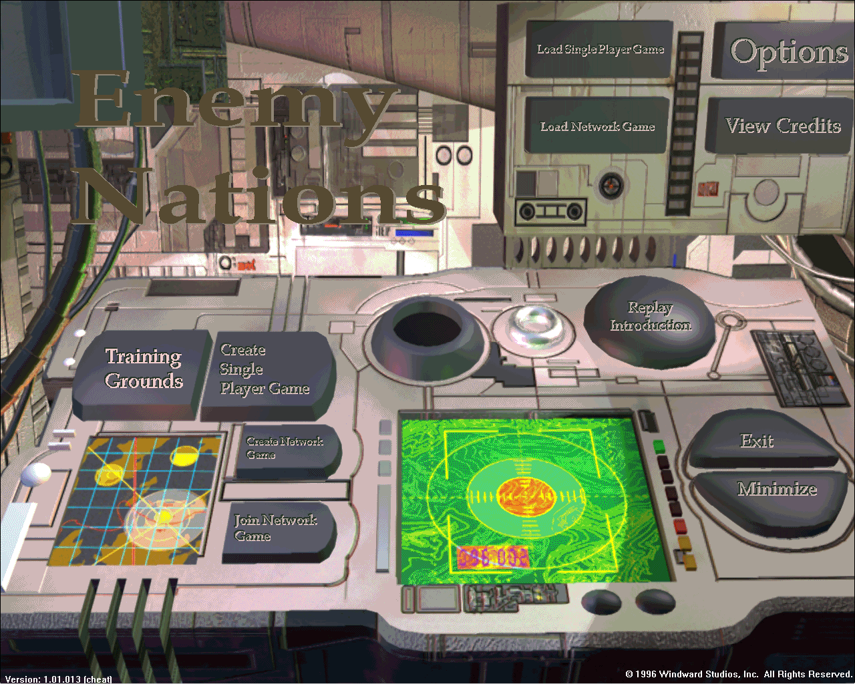
From this main screen you start a game of Enemy Nations. Your choices are described below. To choose any item, click on that button.

Training Grounds
This will take you through a series of missions in a single-player game. We strongly recommend you play this before playing any other games.
While the mission objectives here are the same for each game, the actual world created is randomly generated each time. In addition, the computer opponents will react differently each time. So you will find that replaying the Training Grounds will require different tactics each time.
When you choose Training Grounds you will be presented with this dialog:
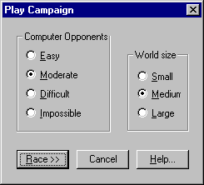
Note: Where possible we use standard Windows dialogs instead of the rendered art from the game because this prints a lot clearer in the manual.
Under Computer Opponent you set how difficult a fight you want from the computer players. This sets both how hard the computer will fight and also, for the harder levels, gives the computer a boost to it’s racial advantages (see Race Dialog).
The number of opponents you have in the Training Grounds is based on the speed of your processor. The more CPU time the computer AI gets, the smarter it can be. So we limit the number of AI players for slower machines.
The World size sets how big the world will be. The actual world size is based on the number of players (human and computer), some of their racial characteristics, and this setting. Because we grow the world based on the number of players, you don’t find the world crowded as the number of players increases.
In a small world you will find yourself at least skirmishing with other players almost from the initial landing. You will usually be competing in at least one place for the same resource. Games at this size will generally be quick affairs and complete in ½ - 1 hour.
In a medium world you get a bit more breathing room. You will generally not find other players for the first 10 - 20 minutes unless you go looking for them (or they go looking for you). You will sometimes find yourself fighting for the same resource but this is rare.
But as you grow past your initial base you will find that you start bumping elbows with other players. Research is important in games this size although you will rarely get to the advanced weapons. Games at this size will generally take 30 minutes - 1½ hours.
In the large world you will have a chance to build up a large colony. Not only do you have a lot of room to yourself but your opponent has a long way to travel to attack you. By the time they get there you will generally have more units.
The length of these games depend on the players but they can take several hours to finally resolve. Because of the time, research usually is the critical factor in these games.
After selecting the computer difficulty and world size press the Race button which will bring up the following dialog:

Choose Race
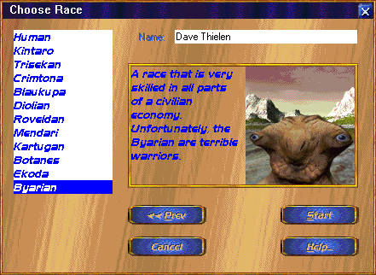
Enemy Nations gives each race over 10 modifiers. These modifiers give each race an advantage (or disadvantage) in items as diverse as attack strength and population growth. The description for each race gives a general idea of each race’s strengths, but it is not comprehensive.
You need to select a race and to type in your name.
Note: The Ekoda race exists to handicap a player who is significantly better than the other players.
Once you select a race press the Start button.

Mission Objectives
Which takes you to the below screen.
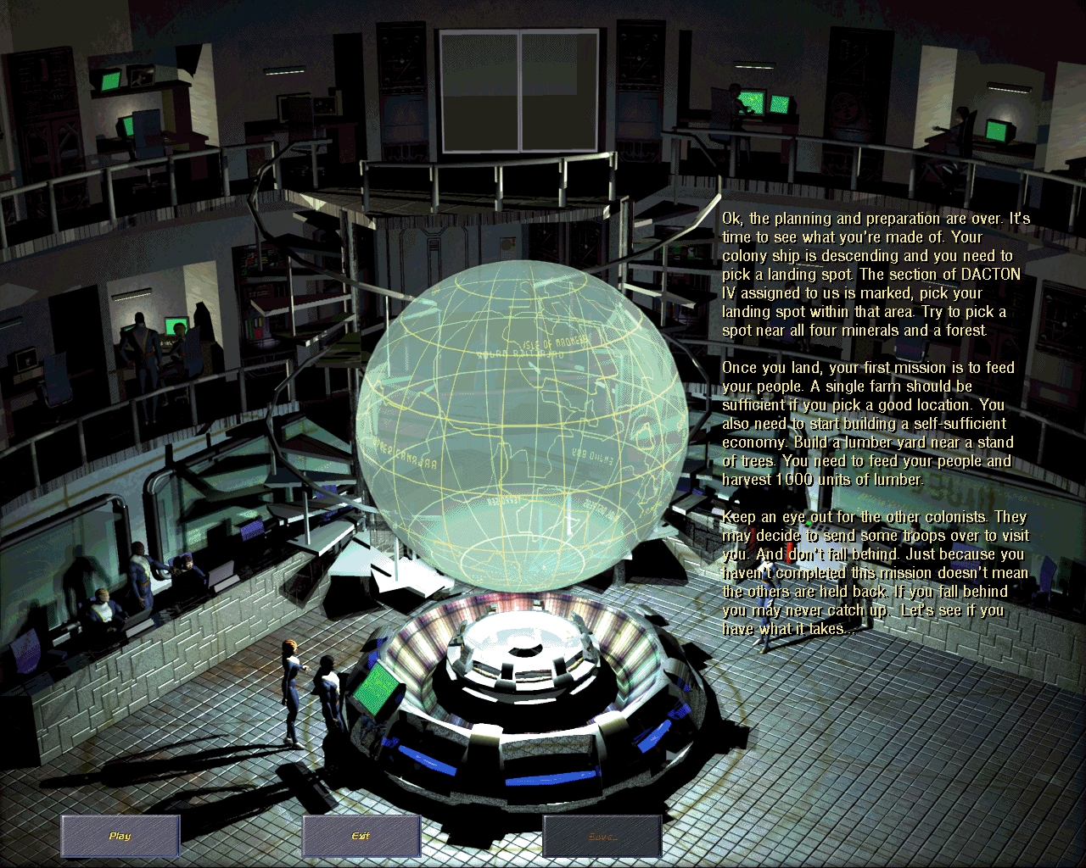
Read your mission carefully. You need to fully complete each mission before you can continue to the following mission. It is very easy to overlook a small part of a mission and wonder why you haven’t completed it.
Note: While it is possible a bug still exists, every bug reported in the final 3 months of testing about missions not completing was traced down to the tester having not completed a part of the mission. So please read it carefully.
If you need to re-read the mission, you can do so by bringing up the File dialog in the game and pressing the Mission button. If you think you have completed the mission, bring this up again and re-read it.
Then press Play and the game will load the artwork and begin. Playing the game is covered in the next chapter.

Create Single Player Game
This creates a game with one human player (that’s you) and however many computer opponents you wish to challenge.
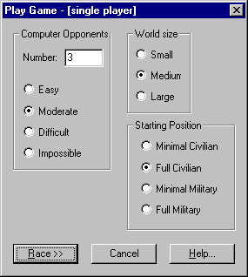
First choose the number of computer opponents you wish to play. Based on the speed of your computer if you select above the suggested limit it will suggest that you choose less. If you select above twice the suggested limit it will refuse to start the game.
Because more CPU time gives the computer opponents more brain power, you are much better off staying below the suggested limit and increasing the opponent difficulty.
Second choose the difficulty level you wish to have the computer play at. Each increase in the difficulty level should make the computer about 50% harder to beat.
Third select the world size. For details on this see the description in the Training Missions section above.
Fourth select the starting position. This has a significant impact on both how the game is played and how long it will last. Because the more you start with the quicker you can have an economy that is producing tanks.
Minimal Civilian provides enough lumber to build a Lumber Mill and Farm and enough steel for those two buildings along with an Iron Mine, Coal Mine, and Smelter. Because you need to generate more materials just to build a basic economy, it generally takes over 15 minutes just to build and send out some Infantry.
Full Civilian gives you enough resources, cranes, and trucks to build all the buildings for a basic economy. Therefore you can be building Infantry in under 5 minutes (and so can your opponents).
Minimal Military gives you Full Civilian as well as enough military units to harass your opponents. It is unlikely that you could actually win a game without building more units but you could definitely slow down your opponents.
Full Military gives you Full Civilian plus a significant military force. While you could potentially end a game quickly with a lighting strike, you could also find this to be a very long game with all sides building an economy in the midst of a battle from the very start.
After choosing the Starting Position press the Race button. Please read the section titled Choose Race above for a description of this dialog.

Create Network Game
This is described in the chapter below discussing Multi-player games.

Join Network Game
This is described in the chapter below discussing Multi-player games.

Load Single Player Game
This brings up the standard Windows Open File dialog. Select a saved game file. The file then loads all of the game art and then the saved game file.
You will then see the following dialog:
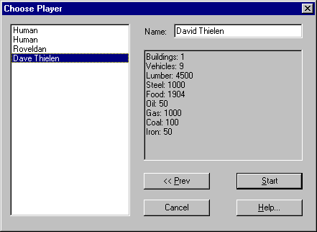
This dialog allows you to pick any player in the saved game. If the saved game was a single player game then it will include all of the computer players. If it was a multi-player game then it will include all of the other human and computer players.
Note: A saved game is a saved game. You can save a single-player game and load it for multi-player and vice-versa. The only restriction is a Train Mission game is always a Training Mission game.
All other players will become computer players. So if the computer is kicking your butt, you can save the game and switch places, thus taking the computer player and letting it take your position.
The box on the right gives you an idea of the present condition of that player. After all, you don’t want to take a player that is about to die.
Note: The two lines saying Human above signify a computer player that took the Human Race, not a human player.
Then press Start and the game will load the artwork and begin. Playing the game is covered in the next chapter.

Load Network Game
This is described in the chapter below discussing Multi-player games.

View Credits
This will play the credits of the people involved in creating the game.

Replay Introduction
This will replay the introductory movie.

Options
Sets game options. Described in chapter below.

Exit
This will exit Enemy Nations™ (but the real question is why would anyone ever want to use this button).

Minimize
This will minimize the game (and kill the sound). This is very useful if your boss walks in while you are playing.

PLAYING THE GAME

LANDING
When the game windows appear, your first task is to land your space ship on the planet. Find a clearing and click the left mouse button. Your space ship will appear, and your initial vehicles will roll out of it. Your space ship, from now on, serves as your first warehouse, containing all the initial materials (RESOURCES, see below) you will need to get started.
Notes On Placement:
- Before landing, you will notice that your colony has an assigned "area" on the planet surface. This area is diamond shaped and is lit. You cannot land outside of this assigned area (the darker areas). Once you land, you will see that your visibility is reduced to the area surrounding your space ship (see Visibility, below).
- As you get deeper into Enemy Nations™, you will find that the placement of your space ship is critical. You want to put the ship as near to the primary resources as possible. These resources include trees, coal, iron, and oil. Trees are easy to spot. Underground resources can be illuminated by using the SHOW RESOURCES toggle button on the Global Tool Bar (see below).
- The rocket, as all buildings, shows a rectangle where it will be placed/built as well as a single square sticking out which shows where vehicles will exit the building. You can rotate the building placement by pressing the CTRL key and clicking the Right Mouse Button (CTRL-RMB) before placing the building.

HARVESTING MATERIALS
To build a strong economy, you will need to harvest many materials from the planet throughout the course of the game, and then convert some of these materials to useable resources.
Lumber
Lumber is needed, among other things, to create buildings. Lumber is harvested by building Lumber Mills near forests. As the Lumber Mill generates lumber, you will see the amount of lumber in the building increase. Trucks will then route the lumber to the appropriate buildings.
Iron
Iron is harvested from the ground by building an Iron Mine. When transported to a Smelter, Iron will be converted (with Coal) into Steel.
Coal
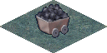Coal is harvested from the ground by building a Coal Mine. When transported to a Smelter, Coal can be converted (with Iron) into Steel. Coal should also be transported to Coal Power Plants to keep them functional.
Steel
Formed in a Smelter from Iron and Coal, Steel is necessary for creating buildings and vehicles. Steel must be transported to your various factories before it can be used to construction.
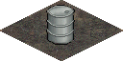Oil
Harvested from the ground with an Oil Well, Oil is converted to gasoline when transported to a Refinery. Oil should also be transported to Oil Power Plants to keep them functional.
Xilitium
The most precious of minerals, Xilitium is harvested from the ground by building a Xilitium Mine, then used for construction of advanced vehicles. You must conduct extensive research before you will be able to mine or use Xilitium.

SCREEN LAYOUT

Toolbar
The toolbar lies across the bottom of the screen and looks like this. This task bar can be hidden at anytime by pressing CTRL-H and unhidden by pressing CTRL-U.
We will break this into pieces and discuss those pieces. First is the task button bar:

These buttons bring up various windows within the game. For each button it brings it’s window to the top on the screen.
The first button brings up the main map. If you have several main maps open it will bring up the one that most recently had the focus.
The second button brings up the World Map/Radar. (It is the world map until you build a Command Center and then it becomes the Radar.)
The third button brings up your e-mail system. This button is only enabled for multi-player games.
The fourth button brings up the relations window. This button is only enabled if you have an Embassy built. You can also bring up this window by double-clicking on the Embassy.
The fifth button brings up the Current Vehicles window, which is a list of all vehicles that currently exist in your colony. By double clicking on vehicles in this list, you can immediately locate the vehicles and the Area Map will center on your selection. You can also select vehicles with a single click.
The sixth button brings up the Current Buildings window, which is a list of all buildings that currently exist in your colony. By double clicking on buildings in this list, you can immediately locate the buildings and the Area Map will center on your selection. You can also select buildings with a single click.
The seventh button brings up the research window. This window can also be brought up by double-clicking on any Research Institute.
The last button brings up the file dialog. This dialog is where you can save or exit the game, set options, etc.
Next, the global status and clock bars:

Resource Management
The four resource bars in the lower right portion of the Global Tool Bar give you a graphical read-out of your four primary resources. By rolling the cursor (mouse) over a given resource bar, you will receive a text read-out (in the Global status bars) of the current state of that resource. If your colony is in desperate need of a given resource, the appropriate resource bar will begin flashing red.

Good resource management is the key to establishing a successful economy.
Gasoline
Increase gasoline supply to your vehicles by harvesting oil from the ground (with an Oil Well) and routing it (with a Truck) to an Oil Refinery. The Refinery will automatically convert the oil to gasoline. Gasoline is a global resource -- you do not need to manually fuel your vehicles. If you run low on gasoline, your vehicles will move more slowly (Trucks and Cranes a little more slowly; other vehicles a lot more slowly. Ground troops are unaffected by gasoline.)
In addition to powering your vehicles, gasoline is also used to build roads. If you have no gasoline you cannot build roads.
Power
Increase power by building Power Plants. Each Power Plant supplies a fixed amount of power. Your need for power will increase as you create more and more buildings. Power is a global resource -- you do not need to manually supply power to buildings.
Population
The population of your colony will increase automatically over time, and will be reflected by the apartment and office buildings which will become available to you for building. The primary purpose of population is allocation for things like research and driving. In order to maintain a steady increase in population, you will need to make sure adequate housing, office space, and food are provided. By checking the populations of individual apartments and offices, you will know when you need to create additional buildings.
Food
Increase food supply to your colony by building Farms. The larger your population, the more Farms you will need to feed your people.
Clock
The clock gives the elapsed game time. If the game speed is set to normal this will match seconds you have been playing the game.
Message Window
Next is the message window.
This will list messages from the game. Most messages will not remain in this bar for over 30 seconds. All voice messages from the game will also generate a more detailed message here.
Help Window
This window provides information about whatever the cursor is presently over. Examples include;
The cursor over the World Map button:
The cursor over a building (the Spaceship):
This shows the type of unit, the damage level (undamaged here) and the resources it is holding. For a factory it will also show what it is building. For an enemy unit it will show the type of unit, the player that owns it, and the damage level.
The cursor over a global status bar (people):
The cursor over a selected building status bar in the main map (the Spaceship):

Main Maps
The game action takes place in the Main Map.
NOTE: In the early stages of the game, you will see only one large Main Map. The exciting technology of Enemy Nations™ allows you to open additional Main Map windows by holding down CTRL and double-clicking the LMB (left mouse button) on a unit (building or vehicle). The new window, as with all windows, can be re-sized, brought to the front, sent to the back, or closed, allowing you to customize your screen to suit your particular command style. For instance, open a window and center it on your enemy's home base. Shrink the window and put it in the corner, and you have a constant, real-time update of your enemy's progress, without having to scroll rapidly half-way across the planet.
The ability to have these multiple windows is not granted at the beginning of a game, but must be researched by your colony.

Getting Around
Scroll across any Main Map by clicking and holding down the RMB (right mouse button) and moving the mouse to the edges of the Area Map. You will see arrows indicating the direction of the scroll. You can scroll vertically, horizontally, or diagonally. The closer you are to the map edge the faster it will scroll.
You can also center on a location in the main map by a RMB-DBLCLK (DouBLe CLicK) at the location you wish centered.

Visibility (fog of war)
After landing on the planet, you will be able to see the terrain of the entire planet, but only when you send out scouts will you be able to see activity on the planet -- other colonies' buildings and vehicles. Visibility range (spotting) varies from vehicle to vehicle, and is indicated by a lightening and darkening of the planet's surface. Spotting may also be affected by the type of terrain your vehicles and buildings occupy.
Notes on visibility:
- Visibility is occluded by trees and terrain peaks.
- When an enemy building is no longer visible, it will remain on the screen in its last known state. Even if a building has been destroyed, it will remain displayed in it’s last known state until one of your vehicles can see that location again.
- Some vehicles can shoot farther than they can see and therefore will continue shooting at a building after it has actually been destroyed if no other vehicle can actually see the building.
- In multi-player mode, if a player marks you as an ally, then you will also see everything that player’s buildings and scout vehicles can see.
THE LOCAL TOOL BAR
More sophisticated commands require the Local Tool Bar, which is the row of buttons at the bottom of the Main Map. Depending upon which unit is currently selected, the Local Tool Bar will alter its arrangement of buttons. Below are the possible commands you can execute from the Local Tool Bar (this is the bar with nothing selected):

Last Attack
This will center the last building of yours that was last attacked in the middle of the Main Map window.
Rotate Clockwise
Rotate Counterclockwise
Zoom In
Zoom Out
The above four commands allow you to alter your view of the specific Area Map to which the Local Tool Bar is attached. If you have multiple Area Maps on screen, each can operate at different rotations and zoom levels.
Show Materials
This toggle button will show you the distribution of natural minerals across the surface of the planet. Small icons represent the minerals. An oil drum indicates the presence of oil, a bucket of coal represents coal, an orange chunk of iron represents iron, a shiny bar represents xilitium.
Stop
This button will bring to a halt any construction or routing that is in progress by the selected unit.
Build
If a Crane is selected, the Build button will bring up a Build Building window, allowing you to create new buildings.
SHORT-CUT: The Build Building command can also be achieved by double-LMB-clicking on a Crane.
If a vehicle-producing building is selected (like the Vehicle Factory), the Build button will bring up a Build Vehicle window, allowing you to create new vehicles.
SHORT-CUT: The Build Vehicle command can also be achieved by double-LMB-clicking on a building.
Below is the toolbar when a crane is selected:

Road
If a Crane is selected, the Road icon will allow you to use the Crane to build roads (see section on Roads, below).
Repair
If a Crane is selected, the Repair icon will change the cursor into a hammer. To use the Crane to repair a building, click the hammer on the building.
Other vehicles have a route button instead of Road and Repair.
Route
If the Route button is clicked, the Route window will appear. Trucks will route themselves automatically, based on needs, but you can always interrupt a Truck's route and give it new instructions.
SHORT-CUT: The Route command can also be achieved by double-LMB-clicking on a Truck.

World Map
The World Map in the corner is your global look at the planet. Units (yours and your enemies') are represented by colored dots. You can scroll the World Map by pressing the right mouse button (RMB). The four buttons on the World Map allow you to alter the display of the World Map as follows:
Upper left button: Toggles display of natural resources.
Upper right button (radar only): Toggles visible regions.
Lower left button: Toggles display of your units.
Lower right button: Toggles display of enemy units.
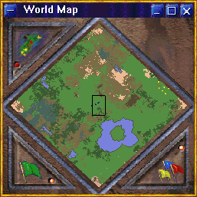
The various colors in the radar denote different terrain types. And the colored dots represent the buildings you have spotted of the various races. If one of your buildings is under attack you will see the building blink red.
The black square in the middle of the map is the part of the world displayed in the Main Map. If you have multiple main maps this is the area displayed in the most recently active main map.

Radar Map
After achieving a certain level of research in the game, you can build a Command Center. With a Command Center you will find that the World Map converts into a Radar, giving you additional functionality. The World Map is static, showing buildings only. The Radar shows visibility and vehicle movement.
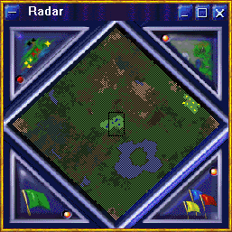
The clear areas are the parts of the world that are presently visible to you. All shaded areas are obscured by fog of war. The area in the center is occupied by the players buildings. The clear area to the right is occupied by a player who is an ally and therefore you can see that area live too.

Build a Building
To build a building you either double click on a crane or select a crane and press the build button on the Main Map toolbar. This will bring up the following dialog:
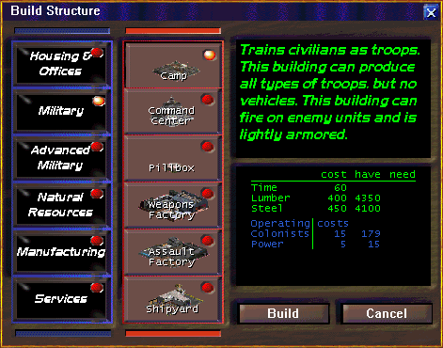
You first pick a category in the left column. Each category will display a different set of choices in the second column. The number of items in the second column is limited by what you have researched (the selection above is after all items have been researched).
For Housing and Offices the choices are set by your population size. As your population grows you will be offered the chance to build bigger buildings.
The section in the upper right describes the building. This gives you a quick rundown about the attributes of each building.
The middle section on the right lists the cost of the building. The first set of numbers tell you how long it will take to build it and how much lumber and steel it will require. The column labeled “have” is how much lumber and steel you have throughout your economy – although it may all be needed elsewhere.
The second set of numbers tells you what is required to run the building. Each building will use colonists and power from the global pool of available people and power. And if you overbuild then all buildings will operate at reduced efficiency.
To actually build the building you either double-click on the building in the second row or press the Build button. You then have to pick the location at which to place the building, just as you landed your rocket.
There is no limitation on where the building is located based on your other buildings, start area, etc. You can build anywhere on the map.
However, you are limited to places where the building can be situated. These restrictions include reasonably flat land, exits vehicles can navigate, etc. If a location is unacceptable, the status bar in the lower left will tell you why and the placement cursor will turn red.
Mines and the lumber mill are a special case. First, they cannot be built unless they are on the necessary resource. In addition, they will measure the relative value of a location and if it is only moderately productive the placement cursor will turn yellow.
The status bar in the lower right will give you a measure of a location’s utility. For a Lumber Mill and Farm this is a 1 - 10 measure with 10 being the most productive possible location.
For Mines it shows the density (0 - 100) and quantity (0-1,000). A more dense location will extract a greater amount of resources per second. A larger quantity will last longer before the mine is exhausted.

Build a Vehicle (or Infantry)
To build a vehicle you either double click on the factory or select a factory and press the Build button on the Main Map toolbar. This will bring up the following dialog:
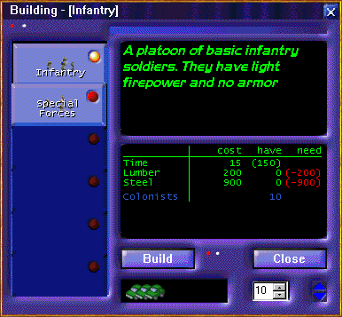
This is the dialog for the Camp but they all look the same. In the column on the left you select the unit you wish to build. In the section in the upper right it describes the selected unit.
The middle section lists the costs to build that unit, and the resources available in that specific building. Please note that this is different from the Build Structure dialog above in that the materials in the “have” column here represent only materials in that building.
In the bottom right you set how many of this unit to build. This can be any number. The cost totals above are for that number of units. The time cost is the time for one unit followed by the time for all of them.
To start construction you either double click on the unit or press the Build button.
Once you start construction of the units, this dialog does not go away. The main map is brought on top of it so if the main map totally obscures the dialog then it will appear to have disappeared but it is still up, just behind the main map.
You can bring it up again after starting construction and construction will continue. If a factory is building units then you will see the following in the dialog:
First, in the caption bar it will list what type of unit is being built. Second, in the bottom middle, the car icons will show how much of the next single unit has been built. (So you can see how long until it is completed.)
Finally, if this window is not active, the number of units to build will be decremented each time a unit is built showing how many units remain to be built. It will only change the number if this dialog is not presently the active (selected) window.
So, you can place this dialog to the side to monitor construction, to place new construction orders without returning to the factory, and to change orders while it is working.

Research
Research is the most important element that will contribute toward the advancement of your colony. Your scientists will be able to conduct research into many different areas, and it is up to you to choose which path(s) you want to take first. For instance, researching Advanced Construction and Manufacturing technologies will increase efficiency in these areas, allowing you to build up more quickly in the long run, but will prevent you from researching Weapons technologies as early as you might like.
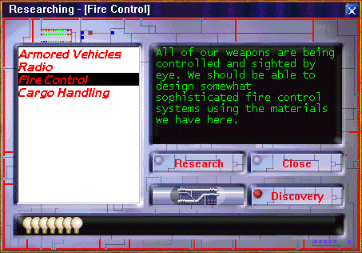
The list in the left-hand column lists those items you can presently research. Each research item may have both previous research items you must complete before researching and specific buildings you must build before it can be researched.
There are also a few research items that are only available in multi-player games because they have no utility in single-player games.
The window on the right explains what the research will achieve. You can click on different items to view their description without affecting what is presently being researched.
To research a given topic you need to either double-click the item in the list or single-click to select it and then press the Research button. That will start researching the selected item.
When an item is being researched, the topic will be listed in the title bar of the window and you will see light bulbs in the status bar across the bottom of the screen.
The amount of time required to research a given topic will be randomly determined each game. However, the rate the light bulbs move across the status bar is always the same for a given topic and the topic will always be discovered by the time the bulbs have gone all the way across.
You can switch topics at any time. When you go back to the old topic you will see that it retains some, but not all of it’s previous progress toward discovery. (In other words you are penalized for bouncing between different topics.)
When a topic is discovered you can press the Discovery button to read exactly what advantage that topic gives you. You can press the Discovery button after starting the next line of research. However, you must press it before the next topic is discovered.
Building multiple Research Institutes will allow you to research individual items more quickly, but will not allow you to research multiple items at once.

Flags
The small, colored flags on each unit differentiate one player's units from another's. You cannot change these values. If there are over 6 players (human and computer) then some players will have identical colors (ie. there are only 6 colors of flags).

GAME CONTROLS

Selecting a Unit
To control any given unit, the unit must first be selected. To select a unit, move the mouse over it until the cursor changes to a white rectangle. Click on the units once with the left mouse button (LMB). If the unit is a vehicle, a rectangle will appear around the selected unit.
Drag Rectangle: Selecting Multiple Units
To select multiple units, you can click SHIFT-LMB on the additional unit. Or, alternatively, you can select multiple units by clicking/holding the LMB and dragging a rectangle around the group of units you wish to select. When you release the LMB, the units will be selected.
If there is more than one unit in the rectangle, the rectangle will ignore civilian units. If you are selecting a single civilian unit with the rectangle, the rectangle will select that unit.
If you drag the rectangle around a group of units, and hold the CTRL key when releasing the LMB, the rectangle will select all units in the rectangle, civilian or military.
Once selected, units can be controlled using a variety of commands.

Commanding Units
Move
To move a selected vehicle(s), simply click the LMB where you want the vehicle(s) to go.
Attack
To attack enemy units (buildings or vehicles), simply click the LMB on the unit you wish to attack. The selected unit(s) will attack your target. (You will notice that, when you place the mouse cursor over an enemy unit, the cursor will change into a target, indicating that the LMB will issue the command to attack.)
NOTE: Not all units are combat units; the Crane, for example, is incapable of attack.
Move Without Attacking
If you wish to move units to an enemy unit without attacking, click CTRL-LMB when choosing the destination. Units will move to the destination but will not attack.
Forced Attack
CTRL-SHIFT-LMB is a "forced attack"; your unit(s) will attack the target, whether it is friendly or not (or even your own!).
INFO BOXES
Each unit (building or vehicle) has an "info box" containing all pertinent information concerning that unit. To view the info box, hold the SHIFT key and click the RMB.
NOTE: The box will remain on the screen as long as your mouse cursor is not moving. To get rid of the box, move the mouse cursor.
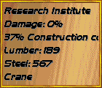
These info boxes are essential to effective game-play. For vehicles, the box indicates precise damage level, as well as (for trucks) materials being transported. For buildings, the box indicates materials which are housed there, with specific amounts, as well as materials needed for construction completion (these numbers will appear in parentheses).

SHORT-CUT KEYS

Use at any time
ALT-F4: Exit the game
CTRL-A: Select area map
CTRL-B: Bring up buildings list
CTRL-D: Bring up diplomacy (relations) window
CTRL-M: Bring up mail & chat
CTRL-O: Bring up options window
CTRL-P: Pause (only the server can pause a multi-player game)
CTRL-R: Bring up research window
CTRL-S: Save
CTRL-V: Bring up vehicles list
F1 Help
F2 Minimize & pause
CTRL-F4: Close selected window
CTRL-W: Select world (radar) map

If World Map or Radar is selected
E: Show enemies
R: Show resources
U: Show my units
V: Show visibility

If a Main Map is selected
B: Build (crane, factories only)
O: Drop selected target and fire at best Opportunity target (may be the same unit)
R: Bring up route window
U: Unload (infantry carrier, landing craft)
DEL: Destroy selected units
arrow keys: Scroll window
ESC: De-select units
HOME: Center on selected units (rocket if nothing selected)
X: Retreat (to repair center if damaged & one exists)
# (0-9): Assign selected units to that number (a unit can be assigned to multiple numbers)
SHIFT-#: Add selected units to the list of units already assigned to that number.
CTRL-#: Set selected units to be the units previously saved to that number (This replaces the units previously selected)
SHIFT-CTRL-#: Add units previously saved to that number to the units presently selected
Note: Be careful that you have the proper window type selected. It’s very easy to bang on the ESC key when a window other than the main map is selected and wonder why the vehicles are still selected.

ADVANCED CONCEPTS

THE ROCKET
The rocket has a couple of extra features. First, it is a warehouse and the trucks, if you have 2 or more, will take excess materials to warehouses when they have nothing else to do. This is very valuable in case your lumber yard is destroyed (and all your lumber with it).
Second, the rocket provides a small amount of apartment and office space to house your initial landing party. This gives you a little breathing room when you first land.
Third, the rocket provides some power for your buildings. Again, this allows you to build your basic economy before having to build a power plant.
Fourth, if your last crane or truck is destroyed, another will be built in the rocket and delivered. (This is our shortcut for the concept that if the last crane in a colony was destroyed the colonists would scavenge everywhere to build a replacement.) The closer the destroyed vehicle was to the rocket, the longer it will take for it to appear. This can take up to 30 seconds.
There is a 1:40 chance you will not get a new vehicle. This was implemented to stop people from destroying their last crane/truck if it was heavily damaged to get a free undamaged one.
Fifth, if you have built any of the 4 basic buildings (lumber mill, coal mine, iron mine, & smelter), and they are destroyed, and you do not have enough lumber and/or steel to build a new one, the rocket will create those new materials.
In this case, it is possible that another truck loading for something else will grab those materials. So you have to be careful that no other truck grabs them.
If your rocket is destroyed you lose all of this. You cannot build another building with these special attributes and the attributes are not transferred to another building.

TRUCKS AND FREIGHTERS
The first rule of handling the trucks is leave them on automatic. The second rule of handling the trucks is leave them on automatic. The third rule of handling the trucks is leave them on automatic. Are you detecting a trend here?
In all initial play-testing, players would first fully control their trucks. Then as they got better, they would control the most important routes. Finally, as they got a real good feel for the game, they would leave the trucks on automatic except for rare instances when they would move one load of materials.
The automatic router cannot read your mind for your priorities. It will occasionally have priorities significantly different from yours. But overall, because it is constantly watching the needs of your buildings, it will do a better job than you can do unless you do nothing but control your trucks.
Over the course of the game the trucks will do a better job than you can. And this frees you up to pay attention to other facets of the game, like the other players who are trying to kill you.

A Single Trip
Occasionally it makes sense to take over a truck for a single run of materials. The most common example of this is loading a camp or factory up with lumber and steel while it is still under construction. This way you can start building tanks as soon as the factory is built.
To do this you select a single truck and send it to a building with excess lumber and/or steel. When you have a truck selected and move the cursor over any of your buildings (or the buildings of anyone who has set themselves as your ally), it will remain a “GoTo” cursor (as opposed to a cursor for selecting that building). Click on the building and your truck will go there.
Load Truck
When the truck arrives you will get this dialog:
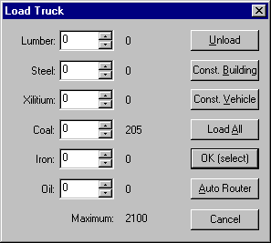
The left column is the amount of materials to place on your truck. In the example above the truck arrived empty but if the truck was not empty it’s materials would show in the left column.
The second column is the materials at that building. As you change the quantity in the truck, the remaining materials in the building will also change to reflect the movement of materials.
However, until you click a button on the dialog no materials actually move. So if you have 2 trucks in a factory, you can set both to load everything and the second truck, when it goes to load, will find nothing there.
At the bottom of the second column is the maximum capacity of the truck. You cannot fill the truck beyond this capacity.
The third column are the commands you can give the truck. Unload will unload everything from the truck to the building.
Const Building will load the truck with the best proportion of lumber and steel to build a building. This is a fast way to load a truck you will use to build a new building. But it may not be the exact amounts for the specific building you are planning on building.
Const Vehicle will load the truck with the best mix of materials to build tanks. This is valuable for sending materials to a factory that is still under construction.
Load All will load everything in the truck (the opposite of Unload). Load All will walk down the materials and load everything it can until it reaches the maximum capacity of the truck. There is no balancing or prioritization. This button is designed for loading up at a Mine or Smelter.
Note: The above 4 buttons do not actually cause any movement of materials. They just change the numbers to move when pressing one of the next two buttons.
OK (select) will transfer the materials as you have set and then send the truck out of the building with the truck selected. You should press this button after loading a truck and after pressing it, click on the next building you want the truck to go to.
Auto Router will return the truck to the auto-router. While you should press Unload first you do not need to because the truck will always unload itself before returning to the auto-router.
Cancel removes this window. The truck remains in the building and the materials on the truck remain unavailable to the building. It is generally not a good idea to press this button.
If you do press Cancel you can get this window back by double clicking on the building – only if it is the only vehicle in the building. Or you can select the truck from the list of vehicles window.
You can send a truck to any building, not just yours, not just your allies, but also your enemies. You need to do a force GoTo (CTRL-LMB) on the building but then it will go to the building clicked on.
When it arrives, if it is the building of someone who has set you as their ally (remember, it’s not your setting, it’s theirs), then you can both load and unload.
If it’s not someone who has set you as an ally, you can still unload materials. You just cannot load. So if another player is fighting your enemy, you can give them lumber and steel without getting into alliances.

Routes
All vehicles, including trucks, can be given permanent routes. To give any vehicle a route, double click on the vehicle. (Cranes cannot be given routes because a double click on them is to build a building.) You will get a window like the one below:
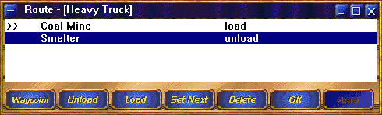
Above is a truck on a route to load coal at a coal mine and unload it at a smelter. The >> before the coal mine means the truck is presently on it’s way to the coal mine.
To add to the route, press either the Waypoint, Load, or Unload button and then click on the main map window where you want that route stop to be.
When a vehicle arrives at a building it is to load at, it will load any materials needed by the next building in the list that requires any materials. (If the route is coal mine, iron, smelter then the coal mine will load for the smelter because the iron mine does not use materials, it just produces materials. However, if your route is coal mine, iron mine, camp, smelter then it will load steel at the smelter for the camp but it will not load coal or iron.)
A waypoint is merely a place to travel to – nothing is done there. Waypoints are very useful if the fastest path between two buildings goes through an enemy camp. With waypoints you can go around the enemy.
Set Next will set the selected route item as the one the vehicle should be going to now.
Delete will delete the selected route item.
OK will start the truck on it’s route and close the window.
Auto will eliminate the route and return the truck to the auto-router. If a truck has any materials on it, it will first go to your nearest warehouse or spaceship and unload all of it’s materials first.
Remember, routes rarely pay off. A coal mine, iron mine, smelter route sounds like a great idea. But it will burn through gas like crazy.

Roads and Bridges
Roads are the lifeblood of an efficient economy. Not only will your trucks move materials quicker, but your troops can respond to an attack quicker. You should build roads to every building that trucks regularly visit. This includes your spaceship which is your initial warehouse.
Many times it can even pay to build roads from the rocket out to your construction site before building the actual site. This way the trucks delivering construction materials arrive quicker.
Another trick is to start the building so the auto-router gets a truck busy. Then pull the crane out of the building (drag select around the construction site - it will select the crane because that is the only vehicle in the selection rectangle) and have it start building the road from the new site toward your road network.
When the truck gets close, grab the crane again and send it back to the construction site. In this case the truck may ignore the road because it determined it’s path before the road was built. Select the truck and send it to the nearest part of the road. Once it arrives there it will re-determine it’s route to it’s destination and drive in on the road.
Remember, building roads requires gas. If you have no gas you cannot build roads. If you have a good road network you are in ok shape defensively with no gas because on the roads speed is still decent. But with no roads and no gas you are dead.
Traffic generally works better if buildings are set back at least one hex from the road so that the single road that comes with the building is essentially a driveway into that one building. Otherwise vehicles exiting the building can get stuck with all the traffic passing by.
You cannot build bridges until you research them. Once you have researched bridges, you can build bridges that span up to 5 hexes of water. To build a bridge you build a road but include the stretch over the water. When it gets to the water the crane will build a bridge.
If there are islands that are a single hex in size the bridge cannot stop there but it will count that as land allowing bridges longer than 5 hexes total.
Note: if you pull a crane away from building a bridge, you need to send it back to one of the end pieces of the bridge to finish the job. If you send it to any other piece of the bridge it can’t get there and will get stuck.

Exiting Buildings
Occasionally vehicles will keep trying to exit a building and failing. This happens for two reasons. First, a bug in the program. Pathing is easily the most complex part of the code and it cannot handle every possible combination of events (at least not on a Pentium). Second, the traffic is so heavy that there is no chance to exit.
When you press SHIFT-RMB on a factory and see numerous vehicles in the factory, then that factory’s exit got blocked. You need to select all vehicles in and near the factory by dragging with CTRL-LMB to select all of them. Then click somewhere clear outside the factory to send all vehicles there.

Building Spacing
You can pretty much place buildings adjacent to each other with no repercussions. However, there are two important criteria to keep in mind. First, do not have a long span on 6 or 7 buildings all adjacent because you will then find you need a road between then instead of around them.
Second, for buildings that are destination buildings, make sure they are either adjacent, or at least 2 hexes away from neighboring buildings. A destination building is a building trucks take materials to. A mine is not a destination building because a truck will never complete a trip there, only start.
When a truck completes a trip, if there is nothing for it to do, it will be parked nearby, off the road. If you have a 1 hex space between buildings, the truck can park in that 1 hex space and block passage between the buildings.

Freighters
Freighters are sort of like trucks that go on water but there is more to it. First, if using the truck auto-router, the materials need to stay on the truck so a truck will drive to a seaport, truck and materials will load onto a freighter, the freighter will go the destination seaport, and the truck will unload and deliver it’s materials. So on automatic a freighter carries trucks, not materials. (This restriction is due to how the router was architected, not to any grand game design goal.)
Second, when a freighter arrives at a seaport all vehicles other than auto-routed trucks on the freighter will automatically unload and exit the seaport and all materials you control carried directly on the freighter will be unloaded into the seaport.
Then all vehicles waiting in the seaport will automatically be loaded onto the freighter and all materials sitting in the seaport will be loaded onto the freighter.
So you can route trucks to load and unload at seaports and set a freighter to travel between the seaports and in this manner move materials automatically across the water.
You can also send a group of vehicles to a seaport and then easily move them to another seaport.

Landing Craft
A freighter can only load and unload at a seaport. This is not a good model for an amphibious invasion. The landing craft can move up on coastline hexes and load and unload both infantry and vehicles.
The landing craft operates much like the infantry carrier except it can carry vehicles as well as troops. Move the landing craft to a coastline then select the units you want to load and then LMB on the landing craft and they will go load.
For amphibious attacks don’t forget that the light tank and medium artillery are hovercraft and therefore can also travel on water. The landing craft is valuable for carrying heavy tanks and artillery to add extra punch to an attack.

Building on an Island
This is easily the most complicated operation in the entire game. If you want to build on an island, or across an ocean, you need a seaport there in order to have the auto-router deliver materials.
You need to have available a truck, crane, landing craft, and freighter. The freighter needs to be left to the auto-router (this is automatic when the freighter is first built).
Select a truck and load it up with steel and lumber. Load the truck and a crane on a landing craft.
Send the landing craft to the island and unload the vehicles.
Select the crane and have it start building a shipyard. You will get a message that a truck cannot deliver it’s materials – this is ok.
Select the truck and send it to the shipyard. When it arrives unload the truck and the select the truck and send it outside the shipyard.
When the shipyard completes, double click on the truck and then press the auto-router button giving the truck back to the auto-router.
Select the crane and start a second building. You should see the auto-router send a truck to a shipyard and the freighter then bring it to your new shipyard for off-loading.
Strongly consider building a warehouse at the new location so you can stockpile necessary materials because it can take a long time for materials to arrive from your original location.

A SUCCESSFUL ECONOMY
The key to winning Enemy Nations is to have a strong well balanced economy. The key to hurting your opponent is to hit them in the weak points of their economy.
The most important attribute of a strong economy is a good road network. Do not put too many buildings off of a single road. And try to have direct routes between source and destination buildings.
The second most important attribute is to have buildings that supply each other close to each other. Placing in order a coal mine, iron mine, smelter, and factory gives you short quick, routes that do not get in each other’s way.
Third is enough trucks. An extra truck can be more valuable than an extra mine or factory (and a lot cheaper). You should have enough trucks that you regularly see 1 truck with nothing to do and occasionally see 2 trucks with nothing to do.
It’s fine if your power supply is a little below 100%. It’s also ok if your population occasionally drops a little below what you need. But try to never run out of gas. If you are out of gas then everything slows down because deliveries take so much longer. And if you need to build more oil wells, it will take longer to get the crane and truck to the site.
That said, don’t let your power and population drop much below 100%. Every little bit helps when competing against another. And try never to let your food supply get too low because that creates a deadly downward spiral.
Watch the balance of your economy. It is common to have lots of coal but not enough iron. However, it does you no good to have lots of iron feeding the smelter which is producing lots of steel and it’s so much the factories can’t use it all.
Finally, don’t forget research. The best economy in the world does you no good if you can only produce infantry and your opponents show up with Boss 8800’s.
So how do you hurt your opponent? The best way is if you are ahead on research when you get a new tank, build some and attack with them. It’s not an overwhelming advantage but it is a strong advantage.
Take out their refinery, oil wells, or power plants. If you can keep pounding on new construction of the same building you took out you can really slow down the production in their economy.
An effective long-term approach is to take out their research facilities. This gives you no short-term advantage and you will lose tanks in the fight. But long term (if you last that long) you may be able to attack with weapons generations ahead of your opponent.
Another effective approach is to take out their cranes and trucks. The trucks are usually the key vehicle because by the time you can do this a player can generally do fine with one crane (unless you destroyed some of their buildings). But the loss of even 2 trucks can significantly slow down an economy.
When you do go for the kill, take out the rocket sooner rather than later. It’s a nasty building to destroy but the rocket provides so many special features, especially for someone getting pounded on, that taking it out is a major hit.
Finally, keep in mind that in Enemy Nations™ you and your opponents control large economies, not small encampments. A small encampment can be securely guarded. A large economy cannot. (This is why, by design, there are no walls in the game.)

THE COMBAT MODEL
The most important thing to keep in mind is that every shot in Enemy Nations™ is modified by several random numbers affecting the accuracy, damage level, etc. Therefore roughly equal forces can have substantially different outcomes. In play-balance testing a force of 10 Destructors against 10 Destructors would at times leave 5 alive on one side in various states of damage and the other side annihilated.
The second most important thing to keep in mind is that combined arms are much more effective than sending a single type of weapon. It generally pays to send at least tanks and artillery and sometimes infantry can be valuable too.
Non-turreted vehicles have to be pointed at their target to shoot at it. This means that, aside from the tanks, vehicles cannot hit targets to their side as they move toward their true target. Some vehicles have a wider field of fire than others but aside from tanks figure your other vehicles don’t get to shoot unless there is an opportunity target directly in front of them or they have arrived at their final target.
Artillery units have a setup time. They need to stop, setup, and then fire. This means they cannot shoot until they have arrived at their final destination. Add to this that the defensive armament of artillery is pretty poor and it almost never pays to send artillery in through defensive fire.
However, artillery are the strongest offensive firepower. So they are the best weapon to have behind a line of tanks, both for offense and defense. And if you are attacking someone with a lineup like this, you need to break it, not just try to run through it.
Units that are not moving receive a defensive bonus. So if you are attacked it is best to sit still and shoot back if possible because in that manner you will inflict more damage than you receive.
Different units have different levels of accuracy. And accuracy decreases for longer distances. However, accuracy means the shot lands somewhere else; not that it doesn’t get fired. So when firing at a large target (larger buildings) or the center of a large group of units, low accuracy is not terribly critical.
Different units also have different blast radiuses. Some have a blast radius of 0 and they will only damage a single unit in each shot. Others have relatively large blast radiuses and while the damage done falls off as you move from the center of the shot, a large number of units can be hurt or even killed in a single shot.
When firing at a single vehicle, low accuracy can be very harmful. A single spotter can take out a rocket launcher occasionally because the rocket launcher keeps missing the spotter. But 6 spotters grouped together will almost always be just 1 - 2 spotters after the rocket launcher fires once.
Infantry get an attack bonus when adjacent to a unit. So have infantry close with the enemy when fighting.
Hovercraft’s accuracy suck when on water. They travel fine on water and can shoot on water. But they can’t hit anything. So don’t try to use them as ships. Cross the water and get on land; then go fight.
Terrain affects defense. Units dug in (not moving) in trees or hills are real hard to take out.
The most important item to remember from all of the above is that defenders have a strong advantage in Enemy Nations™. The rule of thumb in the real world is that attackers need at least a 3:1 advantage and that’s not a bad rule for Enemy Nations™ either.
So, how do you attack successfully? Go around defending units to attack critical buildings. Patton did not win battles by attacking the Germans head on. He won by going around them whenever possible and cutting them off.
And also like Patton, watch your gas. Because your greatest threat is often not the enemy, but lack of gas.

POPULATION
Managing your population is critical to your colony's success. If there is available farm capacity, your population will grow beyond your needs, up to the limit of your current apartment/office capacity.
If there is available food, and you are low on colonists, your population may grow to twice the apartment/office capacity (colonists will be used for driving, research, etc.).
Please note the above two paragraphs discuss two different situations. You will only grow your population beyond your needs if your farms are producing enough food to sustain a population of that size. But your population will grow up to your needs if you have any food, even if you are headed for a food shortage (and starvation) with the growth.
Your population will decrease regardless of need if you are out of food. This is more commonly known as death by starvation.
You need apartment space for every colonist. You need office space for every colonist not driving a vehicle.
But keep in mind that lack of food, farms, apartments, or offices does not stop you from building additional buildings or vehicles. What it does do is lower the productivity of your buildings.
And a low population is actually a double hit because it lowers the productivity of your powerplants and if that drops your power below your needs, then your buildings also lose productivity due to low power.
If your population does not keep up with your needs, or worse is dying off, you are in deep weeds (serious trouble). Make sure you are producing enough food and have enough apartments and offices.
HINT: If you select the Space Ship, then roll the mouse cursor over the Space Ship's status bar, you will see apartment and office totals.

PLAYER RELATIONS
Note: Sorry this has nothing to do with sex. We had to pull that to keep our K/A rating. Enemy Nations™ is however strongly recommended as a great first date.
There are 4 levels of relations you can have with other players. However, to set them specifically you need to build an Embassy. (And to build an Embassy you need to do some research.)
When the game starts your relations with all players are set to Neutral. Also, if your Embassy is destroyed, any relations you have set to Alliance or Peace are downgraded to Neutral.
When you build an Embassy you can then bring up the player relations window. The Player Relations window can be accessed from the Global Tool Bar, or by double-clicking the LMB on an Embassy.
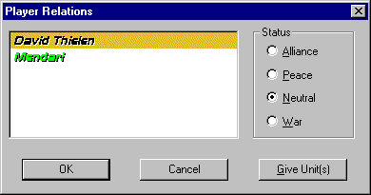
An un-selected player will be shown with their flag color. A selected player will have their name in black with the selection bar in their flag color.
Using this window, you can adjust your diplomatic relationships with the other colonies on the planet. Four relations stages are allowed, and have the following effects:
Alliance
Allied units will not return fire if fired upon by an ally.
Trucks on Auto will pick up from the nearest mines & lumber mills; yours or an ally but not from any other building.
Trucks under manual control can be told to pick up materials from any alliance building.
Colonies in alliance will share visibility for buildings and scout vehicles, but not other types of vehicles.
NOTE: When you set an alliance, or any relationship level, you give the other player these capabilities and get nothing in return. No reciprocity is required when setting an alliance.
NOTE: You cannot set alliance with a computer player, just other human players.
Alliance means you are basically fighting as a single combined entity with each of you handling primary tactical control over your own units.
Peace
Colonies in peace will not return fire if fired upon by a peaceful colony.
You do not share units, visibility, resources.
Peace means that you are not going to fight each other and you will attack the same enemy together. This basically is telling your units not to get mad when the units of the player you are at Peace with occasionally hit your units with friendly fire.
Neutral
This is the initial relations setting for all colonies. Neutral colonies will not initiate combat, but will return fire if fired upon (and automatically switch their relation to War in that case).
If you attack someone you are at neutral relations with, your relations will be changed to war.
While you need to CTRL-SHIFT-LMB to attack a unit you are at peace or alliance with, you can just LMB on a unit you have neutral relations with.
War
Colonies at war will initiate combat against one another. If your units can shoot at units that you are at war with, they will do so.
The difference between neutral and war is crucial. Because units you have a neutral relationship with can drive past your defensive units into the center of your city, and then open fire.
Therefore, before you have an embassy, you may want to shoot once at the other players when you first see them so that your relations are changed to war.
Note: Without an embassy, the only change in relations that ever occurs is Neutral to War when they first shoot at you or you first shoot at them. Once you are set to war you cannot go back to neutral until you build an embassy.
Note: The computer player takes no note of your relations with it. It does take into account how aggressive you are toward it though and in this manner your relations matter. (In other words you can’t sweet talk it into peace – it looks at your actions.)

Give Unit(s)
When the Give button (on the Local Tool Bar) is pressed, all selected units are "given" to the designated player. That player now owns and controls those units.
You can give units, both vehicles and buildings, to any other player, including players you are presently at war with. When you give units it includes any materials they presently hold.
Because the rocket is such a special building, you cannot give your rocket. That is the only building you cannot give.
When you do click on the Give button you will receive a dialog listing the number of buildings and vehicles and asking for confirmation. (Because it would be terrible to have an attack force selected, set you relations with that player to War, and then press Give by mistake…)
Note: Remember, if your last embassy is destroyed, all relations set higher than neutral are reduced back to neutral. So you can destroy other player’s alliances by taking out their embassies. And they can do the same to you.

TRAINING GROUNDS

A WALK-THROUGH
Now that you understand the basic elements of the interface, you are ready for action. By now, you should have landed your space ship, and noticed several vehicles roll out of it.
Note: In the scenarios available, buildings and vehicles are limited not only by research but also by the scenario. Until the scenario where you are required to build something, it generally is not allowed. This restriction obviously does not hold for regular games.

Landing
Look for a location in your landing grid that is near trees, coal, & iron. You also want oil to be relatively close. It’s not critical to have a lot of any given resource, just enough for 1 good mine.
Try to avoid putting the rocket ship in trees. Enemy units can attack through trees and you won’t see them until they are next to you. Try to stay at least 3 - 5 hexes away from forests.
When you’ve found your spot, LMB the mouse. Remember you can press CTRL-RMB before you press LMB to rotate the ship. You want the door pointing toward your initial buildings.

Construction of a Building
Select your Crane, and then click the Build button in the Local Tool Bar (or, you can double-LMB-click on the Crane). The Build Window will appear.
The Build Window
In the Build Window, you must first select a building category by clicking the LMB on an icon from the left column. At this stage, most of the categories are empty, since you are just getting started with your new colony. Select NATURAL RESOURCES.
Once the category is selected, its icon will highlight, and a second column of icons will appear. This column depicts all of the buildings in that category which are available to you. Again, at this stage, very few buildings will be available to you. Select LUMBER MILL.
The building icon will highlight, and on the right side of the Build Window you can read about the purpose of the Lumber Mill, as well as the cost associated with creating it. (Luckily, your space ship has landed with sufficient materials to get you off the ground. You should have enough to build the Lumber Mill and a Farm.)
Finally, click on the BUILD button at the bottom of the window. You will return to the Area Map, and a white rectangle (which is relative to the size of the building you are about to create) will have replaced the mouse cursor. Move the rectangle about until you have decided on a placement location, then click the LMB.
Placing Buildings
You can place a building over most terrain (not mountains or water). You cannot place a building over an existing unit, neither yours nor your enemy’s. The placement rectangle will turn red if you attempt to place the building in an unsuitable location.
Certain buildings, such as mines, must be placed over mineral deposits in order to function properly. Again, the placement rectangle will turn red or white, depending on whether or not the appropriate mineral can be found at that location. Use the SHOW MATERIALS button on the Local Tool Bar to find out which minerals are where.
The Lumber Mill
Find a patch of trees and place the Lumber Mill. Your Crane will travel to the selected location, and a construction foundation will appear. It is up to your Trucks to route the necessary materials to the construction site. Also, your Crane will be unavailable to you until the completion of the building.
Once the Lumber Mill is complete, it will automatically generate lumber (use the pop-up box to track the progress of lumber creation; the number should be increasing).
The Farm
Follow the exact same instructions as the Lumber Mill for creation of a Farm. But the farm should generally be placed out in the plains.
ROADS
As it was in Roman times, roads are the backbone of your colony. Trucks will travel slowly over plains, even more slowly over other types of terrain. But over roads, all vehicles move much more quickly.
Select a Crane, and then click the ROADS button in the Local Tool Bar. Your cursor will change into a white square, indicating that you should place the road. You can either places roads in single segments (by clicking the LMB), or place roads in lengths (by clicking and holding the LMB, dragging the mouse across the intended road path, and then releasing the LMB).
Try to lay down a road leading from your space ship to your Lumber Mill. Trucks will now automatically follow your road when transporting lumber to the various buildings you will be creating. Notice how much more quickly vehicles travel when using a road. This increase in efficiency will be the difference between winning and losing, as you race to establish your dominance.
STORED MATERIALS
Once your mines are busy harvesting minerals from the ground, you will find that you have more materials than you need to complete construction sites. Excess materials can be stored in the space ship (route a Truck from the mine to the space ship), or in Warehouses, which you can build. Materials can also be stored in buildings which require the materials to create; for instance, new vehicles.
SUCCESS
When your Lumber Mill has harvested 1000 units of lumber, you will be told that your mission is a success. Now you are ready to go on to the next challenge, and eventually dominate the planet.
A WORD ON PROGRESS
Unlike many strategy games, Enemy Nations™ is not constrained to fixed scenarios. Each time you play Enemy Nations™, a new planet is generated randomly, using sophisticated fractal calculations. Terrain is distributed differently, minerals are distributed differently -- every time you play. And as you make progress through missions, you will realize that you start each mission exactly where you left off at the last mission, taking with you all your buildings, vehicles, research, and resources. Critical errors early in the game will come back to haunt you later. Take care how you build your colony, because you will have to sustain it throughout your entire conquest!

MULTI-PLAYER GAMES
A player can either create a multi-player game, or join one. If you create a multi-player game, you become the "host" for that game, and can control who joins the game.
This section will first walk you through playing a multi-player game, ignoring which network protocol you select. Following that is a section devoted to each protocol, including troubleshooting.

CREATING A MULTI-PLAYER GAME

Create Network Game
Choose "Create Network Game" from the Main Menu. The following window will appear:
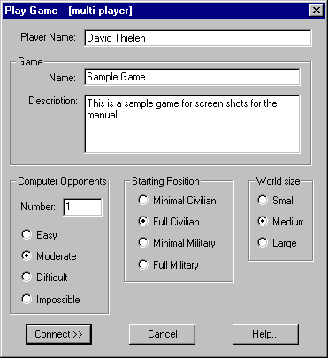
Enter your player name, then select a name for the game you wish to publish, and enter a short description for the game. Other players choosing which game to join will see this name and description so you should list how good you are and what type of game you are looking for, etc.
Once you have entered this information, you will be able to adjust settings for Computer Opponents, Starting Position, and World Size. These settings are described in the section on starting a single-player game. People joining will be able to see these settings too.

Publish a Game
Now choose CONNECT. You will see a window entitled "Publish a Game" shown below:
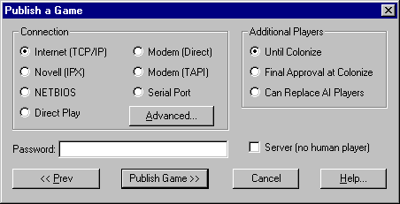
First choose the network protocol appropriate to your network (modem users will need to click ADVANCED to enter a telephone number).
If you want to have a private game with just your friends, enter a password. If a password is entered by the host, all players joining the game will have to enter the same password. Players who do not enter the same password will not see the game.
Settings under "Additional Players" have the following effects:
Until Colonize
Players will not be able to join the game once all players have selected their race. Once all players have selected their race the game will start.
Final Approval
Game will not start until the host accepts or deletes joining players from the list. This gives you a final chance to review all players after they have selected their race and then start the game.
Can Replace
Allows players to join a game in progress by taking over control of a non-human (AI) colony. When this happens the game will pause for a couple of seconds while the game is downloaded to the new player.
Note: A player cannot create a new race, only take over an existing computer player. If there are no computer players then the game cannot be joined while in progress.
Server (no human player)
Allows you to create a game on your computer that you will not be playing in. You can join this game from another computer.
This is useful if you have a large number of computer players because with no human player, there is no need to render the maps at 24 fps leaving a lot more CPU time for the computer players.
If you start a game in this mode see the section below on quitting a multi-player game for a description of the window that comes up.

Game Players
Once your settings are chosen, click PUBLISH GAME. Three windows will then be displayed:
A window entitled "Game Players" lists players who have joined your game.
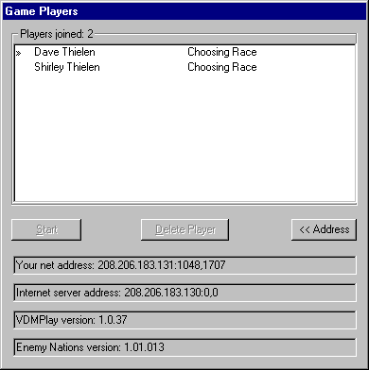
The >> in front of a name shows you. To the right is either a description if you are waiting for that player or a percentage if that player is loading the game (at 100%, the player has landed on the planet).
The Start button will start the game. You cannot press this button until you have chosen your race (see below). When you press this button the game will start. Any human players who have not chosen their race will be dropped.
If you selected the Final Approval option in the Publish a Game dialog then you must press Start after all players have selected their race.
The Delete Player button will delete the selected player. You cannot delete yourself (we felt deleting yourself was a sign of low self-esteem).
A deleted player can rejoin so if someone is annoying you by trying to rejoin, you have about 15 seconds after deleting them to start the game before they show up again.
Your Address is your network address. This is very important if you are trying to create a game over a TCP/IP or IPX network that is not able to use IServe. You need to tell people attempting to join the game this address so that they can enter it in their advanced settings.
Internet Server is the address of the IServe server your game has connected to to publish your game. If people trying to join your game are connecting to a different IServe, they will not see your game.
Note: If Enemy Nations™ cannot find IServe it will report {none} here. In this case you are probably; a) not connected to the network, b) there is a firewall at your company blocking communication, or c) you have the wrong address in your advanced settings.
VDMPlay Version is the version of the Windward Studios™ network library you are using. All of the released versions (as of this printing) are supposed to be compatible. But it is possible that mis-matched versions could be why someone cannot join your game.
Enemy Nations Version is the version of Enemy Nations™ you are running. As of this printing all released versions of Enemy Nations™ can talk to all others. However, it is quite possible that future versions will be incompatible and in that case, will not allow games between them.

Choose Race & Chat
The second window is the Choose Race window as described in the single-player game section. In this window you need to choose your race.
Once you choose your race the Choose Race dialog will disappear but the others will remain until the game starts.
To begin loading your game, choose a Name and Race, as in a Single-Player Game. When all players have reached 100%, the game will begin.
The third window is a common chat window. In this window you can chat with other players. This window remains during game play.
However, this chat window is for messages to all players only. If you want private chat and e-mail you need to research the appropriate items.

JOINING A MULTI-PLAYER GAME

Connect to the Net
Choose "Join Network Game" from the Main Menu. The following window will appear:
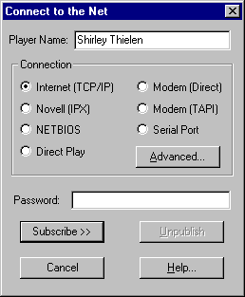
From this window, choose the network protocol appropriate to your network (modem users will need to click ADVANCED to enter a telephone number). If the host of the multi-player game entered a password when creating the game, you will need to enter the same password in order to join the game.

Join a Game
Once your settings are chosen, click PUBLISH GAME. A window entitled "Game Players" lists potential players who are connected to the network.
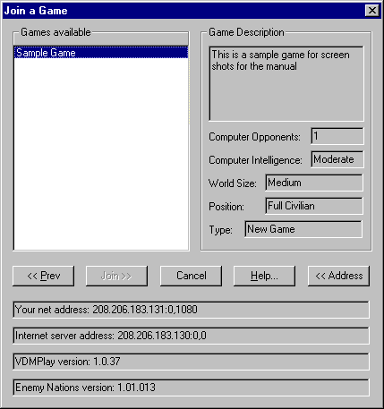
All available games will be listed in the list on the left. When you select a game in the list (note “select” here means select an item in a windows list box, not join a game) it will give a full description of the game on the right.
Note: Here we are showing the game we created for the dialogs shown in the previous section on creating a game.
The first 5 items on the right show the settings for the game that the game creator selected. The final item lists what type of game. There are three types: a) New Game which is a brand new game being created; b) Loaded Game which is a saved game being restarted. The game is not presently being played – everyone is joining it; c) Game in Progress is a game which is presently being played where you can take over one of the computer players.
Note: There is an inherent latency in networks. Therefore you can join a game that actually started or was killed 5 seconds earlier. So occasionally you will join a game only to be told it is gone.
The lines listing the net addresses and versions are identical to those described above for creating a game.

Choose Race & Chat
The second window is the Choose Race window as described in the single-player game section. In this window you need to choose your race.
Once you choose your race, the Choose Race dialog will disappear but the others will remain until the game starts.
To begin loading your game, choose a Name and Race, as in a Single-Player Game. When all players have reached 100%, the game will begin.
The third window is a common chat window. In this window you can chat with other players. This window remains during game play.
However, this chat window is for messages to all players only. If you want private chat and e-mail you need to research the appropriate items.

E-Mail and Chat
In multi-player games there is a complete e-mail and chat system in the game. (It is not there for single-player games because the computer opponents really don’t have much to say.)
Note: Chat from this window is between 2 players. The Chat all players can view is always available but for alliances and directed insults you need this Chat which is person to person.
The e-mail window looks like this:
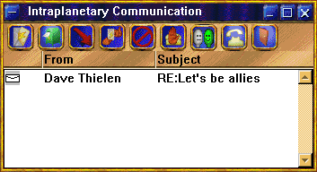
When the game begins you cannot send mail or initiate a chat session. You need to research the appropriate items in order to use these features. However, you can receive messages and chat from other players who have researched the appropriate items.
The first button is to read the selected message.
The second button is to send an e-mail message to someone.
The third button is to reply to a message.
The fourth button is to forward a message. Forwarding is a little different in Enemy Nations™ from a normal e-mail program. You cannot edit the message, only forward it. Therefore when you receive a forwarded e-mail you know it’s exactly what that person received. This allows you to show one player that another player is planning to attack them.
The fifth button deletes the selected message(s).
The sixth button refuses a message. This will return a message to a player telling them it was refused. You can only do this if you have not read the message. If you receive a message that was refused you know the player is not even reading it.
The seventh button is to initiate chat with another single player. You can keep chat windows up with all other players simultaneously if you wish.
The eighth button brings up the global chat which is for chat with all players at the same time.
The last button allows you to set options in mail.

Quitting Multi-Player Games
If a player leaves a multi-player game in progress, the computer AI will take over for that player. However, the person creating the game (the host) must stay on-line until the game is over.
The host may quit as a player (allowing the computer AI to take over), but stay connected as the server machine. If the person creating the game quits, all other windows will be closed and the following window will come up:
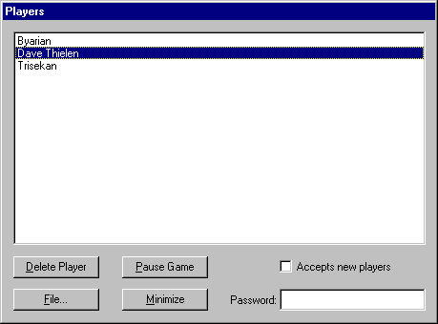
This window will also come up if you create a game with no human player. You can also access this window from the file dialog if you are the server.
Delete Player will delete the selected player. You cannot delete yourself (that self-esteem problem again) or any computer player. If you delete a player the person playing will be dropped from the game and the AI will take over that player.
Pause Game will, you guessed it, pause the game.
File will bring up the file dialog.
Minimize will minimize Enemy Nations™. This is useful if you’ve been killed but are still hosting. You can then get back to other things that are less important than playing Enemy Nations™.
You can change whether or not to accept new players and the password at any time.
If the host wishes to disconnect altogether, another player must save the game, quit, and then start again by loading the game.
Any player can save the game at any time.

IServe
IServe is short for Internet Server. IServe is a means to let players find each other over the Internet without having to know each others IP address, or even that the other is there.
Note: IServe should also work on an IPX network if run on a server. However, since most MIS managers probably won’t allow IServe to be run on a server, it has not been tested thoroughly and is not supported for IPX.
We have IServe running on our server windward.net. However, we have included IServe with the product for people who are either on a network that is not connected to the Internet or is behind a firewall.
All that you need to do is run IServe on any computer on the network. When you run it you will see the following:
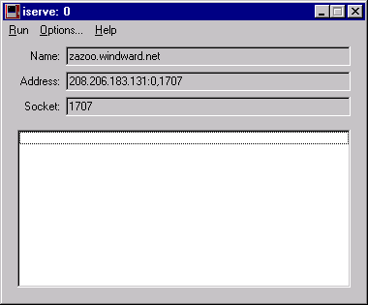
Name is the server name that players should put in their advanced settings for TCP/IP (see below). Socket is the socket setting they should use.
Note: Socket 1707 is assigned to Windward Studios™ for IServe. You should use this value because any other value may conflict with other applications.
The list box in the bottom half will list games presently available to join. The caption will list how many games presently exist.
Once a game starts IServe is no longer used. It exists merely to help people join games. Therefore the network traffic to IServe is minimal and has no affect on playing the game.
There are a few options in IServe. You usually don’t need to set any so they are only documented in the on-line help.

Network Protocols
Network protocols are still a giant pain in the ass. The software is not easy to configure or use and the interface is designed for network gurus. So don’t feel bad if you don’t understand exactly how your network works.
Troubleshooting any protocol consists of two steps. Step 1 is to determine if the connection is good. Step two is to determine why Enemy Nations™ isn’t working on a good connection. (Most of the time the problem is Step 1 but unfortunately Step 2 is also occasionally a problem.)
In this section we will go through each protocol and discuss the advanced settings and troubleshooting that protocol.

TCP/IP
The advanced settings in TCP/IP looks like this:
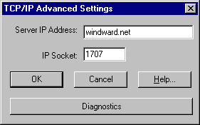
This shows the default settings for TCP/IP.
The Server IP Address is actually used for two different purposes. First, if you are connecting directly to a game that is created, you can enter the IP address of that game here and it will connect you directly to that game.
Second, Enemy Nations™ looks for IServe running on the machine at that address. If IServe is running on that machine, it will connect with IServe. If you are creating a game Enemy Nations™ will register it’s IP address with IServe so others can join your game. If you are joining a game, Enemy Nations™ will ask IServe for all IP address it has to list out available games.
Note: IServe will send newly created games to all games looking to join after the initial list of games is received. So you do not have to re-publish to see games created after you start looking.
Note: You can enter either names or IP address.
The Socket is the channel you are communicating on. All players and IServe must be on the same socket. 1707 has been assigned to Windward Studios for Enemy Nations™ so it is strongly recommended that you not change this number.

Troubleshooting
Step 1: Make sure that all of your settings above are correct. If you are connecting directly to another game or to another copy of IServe, check with the person at the other end and verify the settings.
Step 2: Make sure that you can communicate with the other machine. To do this you want to ping the other machine. Bring up a DOS box and type ping windward.net (substitute the name of the server you are connectiong to). You should see a response like this:
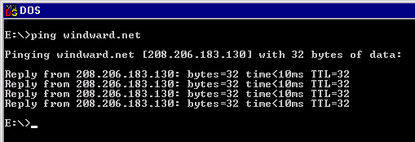
If you get any kind of error message then you cannot communicate with that machine for some reason. If this is your problem we can’t help you – you need to talk to your network support team.
In this case you should try pinging other servers to determine where the problem is. Start with a system close to you and then one at another corporation.
Note: windward.net is down about once a month, usually because we lose power for over 5 minutes.
Step 3: If you can ping the machine you want to connect to but cannot join a game, bring up the Advanced dialog and press the Diagnostics button. To run the diagnostics, both you and the person creating the game need to be running it. The diagnostics are designed to get two specific machines connected.

IPX
The advanced settings in IPX look like this:
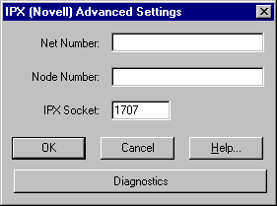
The Net Number and Node Number should normally be left blank. These will identify a specific machine and can be used to connect to someone creating a game if there is a bridge or router between you and the other machine that don’t pass on broadcast packets.
The IPX Socket is the channel that communication occurs on. This must match on all systems. Novell would not assign us our own number so we randomly picked this socket number. This number may conflict with an existing application in which case all players should change to a different number.
Note: We requested Novell to assign us a socket number and they agreed to do so. However, when they discovered that Enemy Nations™ would run on Microsoft’s IPX instead of requiring Novell’s IPX, they then decided to not assign us a socket.

Troubleshooting
Step 1: Make sure that all of your settings above are correct. Check with the person creating the game and verify the settings.
Step 2: Bring up the Advanced dialog and press the Diagnostics button. To run the diagnostics, both you and the person creating the game need to be running it. The diagnostics are designed to get two specific machines connected.

NETBIOS
The advanced settings in NETBIOS look like this:
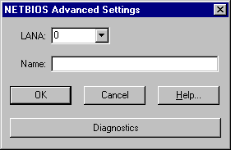
The LANA is the LAN Adapter Number. This was originally specified so you could have multiple net cards in one computer. However, today NETBIOS generally runs on top of another protocol such as TCP/IP or IPX and each separate instance of NETBIOS has a separate LANA.
This is a giant pain because all systems playing the game must be on the same NETBIOS protocol. If you are using the NETBIOS running on top of TCP/IP and the others are playing on the NETBIOS running on top of IPX then you cannot communicate with them.
There is no easy way to determine which LANA on one machine matches the LANA on a second machine. On two of the test systems used for Enemy Nations™ LANA 0 on one talked to LANA 7 on the other and LANA 7 talked to LANA 0.
The drop down combo box will only show LANA numbers that there are protocols loaded for. This is generally only 1 or 2 values. If it’s one value you’re set (assuming the other players have the same NETBIOS loaded).
Otherwise you can either select one, try to connect, if it fails, try the next. Or you can use the Diagnostics which will get two machines talking. (NETBIOS was the primary reason we wrote the diagnostics.)
The Name is a unique name Enemy Nations™ assigns to your computer. It is virtually impossible for the name Enemy Nations will pick for you to not be unique.
However, you can override this setting. If you do and the name conflicts you will get an error when you try to publish a game.

Troubleshooting
Step 1: Make sure that all of your settings above are correct. You probably have the wrong LANA number. Remember, the LANA numbers commonly have to be different to communicate.
Step 2: Bring up the Advanced dialog and press the Diagnostics button. To run the diagnostics, both you and the person creating the game need to be running it. The diagnostics are designed to get two specific machines connected.

DirectPlay
DirectPlay is not supported in this version of Enemy Nations™. DirectPlay II did not support guaranteed delivery of packets and DirectPlay III shipped shortly before we did, not leaving enough time for testing.
DirectPlay support may be available in a future update.

MODEM, TAPI, and Serial (Direct Connect)
There are a couple of items common to all of these protocols.
First, only 2 person games are supported. Even if the person creating the game has 2 MODEMS, Enemy Nations™ only supports a 2 person game.
Second, a more efficient method is to use the Win95 support for a LAN over the serial port and run IPX on top of that. This not only gives you faster communication (IPX’s packet protocol is better than ours) but it will also allow any number of players if you have enough MODEMS.
Note: In a MODEM game the joining player calls the creating player.
Third, MODEM and TAPI always require you to enter the advanced settings to set the phone number. They remember the number last used but do not keep a list of names and numbers.
Fourth, Enemy Nations™ assumes that all machines have a 16550 UART or better buffering serial port. Virtually all Pentium systems and internal MODEMS have this.
Fifth, Enemy Nations™ really needs at least 28.8 MODEMS to handle the traffic generated in heavy combat. Enemy Nations™ can handle slower modems but you will see lags when you have 50 units attack your enemy’s 70 defenders.

Troubleshooting
Step 1: Make sure that all of your settings above are correct. Are you talking to the correct port? Are the MODEM settings correct?
Step 2: There is no Diagnostics for the serial port. Instead, bring up a communication application on both ends and see if you can connect with that. Once that connection is successful, then use the same settings for Enemy Nations™.
Step 3: If you the systems actually connect in the status box that comes up but they don’t connect, exit back to the main screen, bring both systems up to the first create/join screen, click publish for the system creating the game and then for the one joining 3 seconds later.

MODEM
The advanced settings in MODEM look like this:
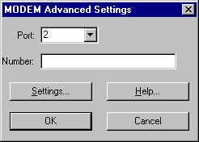
The first setting is the Port number the MODEM is connected to. The combo-box will only show ports not in use so if a communication application presently is using the MODEM, you will not be able to select the correct port.
You must enter the phone number to call in the Number box. This string is passed directly to the MODEM dial command.
To change the settings for the MODEM press Settings and you will get this dialog:
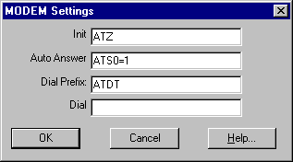
Note: A ^M (carriage return) is appended to all strings.
Init is the string sent to initialize the MODEM. It is strongly recommended that you copy the string that your main telecommunication application uses to initialize the modem and paste it into this entry.
Auto Answer is the string sent to the MODEM when the player creating a game publishes the game. It puts the MODEM into auto-answer mode.
Dial Prefix is the command pre-pended to the phone number to dial the phone.
Dial is placed after Dial Prefix but before the phone number. If you need to dial 9 to get an outside line you should place a 9, here. (The , forces a 2 second pause.)
Note: When the joining player publishes a game the modem is sent the string Dial Prefix + Dial + Number + ^M.

TAPI
The advanced settings in TAPI look like this:
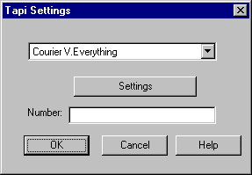
The top combo-box is a list of all TAPI devices you have installed on your system. Select the one you wish to use.
Settings are the settings for that device and are specific to the device. (The dialogs reached here belong to the device, not to Enemy Nations™.)
Number is the phone number you wish to connect to. If your TAPI device is properly installed, you do not need to include items like access codes or 9 to get an outside line.
Direct Connect
The advanced settings for Direct Connect looks like this:
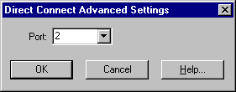
Direct Connect is a fancy way of saying a serial, null-modem, or RS-232 connection. In any case, it’s a connection between two machines using their serial port.
Port is the port number the cable is connected to. The combo-box will only show ports not in use so if a communication application presently is using the port, you will not be able to select the correct port.

OPTIONS

OPTIONS
This takes you to the general options for Enemy Nations™.
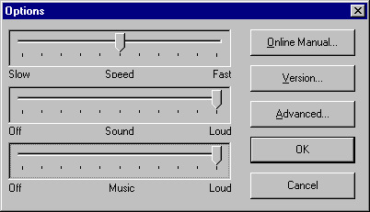
The game Speed, Sound, and Music volume can all be set in the game while it is playing, but you can also set it here.
Enemy Nations™ is designed to be run with the speed set at the middle. However, if you want a slower or faster game, the speed can be set from half to double. If you do change the speed, then the game clock will run at that set speed instead of clicking over 1 second for every real-time second.
To turn the sound off, move the slider all the way to the left. The sound volume is for all sounds except music.
Online Manual brings up the online help.
Version brings up a dialog listing the version of Enemy Nations™, Windows, and the various libraries Enemy Nations™ is using.

ADVANCED OPTIONS
Advanced brings up this dialog. It is STRONGLY recommended that you do not change anything in this dialog.
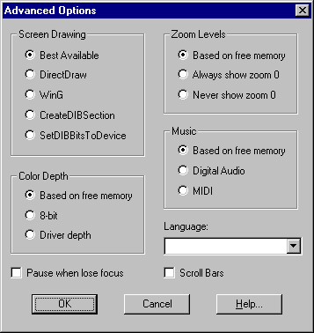
Screen Drawing determines which method Enemy Nations™ uses to BLT it’s images to the screen. They are ordered from the fastest at the top to the safest at the bottom.
Note: Under Windows 3.1 only WinG and SetDIBBitsToDevice are available. Under Win/NT 3.51 DirectDraw is not available.
Color Depth determines which set of art of use in the game. Enemy Nations™ includes 8, 15, 16, 24, & 32-bit art. The higher the bit depth, the more realistic the art will look. However, the higher bit-depth art takes longer to load and requires more memory.
Pause when lose focus, if set, will pause the game if you switch to another application. This is ignored if you join a multi-player game.
Zoom Levels determines if the art for zoom level 0 is loaded (there are 4 zoom levels, 0 - 3). This is the closest in zoom and is rarely needed for game play - but it sure looks beautiful. As with color depth, including zoom level 0 requires more memory and takes longer to load.
Music determines if it should use 16-bit, 22KHz sound effects and music or if it should use 8-bit, 11KHz sound effects and MIDI music. The first (Digital Audio) is very close to CD-Audio quality but requires a fast CD and CPU. The second (MIDI) provides decent sound and can run on slower systems.
Language determines which language to run Enemy Nations™ under. This will list all languages included on the CD. If not set, Enemy Nations™ will use the language Windows is running in, if available.
Scroll Bars will place scroll bars in the main map window(s). If you like using scroll bars set this. However, in our opinion, it detracts greatly from the look of the game.

EVEN MORE ADVANCED…
The file en_ini.wri discusses all other settings for Enemy Nations™. These settings are not available from a dialog box for a reason – you generally should not touch them.
But they are documented because they allow more control over the game and you may wish to exercise that control. If you make changes in enations.ini and then the game will not run – delete the file enations.ini and everything will revert back to it’s default.

RACES
When starting a game, single or multi-player, you must choose the race you wish to play. When the CHOOSE RACE dialogue appears, you can highlight each race's name in the left column of the dialogue, and a description of the race will appear to the right. To choose the race and begin playing, click RACE after highlighting your choice.
NOTE: The RACE button will be inactive until you have entered your name in the box at the top of the CHOOSE RACE dialogue.
Each race is unique in many ways. These descriptions will give you an idea of the major strengths and weaknesses of each race.
Human

While humans have no specific strengths, neither do they have any specific weaknesses. An all around solidly capable species.

Kintaro
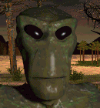
The Kintaro have an incredibly high birthrate. Out of necessity farms are very productive. Their scientists are also above average.

Trisekan
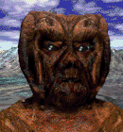
A very productive race that excels at building, manufacturing, and all other facets of a civilian economy.

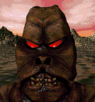
Crimtona
The Crimtona are the most aggressive fighters in the universe. However, they focused on assault to the exclusion of all other skills.

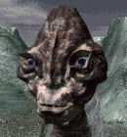
Blaukupa
Evolving on a planet with numerous predators, the Blaukupa have refined defense to an artform. They are also incredibly gifted farmers.


Diolian
The Diolian have devoted themselves to the pursuit of knowledge to the exclusion of everything else. They are also good basic industry workers.

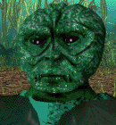
Roveldan
Confident warriors skilled at both offense and defense. They are also capable of manufacturing weapons faster than anyone else.


Mendari
Nothing is known of the Mendari.

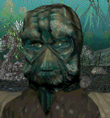
Kartugan
Skilled industrialists and researchers. However, they are not as skilled with natural resources.



Botanes
An introspective race of the most skilled warriors in the universe. Their birth rate is incredibly low.



Ekoda
A very weak race, the Ekoda excel at nothing. (This race exists to give better players a handicap.)

Byarian

A race that is very skilled in all parts of a civilian economy. Unfortunately, the Byarian are terrible warriors.

BUILDINGS
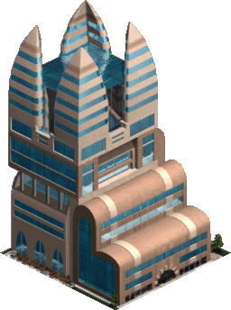
Apartments Housing for your population. Build apartments so that your population can continue to thrive. As you advance through the game, your available apartments will become more and more extravagant.

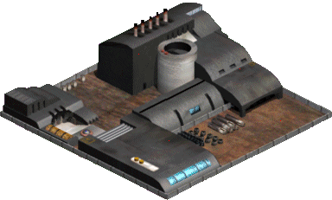
Assault Factory The Assault Factory is one step up from the Weapons Factory. With the Assault Factory, you can build new types of military vehicles, as well as generate old vehicles with more efficient production.
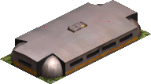
Bunker Medium-level stationary defense fortification. Use the Bunker to protect your colony from invasions.
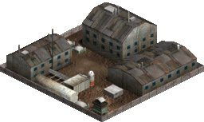
Camp Your first military installation, the Camp is used for training ground troops.
Coal Mine Build Coal Mines over the Coal deposits. They will automatically harvest Coal from the ground, which must then be routed to a Smelter, which will convert Coal and Iron into Steel. Coal is also necessary to power your Coal Power Plants, so you may want to build Coal Power Plants near Coal Mines.
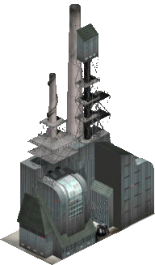

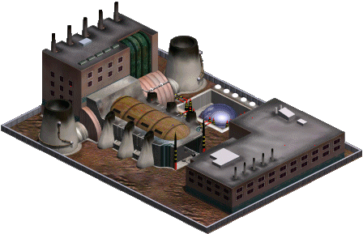
Coal Power Plant This is your basic, level-one power plant. Power Plants are necessary to power the buildings of your colony. The Coal Power Plant requires Coal to operate, so you may want to build your Coal Power Plants near Coal Mines.
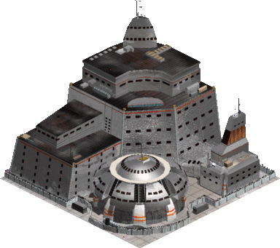
Command Center The Command Center is needed for more advanced buildings and technologies, including the upgrade from a World Map to a Radar. It is not available to you until you have achieved a sufficient level of research.

Dread Factory The most advanced military factory you can build. With the Dread Factory, you can build the most powerful types of military vehicles, as well as generate old vehicles with more efficient production.
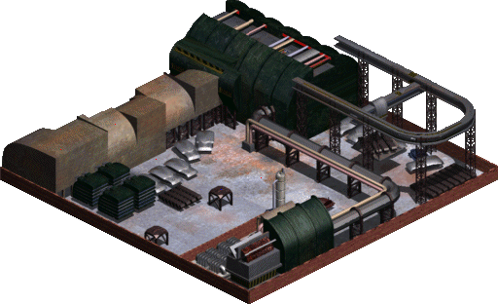
Embassy Embassies give you access to the Player Relations window, which allows you to set relations with other players, including AI players. In multi-player games, use to create alliances.
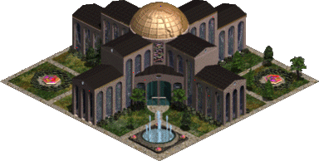
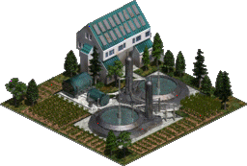
Farm Build Farms in order to feed your people. Some terrain may be more arable than others; be careful where you place your Farms.
Fort High-level stationary defense fortification. Use the Fort to protect your colony from invasions.
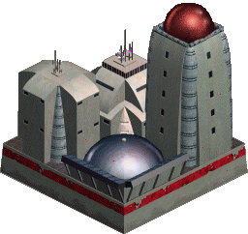

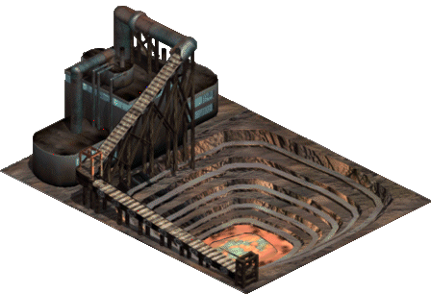
Iron Mine Build Iron Mines over the Iron deposits. They will automatically harvest Iron from the ground, which must then be routed to a Smelter, which will convert Iron and Coal into Steel.
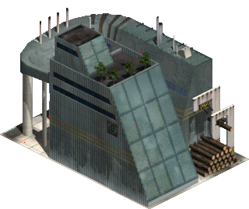
Lumber Mill Build Lumber Mills near trees, and they will automatically harvest trees and convert them to Lumber, which you can then route to various locations. Lumber is a crucial material needed for creating new buildings.

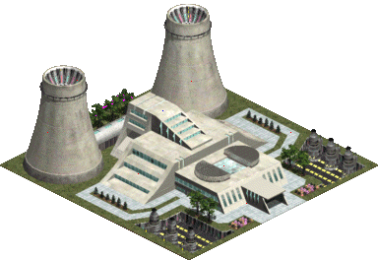
Nuclear Power Plant This is the most advanced Power Plant you can build, and the most efficient way of producing power for your colony.

Office Buildings Work space for your population. Build office buildings so that your population can continue to thrive. As you advance through the game, your available office buildings will become more and more extravagant.
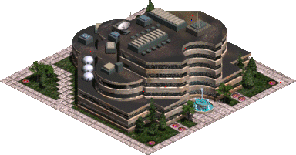
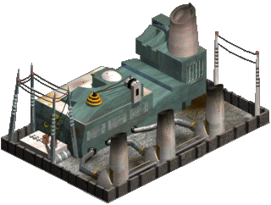
Oil Power Plant This is your level-two power plant. The Oil Power Plant requires Oil to operate, so you may want to build your Oil Power Plants near Oil Wells.
Oil Well Build Oil Wells over oil deposits. They will automatically harvest oil from the ground, which must then be routed to a Refinery, where the oil is converted to gasoline. Gasoline production is registered in one of the status bars in the Global Tool Bar.
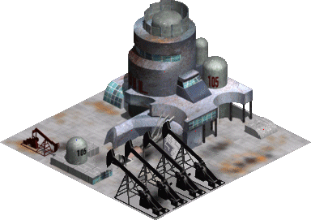
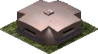
Pillbox Low-level stationary defense fortification. Use the Pillbox to protect your colony from invasions.

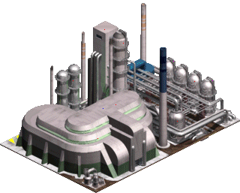
Refinery The Refinery converts crude oil into gasoline. It is a good idea to place your Refinery near an Oil Well, so that your Trucks have a short distance to travel when routing oil.
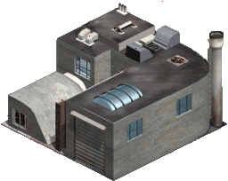
Repair Facility The Repair Facility is necessary to repair damaged vehicles.

Research Institute Once you build a Research Institute, the Research Window will become available to you. Multiple Research Institutes will allow you to research individual items more quickly, but will now allow you to research multiple items simultaneously.
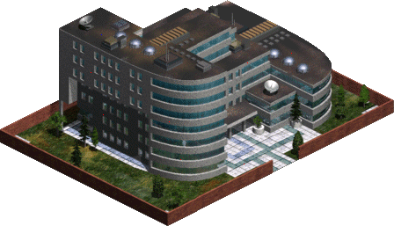
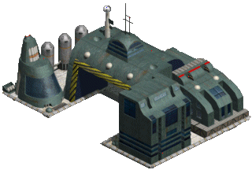

Seaport Use your Seaport to dock Cargo Ships, which are used for routing materials across bodies of water.
Shipyard Use the Shipyard to create a variety of sea vessels.

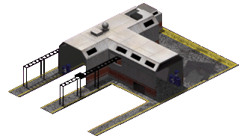
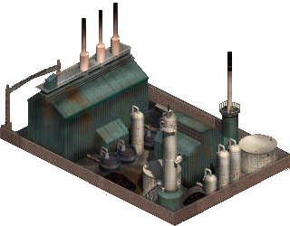
Smelter The Smelter is necessary for production of Steel. Route Coal and Iron to the Smelter, and it will automatically begin generating Steel. It is generally a good idea to place the Smelter equidistant from both your Coal Mine and your Iron Mine.
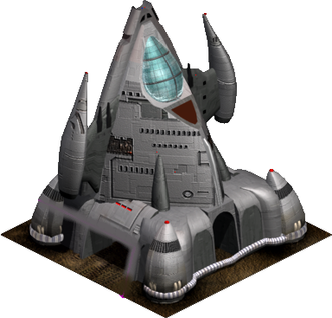
Space Ship Your first building, the space ship will be used by you primarily as a warehouse, storing all raw materials you land with, as well as any you may mine in the future. You cannot build another space ship.

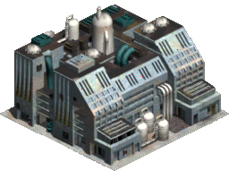
Vehicle Factory The Vehicle Factory is your first vehicle-generating installation. You can create new Cranes and Trucks from the Vehicle Factory, as well as some low-level scout vehicles.

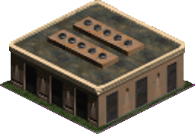
Warehouse Use Warehouses to store materials. Since materials have to be routed to various locations within your colony, strategic placement of Warehouses can aid in the efficiency of vehicle and materials production.
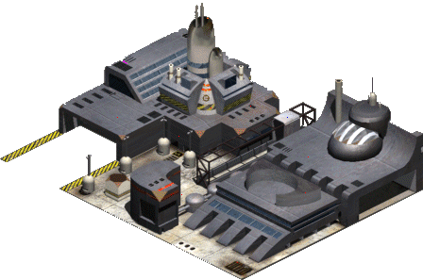

Warship Factory Use the Warship Factory to create advanced military sea vessels.

Weapons Factory The Weapons Factory is the first in a series of three military factories you can build. These installations are used to create new vehicles for doing battle with your opponents.
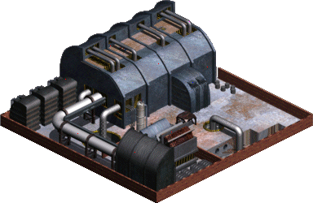
Xilitium Mine The Xilitium Mine will become available to you in the later stages of the game, after necessary research. Xilitium, when harvested from the ground, can be very useful in the construction of advanced weapons.
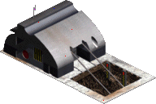

VEHICLES

Atomizer This is your heavy tank. It is actually a howitzer so it must be facing it’s target. It is extremely powerful but also very expensive and slow so you should not depend solely on these units.
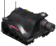
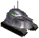
Boss 8800 This is your medium tank. Use this as the mainstay of your attack forces.

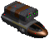
Cannon This is your medium artillery. It is a hovercraft so it can travel over water.

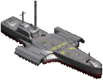
Cargo Ship Use the Cargo Ship to route materials across bodies of water. Cargo Ships can only go from Seaport to Seaport.
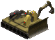
Crane Use Cranes to build new buildings, or repair damaged ones.

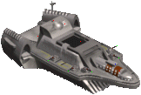
Destroyer This is the mainstay of your naval fleet. A moderately heavy gun on a moderately well armored vessel.

Destructor This is your lightest tank. It is a hovercraft so it can travel over water.
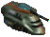
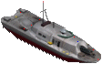
Frigate This is the most powerful weapon in the game. A single gun occupies the entire length of the vessel.

Gunboat This is your smallest boat. It has small guns mounted in it’s bow but is primarily useful as a scout vessel.
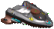
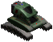
Heavy Rover This is an unarmored vehicle with a very powerful missile. However the missile takes a long time to reload.

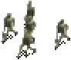
Infantry These are your main ground troops.

Infantry Carrier Use these to carry ground troops to desired locations. The Carrier can also be used as an attack vehicle.
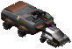
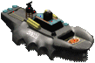
Landing Craft Use the Landing Craft to transport troops and vehicles across bodies of water.

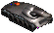
Mortar This is your lightest artillery. It is an effective weapon against infantry if guarded by tanks.
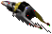
Outrider This is a light, fast, reconnaissance unit. It cannot attack.
Rocket Launcher This is your heaviest artillery unit. It is incredibly powerful but very expensive and lightly armored. It is a powerful defensive weapon and useful in heavy attack if well defended by tanks.
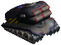
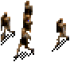
Special Forces These are your advanced ground troops.

Spotter This is a light fast reconnaissance unit that can effectively attack troops and unarmored buildings.
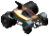

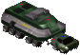
Truck Use Trucks to route materials from storage to construction sites and from mines to smelter to factories.

TERRAIN
Different terrain has different effects on the travel speed of different vehicles. Terrain also can improve the defensive posture of units. Understanding how to utilize or avoid certain terrain is an important strategy for winning.
Coastline Part land, part water. All units are very slow on coastline.
Desert Hot and dry, mostly sand. Difficult for vehicles with wheels.
Forest Tree covered hillsides. Difficult for most vehicles to pass through, but gives advantage to ground troops.
Hill Somewhat steep and rugged, difficult for most vehicles to pass.
Lake Navigable water not connected to the ocean. Passable by hovercrafts as well as boats. Hovercraft have terrible accuracy when shooting from water.
Mountain Very steep and almost impassable.
Ocean Navigable large body of water. Passable by hovercrafts as well as boats. Hovercraft have terrible accuracy when shooting from water.
Plain Flat and fertile, good for placement of farms.
Road Allows fastest travel speed for all vehicles.
River Rapidly moving water, difficult to cross. Hovercraft have terrible accuracy when shooting from water. Infantry can cross rivers.
Rough Slightly steep and rough, slows down most vehicles.
Swamp Shallow ponds and small islands of fertile dirt, slows down most vehicles.

SUPPORT
Live technical support is expensive. The general rule of thumb is that if a user calls us, we lost money on that sale. If you can’t use the game and need help, by all means call us. You bought it and you have the right to use it. However, before you call us, we ask that you try the following to resolve your problem and only call us if these fail.
First, read the manual. The answer to a large number of support questions is covered in the manual. We have endeavored to produce a manual that describes the game in detail.
Second, if you have a network problem, try to ascertain if the problem is the network or if it is Enemy Nations. If the problem is that your network is not working, we cannot help you with that.
Third, we have support available on the Internet. We have a news server where you can post questions and we will answer them. The address for this support is:

And many times you will find the answer to your question posted on the news group. If not, post a question and it will generally be answered within a few hours.
Finally, if the above doesn’t solve your problem, then please call us. Technical Support is at 612-321-9470 and is open from 9:00 - 4:00 central time Monday - Friday (excluding holidays).

CREDITS
Designed & Created by Windward Studios, Inc.
Designer David Thielen
Additional Design Eric Dybsand
Jonathan Knight
Development Lead David Thielen
Senior Developers Eric Dybsand
Geoff Goldberg
Vadim Lebedev
Matt Setzer
Art Direction David Gallagher
Kathleen Lowe
Art Design Jeff Birns
Michael J. May
Alan Tewt
Jack Walsh
Artists Jeff Birns
Tim Cuccolo
David Gallagher
Dallin Haws
Kathleen Lowe
Howard Lyon
Murphy Michaels
Walter Park
Ruth Stanke
Ryan Wood
Jack Walsh
Art Assistants Jay Lewis
Michael J. May
Mark Summers
Music Johann Langlie
Voices Bill Barwick
Deenie Hamacher
Dawn Kiristene
Lynn Mathis
Rog O. Rogers
Tanya Thielen
Sound Engineer Steve Cooper
Fonts Roger White
Producer David Thielen
Testers Noah Abelman
Mike Clissold
Nick Gray
Kevin Kim
David Mitchell Lolis
Matt Munson
Casey Opdahl
Kim Salovaara
Chase Scott
Shirley Thielen
Tanya Thielen
Winter Thielen
Donald Tucker
John Udden
Jason Vaughn
Aaron White
Internet Testers Paul Bayford
Craig Beatty
Joseph Edward Bellerose
Mike Bolotski
Darryl Hammill
Frederick Ho
Michael Paul Martina
Jeff Nibler
Andrew Pann
Joe Payne
Frank Prince
George Shamburger
Terrence Staton
Stephen J. Wire
Jordan Zielin
Finance & Operations Shirley Thielen
Legal Counsel Peter L. Edwards
* * *

Copyright © 1996 Windward Studios, Inc. All Rights Reserved. Windward Studios, Inc, Enemy Nations and all related titles, logos and characters are trademarks of Windward Studios, Inc. Microsoft, Windows, and the Windows Logo are registered trademarks of Microsoft Corporation.

Uses Miles Sound System from RAD Software. Copyright © 1994-1996 by Miles Design, Inc. All Rights Reserved.


www.windward.net



