**移位相加乘法器（Debug后）**

module mult_shift_add #(parameter WIDTH = 8) (

input [WIDTH - 1 : 0] S_data1,

input [WIDTH - 1 : 0] S_data2,

output reg [2 * WIDTH - 1 : 0] F_mult

);

reg [2 * WIDTH - 1 : 0] temp;

//wire [WIDTH - 1 : 0] S_data1, S_data2;

reg [2 * WIDTH - 1 : 0] S_data2_temp;

integer index;

reg [2 * WIDTH - 1 : 0] result;

always @(*)

begin

F_mult = 0;**//需置零，否则是XXX0**

// result = 0;

S_data2_temp = {{WIDTH{1'b0}}, S_data2}; //Expand

$monitor("S_data2_temp = %d", S_data2_temp);

for (index = 0; index < WIDTH; index = index + 1)

begin

temp = {2 * WIDTH{S_data1[index]}} & {2*WIDTH{S_data2_temp}};

F_mult = F_mult + (temp << index);**//移位运算优先级比+-*/低，要加括号**

// $monitor("index = %d", index);

$monitor("F_mult = %d", F_mult);

$monitor("temp = %d", temp);

$monitor("2 * WIDTH{S_data1[index]} %d", {2 * WIDTH{S_data1[0]}});

$monitor("1111 & 1000 = %d", 4'b1111 & 4'b1000);

end

// $monitor("S_data1 = %d", S_data1);

// $monitor("S_data2 = %d", S_data2_temp);

end

endmodule

Testbench：

module tb_mult_shift_add();

parameter WIDTH = 8;

reg clk;

reg [WIDTH - 1 : 0] S_data1,S_data2;

wire [2 * WIDTH - 1 : 0] F_mult;

initial begin

clk = 0;

S_data1 = 0;

S_data2 = 0;

#10

S_data1 = 2;

S_data2 = 6;

#10

S_data1 = 7;

S_data2 = 9;

#10

S_data1 = 17;

S_data2 = 12;

#10 $stop;

// #5 repeat (5) @(posedge clk)

// begin

// S_data1 <= ($random);

// S_data2 <= ($random);

// end

end

always #5 clk = ~clk;

mult_shift_add #(WIDTH) mult_shift_adder(S_data1, S_data2, F_mult);

endmodule

仿真：

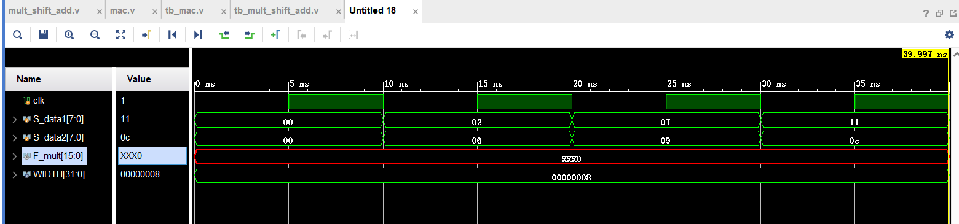

Debug后的仿真：

