Author’s final pre-print version of:

Rosenberg, J. M., Greenhalgh, S. P., Koehler, M. J., Hamilton, E., & Akcaoglu, M. (2016). An investigation of State Educational Twitter Hashtags (SETHs) as affinity spaces. *E-Learning and Digital Media, 13*(1-2), 24-44. http://dx.doi.org/10.1177/2042753016672351

An investigation of State Educational Twitter Hashtags (SETHs) as affinity spaces

Joshua M. Rosenberg1, Spencer P. Greenhalgh1, Matthew J. Koehler1, Erica R. Hamilton2, and Mete Akcaoglu3

Michigan State University1, Grand Valley State University2, Georgia Southern University3

Correspondence concerning this article should be addressed to Joshua M. Rosenberg, [jrosen@msu.edu](mailto:jrosen@msu.edu), Michigan State University, 620 Farm Lane, Room 447, East Lansing, MI 48824-1034

Abstract: Affinity spaces are digital or physical spaces in which participants interact with one another around content of shared interest. In education, some of the largest affinity spaces may be those organized around hashtags on Twitter: These spaces are public, largely unmoderated, and thriving, yet very little is known about them, especially those based in geographical areas, such as American states. This paper provides a novel and first large-scale study of Twitter-based affinity spaces through an examination of 47 State Educational Twitter Hashtags (SETHs). We collected over 580,000 tweets over the course of six months and examined them to determine who is participating in SETHs, how active participants are, and when participation occurred.. Looking across the results, we found support for considering SETHs as Twitter-based affinity spaces that merit further scholarly attention. We conclude with directions for future research on SETHs focused on participants’ individual characteristics, the structure of social networks, content of tweets, and differences between SETHs.

Teaching and learning are social endeavors and occur through interactions with self, others, and the world (Vygotsky, 1978). Indeed, it is through these interactions that humans gain experience and knowledge (Noe, 2009). Accordingly, concepts such as the *affinity space* play an important role in research on learning. Gee (2004) defines these social structures as certain kinds of spaces that are built around some kind of *content* and in which people *interact* with each other through some kind of *portal* (i.e., a means by which people enter the space). Like other conceptions of groups and contexts in education (e.g., Lave and Wenger’s [1991] *community of practice*), affinity spaces call attention to and help us understand how knowledge and learning exist not only at an individual level but also in a distributed, situated form. Gee’s (2004) description of affinity spaces also draws attention to how changes in technology are shifting the nature of these spaces and participants’ related interactions.

In this paper, we explore the possibility that the social networking site Twitter is supporting affinity spaces for teachers across the United States. Recent research suggests that teachers and other educational professionals are using Twitter as a means of interacting and connecting with their colleagues and peers (Carpenter & Krutka, 2014a). Based on a brief comparison of these Twitter practices with Gee’s (2004) definition of affinity spaces, we suggest that some of the largest educational affinity spaces in the world may be those that currently exist on Twitter. For example, State Educational Twitter Hashtags (SETHs) are Twitter conventions developed by teachers whereby they interact with each other through educational hashtags associated with individual American states (e.g., #miched for the state of Michigan).

The possibility that SETHs (and other hashtag-based groups of teachers) do indeed serve as affinity spaces has significant implications for our understanding of teacher education and professional development. At first glance, these hashtag-based spaces seem to be teacher-driven, public, largely unmoderated, and thriving; that informal, Twitter-based interactions among teachers could be providing learning opportunities valued by participants could change the way that we conceive of teachers’ continued learning or that we conduct more formal teacher education. However, phenomena like SETHs have not yet been the subject of any large-scale, systematic study. In fact, very little is known about who participates in these spaces or what even what the most basic patterns of activity in these spaces look like. Thus, this study represents a first of its kind investigation of these patterns.

This study seeks to address basic questions about SETHs as Twitter-based potential affinity spaces. To determine with confidence whether SETHs are serving as affinity spaces is no small undertaking, and an initial exploration of SETH-related data will provide a better understanding of the phenomenon and a stronger foundation for further investigation. Through the use of descriptive data about participants (i.e., Twitter users) and their patterns of activity as tracked through their uses of SETHs, we focus our analysis on 47 key SETHs that appear to serve as content- and region-specific affinity spaces. In doing so, our intention is to further understand the ways in which these spaces create opportunities for interaction and learning among and between these hashtag users.

**Background and Conceptual Framework**

In this study, we introduce SETHs and apply Gee’s (2004) theoretical construct of affinity spaces as a conceptual framework to describe the knowledge, interaction, and learning that exists within SETHs. We use this section to articulate this framework of affinity spaces, describe how Twitter generally—and SETHs specifically—may act as affinity spaces, and provide background on the digital methods that we will use to study SETHs.

**Research on Social Aspects of Learning**

Learning in formal and informal settings is often social, ranging from interacting in a collaborative group to participating in disciplinary activities. While research on social aspects of learning has become more prominent in recent research (Greeno, Collins, & Resnick, 1996; Greeno & Engestrom, 2014), the roots of this thinking can be traced as far back as Dewey’s work in the early 20th century. In the years since Dewey, the *community of practice* (Lave & Wenger, 1991) has emerged as one way of describing how these interactions take place. Individuals and organizations in a community of practice individually and collectively participate in the consumption and dissemination of information and ideas. They also engage in a joint enterprise of contributing to their community’s sustainability as well as producing and sharing a repertoire of communal resources (Wenger, 2000).

Gee (2004) introduced the concept of an *affinity space* as an alternative to the community of practice. He has acknowledged the utility of the idea of a community of practice for describing learning and the interactions that take place during learning but argues that the idea has been overused, in part because it is difficult to use precisely. Gee also notes that “modern technologies allow the creation of more and more spaces where people can enter and interact with others (and with objects and tools) at a distance” (p. 216). Thus, affinity spaces may exist in face-to-face *and* virtual settings. By way of example, Gee explains how people who enter virtual spaces such as an online chat room focused on a particular online, multi-player video game engage in a shared affinity space, where not only the space (i.e., online chat room) but also the reason for joining and participating in the chat room (i.e., interest in a particular on-line, multi-player video game) support its existence as an affinity space.

**Educational Twitter Hashtags as Affinity Spaces**

Twitter is built around 140-character *tweets*, small posts that include small amounts of content such as short phrases or sentences, images, or links (Kaplan & Haenlein, 2011). Most interaction on Twitter is focused on a feed made up of the tweets composed by people someone has chosen to follow. However, certain conventions can be used to break out of the feed for more different interactions. For example, to directly engage with someone, the at-sign (@) can be employed to mention other users, thereby alerting them to the post.

Alternatively, to engage with a focused collection of tweets, users can forego the standard feed in favor of a stream of tweets that match a particular search term. *Hashtags* are standardized search terms prefaced with a number sign (#) that are meant to facilitate reading groups of tweets on the same topic in particular have lent themselves to a variety of educational uses. For example, #edchat is a hashtag that users can follow to read about educational topics writ large (or include in their own tweets to extend their audience to other educators). Other hashtags are more specific, such as #elachat, which is focused on topics related to English / Language Arts (ELA), or #apchat, which focuses on issues related to assistant principals. Researchers have taken note of how these hashtags serve as venues for teacher professional learning and have surveyed participants in order to better understand their participation (Carpenter & Krutka, 2014b). For example, Britt and Paulus (2016) studied the hashtag #edchat. Of particular interest to these researchers was the weekly chat associated with this hashtag and those who participated in these weekly chats. The study’s results indicated that connections to and participation in the weekly #edchat based chat positively supported participants’ professional learning and development, in large part because participants could connect with others to regularly engage and discuss education-based topics as well as share resources and ideas.

While any and all of these hashtags may serve as affinity spaces, State Educational Twitter Hashtags may merit particular attention. In the United States, educational systems have historically been under local control (Spring, 2016); local, district, and state-level entities are directly engaged in decisions related to funding, curriculum development, and assessment. Teachers and other stakeholders engage with their local educational community in many ways, such as through after-school events in their own buildings, local school board meetings, and professional development opportunities at the district level and beyond. It should therefore come as no surprise that many educational hashtags are, in fact, grounded in a particular region. A survey of educational Twitter communities shows that most states are associated with at least one SETH (Junkins, 2014; Mazza, 2014). Given that Gee (2004) explicitly refers to the Internet when describing digital affinity spaces, it is not difficult to apply this conceptual framework to our research on SETHs, and an examination of these hashtags may help us understand state-specific education issues and topics as well as the nature of the ideas and resources their users share.

**Digital Methods for Twitter Research**

Digital technologies not only afford new conceptions of affinity spaces—as Gee (2004) noted—but also afford new methods for researching these affinity spaces. Whereas researchers would have once needed to measure and describe interactions in an affinity space through some indirect means, teachers engaging with affinity spaces now interact with each other in ways that persist long enough and are accessible enough for researchers to collect directly. Indeed, digital methods have been built around the collection and analysis of data coming from Twitter and similar sources (Lazer et al., 2009; Snee, Hine, Morey, Roberts, & Watson, 2016).

The use of digital methods in educational research can be traced as far back as the year 2000 (Baker & Siemens, 2014) and has grown more common over time. Specific fields such as *educational data mining* or *learning analytics* (Baker & Siemens, 2014; Penuel & Frank, 2016) utilize digital methods, but in this paper we focus on the use of online technologies to collect traces of data (Welser, Smith, Fisher, & Gleave, 2008). Studies employing digital methods are often explicitly or implicitly associated with affinity spaces. For example, video games are held to be powerful spaces for learning in part because they produce data that can be used for teaching and assessment purposes (Ifenthaler, Eseryel, & Gun, 2012; Kafai & Dede, 2014; Loh, Sheng, & Ifenthaler, 2015; Steinkuehler & Squire, 2014). Likewise, another kind of online space—the Internet forum—can be downloaded and subsequently analyzed for evidence of knowledge, thinking, and learning (Steinkuehler & Duncan, 2008).

Naturally, a range of digital methods has been used to study the use of Twitter in education. For example, Kassens-Noor (2012) compiled a Twitter *list* (i.e., a customized feed) of undergraduate and graduate students enrolled in a particular class in order to study their learning in the class. Alternatively, Gleason (2013) used a third-party application to archive tweets that used a particular hashtag and then analyzed them for evidence of informal learning. Veletsianos (2012) took yet another route by using the Twitter application programming interface (API) to collect tweets associated with scholars employed at institutions of higher education and then employed qualitative analysis to find themes emerging from their tweets.

**Purpose**

Given SETHs’ potential to serve as important affinity spaces and their absence in the extant literature, our purpose in this study is to present the first examination of SETHs as candidate Twitter-based educational affinity spaces. As mentioned earlier, state-based Twitter affinity spaces are an especially valuable site for research because their size is possibly “just right,” with topics localized to the context in which educators and those connected to education work, learn, and interact, but also large enough to foster a sustainable community. Research on SETHs is critical because with it comes the opportunity to better learn from and support a large number of teachers and those affiliated with education and others who participate in these affinity spaces. Employing digital methods, we seek to understand the characteristics of these affinity spaces evidenced in patterns of their activity over the course of a six-month data collection period. To develop these research questions, we first identified possible SETHs and determined how an examination of who was participating in these affinity spaces could lend initial insight into how these spaces function. Moreover, we sought to determine how active these SETHs were: If their activity was inconsistent (or very low), then perhaps other Twitter-based affinity spaces would be a better target for future research. Finally, we sought to determine and identify when participants were active (i.e., time and/or day), to perhaps reveal whether participation occurred on certain days or at certain times of day. Taken together, these research questions help us better understand the degree to which SETHs, individually and collectively, serve as affinity spaces. Accordingly, we answer the following questions on both an aggregate and individual level:

1. Who is participating in these affinity spaces?
2. How active are participants in these affinity spaces?
3. When are participants active in these affinity spaces?

While the first question is focuses on the members of the affinity group and their characteristics, the second two—about when participants engage with affinity spaces and how active they are—scrutinize patterns of interaction within the groups. Thus, this research seeks to provide analyses of the content of SETH-based tweets and an inquiry into what participants may be taking away from participating in these affinity spaces.

**Method**

In this section, we describe the sources of our data and the means we used to collect it, and the measures we developed for each research question.

**Data Sources**

We identified 47 SETHs using collected lists of education hashtags based in the United States (Junkins, 2014; Mazza, 2014). In cases where a state was associated with multiple SETHs, we chose to focus on the single that appeared to be the most active in terms of the number of recent tweets. We were unable to identify SETHs for Alaska and New Mexico, and while we were able to identify a SETH associated with West Virginia, we excluded it from analysis because it demonstrated very low initial activity. The SETHs and their associate state (and the abbreviation for the associated state) are presented in Table 1.

|  |  |  |
| --- | --- | --- |
| State Abbreviation | State Name | Associated SETH |
| AL | Alabama | #aledchat |
| AR | Arkansas | #arkedchat |
| AZ | Arizona | #azedchat |
| CA | California | #caedchat |
| CO | Colorado | #coedchat |
| CT | Connecticut | #ctedchat |
| HI | Hawaii | #edchathi |
| MA | Massachusetts | #edchatma |
| ME | Maine | #edchatme |
| RI | Rhode Island | #edchatri |
| DE | Delaware | #edude |
| FL | Florida | #fledchat |
| GA | Georgia | #gaed |
| IA | Iowa | #iaedchat |
| ID | Idaho | #idedchat |
| IL | Illinois | #iledchat |
| IN | Indiana | #inelearn |
| KS | Kansas | #ksed |
| KY | Kentucky | #kyedchat |
| LA | Louisiana | #laedchat |
| MD | Maryland | #mdedchat |
| MI | Michigan | #miched |
| MN | Minnesota | #mnedchat |
| MO | Missouri | #moedchat |
| MS | Mississippi | #msedchat |
| MT | Montana | #mtedchat |
| NC | North Carolina | #nced |
| ND | North Dakota | #ndedchat |
| NE | Nebraska | #nebedchat |
| NH | New Hampshire | #nhed |
| NJ | New Jersey | #njed |
| NV | Nevada | #nved |
| NY | New York | #nyedchat |
| OH | Ohio | #ohedchat |
| OK | Oklahoma | #oklaed |
| OR | Oregon | #oredu |
| PA | Pennsylvania | #paedchat |
| SC | South Carolina | #sced |
| SD | South Dakota | #sdedchat |
| TN | Tennessee | #tnedchat |
| TX | Texas | #txeduchat |
| UT | Utah | #uted |
| VA | Virginia | #vachat |
| VT | Vermont | #vted |
| WA | Washington | #wateachlead |
| WI | Wisconsin | #wischat |
| WY | Wyoming | #wyoedchat |

**Table 1.** State abbreviations, names, and associated SETHs.

We also drew basic information on the educational community (i.e., the number of teachers) for each state from the 2013-2014 State Nonfiscal Public Elementary/Secondary Education Survey Data (National Center for Education Statistics, 2014).

**Data Collection**

To collect data from these SETHs, we accessed the Twitter application programming interface (API) through a series of Twitter Archivers built with Google Apps Scripts and Google Sheets (Agarwal, 2015). Once activated, a Twitter Archiver regularly collects any instance of a tweet that matches a particular search term: in this case, a SETH. This includes *retweets*; instances when one twitter user reposts another user’s tweet. The content of the tweet is stored in a Google Sheet alongside the username of the person who tweeted (or retweeted) the post, a timestamp, and other information. We used the Twitter Archivers to continuously collect tweets for six months, from January 1st, 2015 to June 30th, 2015.

We also collected information from Twitter profiles using the programming language and statistical software R. The script we wrote collected participant profile information for a given list of Twitter usernames (in this case, usernames associated with SETHs). That information included what the participants listed in terms of their name, location, and personal description.

**Measures**

Based on these data, we created a number of measures to answer our three research questions. Each measure was created using a script in R and is summarized in Table 2.

|  |  |
| --- | --- |
| Measure | Description |
| Unique participants | Number of unique participants for each specific SETH and across all SETHs |
| Participants per teacher | Number of unique participants for each specific SETH and across all SETHs adjusted for the number of public school teachers in the associated state |
| Participant category | The role a SETH participant plays in the educational community |
| Tweet day | The number of tweets posted by the day of the week for each specific SETH and across all SETHs |
| Tweet time | The number of tweets posted by the hour for each specific SETH and across all SETHs |
| Number of tweets | The total number of tweets posted for each specific SETH and across all SETHs |
| Tweets per teacher | The number of tweets and retweets associated for each specific SETH and across all SETHs adjusted for the number of public school teachers in the associated state |
| Active weeks | The number of weeks in which each participant tweeted using a SETH at least once for each specific SETH and across all SETHs |

**Table 2.** Measures used in this study and their descriptions.

**RQ1: Who is participating in these affinity spaces?** We used three measures to answer this research question. Because each of these measures risked being influenced by spam accounts on Twitter, which sometimes interject themselves into high-traffic hashtags. Therefore, before calculating any of these measures, we preliminarily examined the potential influence of spam accounts. We calculated the number of tweets associated with participants either following or followed by more than 50,000 other participants; after finding that these tweets represented less than 1% of all tweets, we determined that spam accounts were unlikely to have an undue influence on our results and decided not to filter for possible spam accounts.

We first calculated the *unique participants* measure, which allowed us to measure the size of these affinity spaces in terms of participants rather than in terms of activity. We calculated this measure by counting the number of unique participant names associated with both SETHs generally and each specific SETH.

While *unique participants* lends insight into the raw number of participants per state, our *participants per teacher* corrects these numbers according to the size of each state’s educational community, drawing from data on the number of teachers for each state from the 2013-2014 State Nonfiscal Public Elementary/Secondary Education Survey Data (National Center for Education Statistics, 2014).

Last, we developed the *participant category* measure, which describes the role (e.g., teacher, administrator, unknown) that a SETH participant plays in the educational community. We developed this using the previously mentioned R script that collects data from participant profiles. Two raters collected 100 randomly sampled participant profiles and used the resulting data to develop a coding frame for categorizing participants along mutually exclusive roles, such as “Teacher” or “Administrator.” This resulted in 10 different codes (or possible values for this measure), which are listed in Table 3.To apply the *participant category* measure, the raters first coded 50 randomly sampled unique participant profiles to establish the reliability of the frame. The raters achieved 82% agreement and a Fleiss’s kappa of .79, indicating substantial agreement. Subsequently, a single rater randomly sampled and coded 450 new unique participant profiles.

**RQ2: How active are participants in these affinity spaces?** To understand how participants’ patterns of interaction in term of participants’ degree of activity, we developed three measures. Our first, *number of tweets*, allowed us to determine the size of these affinity spaces in terms of activity. We calculated this measure by counting the number of tweets and retweets associated with SETHs as well as by individual SETH.

Our *tweets per teacher* measure provided further insight into the activity across and within SETHs by correcting these numbers according to the size of each state’s educational community as measured by the number of teachers as a proxy for the size of the community (and broader populace) that be relevant to SETHs in the associated state and across all states. To do so, we used the latest available data about the number of teachers working in the United States from the 2013-2014 State Nonfiscal Public Elementary/Secondary Education Survey (Common Core of Data, 2014).

Finally, we developed an *active weeks* measure. Previous research (e.g., Java, Song, Finen, & Tseng, 2007; Veletsianos, 2012) has used the figure of one tweet per week to signify active Twitter participation. For this measure, we therefore used an R script to count the number of weeks in which each participant tweeted using a SETH at least once.

**RQ3: When are participants active in these affinity spaces?** To understand participants’ patterns of interaction with SETHS in terms of the times during which participants engage with SETHs, we developed measures related to the day of the week and hour of the day during which participants tweet. Our first measure related to when participants engage, *tweet day*, indicated which day of the week each tweet was posted.

The second measure, *tweet time*, allowed us to determine the time of day that each tweet was composed. We examined these measures in terms of both SETHs broadly and each SETH individually.

**Results**

In this section, we report results for the three research questions, beginning with findings related to who is participating in the Twitter-based affinity space SETHs, followed by findings related to participant’s degree of activity and when they are active.

**RQ1: Who is Participating in These Affinity Spaces?**

Our *unique participants* measure allowed us to determine the size of these affinity spaces in terms of their participants. We found 68,552 unique SETH participants over the course of these 6 months, for an average of 1,458.55 participants per SETH. Figure 1 (A) indicates the number of unique participants per state. Our *participants per teacher*, which is the number of unique participants adjusted for the number of teachers in the states associated with each SETH, helps to illustrate which states are represented to a greater or lesser degree than others relative to the size of the overall educational community, as in Figure 1 (B). While some states with many participants (such as Oklahoma) still demonstrated higher relative numbers of participants after adjusting for the number of teachers in the state relative to others, states such as Michigan and California demonstrated a more average number of participants given the size of their educational communities. Some states that did not appear to have many participants (such as Vermont) stand out after adjusting for the number of teachers in the state, suggesting higher relative numbers of participants once the size of the educational community in the state is accounted for.

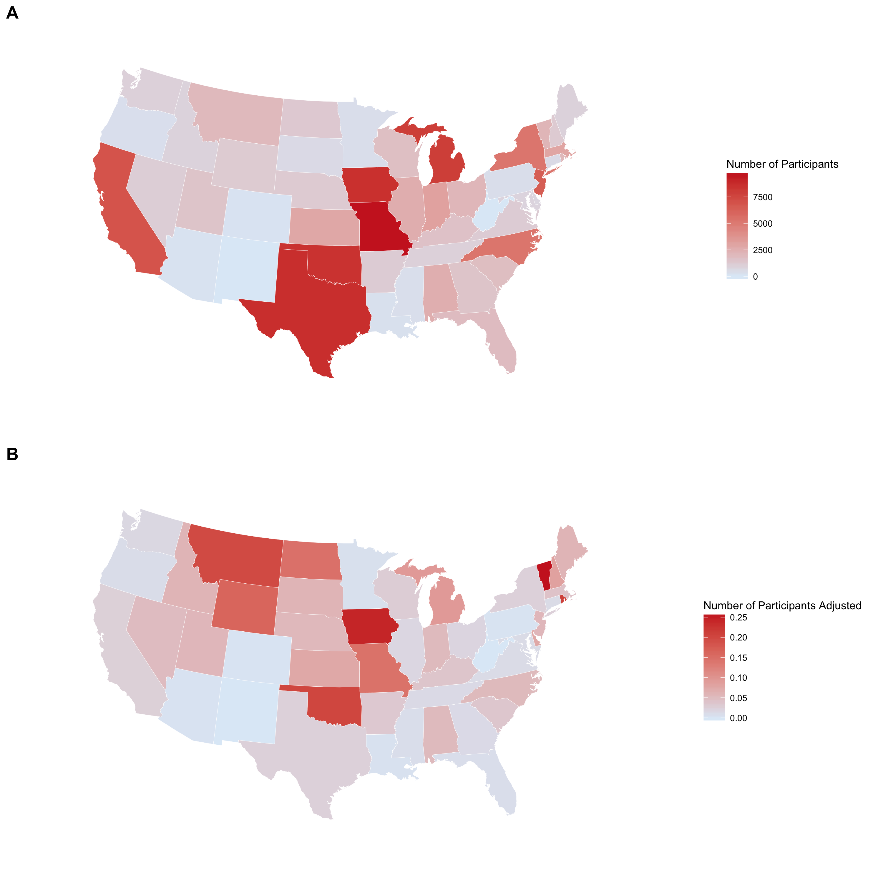

**Figure 1.** Number of participants per SETH (A) and number of participants per SETH adjusted for the number of teachers in the associated state. Data was collected from January 1st, 2015 through June 30th, 2015. No data was available for Alaska, New Mexico, or West Virginia. The number of teachers for each state was retrieved from the 2013-2014 State Nonfiscal Public Elementary/Secondary Education Survey Data (Common Core of Data, 2014).

We determined who was participating in SETH-based affinity spaces with our *participant category* measure, which allowed us to draw specific conclusions about who was sending these tweets. As illustrated in Table 3 along with the category descriptions, self-identified teachers are responsible for the most SETH-related tweets (25%), followed by other education stakeholders (19%), administrators (16%), and instructional support staff (13%). In total, practitioners (i.e., teachers, administrators, and instructional staff) are responsible for over half of SETH tweets.

|  |  |  |
| --- | --- | --- |
| Code | Description | Proportion of Participants |
| Teacher | accounts belonging to teachers | .25 |
| Administrator | accounts belonging to principals, superintendents, or other school administrators | .16 |
| Instructional Support | accounts belonging to technology coaches, curriculum developers, media specialists, etc. | .13 |
| Educational Researcher | accounts belonging to university faculty involved in educational research | .02 |
| Education-Connected | accounts belonging to persons concerned with education but whose specific role is unidentified or does not fall in one of the above categories (i.e., Teacher, Instructional Support, Educational Researcher) | .19 |
| Educational Institution | accounts associated with schools or government bodies | .04 |
| Educational Organization | accounts associated with companies or non-profit organizations affiliated with education | .08 |
| Media | accounts affiliated with media outlets, social media curators, etc. | .04 |
| Hashtag / Chat Accounts | accounts affiliated with educational Twitter communities, such as SETHs or Twitter chats | .02 |
| Not Clear | accounts that did not fall into any of the above categories or could not be coded | .08 |

**Table 3.** Codes, descriptions, and proportion of participants for different roles. These proportions are based on 500 participants’ profiles.

**RQ2: How Active are Participants in these Affinity Spaces?**

To examine how active participants are in these affinity spaces, *number of tweets*, allowed us to measure the amount of activity associated across and within SETHs. This measure yielded 583,716 total tweets associated with all SETHs (*N* = 47). This results in an average of 12,419.49 tweets per SETH. Note that because we collected the tweets from different Twitter Archivers, tweets that contained more than one SETH were counted more than once, one time for each SETH it included. As seen in Figure 2 (A), the actual number of tweets per SETH over the entire six months varies from state to state, with some SETHs, such as #oklaed (associated with Oklahoma) and #miched (associated with Michigan) having much higher activity than others. This also results in an average of 3,224.95 SETH-related tweets per day across the 47 states associated with SETHs (or 68.62 tweets per SETH per day), suggesting high levels of activities in this affinity space. Our *tweets per teacher* measure provided further insight into the activity across and within SETHs by correcting these numbers according to the size of each state’s educational community. The total number of tweets across all 47 SETHs represents about 0.19 tweets per teacher in these 47 states over the course of these six months. As with the previous measure, however, this measure varies from SETH to SETH; the nature of this variance can be seen in Figure 2 (B). Correcting these numbers through for the number of teachers in each state is instructive; whereas SETHs like #oklaed retain high levels of activity, others (e.g., #miched) are no longer as prominent, suggesting that previously-perceived levels of activity may be a function of the size of the educational community in these states. Furthermore, yet other SETHs (e.g., #vted) that were unremarkable in terms of raw activity do stand out when that activity is corrected for number of teachers; this is also true of many states in the western United States.

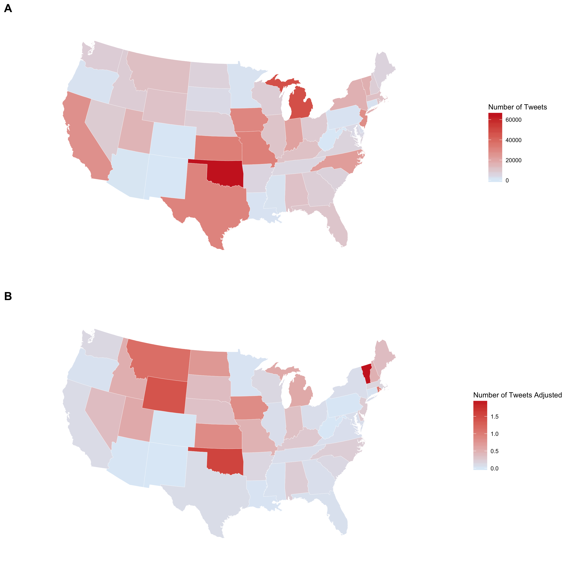

**Figure 2.** Number of tweets per SETH for six months (A) and number of tweets per SETH adjusted for the number of teachers in the associated state (B). Data was collected from January 1st, 2015 through June 30th, 2015. No data was available for Alaska, New Mexico, or West Virginia. The number of teachers for each state was retrieved from the 2013-2014 State Nonfiscal Public Elementary/Secondary Education Survey Data (Common Core of Data, 2014).

Our *active weeks* measure allows us to report the distribution of participants by number of weeks where they send at least one tweet. As previously reported, there were 68,552 unique participants across all SETHs. However, this measure revealed that a majority of participants (61.26%) tweeted only once during the 26 weeks we collected our data, as in Table 4. Furthermore, only 17.54% tweeted in four or more separate (though not necessarily consecutive) weeks. This may suggest that participants’ degree of alignment with this affinity group varies from individual to individual.

|  |  |  |  |
| --- | --- | --- | --- |
|  | Number of Participants | Percentage of Total Participants | Cumulative Percentage of Total Participants |
| 1 Week | 41,992 | 61.26% | 61.26% |
| 2 Weeks | 9,980 | 14.56% | 75.82% |
| 3 Weeks | 4,556 | 6.65% | 82.47% |
| 4 Weeks | 2,647 | 3.86% | 86.33% |
| 5 Weeks | 1,802 | 2.63% | 88.96% |
| 6 Weeks | 1,374 | 2.00% | 90.96% |
| 7 Weeks | 949 | 1.38% | 92.34% |
| 8 Weeks | 744 | 1.09% | 93.43% |
| 9 Weeks | 581 | 0.85% | 94.28% |
| 10 Weeks | 539 | 0.79% | 95.07% |
| 11 Weeks | 439 | 0.64% | 95.71% |
| 12 Weeks | 373 | 0.54% | 96.25% |
| 13 Weeks | 275 | 0.40% | 96.65% |
| 14 Weeks | 259 | 0.38% | 97.03% |
| 15 Weeks | 242 | 0.35% | 97.38% |
| 16 Weeks | 217 | 0.32% | 97.70% |
| 17 Weeks | 196 | 0.29% | 97.99% |
| 18 Weeks | 180 | 0.26% | 98.25% |
| 19 Weeks | 153 | 0.22% | 98.47% |
| 20 Weeks | 148 | 0.22% | 98.69% |
| 21 Weeks | 144 | 0.21% | 98.90% |
| 22 Weeks | 142 | 0.21% | 99.10% |
| 23 Weeks | 131 | 0.19% | 99.30% |
| 24 Weeks | 138 | 0.20% | 99.50% |
| 25 Weeks | 125 | 0.18% | 99.68% |
| 26 Weeks | 226 | 0.33% | - |

**Table 4.** Distribution of participants by number of weeks with at least one tweet. Total number of participants is 68,552. Week 26 was only 6 days long.

**RQ3: When are participants active in these affinity spaces?**

Our *tweet day* measure allowed us to determine the percentage of SETH tweets by the day of the week. Figure 6 shows these results across all 47 SETHs; the most SETHs traffic happens on Sundays and Thursdays (over 15% of tweets on each day), with the least amount of traffic on Fridays and Saturdays. This contrasts with overall patterns of use for Twitter; according to Sysomos (2014), Tuesday, Wednesday, and Friday generally see the most tweet traffic. However, select SETHs, as seen in Figure XXX, help to illustrate some of the variation in terms of the day of the week during which engagement occurs. While #gaed is most active on Thursday (with very low activity during other weekdays), #miched is most active on Wednesday (with higher activity across other weekdays), and participants for #uted demonstrate relatively consistent engagement throughout the week. These individual patterns also contrast with the Sysomos (2014) report, in that SETHs tend to peak on one day of the week whereas general Twitter use is fairly consistent throughout the week.

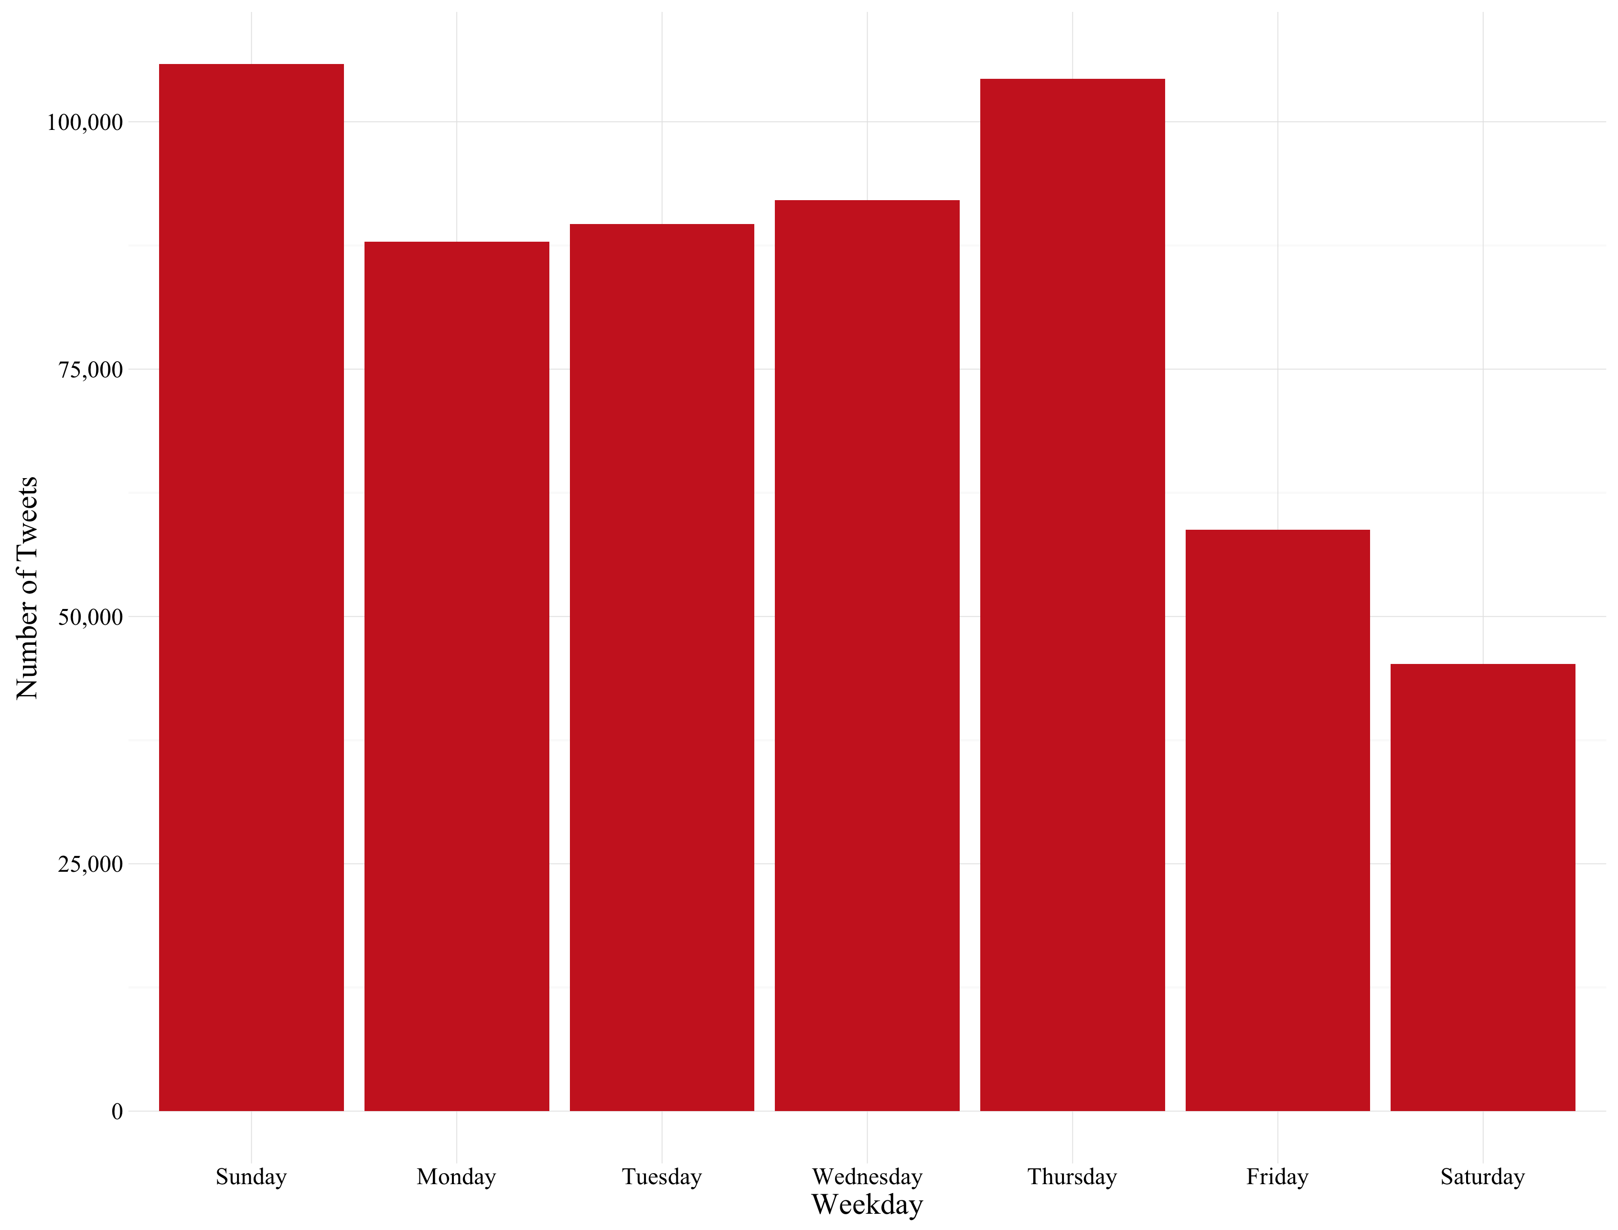

**Figure 3.** Percentage of tweets by day of week for all SETHs.

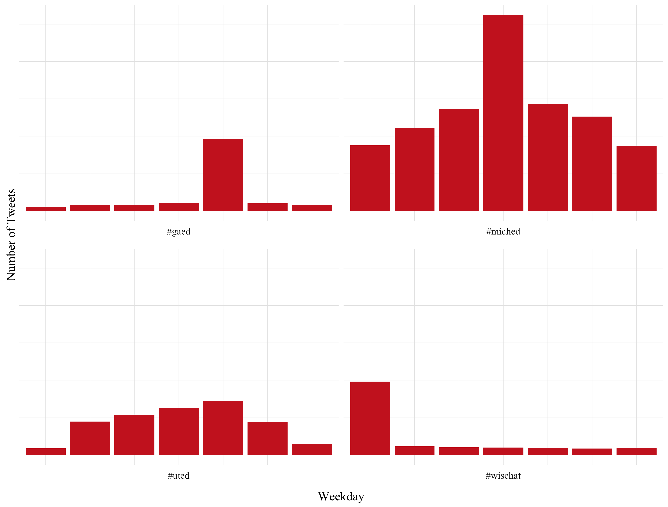

**Figure 4.** Number of tweets by day of week for select SETHs.

Likewise, our *tweet time* measure allowed us to determine the percentage of SETH tweets by the hour of the day. As can be seen in Figure 8, SETH usage picks up between 5:00 am and 8:00 am (presumably as teachers are getting ready for school), decreases between 9:00 am and 3:00 pm (presumably during the school day), and then peaks between 4:00 pm and 9:00 pm, once teachers have returned home. Figure 9 shows that this pattern is consistent across #gaed, #miched, and #wischat (but not #uted), although some states seem to only see the evening peak (and not the morning bump). As for days of the week, the hours associated with peak SETH traffic differs from those associated with peak general Twitter traffic. Sysomos (2014) reports that peak hours for Twitter are between 11am and 3pm, precisely when SETH traffic is seeing a lull.

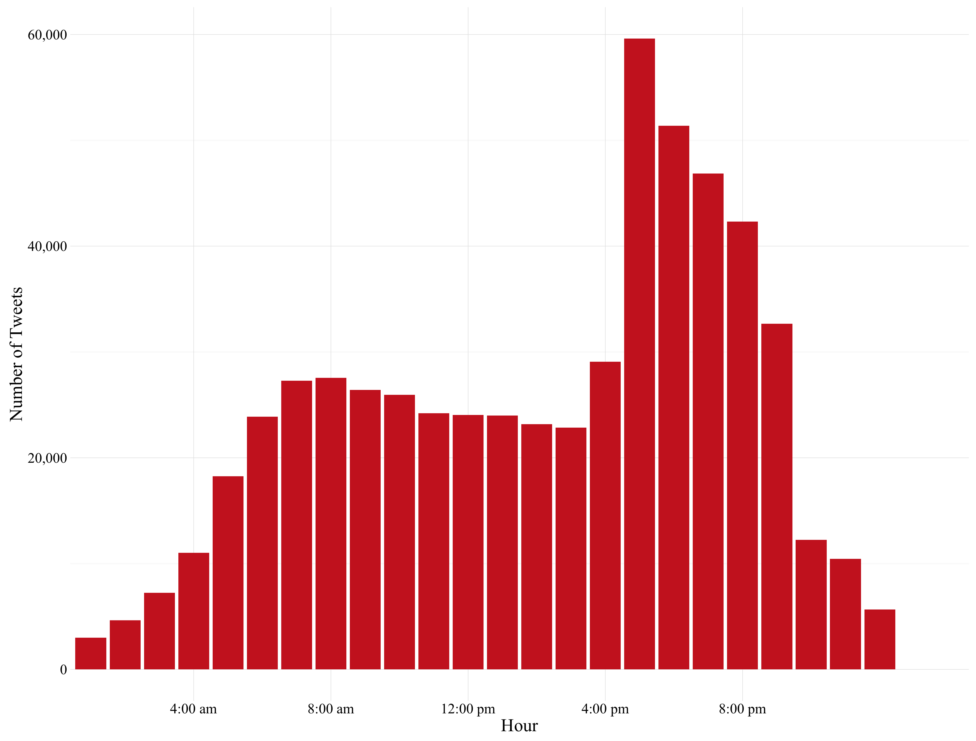

**Figure 5.** Number of tweets by hour of day for all SETHs.

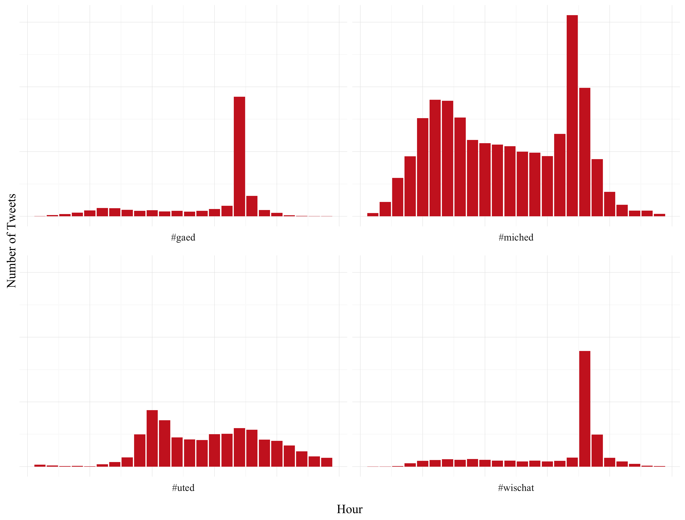

**Figure 6.** Number of tweets by day of week for select SETHs.

**Discussion**

Our findings help illustrate how SETHs may be conceived as Twitter-based affinity spaces, which are active and distinct from other educational-related affinity spaces, warranting further interest and research. In this study, we collected over 580,000 SETH-related tweets sent by over 68,000 individuals over the course of six months; although these numbers are admittedly a drop in the bucket compared to overall Twitter use, it remains noteworthy that a participant in an average SETH on an average day can expect to see nearly 70 tweets that provide information, advice, and other resources related to teaching and education. SETHs may, therefore, represent a steady stream of professional development that can be accessed from anywhere with an Internet connection.

Participation in SETHs seems to be largely self-driven and voluntary and demonstrates features of Gee’s (2004) depiction of affinity spaces. Peak SETH traffic is consistently outside of school hours and often—depending on the hashtag—on weekends, suggesting not only a new place but also a new time for teachers to engage in their professional learning. It is well known that U.S. teachers spend considerable time on evenings and weekends continuing the work that they began in the classroom, participation in a Twitter conversation is hardly part of the regular teaching routine in the same way that planning lessons and grading homework is. A number of scholars (e.g., Gee, 2004; Squire, 2008) have used the example of video games to provide compelling examples of the learning that happens in informal groups, communities, and spaces. Although SETHs are (much) more closely tied to professional obligations than activities such as video games, our findings suggest that they may be just as voluntary and potentially beneficial for participants.

The voluntary nature of SETH-based tweets is even more important when one considers the makeup of the participants sending these tweets. It is not difficult to imagine a “top-down” version of SETHs where educational institutions, researchers, or administrators compose most of the tweets in the hopes that teachers will read them. Instead, SETHs demonstrated a near absence of educational institutions and researchers and that self-identified teachers, administrators, and instructional support staff are collectively responsible for more than twice as many tweets as administrator.

Furthermore, these results also show that those who consider themselves members of the broader educational community have appropriated a general-use tool to serve as a portal for a separate and distinct affinity space. Many technologies are not explicitly intended for educational purposes and must therefore be carefully adapted to be used for teaching and learning (Mishra & Koehler, 2006), and our results suggest that educators and those interested in education-related topics and forums have adapted Twitter to fit their needs. That SETH traffic tends to peak on different days and at different times than general Twitter traffic shows that educational communities across the United States have succeeded in taking a general-purpose technology with corresponding general trends and imposing their particular purposes (and corresponding trends) onto it.

Participants in SETHs and others should be aware that there seem to be vast differences among SETHs. Although SETHs as a whole appear to function as affinity spaces for teacher collaboration, interaction, and learning, the differences among SETHs may be even more remarkable. Even when participation in these affinity spaces is corrected for the number of teachers in each state, SETHs such as #oklaed and #wyoedchat stand out for their levels of activity; on the other hand, we were entirely unable to find SETHs associated with Alaska or New Mexico, and many states with relatively large number of teachers (such as Minnesota and #mnedchat), demonstrated very low numbers of participants and activity.

Some possible explanations for the diversity that exists between SETHs are those related to when participants were active. Most SETHs see a peak number of tweets on a particular day of the week, but that day of the week changes from SETH to SETH. This may reflect different schedules for synchronous “Twitter chats” in which participants log onto Twitter at the same time in order to rapidly answer questions and exchange ideas. By this same logic, SETHs without a peak day may be those that do not hold a Twitter chat.

Participants in SETH communities also demonstrate noteworthy distinctions among them. Over 60% of participants were active in only one of the 26 weeks that we collected tweets for. Because it is possible to read a SETH’s tweets without composing any of one’s own, the possibility should be left open that some of these participants continue to participate more passively in SETHs; it is even possible that a number of users that have never posted nonetheless stay abreast of SETH-based discussions. However, it may be of interest to know what drives some participants to continue posting from week to week while others’ participation is sporadic or drops off as well as what factors seem to relate to or help support participants’ to become more active in the group.

**Recommendations for Future Research**

Building on the findings from this study, we are able to make specific recommendations for future research. We expect that tools like Twitter will continue to be a valuable tool for educators in the years to come; as more teachers participate in more hashtags, the number of questions that can be asked about this phenomenon will only grow. In the remainder of this section, we discuss limitations of digital methods and how we employed them in this study, as well as directions for future research.

We treated tweets as single acts without examining the data they contain. These data include the number of words, characters, hashtags, links, and mentions in each tweet as well as the number of times each tweet was retweeted or favorited. The significance of each of these measures and the relationship between them may not be immediately obvious, but we are confident that continued disciplined analysis could use this information to make observations of and draw conclusions about SETHs and other Twitter communities related to education.

The textual content of the tweets themselves may provide valuable insight into how those interested in and/or belonging to educational communities use Twitter. We note that an examination of why teachers and others participated is critical: This work sets the stage by establishing who participates and what their patterns of activity look like, so further research can target specific communities at specific times, knowing what to anticipate in terms of the breakdown of participants, especially due to their size and scope. Quantitative methods such as cluster analysis could be applied to collections of tweets to identify words and phrases that appear frequently, thereby lending insight into the topics and subjects frequently discussed in these communities. The techniques that make up qualitative content analysis could provide an alternative or supplementary vein of research, which may be able to pick up on subtler patterns, such as what individual tweeters are trying to accomplish or what divisions arise in Twitter communities.

There may be value in looking into organizational characteristics of these Twitter communities in order to explain differences among them in terms of participation and engagement. A brief survey of these SETHs indicates that some are highly structured (i.e., with regular organizers and announcements and external websites) while others are more loosely organized. Likewise, educational institutions such as universities and state departments of education formally or informally support some SETHs—but not all—. Determining these characteristics of SETHs can extend beyond looking at individual tweets to examining the relationships among individuals. Research from a social network analysis perspective in particular may begin to illustrate how participants begin to engage with the network and may be able to help explain how participants’ individual-level characteristics affect their transition from beginners to central members of the community.

Researchers would particularly benefit from studying the levels and nature of synchronous Twitter chats in these different communities. We have hypothesized that synchronous chats are responsible for some the different patterns of use we have seen in this paper, most notably the days that SETHs see the most activity. However, Twitter chats may also be associated with other differences between states, such as overall rates of participation or the makeup of the population of participants. A better understanding of what leads to increased participation and engagement in educational Twitter communities may be of interest to researchers and practitioners. Eventually, this understanding could lead to the development of *best practices*—or *pretty good practices* (Greenhalgh & Koehler, 2015; Mishra, 2008)—for those who are trying to create their own vibrant Twitter communities in the field of education.

References

Agarwal A (2015) How to save tweets from any Twitter hashtag. In: Digital Inspiration. Available at: http://www.labnol.org/internet/save-twitter-hashtag-tweets/6505/ (accessed 26 February 2016).

Baker R and Siemens G (2014) Educational data mining and learning analytics. In Sawyer RK (ed) *The Cambridge Handbook of the Learning Sciences* (2nd ed.) New York: Cambridge University Press, pp. 253-272.

Carpenter JP and Krutka DG (2014a) How and why educators use Twitter: A survey of the field. *Journal of Research on Technology in Education* 46(4): 414-434.

Carpenter JP and Krutka DG (2014b) Engagement through microblogging: Educator professional development via Twitter. *Professional Development in Education* 41(4): 1-22

Gee JP (2004) *Situated Language and Learning: A Critique of Traditional Schooling*. New York: Routledge.

Gleason B (2013) #Occupy Wall Street: Exploring informal learning about a social movement on Twitter. *American Behavioral Scientist* 57(7): 966-982.

Greenhalgh SP and Koehler MJ (2015) “Pretty Good Practices” for the design of teacher portfolio courses. In Niess ML & Gillow-Wiles H (eds) *Handbook of Research on Teacher Education in the Digital Age*. Hershey: IGI Global, pp. 256-280.

Greeno J, Collins A and Resnick L (1996) Cognition and learning. In Berliner D and Calfee R (eds) *Handbook of Educational Psychology*. New York: Macmillan, pp. 15-46.

Greeno JG and Engestrom Y (2014) Learning in activity. In Sawyer RK (ed) *The Cambridge Handbook of the Learning Sciences* (2nd ed.) New York: Cambridge University Press, pp. 128-150.

Ifenthaler D, Eseryel D and Gun X (eds) (2012) *Assessment in Game-Based Learning: Foundations, Innovations, and Perspectives*. New York: Springer Science Business Media.

Java A, Song X, Finin T and Tseng B (2007) Why we Twitter: Understanding micro-blogging usage and communities. In: *Joint 9th Web KDD and 1st SNA-KDD 2007 Workshop on Web Mining and Social Network Analysis*, San Jose, CA.

Junkins S (2014) Twitter chats for teachers (by state). Retrieved from https://sjunkins.wordpress.com/2014/07/28/twitter-chats-for-teachers-by-state/ (accessed 26 February 2016).

Kafai YB and Dede C (2014) Learning in virtual worlds. In Sawyer RK (ed), *The Cambridge Handbook of the Learning Sciences* (2nd ed.) New York: Cambridge University Press, pp. 522-541.

Kaplan AM and Haenlein M (2011) The early bird catches the news: Nine things you should know about micro-blogging. *Business Horizons* 54(2), 105-113.

Kassens-Noor E (2012) Twitter as a teaching practice to enhance active and informal learning in higher education: The case of sustainable tweets. *Active Learning in Higher Education* 13(1), 9-21.

Lazer D, Pentland A, Adamic L, Aral S, Barabási A-L, Brewer D, Christakis N, Contractor N, Fowler J, Gutmann M, Jebara T, King G, Macy M, Roy D and Van Alstyne M (2009) Computational social science. *Science* 323(5915), 721-723

Lave J and Wenger E (1991) *Situated Learning: Legitimate Peripheral Participation*. New York: Cambridge University Press.

Loh CS, Sheng Y and Ifenthaler D (2015) *Serious Games Analytics: Methodologies for Performance Measurement, Assessment, and Improvement*. Cham: Springer International Publishing

Mazza J (2014) Encouraging connectivity – the official state hashtag map. Available at: http://www.leadlearner.com/encouraging-connectivity-official-state-hashtag-map/ (accessed 26 February 2016)

Mishra P (2008) Best practice v.s. PGP Available at: http://punya.educ.msu.edu/2008/04/10/best-practice-vs-pgp/ (accessed 26 February 2016)

Mishra P and Koehler MJ (2006) Technological Pedagogical Content Knowledge: A framework for teacher knowledge. *Teachers College Record*, 108(6): 1017-1054.

National Center for Education Statistics (2014) *2013-2014 State Nonfiscal Public Elementary/Secondary Education Survey Data.* Available at https://nces.ed.gov/ccd/pub_snf_report.asp

Penuel WR and Frank KA (2016) Modes of inquiry in educational psychology and learning sciences research. In Corno L and Anderman EM (eds), *Handbook of Educational Psychology* (3rd ed.). New York: Routledge.

Snee H, Hine C, Morey Y, Roberts S and Watson H (2016) Digital methods as mainstream methodology: An introduction. In Snee H, Hine C, Morey Y, Roberts S and Watson H (eds) *Digital Methods for Social Science: An Interdisciplinary Guide to Research Innovation*. New York: Palgrave Macmillan, pp. 1-11.

Spring J (2016) *American Education* (17th ed.). New York: Routledge.

Squire K (2008) Open-ended video games: A model for developing learning for the interactive age. In Salen K (ed) *The Ecology of Games: Connecting Youth, Games, and Learning* Cambridge: The MIT Press, pp.167-198.

Steinkuehler C and Duncan S (2008) Scientific habits of mind in virtual worlds. *Journal of* *Science Education and Technology* 17(6): 530-543.

Steinkuehler C and Squire K (2014) Videogames and learning. In Sawyer RK (ed), *The* *Cambridge handbook of the learning sciences* (2nd ed). New York: Cambridge University Press, pp. 377-394.

Sysomos (2014) *Inside Twitter: An In-Depth Look Inside the Twitter World.* Available at http://sysomos.com/sites/default/files/Inside-Twitter-BySysomos.pdf

Veletsianos G (2012) Higher education scholars’ participation and practices on Twitter. *Journal of Computer Assisted Learning* 28(4): 336–349.

Vygotsky, LS (1978) *Mind in society: The development of higher psychological processes*. Cambridge: Harvard University Press.

Wenger, E (2000) Communities of practice and social learning systems. *Organization* 7(2): 225-246.