Data Visualization Assignment 3
Group 1
Nawal Kazmi
Bobby Bagley
Yashwanth Reddy Danda
Vamsi Krishna Vuppalapati

March 9, 2026

Critical Questions

Is there a sub-category where high discounting appears to drive sales growth but hurts profitability?
There are subcategories that exhibit a pattern in which high discounting increases sales but hurts profitability. The subcategory Tables appears to have high sales, which are driven by discounts, but the profits appear to be in the negatives. High discounting reduces the percentage of sales that become profit, which explains why Tables is the least profitable subcategory.

Which sub-category sells high quantity but does not translate that volume into strong profit performance?
The average Quantity of items sold is 2273. I will define “high quantity” as SubCategories that sell above that average. They are: Chairs, Accessories, Art, Storage, Furnishings, Paper, and Binders. Of these SubCategories, Chairs and Storage have the worst Profit Margin performance at 8.11% and 9.48% respectively. Chairs is the worst performing SubCategory that sells at a “high quantity”.

Which sub-category demonstrates a strong combination of revenue share, profitability, and stable growth?
The Phones subcategory is clearly the frontrunner in terms of being both a high-volume product line and making high returns. The Phones subcategory represents a large portion of the total business with 14.26% of the overall sales and has approximately $45,000 in profit from that sales volume. The Phones are therefore a highly profitable product line and have demonstrated continuing profitability despite being sold in large quantities. Another aspect of Phones and their success is that while other products can have fluctuating sales and often are experiencing recent sales declines, Phones are having continued and consistent monthly sales growth through 2025 and into 2026. Therefore, due to their large market share combined with a high profit margin and sales growth that is not limited to a specific time period, the Phones subcategory is by far the most continuous and successful subcategory out of all product lines sold.

Which sub-category appears most vulnerable based on recent performance trends?
Tables seems to be one product category most likely to struggle based on previous trends. Looking at the visualizations on the dashboard Tables shows negative profit while holding strong sales. Looking at discount vs profitability Tables shows very high discounts being given but is still operating at a loss. On the quantity vs profit graph Tables shows one of the few categories that have negative profitability while having strong sales.
Based on these findings, Tables seems to have deeper performance issues. Tables seems to have high levels of discounts causing lower margins. They also struggle to have any profit while other categories can have low sales volume but still stay positive. Tables may need some restructuring of prices, discounting, and expenses.

Visualizations
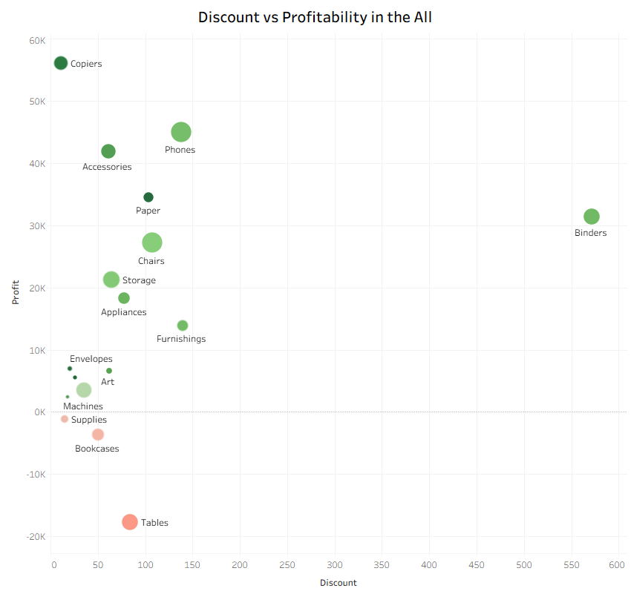
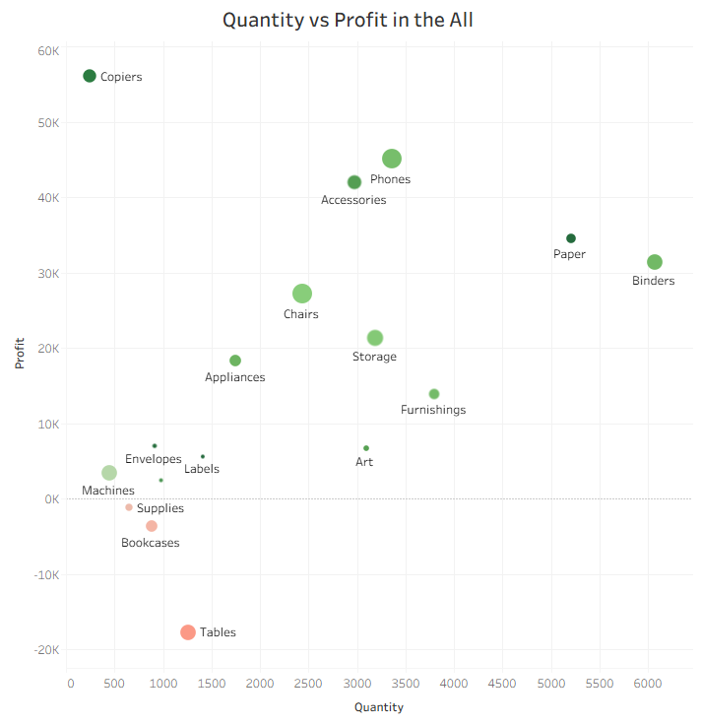
This scatter plot compares discounts given to profit made by product sub-category. It can be seen that more discount does not always mean more profit. Tables is a sub-category that has a high discount percentage but is also showing negative profits. This could mean that we are discounting too much and hurting our margins. Copiers and Phones are showing great profits with mid range discounts.
This graphic represents the relationship between sub-category profitability and quantity sold. Just because a category may have high quantity sales, does not mean that it will be very profitable. Binders and Paper show high quantity sales, but yield only average profits. Copiers and Phones have high profits, yet their quantity sales are significantly lower. This graph is demonstrating that even if you sell large quantities of product, you may not see that same success translated into your financials. Price and margins play a key role in profitability.

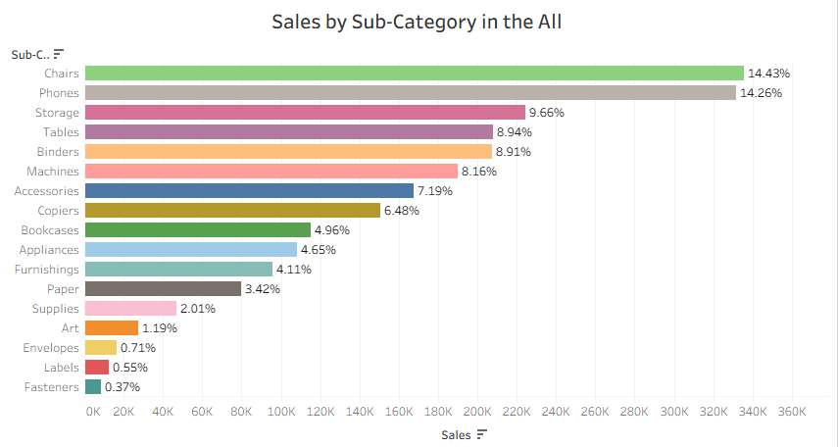
In this chart we plot the percentage of revenue that each product sub-category generates out of total sales.
As we can see Chairs and Phones make up the biggest proportion of sales at about 14% each. Other major sales generators are Storage, Tables, Binders. Small sub-categories like Fasteners, Labels, Envelopes make up much less of the revenue. This chart shows you which product sub-categories account for the majority of your business sales.

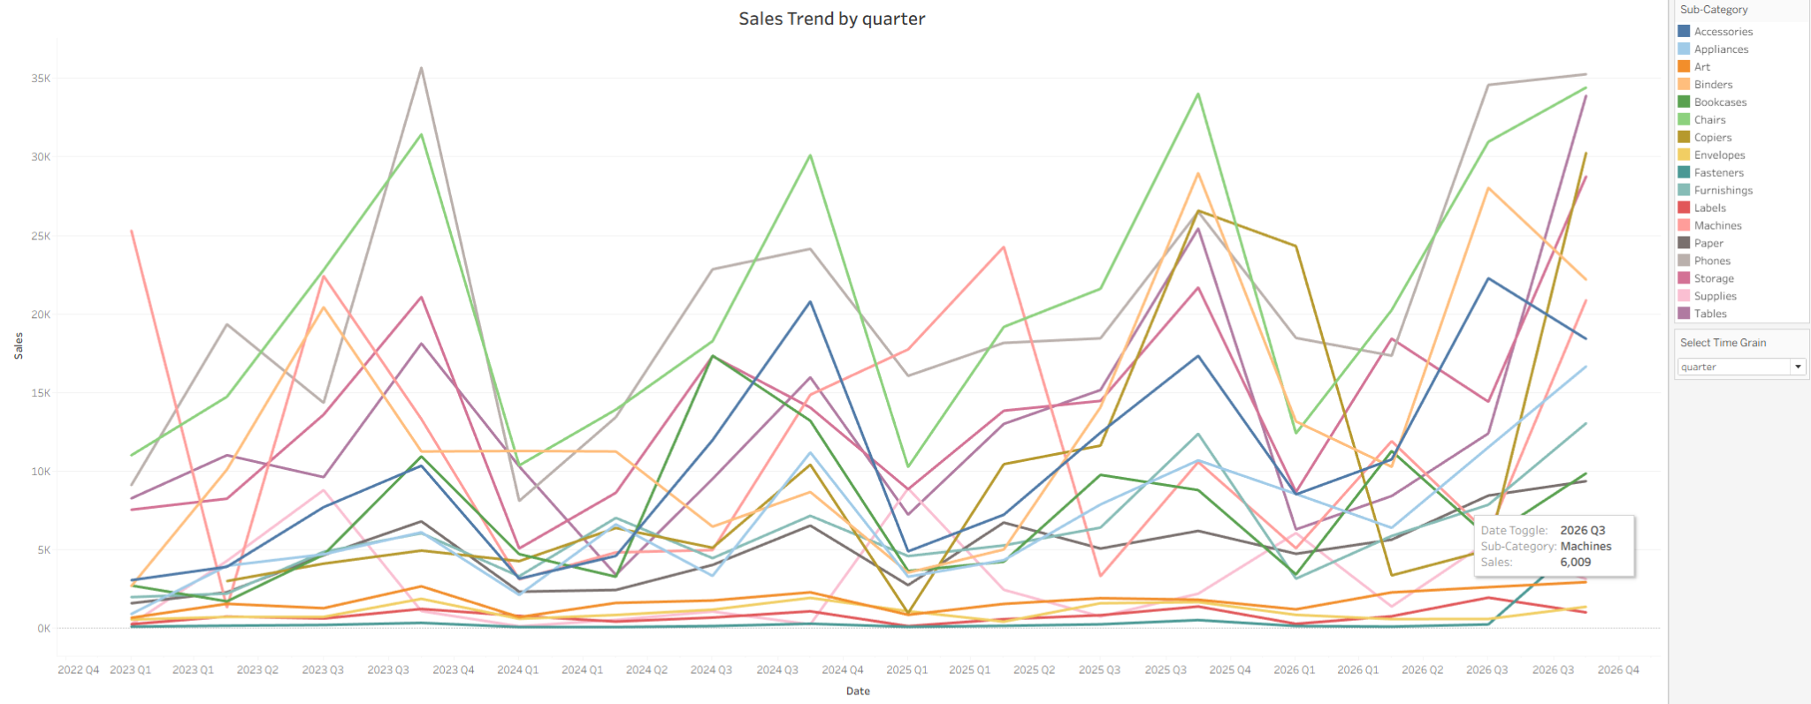
The line chart displays sales by sub-category. You can see peaks and valleys by quarter. Additionally, you can see which categories maintain consistent growth. Phones and Chairs have solid lines higher up on the chart. This means they have high sales over time. Categories with small amounts remain low.

Analytical Report

This dashboard includes several interactive features that help better understand sales performance across sub-categories. A region filter was added to the top of the dashboard to allow users to switch between Central, East, South, or West. In doing so, all KPIs and visualizations will update to show those of the selected region. This will make it easy to compare regional differences in sales, profit, and demand. Moreover, a time-grain selector was implemented on the sales trend chart, which switches between year, quarter, and month to compare sales performance across different periods.

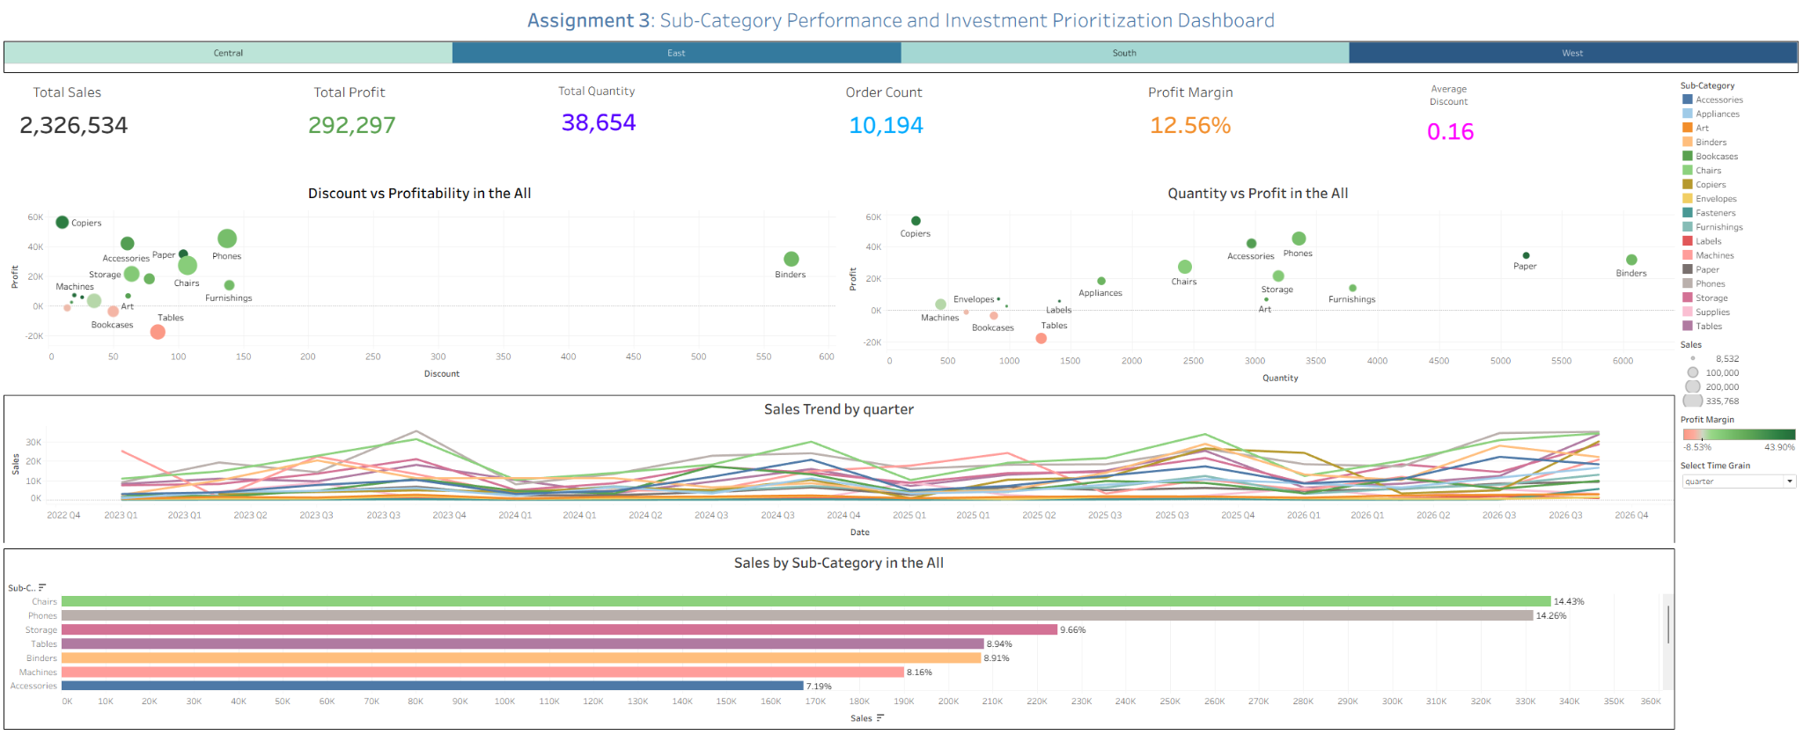
The dashboard was designed in such a way as to provide a clear illustration of sales performance across subcategories. We had displayed six important metrics at the top to summarize the overall performance. Then we added Discount vs. Profit and Quantity vs. Profit to help identify patterns between high discount/sales volumes and profitability. The Sales by Sub-Category bar chart highlights how each product contributes to the total revenue, and we also included the percentage of total sales to highlight the impact.

Key Findings
- Phones and Chairs are the largest segments in terms of revenue with each making up about 14% of sales.

- Phones are the best performing category as it has the largest share of sales with high profit margins ($45,000+) and steady sales over time.

- Higher discounts cause some categories to lose money. Tables are discounted heavily and show a loss in profits.

- High volume does not always mean high profit. Chairs and Storage have some of the highest volume but lower profits. Copiers have a lower volume but a higher profit.

- Tables could be the weakest category as they are consistently loss-making despite bringing in sales.

