Analysis of crime and its impact on real estate investments across Wales

Table of Contents
1 Executive summary 2
2 Introduction 3
3 Seasonality and Time 3
3.1 Crime Over Time 3
3.2 Seasonal Crime 5
6
4 Distribution by Police Force 6
4.1 Crimes reported by each police force 6
4.2 Crime rate 8
5 Distribution by Crime Type 10
6 Crime Map 12
7 Conclusions and Recommendations 12

1 Executive summary
This project takes a detailed look at crime patterns across Wales to understand how safety levels vary between regions and what that might mean for real estate investment. Using two years of data from the UK Police Data Portal, the analysis covered over 600,000 crime records across the four Welsh police forces: South Wales, North Wales, Gwent, and Dyfed-Powys.
The goal was to identify which areas appear most and least desirable based on crime trends — an important factor for property buyers and investors who consider safety a key part of decision-making. The analysis explored several angles, including overall crime volumes, seasonal and yearly changes, crime types, and how incidents are distributed geographically.
Findings show that crime in Wales follows clear seasonal patterns, with offences peaking in the summer months (May–August) and dropping off in winter. South Wales Police consistently recorded the highest number of crimes, reflecting its large urban centres such as Cardiff and Swansea, while Dyfed-Powys Police had the lowest crime levels, consistent with its rural landscape. Gwent Police stood out for having a rising crime rate in 2024, particularly around Newport, making it a region to watch but one that may pose higher risk for investors.
When adjusting for population size, Gwent Police had the highest crime rate overall, while Dyfed-Powys remained the safest. Across all areas, violence and sexual offences made up the largest share of reported crimes, accounting for roughly a third of all offences in Wales.
The geographic analysis using a heatmap revealed clear hotspots in Cardiff, Swansea, and Newport, while the central and western regions of Wales remained relatively low in crime. This contrast highlights the familiar trade-off between urban convenience and rural safety that property buyers often consider.
Based on the findings, two police force areas are recommended for deeper analysis:
South Wales Police – due to its high population, economic activity, and urban complexity, offering valuable insight into crime trends that directly affect real estate in city environments.
Dyfed-Powys Police – as a contrasting case, representing safer, rural areas where lower crime levels may contribute to long-term investment appeal.
Together, these regions provide a balanced foundation for further study into how crime influences property desirability and investment potential across different parts of Wales.

2 Introduction
This project digs into crime patterns across the whole of Wales. Nadine Green, our Head of Sales, has asked us to figure out which areas look most and least appealing based on crime trends—something that really matters when people are making property decisions.
We're working with public data from the UK Police Data Portal, looking at two years' worth of street-level crime records from the four police forces that cover Wales. These regions are: South Wales, North Wales, Dyfed-Powys, and Gwent. With over 600,000 crimes occurring in these areas in this period, this initial exploration will give us a solid picture of safety and risk levels across these areas.
We'll be examining everything from overall crime levels and offence types to monthly patterns, seasonal shifts, and where crime tends to cluster. We'll bring all this to life using a variety of visualisations including tables, charts and maps. What we learn will feed directly into sales strategy and help us narrow down two police force areas that deserve a closer look in the next phase of the project.

3 Data Cleaning Process
Here are the steps that were taken for the data cleaning process:
- Download raw data from source: go to https://data.police.uk/data/ and select Jan 2023 - Dec 2024. Then select the following 4 police forces: Dyfed-Powys, North and South Wales and Gwent. Download and then rearrange the data month folders into police force folders.
- Combine Datasets: Using a for loop to append csv files into empty lists for each of the 4 police forces. These lists were then combined together and merged into a dataframe using the concat method.
- Data inspection: Methods such as shape, dtypes and isna are used to investigate the properties of the newly created dataframe.
- Checking if the falls within and reported by columns are the same using a combination of the sum() function and !=.
- Remove redundant columns: the following columns were deleted using the .drop function: Context, LSOA code, Crime ID, Falls within
- Deal with missing values: using fillna for last outcome category and lsoa name and dropna for all the other missing values
- Changing data types: Changing the month column from string to integer using the to datetime function.
- Checking for formatting errors: Using the .unique method the following columns were checked: Reported by, last outcome category and Crime type
- Standardising format: Using str.title method the following columns were standardised: Location and Lsoa code.
- Exporting the data using the export function.

4 Seasonality and Time

4.1 Crime Over Time
This section explores how crime levels have changed over time across the selected regions. By examining monthly and yearly trends, we can identify patterns such as seasonal fluctuations and understand long and short-term trends in crime statistics. This information can be useful for identifying potential future trends as well as recognising market stability.
As you can see from the table on the right total crimes have slightly decreased in Wales between 2023 and 2024. This implies that Wales is becoming safer, or that police are improving at their jobs.
Year | Total Crimes
2023 | 307123
2024 | 297729
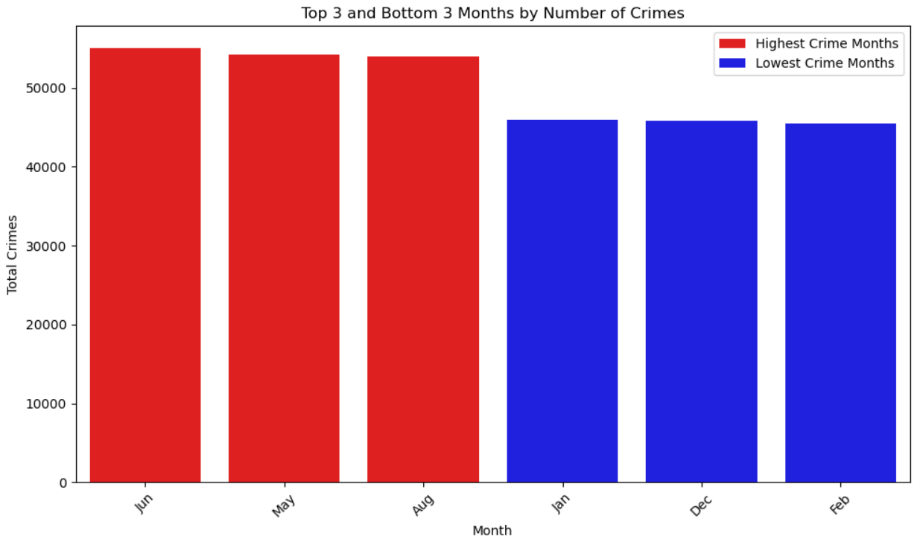
The bar chart below highlights the top 3 and bottom 3 months by the number of crimes committed. The months of May, June, and August stand out as the busiest periods for criminal activity, with each recording over 50,000 crimes. This pattern suggests that crime tends to rise during the warmer summer months. In contrast, January, February, and December show the lowest crime levels, with totals closer to 40,000 crimes. These colder, darker winter months may lead to fewer people being out and about, which could contribute to the decline in reported crimes. Overall, the data appears to suggest that there is a relationship between seasons and crimes committed.

Further evidence of seasonal trends in crime in Wales is shown in the line graph below, which plots the number of crimes. Across all forces, crime levels tend to rise during the warmer months, particularly between May and August, before declining in the colder winter months.
Some notable aspects that the graph shows are that South Wales Police consistently report the highest number of crimes, averaging between 10,000 and 12,000 incidents per month, though with a slight downward trend toward the end of 2024. North Wales Police and Gwent Police record moderate levels of crime, remaining relatively stable with minor seasonal fluctuations. Dyfed-Powys Police report the lowest crime rates throughout the period, staying below 4,000 incidents per month, with a noticeable dip in the 2024 winter months. When viewed as a whole, the temporal data indicates that crime in Wales follows predictable seasonal trends rather than erratic spikes.

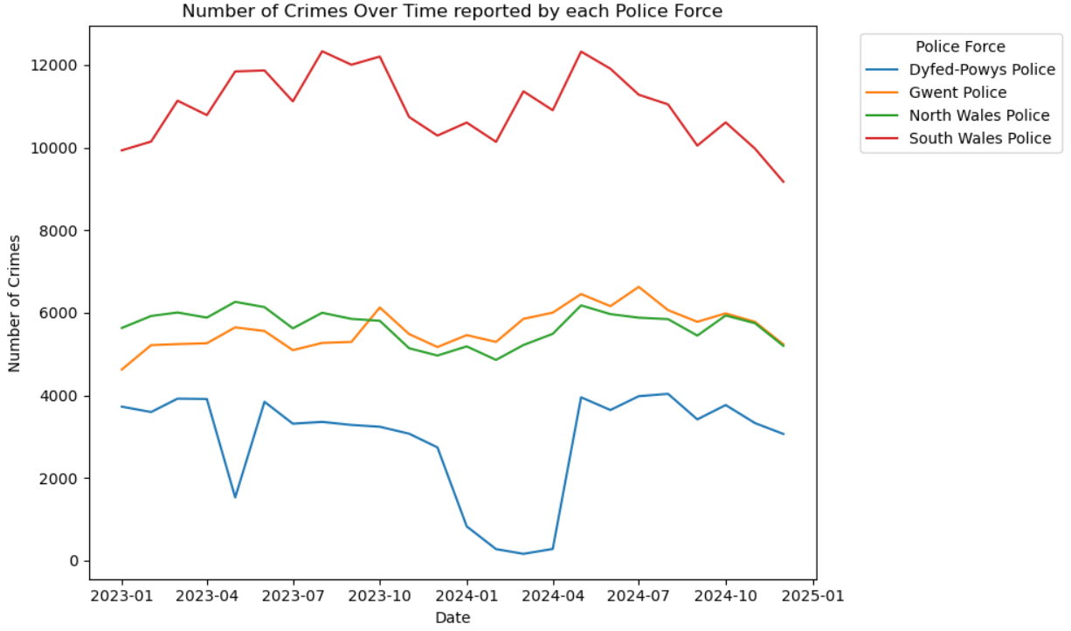

4.2 Seasonal Crime
As we have seen by looking at crimes by month, there is an implied relationship between the season and the number of crimes committed. The chart below explores this relationship directly.
This chart shows a clear seasonal trend in crime levels throughout the year. Summer records the highest number of crimes, reaching around 160,000 incidents, followed closely by Autumn and Spring. The Winter months see the lowest number of crimes, with totals closer to 135,000.
This pattern suggests that crime tends to increase during warmer seasons, possibly due to more people spending time outdoors, attending events, or traveling — all of which can create more opportunities for certain types of crime. In contrast, the drop in Winter may be linked to colder weather, shorter days, and fewer people being out, which can naturally reduce the likelihood of some offences.

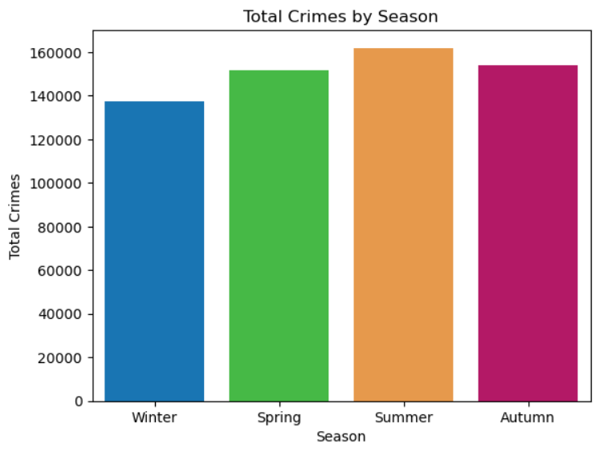

5 Distribution by Police Force

5.1 Crimes reported by each police force
This section explores crime patterns across the four police forces selected. By comparing the volume and trends of crimes between these regions we can identify which areas experience the highest and lowest levels of criminal activity.

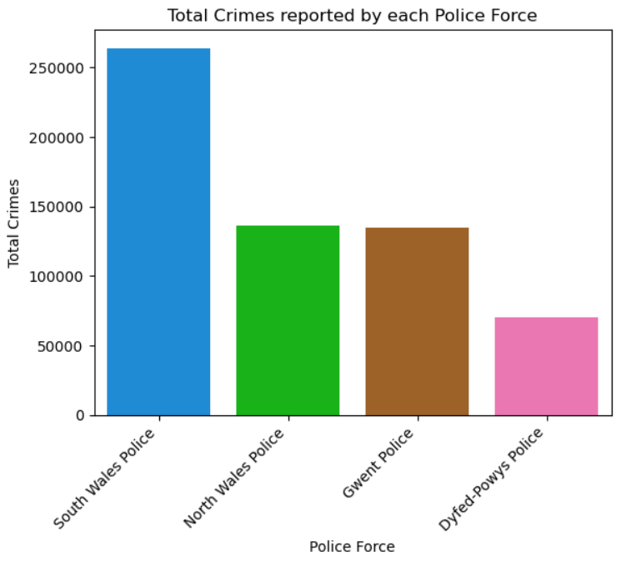
The chart below shows the total number of crimes reported by each police force over the timeframe studied, clearly highlighting that South Wales Police accounts for the largest share of recorded crimes, with over 260,000 incidents. This is significantly higher than any of the other forces, reflecting the fact that South Wales covers a larger and more urban population, including cities such as Cardiff and Swansea. North Wales Police and Gwent Police report similar crime levels, both recording around 135,000 incidents over the two-year period. These regions show moderate activity, suggesting that while crime is present, it is more controlled compared to South Wales. Dyfed-Powys Police stands out as having the lowest number of crimes, at just under 75,000, which is consistent with the area’s more rural character and lower population density.

The second chart used in this section breaks crime down by year as well as by police force. As expected, it shows that South Wales Police maintained the highest levels of crime across both 2023 and 2024, although there is a slight decline in 2024. Gwent Police shows a small increase in reported crimes in 2024, while North Wales Police and Dyfed-Powys Police experience modest decreases.
Overall, these trends suggest that while South Wales consistently faces the greatest volume of criminal activity, crime levels across Wales are relatively stable year to year and for the most part are even on the decline. Places of interest are South Wales and Gwent given their higher or increasing crime rates, while Dyfed-Powys remains the safest and most stable region.

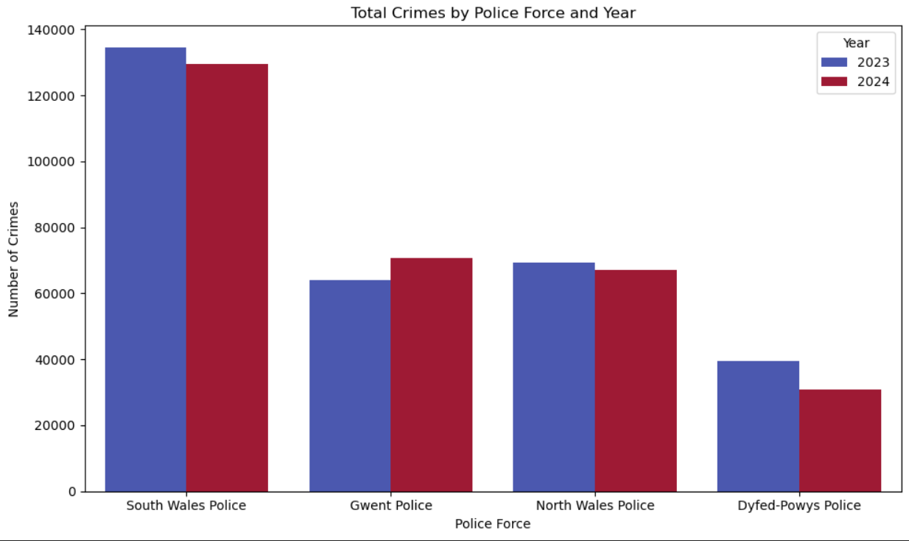

5.2 Crime rate
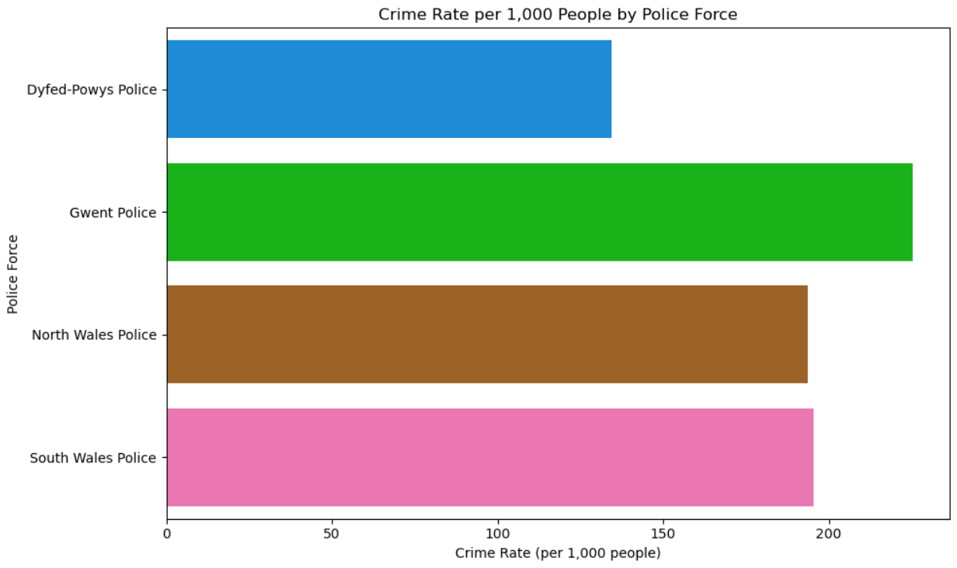
However, while the above graphs are useful in determining the sheer volume of crime that occurs in each area, they do not tell the whole story. It is expected that regions with a higher population have more crimes, so why not consider the population? This part of the report does just that, calculating the number of crimes that occur per 1000 people and calling this figure the crime rate.
The graph above shows the crime rate for each police force across the two-year time span. The highest crime rate is for the Gwent Police approaching 240 crimes per 1000 people. The Lowest crime rate is for the Dyfed-Powys which is sitting clear at around 135 crimes per 1,000 people—a significantly lower rate compared to the others. South Wales Police and North Wales Police are close to each other, both hovering around 190 to 200 crimes per 1,000 people. South Wales Police appear just slightly higher than North Wales Police.
The chart below showcases the crime rate for each police force split apart by year. This allows us to start to see trends and whether the area is becoming more or less dangerous. Noticeably Gwent is the only force where the crime rate increases between 2023 and 2024. Dyfed-Powys made the largest improvement lowering its already low crime rate by around 20%. North and South Wales forces both saw slight decrease in crime rate however the differences for both were negligible.
The most striking findings when taking population into consideration are:
- Gwent Police having the highest overall crime rate as well as being the only force to see an increase in crime rate in 2024. This does not bode well for the future; hence real estate investment here would be ill-advised.
- Dyfed-Powys Police remains the safest in terms of rate and is the force that achieved the most significant reduction in crime year-over-year, a big plus for any potential investors.
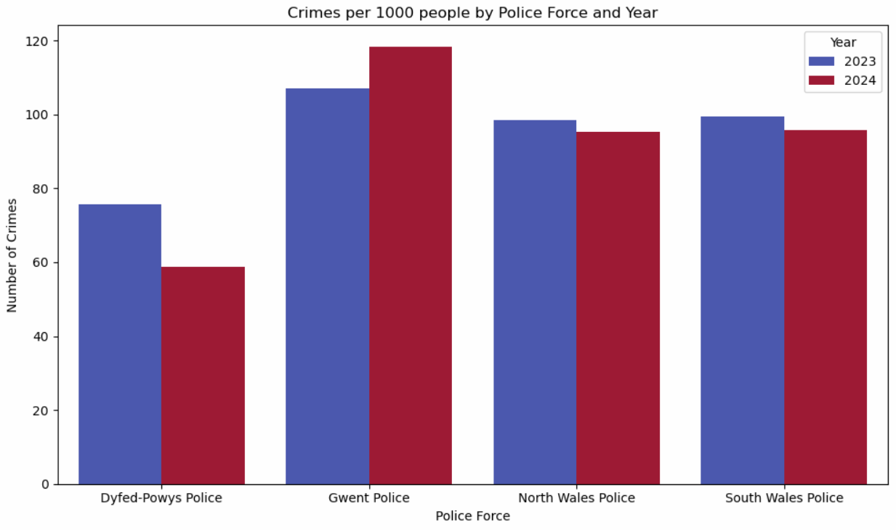
- South Wales: although it has by far the most amount of crime in terms of pure numbers, it has a fairly middling crime rate, suggesting it is no less safe than other areas of Wales

6 Distribution by Crime Type
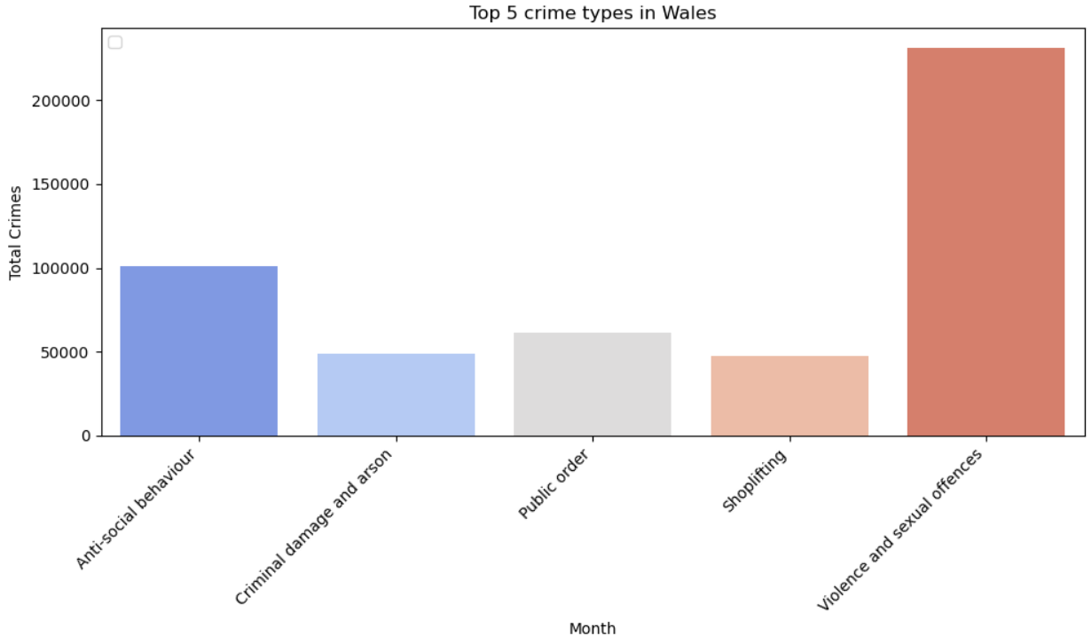
In this section we will look into the most frequent types of crimes that occur across all four police areas as well as looking at Wales as a whole. This is important because understanding the types of crimes that occur most frequently is just as important as knowing where and when they happen. Different kinds of offences — such as antisocial behaviour, burglary, or vehicle crime — can influence how safe an area feels and how attractive it is to potential buyers or investors.
The chart above shows the top 5 crime types committed in Wales over the two-year period studied. These 5 crime types are responsible for around 75% of crimes committed in Wales. The most striking finding is the overwhelming dominance of one category: Violence and Sexual Offences which surpasses 200,000 crimes, making it responsible for around a third of all crimes in Wales.
The four graphs below show the top 5 offences in each region. As you can see, the same five crimes are prevalent across Wales, with the exception of Dyfed-Powys where other types of theft occur more frequently than shoplifting. Violence and sexual offences are the most prevalent category of crime across all regions; however, it must be said that this is because this category contains a wide array of offenses ranging from homicide to verbal harassment. Another interesting point is from the North Wales Police graph which has crimes more evenly spread out than other areas.

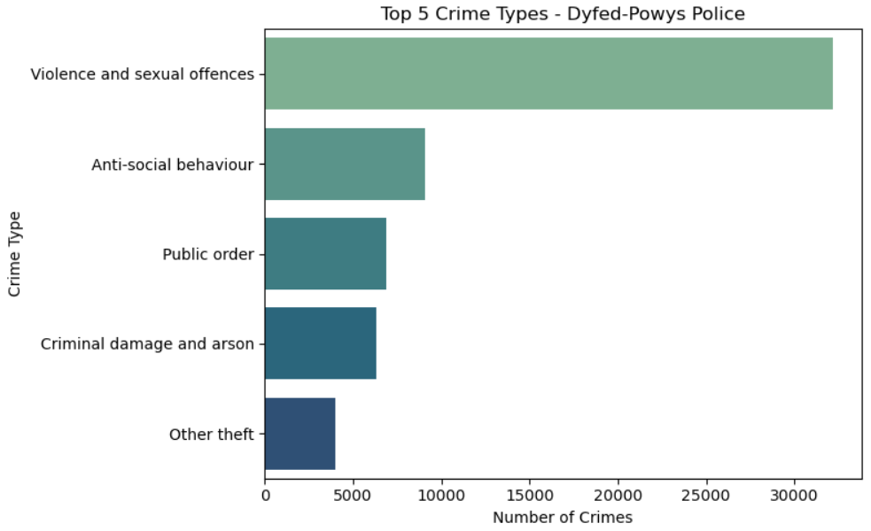
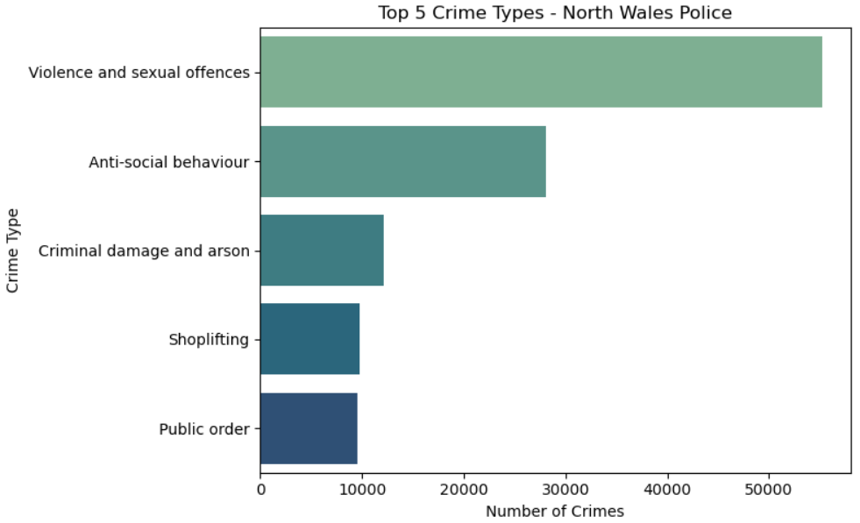

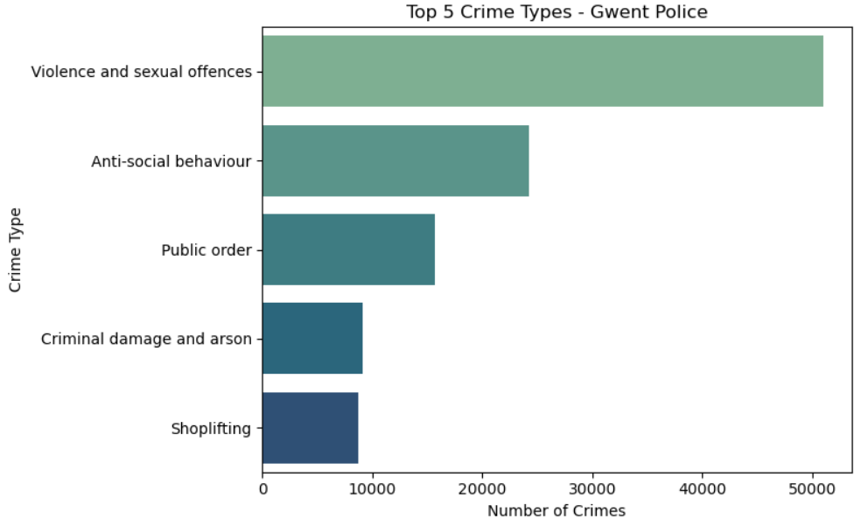
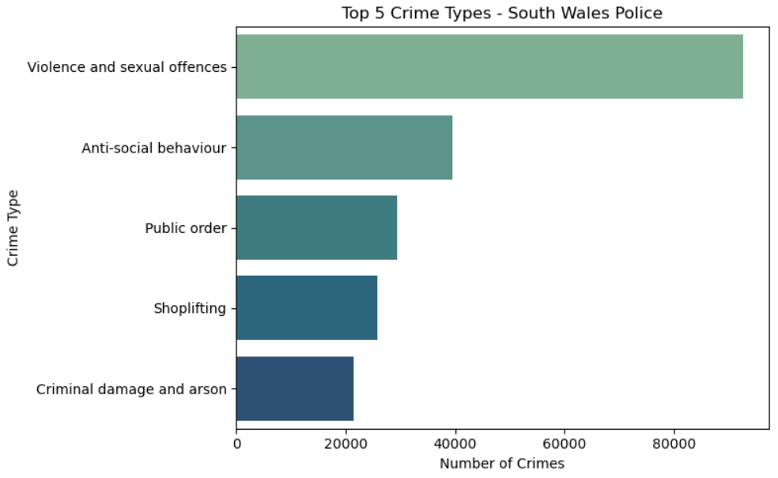

7 Crime Map
This section looks at how crime is spread across Wales, using a heatmap and a police boundary map to show where incidents are most common. By visualising crime in this way, we can clearly see which areas experience higher levels of activity and how these patterns fit within different police force regions.
The main hotspots of crime that can be extrapolated from the heatmap are in the south east of the country. These are Cardiff (South Wales Police) and Newport (Gwent). Cardiff was expected as it is the most populous city in Wales, whereas Newport was less so, however, the immense crime density in Newport could explain why Gwent did so poorly in prior analysis.
There are a couple of secondary hotspots as well. These being Swansea (South Wales Police) and Wrexham (North Wales Police). Both of these cities and their surroundings cover a continuous area green and yellow colour indicating slightly higher crime.
Finally, the rural heartland is mostly empty with a few specs of blue in between, indicating a very limited amount of crime for such large area. This clearly aligns with the Dyfed-Powys area which did so well in the previous analysis. This clearly demonstrates the trade off people make when choosing to live somewhere rural or urban: safety vs connectedness.
Link for interactive map: crime_heatmap2.html
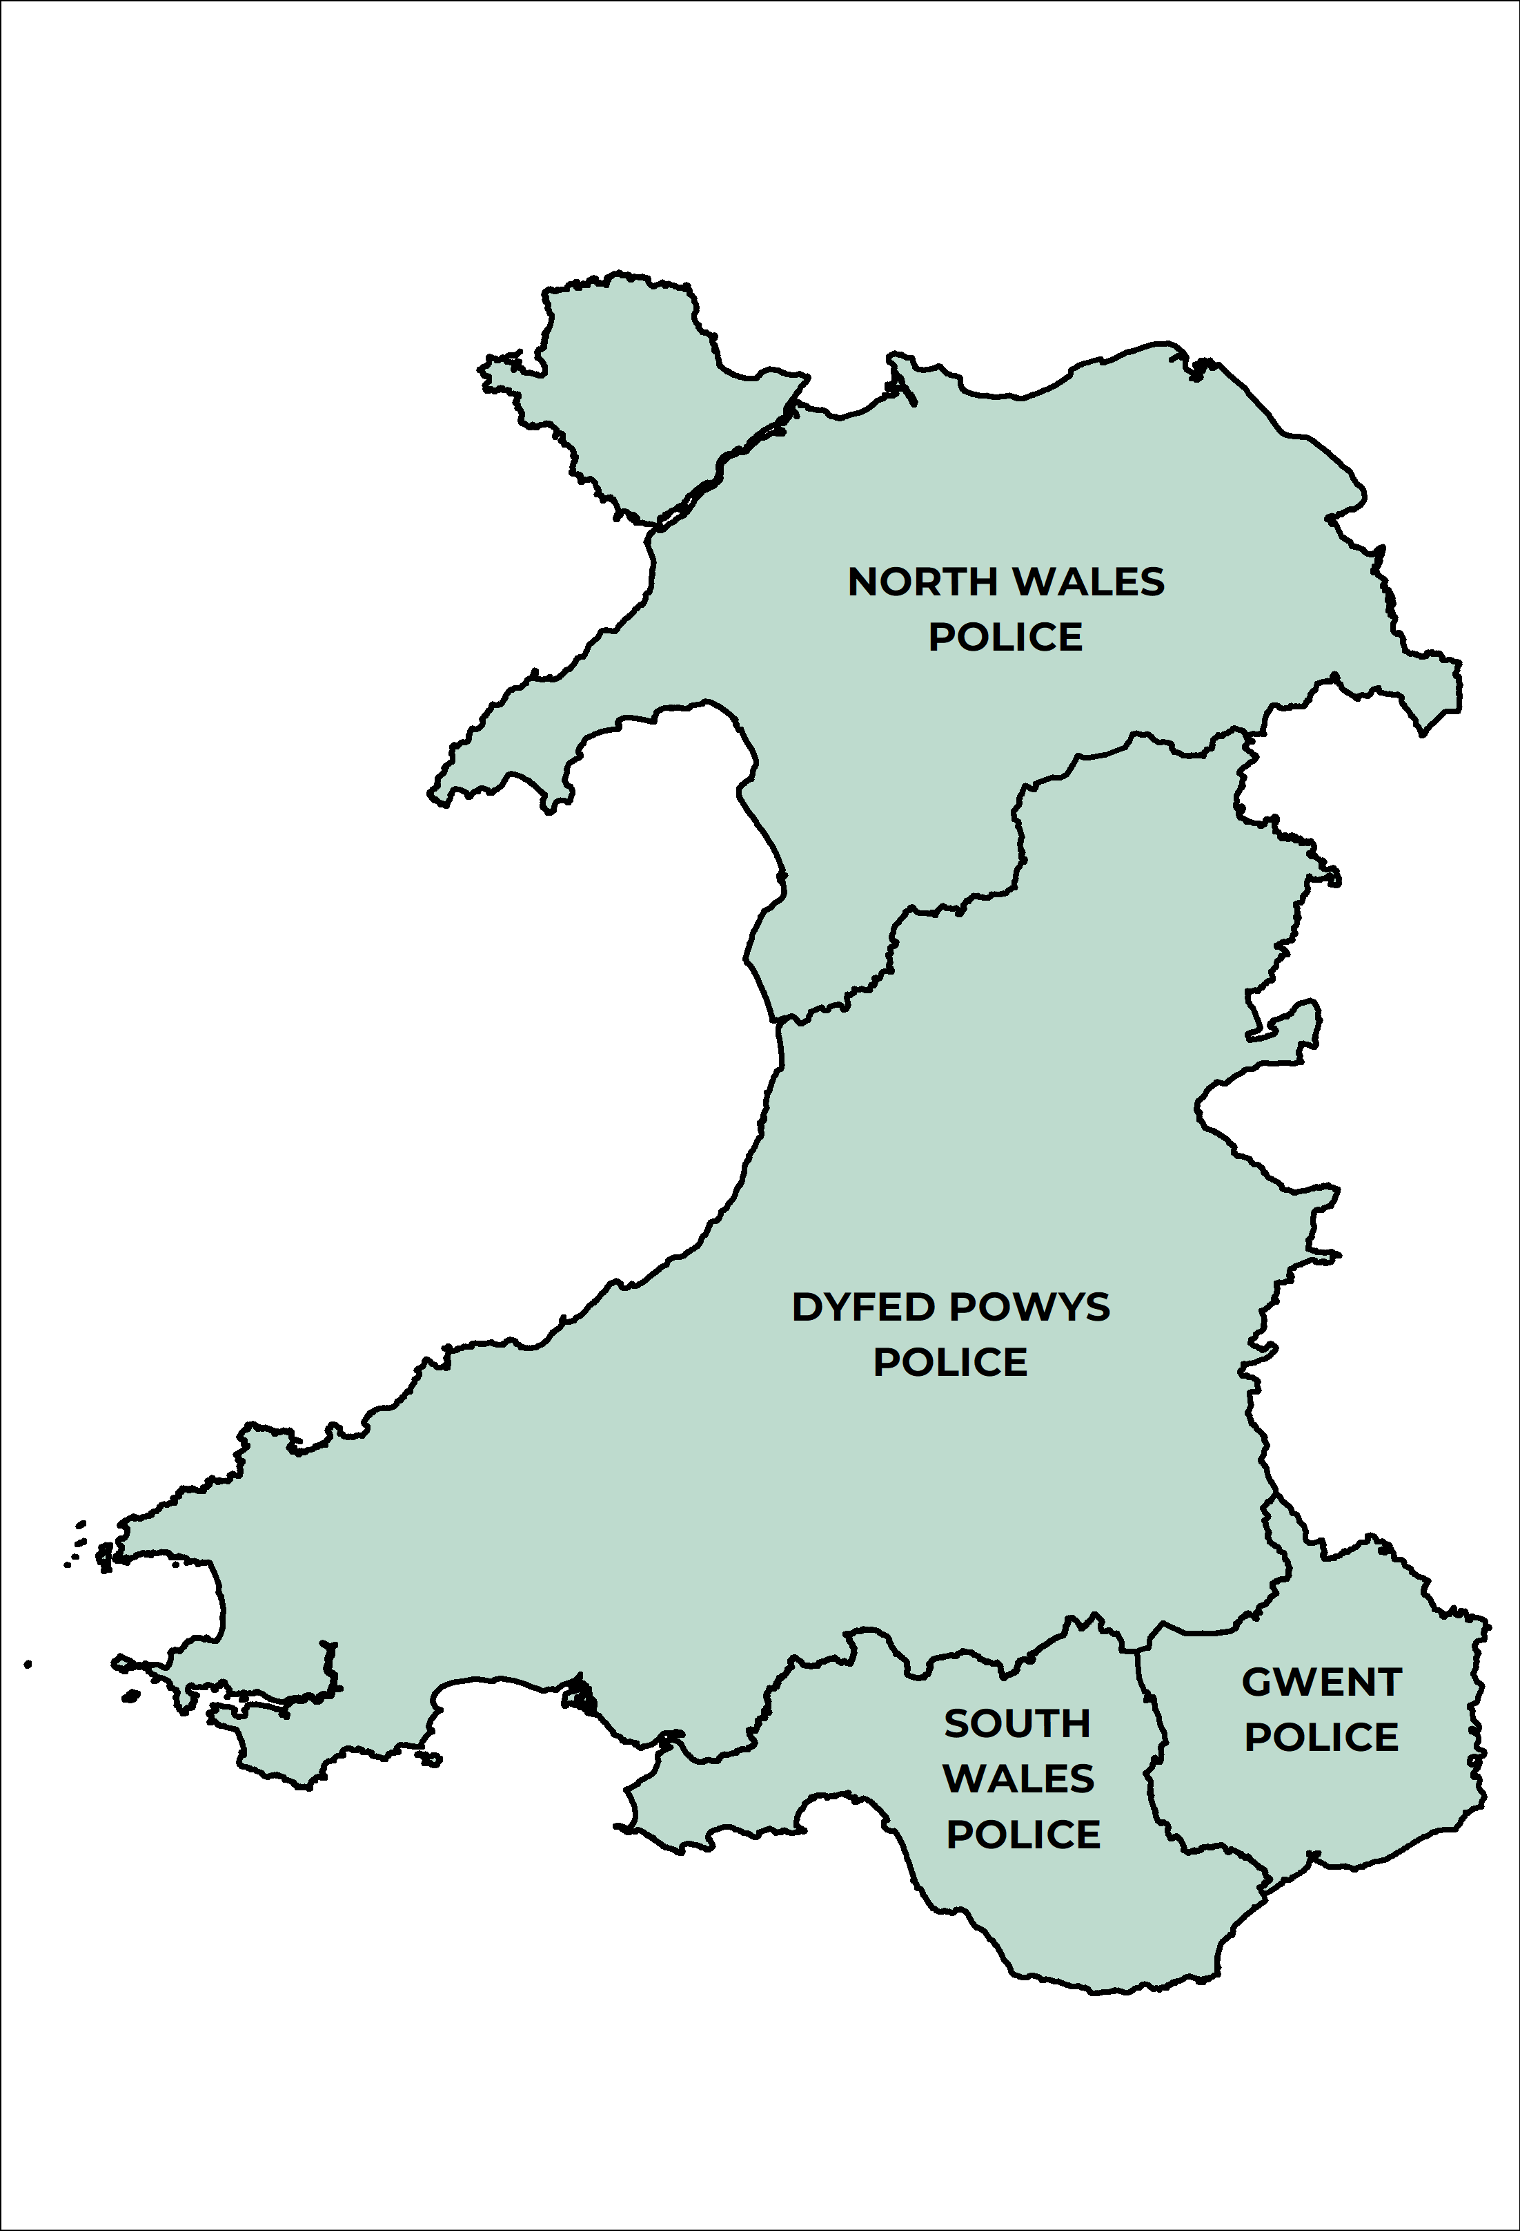
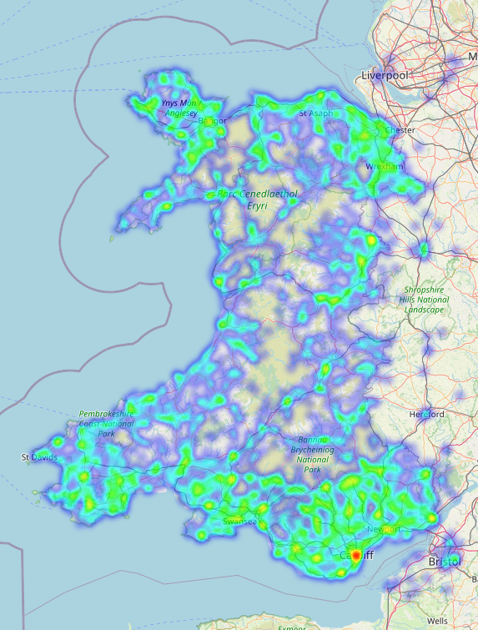

8 Conclusions and Recommendations
This report has provided a broad overview of crime patterns across Wales, helping to identify which areas may be more or less desirable from a real estate perspective. By analysing two years of data across the four Welsh police forces, a few clear patterns emerged. South Wales Police consistently recorded the highest number of crimes, which isn’t surprising given it covers the country’s largest urban areas such as Cardiff and Swansea. On the other hand, Dyfed-Powys Police had the lowest levels of crime, reflecting its more rural and sparsely populated nature.
The analysis also showed a clear seasonal trend — crime tends to rise during the summer months and dip in winter — which suggests that social activity and public gatherings may influence overall crime levels. When combined with the geographic heatmaps, it became clear that higher crime density is concentrated around cities and towns, while rural areas tend to remain relatively low in crime.
For further analysis, South Wales Police and Dyfed-Powys Police are recommended. South Wales Police covers the most densely populated and economically active areas, providing a diverse dataset for deeper study. Dyfed-Powys, meanwhile, offers an interesting comparison as it serves more rural communities, making it useful for exploring differences in crime dynamics across varied environments.

