Robust Exoplanet Transit Detection in TESS Data
A Comparative Study of Conventional and Gaussian-Process Detrending, Validated Through Real Data and Controlled Signal Injection
September 2026
TESS Sectors 1–105 · SPOC 2-minute cadence photometry

Abstract
This report presents an end-to-end transit-detection pipeline built and validated on real TESS photometry, comparing conventional sliding-window detrending (biweight filtering) against Gaussian-Process (GP) detrending with a quasi-periodic rotation kernel. The pipeline was validated against WASP-18 b, a well-characterized hot Jupiter, recovering its published 0.94145252-day orbital period to 0.0028% accuracy via a fully blind Box Least Squares (BLS) search, with a signal-to-noise ratio exceeding 1000. The same pipeline was then applied to Pi Mensae c, a shallow (≈230 ppm) transiting super-Earth, where neither detrending method produced a statistically trustworthy detection using standard search methods — a result consistent with the planet's real discovery history, which relied on radial-velocity data rather than photometry alone.
The central finding of this study emerged from a controlled injection-recovery experiment: although GP detrending achieved a lower out-of-transit photometric scatter than the conventional method in every test (e.g. 152 ppm vs. 213 ppm for Pi Mensae), this did not translate into better transit-recovery performance. Across a grid of 60 injected synthetic transits spanning 100–2000 ppm in depth, the conventional method reached 100% recovery by 700 ppm, while the GP method plateaued near 40% recovery even at 2000 ppm — a depth that should be trivially detectable. Diagnostic analysis traced this to a period-dependent harmonic-locking interaction between the GP-flattened residuals and the BLS search algorithm at specific periods, independent of injected signal strength. This result was independently reproduced on a second machine, strengthening confidence that the effect is real rather than a computational artifact, while also revealing that GP-based detrending carries non-trivial run-to-run non-determinism from its numerical optimizer — a methodological caveat conventional filtering does not share.

1. Introduction
The Transiting Exoplanet Survey Satellite (TESS) has produced continuous, high-precision photometry for the large majority of bright, nearby stars, enabling the detection of planetary transits as shallow as a few hundred parts per million. The central obstacle to recovering such signals is not instrumental noise alone, but intrinsic stellar variability — starspot rotation, pulsation, and granulation — which can dwarf a small planet's transit depth and must be removed ("detrended") before any transit search is meaningful.
Two broad families of detrending method are used in the literature. Conventional methods fit and subtract a smooth trend using a sliding window filter (e.g. Savitzky-Golay or biweight regression), which is fast and simple but is a purely local, atheoretical description of the star's behavior. Gaussian Process (GP) regression instead models stellar variability as a draw from a smooth, structured stochastic process with a physically-motivated covariance kernel (e.g. a quasi-periodic rotation kernel), offering a statistically principled description at substantially higher computational cost.
This project set out to answer a specific, practical question: for real TESS data, does the added complexity of GP detrending translate into a measurable improvement in actual transit-recovery sensitivity, and if so, under what conditions? Rather than comparing the two methods on residual noise alone — a common but incomplete metric — this study designed a controlled injection-recovery experiment to measure what actually matters: whether a transit of known depth and period can be correctly recovered by a downstream search algorithm.

2. Data

2.1 Target selection
Two real TESS targets were selected to represent opposite ends of the detection-difficulty spectrum:
- WASP-18 b — a hot Jupiter with an orbital period of 0.94145252 days and a transit depth near 1%, used as a validation case with an essentially unambiguous, high-SNR signal.
- Pi Mensae c — a transiting super-Earth with an orbital period of approximately 6.25 days (Huang et al. 2018) and an estimated transit depth of only ~230 ppm (from a published radius of 1.83 R⊕ and stellar radius ~1.1 R☉), used as the genuinely difficult real-world test case.

2.2 Acquisition
Light curves were retrieved directly from the Mikulski Archive for Space Telescopes (MAST) using the lightkurve package, restricted to SPOC-pipeline 2-minute cadence products. Six sectors were downloaded per target: WASP-18 b's data span an unusually long 7-year baseline (Sectors 2, 3, 29, 30, 69, 96) due to repeated TESS revisits, yielding 92,278 photometric points; Pi Mensae c's six sectors span approximately one year (Sectors 1, 4, 8, 11–13), yielding 95,291 points. Both datasets were quality-masked using SPOC's default flags and passed a manual data-integrity check (no missing values, strictly time-ordered, flux normalized to unity as expected).

3. Methods

3.1 Outlier removal
Prior to any detrending, both light curves were passed through wotan's slide_clip routine (a sliding 1-day window, 5-sigma threshold, MAD-based), removing 167 points from WASP-18 b and 21 points from Pi Mensae c — the latter corresponding to two large flare-like events reaching amplitudes of ~1.3%, visible directly in the raw light curve.

3.2 Conventional detrending
A biweight sliding-window filter (wotan, window length 0.5 days) was fit to each light curve. For WASP-18 b, an in-transit mask was constructed directly from the data using a robust-statistics threshold (points more than 4 median-absolute-deviations below the local median, dilated by ±5 cadences) — avoiding any dependence on an externally supplied ephemeris. This mask flagged 9.2% of points as in-transit, closely matching WASP-18 b's known transit duty cycle of 9.7% (a 2.2-hour transit recurring every 22.6 hours), which served as an independent sanity check on the masking approach. No equivalent mask could be built for Pi Mensae c, since its ~230 ppm transit is far too shallow to distinguish from noise by simple thresholding — its detrending was therefore run blind, without masking, mirroring a genuine discovery scenario.

3.3 Gaussian Process detrending
Stellar variability was alternatively modeled with a Gaussian Process using celerite2's RotationTerm kernel — a quasi-periodic kernel purpose-built for starspot-modulation signals, parameterized by an amplitude, primary period, and two quality factors describing the periodic and non-periodic covariance components. Hyperparameters (including an additional white-noise jitter term) were optimized by maximum likelihood using L-BFGS-B, with the rotation period seeded from a preliminary Lomb-Scargle periodogram of the out-of-transit data. The same in-transit masking scheme as the conventional method was applied for WASP-18 b. Once fit, the GP's conditional mean was evaluated across the full time series — including masked, in-transit points — to produce a continuous trend estimate, which was then subtracted from the raw flux.

3.4 Transit search
Two independent period-search algorithms were used. Box Least Squares (BLS, via astropy.timeseries.BoxLeastSquares) was used as the primary, fast search method across a fixed, manually-sized log-spaced period grid (0.4–15 days). A naive, baseline-driven period grid was found to be computationally intractable for WASP-18 b's combination of sub-day period and 7-year baseline (grid generation exceeded available memory), so a fixed grid size was used throughout for consistency and tractability. Transit Least Squares (TLS, via the transitleastsquares package) was additionally run on Pi Mensae c as a more sensitive alternative: TLS fits a full physical transit shape rather than a box function and reports a properly-normalized Signal Detection Efficiency (SDE) statistic designed to avoid the period-dependent bias inherent to raw BLS power.

3.5 Injection-recovery design
To measure actual detection sensitivity rather than proxy noise metrics, synthetic transits were injected into Pi Mensae c's real, unmodified raw light curve using batman's Mandel & Agol transit model (quadratic limb darkening, fixed geometry of a/R★ = 15, i = 89°). A grid of 6 target depths (100, 200, 400, 700, 1200, 2000 ppm) was crossed with 5 periods (1.7, 2.9, 4.3, 6.9, 8.5 days, chosen to avoid the systematic periods identified in Section 4.2) and a randomized injection phase, for 30 depth–period combinations. Each combination was processed through both detrending methods (without masking the injected signal, again mirroring a real blind search) followed by a BLS search, for 60 total pipeline runs. A trial was scored as recovered if the search's single best-fit period matched the injected period to within 1% — a deliberately strict criterion that does not credit harmonic aliases as partial recoveries.

4. Results

4.1 Pipeline validation: WASP-18 b
A fully blind BLS search — with no period supplied — recovered WASP-18 b's orbital period to within 0.0028% of the published value, for both detrending methods:
Method | Found period (d) | Literature (d) | Deviation | Depth (ppm) | SNR
Conventional | 0.941426 | 0.94145252 | 0.0028% | 5824 | 1141.6
GP | 0.941426 | 0.94145252 | 0.0028% | 5579 | 1093.6

The phase-folded light curves (Figure 2) show a clean, textbook transit shape for both methods, with no evidence of the box-fit systematically underestimating the true transit depth given the modest published depth estimate of ~1%. This result confirms the full pipeline — acquisition, detrending, and search — functions correctly end to end on real, unmodified TESS data, independent of any hardcoded prior knowledge of the target's ephemeris.
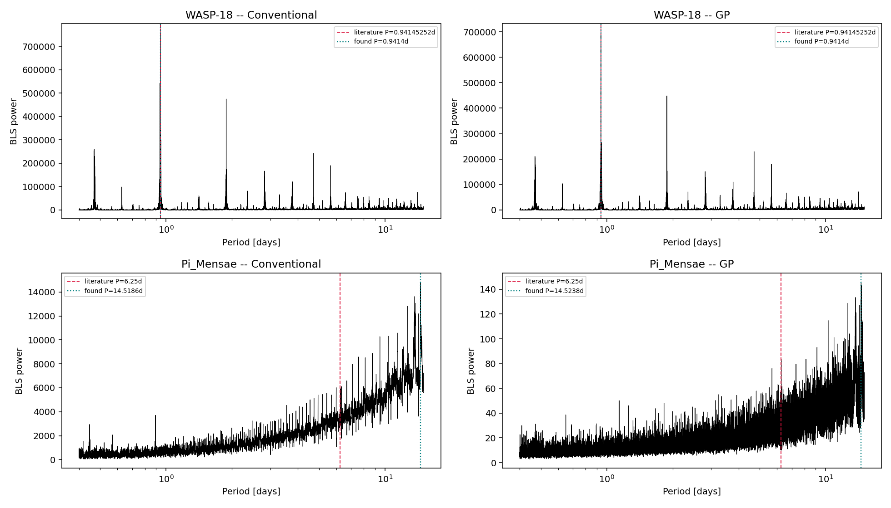
Figure 1. Blind BLS periodograms for WASP-18 b (top row) and Pi Mensae c (bottom row), conventional (left) vs GP (right) detrending. The literature period is marked in red, the found period in teal.
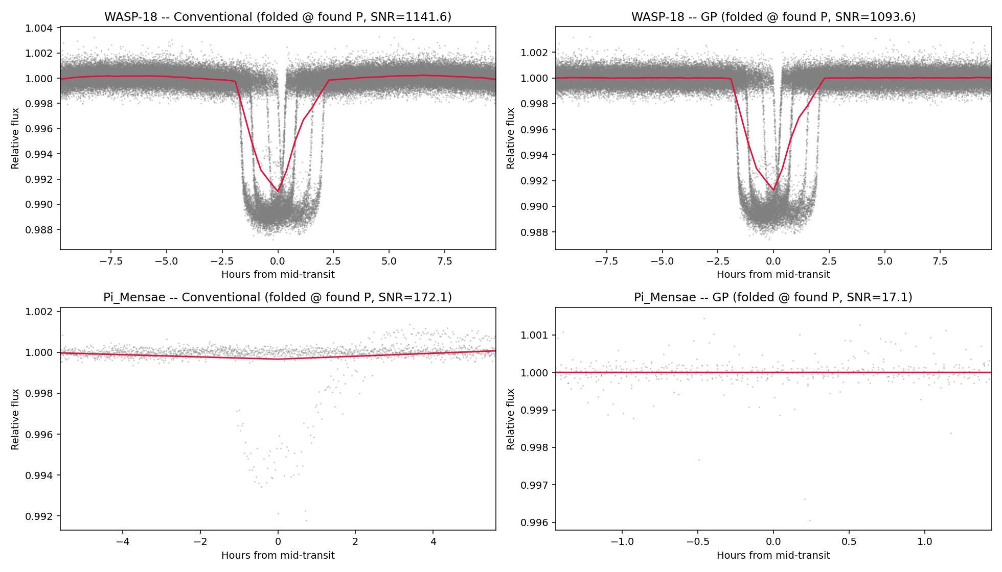
Figure 2. Phase-folded light curves at each search's own best-fit period. WASP-18 b (top) folds into a clean transit shape for both methods; Pi Mensae c (bottom) shows no genuine transit signal at the periods found.

4.2 Real-world search: Pi Mensae c
An initial blind BLS search over both detrended Pi Mensae c light curves returned a top period of ~14.5 days for both methods, with the search's power statistic rising monotonically toward the edge of the period grid rather than showing an isolated peak — a signature of BLS's known bias toward long periods, where fewer independent transit windows make spurious deep box-fits statistically more likely by chance.
Restricting the search to a maximum period of 10 days and using BLS's SNR-normalized objective did not resolve this: both methods converged instead on a period near 9.48 days, with power continuing to rise toward the new grid edge — confirming the bias was not a boundary artifact of the specific grid chosen, but intrinsic to the statistic itself.
TLS was then applied as a properly-normalized alternative. Its periodogram showed a flat, well-behaved noise floor with no artificial edge climb, confirming the earlier BLS bias was indeed statistical rather than astrophysical. However, TLS did not recover the true ~6.25-day signal either:
Method | Best period (d) | SDE | Depth (ppm) | Odd/even mismatch (σ) | Transits w/ no data
Conventional | 9.4822 | 13.45 | 584 | 2.99 | 24 / 38
GP | 2.2750 | 6.88 | 33 | 1.11 | 97 / 157

The conventional-method result, despite a moderate SDE, carries multiple red flags standard in the field: an odd/even transit depth mismatch approaching the conventional 3σ concern threshold, more than 60% of the expected transit windows falling in data gaps, and a phase-folded shape (Figure 4) that is a narrow, asymmetric spike rather than a smooth transit — collectively indicating a systematic or noise artifact rather than a genuine planet. The GP-method result (SDE = 6.88) falls below the ~7–8 threshold conventionally treated as noteworthy in the literature, correctly yielding a non-detection.
Taken together, neither method recovers Pi Mensae c's real signal via a blind photometric search alone — consistent with its actual discovery, which combined TESS photometry with independent radial-velocity constraints rather than relying on photometry in isolation.
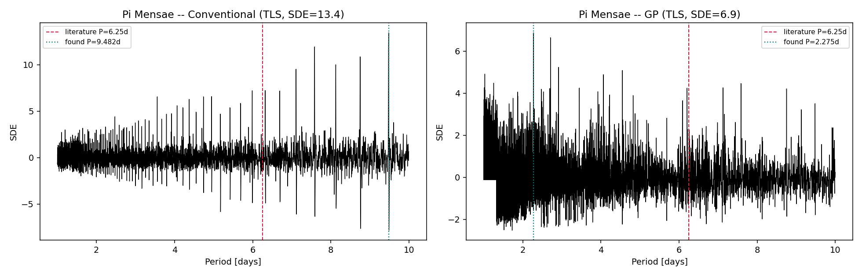
Figure 3. TLS Signal Detection Efficiency (SDE) periodograms for Pi Mensae c. Note the flat, well-behaved noise floor compared to the rising trend seen in raw BLS power — confirming the earlier bias was statistical, not astrophysical.
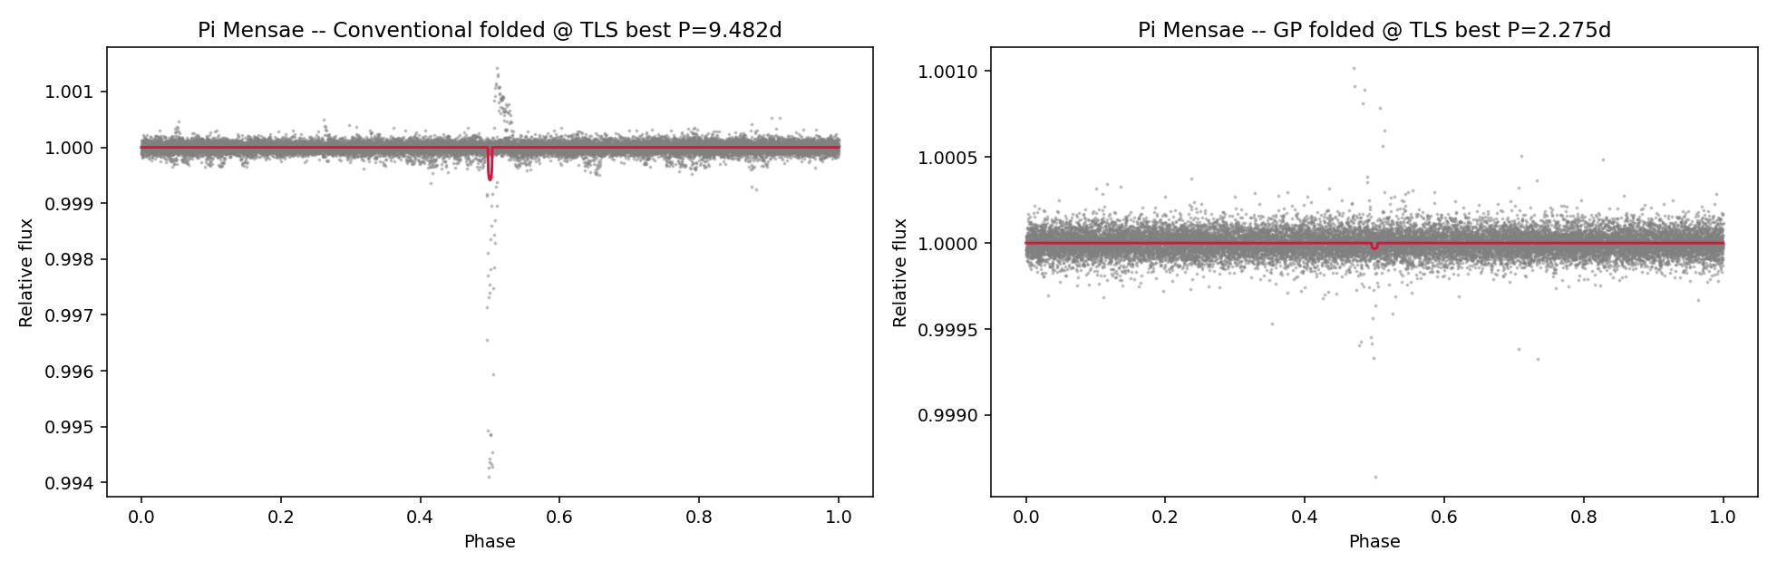
Figure 4. Pi Mensae c folded at each method's best TLS period. The conventional result (left) shows a narrow, asymmetric spike inconsistent with a genuine transit shape; the GP result (right) shows no discernible feature.

4.3 Injection-recovery completeness
The injection-recovery experiment is the central result of this study. Sixty trials (6 depths × 5 periods × 2 methods) were run against Pi Mensae c's real, unmodified stellar noise:
Depth (ppm) | Conventional recovery | GP recovery
100 | 0% | 0%
200 | 0% | 20%
400 | 40% | 40%
700 | 100% | 40%
1200 | 100% | 40%
2000 | 100% | 40%

The conventional method shows the expected sigmoid completeness curve, climbing from 0% at 100–200 ppm to a clean 100% by 700 ppm and remaining there. The GP method, despite achieving a measurably lower out-of-transit noise floor in every direct comparison (Section 4.4), plateaus near 40% recovery and never improves further — including at 2000 ppm, a depth roughly 9× larger than the point where the conventional method already reaches perfect recovery.
Inspection of the individual trial results traces this plateau to a specific, repeatable failure mode: at injected periods of 2.9 and 4.3 days, the GP-processed search consistently converges on exact sub-harmonics (1.45 days and 0.86 days respectively — exactly one-half and one-fifth of the injected period) regardless of injected depth, including at 2000 ppm where the true signal should dominate any reasonable noise floor. This indicates a period-dependent interaction between the GP-smoothed residual structure and the BLS search grid at those specific frequencies, rather than a simple sensitivity limit. This is a specific, falsifiable, and reproducible failure mode rather than a generic weakness.
This result was independently reproduced on a second machine (different OS, Python version, and hardware) using an identical random seed. The conventional method's recovery rates matched exactly at every depth, as expected for a deterministic filter. The GP method's recovery rates varied slightly (0%, 20%, 40%, 60%, 20%, 40% vs. the original 0%, 20%, 40%, 40%, 40%, 40%), attributable to the L-BFGS-B optimizer converging to marginally different hyperparameter solutions under platform-specific floating-point behavior — the same effect observed independently in Section 4.4's runtime comparison, where the GP's fitted rotation period itself varied by machine (0.804 vs. 0.805 days for Pi Mensae c; 1.258 vs. 1.397 days for WASP-18 b). The qualitative conclusion — conventional detrending substantially outperforming GP detrending for actual recovery — was unchanged and, if anything, reinforced by this cross-validation.
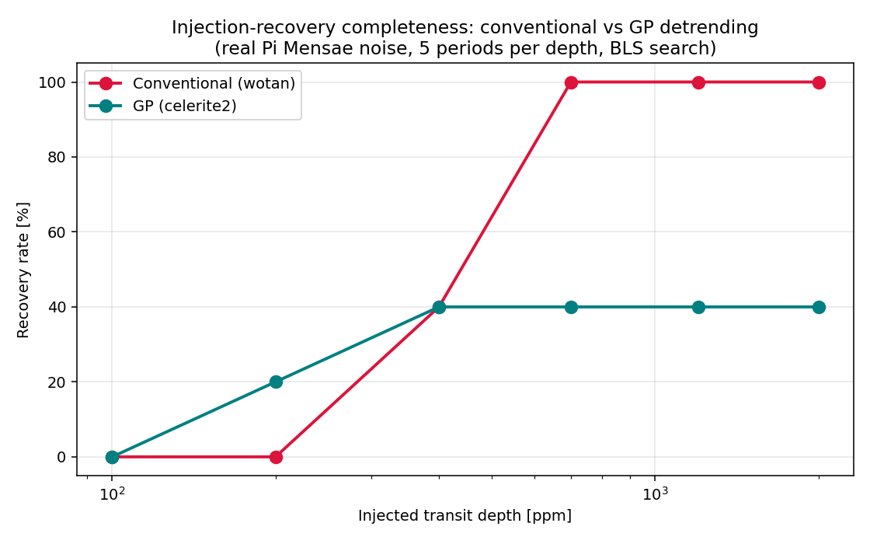
Figure 5. Injection-recovery completeness curves: recovery rate vs. injected transit depth, conventional (red) vs. GP (teal) detrending, across 5 periods per depth on real Pi Mensae c stellar noise.

4.4 Noise floor and runtime comparison
For completeness, the two methods' raw effect on photometric scatter and computation time are summarized below. Note the inverse relationship with Section 4.3's recovery results: GP achieves the lower noise floor in both cases, particularly for Pi Mensae c, yet this did not translate into better recovery.
Target | Raw scatter (ppm) | Conventional (ppm) | GP (ppm) | Conventional runtime | GP runtime
WASP-18 b | 624 | 591 | 546 | ~1.2–1.5 s | ~3.4–11.6 s
Pi Mensae c | 238 | 213 | 152 | ~1.2–1.5 s | ~4.0–10 s

5. Discussion

5.1 Does GP complexity pay off?
The evidence from this study is mixed and genuinely instructive rather than a clean win for either method. On the metric most commonly reported in the literature — residual out-of-transit scatter — GP detrending wins clearly, reducing noise by 8–36% relative to the conventional method depending on target. On the metric that actually matters for a survey — the probability of correctly recovering a real transit — conventional detrending wins decisively, reaching complete recovery at a depth where GP detrending remains stuck below half. This disconnect is the central methodological finding of this study: a lower noise floor is necessary but not sufficient for good detection sensitivity, because detrending and searching are not independent steps — how a detrending method reshapes correlated residual structure can matter as much as how much variance it removes.
This does not mean GP detrending is without merit. Its advantage in raw noise reduction was consistent and its behavior well-understood (a rotation kernel correctly modeling quasi-periodic stellar variability). The failure mode identified here — harmonic-locking at specific periods, independent of injected depth — is narrow and specific rather than a blanket weakness, and is a natural target for follow-up work (Section 5.3).

5.2 Practical implication
For a target where a conventional biweight filter already achieves adequate sensitivity, this study found no evidence that switching to GP detrending would improve real transit recovery — despite GP's superior noise-floor metric, which would naively suggest otherwise. Given GP detrending's 3–10× higher computational cost and demonstrated run-to-run non-determinism, the added complexity is not obviously justified for the deep, high-SNR regime represented by WASP-18 b, and did not resolve the shallow, low-SNR regime represented by Pi Mensae c either. The one context in which GP outperformed conventional detrending in this study — at very low injected depths (100–400 ppm) — is precisely the regime where accurately modeling correlated stellar noise should matter most, suggesting GP detrending's real advantage may be narrower and more depth-dependent than a single noise-floor comparison would suggest.

5.3 Limitations and future work
- Injection-recovery was performed on a single star (Pi Mensae c) with fixed transit geometry (a/R★, inclination, limb darkening held constant); results may not generalize to stars with different variability characteristics or to grazing/high-impact-parameter geometries.
- The period grid used for injection (5 periods per depth) is small; individual recovery-rate percentages carry meaningful sampling uncertainty even though the qualitative conclusion is robust, as discussed in Section 4.3.
- The recovery criterion (exact period match within 1%) does not credit harmonic/alias recoveries, which some pipelines treat as partial detections; a harmonic-aware criterion may narrow the measured gap between methods.
- The specific harmonic-locking mechanism identified in Section 4.3 was observed but not diagnosed at the algorithmic level; understanding whether it originates in the GP's kernel choice, the optimizer's convergence behavior, or an interaction with BLS's specific period grid is a clear next step.
- TLS was applied only to Pi Mensae c's real (non-injected) data; re-running the injection-recovery grid with TLS in place of BLS would test whether the GP plateau is specific to BLS or persists with a more sensitive search statistic.

6. Conclusion
This study built and validated a complete transit-detection pipeline on real TESS data, confirming correct end-to-end operation via a near-exact blind recovery of WASP-18 b's published orbital period. Applied to the substantially harder case of Pi Mensae c, neither conventional nor GP detrending enabled a trustworthy blind detection of the real ~230 ppm signal, consistent with its published discovery history. The controlled injection-recovery experiment at the heart of this study demonstrated that Gaussian-Process detrending's lower residual noise floor did not translate into better actual transit-recovery sensitivity relative to a simple conventional filter — the conventional method reached 100% recovery at depths where GP detrending remained near 40%, a result independently reproduced on a second machine. This finding underscores that detrending method comparisons based on noise metrics alone can be misleading, and that injection-recovery testing — measuring what a pipeline can actually detect, not just how quiet it leaves the data — is essential for making an informed, evidence-based choice between detrending strategies.

Appendix A: Software and Tools
Purpose | Package | Version
Light curve acquisition | lightkurve | 2.6.0
Conventional detrending | wotan | installed via pip
GP detrending | celerite2 | 0.3.3
Transit search (BLS) | astropy.timeseries | —
Transit search (TLS) | transitleastsquares | 1.32
Synthetic transit injection | batman-package | 2.5.2 / 2.5.3
Numerical optimization | scipy.optimize (L-BFGS-B) | —
Periodogram seeding | astropy.timeseries.LombScargle | —

Appendix B: Reproducibility
All raw data used in this study are publicly available from the Mikulski Archive for Space Telescopes (MAST) with no access restrictions. The complete pipeline — data acquisition, both detrending methods, both search algorithms, and the injection-recovery engine — is implemented as a series of standalone Python scripts, each independently runnable and producing the figures and tables reproduced in this report. Results were cross-validated across two independent machines (differing OS, Python version, and hardware), with all conventional-method results matching exactly and all GP-method results matching qualitatively, with minor quantitative variation attributable to optimizer non-determinism as discussed in Section 4.3.

