**Computer Vision-Based** **Vehicle Integrated**

**Information Collection System**



Shangyuan Liu

25344136

[25344136@students.lincoln.ac.uk](mailto:25344136@students.lincoln.ac.uk)

School of Computer Science

College of Science

University of Lincoln

Submitted in partial fulfillment of the requirements for the

Degree of BSc(Hons) Computer Science

*Supervisor:* Dr. Shouyong Jiang

April 2021

**Acknowledgements**

Firstly, I want to thank somebody, and somebody else. Here is another thing.

**Abstract**

摘要在其整体上呈现了项目的简要摘要，并用来帮助读者快速确定项目的目的，上下文和结果。 摘要的目的是让读者在不需要阅读整个文档的情况下就能了解报告的内容，并帮助标记报告的内容。它还通常包含项目的关键结果是什么的简要说明。

Vehicle detection and vehicle license plate recognition (VLPR) is an indispensable component of an intelligent traffic management system, with the quick development of the information technique. Therefore, this project's purpose is to investigate and analyse the various fundamental theories about VLPR technology, which will be used in developing a computer vision-based vehicle integrated information collection system. The issue of accuracy and validity in complex light environments, low resolution, and random distribution has received considerable critical attention.

**Table of Contents**

Introduction 1

1.1 Some notes 1

1.2 Testing some mathematics 1

1.3 Undergraduate Project Report 1

1.4 Referencing 1

1.4.1 Ludography 2

Literature Review 3

2.1 Background 3

2.2 Related Literature 3

Methodology 4

3.1 Project Management 5

3.2 Software Development 5

3.3 Toolsets and Machine Environments 5

3.4 Research Methods 6

Design, Development and Evaluation 7

4.1 Software Development Projects 7

4.2 Research Projects 8

Conclusions 9

Reflective Analysis 10

References 11

**List of Figures**

3.1 A picture of the Brayford from Google Images. . . . . . . . . . . . . . 5

**List of Tables**

1. Here is a table. . . . . . . . . . . . 5

**Chapter 1**

# Introduction

## 1.1 Some notes

It is worth noting that this document is a project report template for the University of Lincoln, School of Computer Science. It should give you some direction and instruction for formatting and presenting your project report. If you have any suggestions or issues, please contact mdoughty@lincoln.ac.uk. It has been derived from the Latex PDF however, so there might be some issues – but ones I suspect you can overcome!

## 1.2 Testing some mathematics

Here are two equations using the equation editor (1, 2):

(1)

(2)

And here is some text with some nice inline maths, (*x,y*) wow *γ* so cool *ρ*.

## 1.3 Undergraduate Project Report

Currently, this template is set up for use with undergraduate project reports. However, the template can be modified fairly easily to conform to, for example, a MComp project report.

**Chapter 2**

# Literature Review

## 2.1 Background

In recent years, intelligent vehicle information monitoring systems have played a positive role in the management and safety of society. In addition, with the rapid development of computer vision technology, some cutting-edge applications in the automotive field have gained widespread popularity, such as VLPR, vehicle tracking, and autonomous driving. Take the VLPR system as an example, the previously published research on this field is circumscribed and problematic, with most of the literature focusing on the use of image processing and Optical Character Recognition (OCR) and other traditional methods. License plate positioning is a prerequisite for the implementation of license plate character recognition, however, Maglad’s (2012) analysis does not take account of the issue of license plate types adequately, nor does he examines how to accurately locate and segment the license plate area under the conditions of poor lighting background, blurred photos, and skewed angles. It is necessary to emphasize that the accuracy of OCR technology depends on the quality and quantity of the original character template in the database. As well as that, the identification speed of OCR should be improved as a real-time system.

Fig. 1: The license plate images under bad circumstances from Google

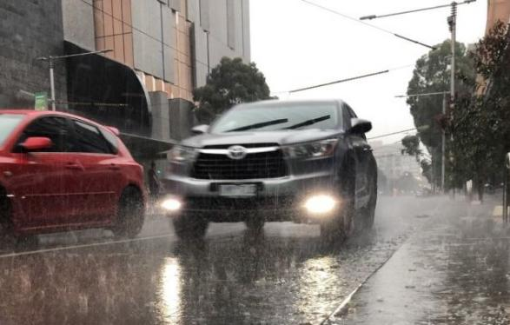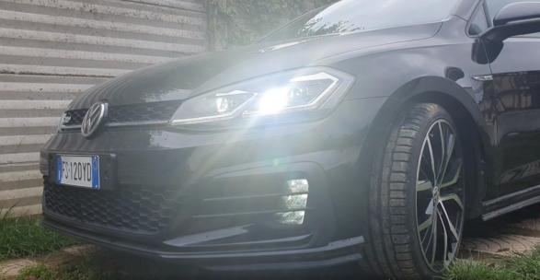

As is shown in the sample images Fig. 1, where it can be seen the negative influences of the above threats clearly. Therefore, I intended to locate the license plate, identify the license number, and other valid information more accurately via a new approach, which is combining convolutional neural network (CNN), U-Net (image segmentation), and OpenCV (cv2) technical etc. - to implement high-precision recognition of license plate and vehicle information such as plate number, brand, model, colour. In comparison to the traditional method of image processing that the proposed improvement approach (U-Net, CNN) for the VLPR system is accurate and robust. (Chowdhury et al., 2020). So in the following project work, it is necessary to compare the traditional identification methods with the new improved methods and to draw conclusions.

## 2.2 Related Literature

This section presents a detailed overview of the literature that relates to this project. The literature reviews will be conducted in two thematic directions, which are vehicle colour recognition, license plate location and recognition respectively. Due to the project focused features, this section will place emphasis on the second thematic direction.

### 2.2.1 Vehicle Colour Recognition

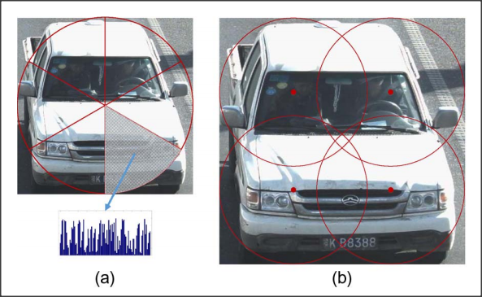The traditional approach is to convert the image in RGB colour space to HSV space and determine which colour family the car in a given image most likely belongs to base on the Hue, Saturation, and Value (H, S, V) ranges of the nine common colours. [In](D:/Dict/8.9.6.0/resultui/html/index.html" \l "/javascript:;) [allusion](D:/Dict/8.9.6.0/resultui/html/index.html" \l "/javascript:;) [to](D:/Dict/8.9.6.0/resultui/html/index.html" \l "/javascript:;) this question, Chen et al. (2014) has adopted a different approach to solve this issue based on the framework of Bag-of-Word (BoW) method, which has been put forward by [Zellig Harris](https://en.wikipedia.org/wiki/Zellig_Harris) (1954). Chen proposed methods is to recognize the dominant colour of vehicles via the region of interest (ROI) and separate the objects into subregions, and generate a histogram for each subregion, and use a linear SVM model to learn it. As can be seen from the Fig. 2, the feature context (FC) method divides the vehicle image into a number of sector sub-regions.

Fig. 2. FC Method to process the image (Pan Chen)

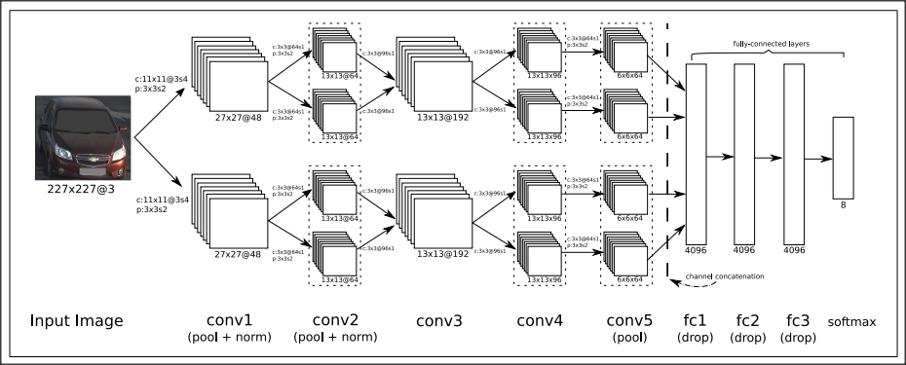The research of Chen has come up with a good solution, however, several practical questions arise when dealing with multiple vehicles in one image. Particularly, the image gets excessively divided as the amount of subregions expands, so the discriminative capacity of the descriptor decreases. As a consequence, Rachmadi and Purnama (2018) had improved the vehicle colour recognition project based on Chen's research. They suggest a CNN-based method (the architecture image can be seen in Fig. 3) to recognize vehicle colour, the final recognition accuracy was 94.47%, and the CNN model's predictions were 2% more accurate than the results of Chen's study.

Fig. 3: The architecture of CNN (Reza Fuad Rachmadi)

### 2.2.2 License Plate Location and Recognition

It is fair to say that the VLPR technology has developed along with the maturity of artificial intelligence technology, and is a separate branch from the OCR system. In terms of OCR, it was invented in the 1950s and has been criticized and ignored because of its low recognition accuracy and slow speed. And Islam, N (2016) indicated that “the earliest OCR systems were not computers but mechanical devices that were able to recognize characters, but very slow speed and low accuracy”.

This system became commercially available in the late 1990s due to the demands of traffic management. And a systematic review of prospective observational studies found that the result offered by Jun-Wei Hsieh (2002) in [Morphology-based License Plate Detection from Complex Scenes] demonstrate that the robust approach to this issue has been proposed. And there was a great effort has been devoted to the study of multiple morphological operations, which used to find high-contrast areas as important features for license plate detection. Also,

V. Kocal (2003) indicated that using image fusion, neural networks, and iterative thresholding operation to identify license plate of vehicle. However, most of the previous studies do not take into account the future social demand and the rapid development of the automotive industry. Due to limited by the capabilities of conventional algorithms, and the low level of camera imaging, etc., so VLPR was not ready for widespread use compared to the current stage of technology. Therefore, it is concluded that these approaches may not be practical in all situations by means of literature review.

During the past twenty years, [many](D:/Dict/8.9.6.0/resultui/html/index.html" \l "/javascript:;) [investigations](D:/Dict/8.9.6.0/resultui/html/index.html" \l "/javascript:;) have appeared in recent years documenting VLPR with the rise and technical maturity of machine learning and deep learning techniques. As a result, the previous research has demonstrated an algorithm that license plate recognition using a binary time-delay neural network (TDNN), which is a classification used for training the neural network. The TDNN architecture diagram is shown in Figure 4. According to the research from Ghasrodashti and Yazdi (2020) has shown that “hard conditions such as the distance and angle variations as well as weather and light conditions are considered, and the recognition rate obtained by the proposed algorithm was 70%.” Moreover, in order to prove that the algorithm can contribute to better results, the proposed algorithm (TDNN) is also compared with the previous method (SVM).

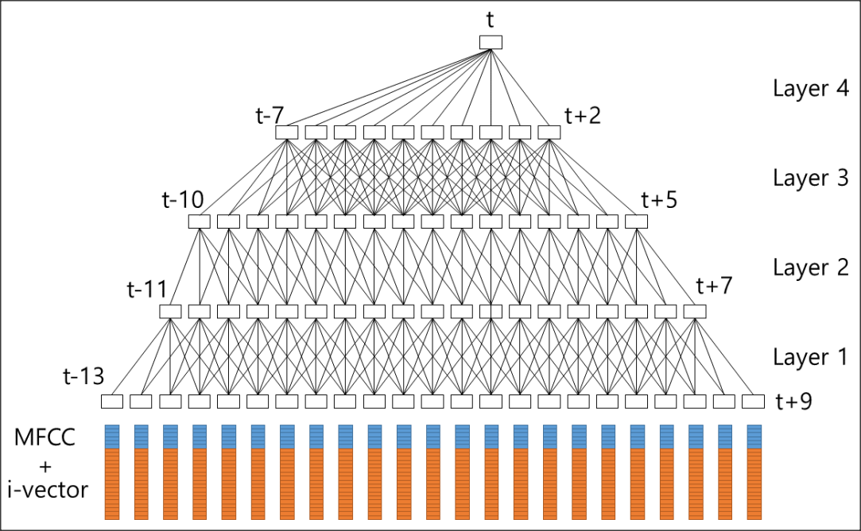

Fig. 4: TDNN architecture (Park, H., Lee, D., Lim, M., Kang)

At present, more research is invested in deep learning in the field of VLPR, especially the end-to-end training network method is extensively used. Glasmachers (2017) has shown that “it is trained in a holistic manner based on a single principle”. The overall architecture of the proposed end-to-end principle is shown in Fig. 5. And it approaches complicated problems by using the Deep Neural Networks (DNNs) model, which is made up of many layers. To end this, Qin and Liu (2020) proposed a strategy for VLPR, which is based on deep neural networks and end-to-end methods. And according to the research, it can decrease the error propagation effectively between the models of location and recognition network by means of common features, convolutional neural network, and multi-task learning strategy. Therefore, this basic structure and theoretical knowledge can be used as the basis for this project.

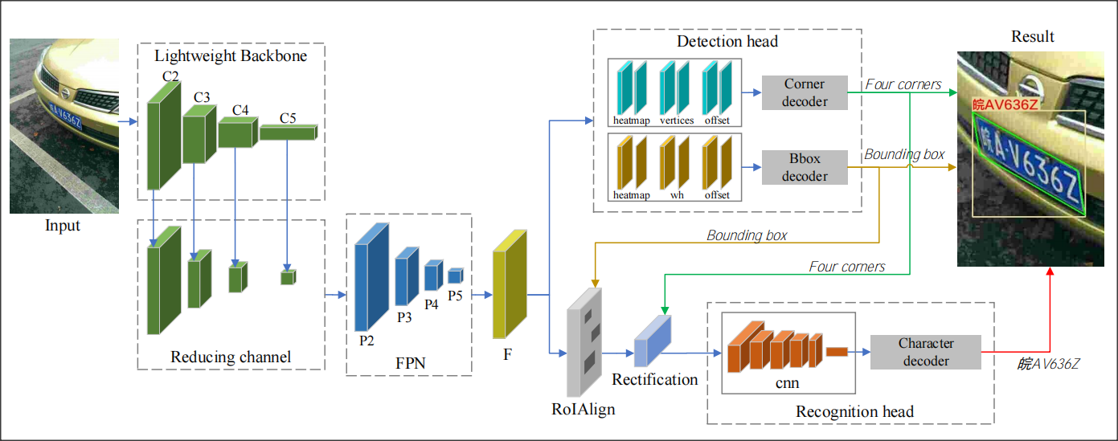

Fig. 5 The end-to-end network structure model for license plate location and recognition (Qin)

However, the end-to-end method is still under debate, and I believe it is not suitable and circumscribed in some cases. This discrepancy could be attributed to the following several reasons. Firstly, a large number of data samples are required to train the model. Secondly, it is difficult to optimize or modify the model system because the DNN model parameters must be replaced and retrained. Moreover, the method is difficult to interpret and validate due to the complicated neural network architecture, which point is significant for the automotive industry particularly. Therefore, the study by Glasmachers (2017) provided that “We have demonstrated that end-to-end learning can be very inefficient for training neural network models composed of multiple non-trivial modules. End-to-end learning can even break down entirely; in the worst-case none of the modules manages to learn. In contrast, each module is able to learn if the other modules are already trained and their weights frozen.”

To sum up, the technologies in this area generally concerns themselves with image processing and computer vision, also it can be divided in to more directions for development. [Although](D:/Dict/8.9.6.0/resultui/html/index.html" \l "/javascript:;) some results would seem to suggest that the current VLPR technology has some limitations, it is against this background that license plate recognition technology, which focuses on non-traffic areas, is gaining more and more attention.

**Chapter 3**

# Methodology

## 3.1 Project Management

Projects are vital to modern society, to companies and to individuals. Project management is the application of resources to objectives in order to achieve the goals of a project and to meet the established requirements of all parties. Therefore, a suitable project management methodology can provide an effective assurance for the implementation of the project. And there are several common project management methodologies such as Agile, Scrum, Waterfall, Kanban, Extreme Programming (XP), and Lean etc.

Table...

|  |  |
| --- | --- |
| **The Natures of this Project** | |
| **Name** | Computer Vision-Based Vehicle Integrated Information Collection System. |
| **Relativity** | The project is structured on the basis of the 'Project Course' assessment, and the students' tasks constitute the project. |
| **Temporary** | The project starts on 12 October 2020 and ends on 13 May 2021, for a total project duration of approximately 31 weeks. When the project ends, the products of project will remain and be used. |
| **Purpose** | Complete functions such as model recognition, color recognition, license plate recognition and vehicle counting with high accuracy. |
| **Constraint** | The knowledge and techniques that I currently mastered are too superficial to complete the project, and I need to continue learning. And a low configuration environment of the computer wastes lots of time in the development process. |
| **Innovation** | During the development of this project, new algorithms will be used to perform functions such as license plate recognition. But in the process of innovation, There will be uncertainties, which can make the project in risk. |

[As](D:/Dict/8.9.6.0/resultui/html/index.html" \l "/javascript:;) [shown](D:/Dict/8.9.6.0/resultui/html/index.html" \l "/javascript:;) [in](D:/Dict/8.9.6.0/resultui/html/index.html" \l "/javascript:;) [the](D:/Dict/8.9.6.0/resultui/html/index.html" \l "/javascript:;) Fig. , a complete project management process should consist of five phases, which are project initiation, planning, execution, monitoring and closure respectively. And in managing this project, the members of the project should shoulder their own responsibilities, have different skills and experience accumulation, and arrange the work correctly and reasonably. In addition, throughout the project members can learn from the project, whether from technical aspects as well as organisational and management aspects.

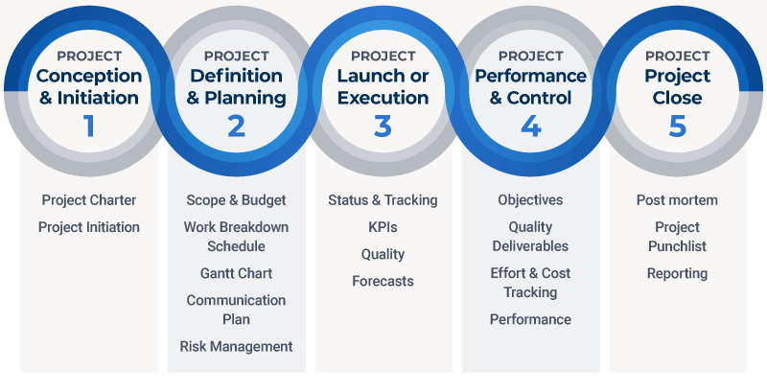

Fig. 5 Phases of Project Management (by [Kate Eby](https://www.smartsheet.com/content-center/author/Kate Eby) on May 29, 2018)

There are diversified types of management method that have been applied in the area of project management, and Toljaga-Nikolic et al. (2017) believe that “the project management approaches should be prepared to deal with requirements of different level of completeness and changes during the project life cycle.” Therefore, in the case of this project, agile project management methodologies will be used. Agile is an emerging project management model that simplifies the cumbersome processes and documentation of traditional project management. When requirements are not clear, usable software can be developed in a shorter cycle to help customers describe their requirements. And through multiple iterations of requirements to enrich the product features of the project.

The main purpose of this project is to develop a VLPR system, so plate recognition function is have priority rather than the others function. However, other functional requirements and specific algorithms are not well defined, so in order to reduce the risk of requirements, continuous analysis, development and evaluation are required to complete the project. Overall, the product of this project should have good functionality, a high-efficiency algorithm model and high recognition accuracy.

Using the agile methodology, the core functionality is analysed and developed at first, and then the unclear requirements are developed iteratively once the main functionality has been implemented. And there is an evidence to support this point that “when the project goal is clear but the solution is missing some or most parts, then an agile approach should be applied in the project management.” Toljaga-Nikolic et al. (2017). As a consequence, agile method is very interactive and the whole project can be adjusted quickly that is suitable for this project.

Table...

|  |  |
| --- | --- |
| **Advantages and Disadvantages of Agile Method** | |
| **Advantages** | **Disadvantages** |
| **Risk Reduction:** Agile methods are an iterative, step-by-step approach that can predicts the success or failure of a project early, so the PMO can take corrective measures in time before project failure.  At least part of the project product is always available, so the project never ends up as a complete failure. | **Rely on Customer Interaction:** Since the whole project is designed according to the requirements provided by the clients, the agile approach is focused on customer participation. As a result, if they do not understand the product features, the process of production will go out of track. |
| **Predictable Results:** By understanding the productivity of developers, the development team can help the PMO to accurately predict the progress and outcome of the project. | **No Specific Goals:** It is easy to get off-topic and keep adding new functions during subsequent iterations. This means that there is no clear endpoint to project. |
| **Improving Product Quality:**  Users can modify their requirements as business needs change to establish a more suitable model.  Project customers, developers, product managers and Scrum leaders can monitor the progress of the project. | **Lack of Documentation Support:**  If there is a high turnover of project staff, this can make it difficult to maintain the project.  The sustainability, maintainability and scalability of the project are at greater risk. |

For the agile method, there is a [conclusion](D:/Dict/8.9.6.0/resultui/html/index.html" \l "/javascript:;) demonstrate that “in the comparative study of agile software development with other software development models we conclude that agile project is much better than other software development process in terms of productivity, performance, faster time cycles, risk analysis.” (Sharma et al., 2012). Although the agile methodology has many advantages in some project management, it also exists with some disadvantages. Table 1 provides a detailed analysis of the advantages and disadvantages of the agile method.

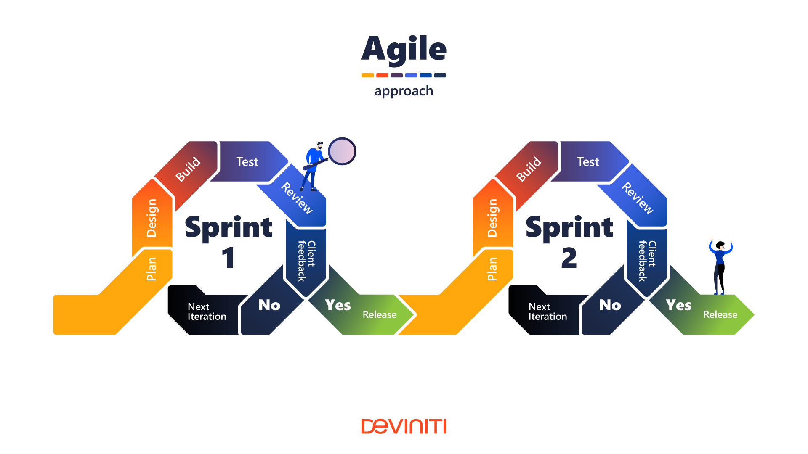

Fig. ....Agile Project Management Structure

https://blog.deviniti.com/agile-devops/requirements-documentation-project-management-approach/

However, taking full advantage of the benefits of agile development can minimise the negative effects it can have. This management method can provide a good solution to a project when the project's objectives are clear, the client is able to actively participate in the project and the project's activities are highly iterative. (Toljaga-Nikolic et al., 2017). Fig. shows the structure diagram of the agile approach, where the project becomes more complete and mature after many iterations.

Basically, using project management software is a good solution to increase productivity. In this project, GIT will be used as a project management tool and the content and results of the project will be uploaded to the GitHub platform. On GitHub, developers can coordinate, track and update the project's work progress, thus keeping the project transparent and on schedule.

## 3.2 Software Development

During the development stage, the software will be developed using an iterative and incremental approach. Because the core of the system's functionality is to implement accurate licence plate recognition, it is possible to carry out requirements analysis, design, implementation and testing operations several times on the basis of the core functionality. This method has a higher development efficiency and success rate in the software development process. And it is significant that the Multiple iterations of the software development cycle can be in operation at the same time during software development.

In order to obtain the functionality of the system and the technical approach used, a detailed analysis of the relevant project, technical and functional requirements will be carried out using data study and survey methodology. The product of this project does not have many functional requirements and it should be focused on algorithmic research, so the questionnaires and interviews approach is not suitable for the development of this project. Instead, the approaches allow for an understanding of the application scenarios, functional requirements and the latest technologies used in the project from the relevant literature. Moreover, the methods are academic and efficient because it targets academic journal articles or official data. The survey findings are evaluated to come up with comprehensive and descriptive results. (Wohlin et al., 2006).

## 3.3 Tool-sets and Machine Environments

### 3.3.1 Tools-Sets

In this chapter, an overview and evaluation of the various development tools and software used in the development and management of this project are presented. In terms of project development, I chose Python as the programming language and Visual Studio Code (VS Code) is the integrated development environment (IDE).

**Python (3.9.2):** The vehicle integrated information collection system project is based on computer vision (CV) technology, and techniques from other disciplines related to CV are also used in the project, such as image processing, machine learning, deep learning, etc. The main programming languages currently used in the computer vision area include C++, and Python, they are compared and analyzed in Table 1. The benefit of developing in Python is that it has an excellent Python developer community, where developers can find a wealth of content about these libraries with a simple search. (Sarkar et al., 2018). Therefore, the Python 3.9.2 was finally chosen to develop the project.

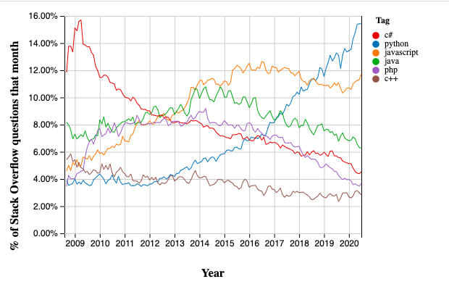

Table 1: The latest annual ranking of popular programming languages by IEEE Spectrum

Table....

|  |  |
| --- | --- |
| **The Comparison of Programming Languages** | |
| **Language** | **Summary of each Programming Language** |
| **Python** | As can be seen from Figure 1, Python is currently the most used and popular programming language, also in the field of machine learning and deep learning, it is currently the most widely used language, so there are many open source projects and courses for learning. Especially for image processing, OpenCV supports a Python interface; for scientific computing, Anaconda also provides a rich package interface. On the other hand, Python has a powerful and effective machine learning library - scikit-learn, and exhaustive resource (numpy, matplotlib).  However, Python is not suitable for embedded development because of inefficient execution. When using a large dataset to train a deep network model, the running speed is very slow and takes up too much memory for too long to do other work. |
| **C++** | In the field of vision and image processing, C++ favours underlying development, so suitable for larger projects and code execution with high efficiency. C++ is similar to Python, also supports interfaces to third-party tools such as OpenGL、EmguCV、OpenCV etc. But the inefficient development that is only suitable for commercial and industrial projects, does not apply to the development of this project. |

**Visual Studio Code:** Python has a variety of integrated development environment (IDE) for professional development, such as PyCharm, Visual Studio Code, and Vim etc. It is indicated in Table 2. That the differences between each software. According to the current computer configuration and project requirements, I have chosen VS Code as the IDE for my project development.

Table....

|  |  |
| --- | --- |
| **The Comparison of Integrated Development Environment** | |
| **Language** | **Summary of each IDE** |
| **PyCharm** | For PyCharm IDE, one of the most widely used IDEs for the Python programming language. It has many functions to help users improve their productivity when developing in the Python language. However, for a more full-featured IDE and to support web development you need to use the professional version of Pycharm, which is available for a fee. For the downside, PyCharm takes up a lot of RAM on your computer and is not ideal for low configuration computers. |
| **VS Code** | T[he](D:/Dict/8.9.6.0/resultui/html/index.html" \l "/javascript:;) [other](D:/Dict/8.9.6.0/resultui/html/index.html" \l "/javascript:;) [one](D:/Dict/8.9.6.0/resultui/html/index.html" \l "/javascript:;) [is](D:/Dict/8.9.6.0/resultui/html/index.html" \l "/javascript:;) VS Code, which is a free open source IDE created by Microsoft for development in Python and other programming languages, with a rich ecosystem of plugins that can be easily searched for, installed and managed directly in the VS Code editor. Moreover, VS Code is more open source than sublime, faster than the Atom and more lightweight than Webstorm. |

**OpenCV (4.5.1):** A significant cross-platform computer vision library- OpenCV (Open Source Computer Vision Library) was also used in the development process. It can be used to develop real-time image processing, computer vision and pattern recognition programs because a variety of basic image processing functions and vision algorithms are encapsulated in the library. More importantly, OpenCV is open source and provides an interface to Python for project development efficiently.

**Tensorflow (2.5.0):** It is quite important to choose suitable Python Libraries for deep learning project because a suitable framework can play a positive role in the project. At [present](D:/Dict/8.9.6.0/resultui/html/index.html" \l "/javascript:;), there are five most popular machine learning libraries, which respectively are TensorFlow, Keras, PyTorch, Caffe2, Scikit-learn. The two most mainstream frameworks, TensorFlow and PyTorch are compared and analysed in Table. In TensorFlow 2.0, Keras is the official high-level API for TensorFlow, allowing for fast and easy model design and training. And the Caffe2 incorporates all of its code into the PyTorch framework.

Although PyTorch is easier for beginners to learn and master, and I have never used any machine learning framework before, I have chosen TensorFlow as the machine learning framework for this project because it supports not only deep learning but also reinforcement learning and other algorithms. For the license plate recognition project, “deep neural networks have achieved breakthrough performance on computer vision tasks such as recognizing objects in photographs, and these tasks are a key application for TensorFlow at Google” (Abadi et al., 2016). In addition, it has complete official documents and learning materials to better support the development of this project.

|  |  |
| --- | --- |
| **The Comparison of Machine Learning Frameworks** | |
| **Language** | **Summary of each framework** |
| **TensorFlow** | TensorFlow is an end-to-end open-source platform for machine learning. It is clear from Fig. That TensorFlow is the most widely used machine learning framework. Because it plays a vital role in the fields of deep neural networks, natural language processing (NLP), image, text, and speech recognition. However, it also has some drawbacks, since TensorFlow computational graphs are written in Python, large neural network models need to take a long time to compile. |
| **PyTorch** | PyTorch is a rival to TensorFlow that was created by Facebook AI Research. It has the advantage of supporting dynamic computational graph models, also known as define-by-run. Also PyTorch is easy to learn because of the large number of pre-trained models. |

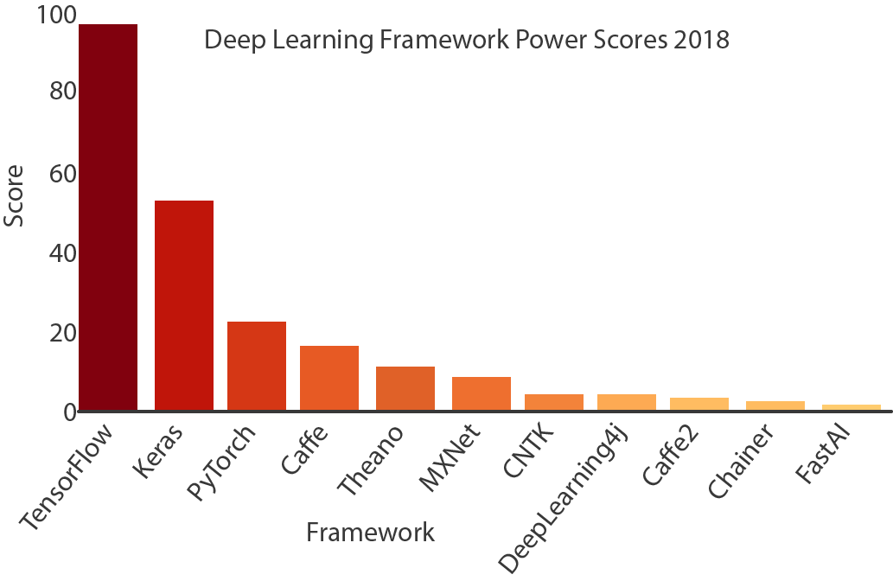

Fig. Top 5 Deep Learning Frameworks to Watch in 2018 - Towards data science

**Labelme:** Labelme is an image annotation tool developed by Massachusetts Institute of Technology (MIT), which can be used to create custom annotation tasks or perform image annotation. The main use in this project is for labelling semantic segmentation datasets of license plates. The image data is annotated in the project using lableme to generate the .json file corresponding to the image. And the reason why I chose this is that can execute the built-in function labelme_json_to_dataset under Labelme to batch convert images to the corresponding x_json file.

**Project Management - GIT:** GIT is a free and open source distributed version control system (VCS), which can handle software project management efficiently. A similar VCS to GIT is Apache Subversion (SVN), the main difference being that GIT is distributed, while SVN is not. And I selected GIT to manage the development of the project for several reasons. Blischak et al (2016) also indicated the same point that “By tracking your code development with a VCS and hosting it online, you are performing science that is more transparent, reproducible, and open to collaboration”.

* Repository localisation, offline commit support, relative independence without impacting collaborative development.
* GIT only generates a .git directory for each project, where all the project's version control information is located, unlike SVN which generates .svn directories under each directory.
* Supports quick branch switching for easy merging, and merges files faster than SVN.
* GIT's content storage uses the SHA-1 hash algorithm. This ensures the integrity of the code content.
* The ability to upload project code remotely to the GitHub platform, allowing efficient development in different environments and platforms

### 3.3.2 Machine Environments

The VLPR system has various application scenarios that mainly used in traffic monitoring, smart parking lots, vehicle access management, and toll station to recognize the license number. The development machine environment required for the system varies depending on the user requirements and application scenarios. Usually the VLPR system is used as a GUI on a Windows PC, but it can also be used for embedded development in a Linux environment.

The project will be developed on Windows 10 operation system, which supports many IDEs, machine learning frameworks and computer vision libraries, among other development tools. This makes it easy to get started with the software development process and does not require the installation of a Linux system or the configuration of a development environment. However, this does not mean that developing on Windows is better than on Linux. Most of the open-source AI platforms are built on Linux, and Python can perform at its best on Linux because of the efficiency of parallel computing and resource pool management on Linux systems, which can be adapted to different production environments.

Table ...

|  |  |  |
| --- | --- | --- |
| **Comparison of Development Machine Environments** | | |
|  | **Windows** | **Linux** |
| **Development Environment** | Windows 10 - 64 bit  CPU: i5-8300  GPU: 4 GB  RAM: 16 GB | Linux: 5.4.0-31-generic  Ubuntu 20.04 LTS - 64 bit  CPU: i5-8300  GPU: 4 GB  RAM: 16 GB |

## 3.4 Research Methods

### 3.4.1 The Aim of this Research

In terms of vehicle information collection system, the conventional identification methods do not satisfy the demands of today's society and therefore the latest technologies and algorithms have to be implemented in this system to achieve efficient, rapid and highly accurate identification functions. Therefore, the research for this project is to compare the advantages and disadvantages of different algorithms, to analyse their technical principles and finally to complete the research project based on computer vision techniques.

### 3.4.2 The Methodology of this Research

In software engineering research, quantitative analysis methods are usually more widespread, while qualitative analysis methods are often used in combination with other methods. However, in this research project, the qualitative analysis method will be used in the course of the research, and qualitative analysis is a method of inferring the nature and trend of things based on the subjective judgment and analytical ability.

Since qualitative analysis is a subjective description in written language, it is not applicable in large-scale social research. And the previous research by DeFranco and Laplante (2017) has demonstrated that “most of those papers did not follow a systematic process during the qualitative analysis. This finding is concerning as this deficiency in research analysis procedure may reduce the validity and/or completeness of the qualitative results”. Therefore, in order to improve the validity and reliability of this research, data collection and analysis should be carried out with purposes, directions and plans.

### 3.4.3 Collecting and Analyzing Research Data

In the case of qualitative research, there are various approaches to collecting data and information. In this research project, the literary research method will be used as a specific research method for qualitative analysis. It is efficient that collect subjective, self-reported data and determine questions about qualitative research through published academic journal articles, research papers, theses and books, etc. There are 20 referenced papers in this research, mainly from technical literature search platforms such as Google Scholar, Microsoft Academic, and IEEE Xplore. And the main content of the selected literature is relevant to the research objectives of this project, which is the study of the VPLR algorithm.

The literature analysis method is an indirect, non-interventionist survey. It only studies and examines a variety of literature, but does not contact the respondent or interfere with any of the respondent's responses. This avoids the various response errors that can occur during the interaction between investigator and respondent, which usually happen in direct surveys. Snyder (2019) illustrated that “the literature analysis method provides the basis for building a new conceptual model or theory, and it can be valuable when aiming to map the development of a particular research field over time”. Moreover, the documentary analysis method is primarily a written survey and is not limited by time or space, and if the literature collected is authentic and scholarly, it can provide more accurate and reliable information than interview methods.

**Chapter 4**

# Design, Development and Evaluation

## 4.1 Software Development Projects

### 4.1.1 Requirements Collection and Analysis

The vehicle integrated information collection system has a wide range of application scenarios, such as the vehicle's traffic management, freeway charge, traffic. therefore, the system needs to combine different application scenarios to collect the relevant functional and non-functional requirements. Generally speaking, functional [requirement](D:/Dict/8.9.6.0/resultui/html/index.html" \l "/javascript:;)s such as number plate recognition, vehicle type recognition, colour recognition and vehicle counting are the most common in these systems.

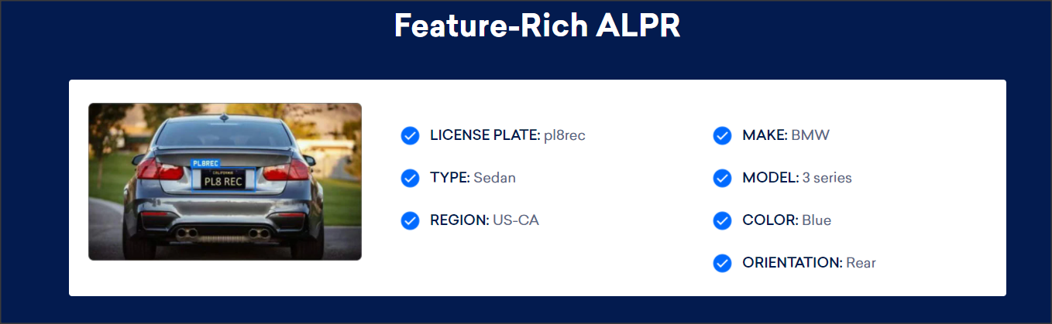

Fig. VLPR Features from Plate Recognizer

As can be seen from Fig., these functional requirements can be obtained intuitively through the analysis of some commercial VLPR or ALPR projects. There are seven functions in this VLPR system, including license plate, make, type, region, model, colour, and orientation. However, this example is a commercial project, whereas the current project is a research project, so the functionality of the product of this project is different. [For](D:/Dict/8.9.6.0/resultui/html/index.html" \l "/javascript:;) [instance](D:/Dict/8.9.6.0/resultui/html/index.html" \l "/javascript:;), the system is intended for using in China, so the region identification function is redundant and the orientation function is not practical for the system. So these two functions should be removed.

**Functional Requirements**

Table ...

|  |  |
| --- | --- |
| **Functions** | **Description** |
| Plate  Positioning | Before the plate recognition, the area of the plate needs to be located in the vehicle image and extracted for the next step in the process. |
| Plate  Recognition | Individual processing of the located plate area to identify the license plate number. |
| Inclination  Correction | Due to the skewed position of some vehicle plate images, it is impossible to identify the number plate accurately. Therefore, it is very remarkable that the plate correction function contributes to the accuracy of the system. |
| Make  Recognition | Identify the make of a car by its image. Such as Volkswagen, Audi, Chevrolet... |
| Model Recognition | Identify the specific series and model of the car brand and the approximate time to market. |
| Colour  Recognition | Identifying the body colour of cars. Such as white, dark, red, blue. However, if the bodywork has multiple colours, it can be difficult to distinguish and identify |
| Vehicle  Counting | Identify the vehicles and mark them with a rectangular frame, and counting the number of vehicles passing in a video of traffic. |
| Multiple Vehicles Recognition | Accurate positioning and identification of multiple vehicles when they are shown in an image. |

**[Non-functional](D:/Dict/8.9.6.0/resultui/html/index.html" \l "/javascript:;) [Requirements](D:/Dict/8.9.6.0/resultui/html/index.html" \l "/javascript:;)**

|  |  |
| --- | --- |
| **Functions** | **Description** |
| Usability  Requirement | The system should to be designed with an aesthetically pleasing User Interface (UI), and with human-computer interaction, operational logic. |
| Availability Requirements | The system should be available at all times and not be unavailable because of lack of internet or other reasons |
| Reliability  Requirement | The VLPR system should have an accuracy of over 90% in recognize license plates and other information about the vehicle. |
| Maintainability  Requirement | The functionality of the system can be upgraded or maintained for different usage scenarios. |
| Data Safety Requirement | In the system, the images of the cars used for identification and the final identification results should be stored securely and not leaked to the public. |

Table ...

**Development Environment**

|  |  |  |
| --- | --- | --- |
| **Hardware [Requirements](D:/Dict/8.9.6.0/resultui/html/index.html" \l "/javascript:;)** | | |
| **Device** | **Basic Configuration** | **Recommended Configuration** |
| CPU | Inter: i3 - 9320  AMD: R5 - 2500X | Inter: i7 - 9700  AMD: R7 - 2700 |
| GPU | 4 GB | 8 GB |
| CPU Frequency | 2.5 ~ 2.9 GHz | 3.5 GHz |
| RAM | 8 GB | 16 GB |
| Disk Volume | 128 GB | 512GB |

Table ...

### 4.1.2 Design and Programming

### 4.1.3 Testing and Evaluation

### 4.1.4 Operation

## 4.2 Research Projects

If your project includes primary research components it is expected that you present this work in a manner appropriate to a scientific report:

1. Participant recruitment
2. Evidence that ethical procedures have been followed
3. Study design (short summary of research methods section) – including hypotheses/research question as appropriate
4. A detailed description of the procedure
5. Results of experiment
6. Analysis of results. Consider the results of your work with respect to both your own specific hypotheses/research question and wider context identified in your literature review.

**Chapter 5**

# Conclusions

The results from this project indicate that ...

**Chapter 6**

# Reflective Analysis

The project went well ...

# References

Ascar, Davix.X., Judson, D. and Pittala, S.K. (2020) ‘SegNet Approach for Vehicle License Plate Localization.’ In: *2020 Seventh International Conference on Information Technology Trends (ITT)*, pp. 113-117, doi: 10.1109/ITT51279.2020.9320883.

Blischak, J.D., Davenport, E.R. and Wilson, G. (2016) A Quick Introduction to Version Control with Git and GitHub F. Ouellette (ed.). *PLOS Computational Biology*, 12(1) e1004668.

Chen, P., Bai, X. and Liu, W. (2014) Vehicle Color Recognition on Urban Road by Feature Context. *IEEE Transactions on Intelligent Transportation Systems*, 15(5) 2340–2346.

Chowdhury, P.N., Shivakumara, P., Raghavendra, R., Pal, U., Lu, T. and Blumenstein, M. (2020) A New U-Net Based License Plate Enhancement Model in Night and Day Images. *Lecture Notes in Computer Science*, 749–763.

Glasmachers, T. (2017) Limits of End-to-End Learning. *arXiv:1704.08305 [cs, stat]*, Available from: <https://arxiv.org/abs/1704.08305> [Accessed 15 April 2021].

detectRecog (2020) *CCPD (Chinese City Parking Dataset, ECCV)* Available from: <https://github.com/detectRecog/CCPD> [Accessed 8 February 2021].

Goodfellow, I.J., Bulatov, Y., Ibarz, J., Arnoud, S. and Shet, V. (2014) Multi-digit Number Recognition from Street View Imagery using Deep Convolutional Neural Networks. *arXiv:1312.6082 [cs].*

Maglad, K. (2012) A Vehicle License Plate Detection and Recognition System. *Journal of Computer Science*, 8(3) 310–315.

Mithe, R., Indalkar, S. and Divekar, N. (2013) Optical character recognition. *Journal of Information & Communication Technology (IJRTE), 2(1), 72-75*

Islam, N., Islam, Z. and Noor, N. (2016) A Survey on Optical Character Recognition System. *ArXiv*, 10(2). Available from: <https://www.semanticscholar.org/paper/A-Survey-on-Optical-Character-Recognition-System-Islam-Islam/6bdb84c02fd56c209c893efda7df083c9ae5c4df> [Accessed 10 February 2021].

Ronneberger, O., Fischer, P. and Brox, T. (2015) U-Net: Convolutional Networks for Biomedical Image Segmentation. *Lecture Notes in Computer Science*, 234–241.

Xu, Z., Yang, W., Meng, A., Lu, N., Huang, H., Ying, C. and Huang, L. (2018) ‘Towards End-to-End License Plate Detection and Recognition: A Large Dataset and Baseline’.In: *Proceedings of the European conference on computer vision* (ECCV) pp. 255-271.

Qin, S. and Liu, S. (2020) Towards End-to-end Car License Plate Location and Recognition in Unconstrained Scenarios. *arXiv:2008.10916 [cs]*, Available from https://arxiv.org/abs/2008.10916v1 [accessed 16 April 2021].

Siqi, S., Nanting, L., Yanjun, M. and Liping, Z. (2020) Robust Recognition of Truck License Plate in Mine Environment. *IEEE Xplore*, 36–42. Available from: <https://ieeexplore.ieee.org/abstract/document/9361802> [Accessed 19 March 2021].

Zhong, Y., Liu, Y., Luo, F. and Zhang, H. (2020) A Novel Integrated Neural Network for License Plate Detection And Recognition. *2020 Chinese Automation Congress (CAC)*, Available from: <https://ieeexplore.ieee.org/abstract/document/9326612> [Accessed 12 March 2021].

Jun-Wei Hsieh, Shih-Hao Yu, & Yung-Sheng Chen. (2002). Morphology-based license plate detection from complex scenes. *Object Recognition Supported by User Interaction for Service Robots*. doi:10.1109/icpr.2002.1047823

Koval, V., Turchenko, V., Kochan, V., Sachenko, A. and Markowsky, G. (2003) Smart license plate recognition system based on image processing using neural network. *Second IEEE International Workshop on Intelligent Data Acquisition and Advanced Computing Systems: Technology and Applications, 2003. Proceedings*. doi:10.1109/idaacs.20031249531

Ghasrodashti, E.K. and Yazdi, M. (2010) Recognizing Persian license plates in digital zoom condition. *2010 2nd International Conference on Education Technology and Computer*, pp. V3-208-V3-212, doi: 10.1109/ICETC.2010.5529561.

Park, H., Lee, D., Lim, M., Kang, Y., Oh, J. and Kim, J.-H. (2018) A Fast-Converged Acoustic Modeling for Korean Speech Recognition: A Preliminary Study on Time Delay Neural Network. *arXiv:1807.05855 [cs, eess]*, Available from: <https://arxiv.org/abs/1807.05855> [Accessed 15 April 2021].

Rachmadi, R.F. and Purnama, I.K.E. (2018) Vehicle Color Recognition using Convolutional Neural Network. *arXiv:1510.07391 [cs]*, Available from: <https://arxiv.org/abs/1510.07391> [Accessed 9 March 2021].

Sarkar, D., Bali, R. and Sharma, T. (2018) *Practical Machine Learning with Python*. Berkeley, CA: Apress.

Abadi, M., Barham, P., Chen, J., Chen, Z., Davis, A., Dean, J., Devin, M., Ghemawat, S., Irving, G., Isard, M., Kudlur, M., Levenberg, J., Monga, R., Moore, S., Murray, D., Steiner, B., Tucker, P., Vasudevan, V., Warden, P. and Wicke, M. (2016) *TensorFlow: A System for Large-Scale Machine Learning.* USENIX.

Toljaga-Nikolic, D., Petrovic, D. and Mihic, M. (2017) How to choose the appropriate project management approach? *2017 12th International Scientific and Technical Conference on Computer Sciences and Information Technologies (CSIT)*, Available from: [https://sci-hub.do/https://ieeexplore.ieee.org/abstract/document/8099448/](https://sci-hub.do/https:/ieeexplore.ieee.org/abstract/document/8099448/) [accessed 22 April 2021].

Sharma, S., Sarkar, D. and Gupta, D. (2012) Agile Processes and Methodologies: A Conceptual Study. *International Journal on Computer Science and Engineering,* Available from: <https://www.yashada.org/yash/egovcii/static_pgs/TC/IJCSE12-04-05-186.pdf> [accessed 22 April 2021].

Wohlin, C., Höst, M. and Henningsson, K. (2006) Empirical Research Methods in Web and Software Engineering. *Web Engineering*, 409–430. Available from https://link.springer.com/chapter/10.1007/3-540-28218-1_13 [accessed 30 April 2021].

DeFranco, J.F. and Laplante, P.A. (2017) A content analysis process for qualitative software engineering research. *Innovations in Systems and Software Engineering*, 13(2-3) 129–141.

Snyder, H. (2019) Literature review as a research methodology: An overview and guidelines. *Journal of Business Research*, 104(104) 333–339. Available from .