AI Vocabulary Trainer – System Understanding & Requirements

1. Purpose of the Application
The application is a web‑based vocabulary training platform designed to help users learn and practice advanced English vocabulary through contextual writing and AI evaluation.

Unlike traditional flashcard systems, this application requires the user to write meaningful sentences or paragraphs using given words. An AI model evaluates the correctness of word usage, grammar, and contextual meaning.

The system adapts the future learning sessions based on the user’s performance using a spaced‑repetition algorithm.

2. Technology Stack
Frontend:
• HTML + CSS + JavaScript
• Runs locally using a lightweight HTTP server (e.g., npm http-server on port 9000)

Backend:
• Google Apps Script (GAS)
• Acts as the API layer

Database:
• Google Sheets

AI Evaluation:
• Gemini 2.5 Flash API (Google Generative Language API)

3. Database Structure (Google Sheets)
Users Sheet
Columns:
1. id
2. email
3. password
4. role
5. overall_accuracy
6. last_login

SessionHistory Sheet
Columns:
1. userId
2. sessionId
3. date
4. session_accuracy
5. words_attempted

WordAccuracy Sheet
Columns:
1. userId
2. word
3. usage_count
4. avg_accuracy
5. last_used
6. next_review

VocabSheet
Columns:
1. No
2. Word
3. Meaning

4. Backend API (Google Apps Script)
GET APIs

1. getSessionWords
Returns 17 vocabulary words for the session based on:
• words due for review (spaced repetition)
• weak words (low accuracy)
• new words

Response example:
{
"words":[
{"word":"Deride","meaning":"to mock or ridicule"},
{"word":"Immanent","meaning":"existing within something"}
]
}

POST APIs

1. register
Registers a new user.

2. login
Authenticates user using username/email + password.

3. evaluateAnswer
Receives:
• words used in round
• user's paragraph

Calls Gemini API and returns:
{
"words": { "Deride":90, "Immanent":80 },
"grammar_accuracy":85,
"overall_context_accuracy":82,
"suggested_correction":"Improved paragraph"
}

4. endSession
Stores session results and updates learning statistics.

5. Learning Session Structure
Each session contains 17 unique vocabulary words.

Rounds follow a sliding‑window pattern:

Round 1 → words 1‑5
Round 2 → words 4‑8
Round 3 → words 7‑11
Round 4 → words 10‑14
Round 5 → words 13‑17

This overlapping design reinforces memory because words appear in multiple rounds.

6. Spaced Repetition Logic
After evaluation, each word receives an accuracy score from the AI.

Based on accuracy, the next review date is scheduled:

Accuracy ≥ 90 → review in 30 days
Accuracy ≥ 80 → review in 14 days
Accuracy ≥ 70 → review in 7 days
Accuracy ≥ 50 → review in 3 days
Accuracy < 50 → review in 1 day

The 'next_review' column determines when a word reappears in future sessions.

7. Session Flow
1. User logs in.
2. User starts a session.
3. Frontend requests 17 words from GAS.
4. Words are shown in round‑based bubbles.
5. User writes a paragraph using the words.
6. Frontend sends answer to GAS.
7. GAS calls Gemini API for evaluation.
8. AI returns accuracy scores.
9. Results are stored during session.
10. When session ends:
• SessionHistory updated
• WordAccuracy updated
• next_review scheduled

8. Frontend State Variables
currentRoundIndex
applyQuestionCount
sessionWordsData
sessionResults
uniqueSessionWords
attemptedQuestions

These variables track session progress and must be reset at the start of every session.

9. Important Design Rules
• Each session must contain 17 unique words.
• No duplicate words should appear in a session.
• Review words may hide meanings to encourage recall.
• New words always show meanings.
• AI evaluation is strict about contextual usage of vocabulary.

10. Future Improvements
Possible enhancements:
- Level progress indicator in the UI
- Leaderboards or progress tracking for the user logged in.
- “Delete account” functionality.
- Add loading and info after hitting SignUp while new registration
- Admin dashboard for vocabulary management

We need to implement Levels for user to start from easy to hard

Level | Name | Difficulty | Description
1 | Basic | Very Easy | Common everyday English
2 | Intermediate | Easy | Standard educated vocabulary
3 | Advanced | Medium | Academic vocabulary
4 | Expert | Hard | Rare or sophisticated words
5 | Master | Very Hard | Literary / GRE-level vocabulary

Mastered Words | User Level
0–79 | Level 1
80–199 | Level 2
200–399 | Level 3
400–699 | Level 4
700+ | Level 5

Current Logic
A word is considered mastered if:
usage_count >= 3
AND
avg_accuracy >= 85

Meaning:
Condition | Explanation
usage_count ≥ 3 | The user has used the word in at least 3 evaluated sessions
avg_accuracy ≥ 85 | The AI judged the average contextual accuracy ≥ 85%

The gemini AI is taking grammar too seriously and considering it too serious in giving percentages.
I want it to give suggestions but don't consider those mistakes for giving scores.
For scores, only usage accuracy that too is it contextual or not only that matters.
Rest of the suggestions are just to improve our understanding and knowledge.
We need to change the prompt according to that.

User profile Modal Window Design:
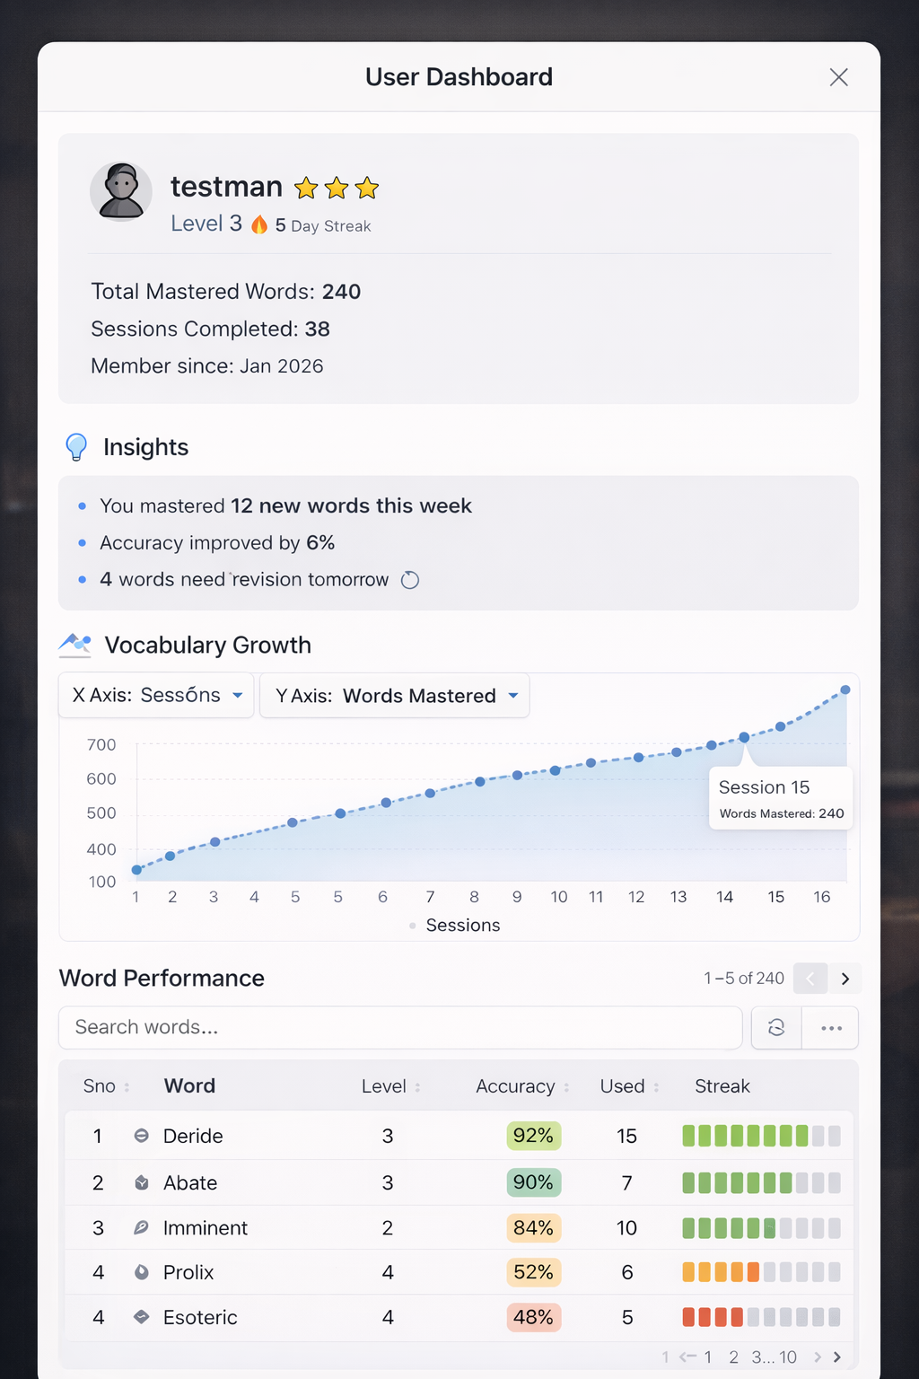

1️⃣ Profile Card (Top Area)
Purpose: identity + motivation
👤 testman
Level 3 ⭐⭐⭐ 🔥 5 Day Streak
Total Mastered Words
Sessions Completed
Member since

2️⃣ Insights Panel
This is where your dashboard becomes special.
Example:
INSIGHTS
• You mastered 12 words this week
• Accuracy improved by 6%
• You are strongest in Level 2 vocabulary
• 3 words need revision
Users love human-like feedback instead of raw numbers.

3️⃣ Progress Graph
Graph style (as you described):
dotted curved line
small circle markers
shaded transparent fill under curve
700 |
600 | ●
500 | ●
400 | ●
300 | ●
200 | ●
100 |
└────────────────────────
1 2 3 4 5 6
Sessions

Controls above graph:
X Axis ▼ Y Axis ▼
Sessions Words Mastered
Date Accuracy

Word Review Table:
This is the largest section.
Table Header
Search: [_____________]

Columns:
Sno
Word
Level
Accuracy
Used
Streak

Example row:
1 Deride 3 92% 4 ████████

Color coding (important)
Accuracy color:
90–100% → green
70–89% → yellow
<70% → red
Users immediately see weak words.

Horizontal Streak Bar:
Example rendering:
████████░░ 8
Meaning 8 successful uses consecutively.
Visually intuitive.

Modal Layout:
Modal should feel like a real dashboard window.
width: 900–1100px
height: 85vh
scrollable
soft shadow
rounded corners

Overlay background:
rgba(0,0,0,0.4)

Visual Hierarchy:
Important rule:
1️⃣ Profile
2️⃣ Insights
3️⃣ Graph
4️⃣ Table
This matches how people mentally process progress.

Who am I?
↓
How am I doing?
↓
How am I improving?
↓
What exactly did I learn?
Perfect cognitive flow.

One Small Feature That Would Make This Amazing:
Add graph hover tooltip.
When hovering a point:
Session 12
Words Mastered: 84
Accuracy: 79%
Date: May 2
This makes the graph feel alive.

NEW LOGIC

Now the Big Question — How to Redefine User Levels?
Right now your level is based on total mastered words:
Level | Words in Level | Master Needed | Accuracy
L1 | 150 | 50 | 70%
L2 | 200 | 70 | 75%
L3 | 250 | 90 | 80%
L4 | 250 | 90 | 82%
L5 | 150 | 50 | 85%

1. SESSION ENGINE (Final)
You already discovered this yourself — 5 rounds is boring.
Final Session:
Round | Words | Type
Round 1 | 5 | Mixed Levels
Round 2 | 5 | Weak Words
Round 3 | 5 | Review + New
Total = 15 words per session → Perfect.

Round-wise selection:
Round | Selection Logic
Round 1 | 1 word from each level (L1–L5)
Round 2 | 5 weak words
Round 3 | 2 new + 2 review + 1 random
This ensures:
- No forgetting
- No boredom
- Continuous progress

3. SPACED REPETITION (Keep Your Existing One)
Already defined in your system:
Accuracy | Next Review
≥ 90 | 30 days
≥ 80 | 14 days
≥ 70 | 7 days
≥ 50 | 3 days
< 50 | 1 day
Keep this exactly.

4. MASTERED WORD DEFINITION (Final)
A word is mastered if:
usage_count ≥ 3
AND avg_accuracy ≥ 85
AND last_used within 45 days
This ensures:
- Used multiple times
- Used correctly
- Not forgotten

5. USER LEVEL ENGINE (Final)
Level must depend on both quantity and accuracy (your requirement).
So:
Each level has:
Level | Words in Level
Level 1 | 150
Level 2 | 200
Level 3 | 250
Level 4 | 250
Level 5 | 150
User level rule:

Level | Mastered Words Needed | Accuracy Needed
Level 1 | 50 or less(if less is there) | 70%
Level 2 | 70 or less(if less is there) | 75%
Level 3 | 90 or less(if less is there) | 80%
Level 4 | 90 or less(if less is there) | 82%
Level 5 | 50 or less(if less is there) | 85%
User level = highest level where both conditions satisfied.

Level | Total Words | Designed Limit | Effective Limit
1 | 21 | 50 | 21
2 | 213 | 80 | 80
3 | 2304 | 120 | 120
4 | 2526 | 150 | 150
5 | 681 | 100 | 100

6. VERY IMPORTANT — Session Composition Rule
To maximize memory:
Type | %
New words | 20%
Weak words | 40%
Review words | 40%
For 15 words:
Type | Words
New | 3
Weak | 6
Review | 6
That’s exactly your 3 rounds model.

7. FINAL SYSTEM FLOW
When user starts session:
Step 1 — Get words due for review
Step 2 — Get weak words
Step 3 — Get new words
Step 4 — Fill remaining with random words
Step 5 — Distribute into rounds

8. FINAL ALGORITHM (You Can Implement This)
Start Session
Round 1:
Pick 1 word from each level (priority: review > weak > new > random)
Round 2:
Pick 5 weak words
Round 3:
Pick 2 new words
Pick 2 review words
Pick 1 random word
Total = 15 words

9. FINAL PROGRESS METRICS (Show in Dashboard)
Metric | Meaning
Level | Difficulty ability
Total Mastered Words | Vocabulary size
Accuracy | Skill
Streak | Consistency
Words Due | Revision load

Round | Level | Word Type
1 | L1 | Review
1 | L2 | Weak
1 | L3 | New
1 | L4 | Review
1 | L5 | Random
2 | L2 | Weak
2 | L3 | Weak
2 | L1 | Weak
2 | L4 | Review
2 | L5 | Weak
3 | L3 | New
3 | L4 | New
3 | L2 | Review
3 | L1 | Review
3 | L5 | Random

