Executive Summary: Willingness to Pay for School Quality
Group Number: 31
Principal Investigators: Kyle Poage (kpoage@wisc.edu), Harshit Goyal (hgoyal7@wisc.edu), Bobby Bui (hhbui2@wisc.edu), Abhay Mettu (mettu@wisc.edu)

1. Introduction and Research Question
This project investigates the relationship between local public-school quality and average home prices. Specifically, we seek to answer the following question: Are Wisconsin homebuyers willing to pay a premium for homes in higher-quality school districts, and does this relationship persist after controlling for neighborhood socioeconomic characteristics?
It is well-documented that higher-quality schools are associated with more expensive neighborhoods. However, as noted in the proposal phase, this simple association suffers from omitted variable bias. Wealthier neighborhoods tend to have more expensive homes and also tend to produce higher school accountability scores due to a variety of socioeconomic factors. If we do not account for these variables, our estimate of the "willingness to pay" for school quality will be upwardly biased.
As a part of our analysis, we have found that a “school premium” exists even when controlling for socioeconomic factors such as economic disadvantage, racial composition, and the percentage of students with disabilities. We found that a 1-point increase in a district’s “Overall Accountability Score” is associated with a $3,307 increase in average home price.

2. Data and Methodology
Our analysis leverages two primary datasets. First, we use the 2024-25 Wisconsin District Report Card Data, published by the Wisconsin Department of Public Instruction. This dataset provides the "Overall Accountability Score" for each school district, serving as our proxy for school quality. It also includes critical district-level demographic and socioeconomic indicators, such as the percent of economically disadvantaged students, racial demographics, and locale descriptions (e.g., Suburb, Rural, City).
Second, we employ Zillow Home Value Index (ZHVI) data for single-family homes and condos across ZIP codes, aggregated to the city level for the year 2024. By merging the district data with the ZHVI data on the city name, we obtained a final dataset of 326 school districts across Wisconsin.
To isolate the effect of school quality, we estimate a multiple Ordinary Least Squares (OLS) regression model. Our dependent variable is the average home value in the district's city. Our primary independent variable of interest is the district's Overall Accountability Score. To address omitted variable bias, we control for the percent of economically disadvantaged students (as a proxy for neighborhood income), racial composition, and percentage of students with disabilities. Our model is then:
$HomeValue\sim β_{0}{+β}_{1}Score+β_{2}EconDisadv+β_{3}PctWhite+β_{4}PctDisabilities+ϵ$
Where $HomeValue$ is the average home price, score is the Overall Accountability Score, $EconDisadv$ is the percentage of economically disadvantaged students, $PctWhite$ is the percentage of white students, and $PctDisabilities$ is the percentage of disabled students. The educational variables are measured at the district level, while home values are measured at the city level after aggregating ZIP-code ZHVI data.

3. Analysis and Technical Considerations
In our initial, naive regression (regressing home values solely on accountability scores), we found a strong and statistically significant positive relationship. This initial analysis suggested that a 1-point increase in Overall Accountability Score is associated with a $7,584 increase in average home value. As shown in Figure 1, an increase in school quality is visibly correlated with higher home values.
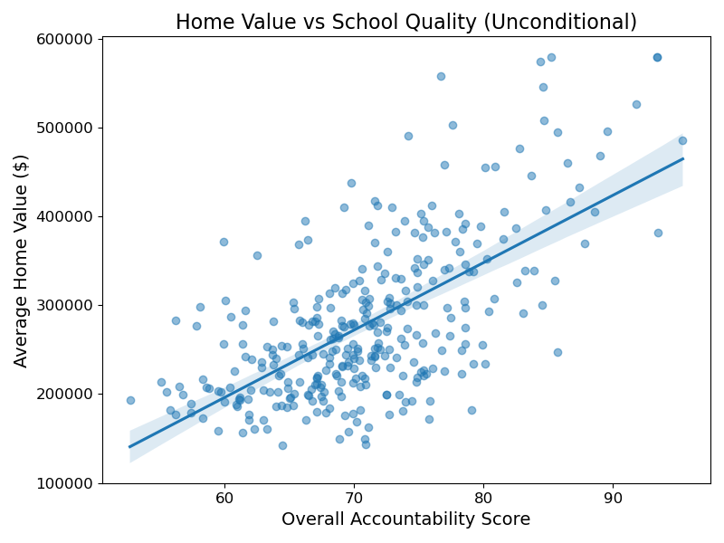
Figure 1: Unconditional relationship between Overall Accountability Score and Average Home Value.
However, recognizing the risk of omitted variable bias, we introduced our socioeconomic and demographic controls. The percent of economically disadvantaged students exhibited a strong negative correlation with home prices (Figure 2), confirming that lower-income neighborhoods correlate with cheaper housing.
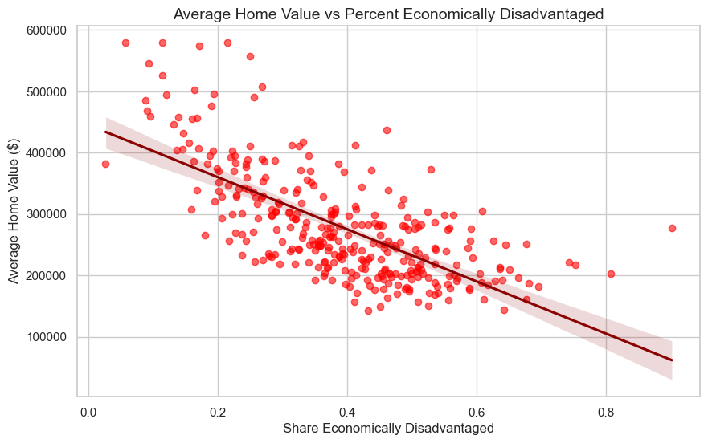
Figure 2: Relationship between Share Economically Disadvantaged and Average Home Value.
When the controls were included in the multiple regression model, the coefficient on the Overall Accountability Score dropped significantly. This reduction in the coefficient confirms our suspicion: a large portion of the apparent premium paid for "school quality" in the naive model was actually capturing differences in neighborhood wealth and demographics. Table 1 displays the full results of our extended multiple regression.

Table 1: Multiple OLS Regression Predicting Average Home Value
Variable | Coefficient | Standard Error | p-value
Overall Accountability Score | 3,306.90 | 591.33 | <0.001
Economically Disadvantaged | -394,400 | 34,400 | <0.001
Percent White | -213,900 | 21,600 | <0.001
Percent Students with Disabilities | 1,583.36 | 112,000 | 0.989
Constant | 371,100 | 59,700 | <0.001

*Note: The dependent variable is average home value in dollars. Percent variables are measured as proportions from 0 to 1.
Table 1 still shows a positive, statistically significant association between Overall Accountability Score and average home value, suggesting evidence of a school-quality premium even after adding these controls.
Two coefficients in the extended model warrant additional discussion. First, the Percent Students with Disabilities variable is statistically insignificant (p = 0.989), meaning it explains essentially no variation in home values once the other controls are included. Although the coefficient is positive, it was retained in the model for completeness and does not meaningfully affect the Score estimate. Second, the negative coefficient on Percent White (-$213,900) likely reflects the fact that predominantly white districts in Wisconsin tend to be rural or small-town communities, where home prices are lower independent of school quality. This is a compositional pattern in the data rather than a direct causal relationship.
Besides these two coefficients, the Economically Disadvantaged coefficient tells us that for every 1 percent increase in economically disadvantaged students, the average home value decreases by $3944, which is similar to the regression line in Figure 2 and confirms the correlation between low income neighborhoods and housing prices. Because of the variable being measured as a percent, it illustrates a compositional pattern just like the Percent White variable.

Technical Difficulties and Assumptions:
A primary technical challenge was merging the datasets. Zillow data is provided at the ZIP code and city levels, whereas educational data is at the district level. We aggregated ZIP-level ZHVI data to the city level and performed an inner join with the district data. This assumes that the boundaries of a school district roughly align with the city boundaries, which may introduce some measurement error in rural or sprawling suburban areas.
Another challenge was finding an accurate metric for school quality. An assumption we made was that Overall Accountability Score is a relevant indicator for school quality. We were willing to make this assumption because the Wisconsin Office of Educational Accountability uses overall accountability scores to group schools into categories based on performance.

4. Conclusion
Our analysis demonstrates that there is a significant positive correlation between home value and school quality, but the naive correlation is heavily overstated. Specifically, in our unconditional model, a one-point increase in a district's accountability score is associated with a $7,584 increase in average home values. However, after controlling for demographic and socioeconomic differences, most notably the percent of economically disadvantaged students, this premium drops by over 50% to $3,307. We interpret this positive association as suggestive evidence of a school-quality premium, although the estimate should not be interpreted as strictly causal because the model may still suffer from unobserved heterogeneity, such as localized property tax rates, household income, neighborhood amenities, or residential sorting. Nonetheless, the substantial reduction in the coefficient underscores the critical importance of causal inference techniques and appropriate controls when evaluating policy-relevant economic questions.
Future research could improve this analysis by matching home values to exact school district boundaries rather than city names, which would reduce measurement error from the data merge. It would also be useful to include additional controls such as household income, property tax rates, and neighborhood amenities, or to study changes over time to better separate the effect of school quality from other local characteristics.

References
[1] Wisconsin Department of Public Instruction. (2024). 2024-25 District Report Card Data. [Dataset].
[2] Zillow Group. (2024). Zillow Home Value Index (ZHVI) - Single-Family Homes and Condos. [Dataset]. Available at: zillow.com/data

