FIELD DESCRIPTIONS FOR

BASINS AT RISK WATER EVENT DATABASE
Shira Yoffe – February 2002

DRAFT – FOR DISTRIBUTION WITH THE WATER EVENT DATA

Citation for BAR Event Database: Yoffe, Shira and Kelli Larson. “Basins at Risk: Water Event Database Methodology” in Shira Yoffe. Basins At Risk: Conflict and Cooperation Over International Freshwater Resources, Ph.D. Dissertation, Department of Geosciences, Oregon State University, 2002.

DATE
This field indicates the date (or closest approximation thereof) of when an event occurred. All dates are entered in a month/day/year format. For meetings or events covering a period of days, often the last date of the event is used, with additional date information covered in the event summary or comments fields. If only a year is available for the event date, it is still entered in the database in a month, day, year format and the convention 01/01/year is used. If only a month and year are available, the 1st or 15th of the month is used as the day. A note is placed in the comment field that the date is an approximation.

DYAD_CODE
This field is a concatenation of the fields CCode1 and CCode2, in that order.

BCODE
A four letter code indicating the basin in which the event occurred. See the BAR Master Codes.xls file for the key to the basin codes.

#_OF_BASINS
The total number of basins associated with an event. A “99” indicates ‘basin not specified’.

LOCATION
More specific information (beyond the basin identification) of where an event occurred.

CCODE1 and CCODE2
These fields contain the three letter country codes for the countries involved in an event. For each pair of actors, the country code used in the CCode1 column is the one that comes first alphabetically, based on the country codes. See the BAR Master Codes List.xls file for the key to the country codes.

COUNTRY_LIST
Perhaps a more appropriate title for this column is entity_list. In this column are listed all the names of the countries or entities involved in an event (and not just the country pair for that row). Country names are spelled out and separated by a double dash (“--“). Information in ( ) following a country names provides more specific identification information. For example, China (Yunnan Province); German Dem. Rep. (East Germany); Turkey (Kurdish rebels).

#_OF_COUNTRIES
The total number of entities associated with an event. The number of countries should match the number of entities in the Country_List column.

BAR_SCALE
A numerical score ranging from –7 to +7, with –7 denoting the most negative events, 0 denoting neutral events, and + 7 denoting the most positive events. See Table describing Water Event Intensity Scale in Appendix 1 for descriptions of the BAR Scale categories.

EVENT_SUMMARY
A detailed description of the event.

ISSUE_TYPE1 and ISSUE_TYPE2
This field contains a number indicating the main issue area of an event. The Issue_Type1 column is for the main issue area and the Issue_Type2 column is for additional issue areas. See Appendix 2 for a list and description of Issue Areas.

COMMENTS
This field is used to provide additional information or clarification regarding the coding of an event, raise questions or concerns, or provide information regarding the event’s relationship to other events in the Event Database.

SOURCE_BAR
Indicates where we obtained the event information, e.g., another database; electronic news files; historical compendiums. These sources are often not primary data sources.

SOURCE_SOURCE
Indicates the more specific source of the event data, often the primary data source from which the information was obtained.

FBIS_REGION
Indicates the world region for FBIS and WNC documents. Facilitates finding original source articles if searching FBIS electronic files.

DOC_DATE
Indicates the date a source article (or book, web page,…) was published.

APPENDIX 1: WATER EVENT INTENSITY SCALE

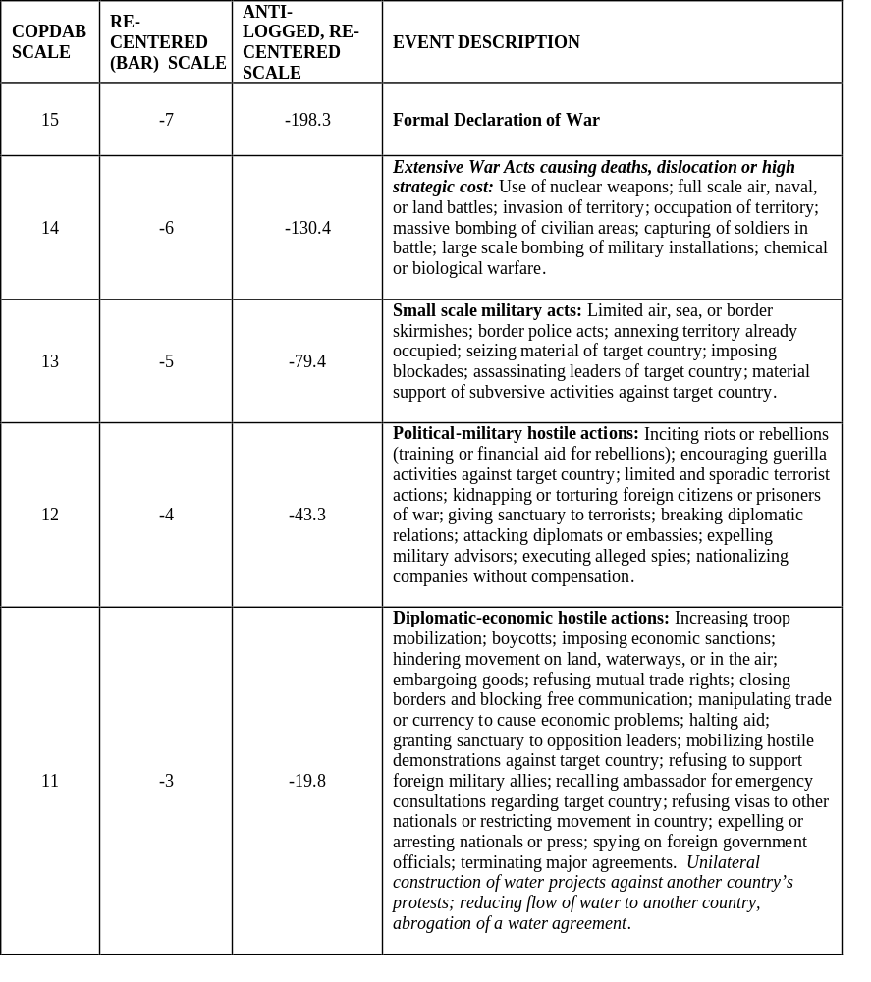

Water Event Intensity Scale (cont.)

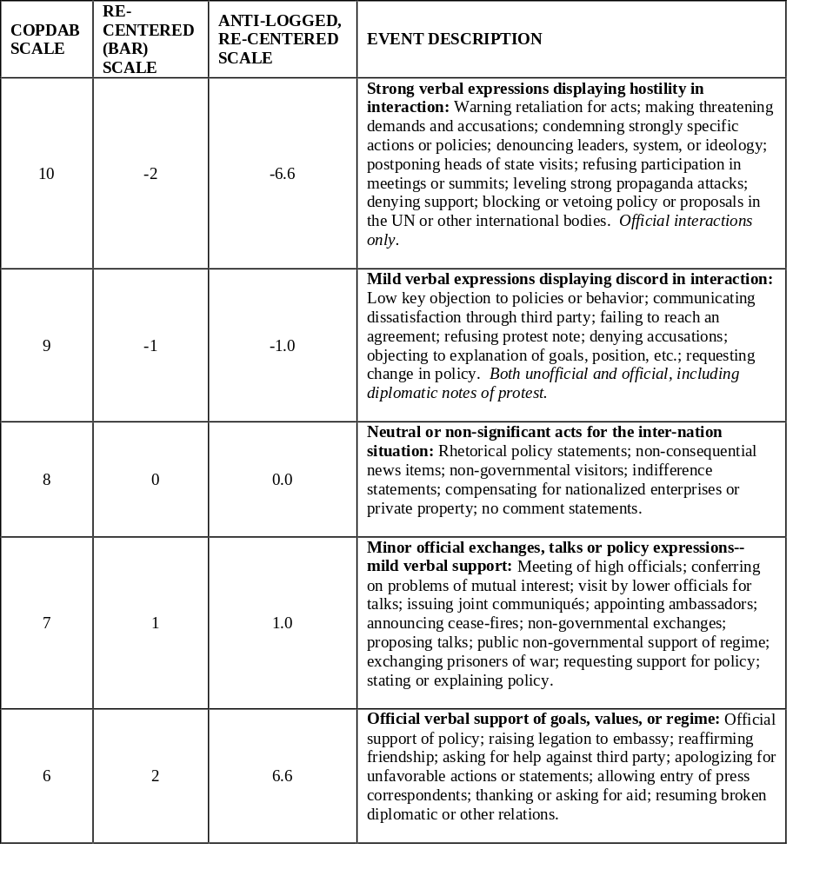
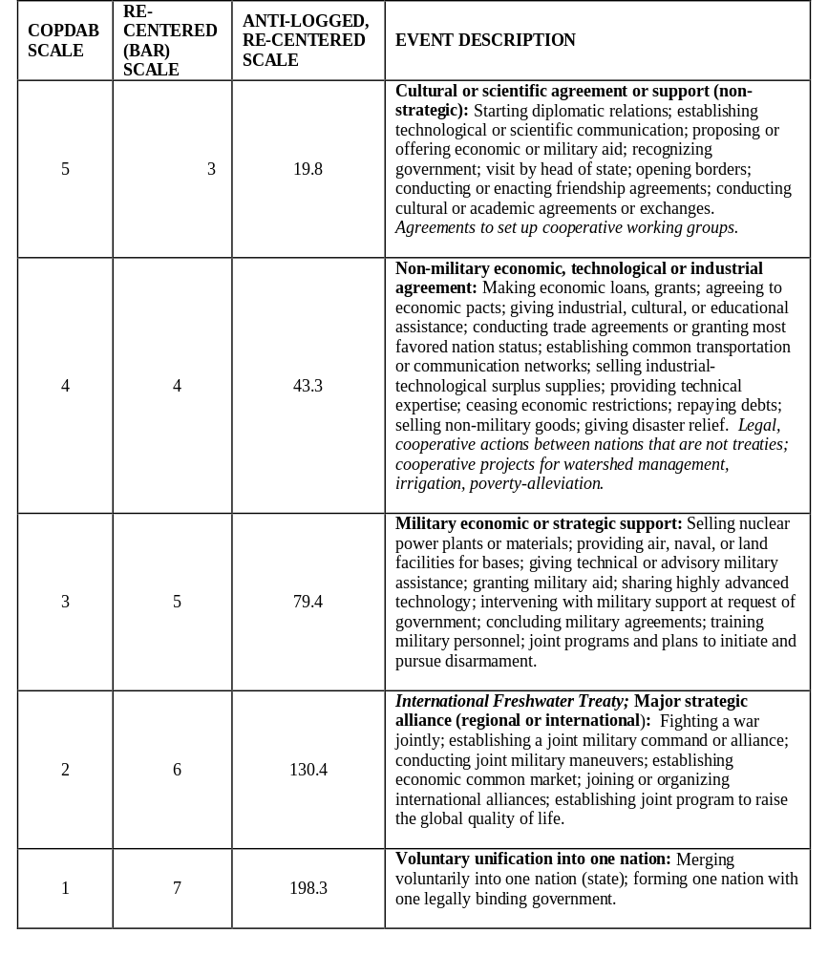
Water Event Intensity Scale (cont.)
APPENDIX 2: ISSUE_TYPE CATEGORIES

Issue Area # | Description of Issue Areas*
1 | Water Quality | Events relating to water quality or water-related environmental concerns
2 | Water Quantity | Events relating to water quantity
3 | Hydro-power/Hydro-electricity | Events relating to hydro-electricity or hydro-power facilities
4 | Navigation | Events relating to navigation, shipping, ports
5 | Fishing | Events relating to fishing
6 | Flood Control/Relief | Events relating to flooding, flood control, flood damage, flood relief
7 | Economic Development | General economic/regional development
8 | Joint Management | Events involving joint management of basin or water resources, especially where the management concerns cover a range of issue areas
9 | Irrigation | Events relating to irrigation of agricultural areas
10 | Infrastructure/Development | Events relating to the infrastructure or development projects, including dams, barrages, draining of swamps for development purposes, canals.
11 | Technical Cooperation/Assistance | Events relating to technical or economic cooperation or assistance, including project evaluations or river surveys and funds for ranges of improvements to water-related technology/infrastructure
12 | Border issues | Events relating to rivers as shared borders/boundaries
13 | Territorial issues | Events relating to territorial claims, where the territory is associated with a water body, e.g., a river island

*Note that not all issue areas listed are relevant "events" in and of themselves.

