CSCE Programming Assignment 2

Bobby Vielma – Section 509

Report Analysis

**Requesting Data Points**

Data points were requested from “1.csv” by sending a datamsg for every point in the file. This was an inefficient process as the function had to go over 15,000 rows and took approximately 90 seconds to copy the entire file. To ensure all data was correct the file was checked with the diff command.

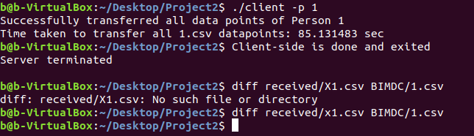

**Requesting A File**

Requesting a file was very similar to requesting individual data points. A filemsg was created and then placed into a buffer with a size allocated for the message itself, the file name, and a null terminating character. Then the filename was copied into the buffer after the filemsg. Since the file size exceeded the limits of our buffer it had to be requested in smaller chunks. Creating and sending a filemsg with parameters (0,0) allowed for the size of the file to be returned. After receiving the length back, we are able to process fileLength / bufferCapacity number of requests to copy the entirety of the file.

This process was much faster than copying individual data points due to the decrease in requests the server had to process. Using the buffer more data can be received and written at once. These processes took less than a second.

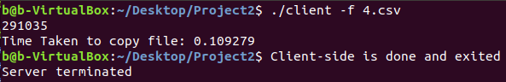

**291035 = Size of File