Blue Group – CSD-310 – Milestone #2 (Python Script Output Screenshots)
Carolina Rodriguez, Robert Breutzmann. Sara White

Below are the output results of the python script and the revised ERD. Our group used ChatGPT to generate sample database entries. We revised the ERD and SQL script to include tables for supply and wine inventory tracking.

Assumptions: Bacchus Winery will need the database to track inventory of components and a separate table to track inventory of available wine varieties for their distributors.

Note: The ERD is displayed in smaller sections for viewability; the full ERD is also displayed below.
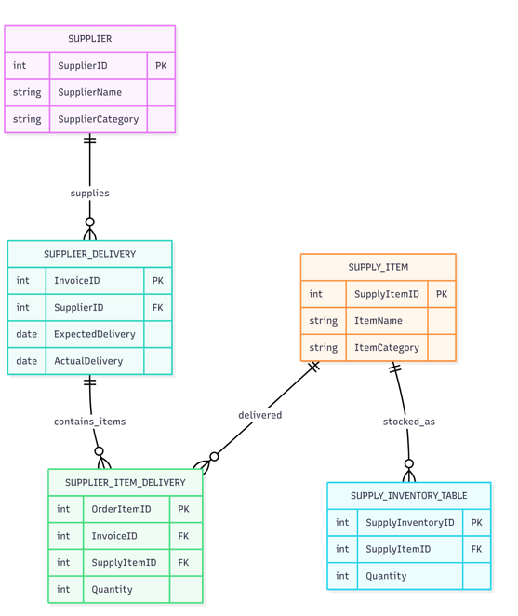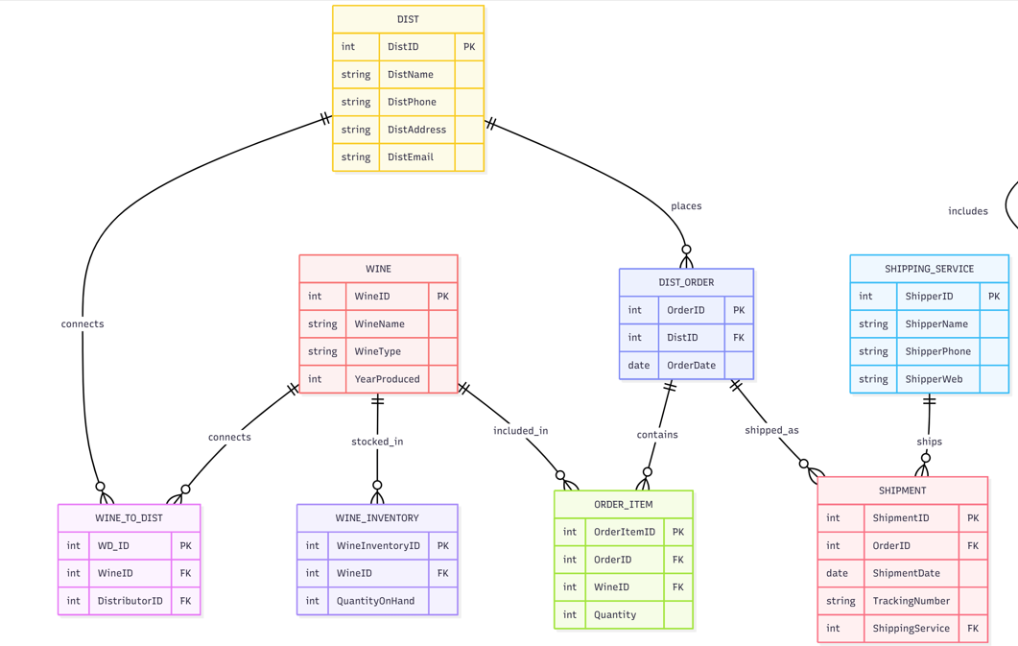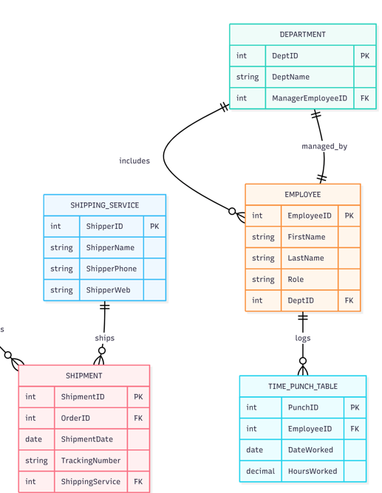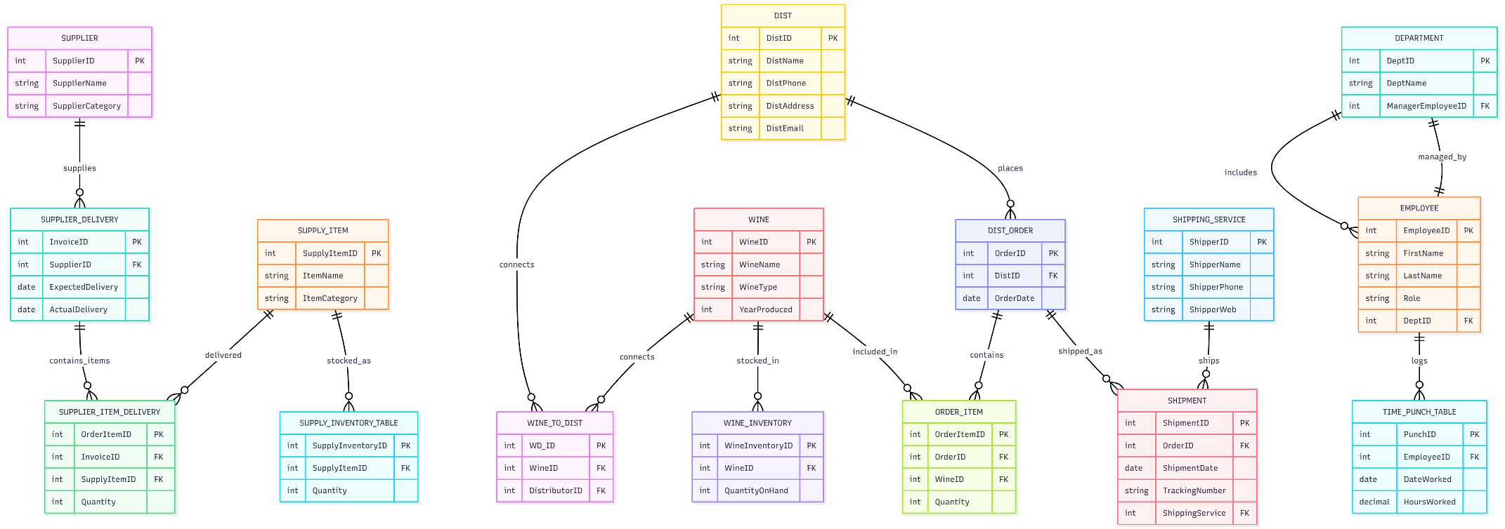

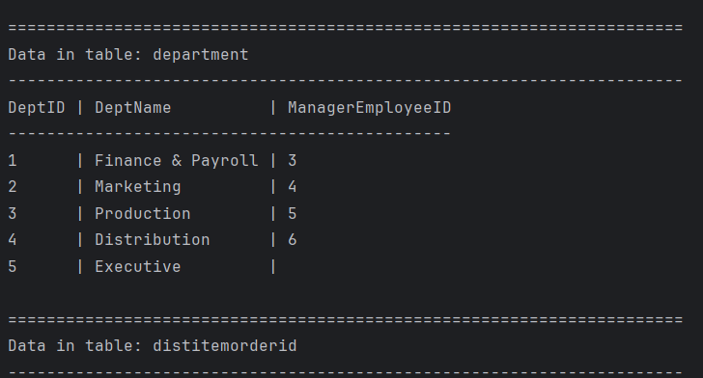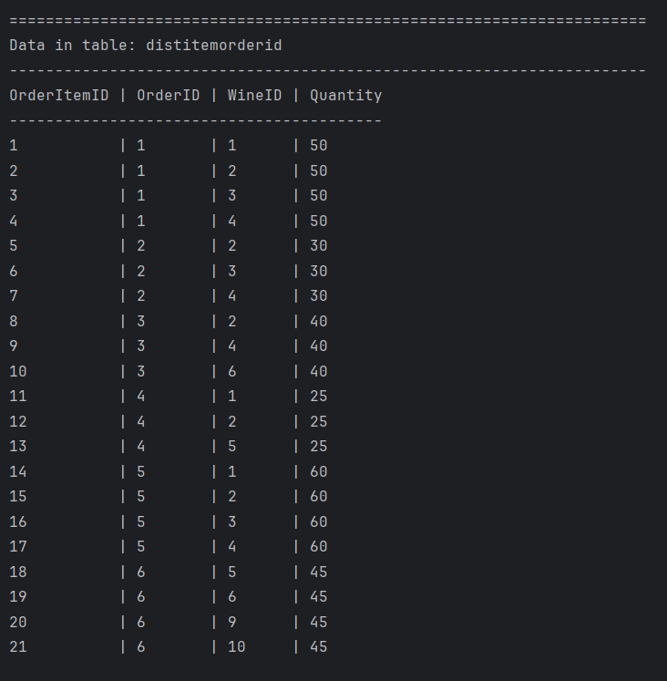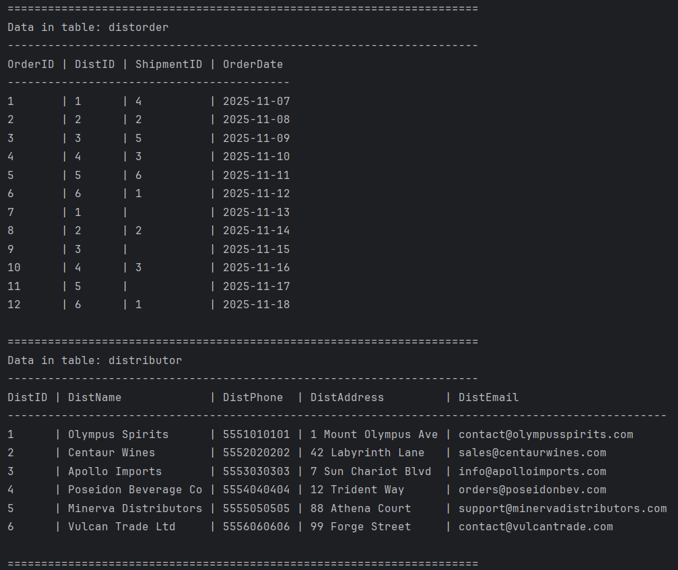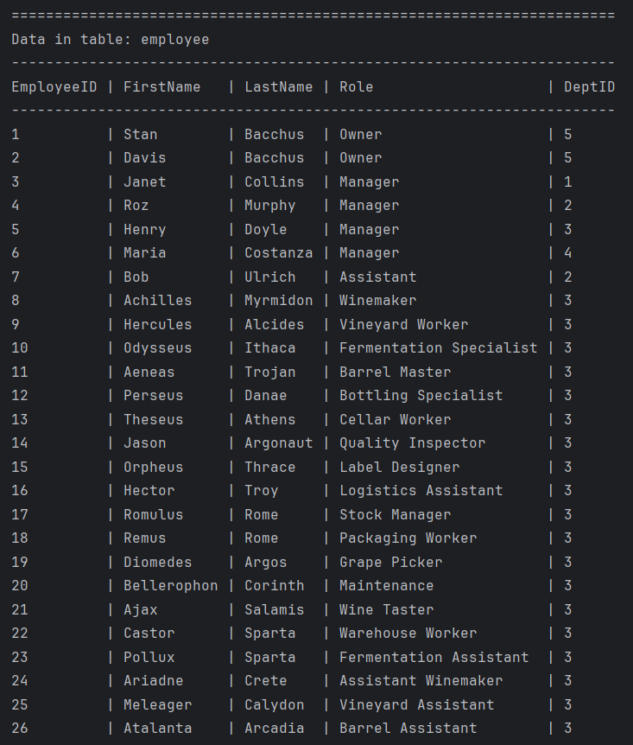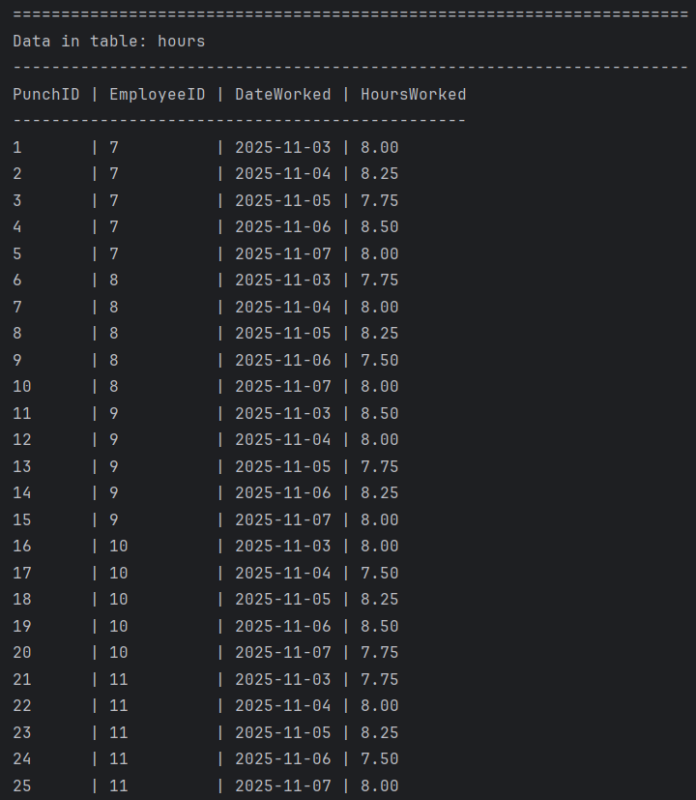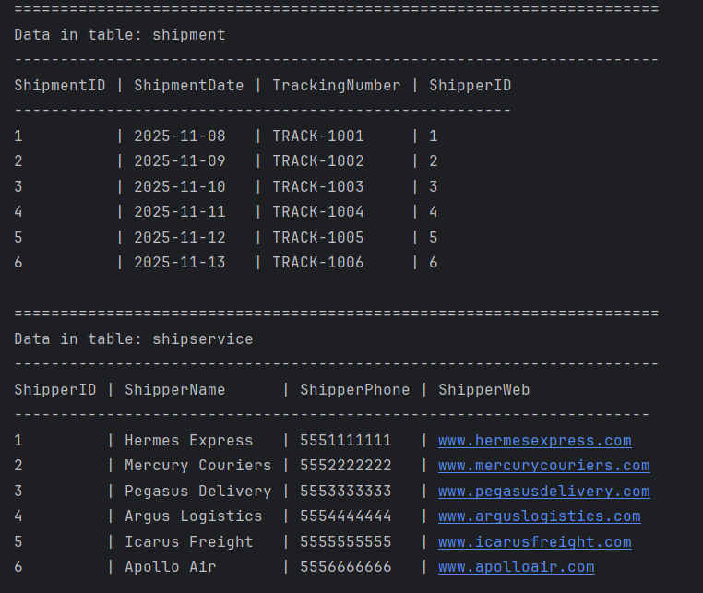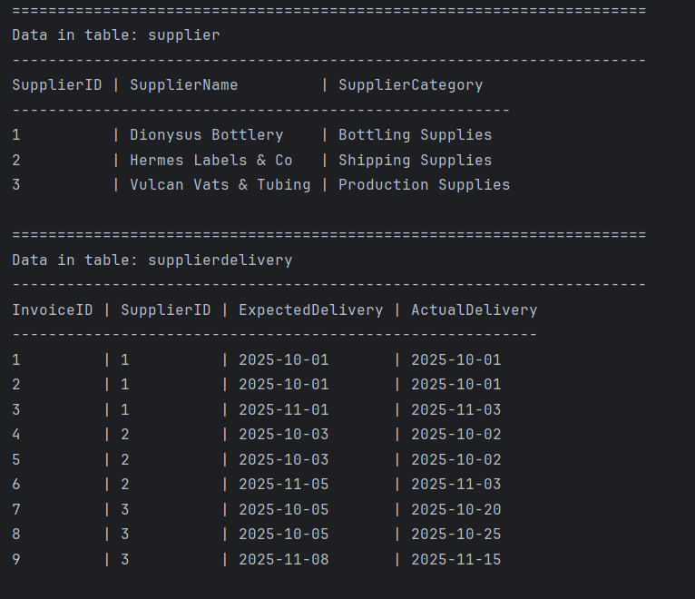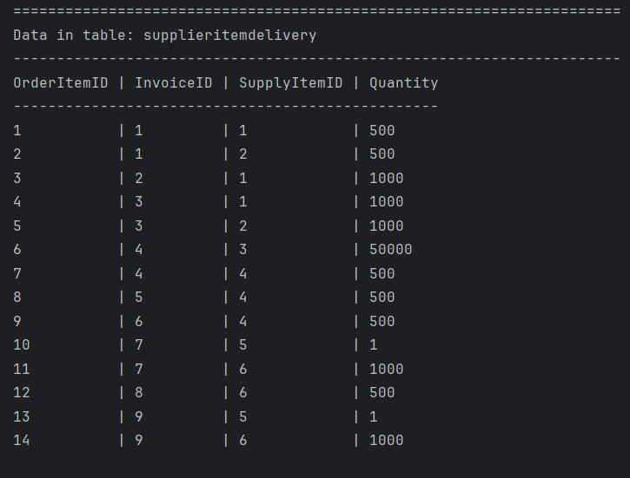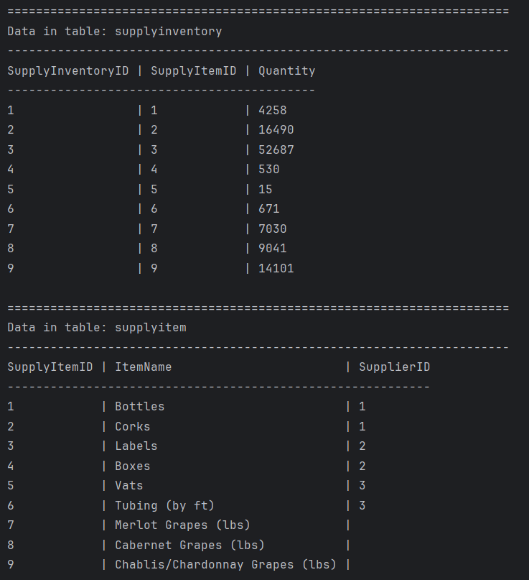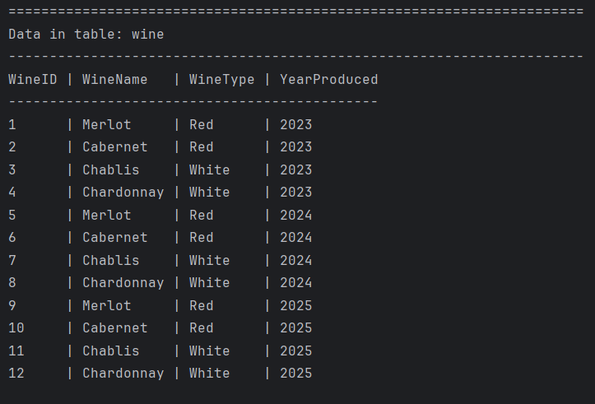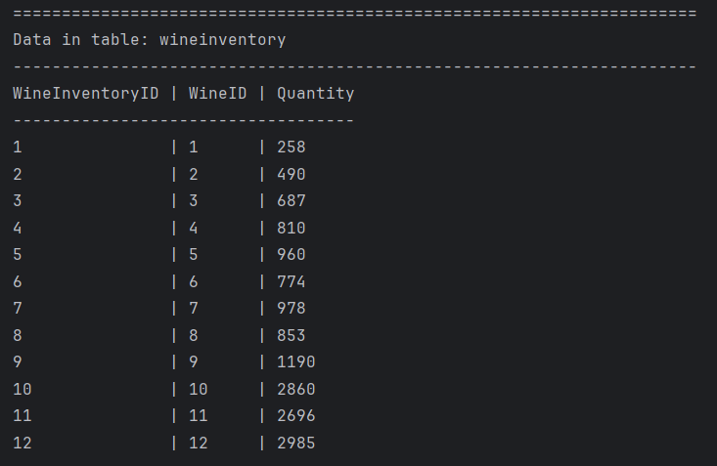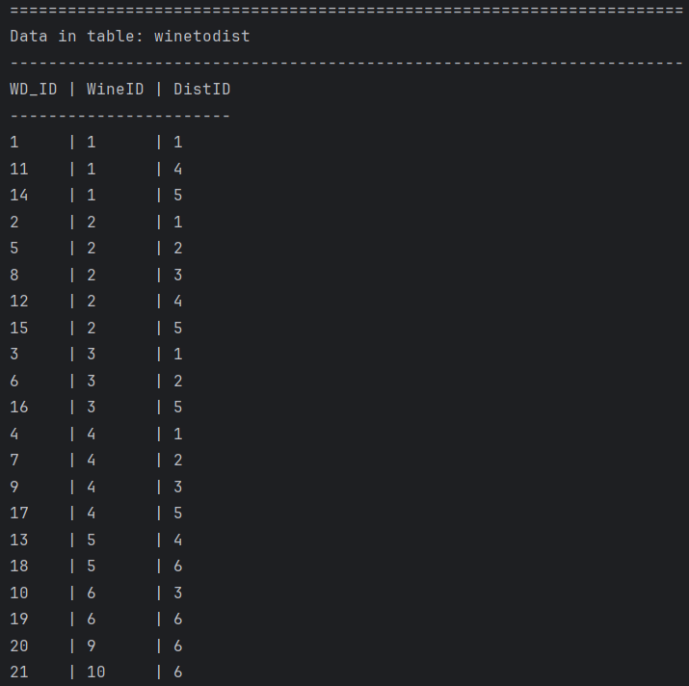

References

OpenAI. (2025). ChatGPT (Feb 2025 version) [Large language model]. https://chat.openai.com/

