Milestone One for Bacchus Case
Create a list of business rules for your case study, including any assumptions you make. Using those business rules, create an initial ERD to satisfy those rules.
A list of business Rules derived from the case study:
- There are several departments, each with one or more employees and a single department head.
- The Departments are:
  - Finance and Payroll (Assumed to be the same since the same person is in charge)
  - Marketing
  - Production
  - Distribution
- They have multiple products and receive supplies from multiple vendors. Each vendor supplies them with specific products, and they do not overlap. Bottles and corks from one supplier, labels and boxes from another, and vats and tubing from a third supplier.
- The Inventory System is either badly outdated or needs updating. Need to be able to track the following for receiving:
  - Expected Delivery Date
  - Actual Delivery Date
  - (Be able to report the discrepancy)
  - Current Inventory
- For Ordering:
  - An Online Ordering System to allow distributors to order products and give the lead time for production.
  - Shipment tracking system.
- For Employees: A time clock management system to track payroll and time punches.

Assumptions:
We have assumed that a single shipment can include multiple orders, and an order may be fulfilled through multiple shipments. Special circumstances, such as increased demand during the holiday season, can affect wine inventory levels. Additionally, all supply items must be tracked to ensure proper inventory management. Raw materials and supplies each need their own separate tables to keep inventory organized and manageable.

Initial ERD;
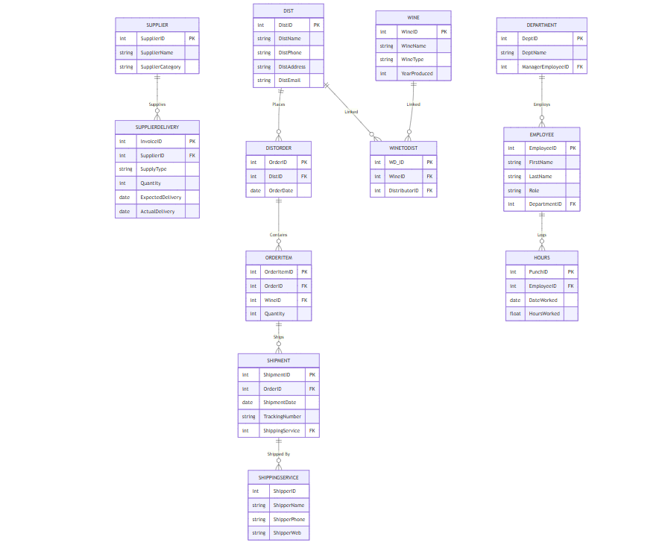

Mermaid code for ERD
erDiagram
%% =======================
%% SUPPLIERS
%% =======================

SUPPLIER {
int SupplierID PK
string SupplierName
string SupplierCategory
}

SUPPLIERDELIVERY {
int InvoiceID PK
int SupplierID FK
string SupplyType
int Quantity
date ExpectedDelivery
date ActualDelivery
}

SUPPLIER ||--o{ SUPPLIERDELIVERY : "Supplies"

%% =======================
%% DISTRIBUTORS
%% =======================

DIST {
int DistID PK
string DistName
string DistPhone
string DistAddress
string DistEmail
}

DISTORDER {
int OrderID PK
int DistID FK
date OrderDate
}

ORDERITEM {
int OrderItemID PK
int OrderID FK
int WineID FK
int Quantity
}

SHIPPINGSERVICE {
int ShipperID
string ShipperName
string ShipperPhone
string ShipperWeb
}

SHIPMENT {
int ShipmentID PK
int OrderID FK
date ShipmentDate
string TrackingNumber
int ShippingService FK
}

WINETODIST {
int WD_ID PK
int WineID FK
int DistributorID FK
}

DIST ||--o{ DISTORDER : "Places"
DISTORDER ||--o{ ORDERITEM : "Contains"
ORDERITEM ||--o{ SHIPMENT : "Ships"
WINE ||--o{ WINETODIST : "Linked"
DIST ||--o{ WINETODIST : "Linked"
SHIPMENT ||--o{ SHIPPINGSERVICE : "Shipped By"

%% =======================
%% INTERNAL OPERATIONS
%% =======================

EMPLOYEE {
int EmployeeID PK
string FirstName
string LastName
string Role
int DepartmentID FK
}

DEPARTMENT {
int DeptID PK
string DeptName
int ManagerEmployeeID FK
}

HOURS {
int PunchID PK
int EmployeeID FK
date DateWorked
float HoursWorked
}

WINE {
int WineID PK
string WineName
string WineType
int YearProduced
}

DEPARTMENT ||--o{ EMPLOYEE : "Employs"
EMPLOYEE ||--o{ HOURS : "Logs"

