Module 6.2 Assignment
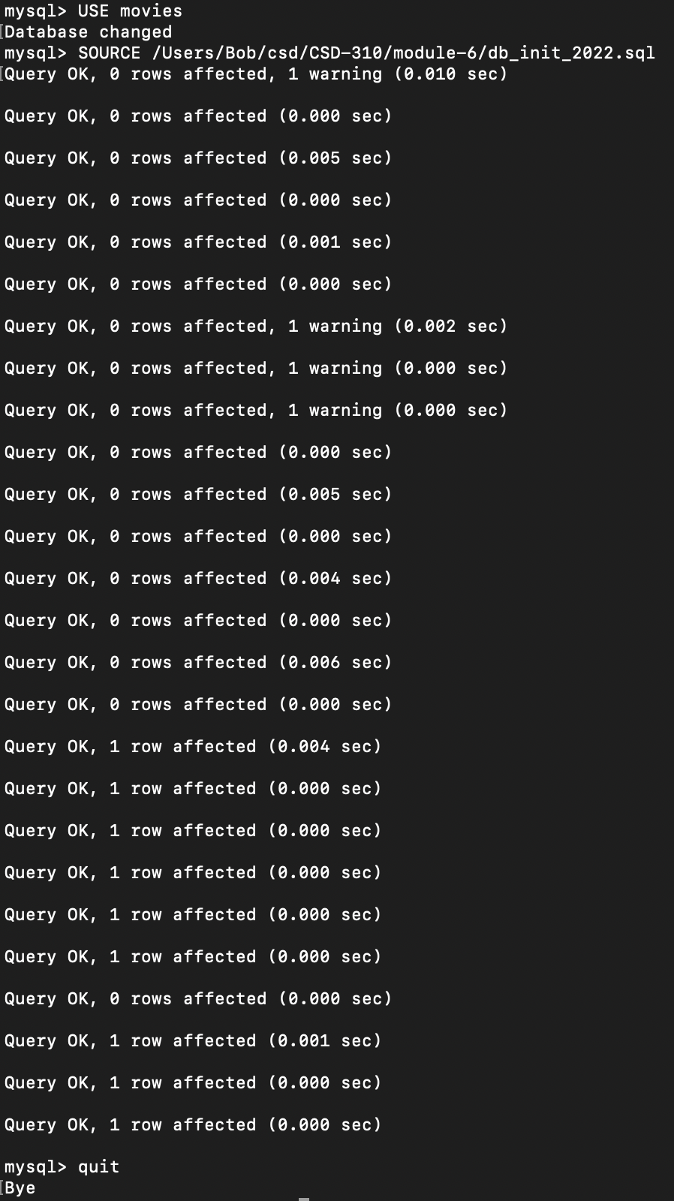
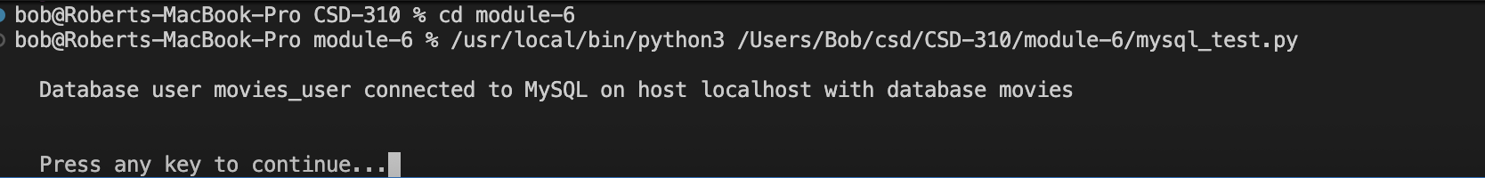
https://github.com/BobbyJoeCool/CSD-310

