Milestone 3
Report 1:
This report was generated to show the average number of hours worked per week by each individual employee. This report uses a dataset for a time period of one month, but could easily be expanded into quarterly or yearly averages. Three outputs are produced: the first is a list of each employee’s ID, followed by their name and average hours worked; the next table shows hours worked by each employee in descending order, and the last organizes this information by the employees last name (alphabetical).

Screenshot for Hours Worked over a week time period:
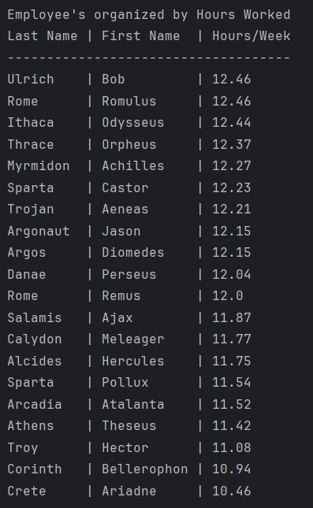
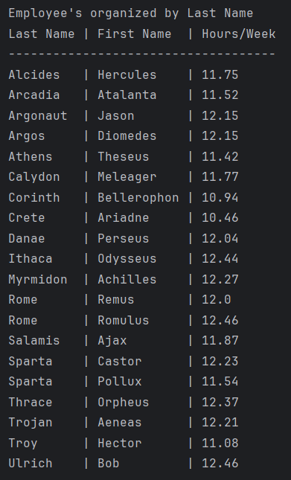

Report 2: This report highlights any differences between expected and actual delivery dates from suppliers. The DaysDifference column shows how many days the delivery is off from the anticipated delivery date, and the DeliveryStatus column states whether the delivery was early or on time.

Screenshot shows the average number of days before or after the delivery date that deliveries arrive for each supplier:
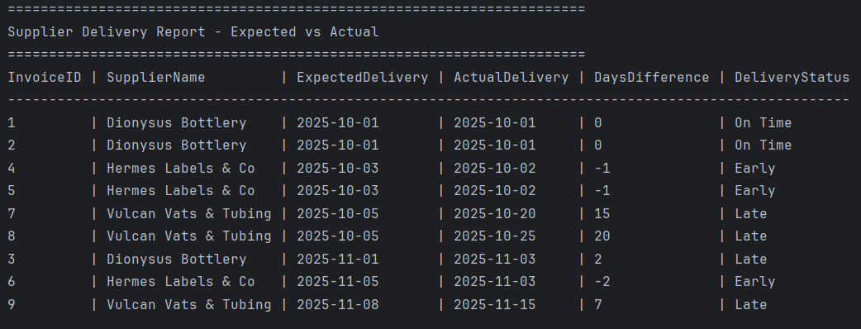
Report 3: This report provides data in three tables: the first table shows the wines carried by the distributors, the second shows the total amount sold for each type of wine, and the third table shows which wines haven’t sold at all.
Screenshot for each wine each distributor carries:
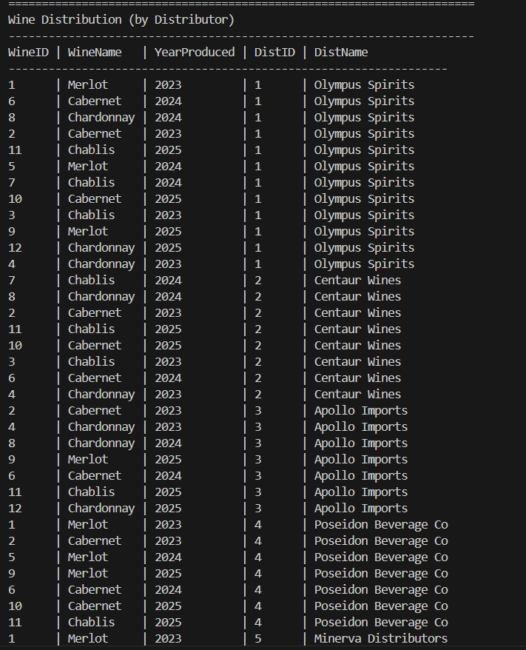

Report for total wines sold and wines that haven’t sold:

