Assignment 9.2
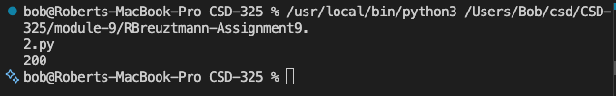
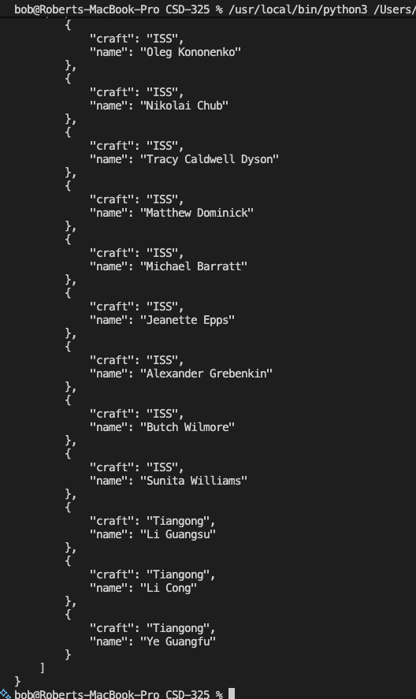
Enter the ZipCode for the forecast you are looking for: 50676

Testing ZIP API connection...
Status Code: 200

Raw ZIP API Response:
{"country": "United States", "country abbreviation": "US", "post code": "50676", "places": [{"place name": "Tripoli", "longitude": "-92.2659", "latitude": "42.8105", "state": "Iowa", "state abbreviation": "IA"}]}

Coordinates for 50676: 42.8105, -92.2659

Testing weather.gov connection...
Status Code: 200

Forecast URL: https://api.weather.gov/gridpoints/DMX/119,106/forecast

Readable Forecast for Tripoli, Iowa:
------------------------------
This Afternoon
Temp: 51°F
Wind: 8 mph S
Forecast: Chance Light Rain

------------------------------
Tonight
Temp: 45°F
Wind: 3 to 7 mph S
Forecast: Chance Light Rain then Areas Of Fog

------------------------------
Tuesday
Temp: 51°F
Wind: 5 to 17 mph SW
Forecast: Chance Light Rain

------------------------------
Tuesday Night
Temp: 26°F
Wind: 17 to 28 mph WNW
Forecast: Chance Light Snow

------------------------------
Wednesday
Temp: 32°F
Wind: 21 to 29 mph WNW
Forecast: Partly Sunny

------------------------------
Wednesday Night
Temp: 20°F
Wind: 15 to 20 mph NW
Forecast: Partly Cloudy

------------------------------
Thanksgiving Day
Temp: 30°F
Wind: 14 to 18 mph NW
Forecast: Mostly Sunny

------------------------------
Thursday Night
Temp: 14°F
Wind: 5 to 12 mph NW
Forecast: Partly Cloudy

------------------------------
Friday
Temp: 29°F
Wind: 7 mph WSW
Forecast: Partly Sunny then Slight Chance Light Snow

------------------------------
Friday Night
Temp: 21°F
Wind: 6 to 9 mph ESE
Forecast: Light Snow Likely

------------------------------
Saturday
Temp: 30°F
Wind: 10 mph ENE
Forecast: Chance Light Snow

------------------------------
Saturday Night
Temp: 20°F
Wind: 10 mph NE
Forecast: Chance Light Snow

------------------------------
Sunday
Temp: 29°F
Wind: 12 mph N
Forecast: Chance Light Snow

------------------------------
Sunday Night
Temp: 13°F
Wind: 12 mph NNW
Forecast: Chance Snow

Would you like to check another location? (y/n)y
Enter the ZipCode for the forecast you are looking for: 50613

Testing ZIP API connection...
Status Code: 200

Raw ZIP API Response:
{"country": "United States", "country abbreviation": "US", "post code": "50613", "places": [{"place name": "Cedar Falls", "longitude": "-92.4497", "latitude": "42.5241", "state": "Iowa", "state abbreviation": "IA"}]}

Coordinates for 50613: 42.5241, -92.4497

Testing weather.gov connection...
Status Code: 200

Forecast URL: https://api.weather.gov/gridpoints/DMX/113,93/forecast

Readable Forecast for Cedar Falls, Iowa:
------------------------------
This Afternoon
Temp: 52°F
Wind: 7 mph S
Forecast: Chance Light Rain

------------------------------
Tonight
Temp: 45°F
Wind: 2 to 6 mph S
Forecast: Chance Light Rain then Areas Of Fog

------------------------------
Tuesday
Temp: 52°F
Wind: 3 to 17 mph SW
Forecast: Chance Light Rain

------------------------------
Tuesday Night
Temp: 27°F
Wind: 17 to 26 mph WNW
Forecast: Slight Chance Light Snow

------------------------------
Wednesday
Temp: 34°F
Wind: 20 to 26 mph WNW
Forecast: Partly Sunny

------------------------------
Wednesday Night
Temp: 22°F
Wind: 14 to 18 mph NW
Forecast: Partly Cloudy

------------------------------
Thanksgiving Day
Temp: 32°F
Wind: 12 to 15 mph NW
Forecast: Mostly Sunny

------------------------------
Thursday Night
Temp: 16°F
Wind: 3 to 10 mph NW
Forecast: Partly Cloudy

------------------------------
Friday
Temp: 31°F
Wind: 3 to 7 mph WSW
Forecast: Partly Sunny then Slight Chance Light Snow

------------------------------
Friday Night
Temp: 23°F
Wind: 8 mph ESE
Forecast: Light Snow Likely

------------------------------
Saturday
Temp: 32°F
Wind: 10 mph ENE
Forecast: Chance Light Snow

------------------------------
Saturday Night
Temp: 21°F
Wind: 9 mph NE
Forecast: Chance Light Snow

------------------------------
Sunday
Temp: 30°F
Wind: 8 to 12 mph N
Forecast: Chance Light Snow

------------------------------
Sunday Night
Temp: 15°F
Wind: 10 mph NNW
Forecast: Chance Snow

Would you like to check another location? (y/n)y
Enter the ZipCode for the forecast you are looking for: 50000

Testing ZIP API connection...
Status Code: 404
There was an error with that ZIP code. Try again

