Assignment 5.2
Robert Breutzmann's CSD340 GitHub
Robert Breutzmann's GitHub Pages Landing Page
Subject Name: Joshua Blomgren

Interview
Note: The interview took place on Facebook Messenger, so I copied/pasted the conversation and formatted it for this. I also shortened and edited out some of the “blurbs” that were not pertinent to the inquiry.
• How did you first get started in blacksmithing, and what made you want to try it for yourself instead of just watching or reading about it?
I first got interested in blacksmithing from watching it and reading about it when I was younger. There was always something about it that stuck with me, especially the idea of shaping metal by hand instead of relying on machines. After a while, just observing wasn’t enough. I wanted to actually try it and see what it was like for myself. Getting hands-on felt like the only way to really understand the process and learn what goes into making something from start to finish. One day, I happened upon a cheap anvil, and the rest is history.
• What kinds of things do you enjoy forging the most, and why do those projects stand out to you?
Household items that get used because I like seeing the stuff I make used.
• Can you walk me through what a typical day at the forge looks like for you, from start to finish?
Clean the firepot out and restock my coal bin. While lighting it and waiting for it to warm up, I decided whether to finish or start a new project.
• What part of the blacksmithing process do you find the most satisfying, and what part do you find the most challenging?
I enjoy almost all of the creation process. The most challenging is when I try something new or decide to make a knife. A knife has a lot of things you have to take into consideration.
The number one thing I find challenging is listening to people talk about Forged in Fire. The show is dramatized a lot, and they cut out a lot of things people would find boring.
• How has blacksmithing changed the way you think about work, patience, or craftsmanship?
Blacksmithing has taught me patience and how to slow down so I don't make as many mistakes. I tend to enjoy handcrafted items more, but I am more of a critic of metal work and its prices of it.
• Growing up, were there experiences or influences that pushed you toward working with your hands or making things?
Growing up, I liked to watch blacksmiths at wild west reenactments or rendezvous. I also always liked dwarves in novels.
• You were diagnosed with Asperger’s. In what ways do you think that influences how you learn or practice blacksmithing?
Asperger’s has helped me keep researching and learning in depth, rather than just monkey see, monkey do.
• Are there aspects of forging that feel especially calming or grounding for you? If so, what about them helps?
Forging can bring a stillness because of the need to focus solely on the project at hand
• What accomplishments in blacksmithing are you most proud of so far, even if they seem small to others?
What I am most proud of is starting and keeping at it, even though it is very physically demanding and you get burned a lot, no matter how careful you are.
• Looking ahead, what do you hope blacksmithing becomes in your life over the next few years?
No real expectations for what blacksmithing will become for me, but I would like to be able to sell more of the things I make.

Bio
Josh’s interest in blacksmithing began as a quiet fascination rather than a sudden decision. From a young age, he was drawn to creating useful objects rather than simply purchasing them. From an interest in times before manufacturing, where everything was crafted by hand, to fantasy worlds where entire civilizations revolved around the forge, Josh always felt drawn to the flame of molten steel. That opportunity to try for himself came when he happened across a cheap anvil and took the chance and purchased it. Slowly, he built a small, humble forge in his backyard, where he spends a lot of his free time, twisting the metal into the shapes he wants.
Josh gravitates toward forging practical household items, valuing usefulness over display. For him, the most rewarding part of the craft is seeing something he made become part of everyday life. A typical day in the forge follows a steady routine: cleaning out the firepot, restocking coal, and lighting the forge. While the fire comes up to temperature, he decides whether to continue an existing project or begin something new, letting the rhythm of preparation set the pace for the work ahead.
He enjoys nearly every stage of the blacksmithing process, from shaping hot steel to refining final details. The greatest challenges arise when he pushes himself to try new techniques, especially when making knives, which require careful planning and attention to detail. Through blacksmithing, Josh has learned the value of patience and the importance of slowing down, as rushing often leads to mistakes. The craft has also deepened his appreciation for handmade metalwork, while making him more discerning about quality and pricing.
Josh was diagnosed with Asperger’s Syndrome, which is now recognized to be a part of the autism spectrum umbrella, and that influences how he approaches the craft. The repetition and focus required in forging can be grounding, and he tends to research techniques deeply rather than rely solely on imitation. Autism can cause a person to fixate on details and dive deeply into a single topic. Looking ahead, he has no fixed expectations but hopes to continue improving and eventually sell more of the pieces he creates.

Images
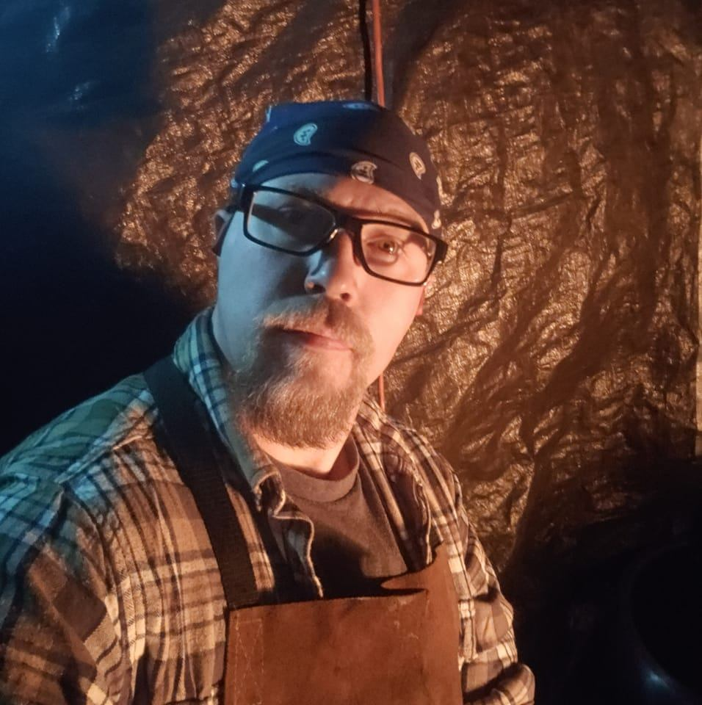
Profile Picture. Josh, in his forge, with his forging apron on, illuminated by the fire of the forge.

Accomplishments

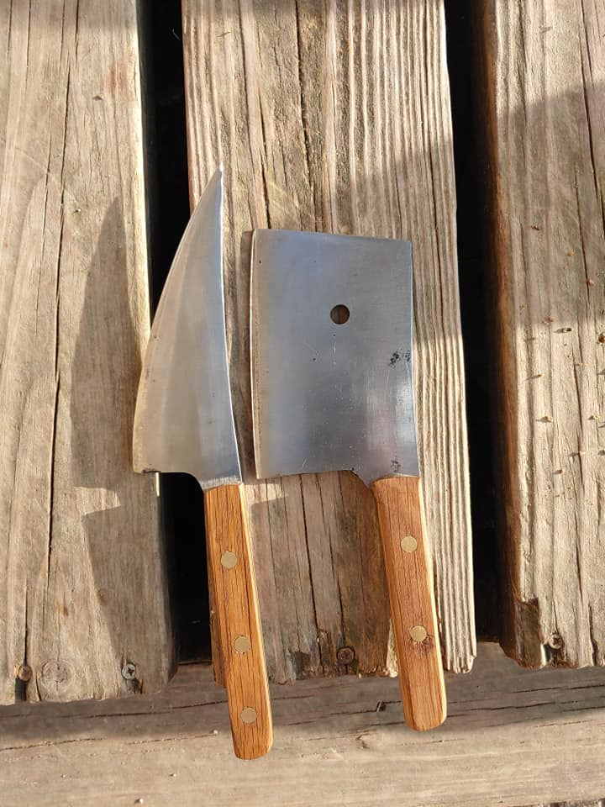
Some of Josh’s first knives

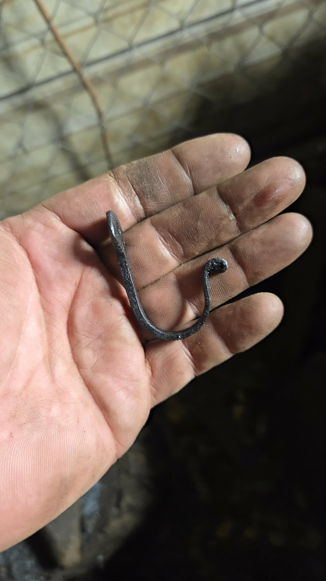
The first thing Josh forged. A key hook to hang on the wall.
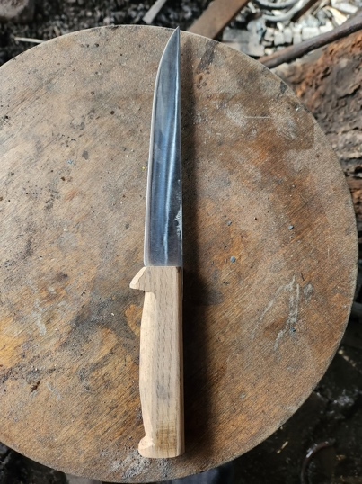
A more polished Knife, one of the first Josh sold

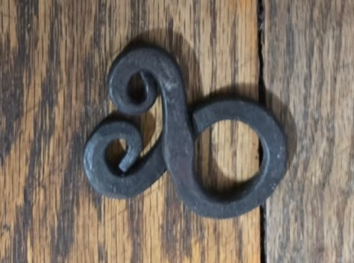

A Nordic Cross, something that interests Josh about Nordic Culture

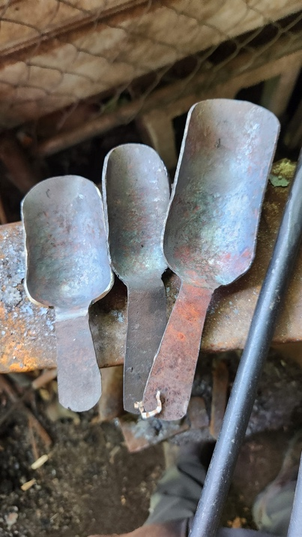
Some scoops Josh made, for practical purposes, around the house.

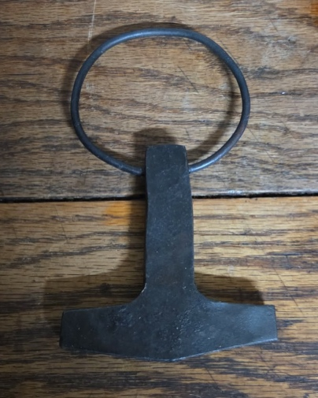

A Mjolnir Pendant. More Nordic Culture crafts.

Hobbies-Stock Photos

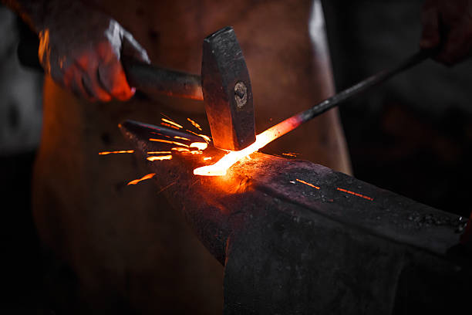
Stock image (iStock) of a blade being hammered on an Anvil.

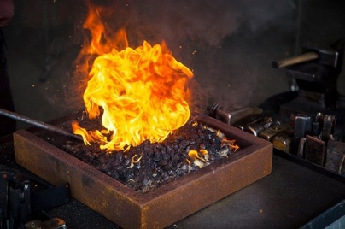
Stock image (iStock) of a blade in a forge.

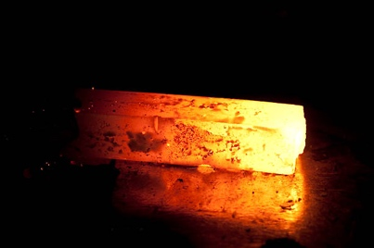
Stock image (iStock) of a piece of molten steel, ready to be shaped.

Style Guide:

1. Design Direction & Rationale
The visual direction of this site is inspired by blacksmithing as a craft: strong, grounded, functional, and timeless. The design emphasizes structure, clarity, and intentional simplicity. Decorative elements are minimal, so the focus remains on Joshua’s work, process, and story. The overall aesthetic reflects durability, focus, and precision rather than trends or visual noise.

2. Color Palette
The color palette draws inspiration from the forge environment: steel, fire, and earth.
Primary Colors
- Charcoal Black – #1F1F1F
Primary background color. Represents iron, strength, and focus.
- Forged Steel Gray – #4A4A4A
Secondary background and structural elements such as headers or footers.
Accent Colors
- Forge Orange – #C65A1E
Accent color used sparingly for buttons, links, or highlights. Represents heat and fire.
- Warm Ash – #D8D2C8
Used for section backgrounds or subtle contrast areas to soften the design.
Text Color
- Off-White – #F2F2F2
Primary body text color for readability against dark backgrounds.
(Swatches made with Adobe Color Selector)

3. Typography
Typography choices prioritize readability and a straightforward, industrial feel.
Headings
- Font: Serif or slab-serif typeface
- Usage: Page titles, section headers, navigation headings
- Style: Bold, high contrast, limited letter spacing
- Purpose: Communicates strength, tradition, and structure
Body Text
- Font: Clean sans-serif typeface
- Usage: Paragraphs, captions, interview excerpts
- Style: Regular weight, comfortable line spacing
- Purpose: Ensures clarity and ease of reading for longer content
Hierarchy
- H1: Page titles
- H2: Section headings
- H3: Subsections
- Figcaption: Image or Object captions
- Paragraphs: Main content and storytelling

4. UI Elements
Buttons
- Default State:
  - Background: Forge Orange (#C65A1E)
  - Text: Off-White (#F2F2F2)
- Hover State:
  - Slight darkening of background color
- Style: Rectangular with subtle edges, no excessive rounding
Links
- Color: Forge Orange
- Hover: Underline or color shift
- Purpose: Clear visibility without distracting from content

5. Layout & Spacing
- Consistent margins and padding to create breathing room
- Content aligned in clean vertical sections
- Images given space to stand on their own
- Text blocks limited in width for readability

Landing Page
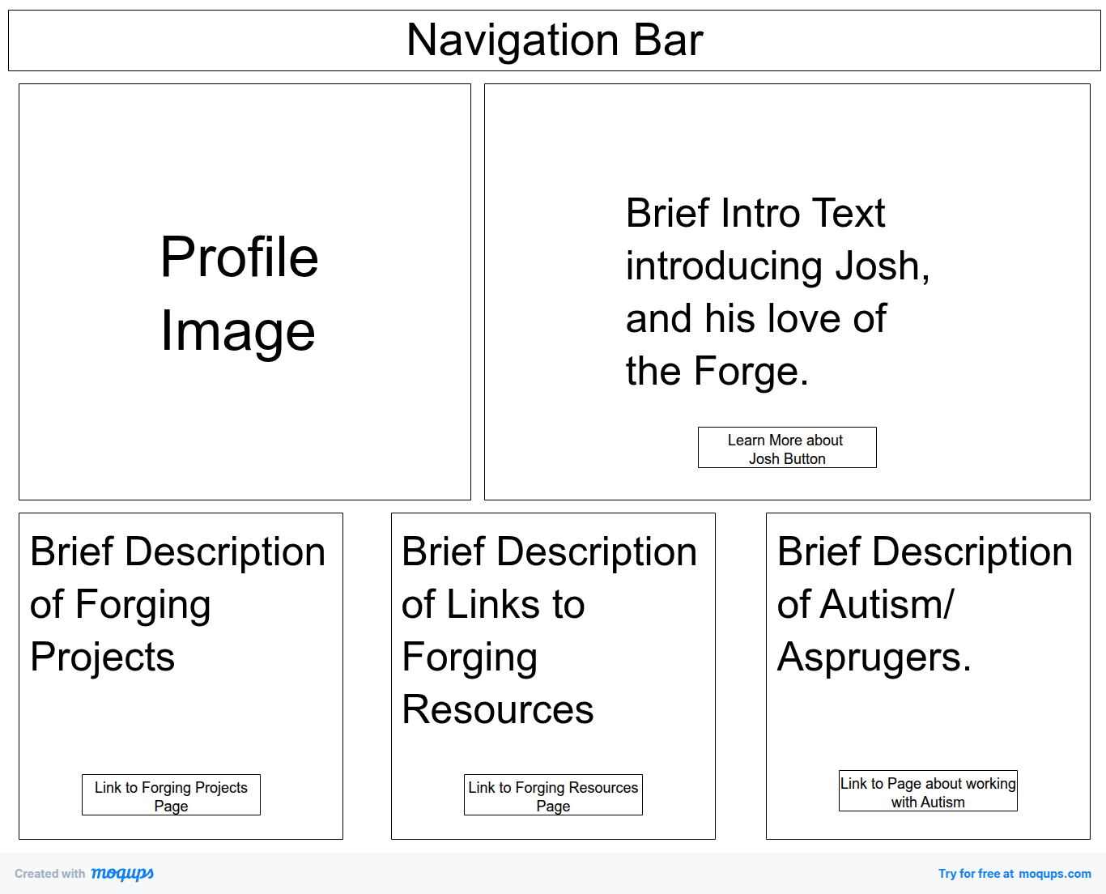

About Page
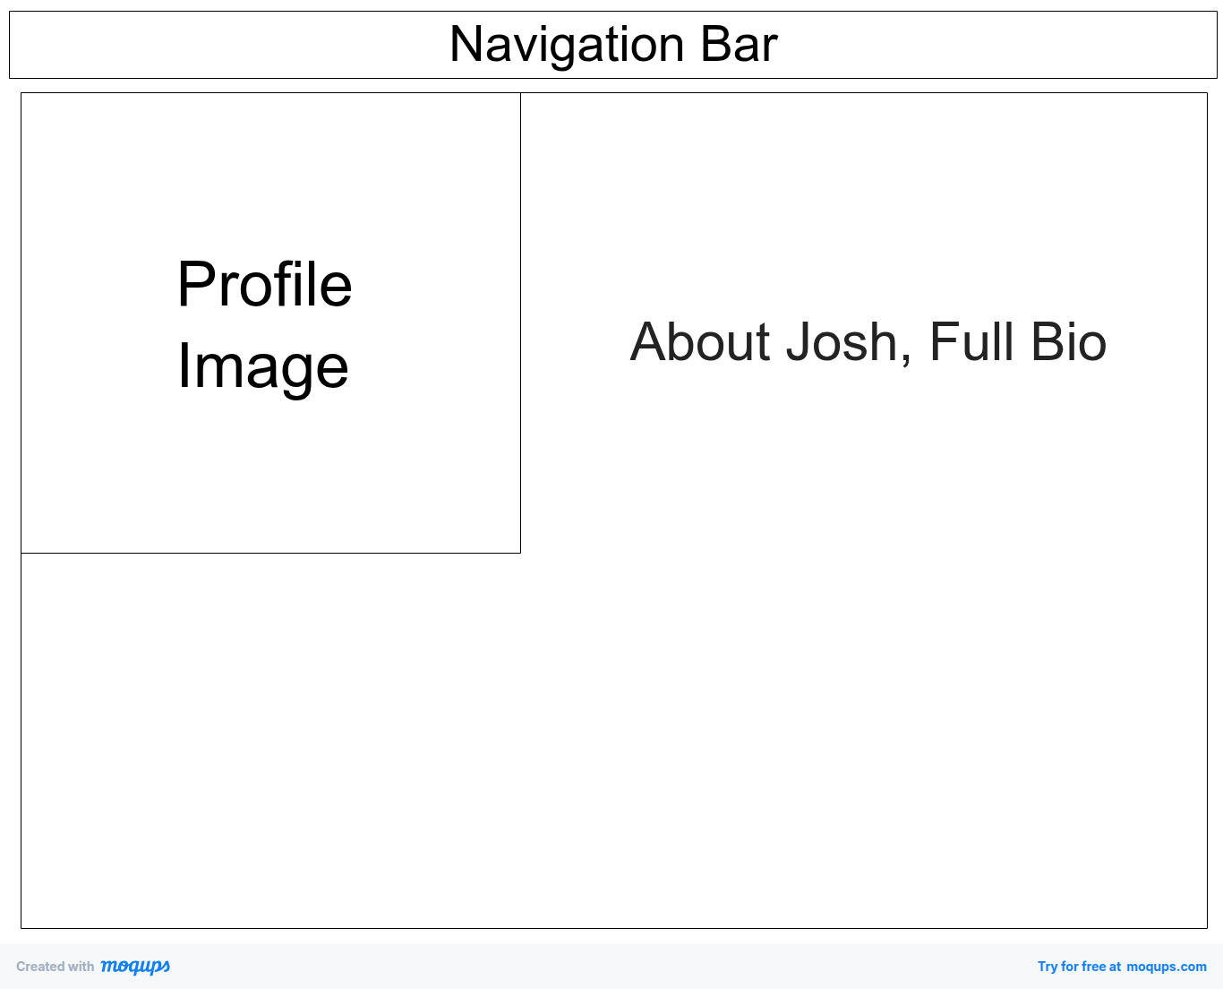

Crafts/Hobbies Page
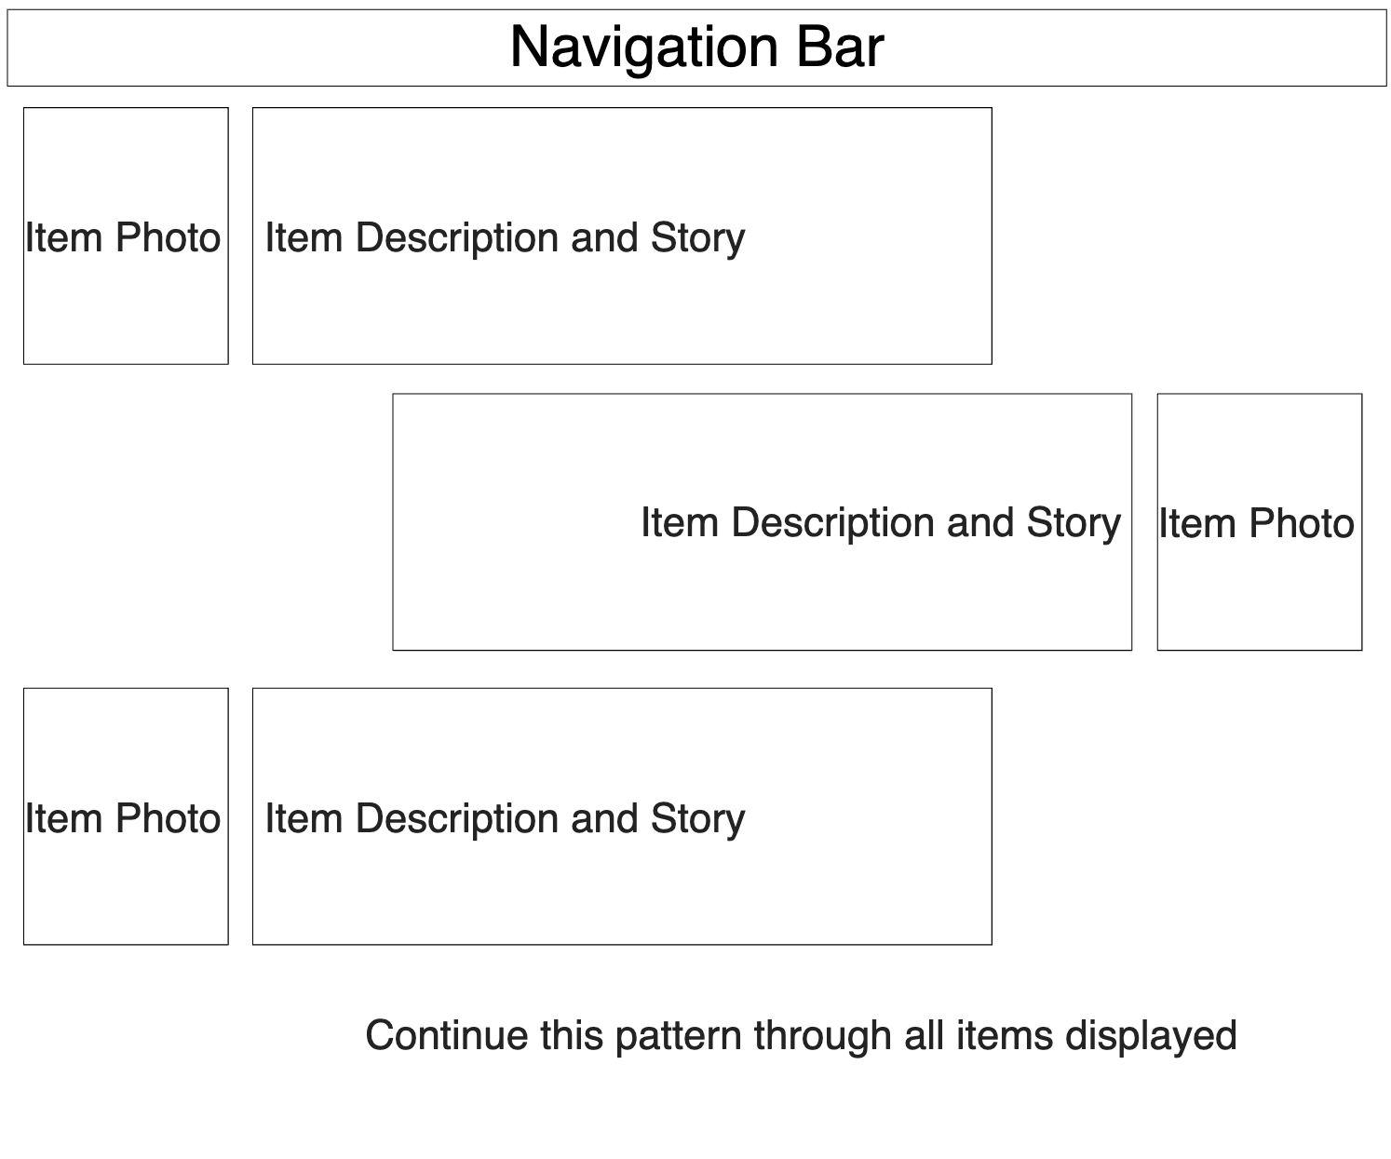

Forging Resources Page

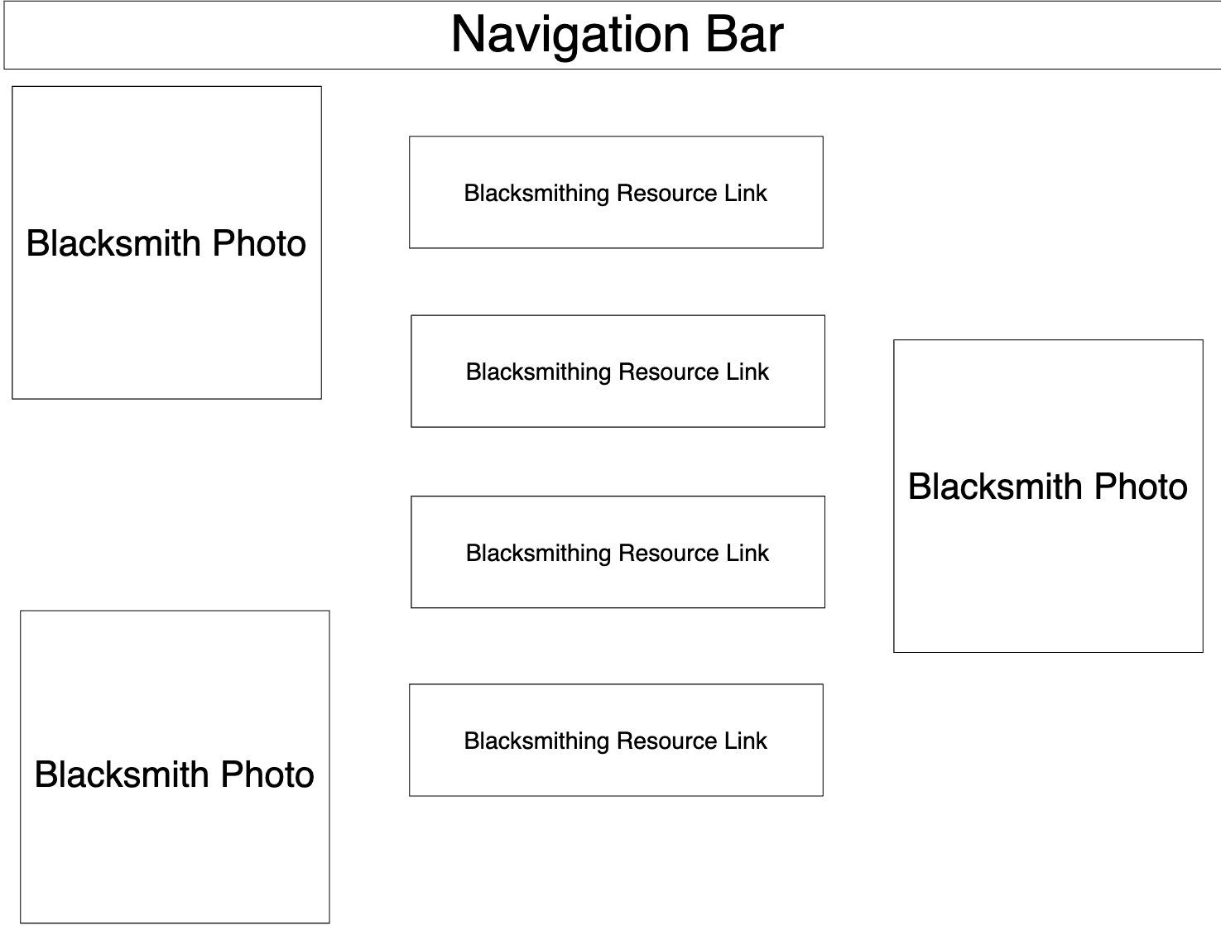

Working with Autism Page

