Assignment 1.2
Robert Breutzmann's CSD340 - Web Development with HTML and CSS GitHub

GitHub Repository Screenshot:
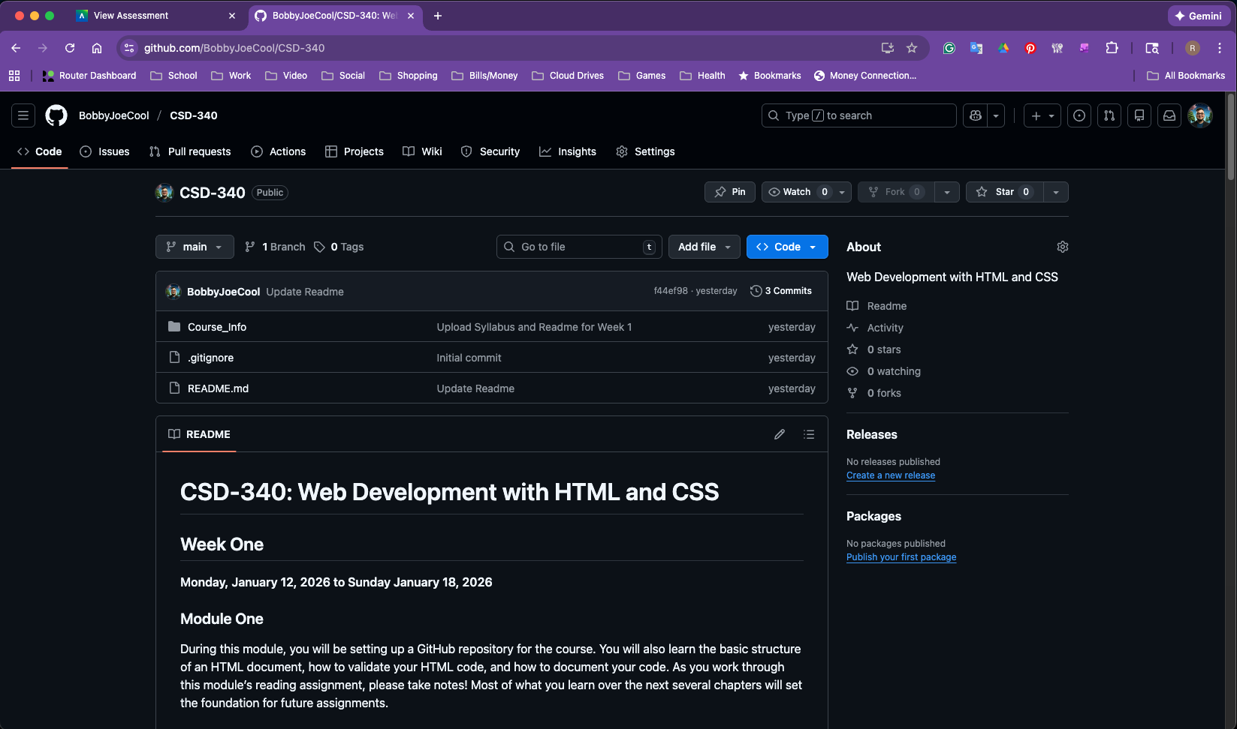

Terminal Directory Screenshot:
