Assignment 3.2
Robert Breutzmann's CSD340 GitHub
Robert Breutzmann's GitHub Pages Landing Page

Webpage
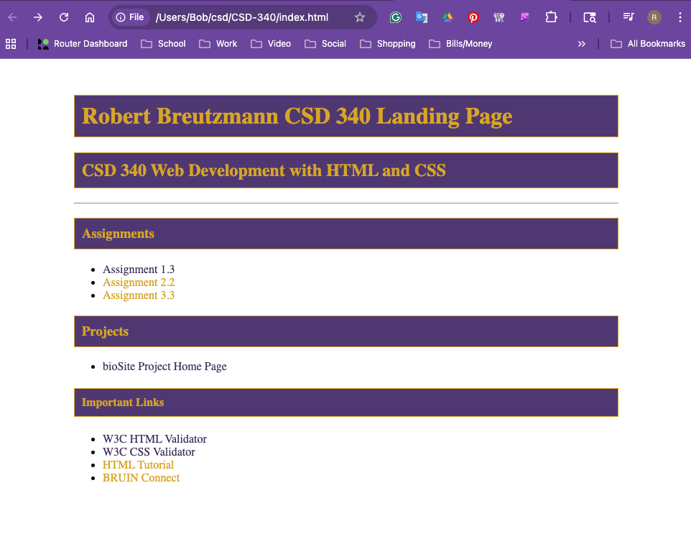

HTML Validator:
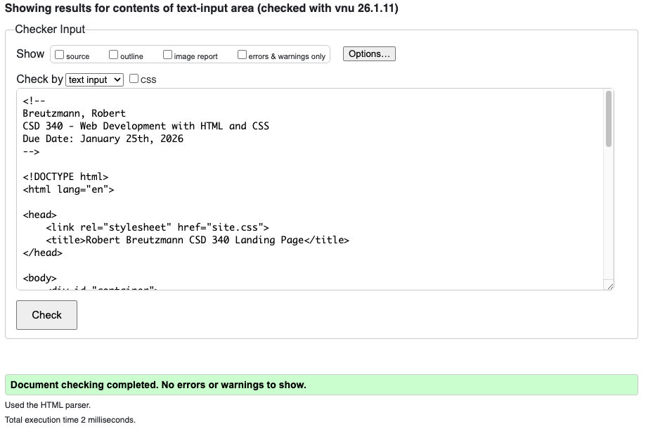
CSS Validator:
