Managing Change Securely
A guide to Configuration Management, Change Control, and DevOps
Robert Breutzmann
CSD 370 – Secure Software Development
Final Report Assignment
Due: May 24th, 2026
Software development is a team effort, and like most team efforts, it requires rules. Without a system for managing how code gets written, reviewed, and changed, even a small development team can end up with unstable applications, unexplained bugs, and no clear way to figure out what went wrong or who changed what. These problems only get worse as a project grows. Mesusa Corporation is at a point where establishing that structure is not just beneficial, it is necessary.
This report covers three closely related processes that address this need: Configuration Management, Change Control, and DevOps. Each one plays a specific role. Configuration Management tracks and protects the system's current state. Change Control governs how that state can change. And DevOps provides the operational pipeline that ties them together and keeps the whole cycle moving. The report explains what each process is, how they interact, the benefits and challenges of implementing them, and what MeCo will need to put in place to make them work.
Configuration Management is the process of controlling and documenting change for a development system (GeeksforGeeks, n.d.). When you have a large team working on a project, it is essential to ensure they can work on the same codebase stably. If you have a developer who is working on an authorization system and another developer who is working on the database management system of the same application, you need to have a way that each person can work on that part of the code base without interfering with the other, especially when there may be some crossover in what they are working on (the DBMS may require a part of the authorization system to work properly). Additionally, if an update breaks the application's functionality, there needs to be a way to revert to the last known safe operating state. Lastly, if someone makes a change or edit that causes issues (whether now or later), it can be helpful to know who made the change so we can find out why it was necessary.
Configuration Management has three major purposes: to identify the software’s configuration at various points in time, to control changes to that configuration, and to maintain the integrity and traceability of the configuration. This solves the problems addressed in the previous paragraph. According to ISO.org, the five key pillars of configuration management are: planning, identification, control, status accounting, and audit (International Organization for Standardization, n.d.). Version Control (which is the key tool of Configuration Management) helps the development team by tracking changes when they occur and who made them. It also allows developers to work on blocks of code independently by “checking out” a copy of the entire code base. This allows for the above scenario where the DBMS developer is working on the database access, which requires the authorization protocols, to take place independently of changes to those protocols made by that developer, as the changes don’t get pushed into the central repository. A copy exists on each developer’s machine.
Closely related to Configuration Management is Change Control, which governs the process of modifying the system once a baseline has been established. Change control is a structured framework for tracking modifications to systems. According to TechTarget, change control ensures “that no unnecessary changes are made, all changes are documented, services are not disrupted unnecessarily, and resources are used efficiently” (Robinson et al., 2025). The system consists of a formal request and review pipeline. A change is sent into the pipeline. It is then assessed for risk and, if approved, implemented by an authority. CISA further defines this as configuration and change management (CCM): “a continuous process of controlling and approving changes to information or technology assets pr related infrastructure that support the critical services of an organization " (CISA, n.d.).
The key to change control is that it audits changes and holds people accountable by logging every change. By having a formal process, any change is documented with information such as who requested it, why it is needed, who made it, and what changed (line by line). This process can be partially automated with Version Control tools like Git, which logs changes, the exact changes made, and who made them, but some of these steps must be part of the documentation process. This part must be governed by actual developers who understand the firm’s approval process and requirements.
The third piece of this framework is DevOps, which provides the operational model through which both Configuration Management and Change Control are applied in practice. DevOps brings operations and development together to deliver applications faster and more reliably (GeeksforGeeks, n.d.). The SDLC stages for DevOps are: Plan, Code, Build, Test, Release, Deploy, and Operate/Monitor. A DevOps team is responsible for facilitating communication between departments such as development, QA, security, and operations, and for ensuring a smooth workflow so that each team fully understands the project. The DevOps team acts as the go-between, focusing on the big picture across all aspects of a project, and also manages the CI/CD pipeline, where Configuration Management and Change Control typically reside.
The DevOps mentality is that code should be updated frequently and incrementally. Rather than holding onto small fixes and patches until a major version update, doing frequent small changes lets you better see how they interact in a deployed environment and makes it easier to debug and resolve errors. The pipeline is mostly automated, with checks that ensure everything runs without errors, and if errors are detected, the system rolls back to the last known secure state. Some systems will even deploy updates to only one server at a time as a staged rollout, so that if an error does get past the automated tools, it can be rolled back and the rest of the rollout can be paused until a solution is found.
Understanding each process individually is useful, but the real value comes from seeing how they work together. DevOps, Configuration Management, and Change Controls are closely related because they all work together to support secure and reliable software development. Configuration Management defines the Secure State. Change Management controls the process of altering that secure state. And DevOps is the pipeline that connects the two. In other words, Configuration Management is the management of the system in its current state, or how it runs while deployed. Change Controls define the rules and process for changing that baseline. And DevOps controls the implementation of the change from the baseline to the new version.
There are real advantages to putting these processes in place, though they come with trade-offs worth acknowledging. Configuration Management provides a clear picture of the system's operational state at any given time. When combined with version control, this includes past states. The main advantage is that when an update is applied, it makes it easier to detect the change that caused the issue and allows a rollback to the last “safe state.” Further, it allows forensic teams to determine who made the change, whether it was authorized, and whether any potential foul play may have occurred.
Change Control helps to ensure that all modifications to a system are intentional and follow a formal review process. This helps to filter out the poor decisions of a single developer. This also requires that everything is properly documented. These things together help reduce the risk that an update will cause issues, and, if they do, reduce the risk that those issues will be major.
DevOps enables faster, more frequent releases. This means bug fixes can be addressed more frequently, and if an update causes an error, it is much easier to identify where the error occurred (since the change is smaller). DevOps also enables greater team scalability by automating many processes, making them faster and easier to implement.
That said, both processes come with challenges that MeCo should plan for. Configuration Management has a few drawbacks as well. First, there is a learning curve for the development team, as they will need to push and pull their code bases from the main repository at regular intervals. Additionally, if multiple developers modify the same code at the same time and try to push it to the repository, it will create a merge conflict that needs to be resolved (which is better than one edit overriding the other).
Change control incurs overhead costs in both time and money. Every change, including the smallest of bug fixes (say, a missing semicolon), must go through a formal process and be approved. This can be particularly cumbersome if the approval process is not streamlined, leading to bottlenecks. Many developers also see documentation as a burden, and as a result, some will seek ways to circumvent it.
DevOps requires a significant shift in the development team's mentality. There is also a cost to implementing all the automation required for the CI/CD pipeline. Since it also introduces a new toolchain, this can add complexity that is hard to integrate, especially for developers who are “set in their ways.”
Implementing these processes at MeCo will require adopting the right tools, establishing clear policies, and putting the right team in place to oversee them. Mesusa Corporation should adopt Configuration Management tools, such as Git, to store code in repositories and work from them. MeCo should also implement Change Control to standardize the process for updating/changing applications.
Beyond the policies themselves, the right automated tools will be critical to implementing them at scale. Automated tools are essential for ensuring that Configuration Management and Change Control operate efficiently. These tools reduce the manual work required of developers and security teams while increasing consistency and reliability. Many modern DevOps environments rely heavily on automation because automated systems can monitor, test, and deploy software faster than a person could manually perform those tasks.
Version control systems such as Git allow developers to track changes to source code, maintain a history of edits, and revert to previous versions if an issue arises. CI/CD tools such as Jenkins or GitHub Actions can automatically build, test, and deploy applications whenever developers submit changes to the repository. This helps identify issues early in the development process and reduces the chances of insecure or unstable code reaching production systems.
Security automation tools are also important. Vulnerability scanners such as Snyk or SonarQube can automatically scan applications for known weaknesses. Automated logging and monitoring tools can continuously monitor systems for suspicious activity and alert security teams when unusual behavior is detected. Bug-tracking systems such as Jira can also help document issues and track progress towards resolution. By combining these automated tools with Configuration Management and Change Control, Mesusa Corporation can improve consistency and respond to security issues more quickly and reliably.
The tools alone are not enough. Someone needs to own them, maintain them, and make sure the rest of the organization is actually using them correctly. To manage these tools and infrastructure, I recommend creating a DevOps team. The team size does not need to be large, as their main job will be to oversee a suite of automated tools. This also requires buy-in from the development, QA, and security teams, as they will need to adopt the collaborative mentality and learn to use the new repositories and systems. The guidelines should be “owned” by DevOps but followed by the entire team. The DevOps mentality breaks down to the following rules:
- No one is allowed to change anything in the project without informing others.
- Every change must ensure quality
- Every change must be made using version control
  - To ensure changes are reversible
  - To ensure the project can be worked on concurrently
  - To ensure records are maintained about who and when changes are made.
- Every change must go through a formal review before implementation
On the next page is an infographic, a quick reference guide to each stage of the Secure Software Development Life Cycle (SecSDLC). This spells out what each of these concepts does as a part of the SDLC when integrated with the current SDLC.
Configuration Management, Change Control, and DevOps are not three separate initiatives. They are one system with three parts, and MeCo needs all three for the system to work. Without Configuration Management, there is no reliable record of what the system looks like or what changed. Without Change Control, there is no process to ensure changes are intentional, reviewed, and documented. Without DevOps, there is no operational pipeline to consistently and repeatedly move approved changes from development to production.
The recommendation is to adopt Git for version control and repository management, implement a formal Change Control process with a designated Change Control Board, and form a small DevOps team to own the pipeline and enforce the guidelines. These steps will not eliminate risk, but they will make it manageable. MeCo will have visibility into who is changing what, a process for deciding whether changes should happen, and the tools to deploy those changes safely. That is a significant improvement over the alternative of no process at all.

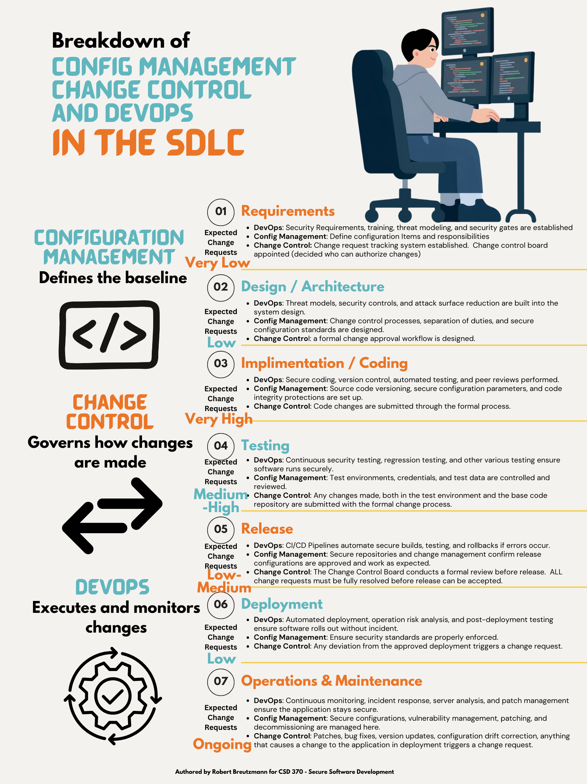

References
Atlassian. (n.d.). Configuration management tools in microservices architecture. https://www.atlassian.com/microservices/microservices-architecture/configuration-management-tools
Atlassian. (n.d.). What is the change control process? Steps, benefits & tools. https://www.atlassian.com/itsm/change-management/change-control-process
Conklin, W. A., & Shoemaker, D. P. (2022). CSSLP Certified Secure Software Lifecycle Professional All-in-One Exam Guide (3rd ed.). McGraw-Hill.
Cybersecurity and Infrastructure Security Agency. (n.d.). CRR supplemental resource guide, volume 3: Configuration and change management (Version 1.1). U.S. Department of Homeland Security. https://www.cisa.gov/sites/default/files/c3vp/crr_resources_guides/CRR_Resource_Guide-CCM.pdf
GeeksforGeeks. (n.d.). Introduction to DevOps. https://www.geeksforgeeks.org/devops/introduction-to-devops/
GeeksforGeeks. (n.d.). Project management, configuration management, and change control. https://www.geeksforgeeks.org/software-engineering/project-management-configuration-management-and-change-control/
International Organization for Standardization. (n.d.). Configuration management and information security. https://www.iso.org/information-security/configuration-management
Robinson, S., Kirvan, P., & Chai, W. (2025, June 11). What is change control? TechTarget. https://www.techtarget.com/searchdisasterrecovery/definition/change-control
(The author used Grammarly to assist in the wording, phrasing, and creation of transitions between topics, as well as heavily in the introduction and conclusion paragraphs. All content, arguments, analysis, and research done by the author is their own.)

