Assignment 1.2
Robert Breutzmann's CSD-402 Java for Programmers GitHub

Screenshot of GitHub Repository: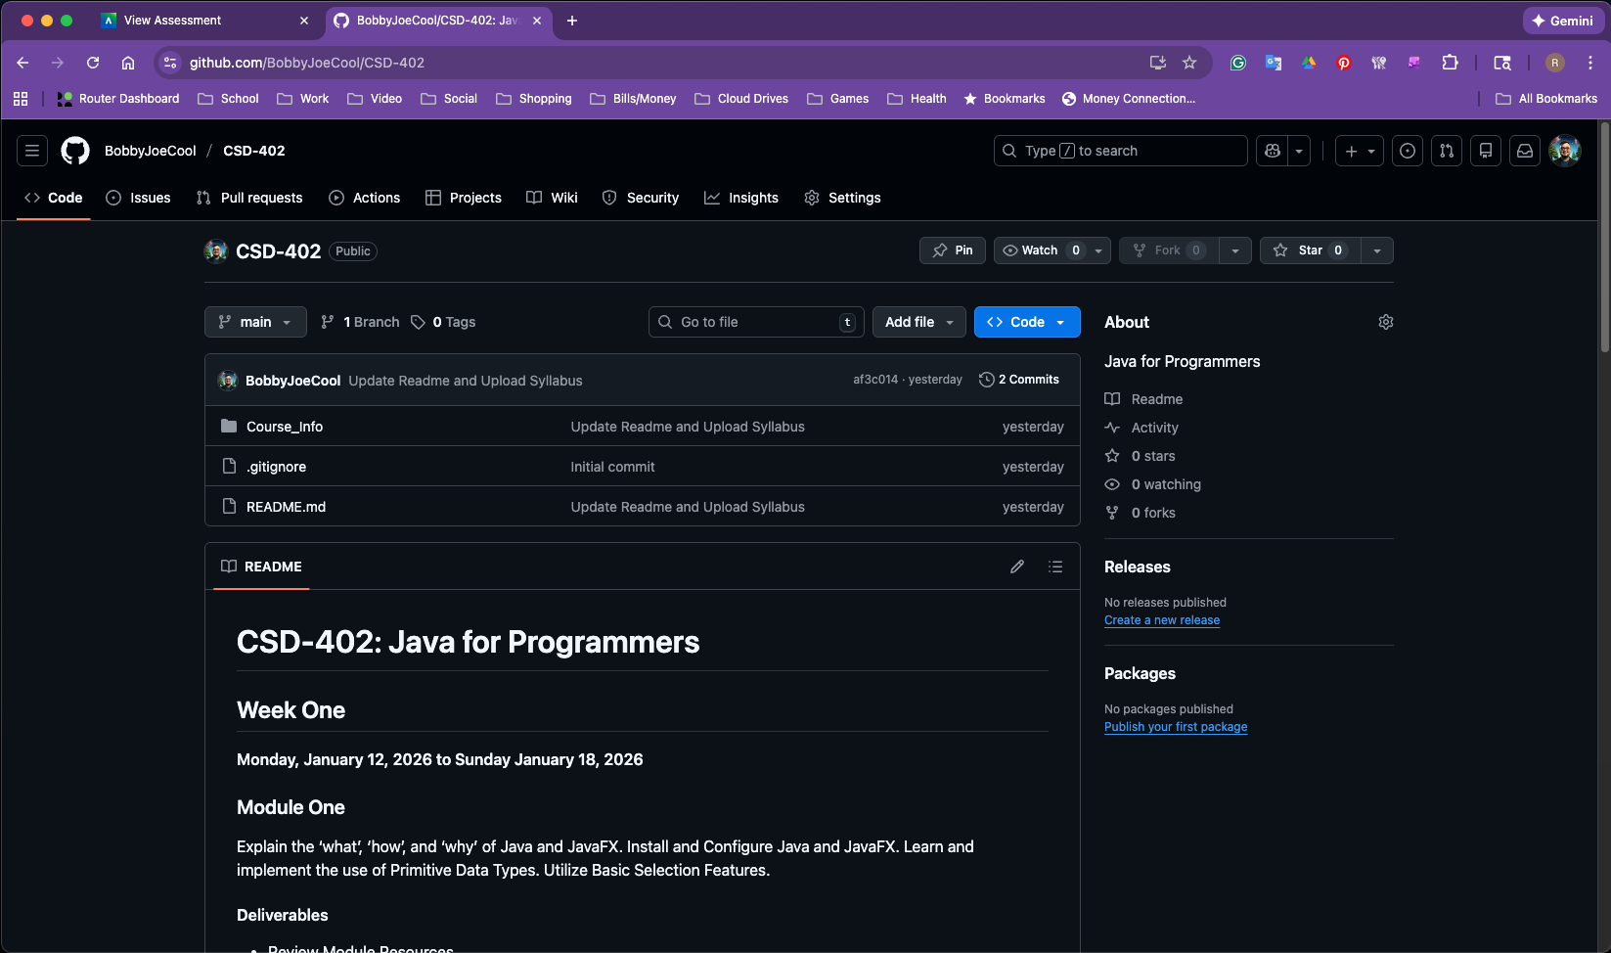
Screenshot of Local Directory in Terminal:

