Assignment 1.3
Robert Breutzmann's CSD402 GitHub

Java Install Proof Screenshot (Terminal <java -version>)
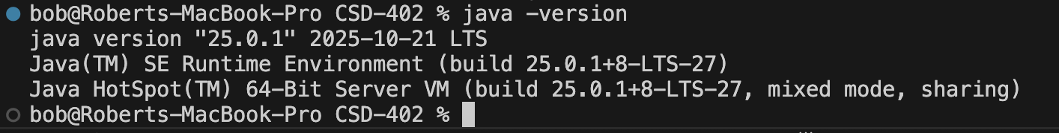

JavaFX Install Proof
(I used CoPilot to create a simple program like your HelloWorld program in your video that displays a box that has “Hello Professor, JavaFX successfully installed”)
