Java Databass
CHAPTER

34



Programming

Objectives
- To understand the concepts of databases and database management systems (§34.2).
- To understand the relational data model: relational data structures, con- straints, and languages (§34.2).
- To use SQL to create and drop tables and to retrieve and modify data (§34.3).
- To learn how to load a driver, connect to a database, execute state- ments, and process result sets using JDBC (§34.4).
- To use prepared statements to execute precompiled SQL statements (§34.5).
- To use callable statements to execute stored SQL procedures and func- tions (§34.6).
- To explore database metadata using the DatabaseMetaData and
ResultSetMetaData interfaces (§34.7).

34-2 Chapter 34 Java Database Programming

Introduction

Key Point
Java provides the API for developing database applications that works with any relational database systems.
You may have heard a lot about database systems. Database systems are everywhere. Your social security information is stored in a database by the government. If you shop online, your purchase information is stored in a database by the company. If you attend a university, your academic information is stored in a database by the university. Database systems not only store data, they also provide means of accessing, updating, manipulating, and ana- lyzing data. Your social security information is updated periodically, and you can register for courses online. Database systems play an important role in society and in commerce.
This chapter introduces database systems, the SQL language, and how database applica- tions can be developed using Java. If you already know SQL, you can skip Sections 34.2 and 34.3.

Relational Database Systems

Key Point
SQL is the standard database language for defining and accessing databases.

database system
A database system consists of a database, the software that stores and manages data in the database, and the application programs that present data and enable the user to interact with the database system, as shown in Figure 34.1.


Application Users
Application Programs
System Users
Database Management System (DBMS)
database
FIGuRE 34.1 A database system consists of data, database management software, and appli- cation programs.



DBMS
A database is a repository of data that form information. When you purchase a database system—such as MySQL, Oracle, IBM’s DB2 and Informix, Microsoft SQL Server, or Sybase—from a software vendor, you actually purchase the software comprising a database management system (DBMS). Database management systems are designed for use by profes- sional programmers and are not suitable for ordinary customers. Application programs are built on top of the DBMS for customers to access and update the database. Thus, application pro- grams can be viewed as the interfaces between the database system and its users. Application programs may be stand-alone GUI applications or Web applications and may access several different database systems in the network, as shown in Figure 34.2.
Most of today’s database systems are relational database systems. They are based on the relational data model, which has three key components: structure, integrity, and language.

Relational Database Systems 34-3

database
Application Users
Application Programs
Database Management System
…
Database Management System
…
…

FIGuRE 34.2 An application program can access multiple database systems.

Structure defines the representation of the data. Integrity imposes constraints on the data.
Language provides the means for accessing and manipulating data.

Relational Structures
The relational model is built around a simple and natural structure. A relation is actually a table that consists of nonduplicate rows. Tables are easy to understand and use. The relational model provides a simple yet powerful way to represent data.
A row of a table represents a record, and a column of a table represents the value of a single attribute of the record. In relational database theory, a row is called a tuple, and a column is called an attribute. Figure 34.3 shows a sample table that stores information about the courses offered by a university. The table has eight tuples, and each tuple has five attributes.

relational model

tuple attribute

Relation/Table Name

Columns/Attributes

Course Table
Tuples/ Rows
courseId subjectId courseNumber title numOfCredits




FIGuRE 34.3 A table has a table name, column names, and rows.
11111 | CSCI | 1301 | Introduction to Java I | 4
11112 | CSCI | 1302 | Introduction to Java II | 3
11113 | CSCI | 3720 | Database Systems | 3
11114 | CSCI | 4750 | Rapid Java Application | 3
11115 | MATH | 2750 | Calculus I | 5
11116 | MATH | 3750 | Calculus II | 5
11117 | EDUC | 1111 | Reading | 3
11118 | ITEC | 1344 | Database Administration | 3

Tables describe the relationship among data. Each row in a table represents a record of related data. For example, “11111,” “CSCI,” “1301,” “Introduction to Java I,” and “4” are related to form a record (the first row in Figure 34.3) in the Course table. Just as the data in the same row are related, so too data in different tables may be related through common attributes. Suppose the database has two other tables, Student and Enrollment, as shown in

34-4 Chapter 34 Java Database Programming

Figures 34.4 and 34.5. The Course table and the Enrollment table are related through their common attribute courseId, and the Enrollment table and the Student table are related through ssn.

Student Table
ssn | firstName | mi | lastName | phone | birthDate |  | street | zipCode | deptID
444111110 | Jacob | R | Smith | 9129219434 | 1985-04-09 | 99 | Kingston Street | 31435 | BIOL
444111111 | John | K | Stevenson | 9129219434 | null | 100 | Main Street | 31411 | BIOL
444111112 | George | K | Smith | 9129213454 | 1974-10-10 | 1200 | Abercorn St. | 31419 | CS
444111113 | Frank | E | Jones | 9125919434 | 1970-09-09 | 100 | Main Street | 31411 | BIOL
444111114 | Jean | K | Smith | 9129219434 | 1970-02-09 | 100 | Main Street | 31411 | CHEM
444111115 | Josh | R | Woo | 7075989434 | 1970-02-09 | 555 | Franklin St. | 31411 | CHEM
444111116 | Josh | R | Smith | 9129219434 | 1973-02-09 | 100 | Main Street | 31411 | BIOL
444111117 | Joy | P | Kennedy | 9129229434 | 1974-03-19 | 103 | Bay Street | 31412 | CS
444111118 | Toni | R | Peterson | 9129229434 | 1964-04-29 | 103 | Bay Street | 31412 | MATH
444111119 | Patrick | R | Stoneman | 9129229434 | 1969-04-29 | 101 | Washington St. | 31435 | MATH
444111120 | Rick | R | Carter | 9125919434 | 1986-04-09 | 19 | West Ford St. | 31411 | BIOL

FIGuRE 34.4 A Student table stores student information.


Enrollment Table
ssn | courseId | dateRegistered | grade
444111110 | 11111 | 2004-03-19 | A
444111110 | 11112 | 2004-03-19 | B
444111110 | 11113 | 2004-03-19 | C
444111111 | 11111 | 2004-03-19 | D
444111111 | 11112 | 2004-03-19 | F
444111111 | 11113 | 2004-03-19 | A
444111112 | 11114 | 2004-03-19 | B
444111112 | 11115 | 2004-03-19 | C
444111112 | 11116 | 2004-03-19 | D
444111113 | 11111 | 2004-03-19 | A
444111113 | 11113 | 2004-03-19 | A
444111114 | 11115 | 2004-03-19 | B
444111115 | 11115 | 2004-03-19 | F
444111115 | 11116 | 2004-03-19 | F
444111116 | 11111 | 2004-03-19 | D
444111117 | 11111 | 2004-03-19 | D
444111118 | 11111 | 2004-03-19 | A
444111118 | 11112 | 2004-03-19 | D
444111118 | 11113 | 2004-03-19 | B

FIGuRE 34.5 An Enrollment table stores student enrollment information.



integrity constraint

Integrity Constraints
An integrity constraint imposes a condition that all the legal values in a table must satisfy. Figure 34.6 shows an example of some integrity constraints in the Subject and Course tables.
In general, there are three types of constraints: domain constraints, primary key con- straints, and foreign key constraints. Domain constraints and primary key constraints are known as intrarelational constraints, meaning that a constraint involves only one relation. The foreign key constraint is interrelational, meaning that a constraint involves more than one relation.

34.2 Relational Database Systems 34-5

Enrollment Table ssn courseId dateRegistered grade

444111110 | 11111 | 2004-03-19 | A
444111110 | 11112 | 2004-03-19 | B
444111110 | 11113 | 2004-03-19 | C
...

Course Table
Each value in courseId in the Enrollment table must match a value in courseId in the Course table

courseId subjectId courseNumber title numOfCredits

11111 | CSCI | 1301 | Introduction to Java | I | 4
11112 | CSCI | 1302 | Introduction to Java | II | 3
11113 | CSCI | 3720 | Database Systems |  | 3
...

Each row must have a value for courseId, and the value must be unique

FIGuRE 34.6 The Enrollment table and the Course table have integrity constraints.

Each value in the numOfCredits column must be greater than 0 and less than 5



Domain Constraints
Domain constraints specify the permissible values for an attribute. Domains can be specified using standard data types, such as integers, floating-point numbers, fixed-length strings, and variant-length strings. The standard data type specifies a broad range of values. Additional con- straints can be specified to narrow the ranges. For example, you can specify that the numOfCredits attribute (in the Course table) must be greater than 0 and less than 5. If an attribute has different values for each tuple in a relation, you can specify the attribute to be unique. You can also specify whether an attribute can be null, which is a special value in a database meaning unknown or not applicable. As shown in the Student table, birthDate may be null.

Primary Key Constraints
A primary key is a set of attributes that uniquely identifyies the tuples in a relations. Why is it called a primary key, rather than simply key? To understand this, it is helpful to know superkeys, keys, and candidate keys. A superkey is an attribute or a set of attributes that uniquely identifies the relation. That is, no two tuples have the same values on a superkey. By definition, a relation consists of a set of distinct tuples. The set of all attributes in the relation forms a superkey.
A key K is a minimal superkey, meaning that any proper subset of K is not a superkey. A relation can have several keys. In this case, each of the keys is called a candidate key. The primary key is one of the candidate keys designated by the database designer. The primary key is often used to identify tuples in a relation. As shown in Figure 34.6, courseId is the primary key in the Course table, and ssn and courseId form a primary key in the Enrollment table.

Foreign Key Constraints
In a relational database, data are related. Tuples in a relation are related, and tuples in different relations are related through their common attributes. Informally speaking, the common attrib- utes are foreign keys. The foreign key constraints define the relationships among relations.
Formally, a set of attributes FK is a foreign key in a relation R that references relation T if it satisfies the following two rules:
- The attributes in FK have the same domain as the primary key in T.
- A nonnull value on FK in R must match a primary key value in T.

domain constraint

superkey

candidate key primary key

relational database

foreign key constraint foreign key

34-6 Chapter 34 Java Database Programming

auto enforcement
As shown in Figure 34.6, courseId is the foreign key in Enrollment that references the primary key courseId in Course. Every courseId value must match a courseId value in Course.

Enforcing Integrity Constraints
The database management system enforces integrity constraints and rejects operations that would violate them. For example, if you attempt to insert the new record (“11115,” “CSCI,” “2490,” “C+ + Programming,” “0”) into the Course table, it would fail because the credit hours must be greater than 0; if you attempted to insert a record with the same primary key as an existing record in the table, the DBMS would report an error and reject the operation; if you attempted to delete a record from the Course table whose primary key value is referenced by the records in the Enrollment table, the DBMS would reject this operation.





SQL

Key Point

database language

standard SQL

MySQL Tutorial Oracle Tutorial Java DB Tutorial

Check Point

Note

All relational database systems support primary key constraints and foreign key constraints, but not all database systems support domain constraints. In the Microsoft Access database, for example, you cannot specify the constraint that numOfCredits is greater than 0 and less than 5.
    - What are superkeys, candidate keys, and primary keys?
    - What is a foreign key?
    - Can a relation have more than one primary key or foreign key?
    - Does a foreign key need to be a primary key in the same relation?
    - Does a foreign key need to have the same name as its referenced primary key?
    - Can a foreign key value be null?

SQL
Structured Query Language (SQL) is the language for defining tables and integrity constraints, and for accessing and manipulating data.
SQL (pronounced “S-Q-L” or “sequel”) is the universal language for accessing relational database systems. Application programs may allow users to access a database without directly using SQL, but these applications themselves must use SQL to access the database. This section introduces some basic SQL commands.


Note
There are many relational database management systems. They share the common SQL language but do not all support every feature of SQL. Some systems have their own extensions to SQL. This section introduces standard SQL supported by all systems.
SQL can be used on MySQL, Oracle, Sybase, IBM DB2, IBM Informix, MS Access, Apache Derby, or any other relational database system. Apache Derby is an open source rela- tional database management system developed using Java. Oracle distributes Apache Derby as Java DB and bundled with Java so you can use it in any Java application without installing a database. Java DB is ideal for supporting a small database in a Java application. This chapter uses MySQL to demonstrate SQL and Java database programming.
The Companion Website contains the following supplements on how to install and use three popular databases: MySQL, Oracle, and Java DB:
- Supplement IV.B: Tutorial for MySQL
- Supplement IV.C: Tutorial for Oracle
- Supplement IV.D: Tutorial for Java DB



  - SQL 34-7

Creating a User Account on MySQL
Assume you have installed MySQL 5 with the default configuration. To match all the examples in this book, you should create a user named scott with the password tiger. You can perform the administrative tasks using the MySQL Workbench or using the command line. MySQL Workbench is a GUI tool for managing MySQL databases. Here are the steps to create a user from the command line:

      - From the DOS command prompt, type
mysql –uroot -p
You will be prompted to enter the root password, as shown in Figure 34.7.
      - At the mysql prompt, enter
use mysql;
      - To create user scott with password tiger, enter
create user 'scott'@'localhost' identified by 'tiger';
      - To grant privileges to scott, enter
grant select, insert, update, delete, create, create view, drop, execute, references on *.* to 'scott'@'localhost';
        - If you want to enable remote access of the account from any IP address, enter
grant all privileges on *.* to 'scott'@'%' identified by 'tiger';
        - If you want to restrict the account’s remote access to just one particular IP address, enter
grant all privileges on *.* to 'scott'@'ipAddress' identified by 'tiger';
      - Enter
exit;
to exit the MySQL console.

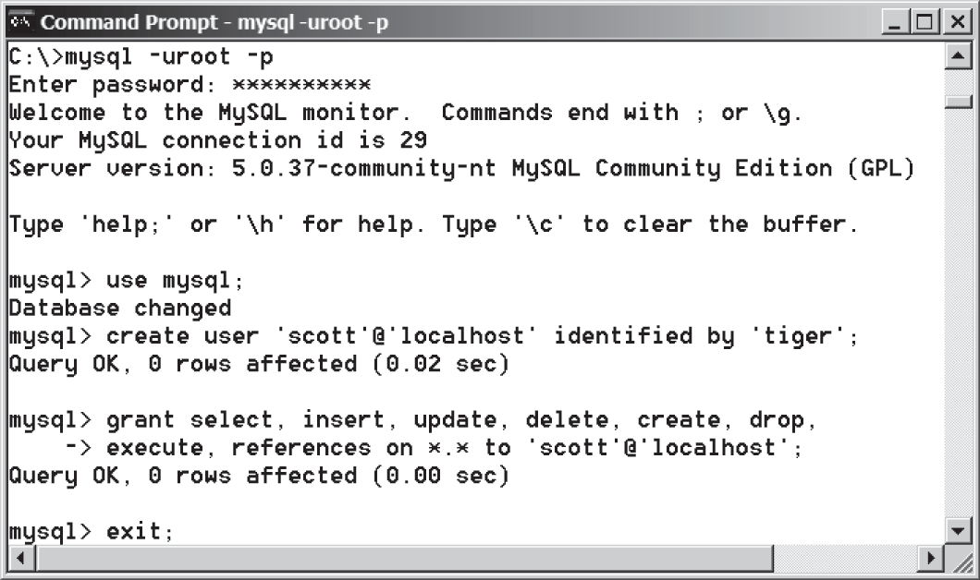
FIGuRE 34.7 You can access a MySQL database server from the command window.

34-8 Chapter 34 Java Database Programming


Note
On Windows, your MySQL database server starts every time your computer starts. You

stop mysql start mysql
can stop it by typing the command net stop mysql and restart it by typing the command net start mysql.
By default, the server contains two databases named mysql and test. The mysql database contains the tables that store information about the server and its users. This database is intended for the server administrator to use. For example, the administrator can use it to cre- ate users and grant or revoke user privileges. Since you are the owner of the server installed on your system, you have full access to the mysql database. However, you should not cre- ate user tables in the mysql database. You can use the test database to store data or create new databases. You can also create a new database using the command create data- base databasename or delete an existing database using the command drop database databasename.

Creating a Database
To match the examples in this book, you should create a database named javabook. Here are the steps to create it:
      - From the DOS command prompt, type

mysql –uscott -ptiger

to login to mysql, as shown in Figure 34.8.
      - At the mysql prompt, enter

create database javabook;

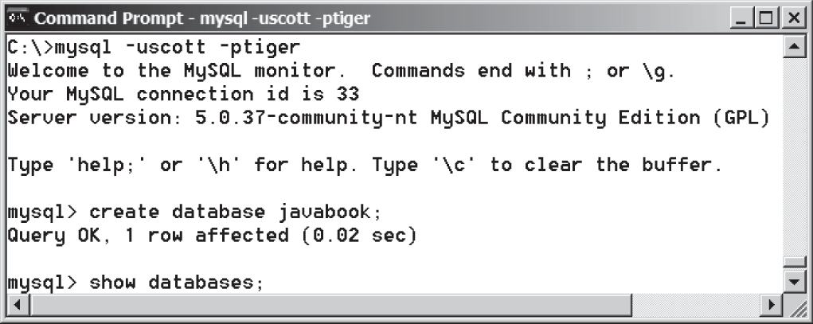
FIGuRE 34.8 You can create databases in MySQL.




run script file

For your convenience, the SQL statements for creating and initializing tables used in this book are provided in Supplement IV.A. You can download the script for MySQL and save it to script.sql. To execute the script, first switch to the javabook database using the following command:
use javabook;
then type
source script.sql;
as shown in Figure 34.9.

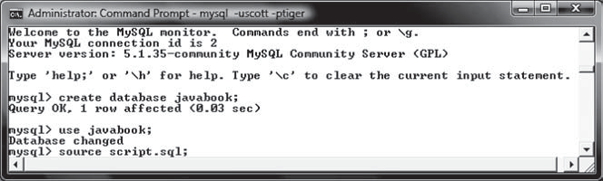
FIGuRE 34.9 You can run SQL commands in a script file.
34.3 SQL 34-9


Note
You can populate the javabook database using the script from Supplement IV.A.

Creating and Dropping Tables
Tables are the essential objects in a database. To create a table, use the create table state- ment to specify a table name, attributes, and types, as in the following example:

create table Course ( courseId char(5),
subjectId char(4) not null, courseNumber integer,
title varchar(50) not null, numOfCredits integer, primary key (courseId)
);

This statement creates the Course table with attributes courseId, subjectId, courseNumber, title, and numOfCredits. Each attribute has a data type that specifies the type of data stored in the attribute. char(5) specifies that courseId consists of five charac- ters. varchar(50) specifies that title is a variant-length string with a maximum of 50 char- acters. integer specifies that courseNumber is an integer. The primary key is courseId.
The tables Student and Enrollment can be created as follows:

populating database

create table

create table Student ( ssn char(9),
firstName varchar(25), mi char(1),
lastName varchar(25), birthDate date, street varchar(25), phone char(11), zipCode char(5), deptId char(4), primary key (ssn)
);
create table Enrollment ( ssn char(9),
courseId char(5), dateRegistered date, grade char(1),
primary key (ssn, courseId),
foreign key (ssn) references
Student(ssn),
foreign key (courseId) references
Course(courseId)
);




Note
SQL keywords are not case sensitive. This book adopts the following naming conventions: tables are named in the same way as Java classes, and attributes are named in the same way as Java variables. SQL keywords are named in the same way as Java keywords.

naming convention

34-10 Chapter 34 Java Database Programming

drop table
If a table is no longer needed, it can be dropped permanently using the drop table
command. For example, the following statement drops the Course table:
drop table Course;
If a table to be dropped is referenced by other tables, you have to drop the other tables first. For example, if you have created the tables Course, Student, and Enrollment and want to drop Course, you have to first drop Enrollment, because Course is referenced by Enrollment.
Figure 34.10 shows how to enter the create table statement from the MySQL console.




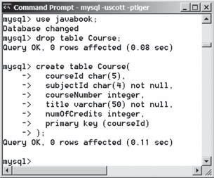
FIGuRE 34.10 A table is created using the create table statement.

If you make typing errors, you have to retype the whole command. To avoid retyping, you can save the command in a file, then run the command from the file. To do so, create a text file to contain commands, named, for example, test.sql. You can create the text file using any text editor, such as Notepad, as shown in Figure 34.11a. To comment a line, precede it with two dashes. You can now run the script file by typing source test.sql from the SQL command prompt, as shown in Figure 34.11b.

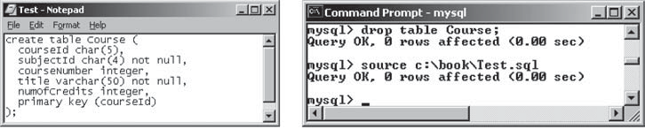
(a) (b)
FIGuRE 34.11 (a) You can use Notepad to create a text file for SQL commands. (b) You can run the SQL commands in a script file from MySQL.

Simple Insert, Update, and Delete
Once a table is created, you can insert data into it. You can also update and delete records. This section introduces simple insert, update, and delete statements.
The syntax to insert a record into a table is:
insert into tableName [(column1, column2, ..., column)]
values (value1, value2, ..., valuen);



  - SQL 34-11

For example, the following statement inserts a record into the Course table. The new record has the courseId ‘11113’, subjectId ‘CSCI’, courseNumber ‘3720’, title ‘Database Systems’, and creditHours 3.

insert into Course (courseId, subjectId, courseNumber, title, numOfCredits)
values ('11113', 'CSCI', '3720', 'Database Systems', 3);

The column names are optional. If they are omitted, all the column values for the record must be entered, even though the columns have default values. String values are case sensitive and enclosed inside single quotation marks in SQL.
The syntax to update a table is:

update tableName
set column1 = newValue1 [, column2 = newValue2, ...] [where condition];

For example, the following statement changes the numOfCredits for the course whose title
is Database Systems to 4.

update Course
set numOfCredits = 4
where title = 'Database Systems';

The syntax to delete records from a table is:

delete from tableName
[where condition];

For example, the following statement deletes the Database Systems course from the Course
table:

delete from Course
where title = 'Database Systems';

The following statement deletes all the records from the Course table:

delete from Course;

Simple Queries
To retrieve information from tables, use a select statement with the following syntax:

select column-list from table-list [where condition];

The select clause lists the columns to be selected. The from clause refers to the tables involved in the query. The optional where clause specifies the conditions for the selected rows.
Query 1: Select all the students in the CS department, as shown in Figure 34.12.

select firstName, mi, lastName
from Student
where deptId = 'CS';



34-12 Chapter 34 Java Database Programming
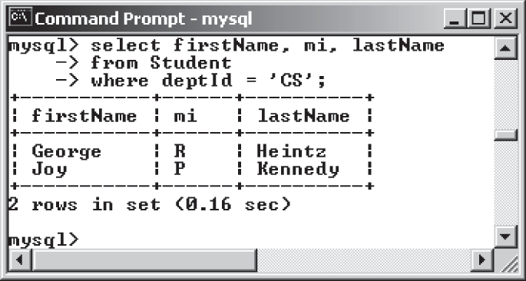
FIGuRE 34.12 The result of the select statement is displayed in the MySQL console.

Comparison and Boolean Operators
SQL has six comparison operators, as shown in Table 34.1, and three Boolean operators, as shown in Table 34.2.

TablE 34.1 Comparison Operators TablE 34.2 Boolean Operators

Operator | Description |  | Operator | Description
= | Equal to |  | not | Logical negation
<> or != | Not equal to |  | and | Logical conjunction
< | Less than |  | or | Logical disjunction
<= | Less than or equal to
> | Greater than
>= | Greater than or equal to


Note
The comparison and Boolean operators in SQL have the same meanings as in Java. In SQL the equal to operator is =, but in Java it is ==. In SQL the not equal to operator is <> or !=, but in Java it is !=. The not, and, and or operators are !, && (&), and || (|) in Java.

Query 2: Get the names of the students who are in the CS dept and live in the ZIP code 31411.

select firstName, mi, lastName
from Student
where deptId = 'CS' and zipCode = '31411';


Note
To select all the attributes from a table, you don’t have to list all the attribute names in the select clause. Instead, you can just use an asterisk (*), which stands for all the attributes. For example, the following query displays all the attributes of the students who are in the CS dept and live in ZIP code 31411.

select *
from Student
where deptId = 'CS' and zipCode = '31411';



  - SQL 34-13
    - The like, between-and, and is null Operators
SQL has a like operator that can be used for pattern matching. The syntax to check whether a string s has a pattern p is
s like p or s not like p
You can use the wildcard characters % (percent symbol) and _ (underline symbol) in the pattern p. % matches zero or more characters, and _ matches any single character in s. For example, lastName like '_mi%' matches any string whose second and third letters are m and i. lastName not like '_mi%' excludes any string whose second and third letters are m and i.


Note
In earlier versions of MS Access, the wildcard character is *, and the character ? matches any single character.
The between-and operator checks whether a value v is between two other values, v1 and
v2, using the following syntax:
v between v1 and v2 or v not between v1 and v2
v between v1 and v2 is equivalent to v >= v1 and v <= v2, and v not between v1 and v2 is equivalent to v < v1 or v > v2.
The is null operator checks whether a value v is null using the following syntax:
v is null or v is not null
Query 3: Get the Social Security numbers of the students whose grades are between ‘C’ and ‘A’.
select ssn
from Enrollment
where grade between 'C' and 'A';

Column Alias
When a query result is displayed, SQL uses the column names as column headings. Usually the user gives abbreviated names for the columns, and the columns cannot have spaces when the table is created. Sometimes it is desirable to give more descriptive names in the result heading. You can use the column aliases with the following syntax:
select columnName [as] alias
Query 4: Get the last name and ZIP code of the students in the CS department. Display the column headings as “Last Name” for lastName and “Zip Code” for zipCode. The query result is shown in Figure 34.13.

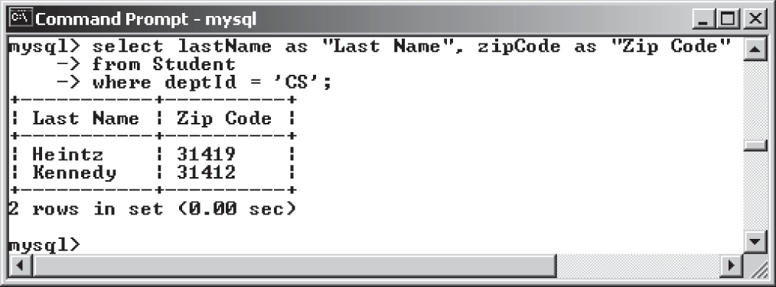
FIGuRE 34.13 You can use a column alias in the display.



34-14 Chapter 34 Java Database Programming
select lastName as "Last Name", zipCode as "Zip Code" from Student
where deptId = 'CS';


Note
The as keyword is optional in MySQL and Oracle, but it is required in MS Access.

The Arithmetic Operators
You can use the arithmetic operators * (multiplication), / (division), + (addition), and − (sub- traction) in SQL.
Query 5: Assume a credit hour is 50 minutes of lectures and get the total minutes for each course with the subject CSCI. The query result is shown in Figure 34.14.
select title, 50 * numOfCredits as "Lecture Minutes Per Week" from Course
where subjectId = 'CSCI';

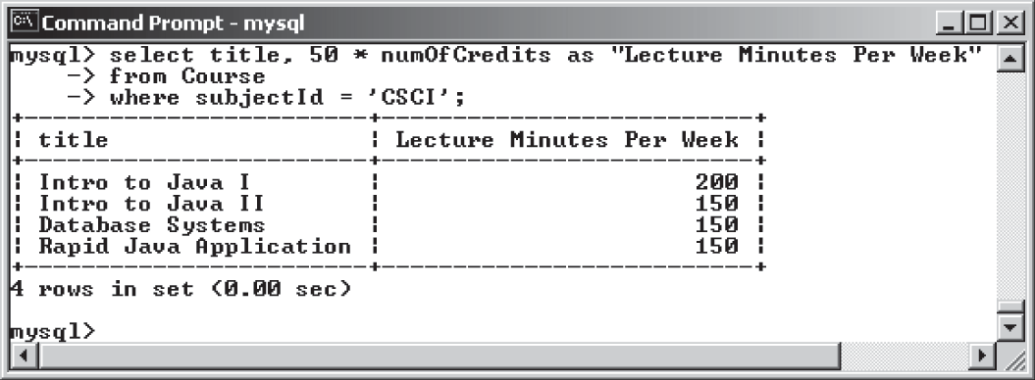
FIGuRE 34.14 You can use arithmetic operators in SQL.

Displaying Distinct Tuples
SQL provides the distinct keyword, which can be used to eliminate duplicate tuples in the result. Figure 34.15a displays all the subject IDs used by the courses, and Figure 34.15b dis- plays all the distinct subject IDs used by the courses using the following statement:

select distinct subjectId as "Subject ID" from Course;

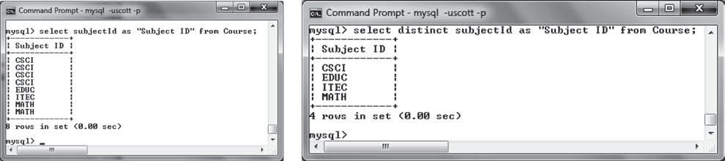
(a) (b)
FIGuRE 34.15 (a) The duplicate tuples are displayed. (b) The distinct tuples are displayed.



  - SQL 34-15

When there is more than one column in the select clause, the distinct keyword applies to the whole tuple in the result. For example, the following statement displays all tuples with distinct subjectId and title, as shown in Figure 34.16. Note some tuples may have the same subjectId but different title. These tuples are distinct.
select distinct subjectId, title
from Course;

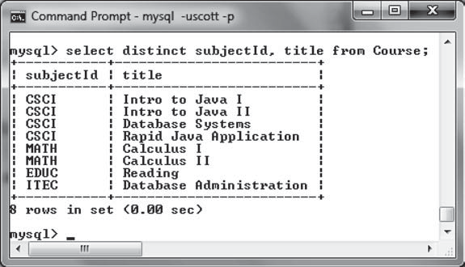
FIGuRE 34.16 The keyword distinct applies to the entire tuple.

Displaying Sorted Tuples
SQL provides the order by clause to sort the output using the following syntax:
select column-list from table-list [where condition]
[order by columns-to-be-sorted];
In the syntax, columns-to-be-sorted specifies a column or a list of columns to be sorted. By default, the order is ascending. To sort in a descending order, append the desc keyword. You could also append the asc keyword after columns-to-be-sorted, but it is not neces- sary. When multiple columns are specified, the rows are sorted based on the first column, then the rows with the same values on the first column are sorted based on the second column, and so on.
Query 6: List the full names of the students in the CS department, ordered primarily on their last names in descending order and secondarily on their first names in ascending order. The query result is shown in Figure 34.17.

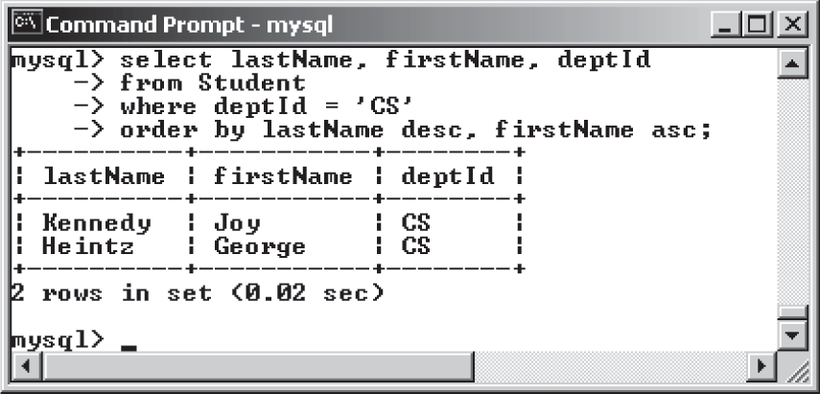
FIGuRE 34.17 You can sort results using the order by clause.




34-16 Chapter 34 Java Database Programming
select lastName, firstName, deptId
from Student
where deptId = 'CS'
order by lastName desc, firstName asc;

Joining Tables
Often you need to get information from multiple tables, as demonstrated in the next query.
Query 7: List the courses taken by the student Jacob Smith. To solve this query, you need to join tables Student and Enrollment, as shown in Figure 34.18.

Student Table Enrollment Table

A tuple
ssn lastName mi firstName …
ssn courseId …

Equal
FIGuRE 34.18 Student and Enrollment are joined on ssn.

You can write the query in SQL as follows:

select distinct lastName, firstName, courseId
from Student, Enrollment
where Student.ssn = Enrollment.ssn and lastName = 'Smith' and firstName = 'Jacob';
The tables Student and Enrollment are listed in the from clause. The query examines every pair of rows, each made of one item from Student and another from Enrollment and selects the pairs that satisfy the condition in the where clause. The rows in Student have the last name, Smith, and the first name, Jacob, and both rows from Student and Enrollment have the same ssn values. For each pair selected, lastName and firstName from Student and courseId from Enrollment are used to produce the result, as shown in Figure 34.19. Student and Enrollment have the same attribute ssn. To distinguish them in a query, use Student.ssn and Enrollment.ssn.

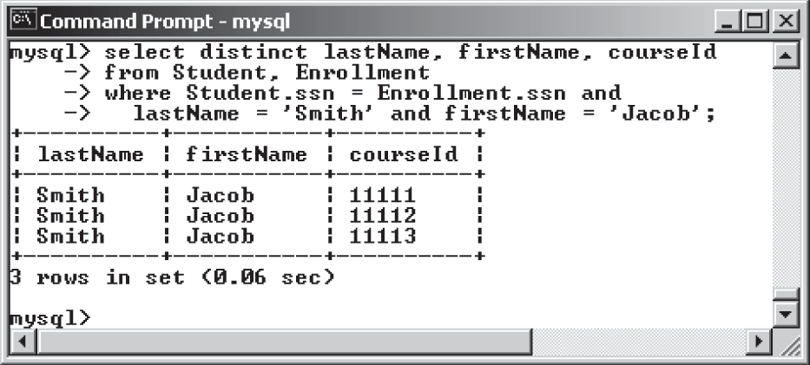
FIGuRE 34.19 Query 7 demonstrates queries involving multiple tables.

  - JDBC 34-17

For more features of SQL, see Supplements IV.H and IV.I.

    - Create the tables Course, Student, and Enrollment using the create table statements in Section 34.3.3, Creating and Dropping Tables. Insert rows into the Course, Student, and Enrollment tables using the data in Figures 34.3–34.5.
    - List all CSCI courses with at least four credit hours.
    - List all students whose last names contain the letter e two times.
    - List all students whose birthdays are null.
    - List all students who take Math courses.
    - List the number of courses in each subject.
    - Assume each credit hour is 50 minutes of lectures. Get the total minutes for the courses that each student takes.

JDBC
JDBC is the Java API for accessing relational database.
The Java API for developing Java database applications is called JDBC. JDBC is the trade- marked name of a Java API that supports Java programs that access relational databases. JDBC is not an acronym, but it is often thought to stand for Java Database Connectivity.
JDBC provides Java programmers with a uniform interface for accessing and manipulat- ing relational databases. Using the JDBC API, applications written in the Java programming language can execute SQL statements, retrieve results, present data in a user-friendly interface, and propagate changes back to the database. The JDBC API can also be used to interact with multiple data sources in a distributed, heterogeneous environment.
The relationships among Java programs, JDBC API, JDBC drivers, and relational databases are shown in Figure 34.20. The JDBC API is a set of Java interfaces and classes used to write Java programs for accessing and manipulating relational databases. Since a JDBC driver serves as the interface to facilitate communications between JDBC and a proprietary database, JDBC drivers are database specific and are normally provided by the database vendors. You need

Check Point

Key Point




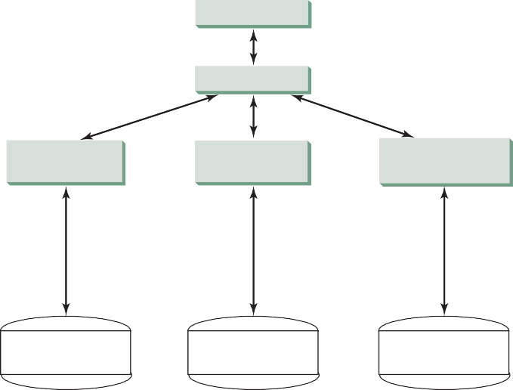
Java Programs
JDBC API
MySQL JDBC
Driver
Oracle JDBC Driver
DB2 JDBC
Driver
Local or remote MySQL DB
Local or remote ORACLE DB
Local or remote DB2 DB
FIGuRE 34.20 Java programs access and manipulate databases through JDBC drivers.

34-18 Chapter 34 Java Database Programming
MySQL JDBC drivers to access the MySQL database, Oracle JDBC drivers to access the Oracle database, and DB2 JDBC driver to access the DB2 database.

Developing Database Applications Using JDBC
The JDBC API is a Java application program interface to generic SQL databases that enables Java developers to develop DBMS-independent Java applications using a uniform interface.
The JDBC API consists of classes and interfaces for establishing connections with data- bases, sending SQL statements to databases, processing the results of SQL statements, and obtaining database metadata. Four key interfaces are needed to develop any database applica- tion using Java: Driver, Connection, Statement, and ResultSet. These interfaces define a framework for generic SQL database access. The JDBC API defines these interfaces, and the JDBC driver vendors provide the implementation for the interfaces. Programmers use these interfaces.
The relationship of these interfaces is shown in Figure 34.21. A JDBC application loads an appropriate driver using the Driver interface, connects to the database using the Connection interface, creates and executes SQL statements using the Statement interface, and processes the result using the ResultSet interface if the statements return results. Note some state- ments, such as SQL data definition statements and SQL data modification statements, do not return results.


Statement Statement Statement Statement
ResultSet ResultSet ResultSet ResultSet
Connection
Connection
Driver
FIGuRE 34.21 JDBC classes enable Java programs to connect to the database, send SQL statements, and process results.

The JDBC interfaces and classes are the building blocks in the development of Java data- base programs. A typical Java program takes the following steps to access a database.
- Loading drivers.
An appropriate driver must be loaded using the statement shown below before connecting to a database.
Class.forName("JDBCDriverClass");
A driver is a concrete class that implements the java.sql.Driver interface. The drivers for MySQL, Oracle, and Java DB are listed in Table 34.3. If your program accesses several differ- ent databases, all their respective drivers must be loaded.
The most recent platform independent version of MySQL JDBC driver is mysql-connector-
mysql-connector-java-5.1.26.jar java-5.1.26.jar. This file is contained in a ZIP file downloadable from dev.mysql.com/down-


ojdbc6.jar
loads/connector/j/. The most recent version of Oracle JDBC driver is ojdbc6.jar (downloadable from www.oracle.com/technetwork/database/enterprise-edition/jdbc-112010-090769.html).

  - JDBC 34-19
TablE 34.3 JDBC Drivers

Database Driver Class Source

MySQL com.mysql.jdbc.Driver mysql-connector-java-5.1.26.jar
Oracle oracle.jdbc.driver.OracleDriver ojdbc6.jar Java DB (embedded) org.apache.derby.jdbc.EmbeddedDriver derby.jar Java DB (network) org.apache.derby.jdbc.ClientDriver derbynet.jar

Java DB has two versions: embedded and networked. Embedded version is used when you access Java DB locally, while the network version enables you to access Java DB on the net- work. To use these drivers, you have to add their jar files in the classpath using the following DOS command on Windows:
set classpath=%classpath%;c:\book\lib\mysql-connector-java-5.1.26. jar;c:\book\lib\ojdbc6.jar;c:\program files\jdk1.8.0\db\lib\derby. jar
If you use an IDE such as Eclipse or NetBeans, you need to add these jar files into the library in the IDE.


Note
com.mysql.jdbc.Driver is a class in mysql-connector-java-5.1.26.jar, and oracle.jdbc.driver.OracleDriver is a class in ojdbc6.jar. mysql- connector-java-5.1.26.jar, ojdbc6.jar, and derby.jar contains many classes to support the driver. These classes are used by JDBC but not directly by JDBC programmers. When you use a class explicitly in the program, it is automatically loaded by the JVM. The driver classes, however, are not used explicitly in the program, so you have to write the code to tell the JVM to load them.


Note
Java supports automatic driver discovery, so you don’t have to load the driver explicitly. At the time of this writing, however, this feature is not supported for all database drivers. To be safe, load the driver explicitly.

why load a driver?

automatic driver discovery



- Establishing connections.
To connect to a database, use the static method getConnection(databaseURL) in the
DriverManager class, as follows:
Connection connection = DriverManager.getConnection(databaseURL);
where databaseURL is the unique identifier of the database on the Internet. Table 34.4 lists the URL patterns for the MySQL, Oracle, and Java DB.

TablE 34.4 JDBC URLs

Database URL Pattern

MySQL jdbc:mysql://hostname/dbname
Oracle jdbc:oracle:thin:@hostname:port#:oracleDBSID
Java DB (embedded) jdbc:derby:dbname
Java DB (network) jdbc:derby://hostname/dbname

34-20 Chapter 34 Java Database Programming



connect MySQL DB

connect Oracle DB


The databaseURL for a MySQL database specifies the host name and database name to locate a database. For example, the following statement creates a Connection object for the local MySQL database javabook with username scott and password tiger:

Connection connection = DriverManager.getConnection ("jdbc:mysql://localhost/javabook", "scott", "tiger");

Recall that by default, MySQL contains two databases named mysql and test. Section 34.3.2, Creating a Database, created a custom database named javabook. We will use javabook in the examples.
The databaseURL for an Oracle database specifies the hostname, the port# where the database listens for incoming connection requests, and the oracleDBSID database name to locate a database. For example, the following statement creates a Connection object for the Oracle database on liang.armstrong.edu with the username scott and password tiger:

Connection connection = DriverManager.getConnection ("jdbc:oracle:thin:@liang.armstrong.edu:1521:orcl",
"scott", "tiger");

- Creating statements.
If a Connection object can be envisioned as a cable linking your program to a database, an object of Statement can be viewed as a cart that delivers SQL statements for execution by the database and brings the result back to the program. Once a Connection object is created, you can create statements for executing SQL statements as follows:

Statement statement = connection.createStatement();
- Executing statements.
SQL data definition language (DDL) and update statements can be executed using executeUpdate(String sql), and an SQL query statement can be executed using executeQuery(String sql). The result of the query is returned in ResultSet. For example, the following code executes the SQL statement create table Temp (col1 char(5), col2 char(5)):

statement.executeUpdate
("create table Temp (col1 char(5), col2 char(5))");
This next code executes the SQL query select firstName, mi, lastName from Student where lastName = 'Smith':
// Select the columns from the Student table ResultSet resultSet = statement.executeQuery
("select firstName, mi, lastName from Student where lastName "
+ " = 'Smith'");
- Processing ResultSet.
The ResultSet maintains a table whose current row can be retrieved. The initial row position is null. You can use the next method to move to the next row and the various getter methods to retrieve values from a current row. For example, the following code displays all the results from the preceding SQL query:

// Iterate through the result and print the student names
while (resultSet.next()) System.out.println(resultSet.getString(1) + " " +
resultSet.getString(2) + " " + resultSet.getString(3));

  - JDBC 34-21

The getString(1), getString(2), and getString(3) methods retrieve the column values for firstName, mi, and lastName, respectively. Alternatively, you can use getString("firstName"), getString("mi"), and getString("lastName") to retrieve the same three column values. The first execution of the next() method sets the current row to the first row in the result set, and subsequent invocations of the next() method set the current row to the second row, third row, and so on, to the last row.
Listing 34.1 is a complete example that demonstrates connecting to a database, executing a simple query, and processing the query result with JDBC. The program connects to a local MySQL database and displays the students whose last name is Smith.



lISTING 34.1 SimpleJdbc.java
1 import java.sql.*;
2
- public class SimpleJdbc {
- public static void main(String[] args)
- throws SQLException, ClassNotFoundException {
- // Load the JDBC driver
- Class.forName("com.mysql.jdbc.Driver");
- System.out.println("Driver loaded");
9
- // Connect to a database 11
Connection connection = DriverManager.getConnection
- ("jdbc:mysql://localhost/javabook", "scott", "tiger");
- System.out.println("Database connected");
14
- // Create a statement
- Statement statement = connection.createStatement(); 17
18 // Execute a statement 19
("select firstName, mi, lastName from Student where lastName "
ResultSet resultSet = statement.executeQuery
20
21 + " = 'Smith'");
22
- // Iterate through the result and print the student names
- while (resultSet.next())
- System.out.println(resultSet.getString(1) + "\t" +
- resultSet.getString(2) + "\t" + resultSet.getString(3)); 27
- // Close the connection
- connection.close();
30 }
31 }

The statement in line 7 loads a JDBC driver for MySQL, and the statement in lines 11–13 connects to a local MySQL database. You can change them to connect to an Oracle or other databases. The program creates a Statement object (line 16), executes an SQL statement and returns a ResultSet object (lines 19–21), and retrieves the query result from the ResultSet object (lines 24–26). The last statement (line 29) closes the connection and releases resources related to the connection. You can rewrite this program using the try-with-resources syntax. See www.cs.armstrong.edu/liang/intro11e/html/SimpleJdbcWithAutoClose.html.


Note
If you run this program from the DOS prompt, specify the appropriate driver in the classpath, as shown in Figure 34.22.

load driver

connect database

create statement

execute statement

get result

close connection

run from DOS prompt

34-22 Chapter 34 Java Database Programming
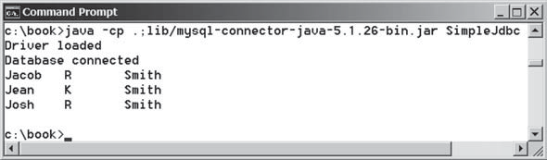
FIGuRE 34.22 You must include the driver file to run Java database programs.

The classpath directory and jar files are separated by commas. The period (.) represents the current directory. For convenience, the driver files are placed under the lib directory.

the semicolon issue

autocommit



Caution

Do not use a semicolon (;) to end the Oracle SQL command in a Java program. The semicolon may not work with the Oracle JDBC drivers. It does work, however, with the other drivers used in this book.


Note
The Connection interface handles transactions and specifies how they are processed. By default, a new connection is in autocommit mode, and all its SQL statements are executed and committed as individual transactions. The commit occurs when the state- ment completes or the next execute occurs, whichever comes first. In the case of state- ments returning a result set, the statement completes when the last row of the result set has been retrieved or the result set has been closed. If a single statement returns multiple results, the commit occurs when all the results have been retrieved. You can use the setAutoCommit(false) method to disable autocommit, so all SQL statements are grouped into one transaction that is terminated by a call to either the commit() or the rollback() method. The rollback() method undoes all the changes made by the transaction.



Accessing a Database from JavaFX
This section gives an example that demonstrates connecting to a database from a JavaFX pro- gram. The program lets the user enter the SSN and the course ID to find a student’s grade, as shown in Figure 34.23. The code in Listing 34.2 uses the MySQL database on the localhost.
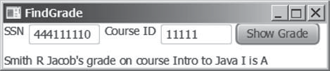
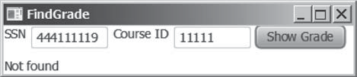
FIGuRE 34.23 A JavaFX client can access the database on the server.

lISTING 34.2 FindGrade.java

1 | import | javafx.application.Application;
2 | import | javafx.scene.Scene;
3 | import | javafx.scene.control.Button;
4 | import | javafx.scene.control.Label;
5 | import | javafx.scene.control.TextField;
6 | import | javafx.scene.layout.HBox;
7 | import | javafx.scene.layout.VBox;
8 | import | javafx.stage.Stage;
9 | import | java.sql.*;

34.4 JDBC 34-23



10
- public class FindGrade extends Application {
- // Statement for executing queries
- private Statement stmt;
- private TextField tfSSN = new TextField();
- private TextField tfCourseId = new TextField();
- private Label lblStatus = new Label(); 17
- @Override // Override the start method in the Application class
- public void start(Stage primaryStage) {
- // Initialize database connection and create a Statement object
- initializeDB();
22
- Button btShowGrade = new Button("Show Grade");
- HBox hBox = new HBox(5);
- hBox.getChildren().addAll(new Label("SSN"), tfSSN,
- new Label("Course ID"), tfCourseId, (btShowGrade)); 27
- VBox vBox = new VBox(10);
- vBox.getChildren().addAll(hBox, lblStatus);
30
- tfSSN.setPrefColumnCount(6);
- tfCourseId.setPrefColumnCount(6);
- btShowGrade.setOnAction(e -> showGrade()); 34
- // Create a scene and place it in the stage
- Scene scene = new Scene(vBox, 420, 80);
- primaryStage.setTitle("FindGrade"); // Set the stage title
- primaryStage.setScene(scene); // Place the scene in the stage
- primaryStage.show(); // Display the stage
40 }
41
- private void initializeDB() {
- try {
- // Load the JDBC driver
- Class.forName("com.mysql.jdbc.Driver");
- // Class.forName("oracle.jdbc.driver.OracleDriver");
- System.out.println("Driver loaded");
48
- // Establish a connection
- Connection connection = DriverManager.getConnection
- ("jdbc:mysql://localhost/javabook", "scott", "tiger");
- // ("jdbc:oracle:thin:@liang.armstrong.edu:1521:orcl",
- // "scott", "tiger");
- System.out.println("Database connected");
55
- // Create a statement
- stmt = connection.createStatement();
58 }
- catch (Exception ex) {
- ex.printStackTrace();
61 }
62 }
63
- private void showGrade() {
- String ssn = tfSSN.getText();
- String courseId = tfCourseId.getText();
- try {
- String queryString = "select firstName, mi, " +
- "lastName, title, grade from Student, Enrollment, Course " +

button listener

load driver
Oracle driver commented

connect to MySQL database connect to Oracle commented

execute statement

show result

create statement

34-24 Chapter 34 Java Database Programming

- "where Student.ssn = '" + ssn + "' and Enrollment.courseId "
71 + "= '" + courseId +
- "' and Enrollment.courseId = Course.courseId " +
- " and Enrollment.ssn = Student.ssn"; 74
75 ResultSet rset = stmt.executeQuery(queryString); 76
- if (rset.next()) {
- String lastName = rset.getString(1);
- String mi = rset.getString(2);
- String firstName = rset.getString(3);
- String title = rset.getString(4);
- String grade = rset.getString(5); 83
- // Display result in a label
- lblStatus.setText(firstName + " " + mi +
- " " + lastName + "'s grade on course " + title + " is " +
- grade);
- } else {
- lblStatus.setText("Not found");
90 }
91 }
- catch (SQLException ex) {
- ex.printStackTrace();
94 }
95 }
96 }

The initializeDB() method (lines 42–62) loads the MySQL driver (line 45), connects to the MySQL database on host liang.armstrong.edu (lines 50–55), and creates a state- ment (line 57).




security hole

Check Point

Note

There is a security hole in this program. If you enter 1' or true or '1 in the SSN
field, you will get the first student’s score, because the query string now becomes

select firstName, mi, lastName, title, grade
from Student, Enrollment, Course
where Student.ssn = '1' or true or '1' and Enrollment.courseId = ' ' and Enrollment.courseId = Course.courseId and Enrollment.ssn = Student.ssn;
You can avoid this problem by using the PreparedStatement interface, which will be discussed in the next section.

    - What are the advantages of developing database applications using Java?
    - Describe the following JDBC interfaces: Driver, Connection, Statement, and
ResultSet.
    - How do you load a JDBC driver? What are the driver classes for MySQL, Oracle, and Java DB?
    - How do you create a database connection? What are the URLs for MySQL, Oracle, and Java DB?
    - How do you create a Statement and execute an SQL statement?
    - How do you retrieve values in a ResultSet?
    - Does JDBC automatically commit a transaction? How do you set autocommit to false?

PreparedStatement

Key Point

PreparedStatement 34-25



PreparedStatement enables you to create parameterized SQL statements.
Once a connection to a particular database is established, it can be used to send SQL statements from your program to the database. The Statement interface is used to execute static SQL statements that don’t contain any parameters. The PreparedStatement interface, extend- ing Statement, is used to execute a precompiled SQL statement with or without parameters. Since the SQL statements are precompiled, they are efficient for repeated executions.
A PreparedStatement object is created using the prepareStatement method in the Connection interface. For example, the following code creates a PreparedStatement for an SQL insert statement:
PreparedStatement preparedStatement = connection.prepareStatement ("insert into Student (firstName, mi, lastName) " +
"values (?, ?, ?)");

This insert statement has three question marks as placeholders for parameters representing values for firstName, mi, and lastName in a record of the Student table.
As a subinterface of Statement, the PreparedStatement interface inherits all the meth- ods defined in Statement. It also provides the methods for setting parameters in the object of PreparedStatement. These methods are used to set the values for the parameters before executing statements or procedures. In general, the setter methods have the following name and signature:

setX(int parameterIndex, X value);

where X is the type of the parameter, and parameterIndex is the index of the parameter in the statement. The index starts from 1. For example, the method setString(int parameterIndex, String value) sets a String value to the specified parameter.
The following statements pass the parameters "Jack", "A", and "Ryan" to the placeholders for firstName, mi, and lastName in preparedStatement:
preparedStatement.setString(1, "Jack"); preparedStatement.setString(2, "A"); preparedStatement.setString(3, "Ryan");
After setting the parameters, you can execute the prepared statement by invoking execute- Query() for a SELECT statement and executeUpdate() for a DDL or update statement.
The executeQuery() and executeUpdate() methods are similar to the ones defined in the Statement interface except that they don’t have any parameters, because the SQL statements are already specified in the prepareStatement method when the object of PreparedStatement is created.
Using a prepared SQL statement, Listing 34.2 can be improved as in Listing 34.3.

lISTING 34.3 FindGradeUsingPreparedStatement.java

1 | import | javafx.application.Application;
2 | import | javafx.scene.Scene;
3 | import | javafx.scene.control.Button;
4 | import | javafx.scene.control.Label;
5 | import | javafx.scene.control.TextField;
6 | import | javafx.scene.layout.HBox;
7 | import | javafx.scene.layout.VBox;
8 | import | javafx.stage.Stage;
9 | import | java.sql.*;
10

34-26 Chapter 34 Java Database Programming



prepare statement



load driver

connect database

placeholder
- public class FindGradeUsingPreparedStatement extends Application {
- // PreparedStatement for executing queries
- private PreparedStatement preparedStatement;
- private TextField tfSSN = new TextField();
- private TextField tfCourseId = new TextField();
- private Label lblStatus = new Label(); 17
- @Override // Override the start method in the Application class
- public void start(Stage primaryStage) {
- // Initialize database connection and create a Statement object
- initializeDB();
22
- Button btShowGrade = new Button("Show Grade");
- HBox hBox = new HBox(5);
- hBox.getChildren().addAll(new Label("SSN"), tfSSN,
- new Label("Course ID"), tfCourseId, (btShowGrade)); 27
- VBox vBox = new VBox(10);
- vBox.getChildren().addAll(hBox, lblStatus);
30
- tfSSN.setPrefColumnCount(6);
- tfCourseId.setPrefColumnCount(6);
- btShowGrade.setOnAction(e -> showGrade()); 34
- // Create a scene and place it in the stage
- Scene scene = new Scene(vBox, 420, 80);
- primaryStage.setTitle("FindGrade"); // Set the stage title
- primaryStage.setScene(scene); // Place the scene in the stage
- primaryStage.show(); // Display the stage
40 }
41
- private void initializeDB() {
- try {
- // Load the JDBC driver
- Class.forName("com.mysql.jdbc.Driver");
- // Class.forName("oracle.jdbc.driver.OracleDriver");
- System.out.println("Driver loaded");
48
- // Establish a connection
- Connection connection = DriverManager.getConnection
- ("jdbc:mysql://localhost/javabook", "scott", "tiger");
- // ("jdbc:oracle:thin:@liang.armstrong.edu:1521:orcl",
- // "scott", "tiger");
- System.out.println("Database connected");
55
- String queryString = "select firstName, mi, " +
- "lastName, title, grade from Student, Enrollment, Course " +
- "where Student.ssn = ? and Enrollment.courseId = ? " +
- "and Enrollment.courseId = Course.courseId"; 60
- // Create a statement
- preparedStatement = connection.prepareStatement(queryString);
63 }
- catch (Exception ex) {
- ex.printStackTrace();
66 }
67 }
68
- private void showGrade() {
- String ssn = tfSSN.getText();

CallableStatement 34-27



- String courseId = tfCourseId.getText();
- try {
- preparedStatement.setString(1, ssn);
- preparedStatement.setString(2, courseId);
- ResultSet rset = preparedStatement.executeQuery(); 76
- if (rset.next()) {
- String lastName = rset.getString(1);
- String mi = rset.getString(2);
- String firstName = rset.getString(3);
- String title = rset.getString(4);
- String grade = rset.getString(5); 83
- // Display result in a label
- lblStatus.setText(firstName + " " + mi +
- " " + lastName + "'s grade on course " + title + " is " +
- grade);
- } else {
- lblStatus.setText("Not found");
90 }
91 }
- catch (SQLException ex) {
- ex.printStackTrace();
94 }
95 }
96 }

This example does exactly the same thing as Listing 34.2 except that it uses the prepared statement to dynamically set the parameters. The code in this example is almost the same as in the preceding example. The new code is highlighted.
A prepared query string is defined in lines 56–59 with ssn and courseId as parameters. An SQL prepared statement is obtained in line 62. Before executing the query, the actual values of ssn and courseId are set to the parameters in lines 73–74. Line 75 executes the prepared statement.
    - Describe prepared statements. How do you create instances of Prepared- Statement? How do you execute a PreparedStatement? How do you set parameter values in a PreparedStatement?
    - What are the benefits of using prepared statements?

CallableStatement
CallableStatement enables you to execute SQL stored procedures.
The CallableStatement interface is designed to execute SQL-stored procedures. The pro- cedures may have IN, OUT, or IN OUT parameters. An IN parameter receives a value passed to the procedure when it is called. An OUT parameter returns a value after the procedure is completed, but it doesn’t contain any value when the procedure is called. An IN OUT parameter contains a value passed to the procedure when it is called and returns a value after it is com- pleted. For example, the following procedure in Oracle PL/SQL has IN parameter p1, OUT parameter p2, and IN OUT parameter p3:

create or replace procedure sampleProcedure
(p1 in varchar, p2 out number, p3 in out integer) is begin
/* do something */
end sampleProcedure;
/

execute statement

show result

Check Point

Key Point

IN parameter OUT parameter
IN OUT parameter




34-28 Chapter 34 Java Database Programming


Note
The syntax of stored procedures is vendor specific. We use both Oracle and MySQL for demonstrations of stored procedures in this book.
A CallableStatement object can be created using the prepareCall(String call) method in the Connection interface. For example, the following code creates a CallableStatement cstmt on Connection connection for the procedure sampleProcedure:
CallableStatement callableStatement = connection.prepareCall(
"{call sampleProcedure(?, ?, ?)}");

{call sampleProcedure(?, ?, ...)} is referred to as the SQL escape syntax, which signals the driver that the code within it should be handled differently. The driver parses the escape syntax and translates it into code that the database understands. In this exam- ple, sampleProcedure is an Oracle procedure. The call is translated to the string begin sampleProcedure(?, ?, ?); end and passed to an Oracle database for execution.
You can call procedures as well as functions. The syntax to create an SQL callable state- ment for a function is:
{? = call functionName(?, ?, ...)}

CallableStatement inherits PreparedStatement. Additionally, the CallableStatement interface provides methods for registering the OUT parameters and for getting values from the OUT parameters.
Before calling an SQL procedure, you need to use appropriate setter methods to pass values to IN and IN OUT parameters, and use registerOutParameter to register OUT and IN OUT parameters. For example, before calling procedure sampleProcedure, the following state- ments pass values to parameters p1 (IN) and p3 (IN OUT) and register parameters p2 (OUT) and p3 (IN OUT):
callableStatement.setString(1, "Dallas"); // Set Dallas to p1 callableStatement.setLong(3, 1); // Set 1 to p3
// Register OUT parameters callableStatement.registerOutParameter(2, java.sql.Types.DOUBLE); callableStatement.registerOutParameter(3, java.sql.Types.INTEGER);
You can use execute() or executeUpdate() to execute the procedure depending on the type of SQL statement, then use getter methods to retrieve values from the OUT parameters. For example, the next statements retrieve the values from parameters p2 and p3:
double d = callableStatement.getDouble(2);
int i = callableStatement.getInt(3);

Let us define a MySQL function that returns the number of the records in the table that match the specified firstName and lastName in the Student table.
/* For the callable statement example. Use MySQL version 5 */
drop function if exists studentFound;

delimiter //

create function studentFound(first varchar(20), last varchar(20)) returns int
begin
declare result int;

select count(*) into result

  - CallableStatement 34-29

from Student
where Student.firstName = first and
Student.lastName = last;

return result;
end;
//

delimiter ;
/* Please note that there is a space between delimiter and ; */

If you use an Oracle database, the function can be defined as follows:

create or replace function studentFound (first varchar2, last varchar2)
/* Do not name firstName and lastName. */
return number is numberOfSelectedRows number := 0; begin
select count(*) into numberOfSelectedRows
from Student
where Student.firstName = first and
Student.lastName = last;

return numberOfSelectedRows;
end studentFound;
/

Suppose the function studentFound is already created in the database. Listing 34.4 gives an example that tests this function using callable statements.

lISTING 34.4 TestCallableStatement.java
1 import java.sql.*;
2
- public class TestCallableStatement {
- /** Creates new form TestTableEditor */
- public static void main(String[] args) throws Exception {
- Class.forName("com.mysql.jdbc.Driver");
- Connection connection = DriverManager.getConnection(
- "jdbc:mysql://localhost/javabook",
- "scott", "tiger");
- // Connection connection = DriverManager.getConnection(
- // ("jdbc:oracle:thin:@liang.armstrong.edu:1521:orcl",
- // "scott", "tiger"); 13
14 // Create a callable statement 15
CallableStatement callableStatement = connection.prepareCall(
16 "{? = call studentFound(?, ?)}"); 17
- java.util.Scanner input = new java.util.Scanner(System.in);
- System.out.print("Enter student's first name: ");
- String firstName = input.nextLine();
- System.out.print("Enter student's last name: ");
- String lastName = input.nextLine(); 23
- callableStatement.setString(2, firstName);
- callableStatement.setString(3, lastName);
- callableStatement.registerOutParameter(1, Types.INTEGER);

load driver connect database

create callable statement

enter firstName

enter lastName

set IN parameter set IN parameter
register OUT parameter



- callableStatement.execute(); execute statement

34-30 Chapter 34 Java Database Programming

get OUT parameter
28
- if (callableStatement.getInt(1) >= 1)
- System.out.println(firstName + " " + lastName +
- " is in the database");
- else
- System.out.println(firstName + " " + lastName +
- " is not in the database");
35 }
36 }


Enter student's first name: Jacob Enter student's last name: Smith Jacob Smith is in the database

Enter student's first name: John Enter student's last name: Smith John Smith is not in the database





database metadata
The program loads a MySQL driver (line 6), connects to a MySQL database (lines 7–9), and creates a callable statement for executing the function studentFound (lines 15–16).
The function’s first parameter is the return value; its second and third parameters correspond to the first and last names. Before executing the callable statement, the program sets the first name and last name (lines 24–25) and registers the OUT parameter (line 26). The statement is executed in line 27.
The function’s return value is obtained in line 29. If the value is greater than or equal to 1, the student with the specified first and last name is found in the table.
    - Describe callable statements. How do you create instances of CallableStatement? How do you execute a CallableStatement? How do you register OUT param- eters in a CallableStatement?
Check Point

Retrieving Metadata

Key Point
The database metadata such as database URL, username, and JDBC driver name can be obtained using the DatabaseMetaData interface and result set metadata such as table column count and column names can be obtained using the ResultSetMetaData interface.
JDBC provides the DatabaseMetaData interface for obtaining database-wide information, and the ResultSetMetaData interface for obtaining information on a specific ResultSet.

Database Metadata
The Connection interface establishes a connection to a database. It is within the context of a connection that SQL statements are executed and results are returned. A connection also pro- vides access to database metadata information that describes the capabilities of the database, supported SQL grammar, stored procedures, and so on. To obtain an instance of Database- MetaData for a database, use the getMetaData method on a Connection object like this:
DatabaseMetaData dbMetaData = connection.getMetaData();
If your program connects to a local MySQL database, the program in Listing 34.5 displays the database information statements shown in Figure 34.24.

lISTING 34.5 TestDatabaseMetaData.java
1 import java.sql.*;
2
- public class TestDatabaseMetaData {
- public static void main(String[] args)
- throws SQLException, ClassNotFoundException {
- // Load the JDBC driver
- Class.forName("com.mysql.jdbc.Driver");
- System.out.println("Driver loaded");
9
- // Connect to a database
- Connection connection = DriverManager.getConnection
  - Retrieving Metadata 34-31

load driver

connect database



- ("jdbc:mysql://localhost/javabook", "scott", "tiger");
- System.out.println("Database connected");
14
DatabaseMetaData dbMetaData = connection.getMetaData();
15
- System.out.println("database URL: " + dbMetaData.getURL());
- System.out.println("database username: " +
- dbMetaData.getUserName());
- System.out.println("database product name: " +
- dbMetaData.getDatabaseProductName());
- System.out.println("database product version: " +
- dbMetaData.getDatabaseProductVersion());
- System.out.println("JDBC driver name: " +
- dbMetaData.getDriverName());
- System.out.println("JDBC driver version: " +
- dbMetaData.getDriverVersion());
- System.out.println("JDBC driver major version: " +
- dbMetaData.getDriverMajorVersion());
- System.out.println("JDBC driver minor version: " +
- dbMetaData.getDriverMinorVersion());
- System.out.println("Max number of connections: " +
- dbMetaData.getMaxConnections());
- System.out.println("MaxTableNameLength: " +
- dbMetaData.getMaxTableNameLength());
- System.out.println("MaxColumnsInTable: " +
- dbMetaData.getMaxColumnsInTable());
37
- // Close the connection
- connection.close();
40 }
41 }
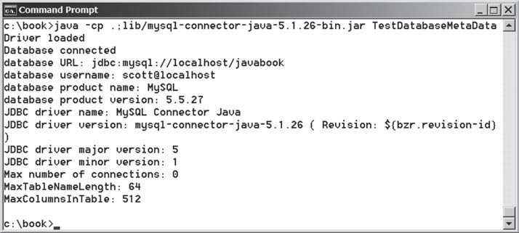
FIGuRE 34.24 The DatabaseMetaData interface enables you to obtain database information.

database metadata get metadata

34-32 Chapter 34 Java Database Programming

Obtaining Database Tables
You can identify the tables in the database through database metadata using the getTables method. Listing 34.6 displays all the user tables in the javabook database on a local MySQL database. Figure 34.25 shows a sample output of the program.

lISTING 34.6 FindUserTables.java
1 import java.sql.*;
2
- public class FindUserTables {
- public static void main(String[] args)
- throws SQLException, ClassNotFoundException {
- // Load the JDBC driver



load driver

connect database

database metadata obtain tables

get table names
- Class.forName("com.mysql.jdbc.Driver");
- System.out.println("Driver loaded");
9
- // Connect to a database
- Connection connection = DriverManager.getConnection
- ("jdbc:mysql://localhost/javabook", "scott", "tiger");
- System.out.println("Database connected");
14
15 DatabaseMetaData dbMetaData = connection.getMetaData(); 16
- ResultSet rsTables = dbMetaData.getTables(null, null, null,
- new String[] {"TABLE"});
- System.out.print("User tables: ");
- while (rsTables.next())
- System.out.print(rsTables.getString("TABLE_NAME") + " "); 22
- // Close the connection
- connection.close();
25 }
26 }
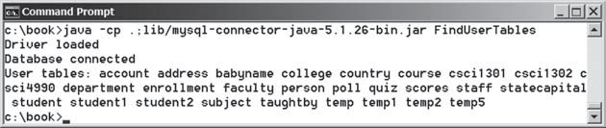
FIGuRE 34.25 You can find all the tables in the database.

Line 17 obtains table information in a result set using the getTables method. One of the columns in the result set is TABLE_NAME. Line 21 retrieves the table name from this result set column.

Result Set Metadata
The ResultSetMetaData interface describes information pertaining to the result set. A ResultSetMetaData object can be used to find the types and properties of the columns in a ResultSet. To obtain an instance of ResultSetMetaData, use the getMetaData method on a result set like this:
ResultSetMetaData rsMetaData = resultSet.getMetaData();

Retrieving Metadata 34-33

You can use the getColumnCount() method to find the number of columns in the result and the getColumnName(int) method to get the column names. For example, Listing 34.7 dis- plays all the column names and contents resulting from the SQL SELECT statement select
* from Enrollment. The output is shown in Figure 34.26.

lISTING 34.7 TestResultSetMetaData.java
1 import java.sql.*;
2
- public class TestResultSetMetaData {
- public static void main(String[] args)
- throws SQLException, ClassNotFoundException {
- // Load the JDBC driver
- Class.forName("com.mysql.jdbc.Driver");
- System.out.println("Driver loaded");
9
- // Connect to a database
- Connection connection = DriverManager.getConnection
- ("jdbc:mysql://localhost/javabook", "scott", "tiger");
- System.out.println("Database connected");
14
- // Create a statement
- Statement statement = connection.createStatement(); 17
- // Execute a statement
- ResultSet resultSet = statement.executeQuery
- ("select * from Enrollment"); 21
- ResultSetMetaData rsMetaData = resultSet.getMetaData();
- for (int i = 1; i <= rsMetaData.getColumnCount(); i++)
- System.out.printf("%-12s\t", rsMetaData.getColumnName(i));
- System.out.println();
26
- // Iterate through the result and print the students' names
- while (resultSet.next()) {
- for (int i = 1; i <= rsMetaData.getColumnCount(); i++)
- System.out.printf("%-12s\t", resultSet.getObject(i));
- System.out.println();
32 }
33
- // Close the connection
- connection.close();
36 }
37 }

load driver

connect database

create statement

create result set

result set metadata column count column name




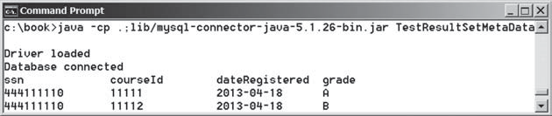
FIGuRE 34.26 The ResultSetMetaData interface enables you to obtain result set information.

34-34 Chapter 34 Java Database Programming

Check Point
    - What is DatabaseMetaData for? Describe the methods in DatabaseMetaData. How do you get an instance of DatabaseMetaData?
    - What is ResultSetMetaData for? Describe the methods in ResultSet- MetaData. How do you get an instance of ResultSetMetaData?
    - How do you find the number of columns in a result set? How do you find the column names in a result set?

KEy TERMS

candidate key 34-5
database system 34-2
domain constraint 34-5
foreign key 34-5
foreign key constraint 34-5
integrity constraint 34-4
primary key 34-5
relational database 34-5
Structured Query Language (SQL) 34-6 superkey 34-5




CHaPTER SuMMaRy
      - This chapter introduced the concepts of database systems, relational databases, rela- tional data models, data integrity, and SQL. You learned how to develop database appli- cations using Java.

      - The Java API for developing Java database applications is called JDBC. JDBC provides Java programmers with a uniform interface for accessing and manipulating relational databases.

      - The JDBC API consists of classes and interfaces for establishing connections with data- bases, sending SQL statements to databases, processing the results of SQL statements, and obtaining database metadata.

      - Since a JDBC driver serves as the interface to facilitate communications between JDBC and a proprietary database, JDBC drivers are database specific. If you use a driver, make sure it is in the classpath before running the program.

      - Four key interfaces are needed to develop any database application using Java: Driver, Connection, Statement, and ResultSet. These interfaces define a framework for generic SQL database access. The JDBC driver vendors provide implementation for them.

      - A JDBC application loads an appropriate driver using the Driver interface, connects to the database using the Connection interface, creates and executes SQL statements using the Statement interface, and processes the result using the ResultSet interface if the statements return results.

      - The PreparedStatement interface is designed to execute dynamic SQL statements with parameters. These SQL statements are precompiled for efficient use when repeat- edly executed.

      - Database metadata is information that describes the database itself. JDBC provides the DatabaseMetaData interface for obtaining database-wide information and the ResultSetMetaData interface for obtaining information on the specific ResultSet.



Programming Exercises 34-35
QuIZ
Answer the quiz for this chapter online at the book Companion Website.

PROgRaMMINg ExERCISES
*34.1 (Access and update a Staff table) Write a program that views, inserts, and updates staff information stored in a database, as shown in Figure 34.27a. The View button displays a record with a specified ID. The Insert button inserts a new record. The Update button updates the record for the specified ID. The Staff table is created as follows:

create table Staff ( id char(9) not null,
lastName varchar(15), firstName varchar(15), mi char(1),
address varchar(20), city varchar(20), state char(2), telephone char(10), email varchar(40), primary key (id)
);

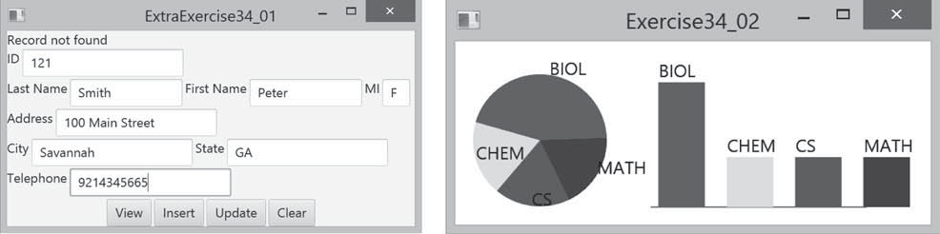
(a) (b)
FIGuRE 34.27 (a) The program lets you view, insert, and update staff information. (b) The PieChart and BarChart
components display the query data obtained from the data module.

**34.2 (Visualize data) Write a program that displays the number of students in each department in a pie chart and a bar chart, as shown in Figure 34.27b. The PieChart and BarChart classes are created in Programming Exercises 14.12 and 14.13. The number of students for each department can be obtained from the Student table (see Figure 34.4) using the following SQL statement:

select deptId, count(*) from Student
where deptId is not null group by deptId;
*34.3 (Connection dialog) Develop a subclass of BorderPane named DBConnection- Pane that enables the user to select or enter a JDBC driver and a URL and to enter a username and password, as shown in Figure 34.28. When the Connect to DB but- ton is clicked, a Connection object for the database is stored in the connection property. You can then use the getConnection() method to return the connection.




34-36 Chapter 34 Java Database Programming
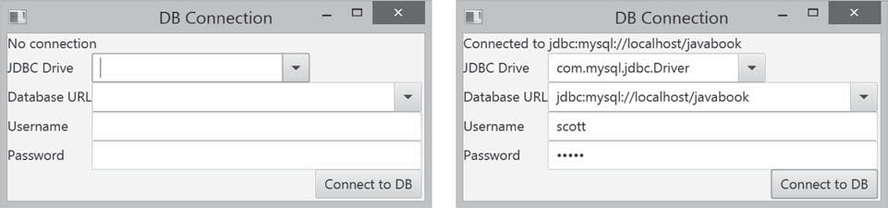
FIGuRE 34.28 The DBConnectionPane component enables the user to enter database information.
*34.4 (Find grades) Listing 34.2, FindGrade.java, presented a program that finds a stu- dent’s grade for a specified course. Rewrite the program to find all the grades for a specified student, as shown in Figure 34.29.
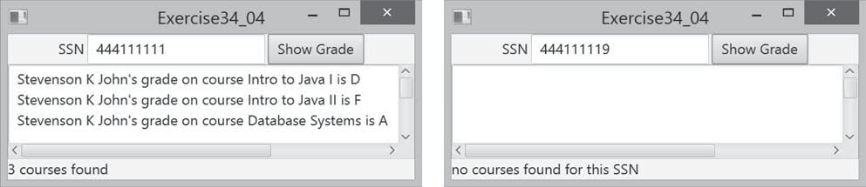
FIGuRE 34.29 The program displays the grades for the courses for a specified student.
*34.5 (Display table contents) Write a program that displays the content for a given table. As shown in Figure 34.30a, you enter a table and click the Show Contents button to display the table contents in the text area.
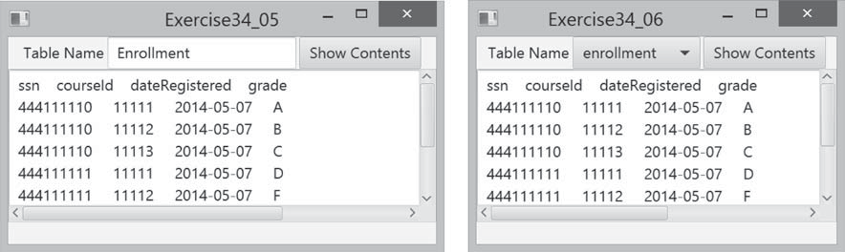
(a) (b)
FIGuRE 34.30 (a) Enter a table name to display the table contents. (b) Select a table name from the combo box to display its contents.
*34.6 (Find tables and showing their contents) Write a program that fills in table names in a combo box, as shown in Figure 34.30b. You can select a table from the combo box to display its contents in the text area.
**34.7 (Populate Quiz table) Create a table named Quiz as follows:
create table Quiz( questionId int, question varchar(4000), choicea varchar(1000),




Programming Exercises 34-37
choiceb varchar(1000), choicec varchar(1000), choiced varchar(1000), answer varchar(5));
The Quiz table stores multiple-choice questions. Suppose the multiple-choice questions are stored in a text file accessible from http://www.cs.armstrong.edu/ liang/data/Quiz.txt in the following format:

- question1
  - choice a
  - choice b
  - choice c
  - choice d Answer:cd

- question2
  - choice a
  - choice b
  - choice c
  - choice d Answer:a

...

Write a program that reads the data from the file and populate it into the Quiz
table.
*34.8 (Populate Salary table) Create a table named Salary as follows:
create table Salary( firstName varchar(100), lastName varchar(100), rank varchar(15), salary float);
Obtain the data for salary from http://cs.armstrong.edu/liang/data/Salary.txt and populate it into the Salary table in the database.
*34.9 (Copy table) Suppose the database contains a student table defined as follows:
create table Student1 (
username varchar(50) not null, password varchar(50) not null, fullname varchar(200) not null,
constraint pkStudent primary key (username)
);

Create a new table named Student2 as follows:

create table Student2 (
username varchar(50) not null, password varchar(50) not null, firstname varchar(100), lastname varchar(100),
constraint pkStudent primary key (username)
);

A full name is in the form of firstname mi lastname or firstname last- name. For example, John K Smith is a full name. Write a program that copies




34-38 Chapter 34 Java Database Programming
table Student1 into Student2. Your task is to split a full name into first- name, mi, and lastname for each record in Student1 and store a new record into Student2.
*34.10 (Record unsubmitted exercises) The following three tables store information on students, assigned exercises, and exercise submission in LiveLab. LiveLab is an automatic grading system for grading programming exercises.

create table AGSStudent ( username varchar(50) not null, password varchar(50) not null, fullname varchar(200) not null,
instructorEmail varchar(100) not null, constraint pkAGSStudent primary key (username)
);

create table ExerciseAssigned ( instructorEmail varchar(100), exerciseName varchar(100), maxscore double default 10,
constraint pkCustomExercise primary key
(instructorEmail, exerciseName)
);

create table AGSLog (
username varchar(50), /* This is the student's user name */ exerciseName varchar(100), /* This is the exercise */
score double default null, submitted bit default 0,
constraint pkLog primary key (username, exerciseName)
);

The AGSStudent table stores the student information. The ExerciseAssigned table assigns the exercises by an instructor. The AGSLog table stores the grading results. When a student submits an exercise, a record is stored in the AGSLog table. However, there is no record in AGSLog if a student did not submit the exercise.
Write a program that adds a new record for each student and an assigned exercise to the student in the AGSLog table if a student has not submitted the exercise. The record should have 0 on score and submitted. For example, if the tables contain the following data in AGSLog before you run this program, the AGSLog table now contains the new records after the program runs.

AGSStudent ExerciseAssigned
username | password | fullname | instructorEmail
abc | p1 | John Roo | t@gmail.com
cde | p2 | Yao Mi | c@gmail.com
wbc | p3 | F3 | t@gmail.com

instructorEmail | exerciseName | maxScore
t@gmail.com | e1 | 10
t@gmail.com | e2 | 10
c@gmail.com | e1 | 4
c@gmail.com | e4 | 20

Programming Exercises 34-39

AGSLog

username | exerciseName | score | submitted
abc | e1 | 9 | 1
wbc | e2 | 7 | 1

*34.11 (Baby names) Create the following table:
AGSLog after the program runs

username | exerciseName | score | submitted
abc | e1 | 9 | 1
wbc | e2 | 7 | 1
abc | e2 |  | 0
wbc | e1 |  | 0
cde | e1 |  | 0
cde | e4 |  | 0



create table Babyname ( year integer,
name varchar(50), gender char(1), count integer,
constraint pkBabyname primary key (year, name, gender)
);

The baby name ranking data was described in Programming Exercise 12.31. Write a program to read data from the following URL and store into the Babyname table. https://liveexample.pearsoncmg.com/data/babynamesranking2001.txt,
. . .
https://liveexample.pearsoncmg.com/data/babynamesranking2010.txt.

