Advanced

JavaFX
CHAPTER

31



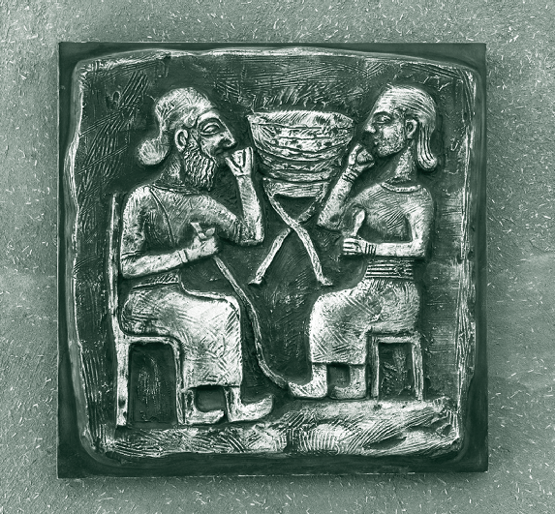and FXML

Objectives
- To specify styles for UI nodes using JavaFX CSS (§31.2).
- To create quadratic curve, cubic curve, and path using the QuadCurve, CubicCurve, and Path classes (§31.3).
- To translate, rotate, and scale to perform coordinate transformations for nodes (§31.4).
- To define a shape’s border using various types of strokes (§31.5).
- To create menus using the Menu, MenuItem, CheckMenuItem, and
RadioMemuItem classes (§31.6).
- To create context menus using the ContextMenu class (§31.7).
- To use SplitPane to create adjustable horizontal and vertical panes (§31.8).
- To create tab panes using the TabPane control (§31.9).
- To create and display tables using the TableView and TableColumn
classes (§31.10).
- To create JavaFX user interfaces using FMXL and the visual Scene Builder (§31.11).



31-2 Chapter 31 Advanced JavaFX and FXML

Introduction

Key Point
JavaFX can be used to develop comprehensive rich Internet applications.
Chapters 14–16 introduced basics of JavaFX, event-driven programming, animations, and simple UI controls. This chapter introduces some advanced features for developing compre- hensive GUI applications.

JavaFX CSS

Key Point
JavaFX cascading style sheets can be used to specify styles for UI nodes.
JavaFX cascading style sheets are based on CSS with some extensions. CSS defines the style for webpages. It separates the contents of webpages from its style. JavaFX CSS can be used to define the style for the UI and separates the contents of the UI from the style. You can define the look and feel of the UI in a JavaFX CSS file and use the style sheet to set the color, font, margin, and border of the UI components. A JavaFX CSS file makes it easy to modify the style without modifying the Java source code.
A JavaFX style property is defined with a prefix –fx- to distinquish it from a property in CSS. All the available JavaFX properties are defined in http://docs.oracle.com/javafx/2/api/ javafx/scene/doc-files/cssref.html. Listing 31.1 gives an example of a style sheet.
Listing 31.1 mystyle.css
.plaincircle {
-fx-fill: white;
-fx-stroke: black;
}
.circleborder {
-fx-stroke-width: 5;
-fx-stroke-dash-array: 12 2 4 2;
}
.border {
-fx-border-color: black;
-fx-border-width: 5;
}
#redcircle {
-fx-fill: red;
-fx-stroke: red;
}
#greencircle {
-fx-fill: green;
-fx-stroke: green;
}

A style sheet uses the style class or style id to define styles. Multiple style classes can be applied to a single node, and a style id to a unique node. The syntax .styleclass defines a style class. Here, the style classes are named plaincircle, circleborder, and circleborder. The syntax #styleid defines a style id. Here, the style ids are named red- circle and greencircle.
Each node in JavaFX has a styleClass variable of the List<String> type, which can be obtained from invoking getStyleClass(). You can add multiple style classes to a node and only one id to a node. Each node in JavaFX has an id variable of the String type, which can be set using the setID(String id) method. You can set only one id to a node.
The Scene and Parent classes have the stylesheets property, which can be obtained from invoking the getStylesheets() method. This property is of the



  - JavaFX CSS 31-3

ObservableList<String> type. You can add multiple style sheets into this property. You can load a style sheet into a Scene or a Parent. Note that Parent is the superclass for containers and UI control.
Listing 31.2 gives an example that uses the style sheet defined in Listing 31.1.

Listing 31.2 StyleSheetDemo.java
- import javafx.application.Application;
- import javafx.scene.Scene;
- import javafx.scene.layout.HBox;
- import javafx.scene.layout.Pane;
- import javafx.scene.shape.Circle;
- import javafx.stage.Stage;
7
- public class StyleSheetDemo extends Application {
- @Override // Override the start method in the Application class
- public void start(Stage primaryStage) {
- HBox hBox = new HBox(5);
- Scene scene = new Scene(hBox, 300, 250);
- scene.getStylesheets().add("mystyle.css"); // Load the stylesheet 14
- Pane pane1 = new Pane();
- Circle circle1 = new Circle(50, 50, 30);
- Circle circle2 = new Circle(150, 50, 30);
- Circle circle3 = new Circle(100, 100, 30);
- pane1.getChildren().addAll(circle1, circle2, circle3);
- pane1.getStyleClass().add("border");
21
- circle1.getStyleClass().add("plaincircle"); // Add a style class
- circle2.getStyleClass().add("plaincircle"); // Add a style class
- circle3.setId("redcircle"); // Add a style id 25
- Pane pane2 = new Pane();
- Circle circle4 = new Circle(100, 100, 30);
- circle4.getStyleClass().addAll("circleborder", "plainCircle");
- circle4.setId("greencircle"); // Add a style class
- pane2.getChildren().add(circle4);
- pane2.getStyleClass().add("border");
32
33 hBox.getChildren().addAll(pane1, pane2);
34
- primaryStage.setTitle("StyleSheetDemo"); // Set the window title
- primaryStage.setScene(scene); // Place the scene in the window
- primaryStage.show(); // Display the window
38 }
39 }
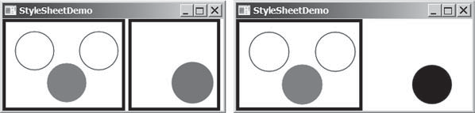
(a) (b)
FIGuRE 31.1 The style sheet is used to style the nodes in the scene.

31-4 Chapter 31 Advanced JavaFX and FXML
The program loads the style sheet from the file mystyle.css by adding it to the stylesheets property (line 13). The file should be placed in the same directory with the source code for it to run correctly. After the style sheet is loaded, the program sets the style class plaincircle for circle1 and circle2 (lines 22 and 23) and sets the style id redcircle for circle3 (line 24). The program sets style classes circleborder and plaincircle and an id greencircle for circle4 (lines 28 and 29). The style class border is set for both pane1 and pane2 (lines 20 and 31).
The style sheet is set in the scene (line 13). All the nodes inside the scene can use this style sheet. What would happen if line 13 is deleted and the following line is inserted after line 15?

pane1.getStylesheets().add("mystyle.css");



Check Point



Key Point
In this case, only pane1 and the nodes inside pane1 can access the style sheet, but pane2 and circle4 cannot use this style sheet. Therefore, everything in pane1 is displayed the same as before the change, and pane2 and circle4 are displayed without applying the style class and id, as shown in Figure 31.1b.
Note the style class plaincircle and id greencircle both are applied to circle4 (lines 28 and 29). plaincircle sets fill to white and greencircle sets fill to green. The property settings in id take precedence over the ones in classes. Thus, circle4 is displayed in green in this program.

    - How do you load a style sheet to a Scene or a Parent? Can you load multiple style sheets?
    - If a style sheet is loaded from a node, can the pane and all its containing nodes access the style sheet?
    - Can a node add multiple style classes? Can a node set multiple style ids?
    - If the same property is defined in both a style class and a style id and applied to a node, which one has the precedence?

  - QuadCurve, CubicCurve, and Path
JavaFX provides the QuadCurve, CubicCurve, and Path classes for creating advanced shapes.
Section 14.11 introduced drawing simple shapes using the Line, Rectangle, Circle, Ellipse, Arc, Polygon, and Polyline classes. This section introduces drawing advanced shapes using the CubicCurve, QuadCurve, and Path classes.

QuadCurve and CubicCurve
JavaFX provides the QuadCurve and CubicCurve classes for modeling quadratic curves and cubic curves. A quadratic curve is mathematically defined as a quadratic polynomial. To create a QuadCurve, use its no-arg constructor or the following constructor:

QuadCurve(double startX, double startY,
double controlX, double controlY, double endX, double endY)

where (startX, startY) and (endX, endY) specify two endpoints and (controlX, controlY) is a control point. The control point is usually not on the curve instead of defining the trend of the curve, as shown in Figure 31.2a. Figure 31.3 shows the UML diagram for the QuadCurve class.

  - QuadCurve, CubicCurve, and Path 31-5

(controlX, controlY)

(startX, startY) (endX, endY)
(controlX1, controlY1)

(startX, startY) (endX, endY)



(controlX2, controlY2)
(a) (b)
FIGuRE 31.2 (a) A quadratic curve is specified using three points. (b) A cubic curve is specified using four points.

The getter and setter methods for property values and a getter for prop- erty itself are provided in the class, but omitted in the UML diagram for brevity.
javafx.scene.shape.QuadCurve
-startX: DoubleProperty
-startY: DoubleProperty
-endX: DoubleProperty
-endY: DoubleProperty
-controlX: DoubleProperty
-controlY: DoubleProperty
+QuadCurve()
+QuadCurve(startX: double, startY: double, controlX: double, controlY: double, endX: double, endY: double)

The x-coordinate of the start point (default 0). The y-coordinate of the start point (default 0). The x-coordinate of the end point (default 0). The y-coordinate of the end point (default 0). The x-coordinate of the control point (default 0). The y-coordinate of the control point (default 0). Creates an empty quad curve.
Creates a quad curve with the specified arguments.

FIGuRE 31.3 QuadCurve defines a quadratic curve.
A cubic curve is mathematically defined as a cubic polynomial. To create a CubicCurve, use its no-arg constructor or the following constructor:
CubicCurve(double startX, double startY, double controlX1, double controlY1, double controlX2, double controlY2, double endX, double endY)
where (startX, startY) and (endX, endY) specify two endpoints and (controlX1, controlY1) and (controlX2, controlY2) are two control points. The control points are usually not on the curve, instead define the trend of the curve, as shown in Figure 31.2b. Figure 31.4 shows the UML diagram for the CubicCurve class.

The getter and setter methods for property values and a getter for property itself are provided in the class, but omitted in the UML diagram for brevity.
javafx.scene.shape.CubicCurve
-startX: DoubleProperty
-startY: DoubleProperty
-endX: DoubleProperty
-endY: DoubleProperty
-controlX1: DoubleProperty
-controlY1: DoubleProperty
-controlX2: DoubleProperty
-controlY2: DoubleProperty
+CubicCurve()
+CubicCurve(startX: double, startY: double, controlX1: double, controlY1: double, controlX2: double, controlY2: double, endX: double, endY: double)

The x-coordinate of the start point (default 0). The y-coordinate of the start point (default 0). The x-coordinate of the end point (default 0). The y-coordinate of the end point (default 0).
The x-coordinate of the first control point (default 0). The y-coordinate of the first control point (default 0). The x-coordinate of the second control point (default 0). The y-coordinate of the second control point (default 0). Creates an empty cubic curve.
Creates a cubic curve with the specified arguments.

FIGuRE 31.4 CubicCurve defines a quadratic curve.




31-6 Chapter 31 Advanced JavaFX and FXML
Listing 31.3 gives a program that demonstrates how to draw quadratic and cubic curves. Figure 31.5a shows a sample run of the program.
Listing 31.3 CurveDemo.java
- import javafx.application.Application;
- import javafx.scene.Scene;
- import javafx.scene.layout.Pane;
- import javafx.scene.text.Text;
- import javafx.scene.shape.Circle;
- import javafx.scene.paint.Color;
- import javafx.scene.shape.*;
- import javafx.stage.Stage;
9
- public class CurveDemo extends Application {
- @Override // Override the start method in the Application class
- public void start(Stage primaryStage) {
- Pane pane = new Pane(); 14
- // Create a QuadCurve
- QuadCurve quadCurve = new QuadCurve(10, 80, 40, 20, 150, 56);
- quadCurve.setFill(Color.WHITE);
- quadCurve.setStroke(Color.BLACK);
19
- pane.getChildren().addAll(quadCurve, new Circle(40, 20, 6),
- new Text(40 + 5, 20 - 5, "Control point"));
22
- // Create a CubicCurve
- CubicCurve cubicCurve = new CubicCurve
25 (200, 80, 240, 20, 350, 156, 450, 80);
- cubicCurve.setFill(Color.WHITE);
- cubicCurve.setStroke(Color.BLACK);
28
- pane.getChildren().addAll(cubicCurve, new Circle(240, 20, 6),
- new Text(240 + 5, 20 − 5, "Control point 1"),
- new Circle(350, 156, 6),
- new Text(350 + 5, 156 − 5, "Control point 2"));
33
- Scene scene = new Scene(pane, 300, 250);
- primaryStage.setTitle("CurveDemo"); // Set the window title
- primaryStage.setScene(scene); // Place the scene in the window
- primaryStage.show(); // Display the window
38 }
39 }
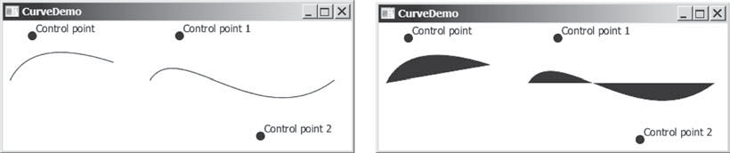

(a) (b)
FIGuRE 31.5 You can draw quadratic and cubic curves using QuadCurve and CubicCurve.
The program creates a QuadCurve with the specified start, control, and end points (line 16) and places the QuadCurve to the pane (line 20). To illustrate the control point, the program also displays the control point as a solid circle (line 21).



31.3 QuadCurve, CubicCurve, and Path 31-7
The program creates a CubicCurve with the specified start, first control, second control, and end points (lines 24 and 25) and places the CubicCurve to the pane (line 29). To illustrate the control points, the program also displays the control points in the pane (lines 29–32).
Note the curves are filled with color. The program sets the color to white and stroke to black in order to display the curves (lines 17 and 18, 26 and 27). If these code lines are removed from the program, the sample run would look like the one in Figure 31.5b.

Path
The Path class models an arbitrary geometric path. A path is constructed by adding path elements into the path. The PathElement is the root class for the path elements MoveTo, HLineTo, VLineTo, LineTo, ArcTo, QuadCurveTo, CubicCurveTo, and ClosePath.
You can create a Path using its no-arg constructor. The process of the path construction can be viewed as drawing with a pen. The path does not have a default initial position. You need to set an initial position by adding a MoveTo(startX, startY) path element to the path. Adding a HLineTo(newX) element draws a horizontal line from the current position to the new x-coordinate. Adding a VLineTo(newY) element draws a vertical line from the current position to the new y-coordinate. Adding a LineTo(newX, newY) element draws a line from the current position to the new position. Adding an ArcTo(radiusX, radiusY, xAxisRotation, newX, newY, largeArcFlag, sweepArcFlag) element draws an arc from the previous position to the new position with the specified radius. Adding a QuadCurveTo(controlX, controlY, newX, newY) element draws a quadratic curve from the previous position to the new position with the specified control point. Adding a CubicCurveTo(controlX1, controlY1, controlX2, controlY2, newX, newY) element draws a cubic curve from the previous position to the new position with the specified control points. Adding a ClosePath() element closes the path by drawing a line that connects the starting point with the end point of the path.
Listing 31.4 gives an example that creates a path. A sample run of the program is shown in Figure 31.6.
Listing 31.4 PathDemo.java
      - import javafx.application.Application;
      - import javafx.scene.Scene;
      - import javafx.scene.layout.Pane;
      - import javafx.scene.paint.Color;
      - import javafx.scene.shape.*;
      - import javafx.stage.Stage;
7
- public class PathDemo extends Application {
- @Override // Override the start method in the Application class
- public void start(Stage primaryStage) {
- Pane pane = new Pane(); 12
- // Create a Path
- Path path = new Path();
- path.getElements().add(new MoveTo(50.0, 50.0));
- path.getElements().add(new HLineTo(150.5));
- path.getElements().add(new VLineTo(100.5));
- path.getElements().add(new LineTo(200.5, 150.5));
19
- ArcTo arcTo = new ArcTo(45, 45, 250, 100.5,
- false, true);
- path.getElements().add(arcTo);
23
- path.getElements().add(new QuadCurveTo(50, 50, 350, 100));
- path.getElements().add(
26 new CubicCurveTo(250, 100, 350, 250, 450, 10));

31-8 Chapter 31 Advanced JavaFX and FXML

27
- path.getElements().add(new ClosePath());
29
- pane.getChildren().add(path);
- path.setFill(null);
- Scene scene = new Scene(pane, 300, 250);
- primaryStage.setTitle("PathDemo"); // Set the window title
- primaryStage.setScene(scene); // Place the scene in the window
- primaryStage.show(); // Display the window
36 }
37 }

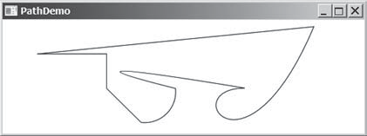ClosePath

HLineTo
VLineTo

LineTo ArcTo QuadCurveTo CubicCurveTo
FIGuRE 31.6 You can draw a path by adding path elements.





Check Point

Key Point
The program creates a Path (line 14), moves its position (line 15), and adds a horizontal line (line 16), a vertical line (line 17), and a line (line 18). The getElements() method returns an ObservableList<PathElement>.
The program creates an ArcTo object (lines 20 and 21). The ArcTo class contains the largeArcFlag and sweepFlag properties. By default, these property values are false. You may set these properties to ture to display a large arc in the opposite direction.
The program adds a quadratic curve (line 24) and a cubic curve (lines 25 and 26) and closes the path (line 28).
By default, the path is not filled. You may change the fill property in the path to specify a color to fill the path.

    - Create a QuadCurve with starting point (100, 75.5), control point (40, 55.5), and end point (56, 80). Set its fill property to white and stroke to green.
    - Create CubicCurve object with starting point (100, 75.5), control point 1 (40, 55.5),
control point 2 (78.5, 25.5), and end point (56, 80). Set its fill property to white and stroke to green.
    - Does a path have a default initial position? How do you set a position for a path?
    - How do you close a path?
    - How do you display a filled path?

Coordinate Transformations
JavaFX supports coordinate transformations using translation, rotation, and scaling.
You have used the rotate method to rotate a node. You can also perform translations and scaling.

Translations
You can use the setTranslateX(double x), setTranslateY(double y), and
setTranslateZ(double z) methods in the Node class to translate the coordinates for a




Coordinate Transformations 31-9
node. For example, setTranslateX(5) moves the node 5 pixels to the right and setTrans- lateY(−10) 10 pixels up from the previous position. Figure 31.7 shows a rectangle displayed before and after applying translation. After invoking rectangle.setTranslateX(−6) and rectangle.setTranslateY(4), the rectangle is moved 6 pixels to the left and 4 pixels down from the previous position. Note the coordinate transformation using translation, rota- tion, and scaling does not change the contents of the shape being transferred. For example, if a rectangle’s x is 30 and width is 100, after applying transformations to the rectangle, its x is still 30 and width is still 100.

0 1 2 3 4 5 6 7 8 9 10 11 12 13 14
0

previous position translation of (– 6, 4) current position
1
2
3
4
5
6
7

FIGuRE 31.7 After applying translation of (- 6, 4), the rectangle is moved by the specified distance relative to the previous position.

Listing 31.5 TranslationDemo.java
      - import javafx.application.Application;
      - import javafx.scene.Scene;
      - import javafx.scene.layout.Pane;
      - import javafx.scene.paint.Color;
      - import javafx.scene.shape.Rectangle;
      - import javafx.stage.Stage;
7
- public class TranslationDemo extends Application {
- @Override // Override the start method in the Application class
- public void start(Stage primaryStage) {
11 |  | Pane pane = new Pane();
12
13 |  | double x = 10;
14 |  | double y = 10;
15 |  | java.util.Random random = new java.util.Random();
16 |  | for (int i = 0; i < 10; i++) {
17 |  | Rectangle rectangle = new Rectangle(10, 10, 50, 60);
18 |  | rectangle.setFill(Color.WHITE);
19 |  | rectangle.setStroke(Color.color(random.nextDouble(),
20 |  | random.nextDouble(), random.nextDouble()));
21 |  | rectangle.setTranslateX(x += 20);
22 |  | rectangle.setTranslateY(y += 5);
23 |  | pane.getChildren().add(rectangle);
24 |  | }
25
26 |  | Scene scene = new Scene(pane, 300, 250);
27 |  | primaryStage.setTitle("TranslationDemo"); // Set the window title
28 |  | primaryStage.setScene(scene); // Place the scene in the window
29 |  | primaryStage.show(); // Display the window
30 | }
31 | }




31-10 Chapter 31 Advanced JavaFX and FXML
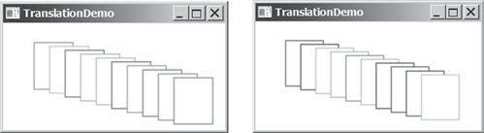
FIGuRE 31.8 The rectangles are displayed successively in new locations.

The program repeatedly creates 10 rectangles (line 17). For each rectangle, it sets its fill property to white (line 18) and its stroke property to a random color (lines 19 and 20), and translates it to a new location (lines 21 and 22). The variables x and y are used to set the translateX and translateY properties. These two variable values are changed every time it is applied to a rectangle (see Figure 31.8).

Rotations
Rotation was introduced in Chapter 14. This section discusses it in more depth. You can use the rotate(double theta) method in the Node class to rotate a node by theta degrees from its pivot point clockwise, where theta is a double value in degrees. The pivot point is automatically computed based on the bounds of the node. For a circle, ellipse, and a rectangle, the pivot point is the center point of these nodes. For example, rectangle.rotate(45) rotates the rectangle 45 degrees clockwise along the eastern direction from the center, as shown in Figure 31.9.

0 1 2 3 4 5 6 7 8 9 10 11 12 13 14
Before rotate Rectangle.rotate(45)

After rotate
0
1
2
3
4
5
6
7

FIGuRE 31.9 After performing rectangle.rotate(45), the rectangle is rotated in 45 degrees from the center.

Listing 31.6 gives a program that demonstrates the effect of rotation of coordinates. Figure 31.10 shows a sample run of the program.
Listing 31.6 RotateDemo.java
      - import javafx.application.Application;
      - import javafx.scene.Scene;
      - import javafx.scene.layout.Pane;
      - import javafx.scene.paint.Color;
      - import javafx.scene.shape.Rectangle;
      - import javafx.stage.Stage;
7
- public class RotateDemo extends Application {
- @Override // Override the start method in the Application class
- public void start(Stage primaryStage) {
- Pane pane = new Pane();
- java.util.Random random = new java.util.Random();



31.4 Coordinate Transformations 31-11

- // The radius of the circle for anchoring rectangles
- double radius = 90;
- double width = 20; // Width of the rectangle
- double height = 40; // Height of the rectangle
- for (int i = 0; i < 8; i++) {
- // Center of a rectangle
- double x = 150 + radius * Math.cos(i * 2 * Math.PI / 8);
- double y = 150 + radius * Math.sin(i * 2 * Math.PI / 8);
- Rectangle rectangle = new Rectangle(
- x − width / 2, y − height / 2, width, height);
- rectangle.setFill(Color.WHITE);
- rectangle.setStroke(Color.color(random.nextDouble(),
- random.nextDouble(), random.nextDouble()));
- rectangle.setRotate(i * 360 / 8); // Rotate the rectangle
- pane.getChildren().add(rectangle);
28 }
29
- Scene scene = new Scene(pane, 300, 300);
- primaryStage.setTitle("RotateDemo"); // Set the window title
- primaryStage.setScene(scene); // Place the scene in the window
- primaryStage.show(); // Display the window
34 }
35 }

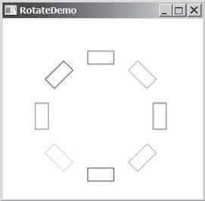
FIGuRE 31.10 The rotate method rotates a node.

The program creates eight rectangles in a loop (lines 17–28). The center of each rectangle is located on the circle centered as (150, 150) (lines 19 and 20). A rectangle is created by speci- fying its upper left corner position with width and height (lines 21 and 22). The rectangle is rotated in line 26 and added to the pane in line 27.

Scaling
You can use the setScaleX(double sx), setScaleY(double sy), and setScaleY(double sy) methods in the Node class to specify a scaling factor. The node will appear larger or smaller depending on the scaling factor. Scaling alters the coordinate space of the node such that each unit of distance along the axis is multiplied by the scale factor. As with rotation transformations, scaling transformations are applied to enlarge or shrink the node around the pivot point. For a node of the rectangle shape, the pivot point is the center of the rectangle. For example, if you apply a scaling factor (x = 2, y = 2), the entire rectangle including the stroke will double in size, growing to the left, right, up, and down from the center, as shown in Figure 31.11.




31-12 Chapter 31 Advanced JavaFX and FXML
0 1 2 3 4 5 6 7 8 9 10 11 12 13 14
0
1
2
3
4
5
6
7
original size
new size after applying scaling factor (x = 2, y = 2)
FIGuRE 31.11 After applying scaling (x = 2, y = 2), the node is doubled in size.

Listing 31.7 gives a program that demonstrates the effect of using scaling. Figure 31.12 shows a sample run of the program.
Listing 31.7 ScaleDemo.java
- import javafx.application.Application;
- import javafx.scene.Scene;
- import javafx.scene.layout.Pane;
- import javafx.scene.shape.Line;
- import javafx.scene.text.Text;
- import javafx.scene.shape.Polyline;
- import javafx.stage.Stage;
8
- public class ScaleDemo extends Application {
- @Override // Override the start method in the Application class
- public void start(Stage primaryStage) {
- // Create a polyline to draw a sine curve
- Polyline polyline = new Polyline();
- for (double angle = −360; angle <= 360; angle++) {
- polyline.getPoints().addAll(
- angle, Math.sin(Math.toRadians(angle)));
17 }
- polyline.setTranslateY(100);
- polyline.setTranslateX(200);
- polyline.setScaleX(0.5);
- polyline.setScaleY(50);
- polyline.setStrokeWidth(1.0 / 25);
23
- // Draw x-axis
- Line line1 = new Line(10, 100, 420, 100);
- Line line2 = new Line(420, 100, 400, 90);
- Line line3 = new Line(420, 100, 400, 110);
28
- // Draw y-axis
- Line line4 = new Line(200, 10, 200, 200);
- Line line5 = new Line(200, 10, 190, 30);
- Line line6 = new Line(200, 10, 210, 30);
33
- // Draw x, y axis labels
- Text text1 = new Text(380, 70, "X");
- Text text2 = new Text(220, 20, "Y"); 37
- // Add nodes to a pane
- Pane pane = new Pane();
- pane.getChildren().addAll(polyline, line1, line2, line3, line4,
- line5, line6, text1, text2); 42

  - Strokes 31-13

- Scene scene = new Scene(pane, 450, 200);
- primaryStage.setTitle("ScaleDemo"); // Set the window title
- primaryStage.setScene(scene); // Place the scene in the window
- primaryStage.show(); // Display the window
47 }
48 }
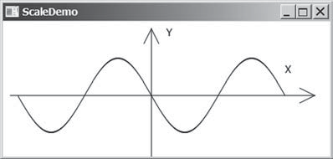
FIGuRE 31.12 The scale method scales the coordinates in the node.

The program creates a polyline (line 13) and adds the points for a sine curve into the polyline (lines 14–17). Since | sin(x) | 6 = 1, the y-coordinates are too small. To see the sine curve, the program scales the y-coordinates up by 50 times (line 21) and shrinks the x-coordinates by half (line 20).
Note scaling also causes the stroke width to change. To compensate it, the stroke width is purposely set to 1.0 / 25 (line 22).

    - Can you perform a coordinate transformation on any node? Does a coordinate trans- formation change the contents of a Shape object?
    - Does the method setTranslateX(6) move the node’s x-coordinate to 6? Does the method setTranslateX(6) move the node’s x-coordinate 6 pixel right from its current location?
    - Does the method rotate(Math.PI / 2) rotate a node 90 degrees? Does the method rotate(90) rotate a node 90 degrees?
    - How is the pivot point determined for performing a rotation?
    - What method do you use to scale a node two times on its x-axis?

Strokes
Stroke defines a shape’s border line style.
JavaFX allows you to specify the attributes of a shape’s boundary using the methods in Figure 31.13.

Check Point




Sets a paint for the stroke.

Key Point
+setStroke(paint: Paint): void
+setStrokeWidth(width: double): void
+setStrokeType(type: StrokeType): void

+setStrokeLineCap(type: StrokeLineCap): void
+setStrokeLineJoin(type: StrokeLineJoin): void
+getStrokeDashArray(): ObservableList<Double>
+setStrokeDashOffset(distance: double): void
javafx.scene.shape.Shape
Sets a width for the stroke (default 1).
Sets a type for the stroke to indicate whether the stroke is placed inside, centered, or outside of the border (default: CENTERED).
Specifies the end cap style for the stroke (default: BUTT). Specifies how two line segments are joined (default: MITER). Returns a list that specifies a dashed pattern for line segments.

Specifies the offset to the first segment in the dashed pattern.
FIGuRE 31.13 The Shape class contains the methods for setting stroke properties.

The setStroke(paint) method sets a paint for the stroke. The width of the stroke can be specified using the setStrokeWidth(width) method.

31-14 Chapter 31 Advanced JavaFX and FXML
The setStrokeType(type) method sets a type for the stroke. The type defines whether the stroke is inside, outside, or in the center of the border using the constants StrokeType.INSIDE, StrokeType.OUTSIDE, or StrokeType.CENTERED (default), as shown in Figure 31.14.

(a) (b) (c) (d)
FIGuRE 31.14 (a) No stroke is used. (b) A stroke is placed inside the border. (c) A stroke is placed in the center of the border. (d) A stroke is placed outside of the border.

Note for the centered style, the stroke is applied by extending the boundary of the node by a distance of half of the strokeWidth on either side (inside and outside) of the boundary.
The setStrokeLineCap(capType) method sets an end cap style for the stroke. The styles are defined as StrokeLineCap.BUTT (default), StrokeLineCap.ROUND, and StrokeLine- Cap.SQUARE, as illustrated in Figure 31.15. The BUTT stroke ends an unclosed path with no added decoration. The ROUND stroke ends an unclosed side of a path with an added half circle whose radius is half of the stroke width. The SQUARE stroke ends an unclosed side of a path with an added square that extends half of the stroke width.

(a) BUTT (b) ROUND (c) SQUARE
FIGuRE 31.15 (a) No decoration for a BUTT line cap. (b) A half circle is added to an unclosed path. (c) A square with half of the stroke width is extended to an unclosed path.

The setStrokeLineJoin method defines the decoration applied where path segments meet. You can specify three types of line join using the constants StrokeLineJoin.MITER (default), StrokeLineJoin.BEVEL, and StrokeLineJoin.ROUND, as shown in Figure 31.16.

(a) MITER (b) BEVEL (c) ROUND
FIGuRE 31.16 Path segments can be joined in three ways: (a) MITER, (b) BEVEL, and
(c) ROUND.

The Shape class has a property named strokeDashArray of the ObservableList<Double> type. This property is used to define a dashed pattern for the stroke. Alternate numbers in the list specify the lengths of the opaque and transparent segments of the dashes. For example, the list [10.0, 20.0, 30.0, 40.0] specifies a pattern as shown in Figure 31.17.

10 20 30 40

10 20 30 40

… [10.0, 20.0, 30.0, 40.0]

10 20 30 40

50 10 20 30 40 50

… [10.0, 20.0, 30.0, 40.0, 50]



FIGuRE 31.17 The numbers in the list specify the opaque and transparent segments of the stroke alternately.

  - Strokes 31-15

The setStrokeDashOffset(distance) method defines the offset to the first segment in the dash pattern. Figure 31.18 illustrates the offset 5 for the dash list [10.0, 20.0, 30.0, 40.0].

5 5 20 30 40

10 20 30 40

Dash offset is 5

… [10.0, 20.0, 30.0, 40.0]



FIGuRE 31.18 The dash offset specifies on offset for the first segment.

Listing 31.8 gives a program that demonstrates the methods to set attributes for a stroke. Figure 31.19 shows a sample run of the program.
Listing 31.8 StrokeDemo.java
- import javafx.application.Application;
- import javafx.scene.Scene;
- import javafx.scene.layout.Pane;
- import javafx.scene.paint.Color;
- import javafx.stage.Stage;
- import javafx.scene.shape.Rectangle;
- import javafx.scene.shape.*;
8
- public class StrokeDemo extends Application {
- @Override // Override the start method in the Application class
- public void start(Stage primaryStage) {
- Rectangle rectangle1 = new Rectangle(20, 20, 70, 120);
- rectangle1.setFill(Color.WHITE);
- rectangle1.setStrokeWidth(15);
- rectangle1.setStroke(Color.ORANGE);
16
- Rectangle rectangle2 = new Rectangle(20, 20, 70, 120);
- rectangle2.setFill(Color.WHITE);
- rectangle2.setStrokeWidth(15);
- rectangle2.setStroke(Color.ORANGE);
- rectangle2.setTranslateX(100);
- rectangle2.setStrokeLineJoin(StrokeLineJoin.BEVEL);
23
- Rectangle rectangle3 = new Rectangle(20, 20, 70, 120);
- rectangle3.setFill(Color.WHITE);
- rectangle3.setStrokeWidth(15);
- rectangle3.setStroke(Color.ORANGE);
- rectangle3.setTranslateX(200);
- rectangle3.setStrokeLineJoin(StrokeLineJoin.ROUND);
30
31 Line line1 = new Line(320, 20, 420, 20);
- line1.setStrokeLineCap(StrokeLineCap.BUTT);
- line1.setStrokeWidth(20);
34
35 Line line2 = new Line(320, 70, 420, 70);
- line2.setStrokeLineCap(StrokeLineCap.ROUND);
- line2.setStrokeWidth(20);
38
39 Line line3 = new Line(320, 120, 420, 120);
- line3.setStrokeLineCap(StrokeLineCap.SQUARE);
- line3.setStrokeWidth(20);
42
43 Line line4 = new Line(460, 20, 560, 120);
44 line4.getStrokeDashArray().addAll(10.0, 20.0, 30.0, 40.0);
45

31-16 Chapter 31 Advanced JavaFX and FXML

- Pane pane = new Pane();
- pane.getChildren().addAll(rectangle1, rectangle2, rectangle3,
- line1, line2, line3, line4); 49
- Scene scene = new Scene(pane, 610, 180);
- primaryStage.setTitle("StrokeDemo"); // Set the window title
- primaryStage.setScene(scene); // Place the scene in the window
- primaryStage.show(); // Display the window
54 }
55
56 |  | // Launch the program from command-line
57 |  | public static void main(String[] args) {
58 |  | launch(args);
59 |  | }
60 | }
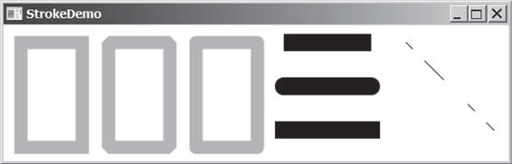butt cap round cap

dash line

miter join bevel join round join square cap
FIGuRE 31.19 You can specify the attributes for strokes.




Check Point

Key Point
The program creates three rectangles (lines 12–29). Rectangle 1 uses default miter join, rec- tangle 2 uses bevel join (line 22), and rectangle 3 uses round join (line 29).
The program creates three lines with butt, round, and square end cap (lines 31–41).
The program creates a line and sets dash pattern for this line (line 44). Note the strokeDashArray property is of the ObservableList<Double> type. You have to add Double values to the list. Adding a number such as 10 would cause an error.
    - Are the methods for setting a stroke and its attributes defined in the Node or
Shape class?
    - How do you set a stroke width to 3 pixels?
    - What are the stroke types? What is the default stroke type? How do you set a stroke type?
    - What are the stroke line join types? What is the default stroke line join type? How do you set a stroke line join type?
    - What are the stroke cap types? What is the default stroke cap type? How do you set a stroke cap type?
    - How do you specify a dashed pattern for strokes?

Menus
You can create menus in JavaFX.
Menus make selection easier and are widely used in window applications. JavaFX provides five classes that implement menus: MenuBar, Menu, MenuItem, CheckMenuItem, and RadioButtonMenuItem.


  - Menus 31-17

MenuBar is a top-level menu component used to hold the menus. A menu consists of menu items that the user can select (or toggle on or off). A menu item can be an instance of MenuItem, CheckMenuItem, or RadioButtonMenuItem. Menu items can be associated with nodes and keyboard accelerators.

Creating Menus
The sequence of implementing menus in JavaFX is as follows:
      - Create a menu bar and add it to a pane. For example, the following code creates a pane and a menu bar, and adds the menu bar to the pane:
MenuBar menuBar = new MenuBar(); Pane pane = new Pane(); pane.getChildren().add(menuBar);
      - Create menus and add them under the menu bar. For example, the following creates two menus and adds them to a menu bar, as shown in Figure 31.20a:
Menu menuFile = new Menu("File"); Menu menuHelp = new Menu("Help");
menuBar.getMenus().addAll(menuFile, menuHelp);

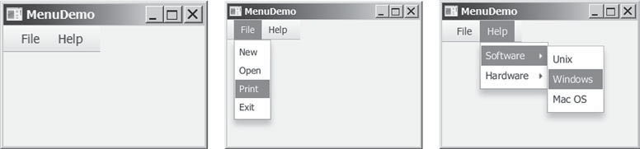
(a) (b) (c)
FIGuRE 31.20 (a) The menus are placed under a menu bar. (b) Clicking a menu on the menu bar reveals the items under the menu. (c) Clicking a menu item reveals the submenu items under the menu item.

      - Create menu items and add them to the menus.

menuFile.getItems().addAll(new MenuItem("New"), new MenuItem("Open"), new MenuItem("Print"), new MenuItem("Exit"));
This code adds the menu items New, Open, Print, and Exit, in this order, to the File menu, as shown in Figure 31.20b.
        - Creating submenu items.
You can also embed menus inside menus so the embedded menus become submenus. Here is an example:
Menu softwareHelpSubMenu = new Menu("Software"); Menu hardwareHelpSubMenu = new Menu("Hardware"); menuHelp.getItems().add(softwareHelpSubMenu); menuHelp.getItems().add(hardwareHelpSubMenu);
softwareHelpSubMenu.getItems().add(new MenuItem("Unix")); softwareHelpSubMenu.getItems().add(new MenuItem("Windows")); softwareHelpSubMenu.getItems().add(new MenuItem("Mac OS"));



31-18 Chapter 31 Advanced JavaFX and FXML
This code adds two submenus, softwareHelpSubMenu and hardwareHelpSubMenu, in MenuHelp. The menu items Unix, NT, and Win95 are added to softwareHelpSub- Menu (see Figure 31.20c).
        - Creating check-box menu items.
You can also add a CheckMenuItem to a Menu. CheckMenuItem is a subclass of Menu- Item that adds a Boolean state to the MenuItem and displays a check when its state is true. You can click a menu item to turn it on or off. For example, the following statement adds the check-box menu item Check it (see Figure 31.21a).

menuHelp.getItems().add(new CheckMenuItem("Check it"));

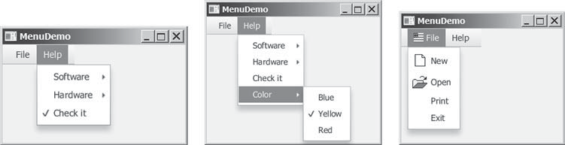
(a) (b) (c)
FIGuRE 31.21 (a) A check box menu item lets you check or uncheck a menu item just like a check box. (b) You can use RadioMenuItem to choose among mutually exclusive menu choices. (c) You can set image icons and keyboard accelerators in menus.


        - Creating radio menu items.
You can also add radio menu items to a menu, using the RadioMenuItem class. This is often useful when you have a group of mutually exclusive choices in the menu. For example, the following statements add a submenu named Color and a set of radio buttons for choosing a color (see Figure 31.21b):

RadioMenuItem rmiBlue, rmiYellow, rmiRed; colorHelpSubMenu.getItems().add(rmiBlue =
new RadioMenuItem("Blue")); colorHelpSubMenu.getItems().add(rmiYellow =
new RadioMenuItem("Yellow")); colorHelpSubMenu.getItems().add(rmiRed =
new RadioMenuItem("Red"));

ToggleGroup group = new ToggleGroup(); rmiBlue.setToggleGroup(group); rmiYellow.setToggleGroup(group); rmiRed.setToggleGroup(group);
      - The menu items generate ActionEvent. To handle ActionEvent, implement the
setOnAction method.
      - Image Icons and Keyboard Accelerators
The Menu, CheckMenuItem, and RadioMenuItem are the subclasses of MenuItem. The MenuItem has a graphic property for specifying a node to be displayed in the menu item. Usually, the graphic is an image view. The classes Menu, MenuItem, Check- MenuItem, and RadioMenuItem have another constructor that you can use to specify a graphic. For example, the following code adds an image to the menu, menu item, check menu item, and radio menu item (see Figure 31.21c).


  - Menus 31-19

Menu menuFile = new Menu("File",
new ImageView("image/usIcon.gif")); MenuItem menuItemOpen = new MenuItem("New",
new ImageView("image/new.gif"));
CheckMenuItem checkMenuItem = new CheckMenuItem("Check it", new ImageView("image/us.gif"));
RadioMenuItem rmiBlue = new RadioMenuItem("Blue",
new ImageView("image/us.gif"));
      - A key accelerator lets you select a menu item directly by pressing the CTRL and the accelerator key. For example, by using the following code, you can attach the accelerator key CTRL+N to the Open menu item:
menuItemOpen.setAccelerator( KeyCombination.keyCombination("Ctrl+O"));

Example: Using Menus
This section gives an example that creates a user interface to perform arithmetic. The inter- face contains labels and text fields for Number 1, Number 2, and Result. The Result text field displays the result of the arithmetic operation between Number 1 and Number 2. Figure 31.22 contains a sample run of the program.

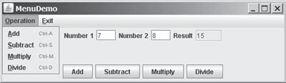
FIGuRE 31.22 Arithmetic operations can be performed by clicking buttons or by choosing menu items from the Operation menu.

Here are the major steps in the program (Listing 31.9):
      - Create a menu bar and add it into a VBox. Create the menus Operation and Exit, and add them to the menu bar. Add the menu items Add, Subtract, Multiply, and Divide under the Operation menu and add the menu item Close under the Exit menu.
      - Create an HBox to hold labels and text fields and place it into the VBox.
      - Create an HBox to hold the four buttons labeled Add, Subtract, Multiply, and Divide and place it into the VBox.
      - Implement the handlers to process the events from the menu items and the buttons.

Listing 31.9 MenuDemo.java
- import javafx.application.Application;
- import javafx.geometry.Pos;
- import javafx.scene.Scene;
- import javafx.scene.control.Button;
- import javafx.scene.control.Label;
- import javafx.scene.control.Menu;
- import javafx.scene.control.MenuBar;
- import javafx.scene.control.MenuItem;
- import javafx.scene.control.TextField;
- import javafx.scene.input.KeyCombination;




31-20 Chapter 31 Advanced JavaFX and FXML

- import javafx.scene.layout.HBox;
- import javafx.scene.layout.VBox;
- import javafx.stage.Stage;
14
- public class MenuDemo extends Application {
- private TextField tfNumber1 = new TextField();
- private TextField tfNumber2 = new TextField();
- private TextField tfResult = new TextField(); 19
- @Override // Override the start method in the Application class
- public void start(Stage primaryStage) {
- MenuBar menuBar = new MenuBar(); 23
- Menu menuOperation = new Menu("Operation");
- Menu menuExit = new Menu("Exit");
- menuBar.getMenus().addAll(menuOperation, menuExit);
27
- MenuItem menuItemAdd = new MenuItem("Add");
- MenuItem menuItemSubtract = new MenuItem("Subtract");
- MenuItem menuItemMultiply = new MenuItem("Multiply");
- MenuItem menuItemDivide = new MenuItem("Divide");
- menuOperation.getItems().addAll(menuItemAdd, menuItemSubtract,
- menuItemMultiply, menuItemDivide);
34
- MenuItem menuItemClose = new MenuItem("Close");
- menuExit.getItems().add(menuItemClose);
37
- menuItemAdd.setAccelerator(
- KeyCombination.keyCombination("Ctrl+A"));
- menuItemSubtract.setAccelerator(
- KeyCombination.keyCombination("Ctrl+S"));
- menuItemMultiply.setAccelerator(
- KeyCombination.keyCombination("Ctrl+M"));
- menuItemDivide.setAccelerator(
- KeyCombination.keyCombination("Ctrl+D"));
46
- HBox hBox1 = new HBox(5);
- tfNumber1.setPrefColumnCount(2);
- tfNumber2.setPrefColumnCount(2);
- tfResult.setPrefColumnCount(2);
- hBox1.getChildren().addAll(new Label("Number 1:"), tfNumber1,
- new Label("Number 2:"), tfNumber2, new Label("Result:"),
- tfResult);
- hBox1.setAlignment(Pos.CENTER);
55
- HBox hBox2 = new HBox(5);
- Button btAdd = new Button("Add");
- Button btSubtract = new Button("Subtract");
- Button btMultiply = new Button("Multiply");
- Button btDivide = new Button("Divide");
- hBox2.getChildren().addAll(btAdd, btSubtract, btMultiply, btDivide);
- hBox2.setAlignment(Pos.CENTER);
63
- VBox vBox = new VBox(10);
- vBox.getChildren().addAll(menuBar, hBox1, hBox2);
- Scene scene = new Scene(vBox, 300, 250);
- primaryStage.setTitle("MenuDemo"); // Set the window title
- primaryStage.setScene(scene); // Place the scene in the window
- primaryStage.show(); // Display the window 70

 |  |  | 31.6 | Menus 31-21
71 |  | // Handle menu actions
72 |  | menuItemAdd.setOnAction(e -> perform('+'));
73 |  | menuItemSubtract.setOnAction(e -> perform('−'));
74 |  | menuItemMultiply.setOnAction(e -> perform('*'));
75 |  | menuItemDivide.setOnAction(e -> perform('/'));
76 |  | menuItemClose.setOnAction(e -> System.exit(0));
77
78 |  | // Handle button actions
79 |  | btAdd.setOnAction(e -> perform('+'));
80 |  | btSubtract.setOnAction(e -> perform('−'));
81 |  | btMultiply.setOnAction(e -> perform('*'));
82 |  | btDivide.setOnAction(e -> perform('/'));
83 | }
84
- private void perform(char operator) {
- double number1 = Double.parseDouble(tfNumber1.getText());
- double number2 = Double.parseDouble(tfNumber2.getText()); 88
- double result = 0;
- switch (operator) {
- case '+': result = number1 + number2; break;
- case '−': result = number1 − number2; break;
- case '*': result = number1 * number2; break;
- case '/': result = number1 / number2; break;
95 }
96
97 tfResult.setText(result + "");
98 }
100 }



The program creates a menu bar (line 22), which holds two menus: menuOperation and menuExit (lines 24–36). The menuOperation contains four menu items for doing arithmetic: Add, Subtract, Multiply, and Divide. The menuExit contains the menu item Close for exiting the program. The menu items in the Operation menu are created with keyboard accelerators (lines 38–45).
The labels and text fields are placed in an HBox (lines 47–54) and four buttons are placed in another HBox (lines 56–62). The menu bar and these two HBoxes are added to a VBox (line 65), which is placed in the scene (line 66).
The user enters two numbers in the number fields. When an operation is chosen from the menu, its result, involving two numbers, is displayed in the Result field. The user can also click the buttons to perform the same operation.
The program sets actions for the menu items and buttons in lines 72–82. The private method perform(char operator) (lines 85–98) retrieves operands from the text fields in Number 1 and Number 2, applies the binary operator on the operands, and sets the result in the Result text field.

    - How do you create a menu bar, menu, menu item, check menu item, and radio menu item?
    - How do you place a menu into a menu bar? How do you place a menu item, check menu item, and radio menu item into a menu?
    - Can you place a menu item into another menu item or a check menu or a radio menu item into a menu item?
    - How do you associate an image with a menu, menu item, check menu item, and radio menu item?
    - How do you associate an accelerator CTRL+O with a menu item, check menu item, and radio menu item?

Check Point


31-22 Chapter 31 Advanced JavaFX and FXML

Context Menus

Key Point
You can create context menus in JavaFX.
A context menu, also known as a popup menu, is like a regular menu, but does not have a menu bar and can float anywhere on the screen. Creating a context menu is similar to creating a regular menu. First, you create an instance of ContextMenu, and then you can add MenuItem, CheckMenuItem, and RadioMenuItem to the context menu. For example, the following code creates a ContextMenu, then adds MenuItems into it:
ContextMenu contextMenu = new ContextMenu(); ContextMenu.getItems().add(new MenuItem("New")); ContextMenu.getItems().add(new MenuItem("Open"));
A regular menu is always added to a menu bar, but a context menu is associated with a parent node and is displayed using the show method in the ContextMenu class. You specify the parent node and the location of the context menu, using the coordinate system of the parent like this:

contextMenu.show(node, x, y);

Customarily, you display a context menu by pointing to a GUI component and clicking a certain mouse button, the so-called popup trigger. Popup triggers are system dependent. In Windows, the context menu is displayed when the right mouse button is released. In Motif, the context menu is displayed when the third mouse button is pressed and held down.
Listing 31.10 gives an example that creates a pane. When the mouse points to the pane, clicking a mouse button displays a context menu, as shown in Figure 31.23.

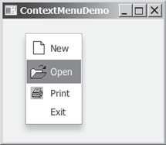
FIGuRE 31.23 A context menu is displayed when the popup trigger is issued on the pane.
Here are the major steps in the program (Listing 31.10):
- Create a context menu using ContextMenu. Create menu items for New, Open, Print, and Exit using MenuItem.
- Add the menu items into the context menu.
- Create a pane and place it in the scene.
- Implement the handler to process the events from the menu items.
- Implement the mousePressed handler to display the context menu.
Listing 31.10 ContextMenuDemo.java
- import javafx.application.Application;
- import javafx.scene.Scene;
- import javafx.scene.control.ContextMenu;
- import javafx.scene.control.MenuItem;
- import javafx.scene.image.ImageView;
- import javafx.scene.layout.Pane;
- import javafx.stage.Stage;
8

  - SplitPane 31-23

- public class ContextMenuDemo extends Application {
- @Override // Override the start method in the Application class
- public void start(Stage primaryStage) {
- ContextMenu contextMenu = new ContextMenu();
- MenuItem menuItemNew = new MenuItem("New",
- new ImageView("image/new.gif"));
- MenuItem menuItemOpen = new MenuItem("Open",
- new ImageView("image/open.gif"));
- MenuItem menuItemPrint = new MenuItem("Print",
- new ImageView("image/print.gif"));
- MenuItem menuItemExit = new MenuItem("Exit");
- contextMenu.getItems().addAll(menuItemNew, menuItemOpen,
- menuItemPrint, menuItemExit);
22
- Pane pane = new Pane();
- Scene scene = new Scene(pane, 300, 250);
- primaryStage.setTitle("ContextMenuDemo"); // Set the window title
- primaryStage.setScene(scene); // Place the scene in the window
- primaryStage.show(); // Display the window 28
- pane.setOnMousePressed(
- e -> contextMenu.show(pane, e.getScreenX(), e.getScreenY())); 31
- menuItemNew.setOnAction(e -> System.out.println("New"));
- menuItemOpen.setOnAction(e -> System.out.println("Open"));
- menuItemPrint.setOnAction(e -> System.out.println("Print"));
- menuItemExit.setOnAction(e -> System.exit(0));
36 }
37 }

The process of creating context menus is similar to the process for creating regular menus. To create a context menu, create a ContextMenu as the basis (line 12) and add MenuItems to it (lines 13–21).
To show a context menu, use the show method by specifying the parent node and the loca- tion for the context menu (lines 29 and 30). The show method is invoked when the context menu is triggered by a mouse click on the pane (line 30).
    - How do you create a context menu? How do you add menu items, check menu items, and radio menu items into a context menu?
    - How do you show a context menu?
  - SplitPane
The SplitPane class can be used to display multiple panes and allow the user to adjust the size of the panes.
The SplitPane is a control that contains two components with a separate bar known as a divider, as shown in Figure 31.24.

Check Point

Key Point




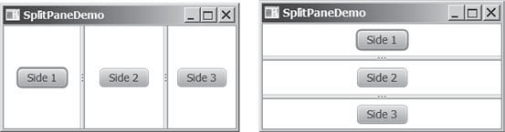
(a) Horizontal orientation (b) Vertical orientation
FIGuRE 31.24 SplitPane divides a container into two parts.




31-24 Chapter 31 Advanced JavaFX and FXML

The two sides separated by the divider can appear in horizontal or vertical orientation. The divider separating two sides can be dragged to change the amount of space occupied by each side. Figure 31.25 shows the frequently used properties, constructors, and methods in SplitPane.

The getter and setter methods for property values and a getter for property itself are provided in the class, but omitted in the UML diagram for brevity.
−orientation: ObjectProperty<Orientation>
javax.scene.control.SplitPane
javafx.scene.control.Control

Specifies the orientation of the pane.
Constructs a default split pane with horizontal orientation. Returns a list of items in the pane.
+SplitPane()
+getItems(): ObservableList<Node>

FIGuRE 31.25 SplitPane provides methods to specify the properties of a split pane and for manipulating the components in a split pane.

Listing 31.11 gives an example that uses radio buttons to let the user select a country and displays the country’s flag and description in separate sides, as shown in Figure 31.26. The description of the currently selected layout manager is displayed in a text area. The radio but- tons, buttons, and text area are placed in two split panes.
Listing 31.11 SplitPaneDemo.java
- import javafx.application.Application;
- import javafx.geometry.Orientation;
- import javafx.scene.Scene;
- import javafx.scene.control.RadioButton;
- import javafx.scene.control.ScrollPane;
- import javafx.scene.control.SplitPane;
- import javafx.scene.control.TextArea;
- import javafx.scene.control.ToggleGroup;
- import javafx.scene.image.Image;
- import javafx.scene.image.ImageView;
- import javafx.scene.layout.StackPane;
- import javafx.scene.layout.VBox;
- import javafx.stage.Stage;
14
- public class SplitPaneDemo extends Application {
- private Image usImage = new Image(
- "http://www.cs.armstrong.edu/liang/common/image/us.gif");
- private Image ukImage = new Image(
- "http://www.cs.armstrong.edu/liang/common/image/uk.gif");
- private Image caImage = new Image(
- "http://www.cs.armstrong.edu/liang/common/image/ca.gif");
- private String usDescription = "Description for US ...";
- private String ukDescription = "Description for UK ...";
- private String caDescription = "Description for CA ..."; 25
- @Override // Override the start method in the Application class
- public void start(Stage primaryStage) {
- VBox vBox = new VBox(10);
- RadioButton rbUS = new RadioButton("US");



  - SplitPane 31-25
- RadioButton rbUK = new RadioButton("UK");
- RadioButton rbCA = new RadioButton("CA");
- vBox.getChildren().addAll(rbUS, rbUK, rbCA); 33
- SplitPane content = new SplitPane();
- content.setOrientation(Orientation.VERTICAL);
- ImageView imageView = new ImageView(usImage);
- StackPane imagePane = new StackPane();
- imagePane.getChildren().add(imageView);
- TextArea taDescription = new TextArea();
- taDescription.setText(usDescription);
- content.getItems().addAll(
- imagePane, new ScrollPane(taDescription)); 43
- SplitPane sp = new SplitPane();
- sp.getItems().addAll(vBox, content);
46
- Scene scene = new Scene(sp, 300, 250);
- primaryStage.setTitle("SplitPaneDemo"); // Set the window title
- primaryStage.setScene(scene); // Place the scene in the window
- primaryStage.show(); // Display the window 51
- // Group radio buttons
- ToggleGroup group = new ToggleGroup();
- rbUS.setToggleGroup(group);
- rbUK.setToggleGroup(group);
- rbCA.setToggleGroup(group);
57
- rbUS.setSelected(true);
- rbUS.setOnAction(e -> {
- imageView.setImage(usImage);
- taDescription.setText(usDescription);
62 });
63
- rbUK.setOnAction(e -> {
- imageView.setImage(ukImage);
- taDescription.setText(ukDescription);
67 });
68
- rbCA.setOnAction(e -> {
- imageView.setImage(caImage);
- taDescription.setText(caDescription);
72 });
73 }
74 }

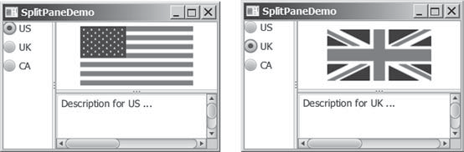
FIGuRE 31.26 You can adjust the component size in the split panes.



31-26 Chapter 31 Advanced JavaFX and FXML
The program places three radio buttons in a VBox (lines 28–32) and creates a vertical split pane for holding an image view and a text area (lines 34–42). Split panes can be embedded. The program creates a horizontal split pane and places the VBox and the vertical split pane into it (lines 44 and 45).
Adding a split pane to an existing split pane results in three split panes. The program creates two split panes (lines 34, 42) to hold a panel for radio buttons, a panel for buttons, and a scroll pane.
The program groups radio buttons (lines 53–56) and processes the action for radio buttons (lines 59–72).

    - How do you create a horizontal SplitPane? How do you create a vertical
Check Point
SplitPane?
    - How do you add items into a SplitPane? Can you add a SplitPane to another
SplitPane?

TabPane

Key Point
The TabPane class can be used to display multiple panes with tabs.
TabPane is a useful control that provides a set of mutually exclusive tabs, as shown in Figure 31.27. You can switch between a group of tabs. Only one tab is visible at a time. A Tab can be added to a TabPane. Tabs in a TabPane can be placed in the position top, left, bottom, or right.

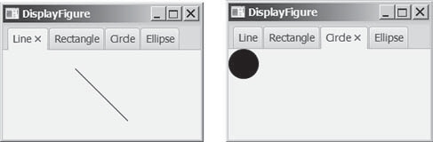
FIGuRE 31.27 TabPane holds a group of tabs.

Each tab represents a single page. Tabs are defined in the Tab class. Tabs can contain any Node such as a pane, a shape, or a control. A tab can contain another pane. Therefore, you can create a multilayered tab pane. Figures 31.28 and 31.29 show the frequently used properties, constructors, and methods in TabPane and Tab.

The getter and setter methods for property values and a getter for property itself are provided in the class, but omitted in the UML diagram for brevity.
javafx.scene.control.Control
javafx.scene.control.TabPane
-side: ObjectProperty<Side>
+TabPane()
+getTabs(): ObservableList<Tab>

The position of the tab in the tab pane. Possible values are: Side.TOP, Side.BOTTOM, Side.LEFT, and Side.RIGHT (default: Side.TOP).

Creates a default Tab Pane.
Returns a list of tabs in this Tab Pane.

FIGuRE 31.28 TabPane displays and manages the tabs.

  - TabPane 31-27

The getter and setter methods for property values and a getter for property itself are provided in the class, but omitted in the UML diagram for brevity.
java.lang.Object
javafx.scene.control.Tab
-content: ObjectProperty<Node>
-contextMenu: ObjectProperty<ContextMenu>
-graphics: ObjectProperty<Node>
-id: StringProperty
-text: StringProperty
-tooltip: StringProperty
+Tab()
+Tab(text: String)

The content associated with the tab.
The context menu associated with the tab.

The graphics in the tab. The id for the tab.
The text shown in the tab.
The tooltip associated with the tab.

FIGuRE 31.29 Tab contains a node.
Constructs a default tab.
Constructs a tab with the specified string.




Listing 31.12 gives an example that uses a tab pane with four tabs to display four types of fig- ures: line, rectangle, rounded rectangle, and oval. You can select a figure to display by clicking the corresponding tab, as shown in Figure 31.27.
Listing 31.12 TabPaneDemo.java
- import javafx.application.Application;
- import javafx.scene.Scene;
- import javafx.scene.control.Tab;
- import javafx.scene.control.TabPane;
- import javafx.scene.layout.StackPane;
- import javafx.scene.shape.Circle;
- import javafx.scene.shape.Ellipse;
- import javafx.scene.shape.Line;
- import javafx.scene.shape.Rectangle;
- import javafx.stage.Stage;
11
- public class TabPaneDemo extends Application {
- @Override // Override the start method in the Application class
- public void start(Stage primaryStage) {
- TabPane tabPane = new TabPane();
- Tab tab1 = new Tab("Line");
- StackPane pane1 = new StackPane();
- pane1.getChildren().add(new Line(10, 10, 80, 80));
- tab1.setContent(pane1);
- Tab tab2 = new Tab("Rectangle");
- tab2.setContent(new Rectangle(10, 10, 200, 200));
- Tab tab3 = new Tab("Circle");
- tab3.setContent(new Circle(50, 50, 20));
- Tab tab4 = new Tab("Ellipse");
- tab4.setContent(new Ellipse(10, 10, 100, 80));
- tabPane.getTabs().addAll(tab1, tab2, tab3, tab4); 27
- Scene scene = new Scene(tabPane, 300, 250);
- primaryStage.setTitle("DisplayFigure"); // Set the window title
- primaryStage.setScene(scene); // Place the scene in the window
- primaryStage.show(); // Display the window
32 }
33 }



31-28 Chapter 31 Advanced JavaFX and FXML
The program creates a tab pane (line 15) and four tabs (lines 16, 20, 22, and 24). A stack pane is created to hold a line (line 18) and placed into tab1 (line 19). A rectangle, circle, and oval are created and placed into tab2, tab3, and tab4. Note the line is centered in tab1 because it is placed in a stack pane. The other shapes are directly placed into the tab. They are displayed at the upper left corner of the tab.
By default, the tabs are placed at the top of the tab pane. You can use the setSide method to change its location.

    - How do you create a tab pane? How do you create a tab? How do you add a tab to a tab pane?
Check Point
    - How do you place the tabs on the left of the tab pane?
    - Can a tab have a text as well as an image? Write the code to set an image for tab1
in Listing 31.12.

TableView

Key Point
You can display tables using the TableView class.
TableView is a control that displays data in rows and columns in a two-dimensional grid, as shown in Figure 31.30.

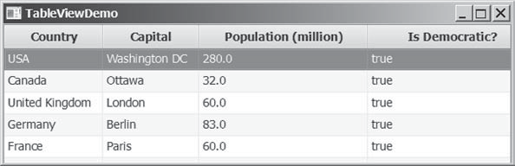
FIGuRE 31.30 TableView displays data in a table.

TableView, TableColumn, and TableCell are used to display and manipulate a table. TableView displays a table. TableColumn defines the columns in a table. TableCell rep- resents a cell in the table. Creating a TableView is a multistep process. First, you need to create an instance of TableView and associate data with the TableView. Second, you need to create columns using the TableColumn class and set a column cell value factory to specify how to populate all cells within a single TableColumn.
Listing 31.13 gives a simple example to demonstrate using TableView and TableColumn.
A sample run of the program is shown in Figure 31.31.

Listing 31.13 TableViewDemo.java
- import javafx.application.Application;
- import javafx.beans.property.SimpleBooleanProperty;
- import javafx.beans.property.SimpleDoubleProperty;
- import javafx.beans.property.SimpleStringProperty;
- import javafx.collections.FXCollections;
- import javafx.collections.ObservableList;
- import javafx.scene.Scene;
- import javafx.scene.control.TableColumn;
- import javafx.scene.control.TableView;
- import javafx.scene.control.cell.PropertyValueFactory;
- import javafx.scene.layout.Pane;
- import javafx.stage.Stage;



  - TableView 31-29

13
- public class TableViewDemo extends Application {
- @Override // Override the start method in the Application class
- public void start(Stage primaryStage) {
- TableView<Country> tableView = new TableView<>();
- ObservableList<Country> data =
- FXCollections.observableArrayList(
- new Country("USA", "Washington DC", 280, true),
- new Country("Canada", "Ottawa", 32, true),
- new Country("United Kingdom", "London", 60, true),
- new Country("Germany", "Berlin", 83, true),
- new Country("France", "Paris", 60, true));
- tableView.setItems(data);
26
- TableColumn countryColumn = new TableColumn("Country");
- countryColumn.setMinWidth(100);
- countryColumn.setCellValueFactory(
- new PropertyValueFactory<Country, String>("country")); 31
- TableColumn capitalColumn = new TableColumn("Capital");
- capitalColumn.setMinWidth(100);
- capitalColumn.setCellValueFactory(
- new PropertyValueFactory<Country, String>("capital")); 36
- TableColumn populationColumn =
- new TableColumn("Population (million)");
- populationColumn.setMinWidth(200);
- populationColumn.setCellValueFactory(
- new PropertyValueFactory<Country, Double>("population")); 42
- TableColumn democraticColumn =
- new TableColumn("Is Democratic?");
- democraticColumn.setMinWidth(200);
- democraticColumn.setCellValueFactory(
- new PropertyValueFactory<Country, Boolean>("democratic")); 48
- tableView.getColumns().addAll(countryColumn, capitalColumn,
- populationColumn, democraticColumn);
51
- Pane pane = new Pane();
- pane.getChildren().add(tableView);
- Scene scene = new Scene(pane, 300, 250);
- primaryStage.setTitle("TableViewDemo"); // Set the window title
- primaryStage.setScene(scene); // Place the scene in t he window
- primaryStage.show(); // Display the window
58 }
59
- public static class Country {
- private final SimpleStringProperty country;
- private final SimpleStringProperty capital;
- private final SimpleDoubleProperty population;
- private final SimpleBooleanProperty democratic; 65
- private Country(String country, String capital,
- double population, boolean democratic) {
- this.country = new SimpleStringProperty(country);
- this.capital = new SimpleStringProperty(capital);
- this.population = new SimpleDoubleProperty(population);
- this.democratic = new SimpleBooleanProperty(democratic);
72 }




31-30 Chapter 31 Advanced JavaFX and FXML

73
74 | public String getCountry() {
75 | return country.get();
76 | }
77
78 | public void setCountry(String | country) {
79  80 | this.country.set(country);  }
81
82 | public String getCapital() {
83 | return capital.get();
84 | }
85
86 | public void setCapital(String | capital) {
87 | this.capital.set(capital);
88 }
89
- public double getPopulation() {
- return population.get();
92 }
93
- public void setPopulation(double population) {
- this.population.set(population);
96 }
97
- public boolean isDemocratic() {
- return democratic.get();
100 }
101
- public void setDemocratic(boolean democratic) {
- this.democratic.set(democratic);
104 }
105 }
106 }

The program creates a TableView (line 17). The TableView class is a generic class whose concrete type is Country. Therefore, this TableView is for displaying Country. The table data is an ObservableList<Country>. The program creates the list (lines 18–24) and associates the list with the TableView (line 25).
The program creates a TableColumn for each column in the table (lines 27–47). A Prop- ertyValueFactory object is created and set for each column (line 30). This object is used to populate the data in the column. The PropertyValueFactory<S, T> class is a generic class. S is for the class displayed in the TableView and T is the class for the values in the column. The PropertyValueFactory object associates a property in class S with a column. When you create a table in a JavaFX application, it is a best practice to define the data model in a class. The Country class defines the data for TableView. Each property in the class defines a column in the table. This property should be defined as binding property with
the getter and setter methods for the value.
The program adds the columns into the TableView (lines 49 and 50), adds the TableView in a pane (line 53), and places the pane in the scene (line 54). Note line 31 can be simplified using the following code:

new PropertyValueFactory<>("country");

From this example, you see how to display data in a table using the TableView and TableCol- umn classes. The frequently used properties and methods for the TableView and TableColumn classes are given in Figures 31.32 and 31.33.



31.10 TableView 31-31

The getter and setter methods for property values and a getter for property itself are provided in the class, but omitted in the UML diagram for brevity.
javafx.scene.control.Control
javafx.scene.control.TableView<S>
-editable: BooleanProperty

-items:
ObjectProperty<ObservableList<S>>
-placeholder: ObjectProperty<Node>
-selectionModel: ObjectProperty< TableViewSelectionModel<S>>
+TableView()
+TableView(items: ObservableList<S>)

Specifies whether this TableView is editable. For a cell to be editable, TableView, TableColumn, and TableCell for the cell should all be true.
The data model for the TableView.

This Node is shown when table has no contents. Specifies single or multiple selections.

Creates a default TableView with no content.
Creates a default TableView with the specified content.
FIGuRE 31.31 TableView displays a table.

The getter and setter methods for property values and a getter for property itself are provided in the class, but omitted in the UML diagram for brevity.
java.lang.Object
javafx.scene.control.TableColumn<S,T>
-editable: BooleanProperty
-cellValueFactory: ObjectProperty<Callback<TableColumn. CellDataFeatures<S,T>,ObservableValue
<T>>>
-graphic: ObjectProperty<Node>
-id: StringProperty
-resizable: BooleanProperty
-sortable: BooleanProperty
-text: StringProperty
-style: StringProperty
-visible: BooleanProperty
+TableColumn()
+TableColumn(text: String)

Specifies whether this TableColumn allows editing.
The cell value factory to specify how to populate all cells within a single column.

The graphic for this TableColumn. The id for this TableColumn.
Indicates whether the column is resizable. Indicates whether the column is sortable. The text in the table column header.
Specifies the CSS style for the column.
Specifies whether the column is visible (default: true).
Creates a default TableColumn.
Creates a TableView with the specified header text.
FIGuRE 31.32 TableColumn defines a column in the TableView.

You can create nested columns. For example, the following code creates two subcolumns under Location, as shown in Figures 31.33.
TableColumn locationColumn = new TableColumn("Location"); locationColumn.getColumns().addAll(new TableColumn("latitude"),
new TableColumn("longitude"));
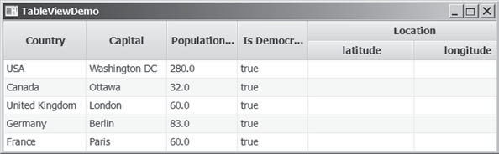
FIGuRE 31.33 You can add subcolumns in a column.




31-32 Chapter 31 Advanced JavaFX and FXML
The TableView data model is an observable list. When data is changed, the change is auto- matically shown in the table. Listing 31.14 gives an example that lets the user add new rows to the table.
Listing 31.14 AddNewRowDemo.java
- import javafx.application.Application;
- import javafx.beans.property.SimpleBooleanProperty;
- import javafx.beans.property.SimpleDoubleProperty;
- import javafx.beans.property.SimpleStringProperty;
- import javafx.collections.FXCollections;
- import javafx.collections.ObservableList;
- import javafx.scene.Scene;
- import javafx.scene.control.Button;
- import javafx.scene.control.CheckBox;
- import javafx.scene.control.Label;
- import javafx.scene.control.TableColumn;
- import javafx.scene.control.TableView;
- import javafx.scene.control.TextField;
- import javafx.scene.control.cell.PropertyValueFactory;
- import javafx.scene.layout.BorderPane;
- import javafx.scene.layout.FlowPane;
- import javafx.stage.Stage;
18
- public class AddNewRowDemo extends Application {
- @Override // Override the start method in the Application class
- public void start(Stage primaryStage) {
- TableView<Country> tableView = new TableView<>();
- ObservableList<Country> data =
- FXCollections.observableArrayList(
- new Country("USA", "Washington DC", 280, true),
- new Country("Canada", "Ottawa", 32, true),
- new Country("United Kingdom", "London", 60, true),
- new Country("Germany", "Berlin", 83, true),
- new Country("France", "Paris", 60, true));
- tableView.setItems(data);
31
- TableColumn countryColumn = new TableColumn("Country");
- countryColumn.setMinWidth(100);
- countryColumn.setCellValueFactory(
- new PropertyValueFactory<Country, String>("country")); 36
- TableColumn capitalColumn = new TableColumn("Capital");
- capitalColumn.setMinWidth(100);
- capitalColumn.setCellValueFactory(
- new PropertyValueFactory<Country, String>("capital")); 41
- TableColumn populationColumn =
- new TableColumn("Population (million)");
- populationColumn.setMinWidth(100);
- populationColumn.setCellValueFactory(
- new PropertyValueFactory<Country, Double>("population")); 47
- TableColumn democraticColumn =
- new TableColumn("Is Democratic?");
- democraticColumn.setMinWidth(100);
- democraticColumn.setCellValueFactory(
- new PropertyValueFactory<Country, Boolean>("democratic")); 53
- tableView.getColumns().addAll(countryColumn, capitalColumn,



31.10 TableView 31-33

- populationColumn, democraticColumn);
56
- FlowPane flowPane = new FlowPane(3, 3);
- TextField tfCountry = new TextField();
- TextField tfCapital = new TextField();
- TextField tfPopulation = new TextField();
- CheckBox chkDemocratic = new CheckBox("Is democratic?");
- Button btAddRow = new Button("Add new row");
- tfCountry.setPrefColumnCount(5);
- tfCapital.setPrefColumnCount(5);
- tfPopulation.setPrefColumnCount(5);
- flowPane.getChildren().addAll(new Label("Country: "),
- tfCountry, new Label("Capital"), tfCapital,
- new Label("Population"), tfPopulation, chkDemocratic,
- btAddRow);
70
- btAddRow.setOnAction(e -> {
- data.add(new Country(tfCountry.getText(), tfCapital.getText(),
- Double.parseDouble(tfPopulation.getText()),
- chkDemocratic.isSelected()));
- tfCountry.clear();
- tfCapital.clear();
- tfPopulation.clear();
78 });
79
- BorderPane pane = new BorderPane();
- pane.setCenter(tableView);
- pane.setBottom(flowPane);
83
- Scene scene = new Scene(pane, 500, 250);
- primaryStage.setTitle("AddNewRowDemo"); // Set the window title
- primaryStage.setScene(scene); // Place the scene in the window
- primaryStage.show(); // Display the window
88 }
89
- public static class Country {
- private final SimpleStringProperty country;
- private final SimpleStringProperty capital;
- private final SimpleDoubleProperty population;
- private final SimpleBooleanProperty democratic; 95
- private Country(String country, String capital,
- double population, boolean democratic) {
- this.country = new SimpleStringProperty(country);
- this.capital = new SimpleStringProperty(capital);
- this.population = new SimpleDoubleProperty(population);
- this.democratic = new SimpleBooleanProperty(democratic);
102 }
103
- public String getCountry() {
- return country.get();
106 }
107
- public void setCountry(String country) {
- this.country.set(country);
110 }
111
- public String getCapital() {
- return capital.get();
114 }




31-34 Chapter 31 Advanced JavaFX and FXML

115
- public void setCapital(String capital) {
- this.capital.set(capital);
118 }
119
- public double getPopulation() {
- return population.get();
122 }
123
- public void setPopulation(double population) {
- this.population.set(population);
126 }
127
- public boolean isDemocratic() {
- return democratic.get();
130 }
131
- public void setDemocratic(boolean democratic) {
- this.democratic.set(democratic);
134 }
135 }
136 }

The program is the same in Listing 31.13 except that a new code is added to let the user enter a new row (lines 57–82). The user enters the new row from the text fields and a check box and presses the Add New Row button to add a new row to the data. Since data is an observable list, the change in data is automatically updated in the table.
As shown in Figure 31.34a, a new country information is entered in the text fields. After clicking the Add New Row button, the new country is displayed in the table view.

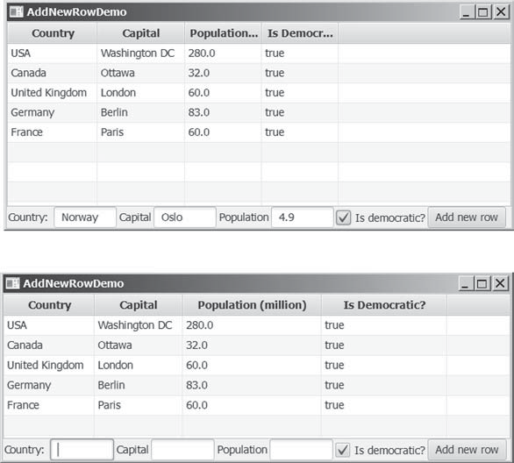
(a)
(b)
FIGuRE 31.34 Change in the table data model is automatically displayed in the table view.




31.11 Developing JavaFX Programs Using FXML 31-35
TableView not only displays data, but also allows data to be edited. To enable data editing in the table, write the code as follows:
- Set the TableView’s editable to true.
- Set the column’s cell factory to a text field table cell.
- Implement the column’s setOnEditCommit method to assign the edited value to the data model.
Here is the example of enabling editing for the countryColumn.
tableView.setEditable(true); countryColumn.setCellFactory(TextFieldTableCell.forTableColumn()); countryColumn.setOnEditCommit(
new EventHandler<CellEditEvent<Country, String>>() { @Override
public void handle(CellEditEvent<Country, String> t) { t.getTableView().getItems().get(
t.getTablePosition().getRow())
.setCountry(t.getNewValue());
}
}
);

    - How do you create a table view? How do you create a table column? How do you add a table column to a table view?
Check Point
    - What is the data type for a TableView’s data model? How do you associate a data model with a TableView?
    - How do you set a cell value factory for a TableColumn?
    - How do you set an image in a table column header?

Developing JavaFX Programs Using FXML

Key Point
You can create JavaFX user interfaces using FXML scripts.
There are two ways to develop JavaFX applications. One way is to write everything in Java source code as you have done so far. The other way is to use FXML. FXML is an XML-based script language for describing the user interface. Using FXML enables you to separate user interface from the logic of the Java code. JavaFX Scene Builder is a visual design tool for creating the user interface without manually writing the FXML script. You drag and drop the UI components to the content pane and set properties for the components in the Inspector. The Scene Builder automatically generates the FXML scripts for the user interface. This section
demonstrates how to use the Scene Builder to create JavaFX applications.


NOTE
It is important that you first learn how to write the JavaFX code without using FXML to grasp the fundamentals of JavaFX programming before learning FXML. Once you understand the basics of JavaFX, it is easy to create JavaFX programs using FXML. For this reason, FXML is introduced after you have learned the basics of JavaFX programming.

Installing JavaFX Scene Builder
You can use the JavaFX Scene Builder standalone or with an IDE such as NetBeans or Eclipse. This section demonstrates using the JavaFX Scene Builder with NetBeans. You can download the latest version of Scene Builder from http://gluonhq.com/open-source/scene-builder/.



31-36 Chapter 31 Advanced JavaFX and FXML

Creating a JavaFX FXML Project
To use JavaFX FXML, you need to create a JavaFX FXML in NetBeans. Here are the steps of creating a JavaFX FXML project:
      - Choose File, New Project to display the New Project dialog box, as shown in Figure 31.35.
      - Choose JavaFX in the Categories and JavaFX FXML Application in the Projects. Click
Next to display the New JavaFX Application dialog box, as shown in Figure 31.36.
      - Enter Calculator as the project name and click Finish to create the project. You will see the project created as shown in Figure 31.37.
Three files, Calculator.java, FXMLDocument.fxml, and FXMLDocumentController. java, are created in the project. Their source codes are shown in Listings 31.15, 31.16, and 31.17. From the perspective of the MVC architecture, these three files correspond to model, view, and controller. You can define data model in the Calculator.java class. The .fxml file describes the user interface. The controller file defines the actions for processing the events for the user interface.

Listing 31.15 Calculator.java
1 package calculator;
2
- import javafx.application.Application;
- import javafx.fxml.FXMLLoader;
- import javafx.scene.Parent;
- import javafx.scene.Scene;
- import javafx.stage.Stage;
8
- public class Calculator extends Application {
- @Override
- public void start(Stage stage) throws Exception {
- Parent root =
- FXMLLoader.load(getClass().getResource("FXMLDocument.fxml"));
- Scene scene = new Scene(root);
- stage.setScene(scene);
- stage.show();
17 }
18
19 /**
- * @param args the command line arguments
- */
- public static void main(String[] args) {
- launch(args);
24 }
25 }

Listing 31.16 FXMLDocument.fxml
<?xml version="1.0" encoding="UTF-8"?>

<?import java.lang.*?>
<?import java.util.*?>
<?import javafx.scene.*?>
<?import javafx.scene.control.*?>
<?import javafx.scene.layout.*?>

<AnchorPane id="AnchorPane" prefHeight="200" prefWidth="320" xmlns:fx="http://javafx.com/fxml/1"




31.11 Developing JavaFX Programs Using FXML 31-37

fx:controller="calculator.FXMLDocumentController">
<children>
<Button layoutX="126" layoutY="90" text="Click Me!" onAction="#handleButtonAction" fx:id="button" />
<Label layoutX="126" layoutY="120" minHeight="16" minWidth="69" fx:id="label" />
</children>
</AnchorPane>

Listing 31.17 FXMLDocumentController.java
package calculator;
import java.net.URL;
import java.util.ResourceBundle; import javafx.event.ActionEvent; import javafx.fxml.FXML;
import javafx.fxml.Initializable;
import javafx.scene.control.Label;
public class FXMLDocumentController implements Initializable { @FXML
private Label label;

@FXML
private void handleButtonAction(ActionEvent event) { System.out.println("You clicked me!"); label.setText("Hello World!");
}

@Override
public void initialize(URL url, ResourceBundle rb) {
// TODO
}
}

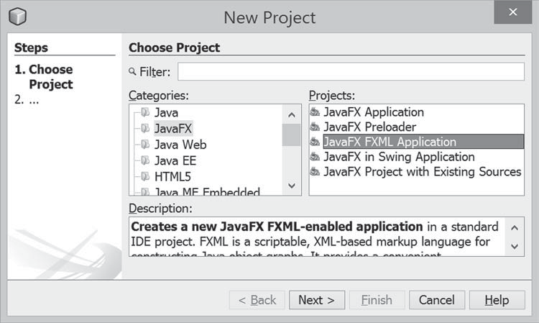
FIGuRE 31.35 You can choose JavaFX in the Categories and JavaFX FXML Application in the Project to create a FXML project.



31-38 Chapter 31 Advanced JavaFX and FXML
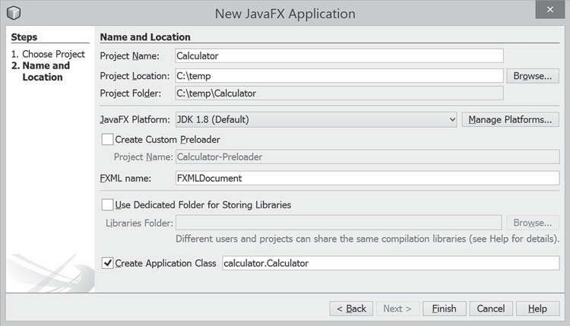
FIGuRE 31.36 You can enter project information in the New JavaFX Application dialog.

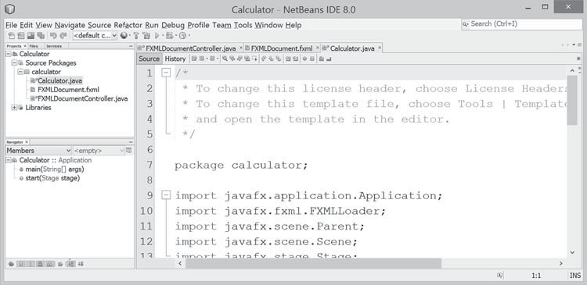
FIGuRE 31.37 A FXML project is created.

Creating User Interfaces
We now turn our attention to developing a simple calculator as shown in Figure 31.38. The Calculator program enables the user to enter numbers and perform addition, subtraction, multiplication, and division.
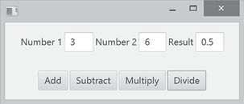
FIGuRE 31.38 The application performs arithmetic operations.
When you create a JavaFX FXML project, NetBeans creates a default .fxml file that contains the contents for a simple sample user interface. To view the user interface, double-click the
.fxml file to open the Scene Builder, as shown in Figure 31.39. Note NetBeans can automati- cally detect the Scene Builder after it is installed on your machine.



Developing JavaFX Programs Using FXML 31-39
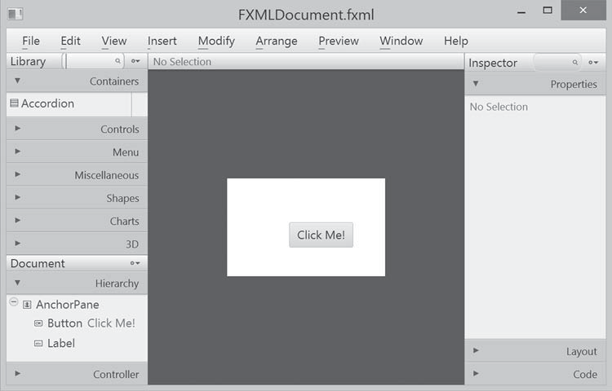
FIGuRE 31.39 Double-click the .fxml file to open the Scene Builder.

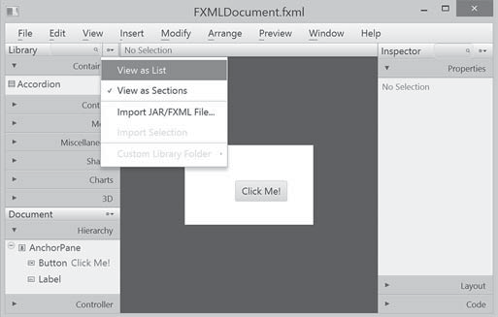
FIGuRE 31.40 You can open the Library pane by clicking the Library icon and choose View as List.

To start a new user interface, delete the default user interface in the .fxml file from the content pane, as shown in Figure 31.41. Here are the steps to create a new user interface:
- (Optional) On some systems, the components in the Library pane are not visible by sections. Click the Library icon to open the context menu as shown in Figure 31.40 and choose View as List.
- Drag a BorderPane into the user interface and drag an HBox to the center of the BorderPane and another HBox to the bottom of the BorderPane. Set the alignment of both HBox to CENTER as shown in Figure 31.42. Set the Spacing property in the Layout section of the Inspector to 5. When you select a component in the visual layout, the properties of the component are displayed in the Inspector pane, where you can set the properties.



31-40 Chapter 31 Advanced JavaFX and FXML
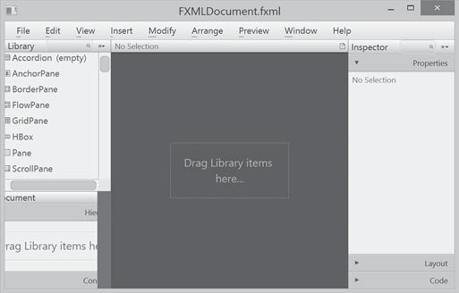
FIGuRE 31.41 The UI is empty after deleting the default button in the pane.

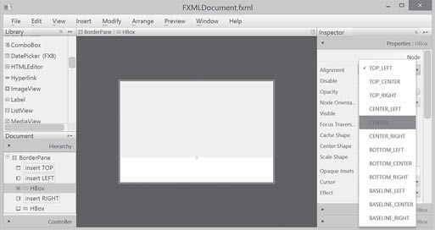
FIGuRE 31.42 A BorderPane is dropped to the UI and an HBox is placed at the bottom of the BorderPane.

- Drag and drop a Label, a TextField, a Label, a TextField, a Label, and a Tex- tField and change the label’s text to Number 1, Number 2, and Result, as shown in Figure 31.43. Set the Pref Column Count property for each text field to 2 in the Layout section of the Inspector. In the Code section of the Inspector, set the id for the text fields to tfNumber1, tfNumber2, and tfResult, as shown in Figure 31.44. These ids are useful to reference the text fields and obtain their values in the controller.
- Drag and drop four Buttons to the second HBox and set their text property to Add, Subtract, Multiply, and Divide, as shown in Figure 31.45.

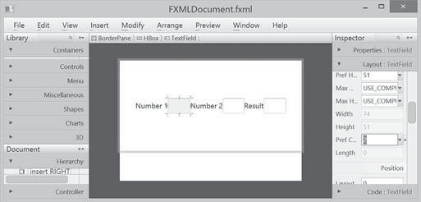
FIGuRE 31.43 The labels and text fields are dropped to the UI.

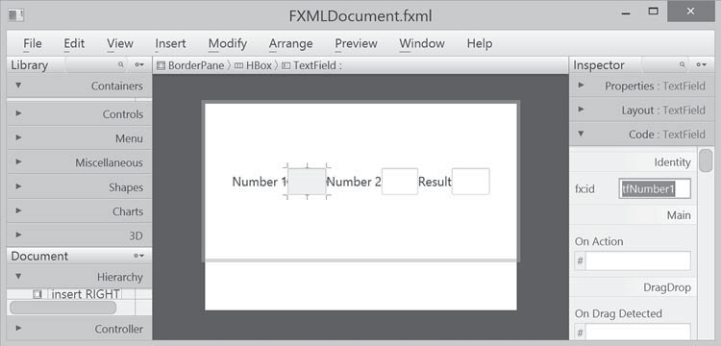
FIGuRE 31.44 Set the appropriate id for the text fields.
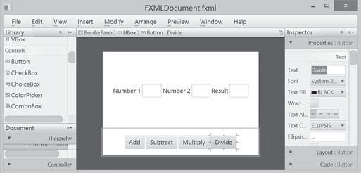
FIGuRE 31.45 The buttons are dropped to the HBox.
After you create and make changes to the user interface in the content pane, you need to save the changes by choosing File, Save from the menu bar in the Scene Builder. The .fxml file is updated and synchronized with the changes in the content pane. You can view the contents in the .fxml file from NetBeans, as shown in Figure 31.46.
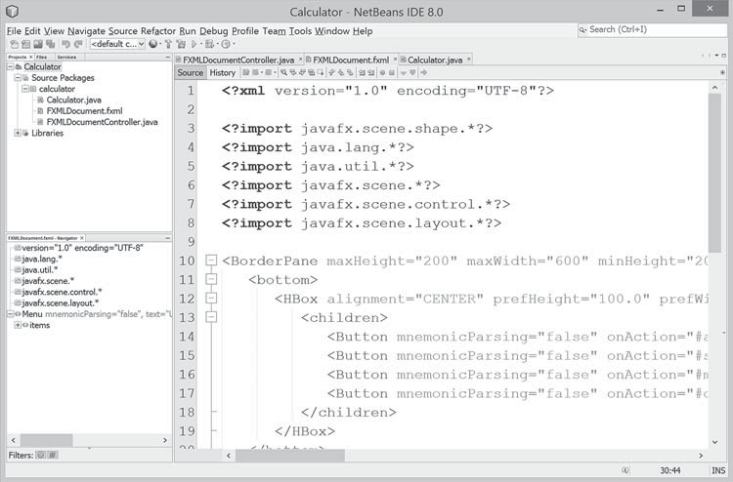



FIGuRE 31.46 You can view the contents of the FXML file.
31-41



31-42 Chapter 31 Advanced JavaFX and FXML

Handling Events in the Controller
The .fxml file describes the user interface. You write the code to implement the logic in the controller file, as shown in Listing 31.18.
Listing 31.18 FXMLDocumentController.java
1 package calculator;
2
- import javafx.event.ActionEvent;
- import javafx.fxml.FXML;
- import javafx.scene.control.TextField;
6
- public class FXMLDocumentController {
- @FXML
- private TextField tfNumber1, tfNumber2, tfResult; 10
- @FXML
- private void addButtonAction(ActionEvent event) {
- tfResult.setText(getResult('+') + "");
14 }
15
- @FXML
- private void subtractButtonAction(ActionEvent event) {
- tfResult.setText(getResult('−') + "");
19 }
20
- @FXML
- private void multiplyButtonAction(ActionEvent event) {
- tfResult.setText(getResult('*') + "");
24 }
25
- @FXML
- private void divideButtonAction(ActionEvent event) {
- tfResult.setText(getResult('/') + "");
29 }
30
- private double getResult(char op) {
- double number1 = Double.parseDouble(tfNumber1.getText());
- double number2 = Double.parseDouble(tfNumber2.getText());
- switch (op) {
- case '+': return number1 + number2;
- case '−': return number1 − number2;
- case '*': return number1 * number2;
- case '/': return number1 / number2;
39 }
40 return Double.NaN;
41 }
42 }
The controller class declares three TextFields, tfNumber1, tfNumber2, and tfResult (line 9). The @FXML annotation denotes that these data fields are linked to the text fields in the user interface. Recall in the user interface, we set the id for the three text fields as tfNumber1, tfNumber2, and tfResult.
The codes for handling the events from the buttons are defined in the methods addButton- Action, subtractButtonAction, multiplyButtonAction, and divideButtonAction (lines 11–29). The @FXML annotation is used to denote that these methods will be tied to the button actions in the view.
Through the @FXML annotation, the data fields and methods in the controller are linked to the components and actions defined in the .fxml file.



31.11 Developing JavaFX Programs Using FXML 31-43

Linking View with Controller
You can now link the actions from the components in the view with the processing methods in the controller. Here are the steps to accomplish it:
      - Add the following attribute in the <BorderPane> tag for using a controller with the view.

fx:controller="calculator.FXMLDocumentController"

      - Double-click the .fxml file in the project to display the visual layout window. In the Inspector for the Add button, choose addButtonAction from a list of action process- ing methods, as shown in Figure 31.47. The complete code for the .fxml file is shown in Listing 31.19.

Listing 31.19 FXMLDocument.fxml
<?xml version="1.0" encoding="UTF-8"?>
<?import java.lang.*?>
<?import java.util.*?>
<?import javafx.scene.*?>
<?import javafx.scene.control.*?>
<?import javafx.scene.layout.*?>

<BorderPane maxHeight="200" maxWidth="600" minHeight="200" minWidth="600" prefHeight="400.0" prefWidth="600.0" xmlns="http://javafx.com/javafx/8" xmlns:fx="http://javafx.com/fxml/1" fx:controller="calculator.FXMLDocumentController">
<bottom>
<HBox alignment="CENTER" prefHeight="100.0" prefWidth="200.0" spacing="5.0" BorderPane.alignment="CENTER">
<children>
<Button mnemonicParsing="false" onAction="#addButtonAction" text="Add" />
<Button mnemonicParsing="false" onAction="#subtractButtonAction" text="Subtract" />
<Button mnemonicParsing="false" onAction="#multiplyButtonAction" text="Multiply" />
<Button mnemonicParsing="false" onAction="#divideButtonAction" text="Divide" />
</children>
</HBox>
</bottom>
<center>
<HBox alignment="CENTER" prefHeight="232.0" prefWidth="572.0" spacing="5.0" BorderPane.alignment="CENTER">
<children>
<Label text="Number 1" />
<TextField fx:id="tfNumber1" prefColumnCount="2" prefHeight="51.0" prefWidth="74.0" />
<Label text="Number 2" />
<TextField fx:id="tfNumber2" prefColumnCount="2" prefHeight="51.0" prefWidth="70.0" />
<Label text="Result" />
<TextField fx:id="tfResult" prefColumnCount="2" />
</children>
</HBox>
</center>
</BorderPane>



31-44 Chapter 31 Advanced JavaFX and FXML

Running the Project
The code in the model is automatically generated as shown in Listing 31.15. This is the main program that loads the FXML to create the user interface in a Parent object (lines 12 and 13). The parent object is then added to the scene (line 14). The scene is set to the stage (line 15). The stage is displayed in line 16.
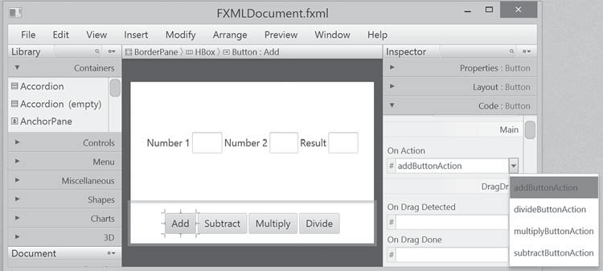
FIGuRE 31.47 Choosing addButtonAction to generate the code for handling action for the Add button.

CHaPTER SuMMaRy
      - JavaFX provides the cascading style sheets based on CSS. You can use the getStylesheets method to load a style sheet and use the setStyle, setStyleClass, and setId methods to set JavaFX CSS for nodes.
      - JavaFX provides the QuadCurve, CubicCurve, and Path classes for creating advanced shapes.
      - JavaFX supports coordinate transformations using translation, rotation, and scaling.
      - You can specify the pattern for a stroke, how the lines are joined in a stroke, the width of a stroke, and the type of a stroke.
      - You can create menus using the Menu, MenuItem, CheckMenuItem, and
RadioMenuItem classes.
      - You can create context menus using the ContextMenu class.
      - The SplitPane can be used to display multiple panes horizontally or vertically and allows the user to adjust the sizes of the panes.
      - The TabPane can be used to display multiple panes with tabs for selecting panes.
      - You can create and display tables using the TableView and TableColumn classes.
      - You can create JavaFX user interfaces using FXML. FXML is XML-based script lan- guage for describing the user interface. Using FXML enables you to separate user inter- face from the logic of Java code.
      - JavaFX Scene Builder is a visual tool for creating the user interface without manually writing the FXML scripts.




Programming Exercises 31-45
QuIZ
Answer the quiz for this chapter online at the book Companion Website.

PROgRaMMINg ExERCISES

Sections 31.2
  - (Use JavaFX CSS) Create a CSS style sheet that defines a class for white fill and black stroke color and an id for red stroke and green color. Write a program that displays four circles and uses the style class and id. The sample run of the program is shown in Figure 31.48a.

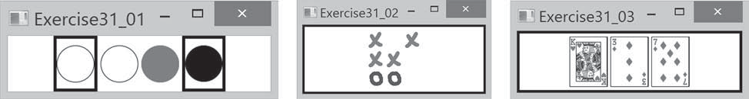
(a) (b) (c)
FIGuRE 31.48 (a) The border and the color style for the shapes are defined in a style class. (b) Exercise 31.2 displays a tic-tac-toe board with images using style sheet for border. (c) Three cards are randomly selected.

*31.2 (Tic-tac-toe board) Write a program that displays a tic-tac-toe board, as shown in Figure 31.48b. A cell may be X, O, or empty. What to display at each cell is randomly decided. The X and O are images in the files x.gif and o.gif. Use the style sheet for border.
*31.3 (Display three cards) Write a program that displays three cards randomly selected from a deck of 52, as shown in Figure 31.48c. The card image files are named 1.png, 2.png, . . ., 52.png and stored in the image/card directory. All the three cards are distinct and selected randomly. Hint: You can select random cards by stor- ing the numbers 1–52 to an array, perform a random shuffle using Section 7.2.6, and use the first three numbers in the array as the file names for the image. Use the style sheet for border.

Sections 31.3
31.4 (Color and font) Write a program that displays five texts vertically, as shown in Figure 31.49a. Set a random color and opacity for each text and set the font of each text to Times Roman, bold, italic, and 22 pixels.

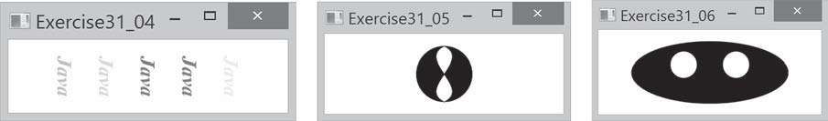
(a) (b) (c)
FIGuRE 31.49 (a) Five texts are displayed with a random color and a specified font. (b) A path is displayed inside the circle. (c) Two circles are displayed in an oval.




31-46 Chapter 31 Advanced JavaFX and FXML
*31.5 (Cubic curve) Write a program that creates two shapes: a circle and a path consist- ing of two cubic curves, as shown in Figure 31.49b.
*31.6 (Eyes) Write a program that displays two eyes in an oval, as shown in Figure 31.49c.

Sections 31.4
*31.7 (Translation) Write a program that displays a rectangle with upper-left corner point at (40, 40), width 50, and height 40. Enter the values in the text fields x and y and press the Translate button to translate the rectangle to a new location, as shown in Figure 31.50a.

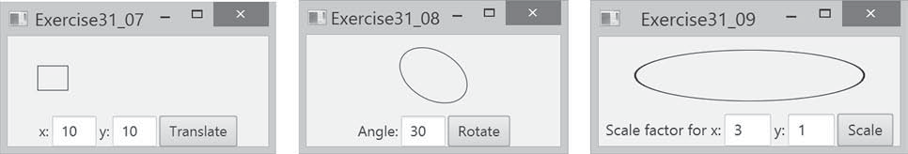
(a) (b) (c)
FIGuRE 31.50 (a) Exercise 31.7 translates coordinates. (b) Exercise 31.8 rotates coordinates. (c) Exercise 31.9 scales coordinates.

*31.8 (Rotation) Write a program that displays an ellipse. The ellipse is centered in the pane with width 60 and height 40. Enter the value in the text field Angle and press the Rotate button to rotate the ellipse, as shown in Figure 31.50b.
*31.9 (Scale graphics) Write a program that displays an ellipse. The ellipse is centered in the pane with width 60 and height 40. Enter the scaling factors in the text fields and press the Scale button to scale the ellipse, as shown in Figure 31.50c.
*31.10 (Plot the sine function) Write a program that plots the sine function, as shown in Figure 31.51a.

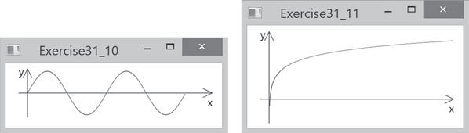
(a) (b)
FIGuRE 31.51 (a) Exercise 31.10 displays a sine function. (b) Exercise 31.11 displays the log function.

*31.11 (Plot the log function) Write a program that plots the log function, as shown in Figure 31.51a.
*31.12 (Plot the n² function) Write a program that plots the n² function, as shown in Figure
31.51b 2a.



Programming Exercises 31-47
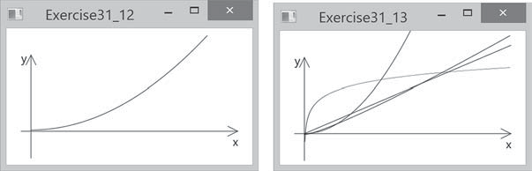
(a) (b)

FIGuRE 31.52 (a) Exercise 31.13 displays the n² function. (b) Exercise 31.13 displays several functions.

*31.13 (Plot the log, n, nlogn, and n² functions) Write a program that plots the log, n, nlogn, and n² functions, as shown in Figure 31.52b.
*31.14 (Scale and rotate graphics) Write a program that enables the user to scale and rotate the STOP sign, as shown in Figure 31.53. The user can press the UP/DOWN arrow key to increase/decrease the size and press the RIGHT/LEFT arrow key to rotate left or right.

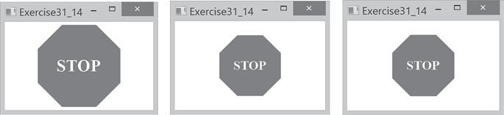
FIGuRE 31.53 The program can rotate and scale the painting.

Sections 31.5
*31.15 (Sunshine) Write a program that displays a circle filled with a gradient color to animate a sun and display light rays coming out from the sun using dashed lines, as shown in Figure 31.54a.

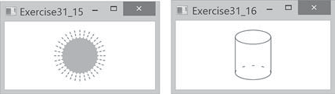
(a) (b)
FIGuRE 31.54 (a) Exercise 31.15 displays the sunshine. (b) Exercise 31.16 displays a cylinder.

*31.16 (Display a cylinder) Write a program that displays a cylinder, as shown in Figure 31.54b. Use dashed strokes to draw the dashed arc.




31-48 Chapter 31 Advanced JavaFX and FXML

Sections 31.6
*31.17 (Create an investment value calculator) Write a program that calculates the future value of an investment at a given interest rate for a specified number of years. The formula for the calculation is as follows:

futureValue = investmentAmount × (1 + monthlyInterestRate)^{years×12}
Use text fields for interest rate, investment amount, and years. Display the future amount in a text field when the user clicks the Calculate button or chooses Calcu- late from the Operation menu (see Figure 31.55). Click the Exit menu to exit the program.
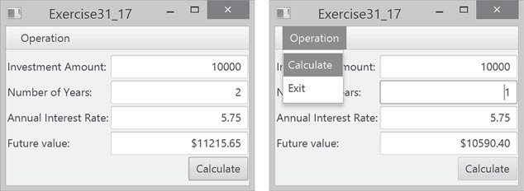
FIGuRE 31.55 The user enters the investment amount, years, and interest rate to compute future value.

Sections 31.8
*31.18 (Use popup menus) Modify Listing 31.9, MenuDemo.java, to create a popup menu that contains the menus Operations and Exit, as shown in Figure 31.56. The popup is displayed when you click the right mouse button on the panel that contains the labels and the text fields.
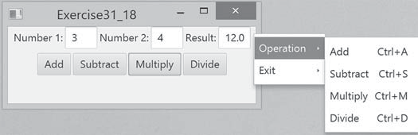
FIGuRE 31.56 The popup menu contains the commands to perform arithmetic operations.

*31.19 (Use SplitPane) Create a program that displays four shapes in split panes, as shown in Figure 31.57a.

Sections 31.9
*31.20 (Use tab panes) Modify Listing 31.12, TabPaneDemo.java, to add a pane of radio buttons for specifying the tab placement of the tab pane, as shown in Figure 31.57b and c.



Programming Exercises 31-49
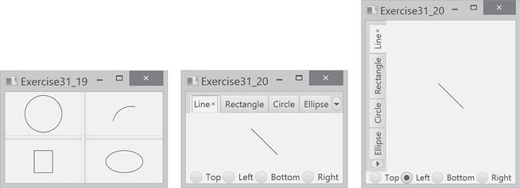
(a) (b) (c)
FIGuRE 31.57 (a) Four shapes are displayed in split panes. (b and c) The radio buttons let you choose the tab placement of the tabbed pane.

*31.21 (Use tab panes) Write a program using tab panes for performing integer and rational number arithmetic as shown in Figure 31.58.

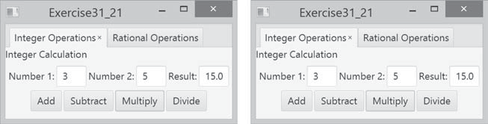
FIGuRE 31.58 A tab pane is used to select panes that perform integer operations and rational number operations.

Sections 31.10
*31.22 (Use table view) Revise Listing 31.14 to add a button to delete the selected row from the table, as shown in Figure 31.59.

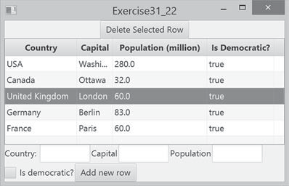
FIGuRE 31.59 Clicking the Delete Selected Row button removes the selected row from the table.

