Milestone Three
Three Python Scripts are needed to generate reports:
Report 1:
Script to show how many hours an employee is working,
Output – Hours Worked over a period (average per week)
Report 2:
Script to show the difference between expected and actual delivery times for shipments.
Output – Shows the average number of days before or after the delivery date that deliveries arrive for each supplier.
Output 2 – Simply shows which distributor currently carries which wine.
Report 3:
Script to track increase/decrease in orders by distributors and wine types:
Output – Shows past to present orders by distributors of each wine they carry.
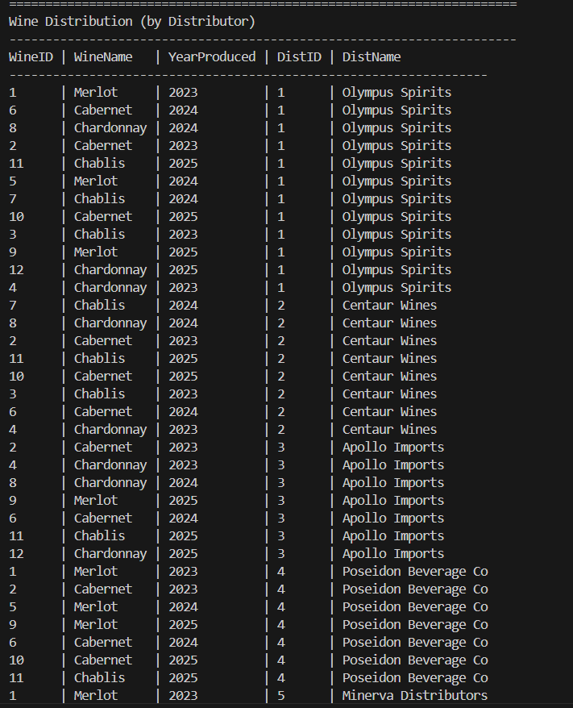
Report for each wine each distributor carries:

Report for total wines sold and wines that haven’t sold: 