Sara White – Blue Team
CSD460 – Module 10 Beta Tester Feedback
September 29, 2026

Beta Tester: Andy Cubrich
Andy followed the instructions below, and then provided notes as he went through each step.
1. Create an account for yourself on the site.
2. Add a boat to your account — pick any name and length you like*
* (Make sure the boat length is between 41 and 50 feet, or less than 26 feet so it will be able to be booked at a slip!)
3. Book a slip for that boat.
4. Navigate to the Home Screen.
5. Without any hints from me (or using the back button), find your reservation again and confirm the details are right.
6. Update one piece of your account information (anything — phone number, address, whatever you'd actually change) and confirm the change stuck.

Andy’s Notes:
1. Create an account for yourself on the site.
2. Add a boat to your account — pick any name and length you like*
- Sign in pop up has all the necessary things
- All the info is spaced out very well, everything is so easy to read, nothing exhausting
- Great colors, soothing, the art adds to that

3. Book a slip for that boat.
- Really like how the slip size is auto selected after choosing boat, yet the information is all there for you to read before you select the craft. Slick.
- Reservation summary staying put at the top right when scrolling down is great, I can watch my cost increase as I choose new features
- Confirmation# MB-00061 (I noted this because the website told me to do that)

4. Navigate to the Home Screen.
5. Without any hints from me (or using the back button), find your reservation again and confirm the details are right.
- Easy to find the My Reservations link but took a second longer than I’d like to admit because the “Plan Your Stay” menu option doesn’t seem account specific. It seems more like something a person would click to see advertised packages or something. Still, there’s so few options, you’re a click or two away from seeing “My Reservations”. I will say, the first place I clicked was “Welcome, Andy C.” because I suspected it would take me to an account dashboard that highlights my upcoming reservation, so I had to back out of the “Your Account” page to get to my reservations. Didn’t feel the most intuitive to me personally, but I can’t complain what-with being able to just click one home page option to the left and get to where I need to be.

6. Update one piece of your account information (anything — phone number, address, whatever you'd actually change) and confirm the change stuck.
- Can’t change area code on phone number in the “Your Account” page without first clicking in the single digit box to left of “Phone” – It doesn’t let you backspace over the area code in the “Phone” data field box, you have to click the “1” and tab over or whatever
- Save these changes box is nice, but a little confusing visually as I changed both my first name and phone number and it is just kinda confusing to see my name change info to the right of “First Name” but my phone number change information is on a new line below the “Phone” field indicator, seen here:
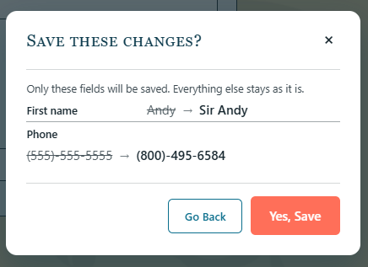
- Also - “Yes, Save” seems redundant and confused me too, SORRY! It’s a great site, I’m just saying what confused my potentially average user level or less mind
- Very cool to see my name change instantly implemented when going back to the home page. My phone number change stuck. Both changes stuck after logging out and logging back in. I really like how clicking Log Out immediately removed the “Welcome, Sir Andy C.” message. If you’re going to log out of a website, it’s comforting to see it reflected immediately.

Final Notes:
Overall – this website is actually excellent. Nothing too intense or jarring or disorienting. It keeps you quickly knowing where to go for whatever you need to do on the site. Easy on the eyes. Things like the layout and confirmation steps and I’m sure something I’m forgetting make everything feel easy to verify whether you’re inputting/updating account/boat data or you’re checking on already saved information.
Great work, Team!

