Project: Blue Team – Moffat Bay Marina | Team members: Robert Breutzmann, Miguel Fernandez, Carolina Rodriguez, Sara White
Course: CSD-460
Description: Test Plan for landing (index), registration and login pages
Date: 2026/09/05
To complete the test case plan, fill out the information for Project, Course, Description and Date in the header below.
.
TABLE OF CONTENTS
<DESCRIPTION> 2
<DESCRIPTION> 2
<DESCRIPTION> 3

For each test, the developer should: provide a test description, a test objective, the developer name and date tested. For each step, fill out the actions to be taken and describe the expected results, and indicate yes or no for each step depending upon the result. The peer tester should provide their name, date tested, indicate yes or no for each step depending upon the result, and a screenshot (thumbnail) of the result.

Test 1 | Landing Page
 | Test Objective: Verifies site header is visible at all times (sticky header) | Developer:  Date tested: <yyyy/mm/dd> | Peer tester:  Date tested: <yyyy/mm/dd>
Step | Action | Expected results: | Developer pass/fail | Tester pass/fail  + Screenshot
1 | In a browser, navigate to http://localhost:8080/marinawebsite/index.jsp | The Moffat Bay Marina landing page should load. | <yes/no> | <yes/no>
2 | Scroll halfway down the page. | The header should remain at the top of the page as you scroll. | <yes/no> | <yes/no>
3 | Scroll to the bottom of the page. | The header should remain at the top of the page as you scroll. | <yes/no> | <yes/no>
4 | Scroll back to the top of the page. | The header should remain at the top of the page as you scroll. | <yes/no> | <yes/no>
5 | <Enter an action> | <Enter the expected results> | <yes/no> | <yes/no>
Comments | Comments should be substantive; this means there should be at least 2-3 well-structured sentences with constructive feedback.

Test 2 | Landing Page
 | Test Objective: Verifies landing page content is responsive and stacks when browser minimized past <a certain point> | Developer:  Date tested: <yyyy/mm/dd> | Peer tester:  Date tested: <yyyy/mm/dd>
Step | Action | Expected results: | Developer pass/fail | Tester pass/fail
1 | In a browser, navigate to http://localhost:8080/marinawebsite/index.jsp | The Moffat Bay Marina landing page should load. | <yes/no> | <yes/no>
2 | Expand the browser to full size and make sure zoom is set to 100%. | The landing page should show the header with navigation links at the top of the page. The hero section shows an image of the marina behind branding text. Below the text in the hero section is a button to reserve a slip. The main content below the hero section will have three content cards displayed horizontally. The footer contains information distributed evenly in three columns. | <yes/no> | <yes/no>
3 | Resize the browser window to about 2/3 full size. | The contents of the page should display more compactly, but still be horizontal. | <yes/no> | <yes/no>
4 | Resize the browser to about 1/4 of full size. | As the browser gets smaller, the contents should start to stack vertically. The header should still remain at top and the navigation elements should become more compact. | <yes/no> | <yes/no>
5 | <Enter an action> | <Enter the expected results> | <yes/no> | <yes/no>
Comments | Comments should be substantive; this means there should be at least 2-3 well-structured sentences with constructive feedback.

Test 3 | Registration
 | Test Objective: Verifies password criteria is checked off as user creates password | Developer:  Date tested: <yyyy/mm/dd> | Peer tester:  Date tested: <yyyy/mm/dd>
Step | Action | Expected results: | Developer pass/fail | Tester pass/fail
1 | Open a browser and navigate to http://localhost:8080/marinawebsite/registration.jsp | The account registration page should load with three cards (personal information, boat information, and user information) containing input fields | <yes/no> | <yes/no>
2 | Under the user information section, enter “abc” into the password field. Do not delete “abc” after completing this step. | Below the password fields, a checkmark should appear to the left of the password criteria list item “One lower case letter” | <yes/no> | <yes/no>
3 | In the password field, type “123” next to “abc” | A checkmark should appear to the left of the password criteria list item “ | <yes/no> | <yes/no>
4 | In the password field, type “DEF” next to “abc123” | A checkmark should appear to the left of the password criteria list item “ | <yes/no> | <yes/no>
5 | In the password field, type an exclamation point (“!”) after “abc123DEF” | A checkmark should appear to the left of the password criteria list items “One special character (! $ % * #)” and “At least 10 characters” | <yes/no> | <yes/no>
Comments | Comments should be substantive; this means there should be at least 2-3 well-structured sentences with constructive feedback.

Test 4 | Registration
 | Test Objective: Verifies account creation on registration page successfully creates database records | Developer:  Date tested: <yyyy/mm/dd> | Peer tester:  Date tested: <yyyy/mm/dd>
Step | Action | Expected results: | Developer pass/fail | Tester pass/fail
1 | Open a browser and navigate to http://localhost:8080/marinawebsite/registration.jsp | The account registration page should load with three cards (personal information, boat information, and user information) containing input fields | <yes/no> | <yes/no>
2 | Select “United States” from the country drop down | Drop down should display “Canada”, “United States” and “Other” as three options. After selecting “United States”, that selection should remain in the country field | <yes/no> | <yes/no>
3 | For the personal information section, enter your first and last name and the following for the address fields:  Street Address: 123 ABC Drive  City: Bellevue  Zipcode: 55555 | Field information should remain | <yes/no> | <yes/no>
4 | Select Nebraska from the state dropdown menu | Dropdown menu should display 50 states. After selecting “Nebraska”, that selection should remain in the state field | <yes/no> | <yes/no>
5 | For the phone number field, enter 555 | A message should appear below the phone field that says “Phone number needs all 10 digits” | <yes/no> | <yes/no>
 | In the phone field, after 555, enter 555-5555 | “Phone number needs all 10 digits” message should disappear after entering remaining phone number digits
6 | For the boat information section, enter the following:  boat name: “Boatzilla”  boat length: 30  HIN: ABC1234DE67
 | Select Nebraska from the registration state dropdown menu and enter “1234 AB” for the registration number | Dropdown menu should display all 50 states. After making state selection (Nebraska), the state name should remain in the registration state field
9 | In the user information section use the following:  Email: emailuser@email.email  Password: abc123DEF456! | After entering information, the “create account” button should appear bolder and now be clickable
10 | Click the “create account” button
11 | Confirm creation of a customer record with the following MySQL statements:  USE MoffatBayMarinaDB;  SELECT * FROM Customer WHERE email = “emailuser@email.email”;
12 | Confirm creation of a boat record with the following MySQL statements:  USE MoffatBayMarinaDB;  SELECT * FROM Boat WHERE boatName = "Boatzilla";
Comments | Comments should be substantive; this means there should be at least 2-3 well-structured sentences with constructive feedback.

Test 5 | Login
 | Test Objective:  Verifies that the site shows the signed-in state in the shared header on every page, that landing page controls change once a customer is signed in, and that logging out ends the session. | Developer:  Miguel Fernandez  Date tested:  2026/09/06 | Peer tester:  Date tested:
Step | Action | Expected results: | Developer pass/fail | Tester pass/fail  + Screenshot
1 | In a browser, navigate to http://localhost:8081/marinawebsite/ | The Moffat Bay Marina landing page should load. The button at the far right of the header should read "Log In" and there should be no welcome text next to it. | yes
2 | Click the "Log In" button in the header. | A sign in popup should open over the page with an "Email address" field, a "Password" field, a "Sign in" button, and a "Register here" link. The page behind it should dim. | yes
3 | Enter elena.marsh@example.com in the email field and the matching seeded password in the password field, then click "Sign in". | The popup should close and the browser should return to the landing page. The header should now read "Welcome, Elena M." with a "Log Out" button in place of "Log In". | yes
4 | Scroll down to the "Ready to Reserve Your Slip?" section near the bottom of the landing page. | The section should read "Check availability and book your spot today" with a "Book a Slip" button. It should no longer offer to create an account, because the visitor already has one. | yes
5 | Click "About Us" in the header navigation. | The About Us page should load and its header should also show "Welcome, Elena M." and "Log Out". The signed-in state is shown by the shared header, so it appears on every page without each page checking the session itself. | yes
6 | Click the "Log Out" button in the header. | The browser should land on the landing page at http://localhost:8081/marinawebsite/ and the header should read "Log In" again. Logout deliberately returns to the landing page rather than the previous page, since that page may itself require a signed-in session. | yes
7 | Press the browser's Back button. | The previous page may briefly appear with the signed-in header still showing. This is the browser's cached copy of the page, not a live session. | yes
8 | Press F5 to reload that same page. | The header should now read "Log In", confirming the session was actually invalidated on the server and the previous view was only a cached page. | yes
Comments | All eight steps passed. The signed-in state is handled entirely by the shared header include, so it appeared correctly on the landing page and the About Us page without either page containing its own session check. The display name arrives from the session already formatted as first name plus last initial, so no page has to build it.  Step 7 is worth flagging for the team rather than counted as a failure. Pressing Back after logout shows a cached copy of the signed-in page. The session really is gone, as step 8 proves, but on a shared computer the next person could still glimpse the previous user's page from history. Adding no-cache response headers to pages that require a login would close that gap, and it is worth considering before the site is handed over.  The landing page hero button also changes behaviour once signed in. It links straight to the reservations page instead of opening the sign in popup, which removes the loop where a signed-in customer was still being asked to log in.

Test 6 | Login
 | Test Objective:  Verifies that a failed sign in shows the same generic message whether or not the email belongs to a real account, and that three consecutive failures lock the account until it is unlocked. | Developer:  Miguel Fernandez  Date tested:  2026/09/06 | Peer tester:  Date tested:
Step | Action | Expected results: | Developer pass/fail | Tester pass/fail  + Screenshot
1 | Reset the test account so the failure count starts at zero, using this MySQL statement:  USE MoffatBayMarinaDB;  UPDATE Customer SET failedLoginAttempts = 0, accountLocked = 0 WHERE email = 'elena.marsh@example.com'; | The statement should report one row affected. The account is now unlocked with no recorded failures. | yes
2 | Navigate to http://localhost:8081/marinawebsite/ and click "Log In". | The sign in popup should open with empty email and password fields. | yes
3 | Enter elena.marsh@example.com with a deliberately incorrect password and click "Sign in". | The popup should reopen showing two messages: "The username or password you entered is incorrect." in red, and "Accounts are locked after 3 unsuccessful attempts." in amber below it. The email address should still be filled in and the password field should be empty. | yes
4 | Clear the email field, enter nobody@example.com, which has no account in the database, with any password, and click "Sign in". | The result should be identical to the previous step in every respect: the same two messages, the same wording and styling, and no additional or missing elements. Nothing in the response should reveal that this email has no account. | yes
5 | Enter elena.marsh@example.com with an incorrect password again. This is the second consecutive failure for that account. | The same two messages should appear again, unchanged. The message does not count down, so it looks the same on every failed attempt. | yes
6 | Enter elena.marsh@example.com with an incorrect password a third time. | The popup should now show "This account has been locked after multiple failed login attempts." The email and password fields and the "Sign in" button should be replaced by an "Unlock Account" button. The lockout rule message should no longer appear, since the account is already locked. | yes
7 | Confirm the lock was recorded, using this MySQL statement:  SELECT email, failedLoginAttempts, accountLocked FROM Customer WHERE email = 'elena.marsh@example.com'; | The query should return one row with failedLoginAttempts of 3 and accountLocked of 1. | yes
8 | Click the "Unlock Account" button. | The browser should return to whichever page the popup was opened from, not the site root, and the popup should close. The unlock clears both the lock and the failure count. | yes
9 | Click "Log In" again and sign in with elena.marsh@example.com and the correct password. | The sign in should succeed and the header should show "Welcome, Elena M." with a "Log Out" button, proving the unlock cleared the lock. | yes
10 | Confirm the counter was reset, using this MySQL statement:  SELECT email, failedLoginAttempts, accountLocked FROM Customer WHERE email = 'elena.marsh@example.com'; | The query should return failedLoginAttempts of 0 and accountLocked of 0. A successful sign in always clears the running count, so scattered typos over time never add up to a lockout. | yes
Comments | All ten steps passed. Step 4 is the important one. The failure message for an email that has no account is identical to the message for a real account with a wrong password, so the popup cannot be used to work out which email addresses are registered.  This behaviour is the result of a change made during this module. The message originally counted down the remaining attempts, showing "2 more failed attempts will lock this account." That was replaced because a countdown can only ever appear for an address that exists, so watching for it confirmed valid accounts and undid the purpose of the single generic error message. The fixed message gives a real user the same useful warning while telling an attacker nothing.  Attempts against an email with no account are deliberately not recorded anywhere, since there is no account row to attach a count to. That is worth knowing when repeating this test, because step 4 does not affect the running failure count used by steps 3, 5 and 6.

Login Test Screenshots (Tests 5 and 6)
Screenshots are grouped here rather than as thumbnails inside the test tables so each one is large enough to read. Every image is labelled with the test and step it belongs to. Tested by Miguel Fernandez on 2026/09/06.
Test 5, Step 1 - Landing page while signed out. The header shows Log In.
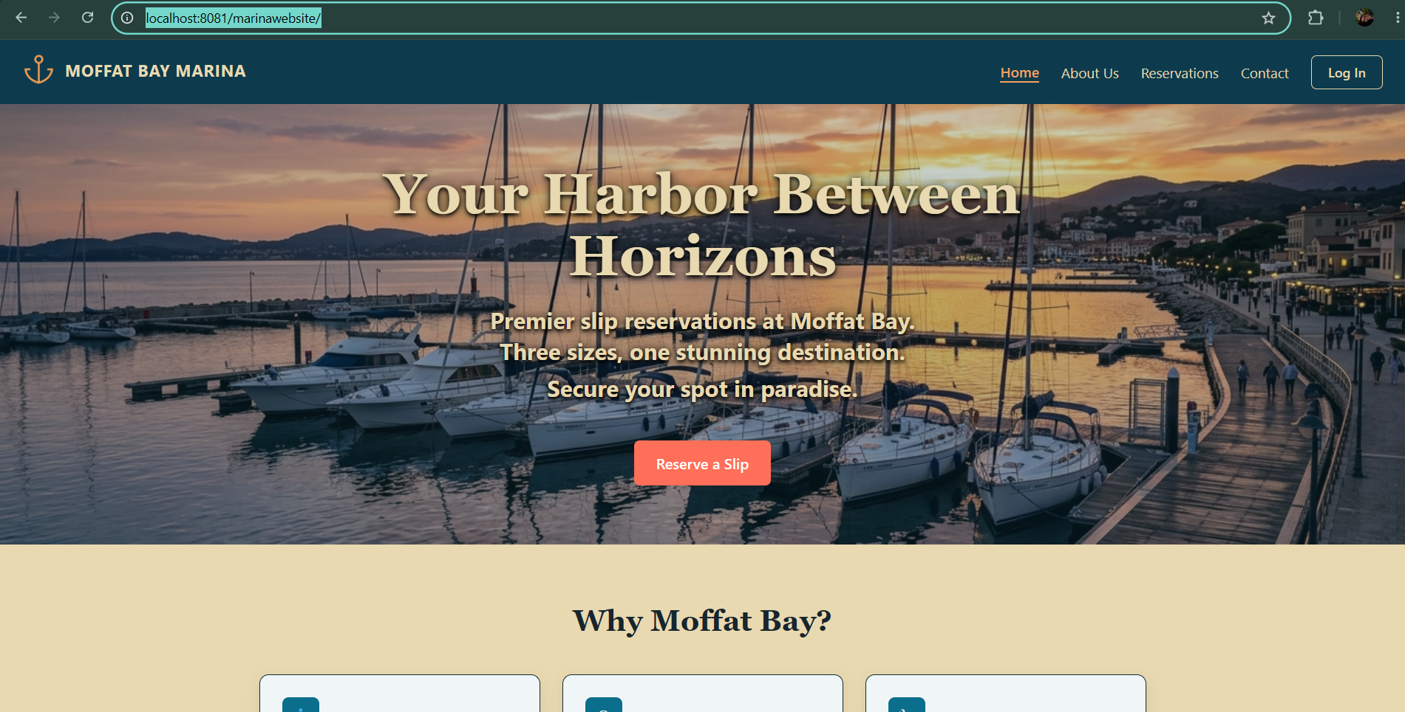
Test 5, Step 3 - After signing in. The header now shows Welcome, Elena M. and Log Out.
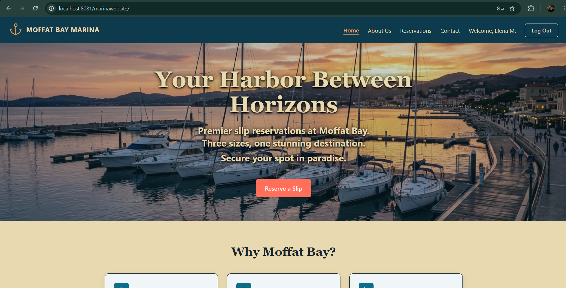
Test 5, Step 4 - The reservation section now reads Book a Slip instead of Create an Account.
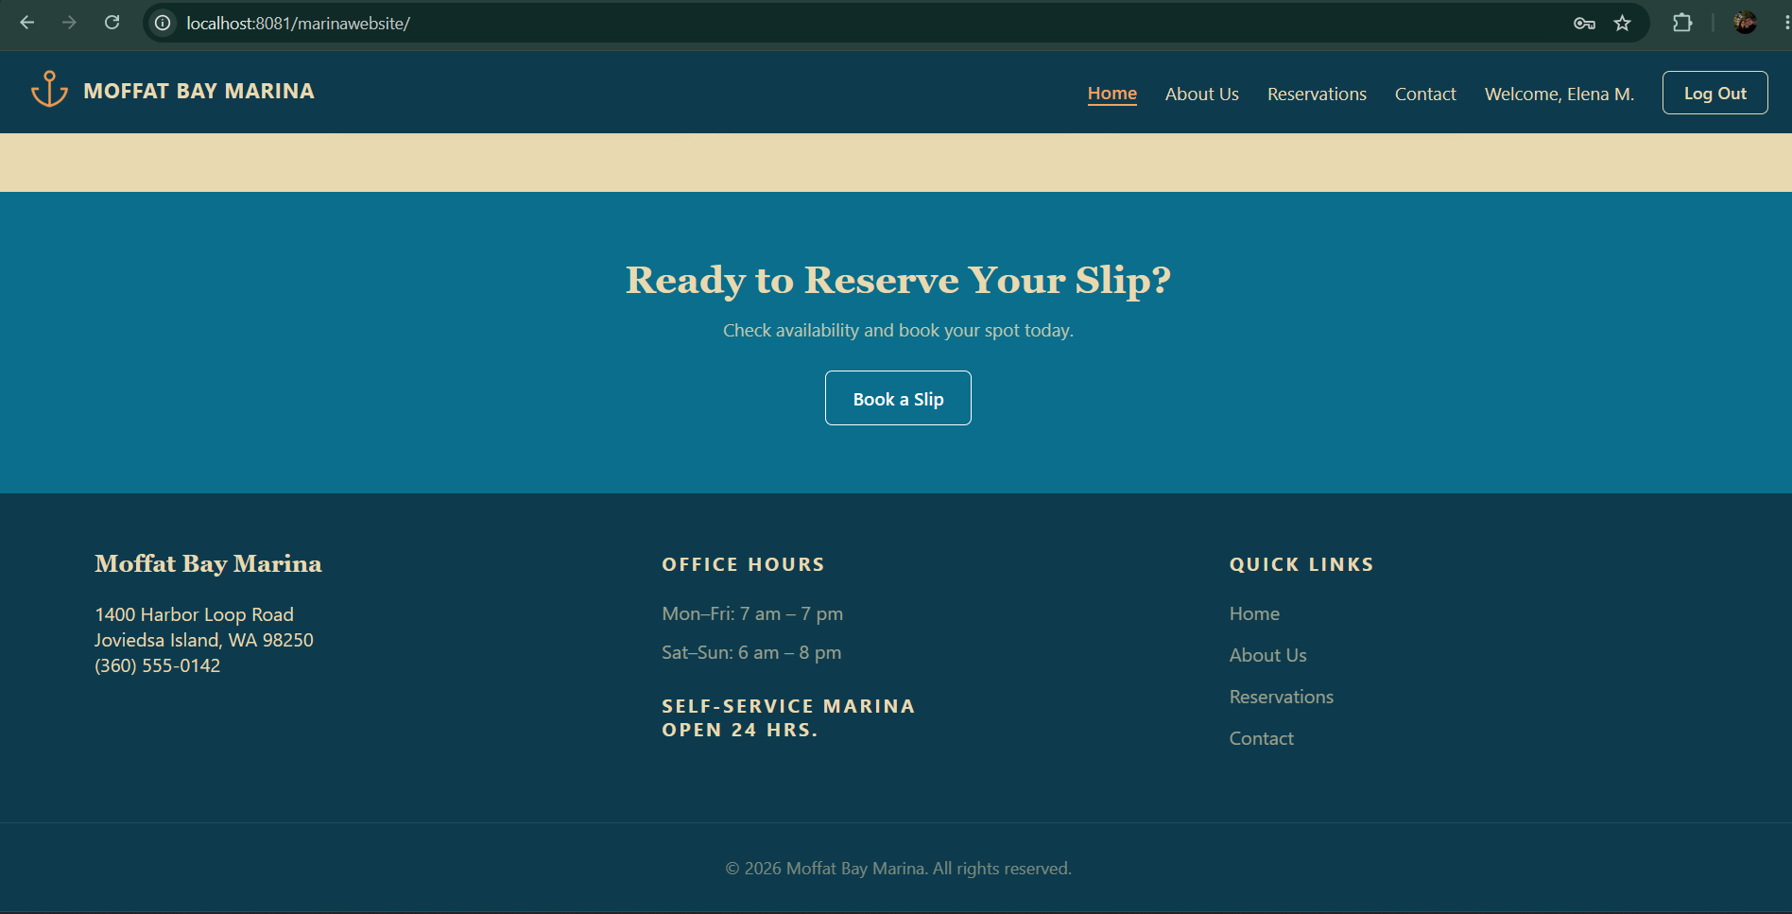
Test 5, Step 5 - The About Us page shows the same signed-in header, without any page-specific code.
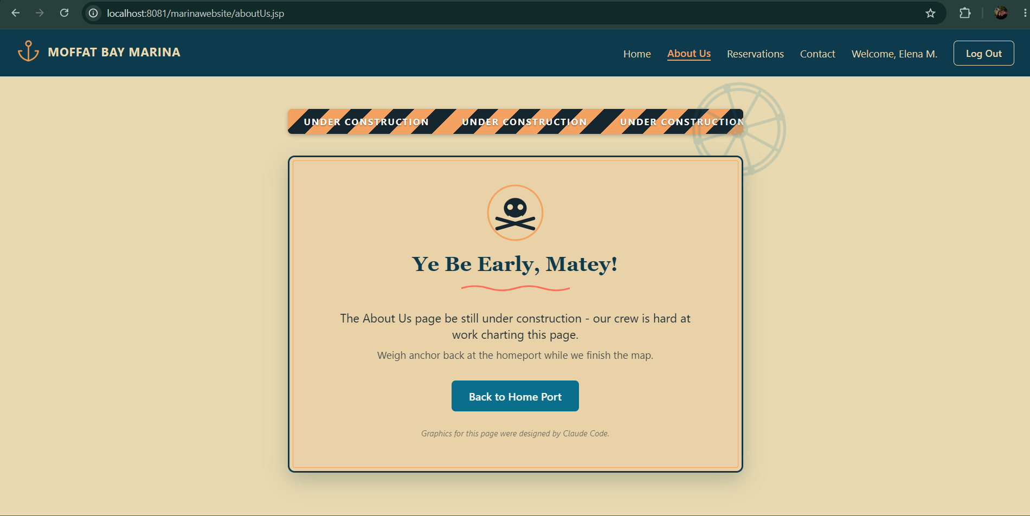
Test 5, Step 6 - After logging out. Back on the landing page with the header showing Log In.
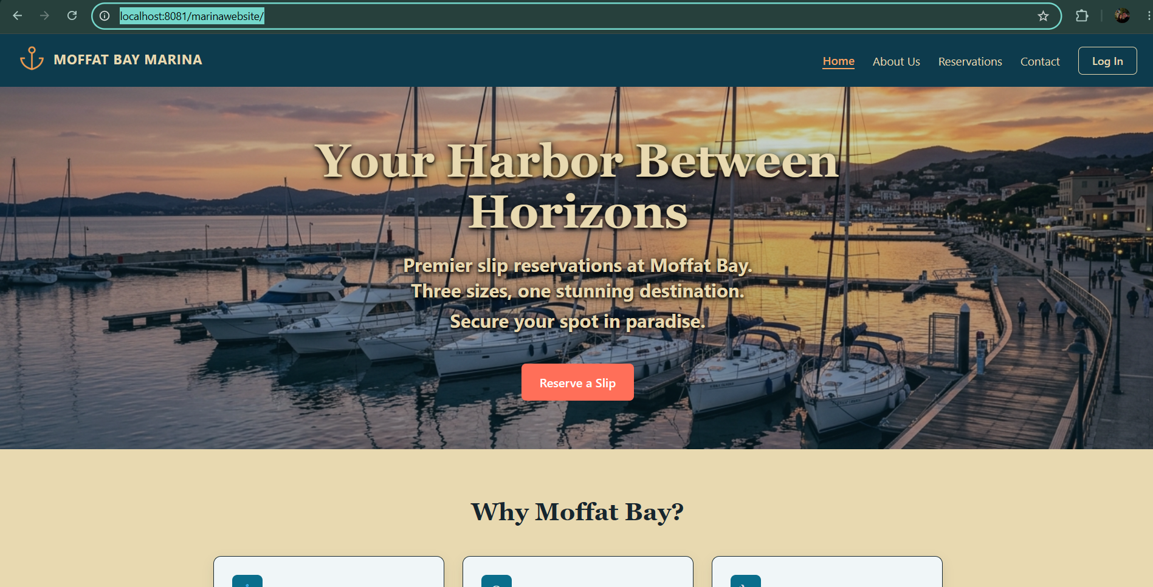
Test 5, Step 7 - The browser Back button shows a cached copy of the signed-in page.
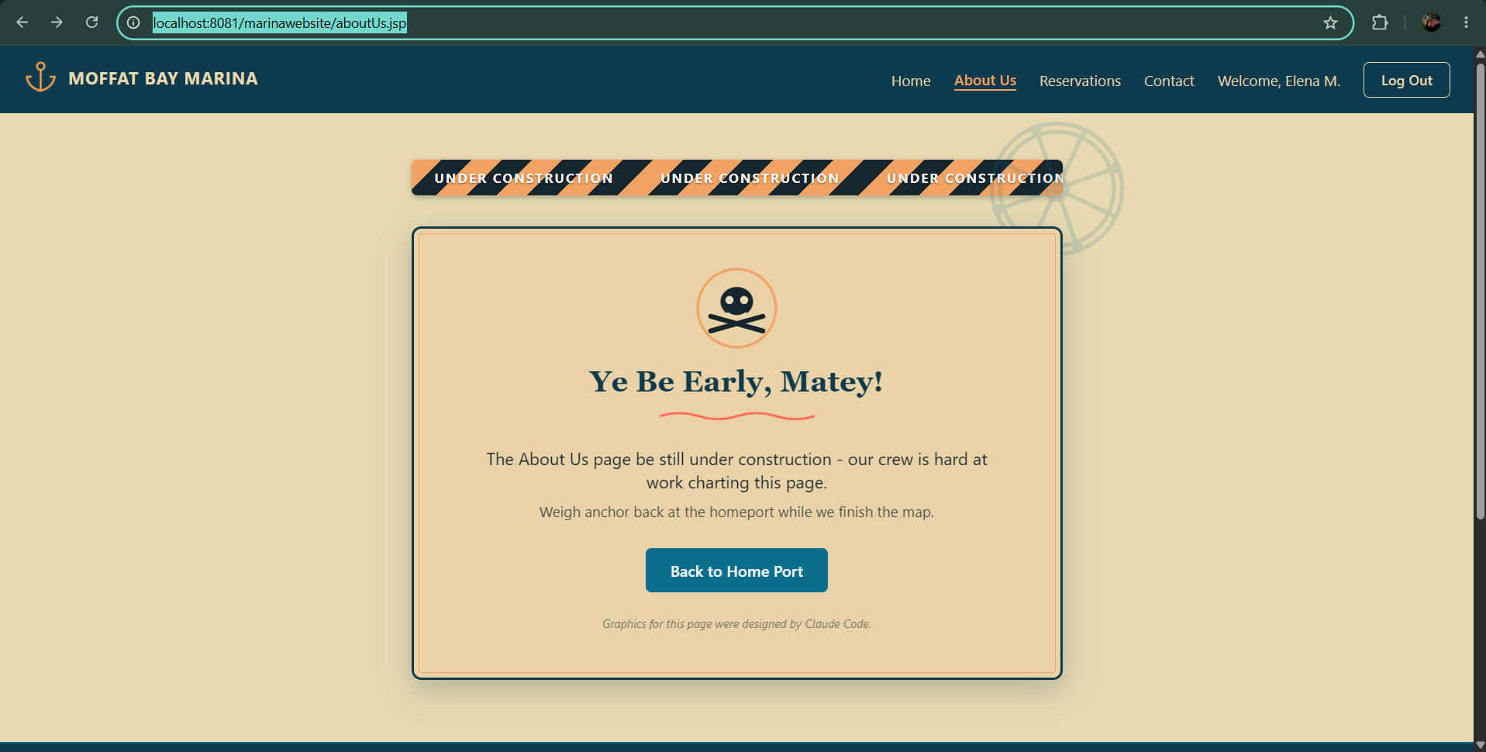
Test 5, Step 8 - After pressing F5 the same page shows Log In, confirming the session ended.
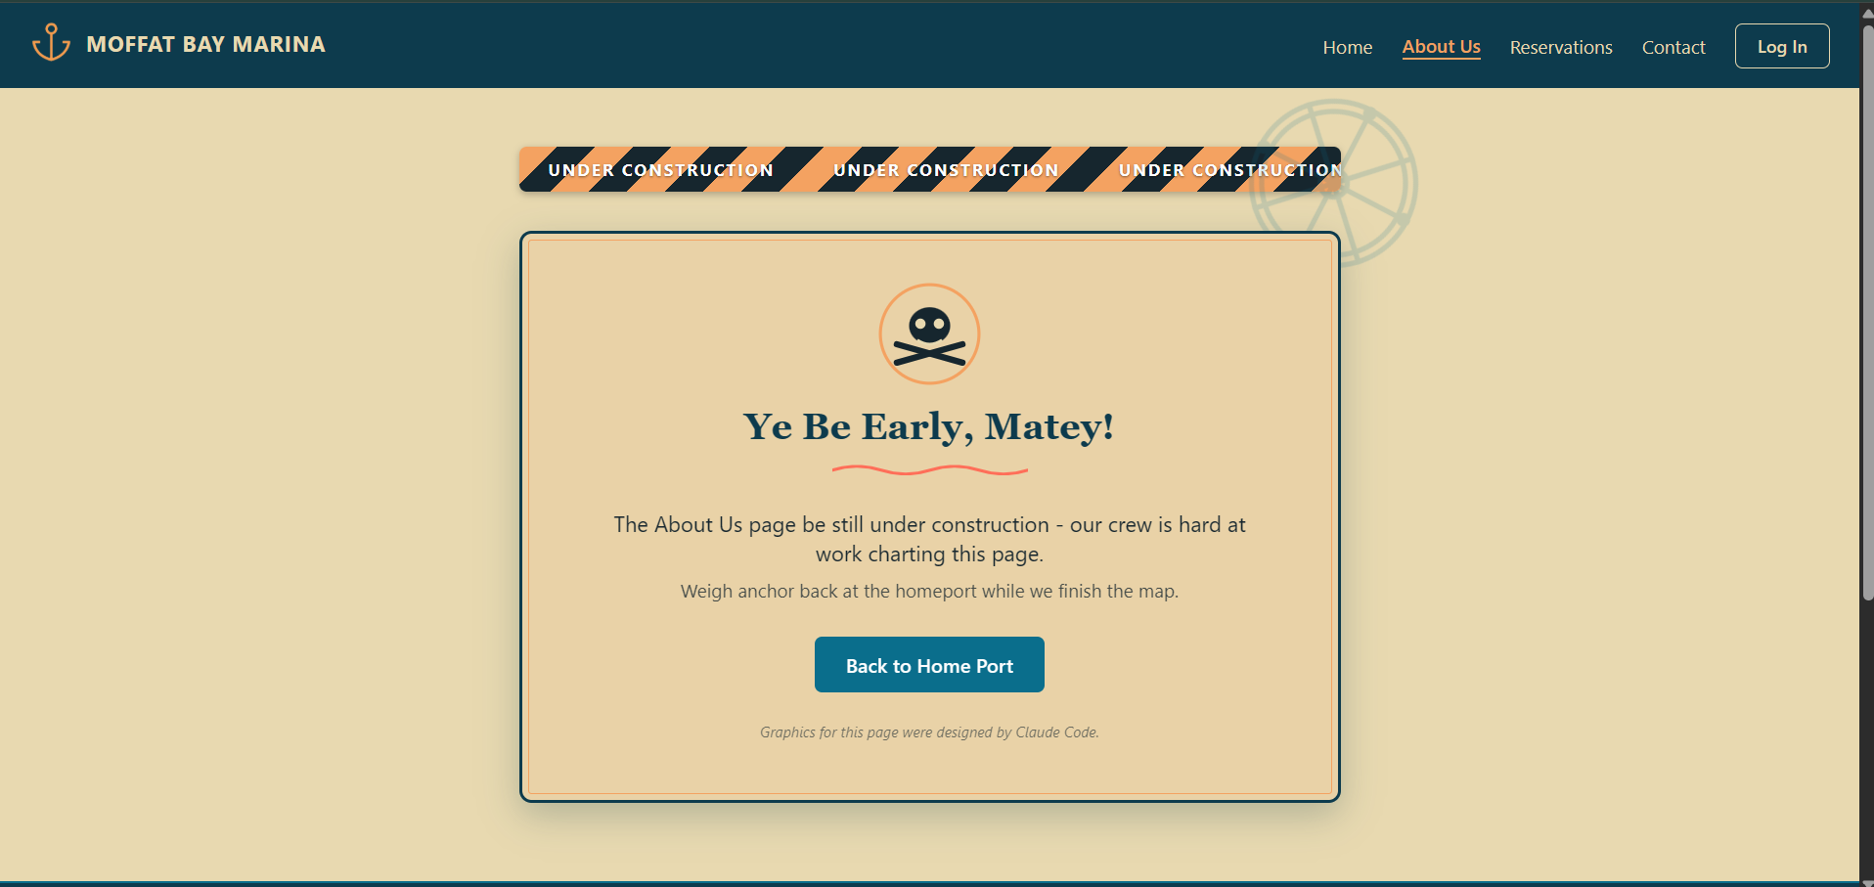
Test 6, Step 3 - Failed sign in for a registered account.
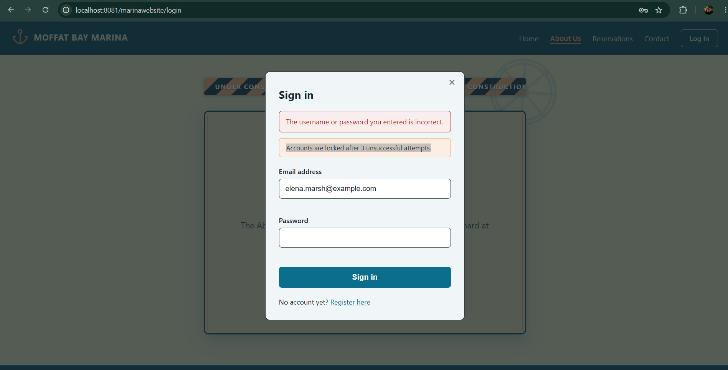
Test 6, Step 4 - Failed sign in for an email with no account. Compare with the image above: the two are identical.
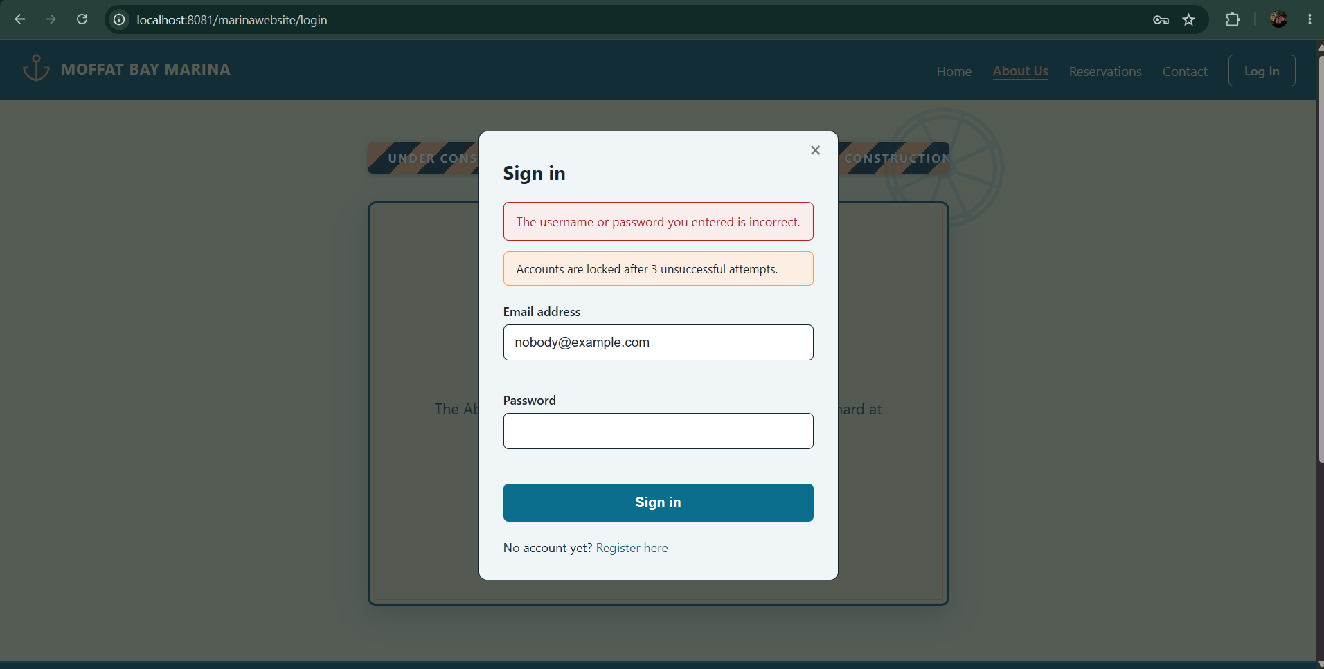
Test 6, Step 5 - Second consecutive failure. The message does not change.
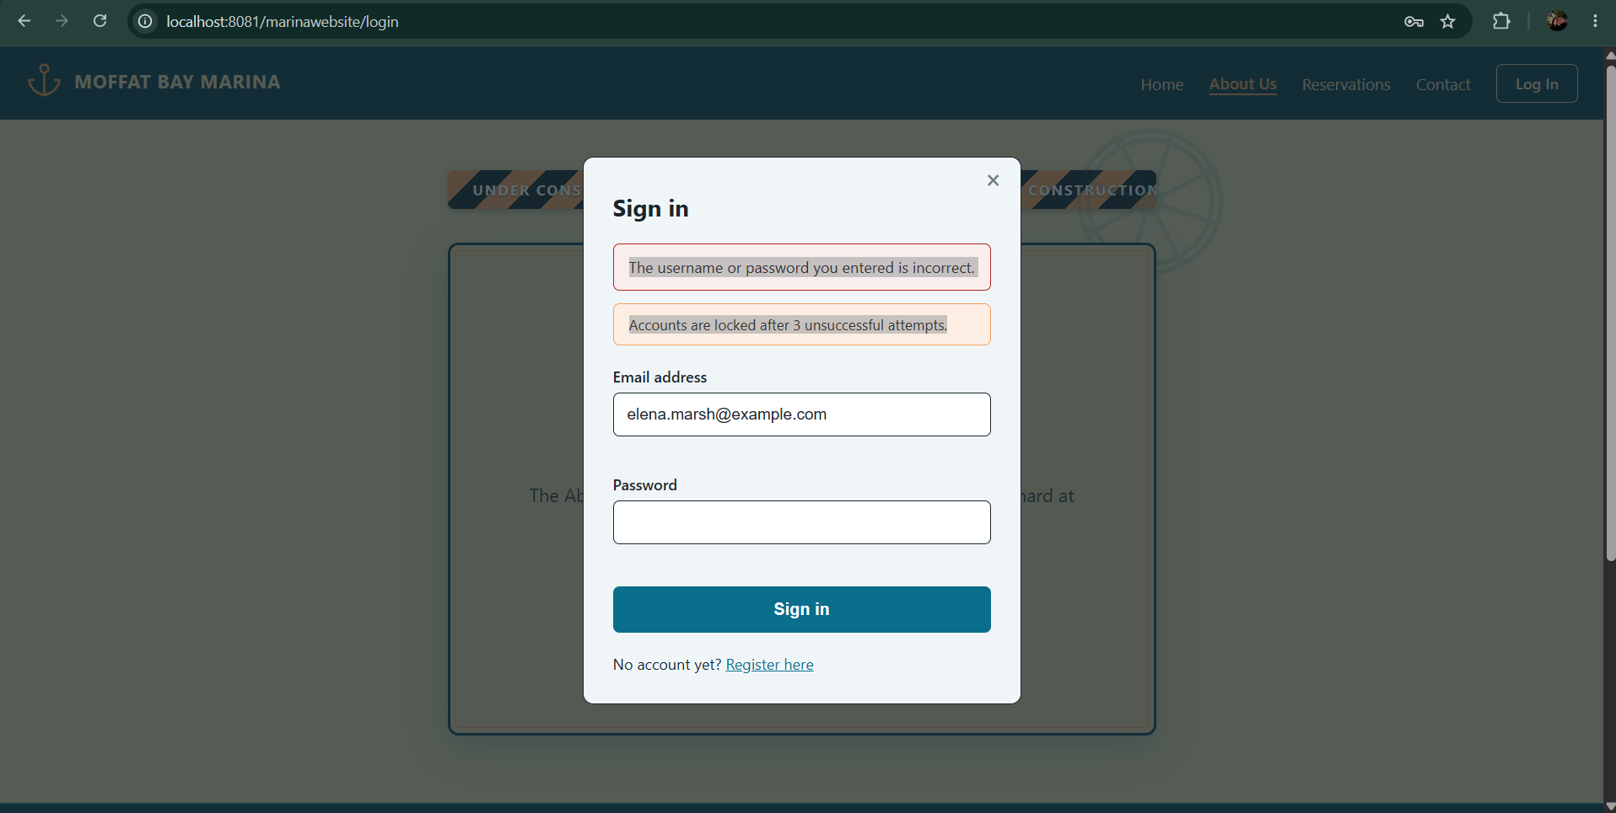
Test 6, Step 6 - Third failure. The account is locked and the form is replaced by Unlock Account.
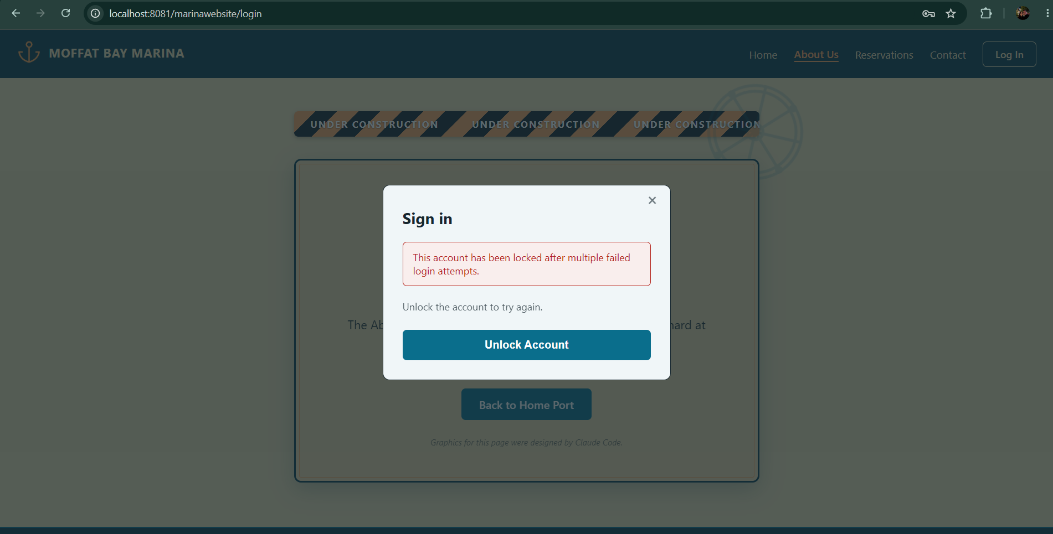
Test 6, Step 8 - After unlocking, the browser returns to the page the popup was opened from.
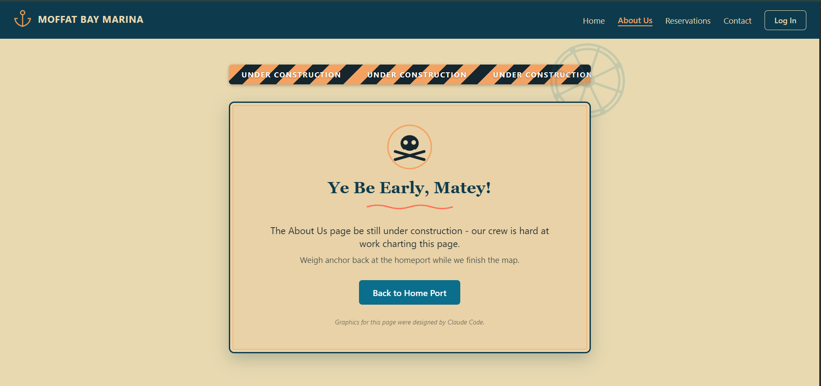
Test 6, Step 9 - Signing in after the unlock succeeds.
