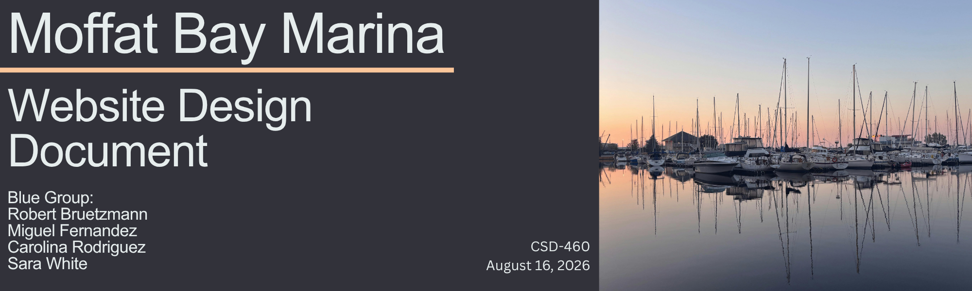
Introduction
This document will provide technical implementation details for a website that is to be created for Moffat Bay Marina. Within this document you will find a Terminology section for all stakeholders to reference.

Purpose
Moffat Bay Marina currently offers long-term slip reservations that can be booked in person, over the phone and via email. Their office manager tracks reservations with a spreadsheet that they manually update. Moffat Bay Marina does not currently have a website, so customers must call or email to request information regarding the size of slips and reservation dates available. This process requires careful coordination and manual data entry, which can be time-consuming.
Moffat Bay Marina would like a website that can provide details about the marina and slip availability to any visitors. They would like their website to manage reservations and user accounts for their customers. It is important to note that, while a customer account needs to be created to utilize the online booking system, the website itself should be viewable to any visitors regardless of customer account creation. Additionally, the reservation system will not process payments for customers and will not require payment to confirm a reservation.

Terminology
Marina/Business terms
Slip - a designated area in a marina where a boat can "park" (Discover Boating, n.d.)
Harbormaster - a person who oversees harbor or marina traffic and manages anchorages (Discover Boating, n.d.)
VHF - stands for "Very High Frequency" and is a bandwidth designation typically used by marine radios (Discover Boating, n.d.)
Long-Term Reservation - reservations that last for a season (several months) to an entire year, as opposed to short-term reservations, which are measured in days, weeks or months

Technical/System terms
Authentication - "in web security, it is the process of verifying the claimed identity of some entity, such as a user. This then makes it possible to decide whether to grant the user the access that they are requesting, such as being signed into a particular account." (MDN contributors, 2025a)
User - in most cases, this will refer to the customer, but can refer to any person who is using a system (in this case, the website)
User account – in most cases this will be refer to a customer account, but Moffat Bay Marina staff will have user accounts, as well, with varying permissions.
CustomerID - a unique identifier for each customer to be stored in the Moffat Bay Marina database
ReservationID - a unique identifier for each reservation made to be stored in the Moffat Bay Marina database
Session - a window of time in which a user accesses a website
Landing Page - the main page of a website through which a user can access other sections of the website. The landing page will typically contain basic information about the business and navigation elements, like a menu
Form / Form Field - in HTML, a form contains elements, like fields, that can receive user input (ex. Email field) or user interactions (ex. Clicking the "submit" button after filling out an email field) (MDN contributors, 2025c)
Database - a system that collects and stores organized data. Databases make searching and structuring information easier and more efficient. (Erickson, 2024)
Open Source - publicly available code/designs
RDBMS - stands for Relational Database Management System (Erickson, 2024)
MySQL - an open-source RDBMS that is commonly used to manage databases for companies (Erickson, 2024)
Regular Expression (Regex) - a pattern-matching mechanism that can be used to check whether text conforms to a specific format. For example, a phone number is 10 digits and is typically formatted XXX-XXX-XXXX
ERD - stands for "Entity-Relationship Diagram"; this is a visual flowchart typically used in database design that illustrates how entities (ex. Customers, slip reservations) are related within a system
HTML - stands for "HyperText Markup Language"; this is the standard language that is used to create website content (MDN contributors, 2025c)
CSS - stands for "Cascading Style Sheets"; used for the visual organization of HTML (MDN contributors, 2025c)
JSP - stands for "JavaServer Pages"; a technology that is used to create web pages that can display changing information (dynamic) from a Java-based web application. For example, if a customer visits the Moffat Bay Marina website and logs into their account, the banner on the webpage might display their name in the upper right corner to indicate they are logged in. (MDN contributors, 2025b)
PII - stands for "Personally Identifiable Information"; this can be any data that can be used to identify a specific person. For example, a person's social security number would be considered PII.

User Personas
User 1: Angela  Gender: Female  Age: 42  Occupation: Elementary Teacher  Education: College/Undergraduate  Marital Status: Married  Location: Local, lives in town year-round |  |  |  | Figure 1    Note. AI-generated image created with Google Gemini (Google, 2026).
Background
Angela and her family have had a 40 ft boat for six years now, and they are looking to reserve a slip in the Moffat Bay area. She's got a full-time job and two kids with their own schedules, so she doesn't have time to sit on the phone dealing with reservations. She just wants something quick that works.
Angela’s Needs
- An option to see what slips are open without calling the business
- Some kind of confirmation she can send to her husband once it's booked
- An account that remembers her info so she's not typing the same stuff in every season
Angela’s User Stories
- As a busy teacher, I want to check slip availability online so I can plan my season without calling the office.
- As a busy parent, I want my account and boat info saved after I register so I don't have to re-enter them every time.
- As a slip holder, I want confirmation that I can save or forward the reservation details to share with my family.
 | User 2: Walt  Gender: Male  Age: 68  Occupation: Retired Electrician  Education: High School  Marital Status: Widowed  Location: Winter Visitor |  | Figure 2    Note. AI-generated image created with ChatGPT (OpenAI, 2026).
Background
Walt is a 68-year-old retired electrician and widower who wants to spend his winter vacation at Moffat Bay. From November through February he plans to stay at Moffat Bay Lodge for three to four months and keep his boat at Moffat Bay Marina so he can spend his days fishing. Since losing his wife, Walt values reliability, simplicity, and a sense of community.
Walt’s Needs
- A reserved slip for his entire 3-4 month winter stay
- Easy, clear booking so he can coordinate his stay at the lodge with his marina reservation
- Peace of mind that his boat is secure between fishing trips
Walt’s User Stories
- As a winter dock guest, I want to reserve a dock slip for a full 3–4-month block in one transaction, so I don’t have to re-book or risk losing my spot month to month.
- As a guest who is older, I would prefer to select a dock slip that is closer to the shore, so I don’t have to haul my equipment as far when I take it to and from the lodge.
- As a long-term slip holder, I would like clear, upfront pricing for a multi-month stay, including any seasonal or long-term discounts, so that I can budget for the winter without surprise fees.
User 3: Jesse  Gender: Male  Age: 47  Occupation: Harbormaster  Education: Community College/Vocational School  Marital Status: Married  Location: Local, lives in town year-round |  | Figure 3  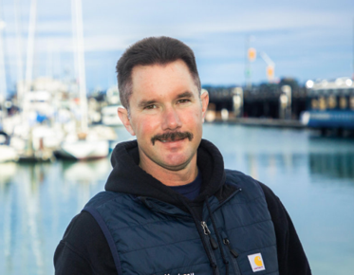  Note. From Harbor and Marina Staff Directory, by City of Monterey (n.d.).
Background
This is Jesse, he is a staff member at the Moffat Bay Marina. Jesse’s goal is to keep long-term slip reservations organized and make sure customers are assigned to slips that fit their boats.
Jesse’s Needs
- Accurate reservations
- Slip availability
- Efficient access to registered customer information
- An easy way to confirm reservations.
Jesse’s User Stories
- As a marina staff member, I want to view current slip availability so that I can know which long-term slips are still available.
- As a marina staff member, I want customers to be matched with the right slip size based on the length of their boat.
- As a marina staff member, I want to see confirmed reservations so that I can track available slips and avoid double bookings.

User Story Prioritization

High Priority
- As a busy teacher, I want to check slip availability online so I can plan my season without calling the office.
- As a winter dock guest, I want to reserve a dock slip for a full 3–4-month block in one transaction, so I don’t have to re-book or risk losing my spot month to month.
- As a marina staff member, I want customers to be matched with the right slip size based on the length of their boat.
Medium Priority
- As a marina staff member, I want to view current slip availability so that I can know which long-term slips are still available.
- As a marina staff member, I want to see confirmed reservations so that I can track available slips and avoid double bookings.
- As a long-term slip holder, I would like clear, upfront pricing for a multi-month stay, including any seasonal or long-term discounts, so that I can budget for the winter without surprise fees.
- As a guest who is older, I would prefer to select a dock slip that is closer to the shore, so I don’t have to haul my equipment as far when I take it to and from the lodge.
Low Priority
- As a busy parent, I want my account and boat info saved after I register so I don't have to re-enter them every time.
- As a slip holder, I want confirmation that I can save or forward the reservation details to share with my family.

Development Estimates

The following development estimates break down the three highest priority user stories into individual tasks. Estimated hours are approximate and were developed using the original work estimations as a baseline. Some tasks support multiple user stories, and shared development work is accounted for in the broader project task list.

Story 1: As a busy teacher, I want to check slip availability online so I can plan my season without calling the office.
Development Steps | Hours
Create database queries to retrieve available slips | 2
Implement backend logic to check availability | 2
Display available slips on the reservation page | 2
Test availability results | 1
Total hours: 7

Story 2: As a winter dock guest, I want to reserve a dock slip for a full 3–4-month block in one transaction, so I don’t have to re-book or risk losing my spot month to month.
Development Steps | Hours
Create reservation form | 2
Implement reservation processing and database storage | 3
Display reservation confirmation | 2
Test reservation functionality | 1
Total hours: 8
Story 3: As a marina staff member, I want customers to be matched with the right slip size based on the length of their boat.
Development Steps | Hours
Define boat-length and slip-size requirements | 1
Implement matching logic | 2
Integrate matching into the reservation process | 1
Test matching and invalid boat lengths | 1
Total hours: 5

Prototypes

Landing Page:
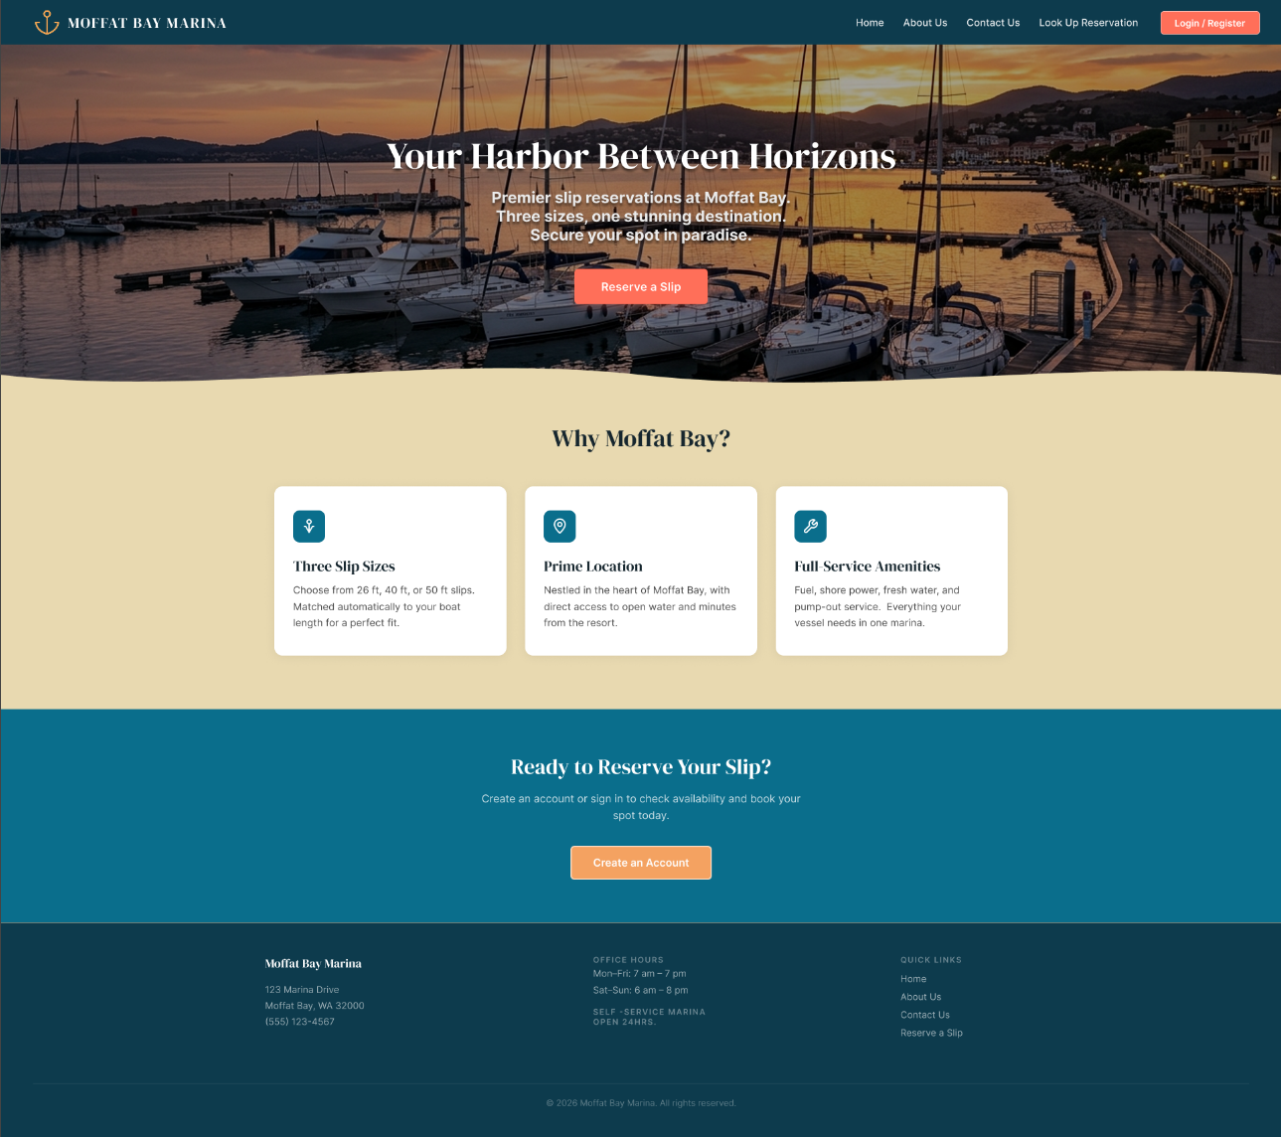

Registration:

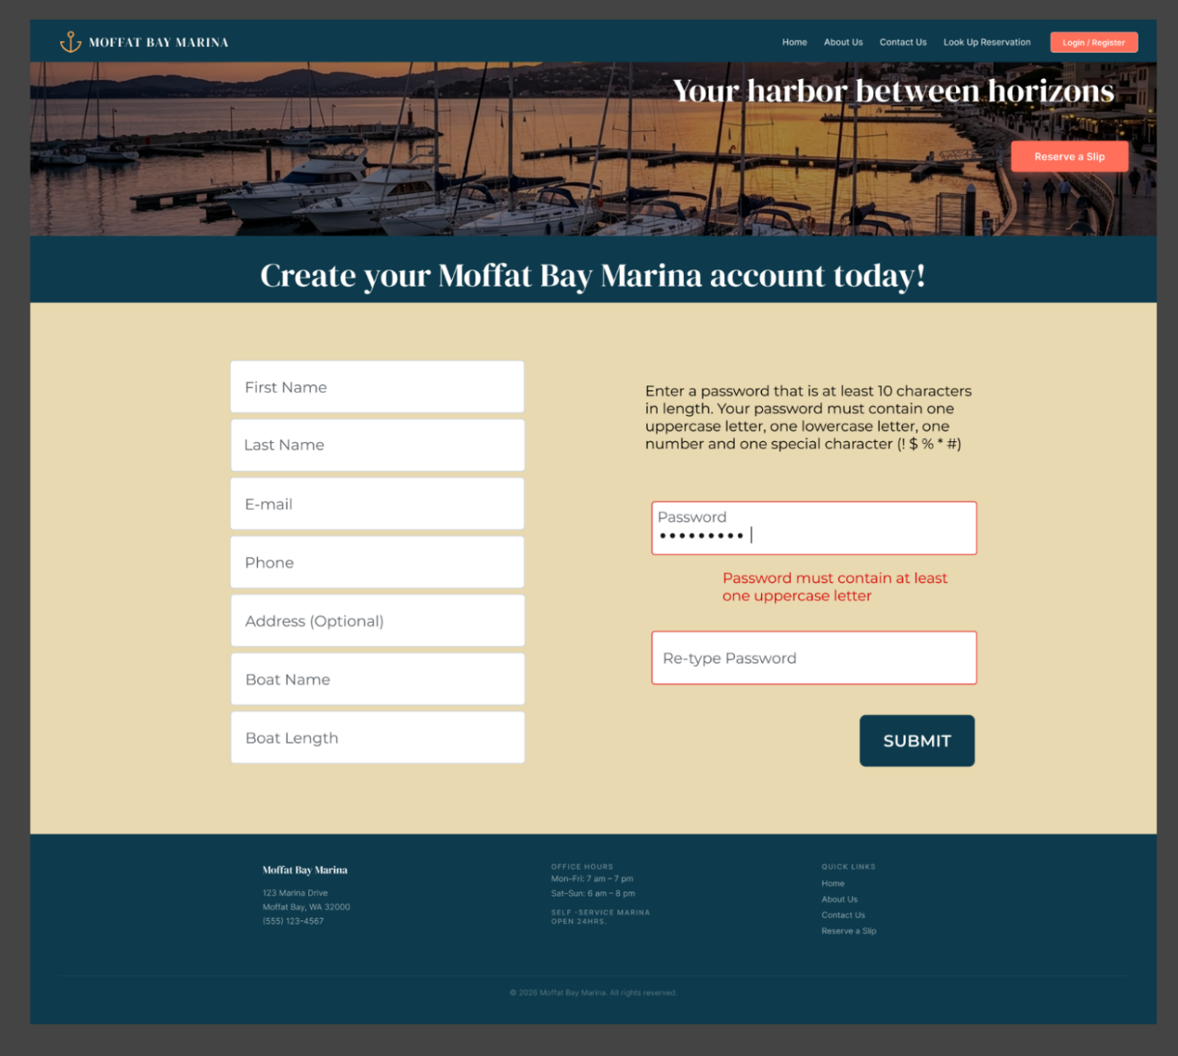

Waitlist:
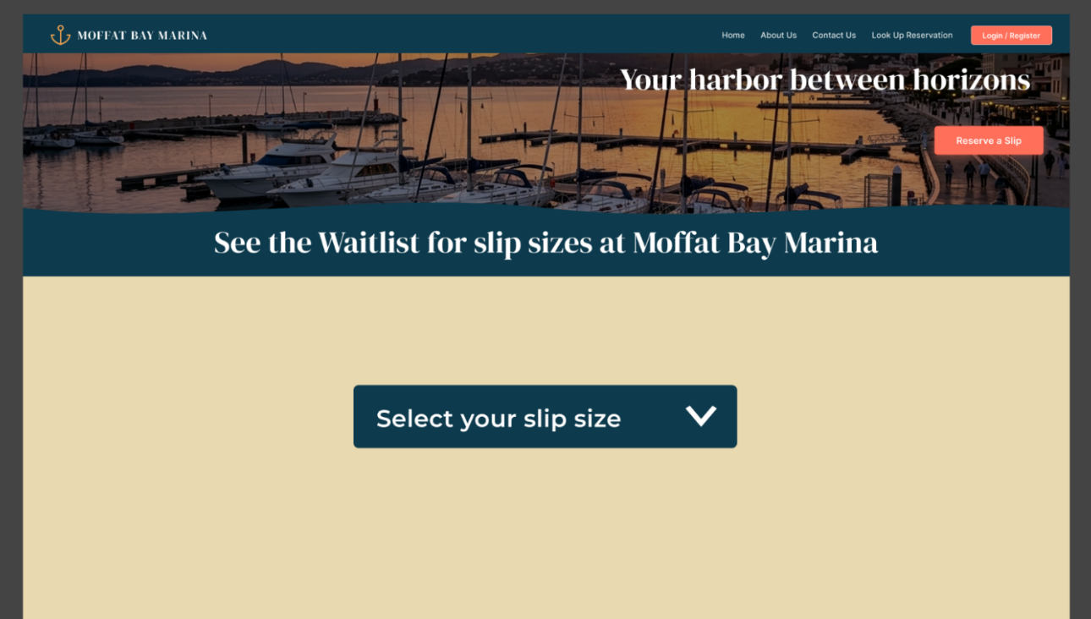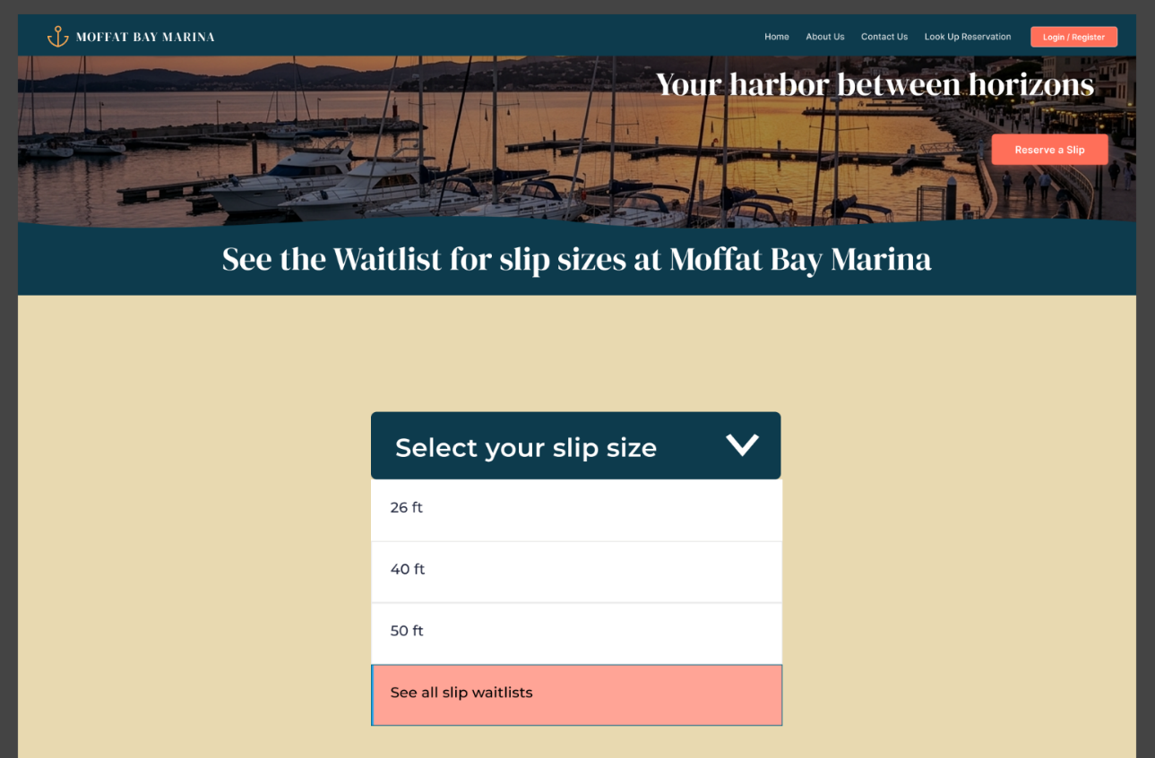

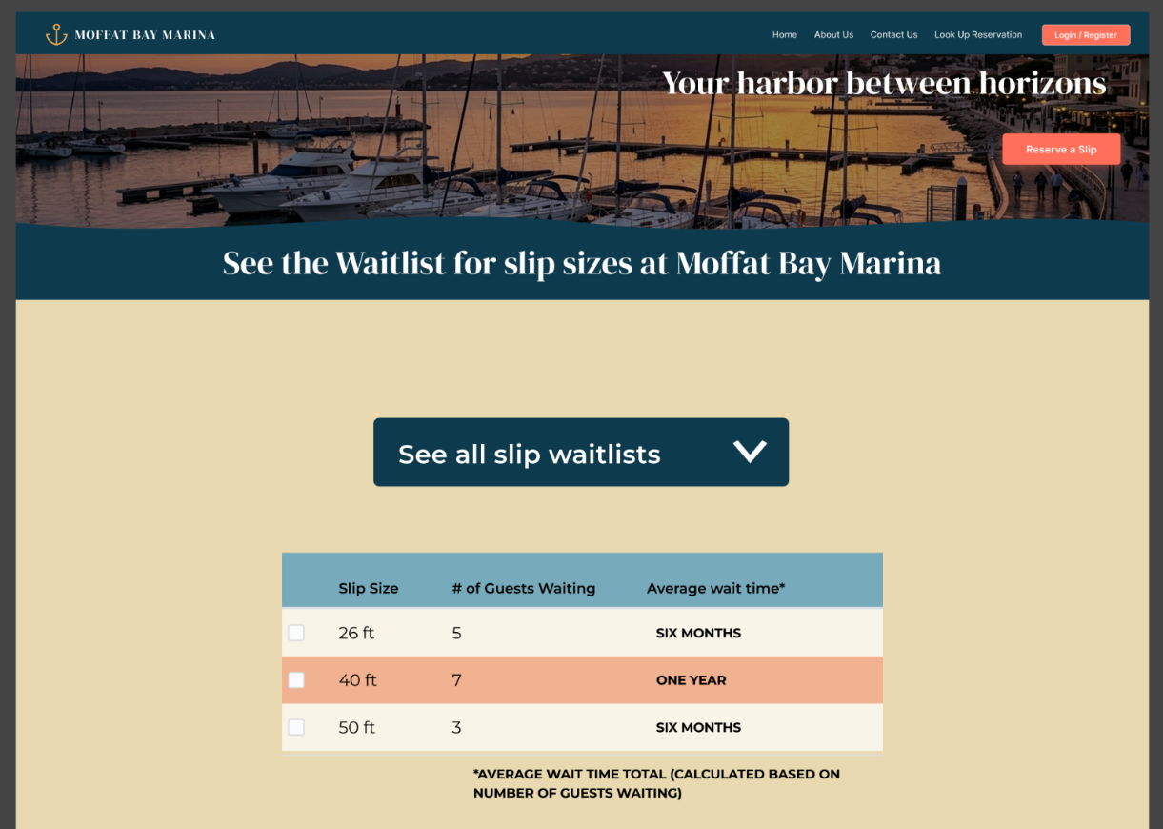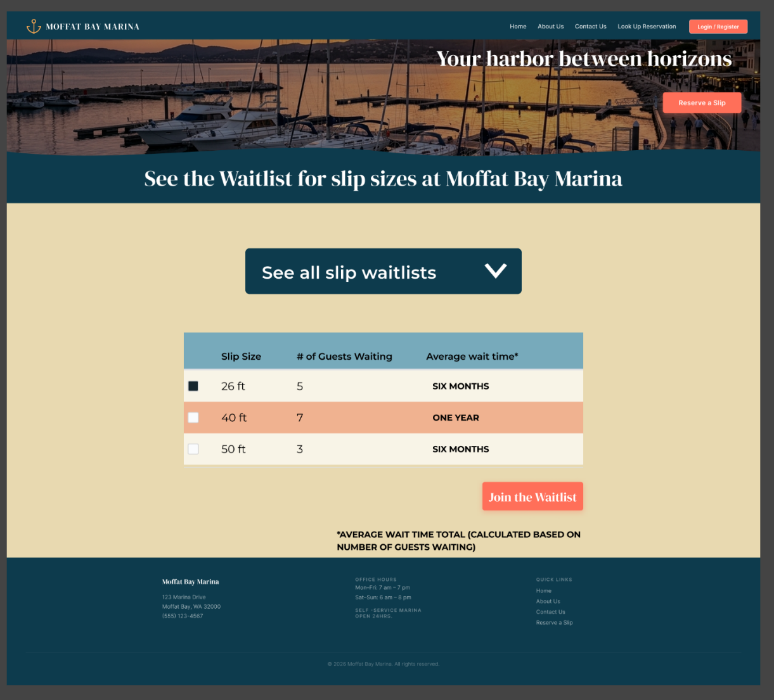
Wireframes:
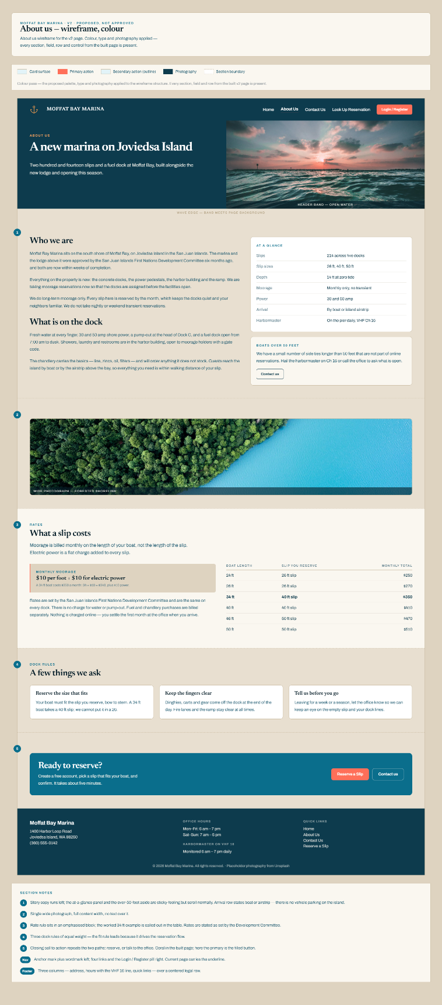

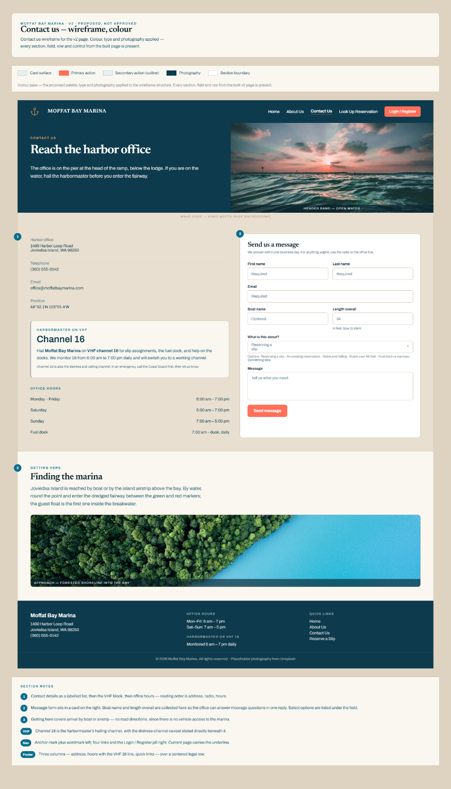

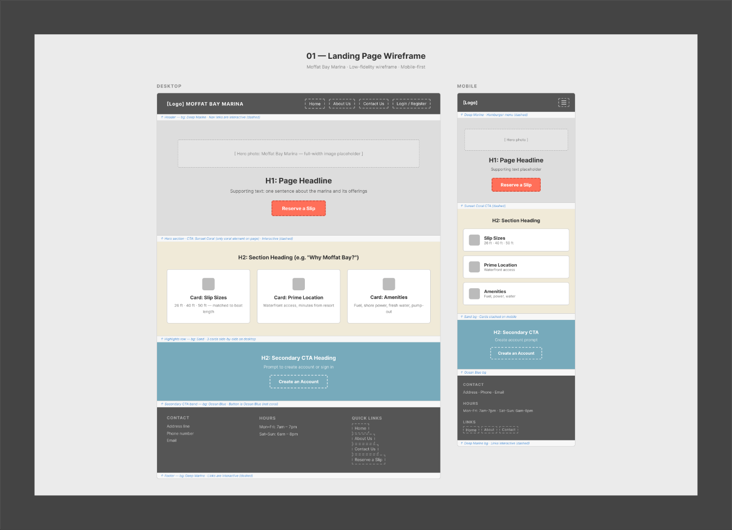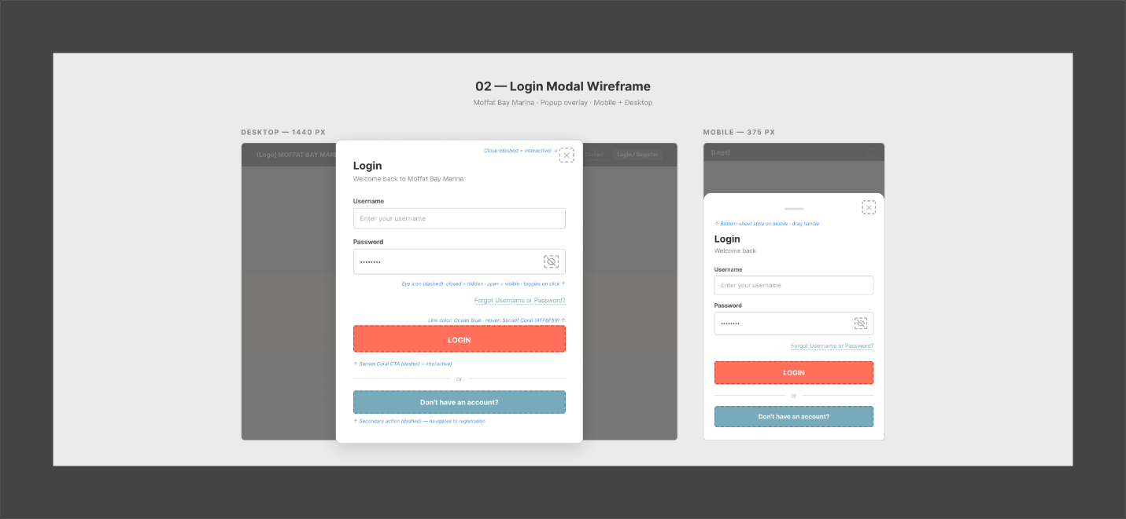
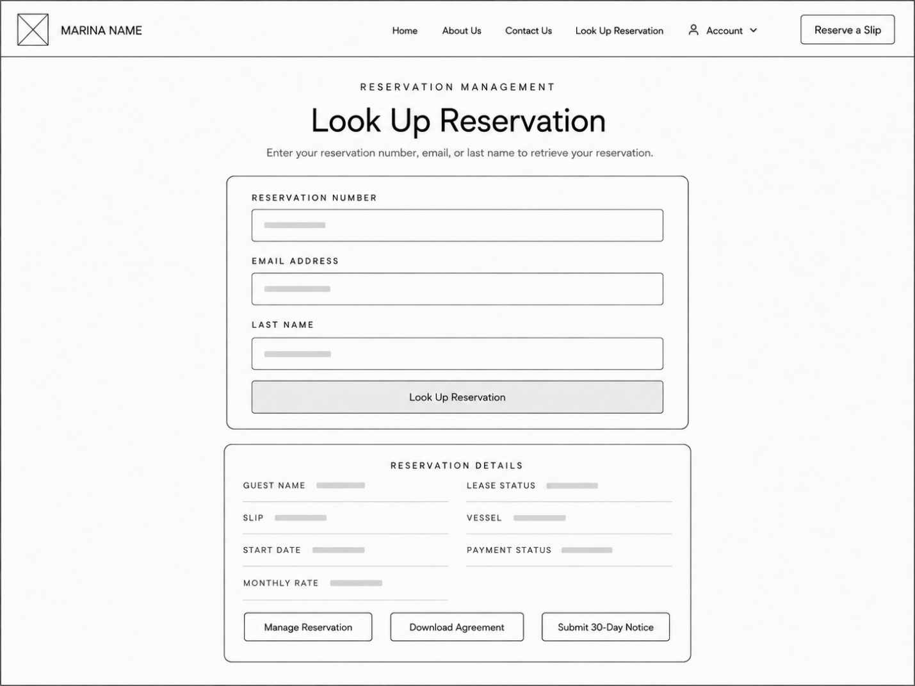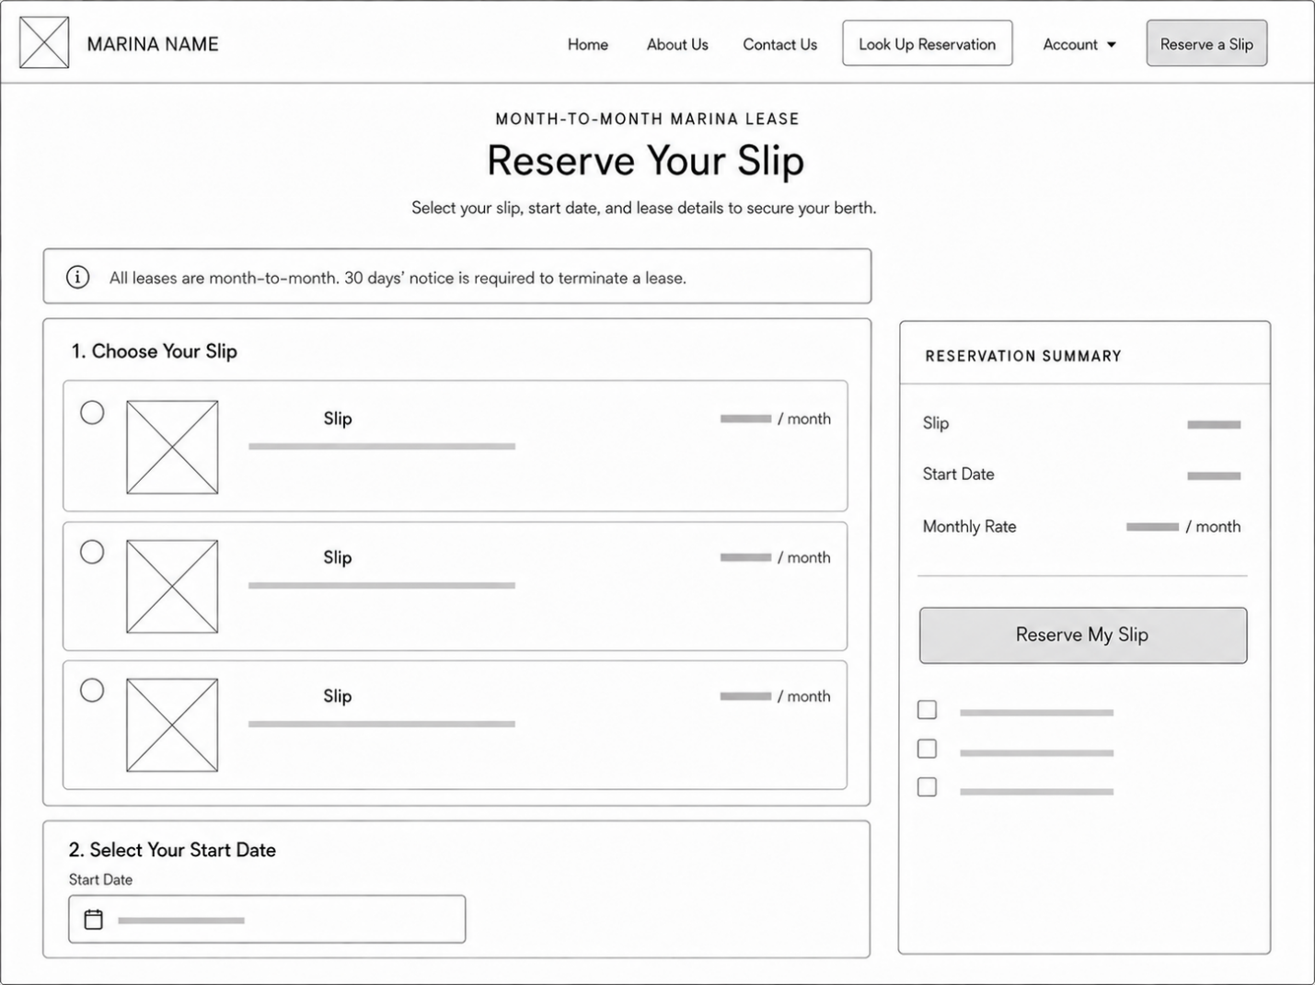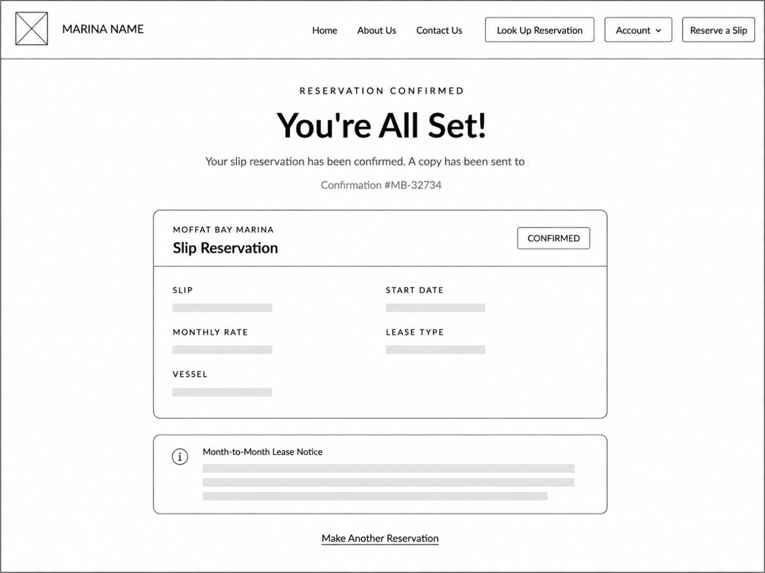

ERD

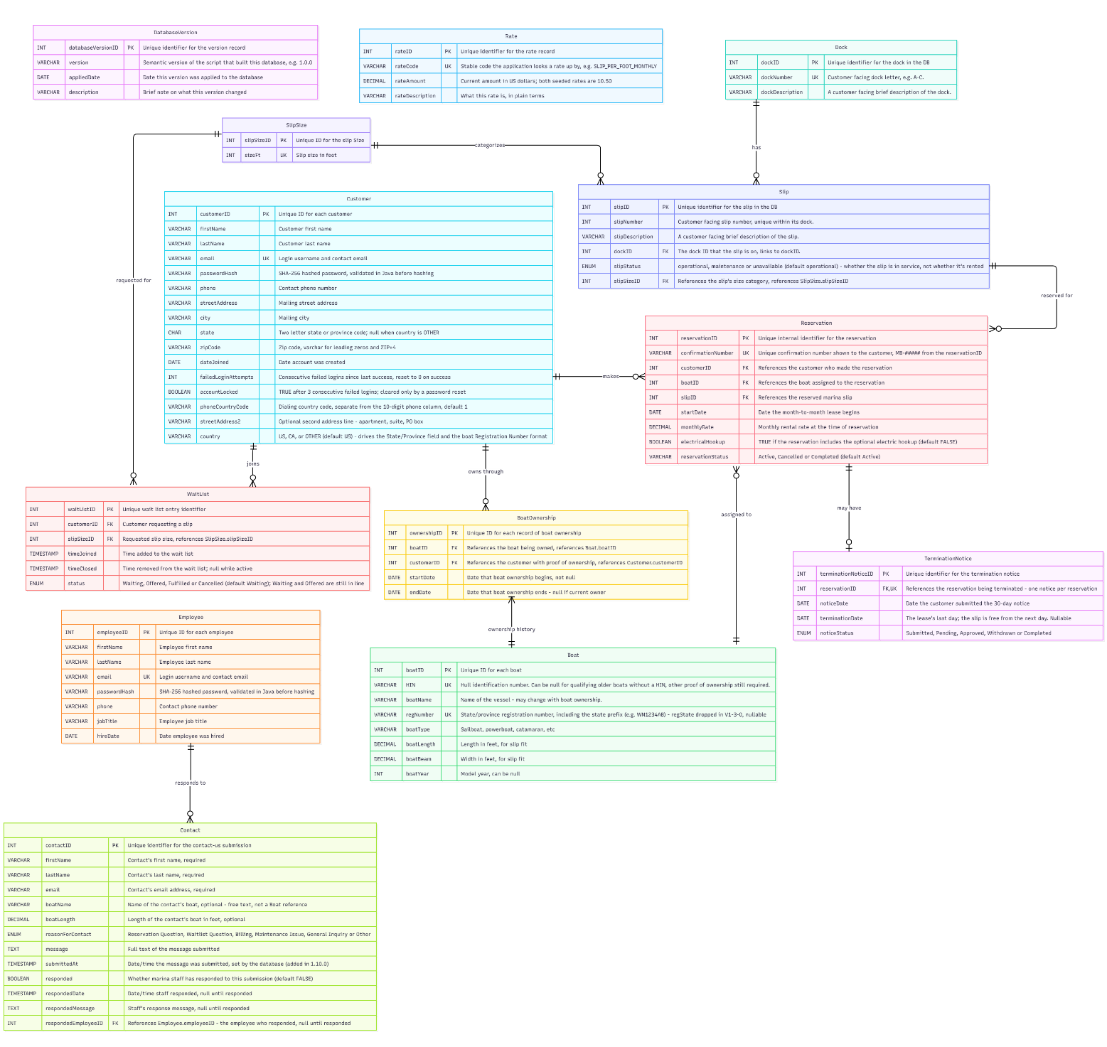

Moffat Bay Marina - Group Task List & Work Estimations
Each page is broken into Front End, Back End, and Database needs. Estimated hours are approximate - see citations below.

Task | Description | Estimated Hours | Due Date
MODULE 1 - Project Setup & Requirements Gathering (due Aug 16) - DONE
Requirements Gathering | Draft data requirements, user personas, and user stories for the TDD | 6 hrs | Aug 16 (Done)
Project Setup | Confirm Marina project, set up GitHub repo, shared MySQL environment, comms channel | 4 hrs | Aug 16 (Done)
MODULE 2 - Prototype (due Aug 23)
Page Prototypes | Functional prototype for all 9 pages (Landing, About Us, Contact Us, Wait List Lookup, Registration, Login, Slip Reservation, Reservation Summary, Look Up Reservation) | 9 hrs | Aug 23
Landing Page Mockup | Realistic mockup (color, layout, font) of the Landing page | 3 hrs | Aug 23
MODULE 3 - ERD (due Aug 30) - DATABASE
Entity Relationship Diagram | Design the ERD covering customers, slips, reservations, and wait list, and how they relate | 6 hrs | Aug 30
MODULE 4 - Database Development, Sprint 1 (due Aug 30) - DATABASE
Database Schema | Build the MySQL schema from the ERD (customers, slips, reservations, wait list tables) | 6 hrs | Aug 30
Slip Inventory | Load slip inventory by size category (26 ft, 40 ft, 50 ft) based on the marina map | 2 hrs | Aug 30
Shared Data Access Functions | Build shared functions so every page has a consistent way to read/write the database | 7 hrs | Aug 30
Password Hashing | Research and implement password hashing approach (cited source) | 4 hrs | Aug 30
MODULE 5 - Web Dev 1, Sprint 2 Begins (due Sep 6)
Landing Page - Front End | HTML/CSS build | 3 hrs | Sep 6
Landing Page - Back End | Any dynamic content | 2 hrs | Sep 6
Landing Page - Database | None - static content | - | Sep 6
Login Page - Front End | Username/password form | 2 hrs | Sep 6
Login Page - Back End | Check credentials, hash check, start session | 4 hrs | Sep 6
Login Page - Database | Reads customers table (username, password hash) | - | Sep 6
Registration Page - Front End | Registration form | 2 hrs | Sep 6
Registration Page - Back End | Create customer record, validate email format, hash password | 4 hrs | Sep 6
Registration Page - Database | Writes to customers table (new row, unique CustomerID, hashed password) | - | Sep 6
Module 5 Test Plan | 6 functional tests (2 per page) using TestPlanTemplate.docx, run and document with screenshots | 3 hrs | Sep 6
MODULES 6 & 7 - Web Dev 2 & 3, Sprint 2 Continues (due Sep 13)
Slip Reservation Page - Front End | Reservation form | 3 hrs | Sep 13
Slip Reservation Page - Back End | Boat-length-to-slip-size matching, availability check | 5 hrs | Sep 13
Slip Reservation Page - Database | Reads slips (availability by size), writes reservations | - | Sep 13
About Us Page - Front End | HTML/CSS build | 2 hrs | Sep 13
About Us Page - Back End | Any dynamic content | 1 hr | Sep 13
About Us Page - Database | None - static content | - | Sep 13
Reservation Summary Page - Front End | Summary display | 2 hrs | Sep 13
Reservation Summary Page - Back End | Pull reservation + slip details for display | 3 hrs | Sep 13
Reservation Summary Page - Database | Reads reservations, slips, customers | - | Sep 13
Module 7 Test Plan | 4 functional tests (2 per page) | 2 hrs | Sep 13
Scrum 2 Discussion | Initial post plus 3 peer responses (per person) | 1 hr/person | Sep 13
MODULE 8 - Web Dev 4, Sprint 3 Begins (due Sep 20)
Contact Us Page - Front End | HTML/CSS build | 2 hrs | Sep 20
Contact Us Page - Back End | Any dynamic content | 1 hr | Sep 20
Contact Us Page - Database | None - static content (unless a stored contact form is added later) | - | Sep 20
Look Up Reservation Page - Front End | Lookup form | 2 hrs | Sep 20
Look Up Reservation Page - Back End | Query reservation by ID/customer | 3 hrs | Sep 20
Look Up Reservation Page - Database | Reads reservations | - | Sep 20
Module 8 Test Plan | 4 functional tests (2 per page) | 2 hrs | Sep 20
Scrum 3 Discussion | Initial post plus 3 peer responses (per person) | 1 hr/person | Sep 20
MODULE 9 - Web Dev 5, Sprint 3 Wraps Up (due Sep 27)
Wait List Lookup Page - Front End | Wait list display | 2 hrs | Sep 27
Wait List Lookup Page - Back End | Wait-list logic when a slip size is full | 4 hrs | Sep 27
Wait List Lookup Page - Database | Reads/writes wait_list, reads slips | - | Sep 27
Module 9 Test Plan | 2 functional tests | 1 hr | Sep 27
MODULE 10 - QA & Peer Review (due Oct 4)
QA Presentation | Team intro, prototypes, ERD, 5+ tests and results, lessons learned | 4 hrs | Oct 4
Screen Capture Walkthrough | Narrated recording walking through every page of the site | 3 hrs | Oct 4
MODULE 11 - QA Testing & Delivery (due Oct 11)
Peer Critiques | 2 critiques of other teams, 150+ words each, 2 strengths/2 improvements | 2 hrs/person | Oct 11
Peer Feedback Fixes | Fix issues raised in peer feedback across pages/database | 5-8 hrs | Oct 11
Changes Write-Up | Document the changes made based on feedback | 2 hrs | Oct 11
Final Submission | Zip and submit the final project | 1 hr | Oct 11

How These Estimates Were Generated
We started with two numbers we found while researching typical web project timelines: about 40 hours for planning and design, and roughly 5 hours to build each page. For the login page, we used a starting point of 1 to 3 hours for a basic username and password check. From there, we adjusted each task up or down by hand. A page like Slip Reservation, which has to match a boat's length to an available slip, took more time than something like the About Us page. It's worth knowing that both of these numbers came from articles written to help price out client projects, not from a formal study of how long development actually takes. So, think of them as a solid starting point, not a guarantee.

References
Ceccarelli, G. (2026, August 1). Technical design documents: A practical guide. Stoa.
https://withstoa.com/blog/technical-design-documents

City of Monterey. (n.d.). Harbor and marina staff directory [Photograph].
https://monterey.gov/your_city_hall/departments/public_works/harbor_and_marina/staff_
directory/index.php#prettyPhoto

Discover Boating. (n.d.). Boating glossary. https://www.discoverboating.com/glossary-items

Erickson, J. (2024, August 29). MySQL: Understanding what it is and how it’s used. Oracle.
https://www.oracle.com/mysql/what-is-mysql/

Givnish, C. (2015, July 21). User-centered design: User personas vs. user stories. Function1.
https://www.function1.com/2015/07/user-centered-design-user-personas-vs-user-stories

Google. (2026). Portrait of marina customer [AI-generated image]. Gemini.

Martin, M. (2025, February 12). How much does it cost to develop a website? DesignRush.
https://www.designrush.com/agency/web-development-companies/trends/cost-of-web-
development

MDN contributors. (2025a, July 11). Glossary of web terms. MDN Web Docs.
https://developer.mozilla.org/en-US/docs/Glossary

MDN contributors. (2025b, November 7). JavaScript Guide. MDN Web Docs.
https://developer.mozilla.org/en-US/docs/Web/JavaScript/Guide

MDN contributors. (2025c, December 22). HTML: HyperText Markup Language. MDN Web
Docs. https://developer.mozilla.org/en-US/docs/Web/HTML

NS804. (2019, June 4). How much does it cost to implement login capabilities?
https://www.ns804.com/blog/how-much-does-it-cost-to-implement-login-capabilities/

Oracle. (n.d.). MySQL glossary. In MySQL 8.4 reference manual.
https://dev.mysql.com/doc/refman/8.4/en/glossary.html

