Miguel, Fernandez
CSD 460 - Capstone in Software Development
8/13/2026

User Persona:

Angela

Profile:

- Gender: Female
- Age: 42
- Occupation: Elementary school teacher
- Marital Status: Married, two kids
- Location: Local, lives in town year-round

Biography:

Angela and her family have had a 40 ft boat for six years now, and they book a long-term slip every season. She's got a full-time job and two kids with their own schedules, so she doesn't have time to sit on the phone dealing with reservations. She just wants something quick that works.

Needs:

- An option to see what slips are open without calling the business
- Some kind of confirmation she can send to her husband once it's booked
- An account that remembers her info so she's not typing the same stuff in every season

Problems:

- Not a lot of free time to deal with this kind of Work
- Tired of explaining her boat info over the phone every time
- Worried her slip could get given away while she's still figuring out dates

Stories:

- As a returning customer, I want to check slip availability online so I can plan my season without calling the office.

- As a busy parent, I want my account and boat info saved after I register so I don't have to re-enter them every time.

- As a slip holder, I want confirmation that I can save or forward the reservation details to share with my family.

- As a returning customer, I want to see my past reservations so I know which slip I had last season and can request it again.

- As a slip holder, I want to get a reminder before my reservation period ends so I'm not caught off guard when it's time to renew.

Photo:

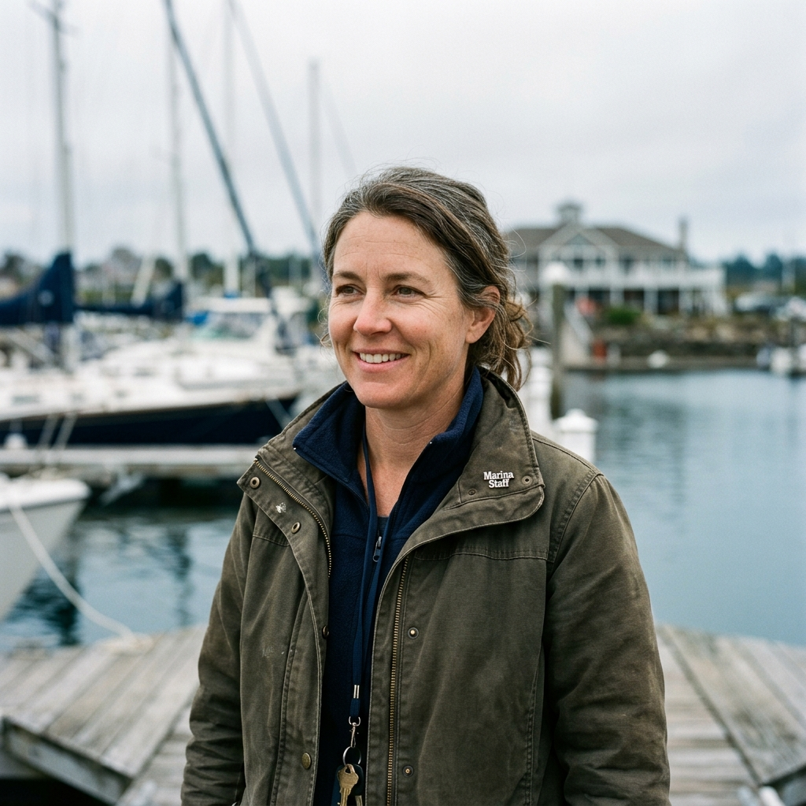
Made Using Gemini

