BLUE TEAM
Sara White’s mermaid code and waitlist table (plus slipSize)
Code:
---
config:
theme: redux
---
erDiagram
slipSize {
int sizeFt PK
}

waitList {
int waitListID PK
int boatID FK
int sizeFt FK
timestamp timeJoined
timestamp timeClosed
string status
}

slipSize ||--o{ waitList : requestedFor

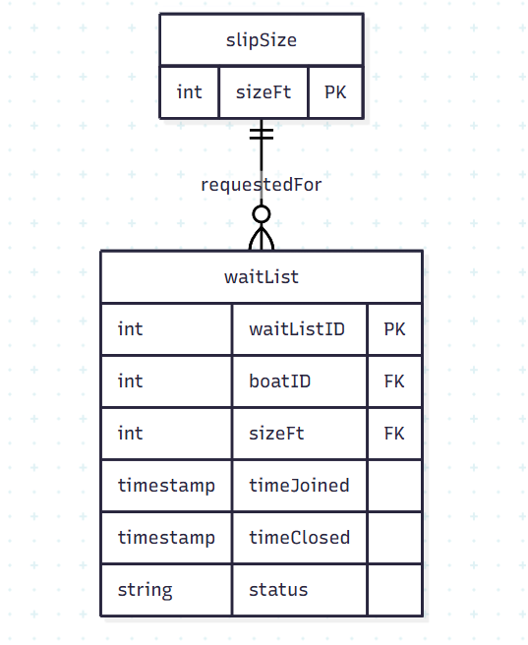

I made a table for slip size because the waitlist will be categorized based on the slip size. That way, we can calculate easily when a slip of a certain size becomes available as well as ensuring customers are reserving the right slip size for the size of their boat. We could also calculate the averages for how long customers typically wait on the waitlist with the timeClosed attribute. This won’t include cancelled waitlist spots – there will be a status for cancelled.

The slip size table will just use the sizeFt attribute as the primary key since the sizes are fixed (26ft, 40ft, 50ft), unless the group prefers having a slipSizeID PK.

