**Section 2: How to’s…….**

1. know in what Directory you are located:

**fellow$ pwd**

/home/fellow/Training

 #use this command for when lost in the

terminal with no idea how you got there or in

what folder you are in

2. list the files in current directory:

Goal: you want to list all the files you have in you home folder

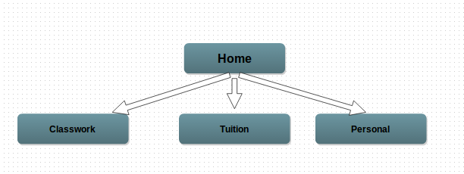

**fellow/Home$ ls**

#this will give you

**Classwork Tuition Personal**

#These are the three folders in your home file that are

“returned”

3. rename a file

Goal: You want to rename a directory name from “Yellow” to “Green”

#to see where you are.. in this instance lets pretend you are

in the Home folder and know the pathway to Yellow folder as

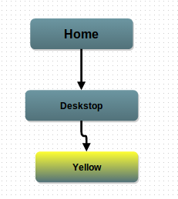

**fellow$ cd Home/Desktop/**  #to be able to go to the folder you need to go to.

NOTE: you are going one above the folder you need to change, not the actual folder itself!!

**fellow$ mv Yellow Green** #once you are finally in the folder you need to go, you

rename your folder. NOTE: you will only be able to change the folder from Home/Desktop $, not from Home/Desktop/Yellow

4. create a directory:

fellow@codefellow2:~/Desktop$ mkdir Flowers

(You’ve created a directory on the desktop called Flowers! Yay!)

guide the terminal to where you want to create a directory. In this case, you want

to create a new directory, “Flowers” in side the ‘Desktop” folder

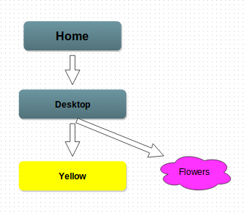

**fellow$ pwd**

**> home/**

**fellow$ cd Desktop**

**fellow$ ls**

**>Yellow**

**fellow$ mkdir Flowers**

**fellow$ ls**

**>Yellow Flowers**

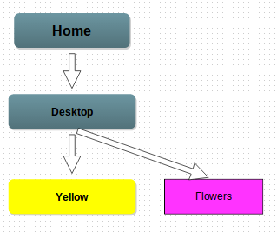

5. create a document inside a directory:

First get inside the directory called Flowers and create a file: fellow@codefellow2:~/Desktop$ cd Flowers

then use the command touch:

fellow@codefellow2:~/Desktop/Flowers$ touch Daisy

(You should know now have a file inside the Flowers directory titled daisy! Double yay!)

6. move file to another directory:

First get into the directory that has the file you want to move:

fellow@codefellow2:~$ cd Desktop/Flowers

Then you write the name of the file (Daisy) that you want to move, space, and the name of the directory you want to move it into! (Bee)

fellow@codefellow2:~/Desktop/Flowers$ mv Daisy Bee

(Now the Daisy file should be inside the Bee directory!)

7. create multiple directories at the same time:

fellow@codefellow2:~/Desktop$ mkdir Red Blue Yellow

(You’ve created 3 directories named Red, Blue, Yellow on the Desktop)

8. Go to specific folder to work:

I wanted to go into Week 10 folder that was in my training folder:

fellow@codefellow2:~$ cd Training/Week10

fellow@codefellow2:~/Training/Week10

9. how to copy folder

Enter the directory that has the folder you would like to copy.

write the name of the file then type cp then write the name of the directory that you would like to copy the file to.

fellow@codefellow2:~/Desktop$ nameoffolder cp nameoffolderdestination

10. download an application (sudo)

Enter the directory in which you would like to download the application.

You will be pulling the application from the pip module by typing pip install name of application:

fellow@codefellow2:~/Desktop$ pip install flask

11. remove files or directories

Enter the directory which the file is inside of

Type rmdir before the directory name to remove the directory

fellow@codefellow2:~/Desktop$ rmdir Nameofdirectory

In order to remove a file

Type rm before the file name to remove the file.

fellow@codefellow2:~/Desktop$ rm Nameoffile