Error: No Such file or directory
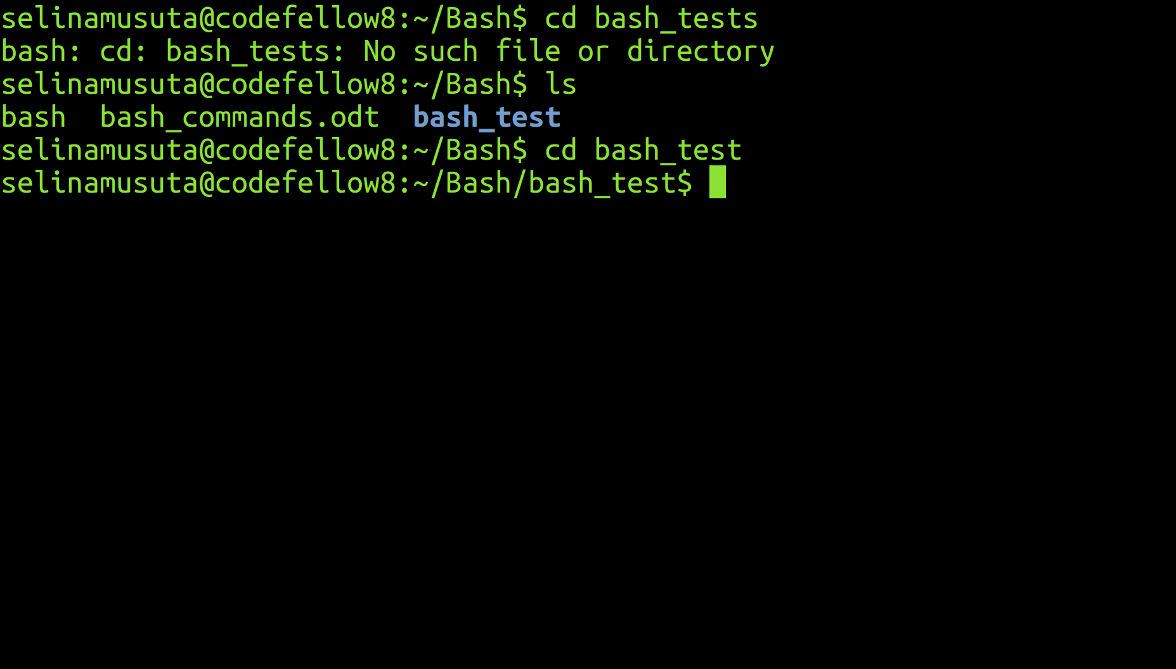
Oops! That's not bash_tests
What Does This Mean?: This error message means that the directory you are referring to cannot be located by the computer. This is typically the result of misspelling the name of the file or directory, or you are searching for the file or folder in the wrong directory.

What Happened?: I wanted to change my directory to bash_tests. But I was given the error above.

How did you solve it? I typed ls in my command line in order to see what directories and files were in my Bash directory. I saw that the listed directory that I wanted was spelled differently (bash_test without an 's') from the directory (bash_tests) that I had previously typed. The computer could not find that file. So now for the correct directory name with command:

cd bash_test

