Troubleshooting:

Correcting a mis-spelling:
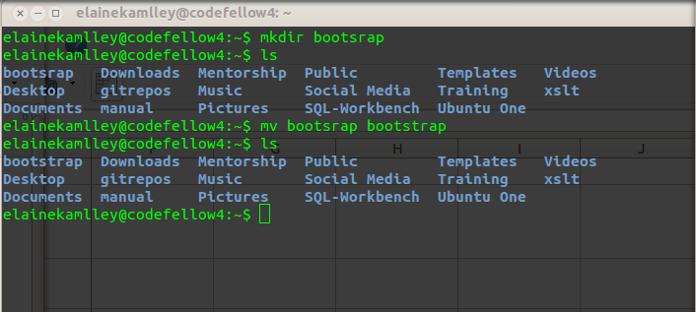
Whoops!
That's better!
1. You want to make a directory that will hold your new app. You use the command mkdir:

mkdir bootsrap

2. You see that it is mis-spelled it. To correct it, use the mv command and write the original directory name followed by the correct spelling:

mv bootsrap bootstrap

