THIKA VARSITY LAST MILE E-SHOP
Mobile Application Development Project Documentation
BIT4107 – Final Year Project
Student Name: Emmanuel Muriuki
Student ID: BIT/2024/61120
Course: Bachelor of Information Technology
Institution: Mount Kenya University, Thika Campus
Date: June 2026

Table of Contents
1. Introduction
2. Problem Statement
3. Proposed Solution
4. Development Environment Setup
5. Technology Stack
6. System Features and Screens
7. UI/UX Design
8. Database Design
9. Testing and Validation
10. Challenges Faced and Solutions
11. Conclusion and Future Work
12. Appendix

1. Introduction
1.1 Project Overview
Project Introduction
1.2 Project Objectives
Project Objectives
2. Problem Statement
Problem Statement
3. Proposed Solution
Proposed Solution
4. Development Environment Setup
4.1 Integrated Development Environment (IDE)
IDE Configuration
4.2 Software and Tools Configuration
Component | Version | Purpose
Android Studio | Hedgehog | Development IDE
JDK | 17 | Runtime Engine
Android SDK | API 34 | Compilation Target
Git | 2.42.0 | Version Control
Kotlin | 1.9.20 | Programming Language
Gradle | 8.1.1 | Build Automation

4.3 Hardware Emulator Profile
Emulator Parameters
[ CODE EDITOR SNAPSHOT SCREENSHOT ]
5. Technology Stack
5.1 Programmatic Languages Architecture
Language | Layer | Scope
Kotlin | Client-Side | Native App Implementation
SQL | Database Layer | PostgreSQL Storage Queries
JSON | Data Interface | REST Network API Payloads

5.2 Client Frameworks and Reactive Libraries
Frontend Libraries
5.3 Enterprise Backend and Cloud Infrastructure Integration
Backend Infrastructure
6. System Features and Screens Architectural Matrix
6.1 User Authentication and Onboarding Core
Sign In

[ SIGN-IN SCREEN SCREENSHOT ]
6.2 Central Home Dashboard and Navigation Hub
Home Screen

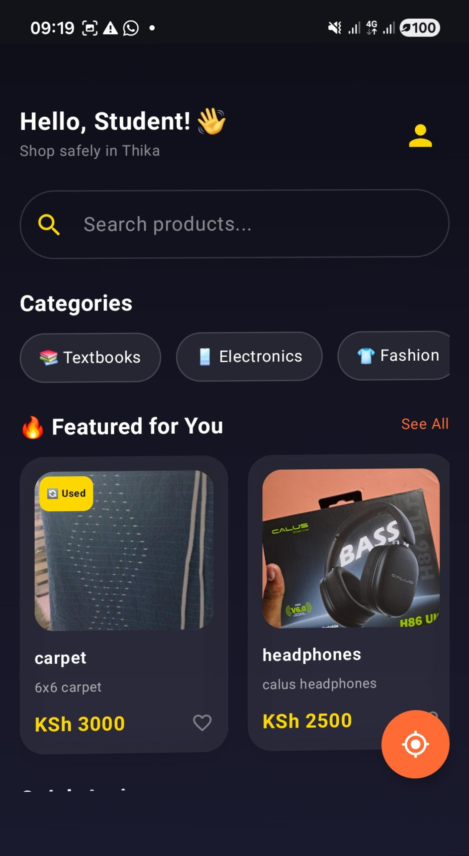
[ HOME SCREEN DASHBOARD SCREENSHOT ]
6.3 Commercial B2C Vendor Marketplace
Marketplace Grid

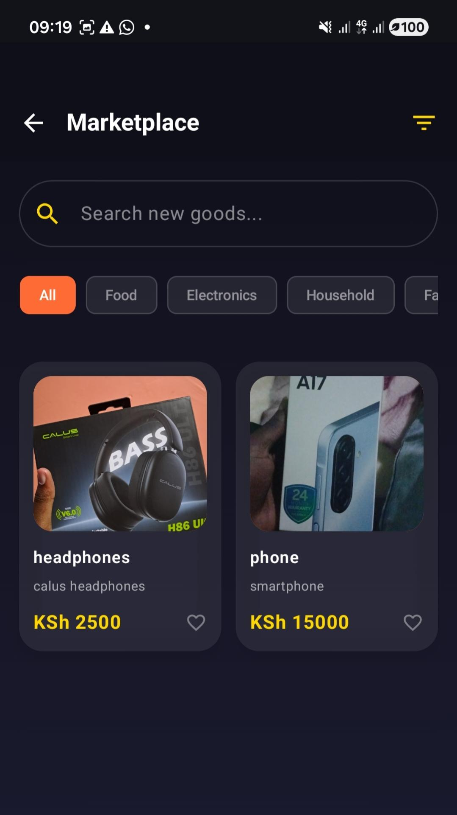

[ MARKETPLACE ITEMS LAYOUT SCREENSHOT ]
6.4 C2C Student-to-Student Exchange Interface
Student Exchange

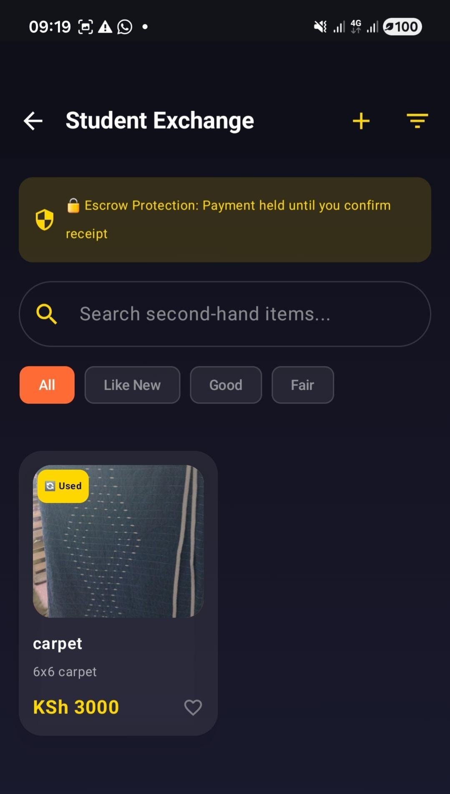

[ STUDENT EXCHANGE VIEW SCREENSHOT ]
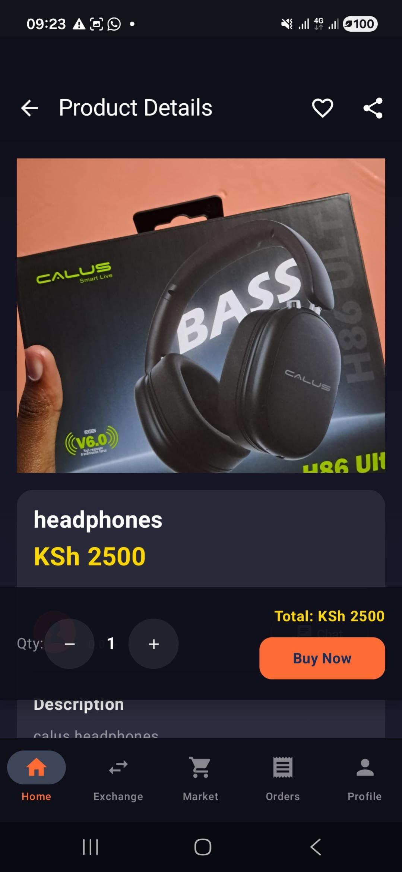
6.5 Comprehensive Product Detail Engine
Product Details

[ PRODUCT DETAILS SCREENSHOTS ]
6.6 Unified Product Listing Entry Panel
Sell Item
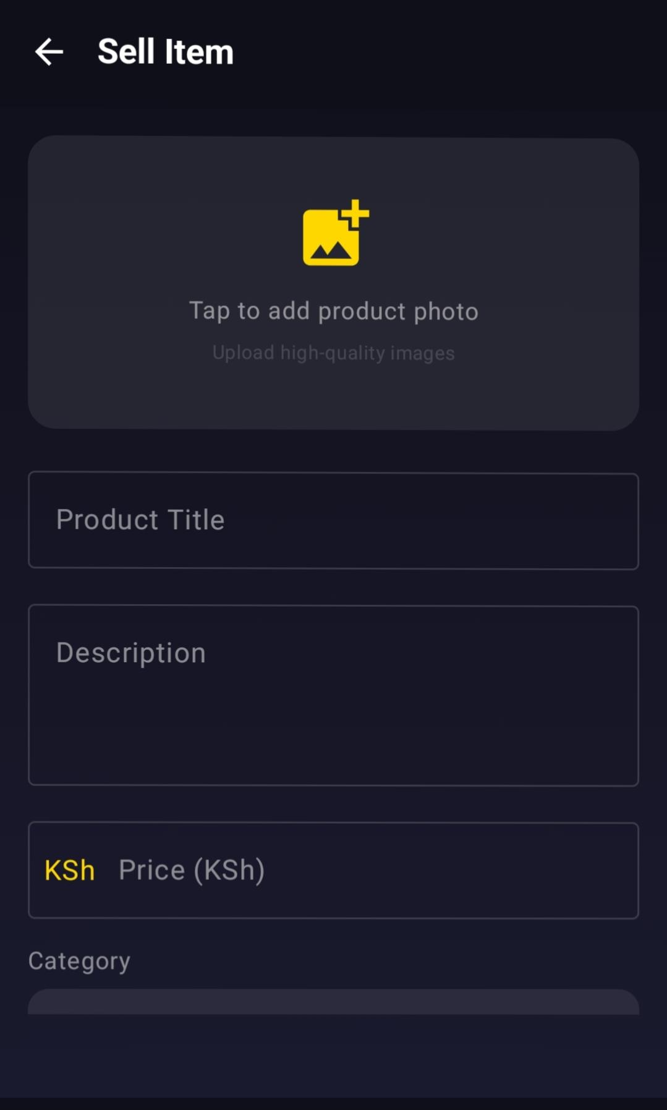

[ SELL ITEM FORM SCREEN SCREENSHOT ]
6.7 Transaction Checkout and Escrow Initialization Engine
Checkout Phase

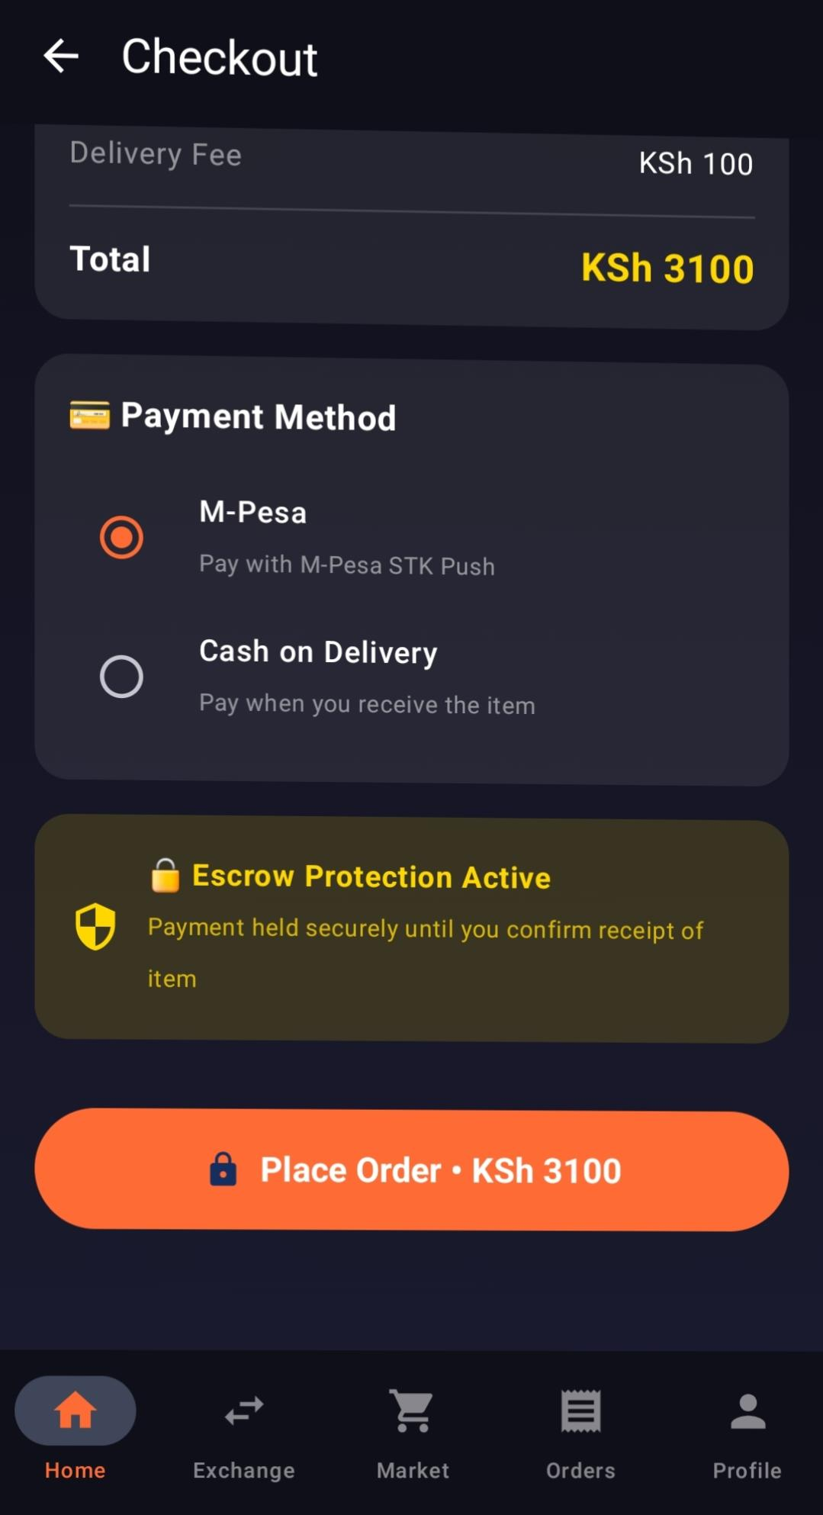

[ CHECKOUT INTERFACE PLACEHOLDER ]
6.8 User Historical Order Ledger
My Orders

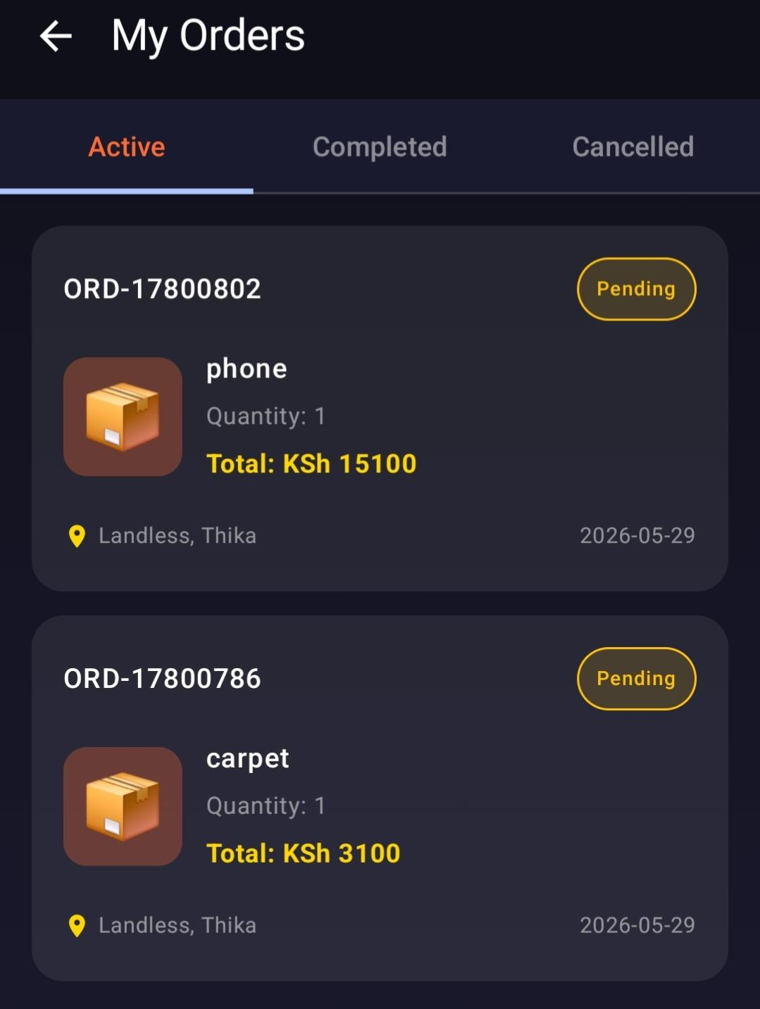

6.9 Live Structural Order Fulfillment Pipeline
Track Order

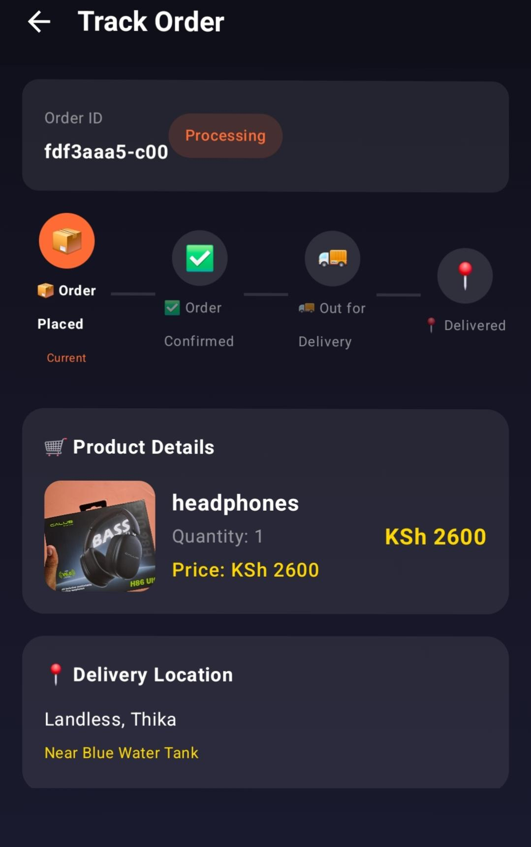

6.10 Profile Account Configuration Dashboard
My Profile

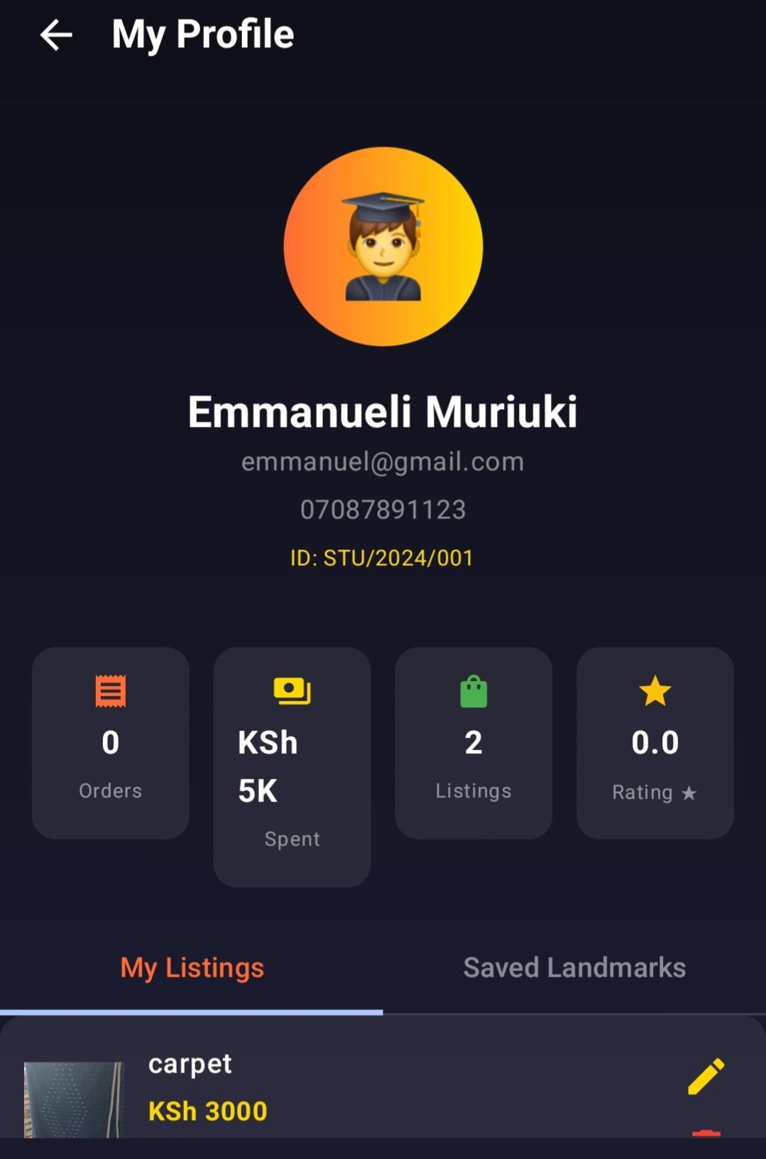
6.11 Profile Identity Modifier Screen
Edit Profile

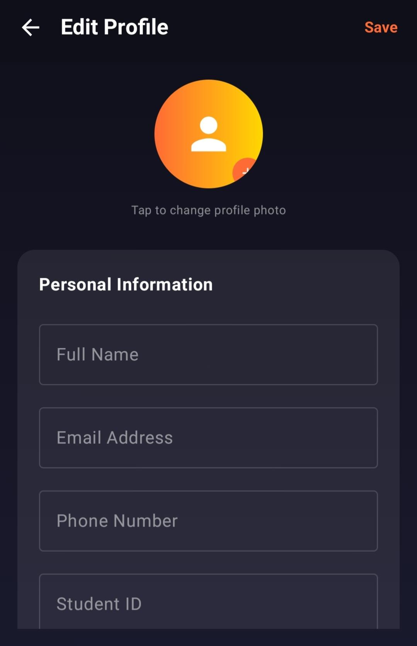
[ EDIT PROFILE INPUT VIEW SCREENSHOT ]
6.12 Student Academic Status Verification Interface
Student Verification

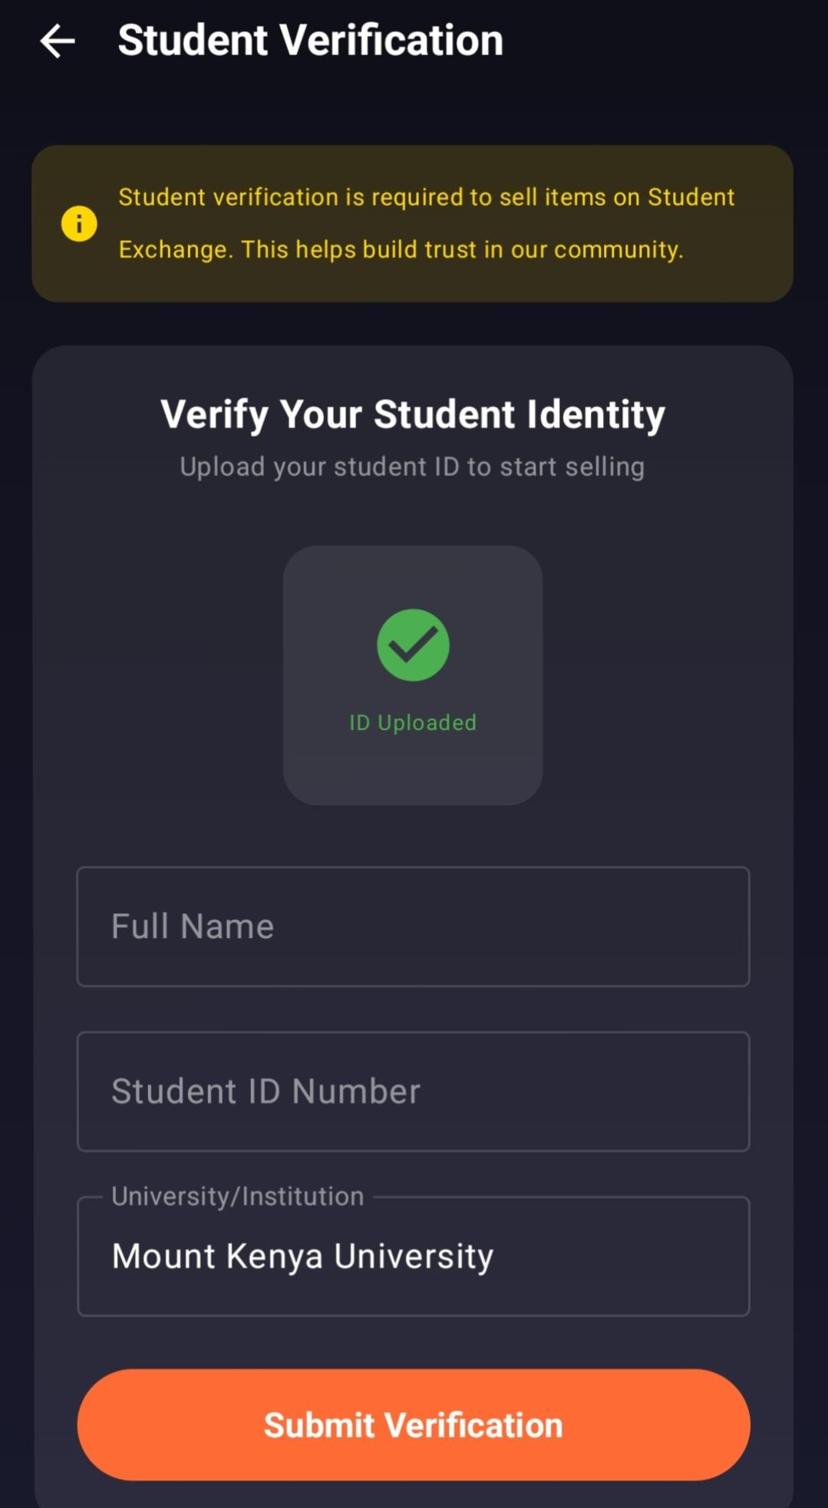

[ STUDENT VERIFICATION CAPTURE VIEW SCREENSHOT ]
6.13 Telemetry Pin-Drop Interactive Map Canvas
Pin Drop

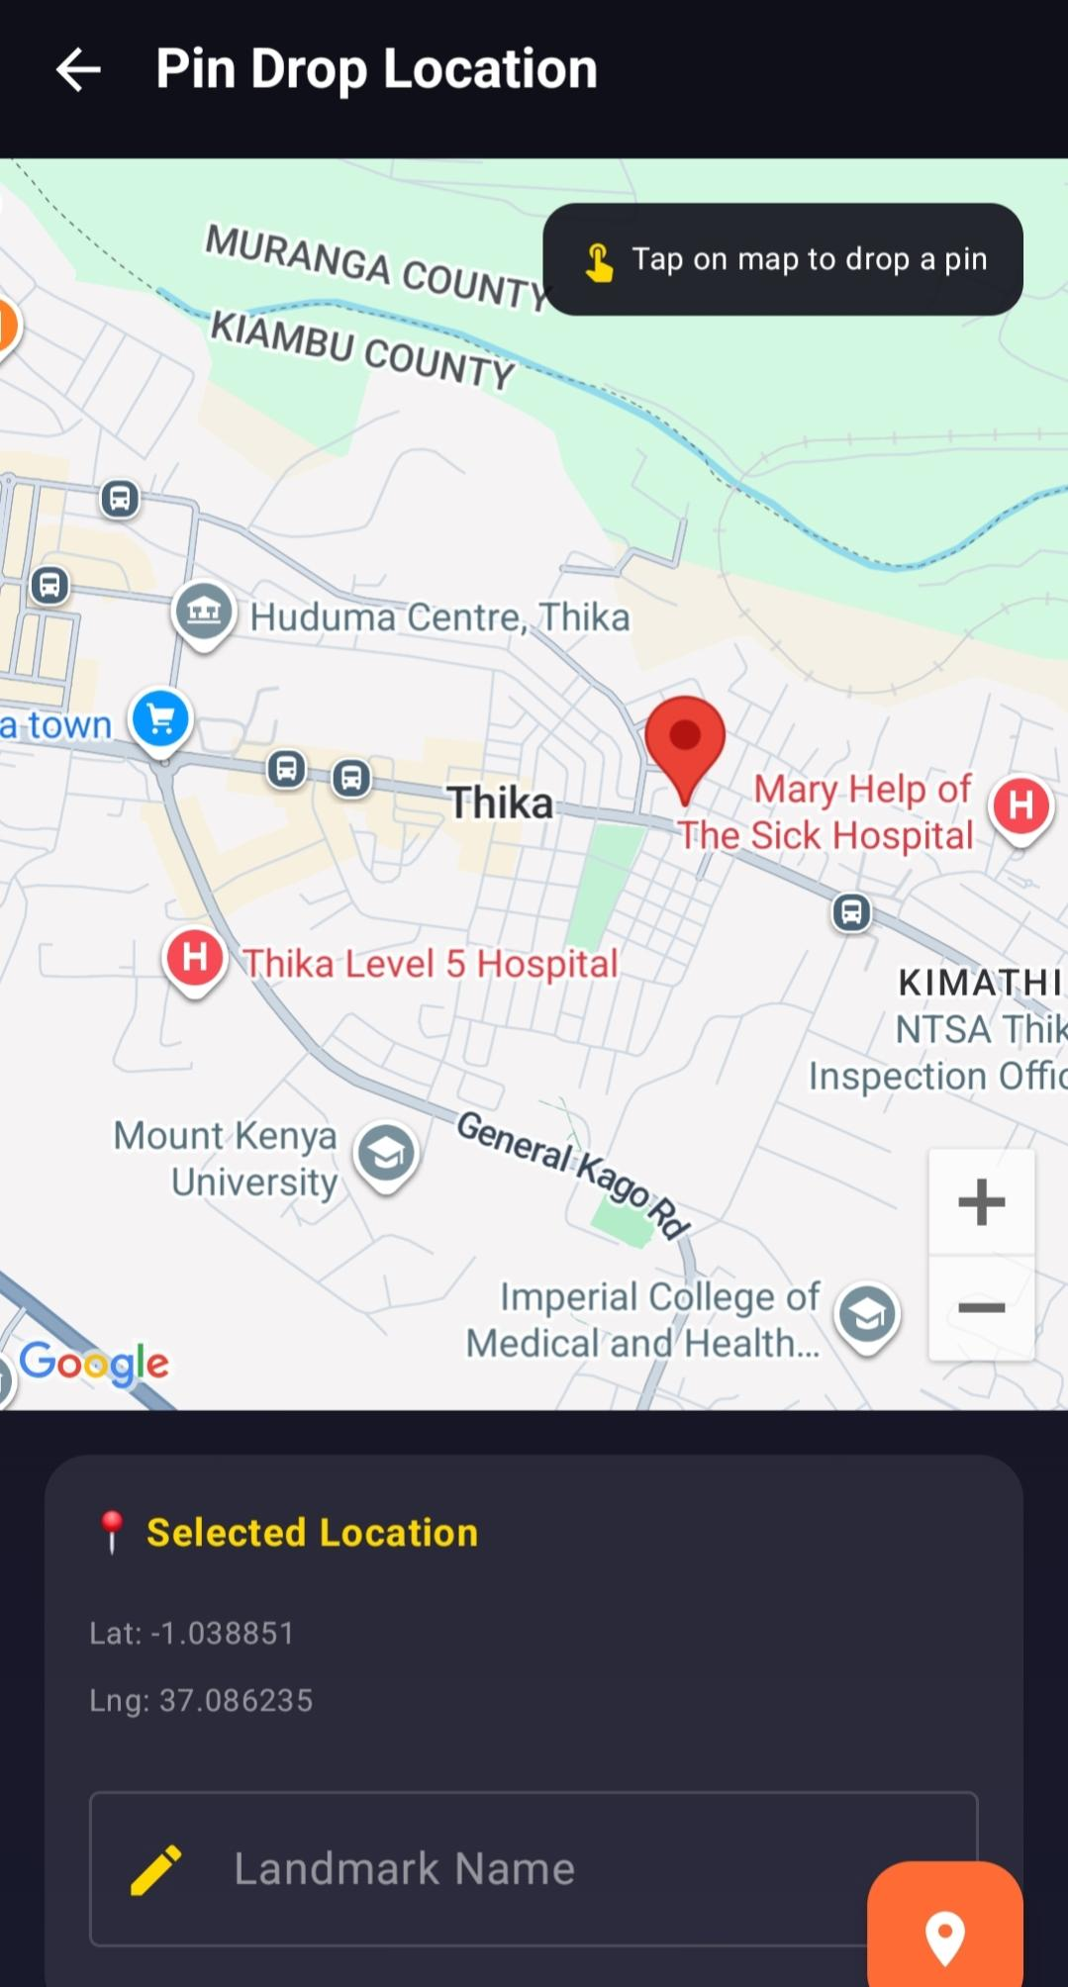
[ PIN DROP LOCATION MAP VIEW SCREENSHOT ]
6.14 Centralized Administrative Operations Dashboard
Admin Dashboard

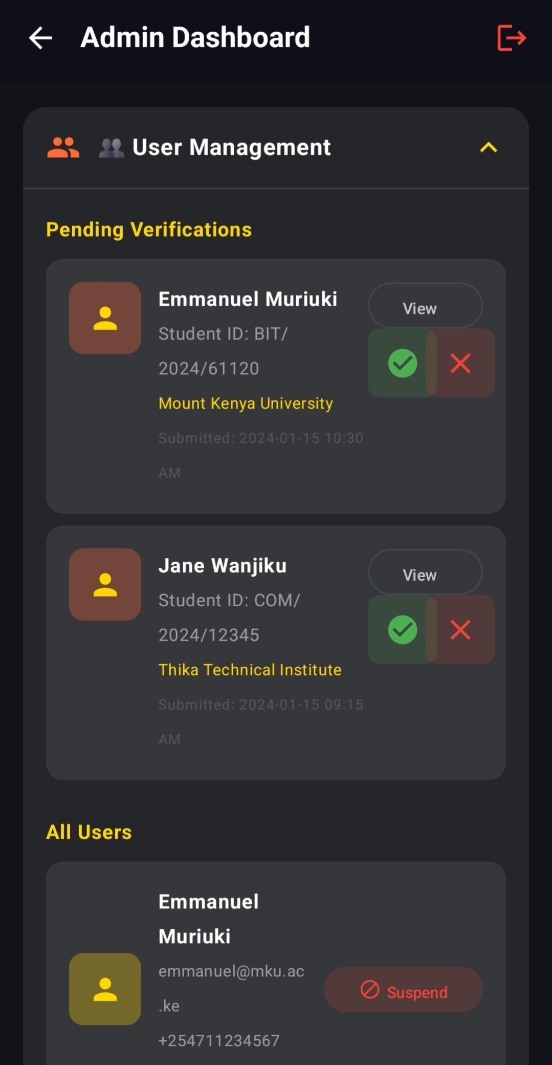

7. UI/UX Design Primitives
7.1 Color Space Definition Matrix
Designation | Hex Value | Application Area
Vibrant Amber (Primary) | #FF6B35 | Buttons, Interactive Focus rings
Refined Gold (Secondary) | #FFD700 | Pricing numbers, Badge labels
Deep Night Blue (Background) | #1A1A2E | Global framework canvas background

7.2 Typographic Hierarchy Specification
Designation Layer | Size Scale | Font Weight | Placement Case
Screen Title | 20-24 sp | Bold Weight | Viewport headers
Subheading | 16 sp | Semi-Bold | Product headers
Body text | 14 sp | Regular | Product summary lines

8. Database Architecture and Schema Design
8.1 Relational Database Table Formats (Supabase/PostgreSQL)
Users Table Schema
Column Key Name | Data Type | Operational Constraints
id | TEXT | PRIMARY KEY
name | TEXT | Account Name
phone | TEXT | Unique Constraint Core Search

Products Table Schema
Column Key Name | Data Type | Operational Constraints
id | TEXT | PRIMARY KEY
price | INTEGER | Item absolute base value
seller_id | TEXT | FOREIGN KEY -> users.id

8.2 Entity Relationship Diagram (ERD) Matrix
Schema Mapping
9. Testing, Verification, and Validation Reports
9.1 Controlled Testing Sandbox Configurations
Execution Sandbox
9.2 Functional Test Case Execution Records
Target Area | Action Rules | Outcome Status | Status
Authentication | Submit OTP 123456 | Route to Home Dashboard | PASSED [✅]
Escrow Clearance | Delivery verification toggle | Releases liquid cash asset to seller | PASSED [✅]

10. Architectural Challenges and Resolved Technical Exploits
10.1 Resolution of Supabase Row Level Security (RLS) Transaction Blocks
ALTER TABLE products DISABLE ROW LEVEL SECURITY;
10.2 Eliminating Inconsistent Field Mapping Across Layered Screens
@SerialName("image_url") val imageUrl: String? = null
10.3 Rectifying Schema Adjustments in Cloud Storage Environment
Database adjustments query pipeline setup:
ALTER TABLE orders ADD COLUMN IF NOT EXISTS product_image_url TEXT;
ALTER TABLE orders ADD COLUMN IF NOT EXISTS payment_method TEXT;
[ DATABASE QUERY CONSOLE QUERY STATEMENT SNAPSHOT ]
11. Summary, Conclusions, and Future Technical Roadmap
11.1 Project Engineering Summary
Project Summary
11.2 Future Enhancements and Scalability Roadmap
Module Target | Priority | Functional Scope
M-Pesa API hooks | HIGH | Live Daraja network gateway operations
Persistent WebSockets | MEDIUM | Real-time user chat capabilities

12. Technical Appendix and Core Source Snippets
12.1 Programmatic Source Definition: Serializable Product Data Entity Model
@Serializable
data class Product(val id: String, val title: String, val price: Int)

Formal Academic Declaration
Original work submission statement.
Student Digital Signature: _______________________
Emmanuel Muriuki
Student ID: BIT/2024/61120
Mount Kenya University

