Northwind Traders Sales Analytics Dashboard
GitHub - BobbySU/Data-Analytics-and-Visualizations
Project Overview
The purpose of this project was to design and implement a complete business intelligence solution for Northwind Traders using PostgreSQL, DBeaver, and Power BI Desktop. The project focused on transforming raw operational data into meaningful business insights through data preparation, dimensional modeling, analytical calculations, and interactive visualizations.
The solution was developed to support the analysis of sales performance, product trends, employee contribution, customer activity, and shipping operations. By combining SQL-based data processing with Power BI reporting capabilities, the project delivers a scalable and efficient analytical environment for business decision-making.
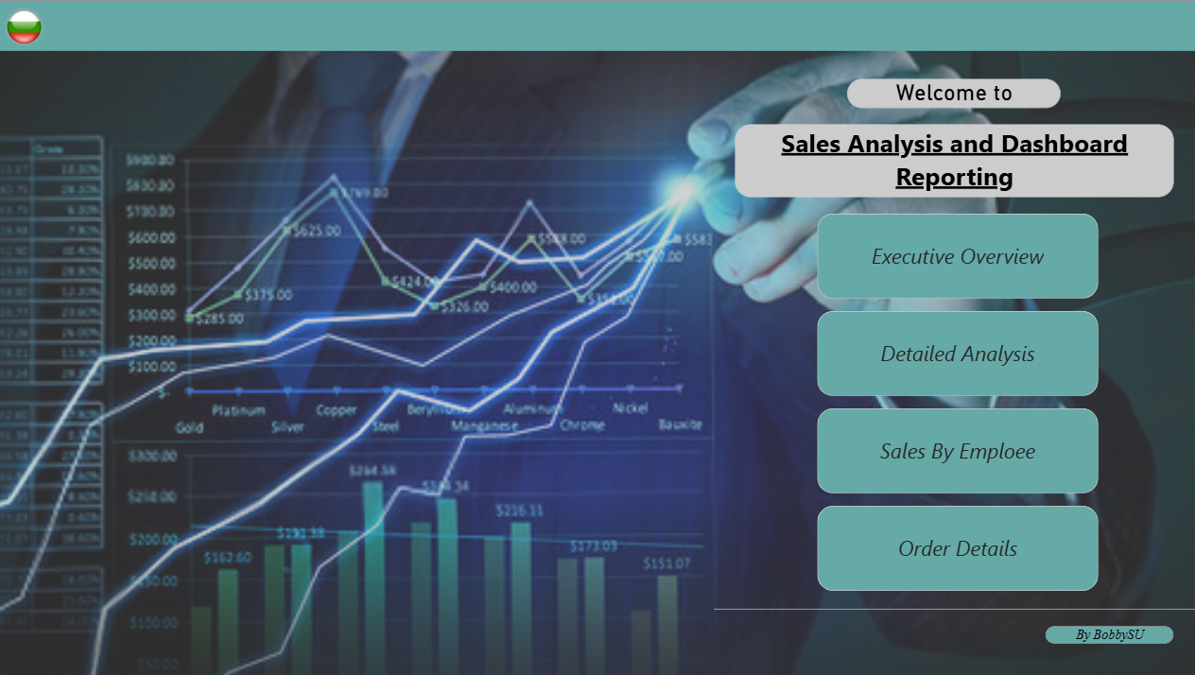

Data Preparation and Data Modeling
A significant part of the project involved preparing and structuring the source data before importing it into Power BI. Following data warehousing best practices, data transformation was performed primarily at the database level through SQL Views, reducing the need for excessive transformations within Power Query.
Three dedicated Views were created:
v_Product_Enriched
This view integrates information from the Products, Categories, and Suppliers tables, creating a consolidated product dimension. The resulting dataset provides product attributes, category classifications, supplier information, and pricing details required for analytical reporting.
v_Order_Sales
This view combines Orders and Order Details into a sales fact table. A calculated field, TotalLineAmount, was implemented directly in SQL to calculate the monetary value of each transaction after discounts. This approach improves performance and ensures consistency across all report calculations.
v_Customer_Geo
This view contains customer and geographical information that supports location-based analysis. It enables the evaluation of customer distribution and sales performance across different countries and regions.
To support efficient analytics, a Star Schema model was implemented within Power BI. The model consists of a central sales fact table surrounded by related dimension tables for products, customers, employees, shippers, and dates. Relationships were configured using single-direction filtering, following industry best practices for optimized query performance and accurate aggregation behavior.
Additionally, a dedicated Calendar Table was created to support advanced time intelligence calculations and period-over-period comparisons.
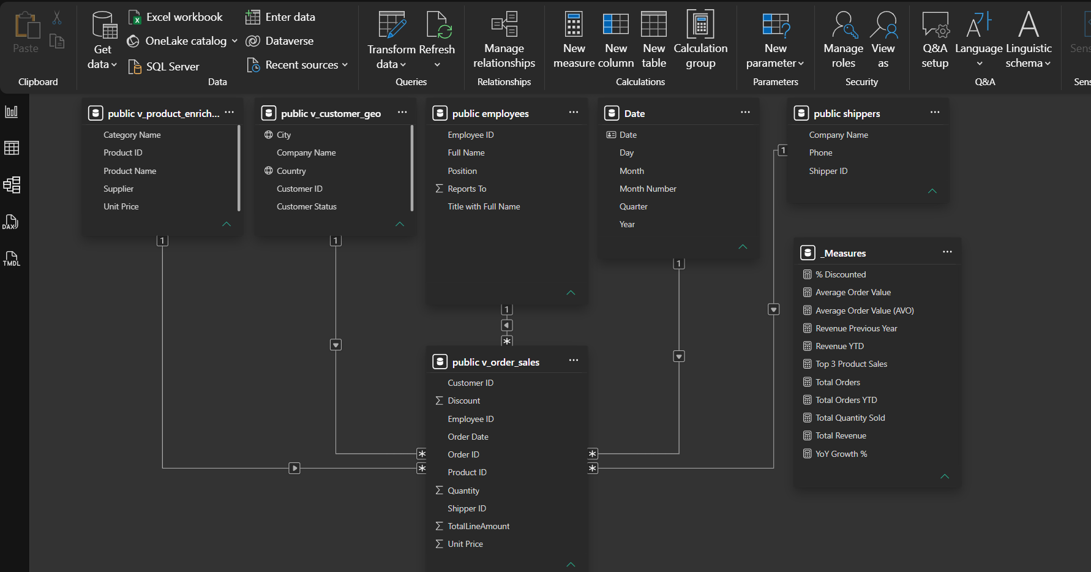

Analytical Measures
Business calculations were developed using DAX and organized within a dedicated _Measures table to enhance model maintainability and readability.
The implemented measures include:
- Total Revenue
- Total Orders
- Average Order Value (AOV)
- Total Quantity Sold
- Revenue Year-to-Date (YTD)
- Revenue Previous Year
- Year-over-Year Growth Percentage
- Percentage of Discounted Revenue
- Top Product Sales
These measures provide the analytical foundation of the report and allow users to monitor business performance from multiple perspectives.

Report Design and Visualization
The reporting solution consists of four analytical report pages, each designed to address specific business questions and support different levels of analysis.
Executive Overview
The Executive Overview page provides a high-level summary of business performance through a collection of key performance indicators and visual analytics.
The page includes:
- Total Revenue KPI
- Total Orders KPI
- Average Order Value KPI
- Year-over-Year Growth KPI
- Monthly Sales Trend Analysis
- Sales by Country Map
- Sales Distribution by Shipper
This page enables decision-makers to quickly evaluate overall business performance and identify key trends.

Detailed Analysis (Products & Employees)
The Detailed Analysis page focuses on deeper exploration of product and operational performance.
Key visualizations include:
- Top Revenue-Generating Products
- Category-Level Performance Analysis
- Product Performance Breakdown
- Interactive Filtering by Year, Category, and Employee
The page allows users to identify major revenue drivers and evaluate product portfolio performance.
Sales by Employee
This report page is dedicated to employee performance evaluation.
Through comparative visualizations, users can assess:
- Revenue generated by individual employees
- Relative contribution to overall company sales
- Performance differences among sales representatives
This analysis supports performance monitoring and management decision-making related to resource allocation and employee productivity.
Drill-through (Order Details)
The Drill-through page enables detailed transaction-level analysis.
Users can navigate directly from summary visuals to detailed records containing:
- Order Date
- Customer Information
- Product Information
- Quantity Sold
- Discount Applied
- Sales Amount
This functionality enhances the analytical depth of the solution and facilitates detailed investigation of specific transactions.

Mobile Reporting Experience
In addition to the desktop report, a dedicated Mobile View was designed to improve accessibility and usability on smartphones and tablets.
The mobile layout reorganizes key performance indicators and critical visualizations for smaller screens while preserving analytical functionality. This ensures that business users can access essential information and monitor performance regardless of location or device.

Applied Logic and Methodology
The implemented solution follows established business intelligence and data modeling principles:
- Data preparation was performed primarily within the database layer using SQL Views.
- A Star Schema architecture was adopted to improve model efficiency and scalability.
- Time Intelligence functionality was enabled through a dedicated Calendar Table.
- DAX measures were centralized within a dedicated Measures table.
- Interactive filters and drill-through navigation were implemented to enhance analytical flexibility.
- Mobile optimization was included to support cross-device access and reporting consistency.

Documentation Contents
The documentation includes screenshots of the following report components:
- Landing Page
- Executive Overview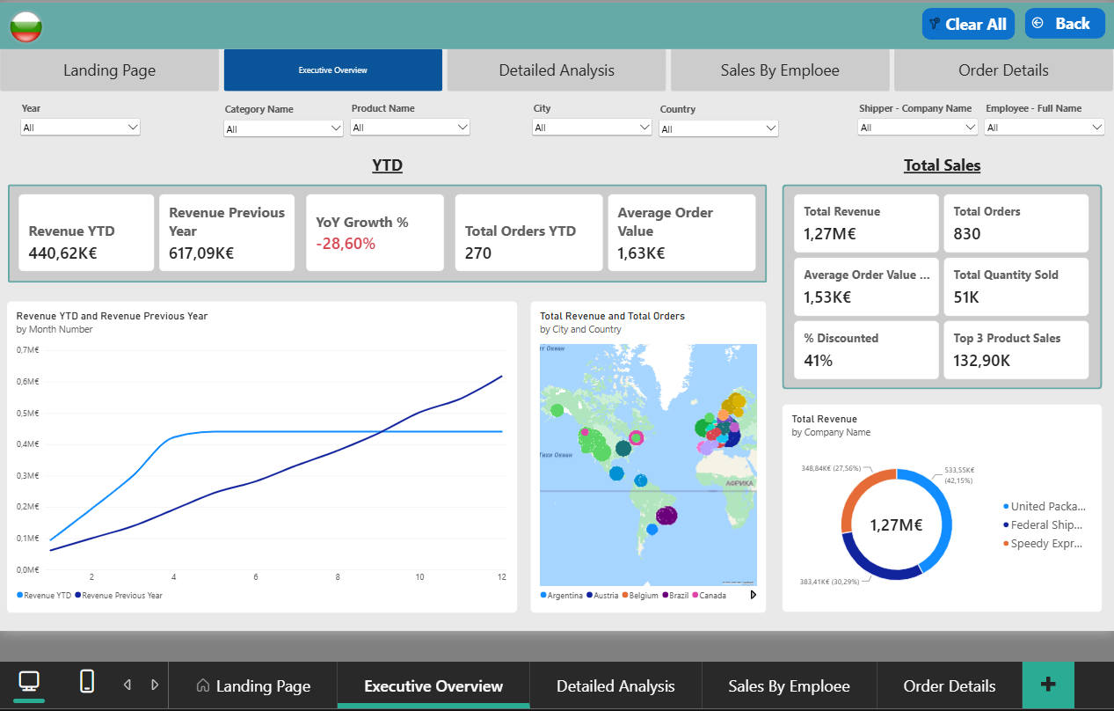

- Detailed Analysis (Products & Employees) 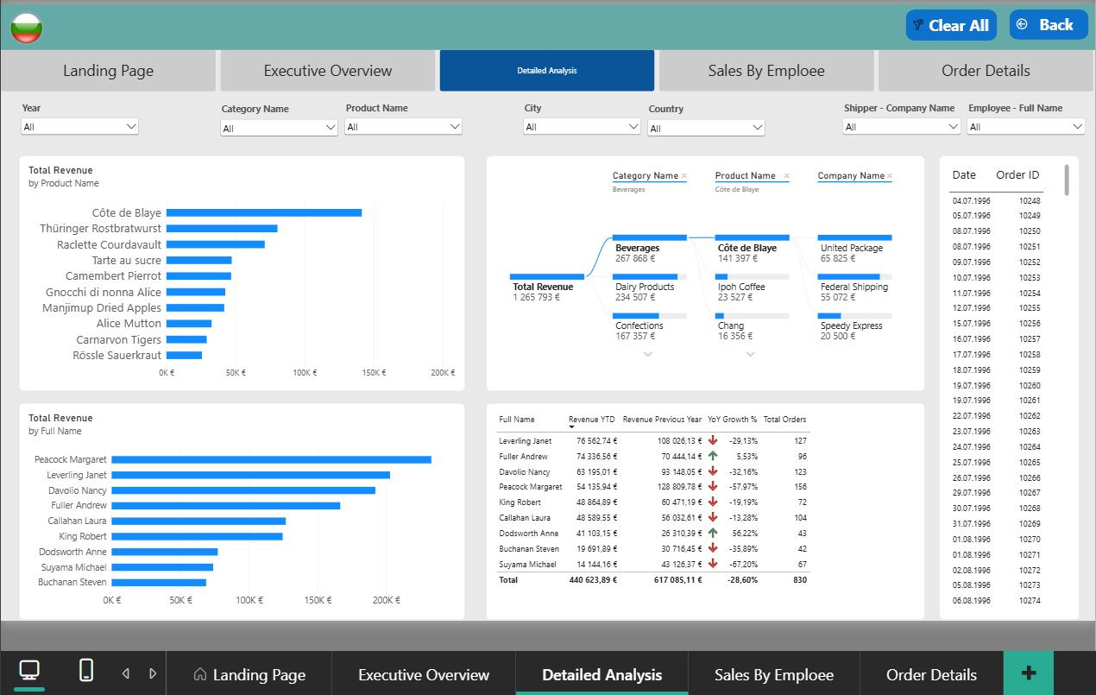

- Sales by Employee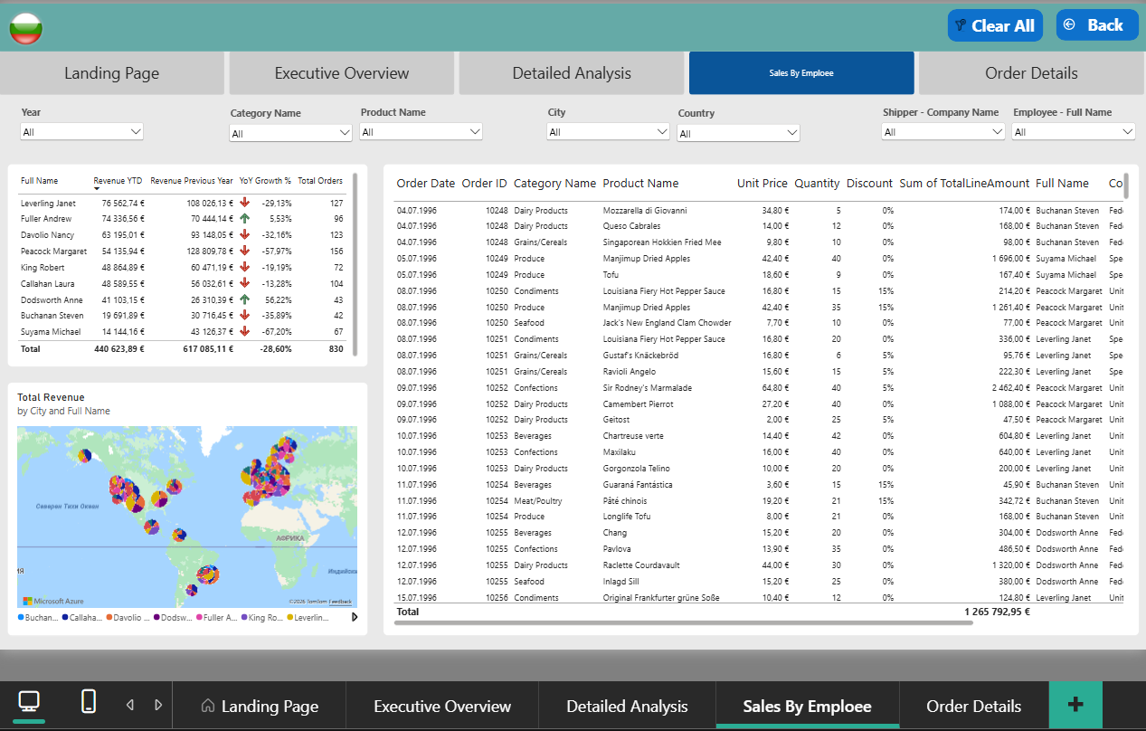

- Drill-through (Order Details)

- Data Model (Star Schema) 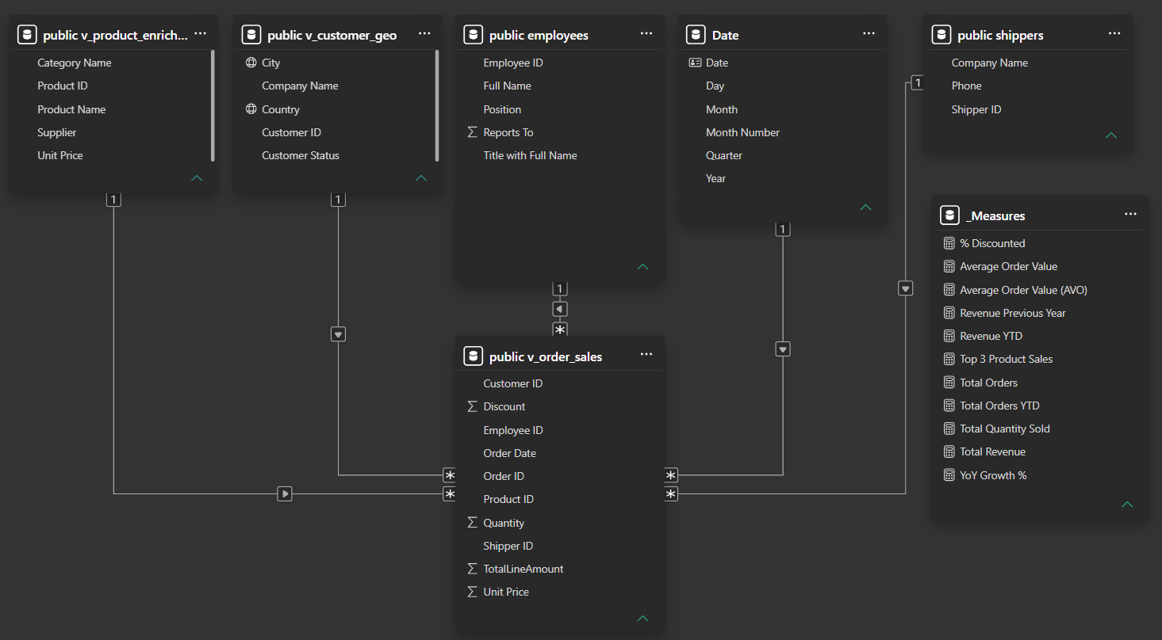

- Mobile View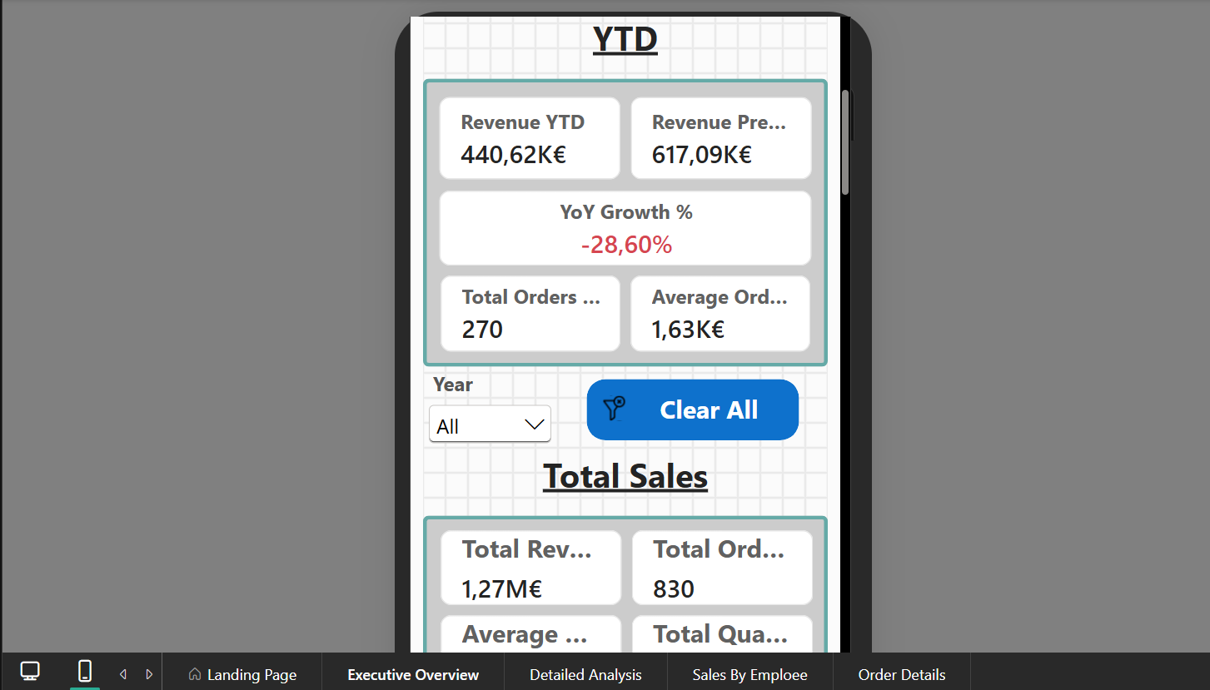

Conclusion
This project successfully demonstrates the complete implementation of a modern business intelligence solution, from database preparation and dimensional modeling to advanced analytics and dashboard development. The final report provides a comprehensive view of organizational performance by integrating sales, product, customer, employee, and operational data into a unified analytical platform.
The application of SQL preprocessing, Star Schema modeling, DAX calculations, interactive reporting features, and mobile optimization ensures both technical robustness and practical business value. As a result, the solution effectively supports data-driven decision-making and aligns with established Power BI and data analytics best practices.

