The football transfer market: who pays whom, and what age costs
Executive summary for the investment committee · 15 August 2026

What we set out to test
Two things everyone in football takes for granted: that transfer money is concentrating in fewer and fewer clubs, and that young players now carry a growing price premium. Both matter to this fund, because between them they decide whether "develop and sell" still has a margin or whether capital belongs at the buying end.
We wrote that expectation down before opening the data. The analysis contradicted it on both counts.

What we found
The money is spreading out, not concentrating.
The ten largest buying clubs took 32.1% of European transfer spending in 2022/23 and 26.7% in 2025/26, while the number of clubs buying at all rose from 339 to 382. This is not an English effect — excluding English buyers the share still falls, 30.6% to 24.0% — and it is not a four-season blip: FIFA’s census shows 45% more clubs paying transfer fees in 2025 than in 2018.
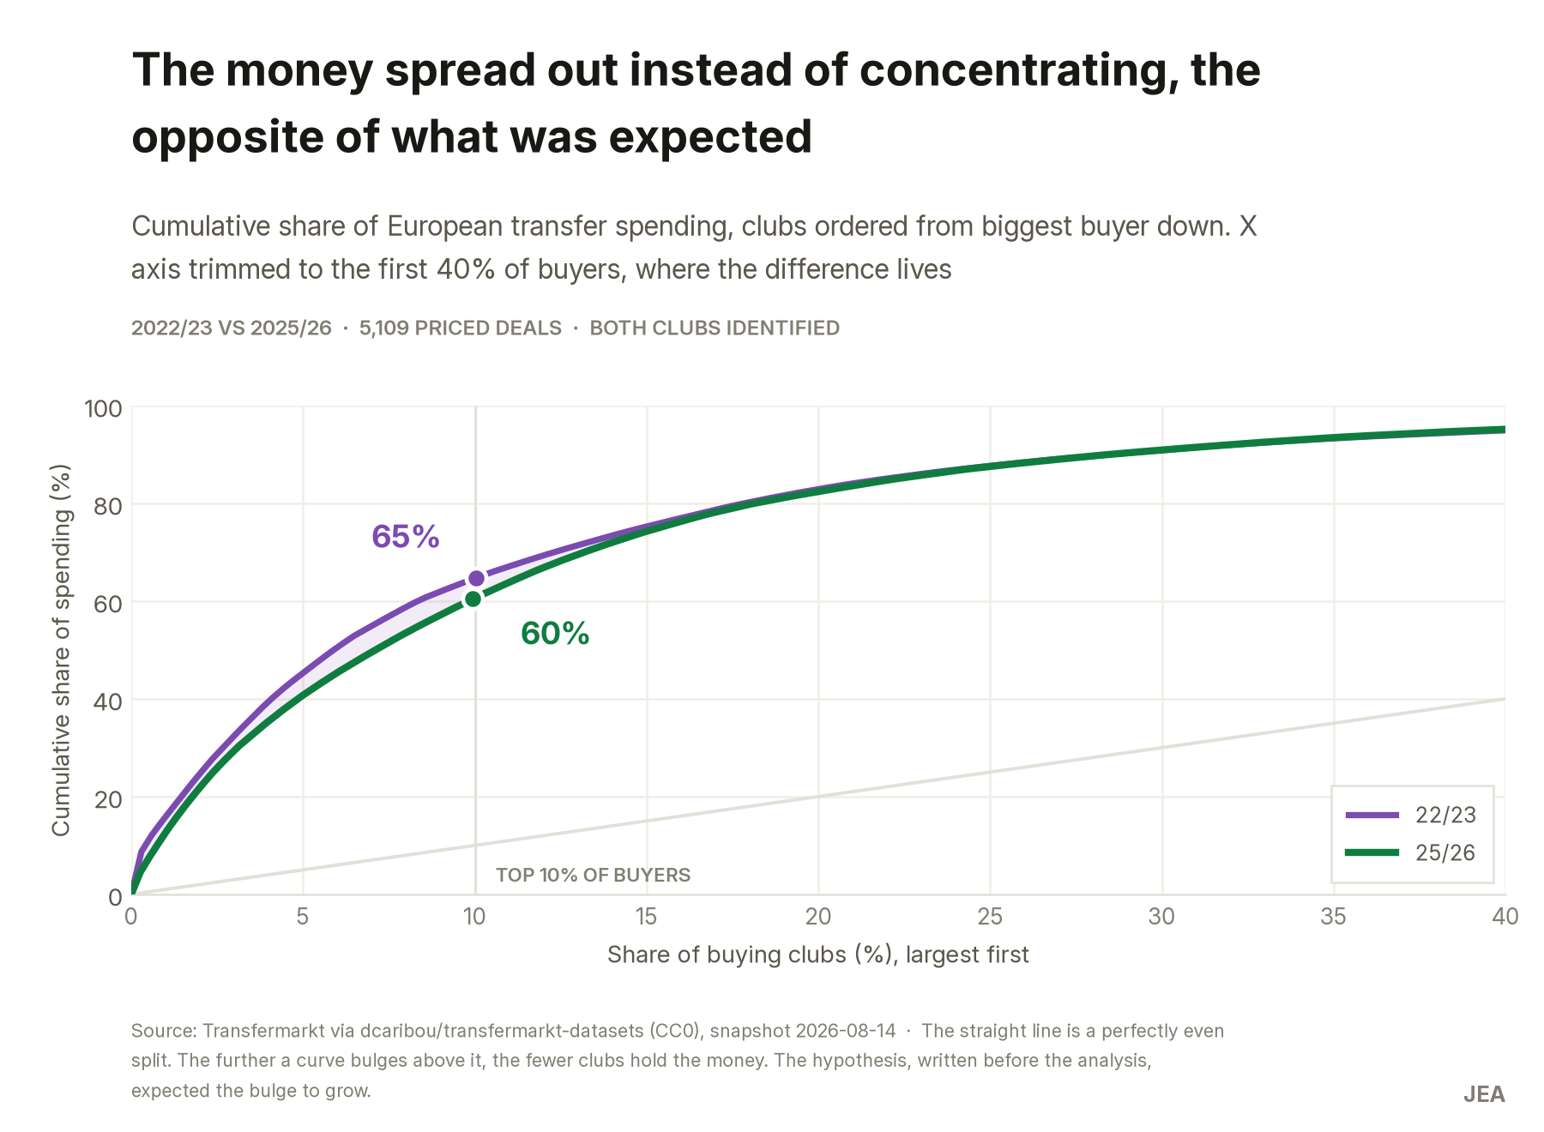
The top 10% of buyers took 65% of the money in 2022/23 and 60% in 2025/26.
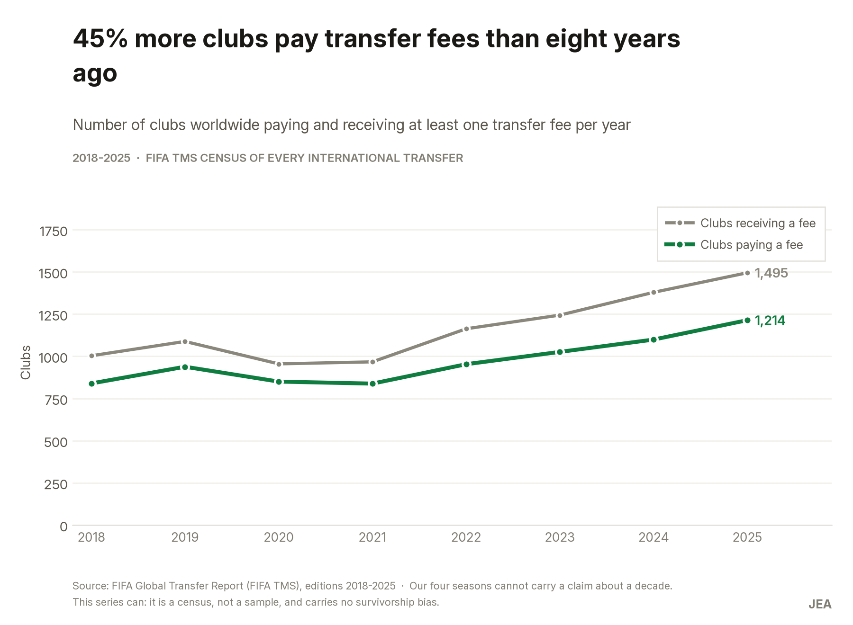
FIFA TMS census: clubs paying a fee up 45% since 2018, clubs receiving one up 49%.
Selling is a durable position, not a bad year.
Of 350 clubs present in all four seasons, 202 were net sellers in three or more, and 96 in all four; chance alone would have produced 61. Ajax banked €267m net across the period, Salzburg €234m, Lille €185m. Chelsea (−€800m) and Manchester United (−€672m) never once finished a season as net sellers.
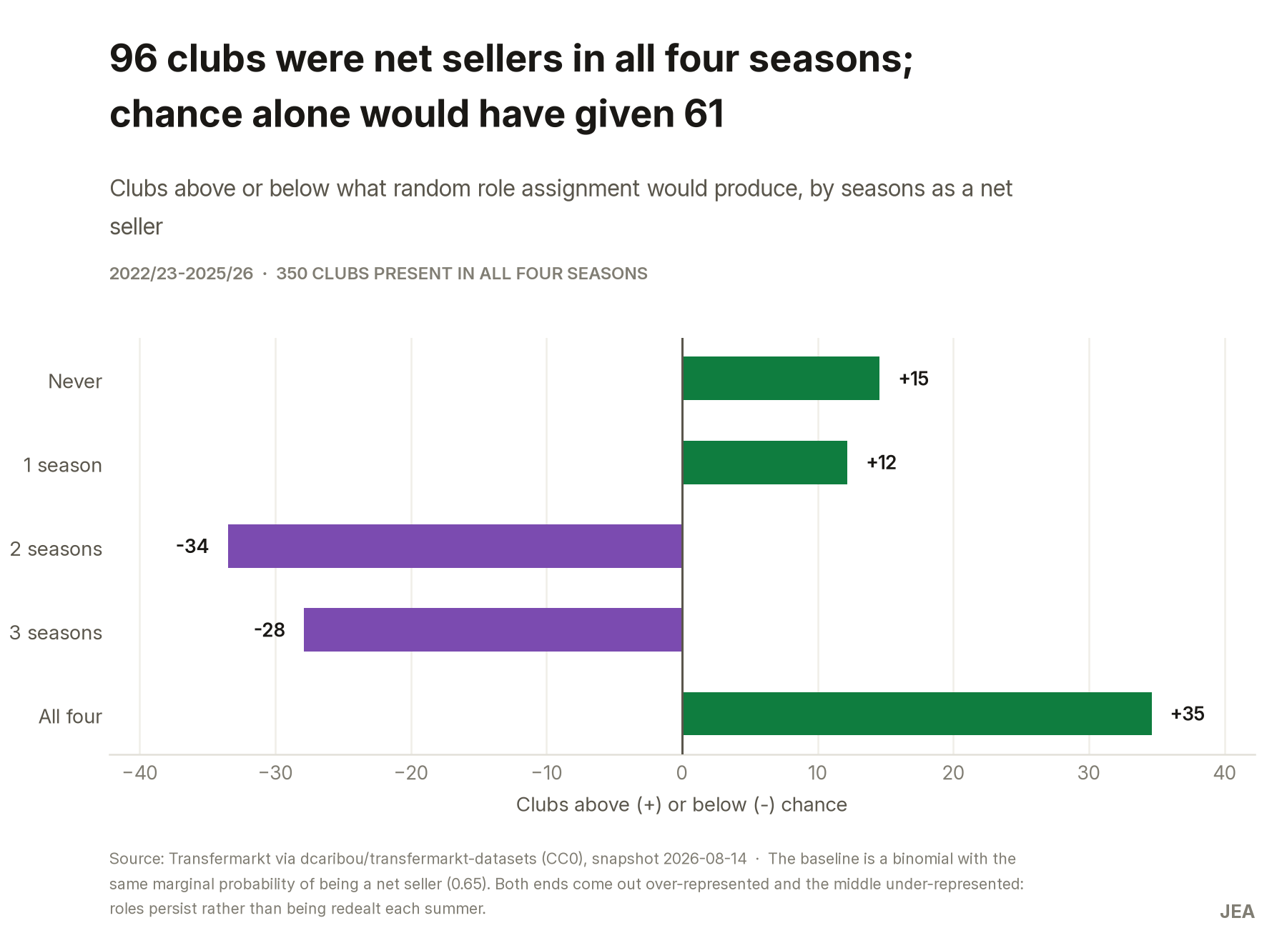
Clubs above or below what random role assignment would produce.
Youth carries no premium.
An 18–23 player costs roughly what a 24–29 player costs — a ratio around 1.0 that does not escalate in either of our two independent sources. Clubs paying more for youth as such are not following the market.
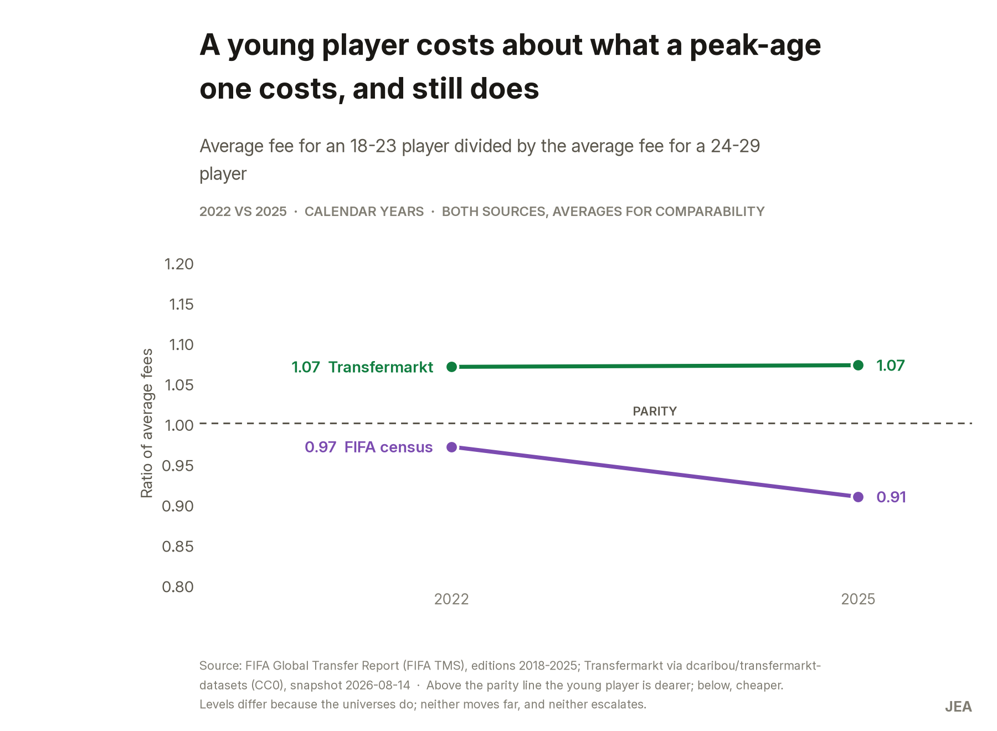
Ratio of average fees, 18-23 against 24-29, in both sources.
But the young market runs at two speeds.
Deals of €40m or more are 2.3% of all young-player transactions and take 23.8% of the money spent on them, while the 71% priced under €5m account for just 15%. The headline signings are real; they simply sit on top of a long, cheap tail that is what actually moves the totals.
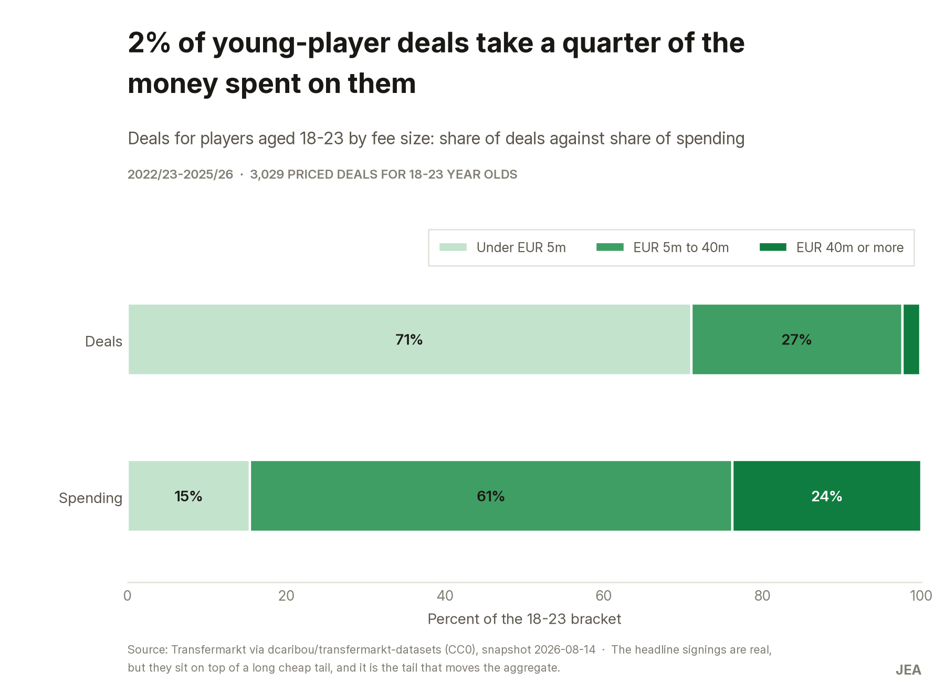
Share of deals against share of spending, players aged 18-23.

What we recommend
- Put the next tranche into a persistent net seller in a mid-tier league, not into an elite club. The scarce asset is not money to spend — that side of the market has more participants every year — but a reliable supply of sellable players.
- Cap prices against the market band and write into the mandate that age carries no premium. A policy change, not a project.
- Make each club pick its lane in the young-player market: cheap volume or elite few. A club drifting between the two competes badly in both.

What this analysis cannot tell you
Four seasons of deal-level data is not a trend, so every statement about direction over time rests on FIFA’s census rather than on ours. We make no claim about the share of spending going to young players in level or direction: our two sources disagree, and the gap doubles in 2025 for reasons we cannot defend. Nothing here is causal — the case describes how the market is structured, not what moves it. And net transfer income is not profit: without club accounts, "sells well" is not the same as "makes money".
Full method, checks and decision log: CASO.md in the case repository.

