Practical 1

Project: Movie Collection Manager
Objective: Work with arrays and objects to manage a collection of movies dynamically.
Tasks:
- Create an array of movie objects, where each object has fields like title, genre, rating, and release year.
- Write functions to:
  - Add a new movie to the collection.
  - List all movies in a specific genre.
  - Find the highest-rated movie in the collection.
  - Use map() to create a list of all movie titles.
  - Use filter() to find movies released after a specific year.
  - Log the results to the console using template literals.

Screenshots of Code:
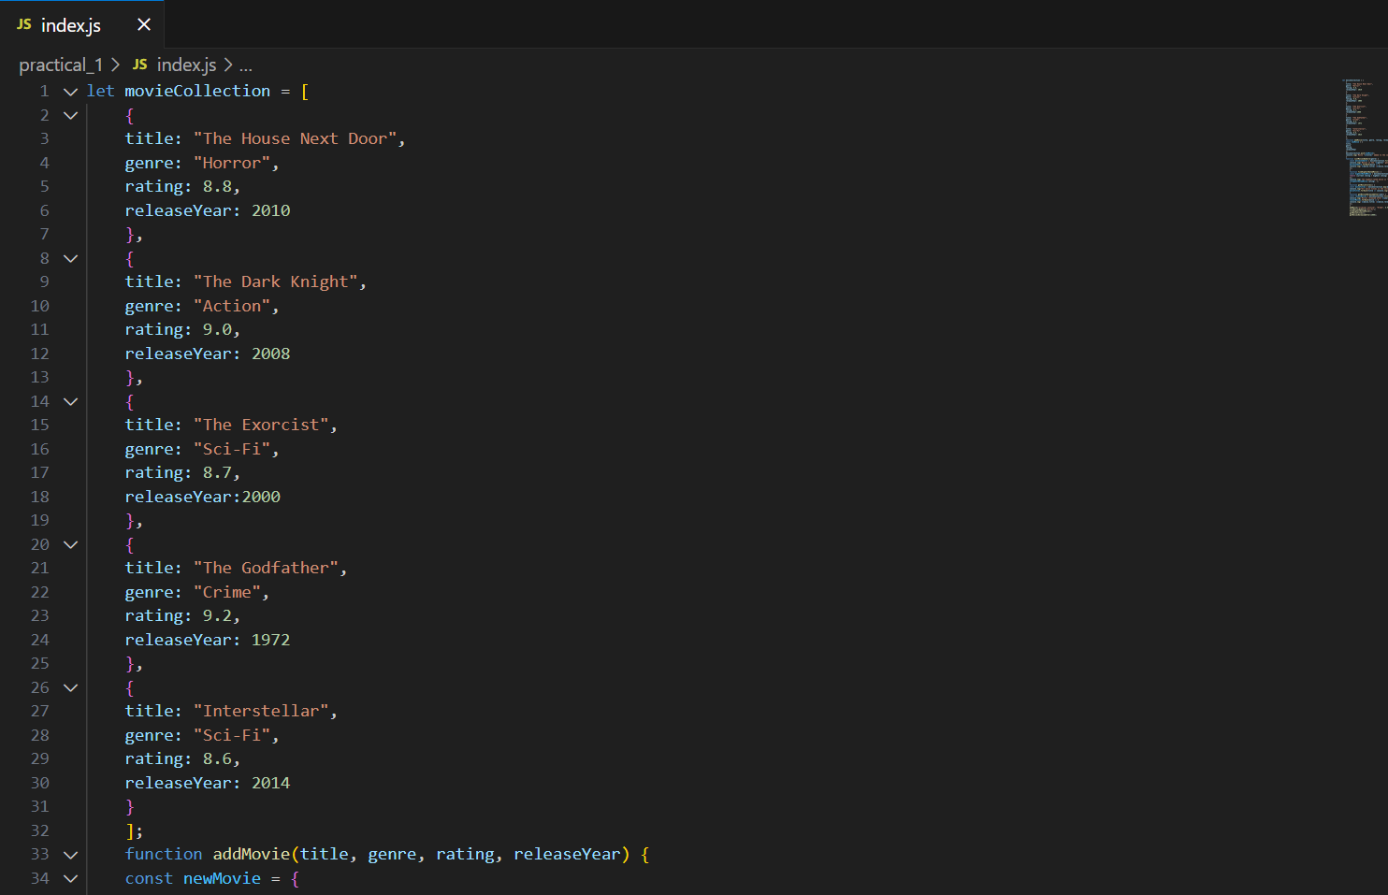
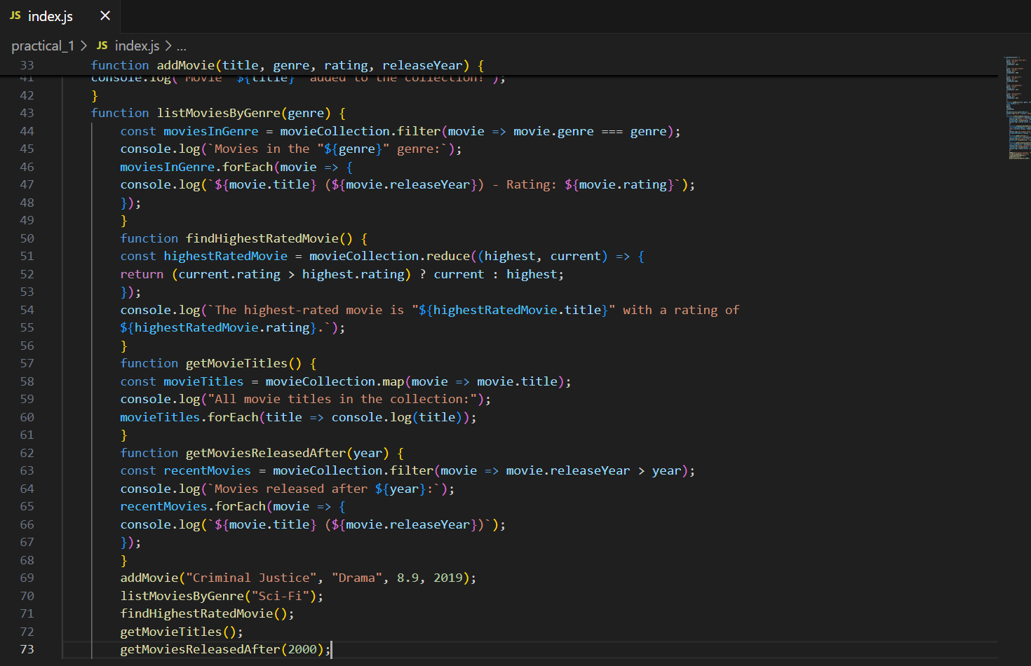
Screenshots of Output:
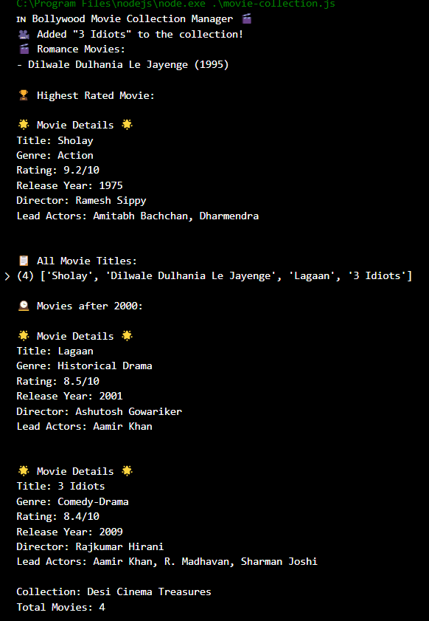

Conclusion: This practical taught us how to organize movie information using arrays and objects in JavaScript. We learned to add movies, search through them by genre, find the highest-rated movies, and create lists of movie titles. This helps understand how to organize and search through collections of information.

Practical 2

Project: Task Reminder System
Objective: Build a task reminder system that schedules reminders and
handles asynchronous delays.
Tasks
● Create an array of task objects, where each task has fields like
title, dueTime (in minutes from now), and priority.
● Write functions to:
○ Add a new task to the list.
○ Sort tasks by their priority.
○ Display tasks due within a certain timeframe (e.g., next 10 minutes).
○ Simulate sending reminders using setTimeout() based on
the task's dueTime.
● Use try...catch to handle errors, such as invalid task data or
missing fields.
● Export and import the task management functions using Jav
aScript modules.
Screenshots of Code:
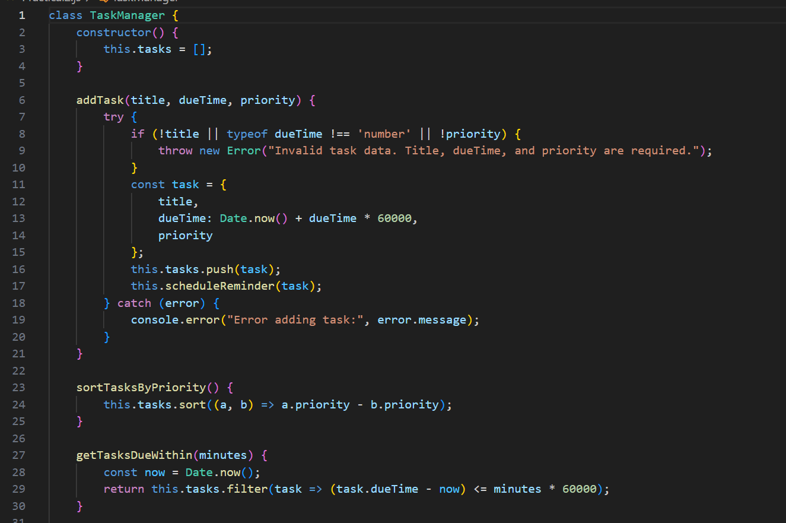
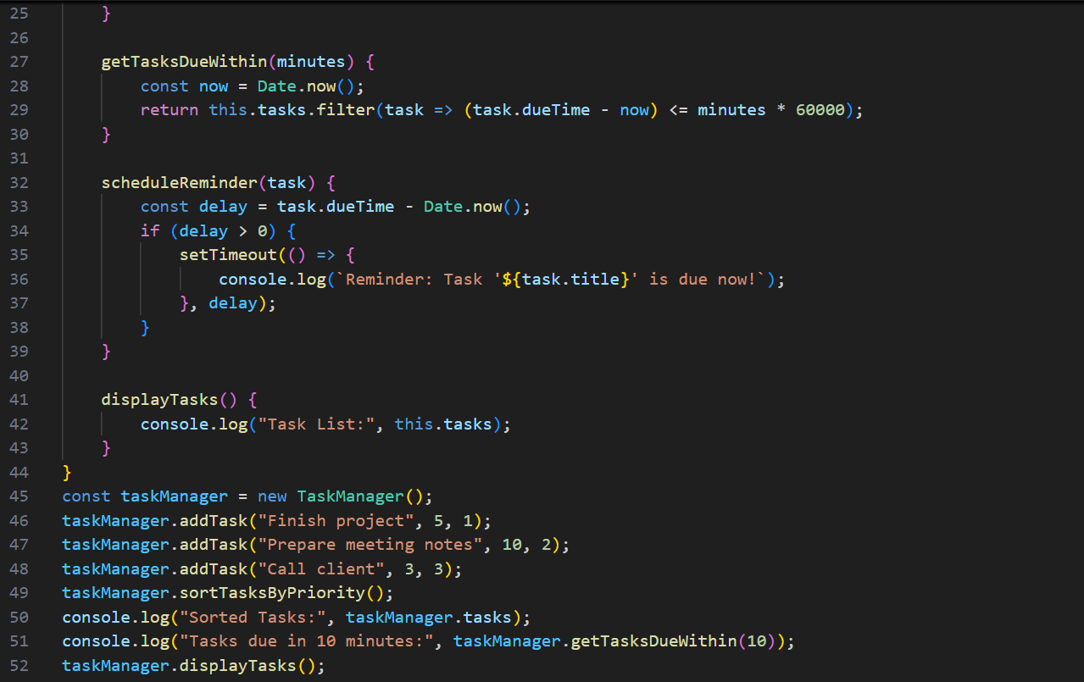
Screenshots of Output:
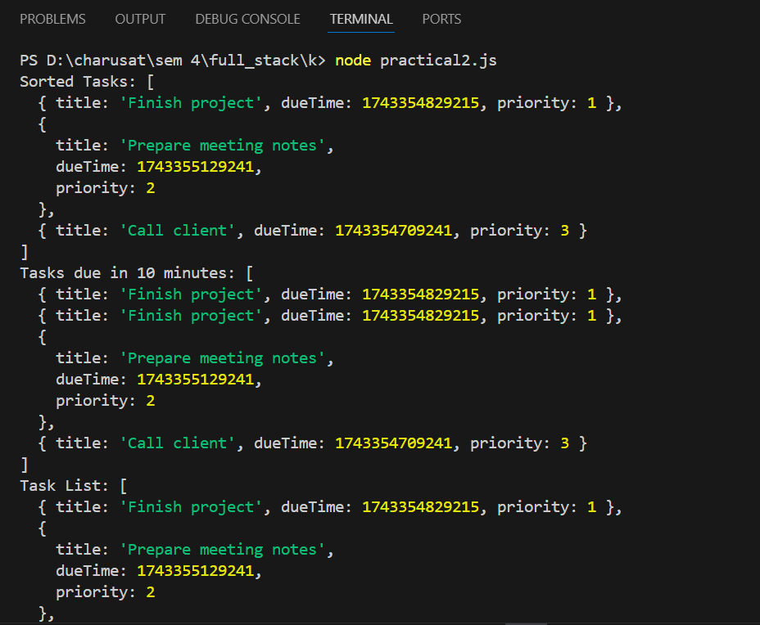

Conclusion: In this practical, we built a system that reminds users about tasks they need to complete. We learned how to schedule tasks, organize them by priority, and show which tasks are due soon. This teaches us how computers can help us remember important things at the right time.

Practical 3

Project: System Utility Dashboard
● Objective: Create a command-line tool that provides system
information.
● Tasks:
1. Use the os module to display the OS type, total memory,
free memory, and CPU details.
2. Use the fs module to save the system information to a log
file.
3. Use the path module to ensure the file is saved in a
standardized format (logs/system-info.txt).
Screenshots of Code:
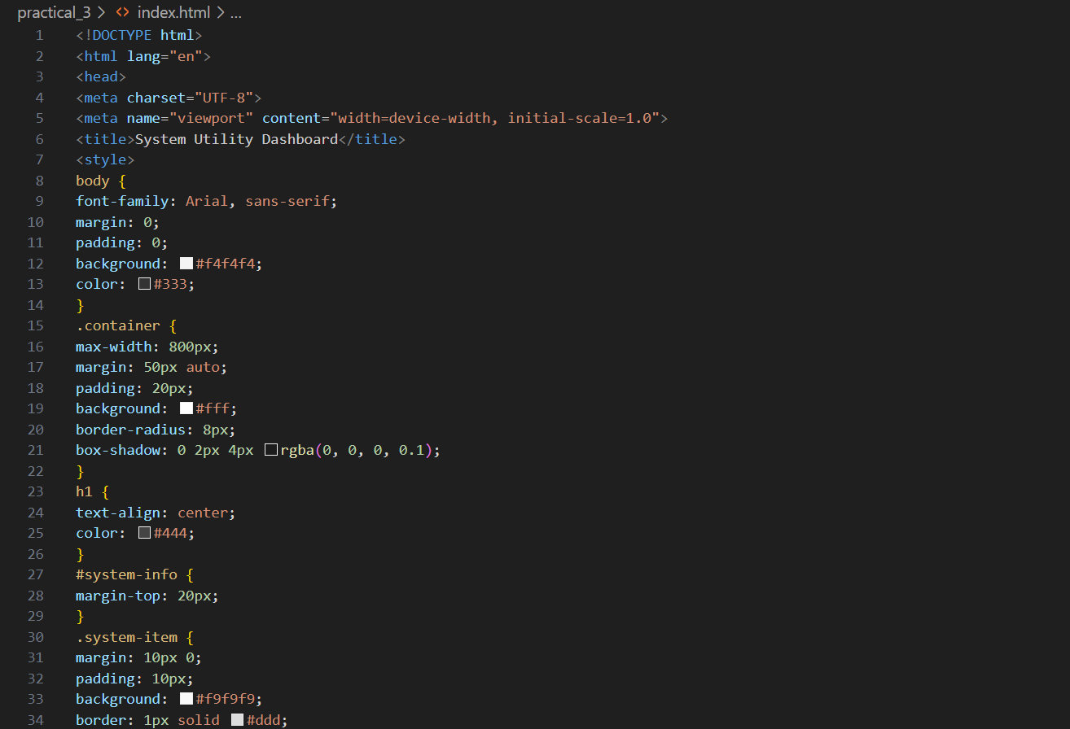

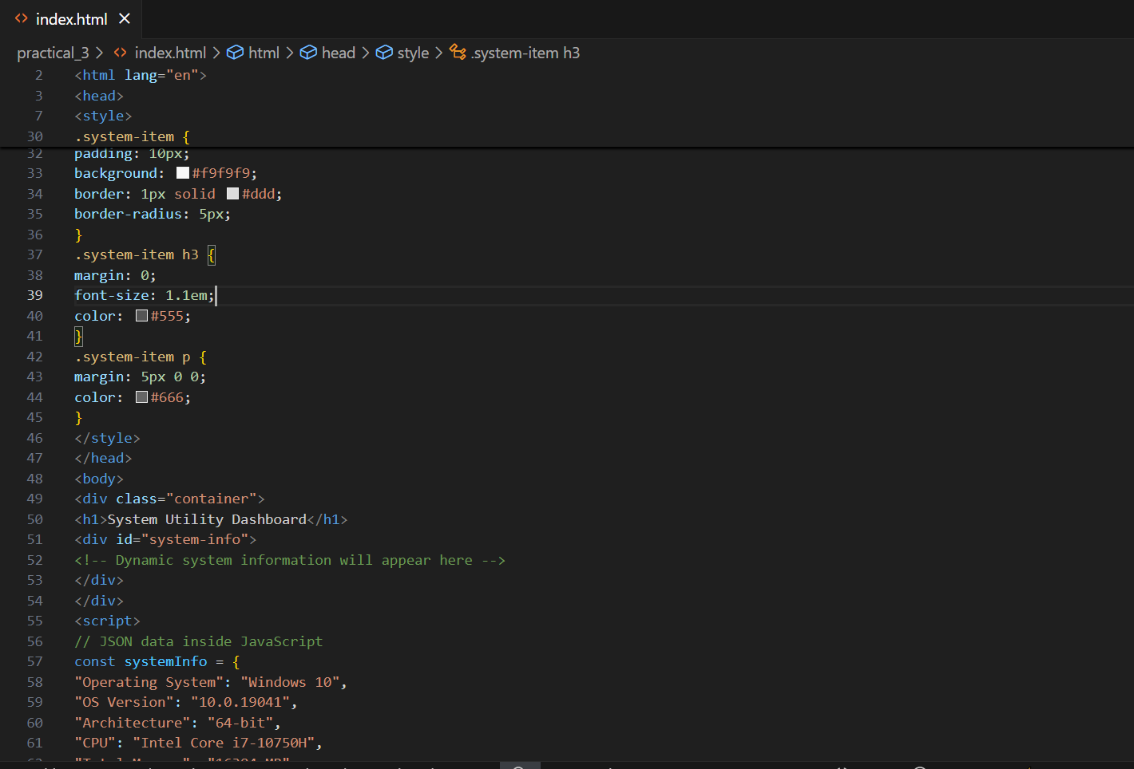

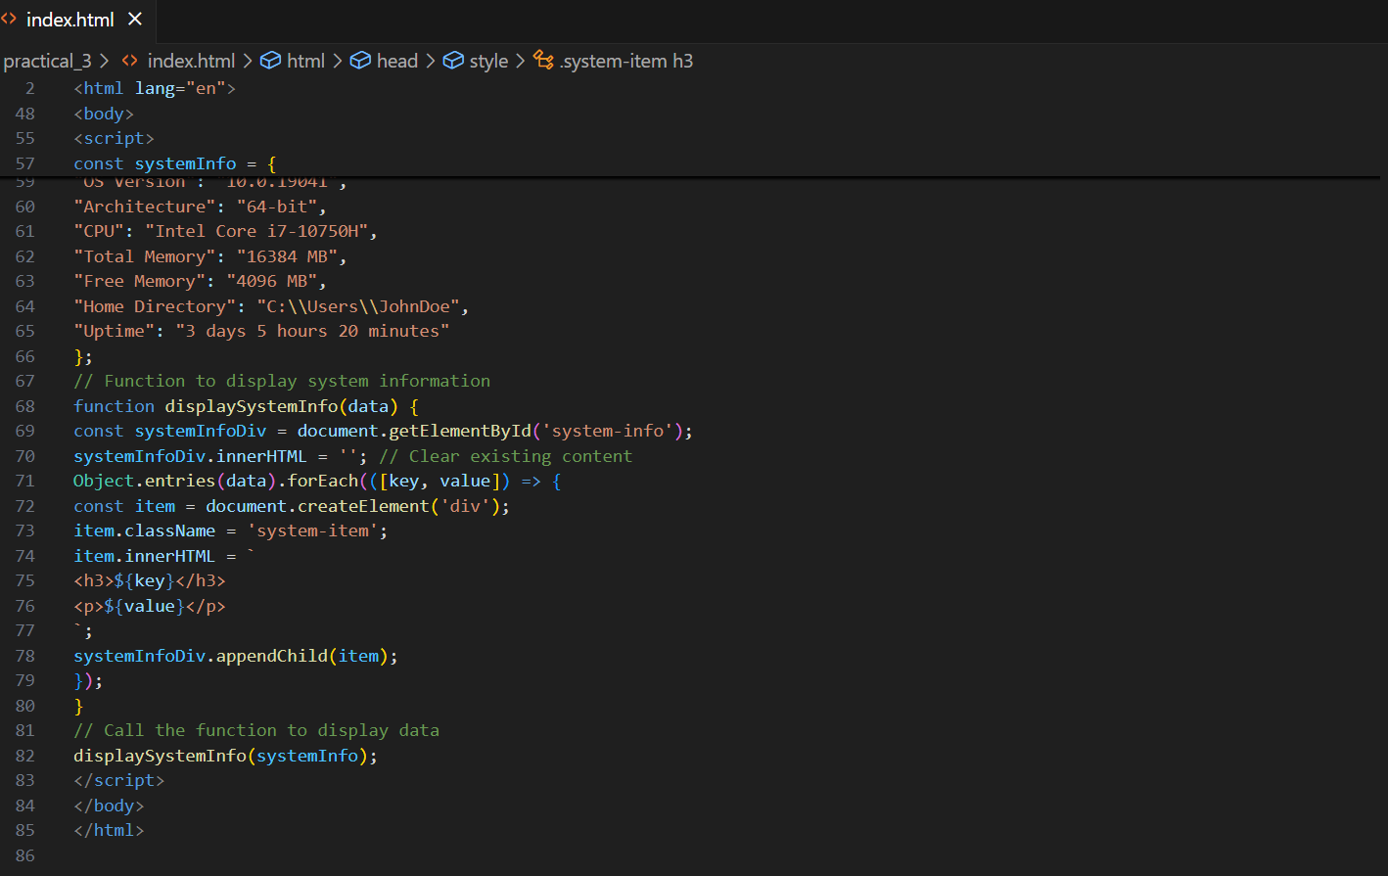
Screenshots of Output:
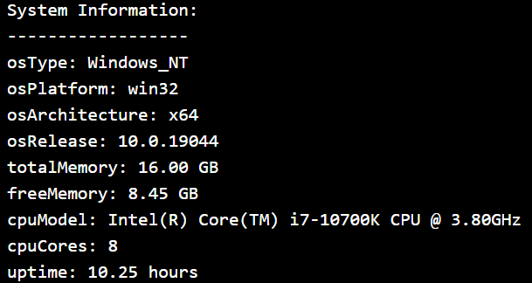

Conclusion: This practical showed us how to create a tool that gives information about a computer's system, like its memory and processor. We also learned how to save this information to a file for later. This helps understand how to gather and store system information.

Practical 4

Project: Basic Static File Server
Objective: Build an HTTP server to serve static files like HTML, CSS,
and images.
Tasks:
● Create a simple HTML page with a welcome message and a few
images.
● Use the http and fs modules to serve these files when the
browser requests them.
● Add logic to handle 404 errors when a file is not found.

Screenshots of Code:
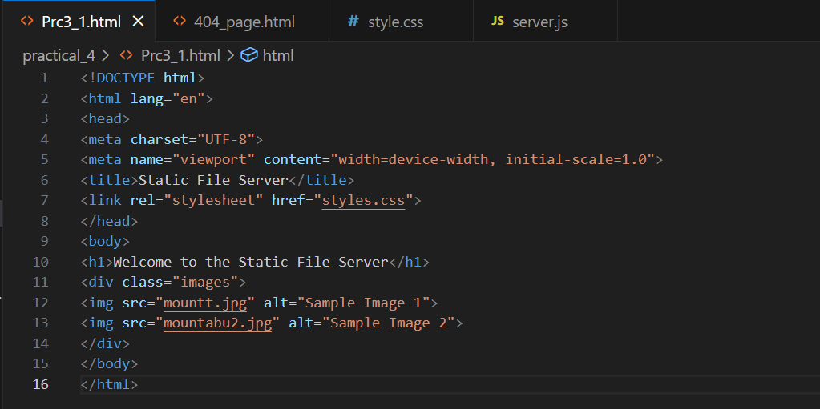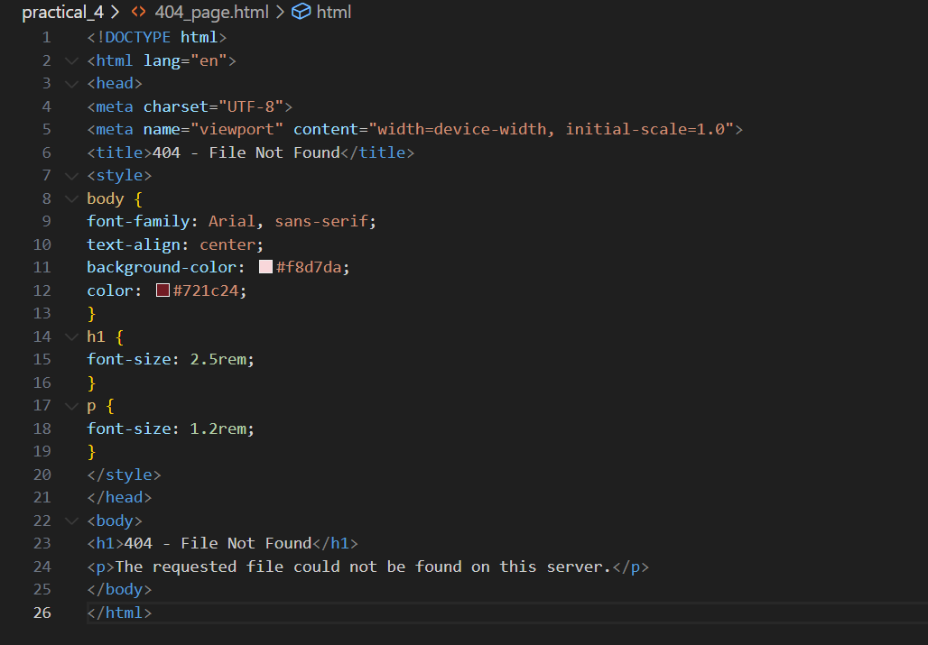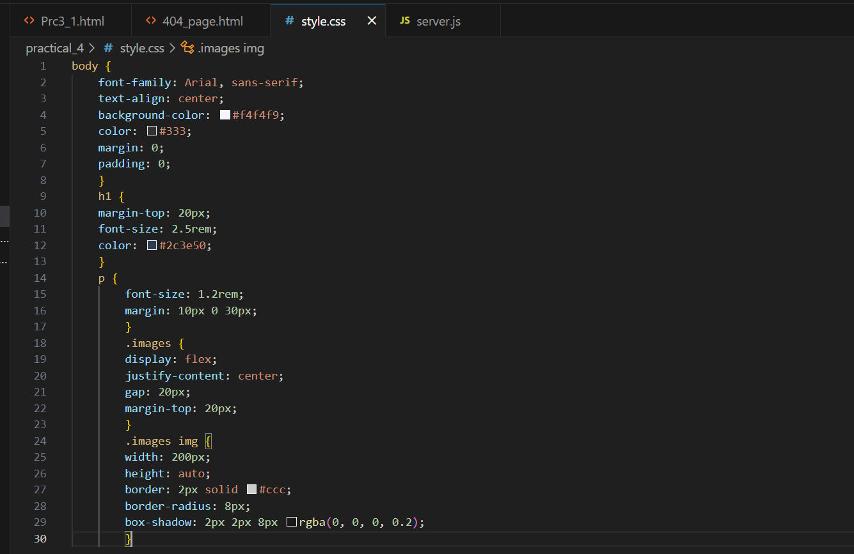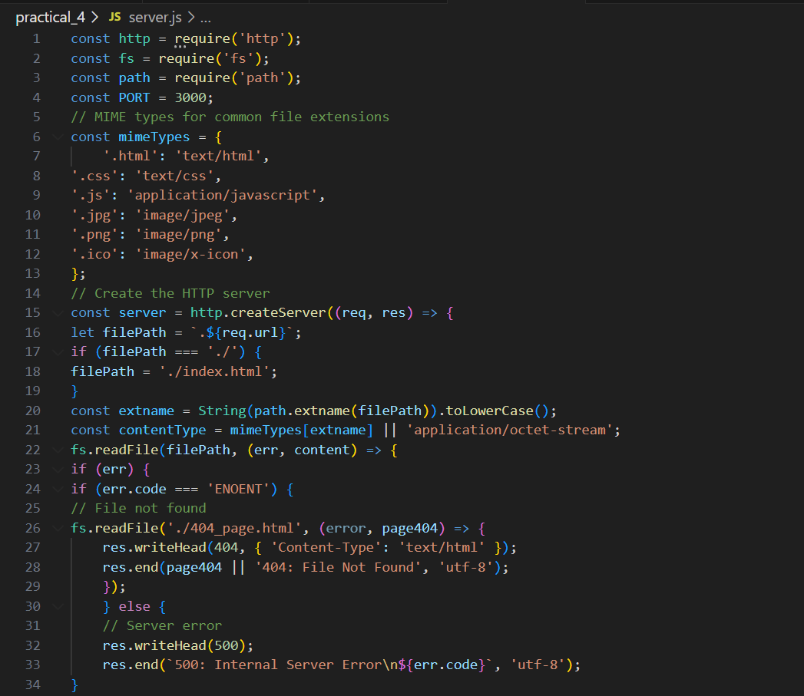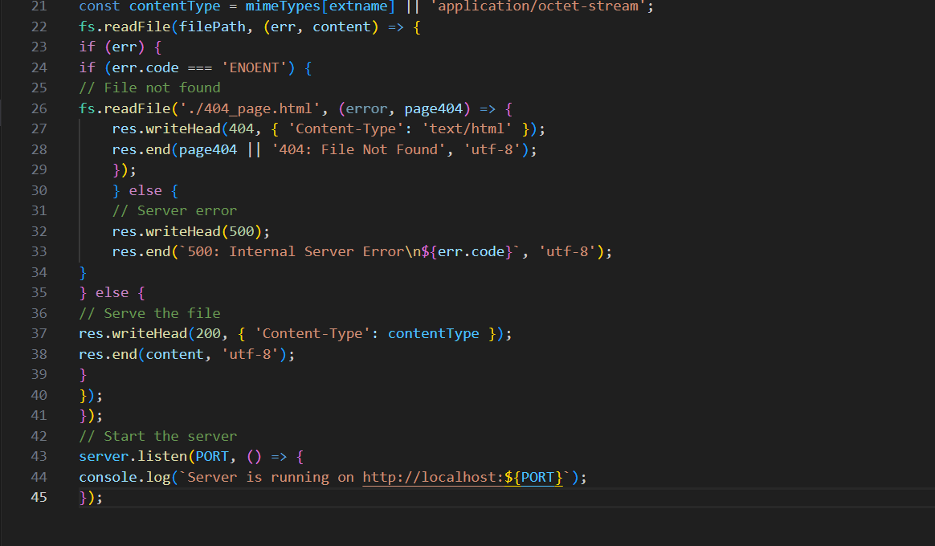
Screenshots of Output:
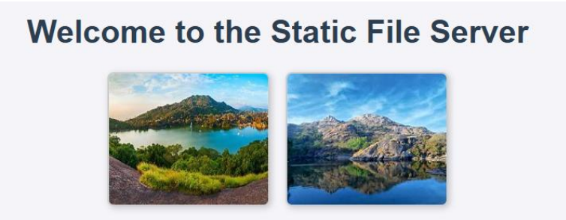

Conclusion: We built a simple web server that can show webpages, images, and other files when someone visits our website. We also learned how to handle errors when a file can't be found. This helps understand how websites deliver content to visitors.

Practical 5

Project: File Organizer Tool
Objective: Build a CLI tool to organize files into folders based on their
type (e.g., images, documents, videos).
Tasks:
● Accept a directory path as an input from the user.
● Use the fs module to read all files in the directory.
● Move files into folders like Images, Documents, and Others
based on their extensions.
● Log the operations performed into a summary.txt file.
Screenshots of Code:
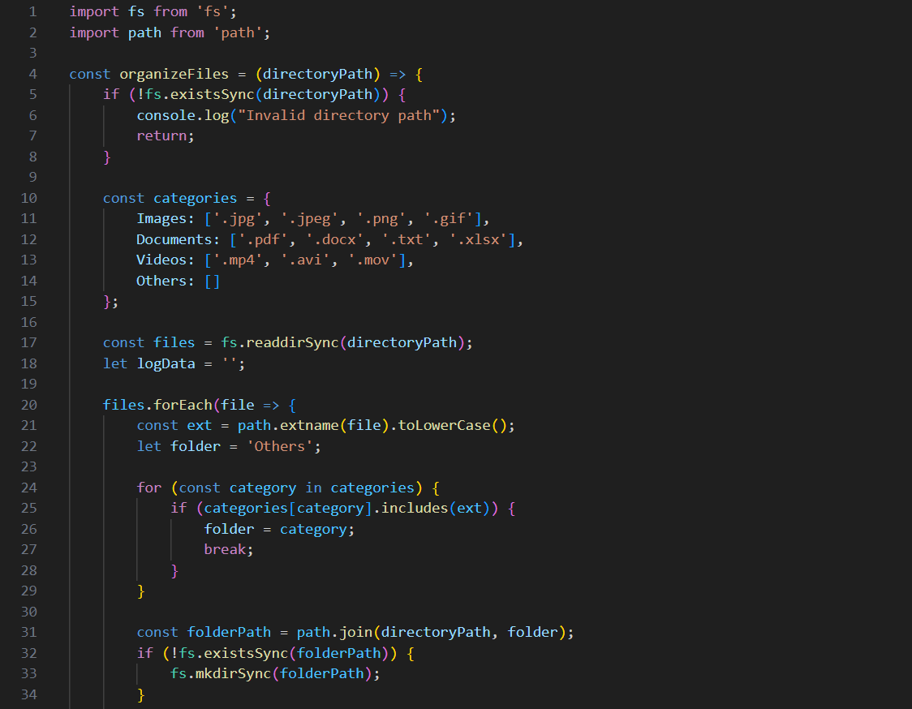
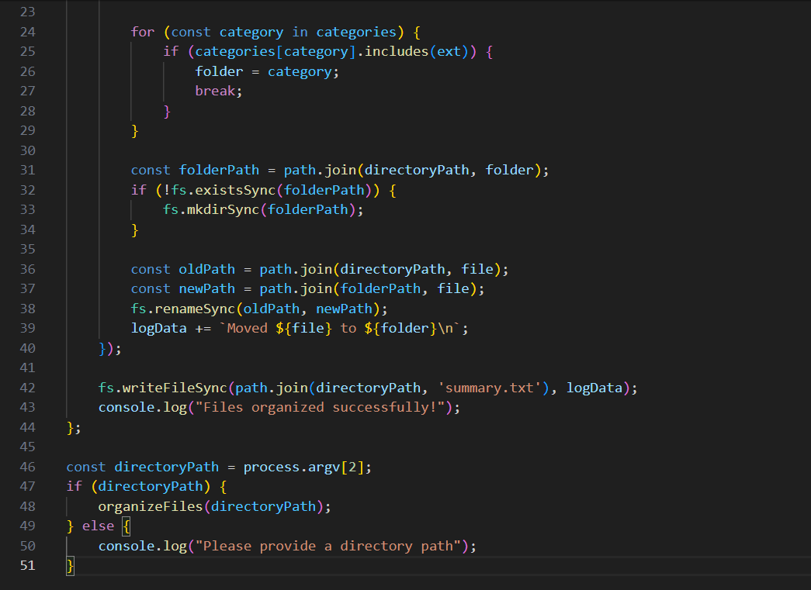
Screenshots of Output:
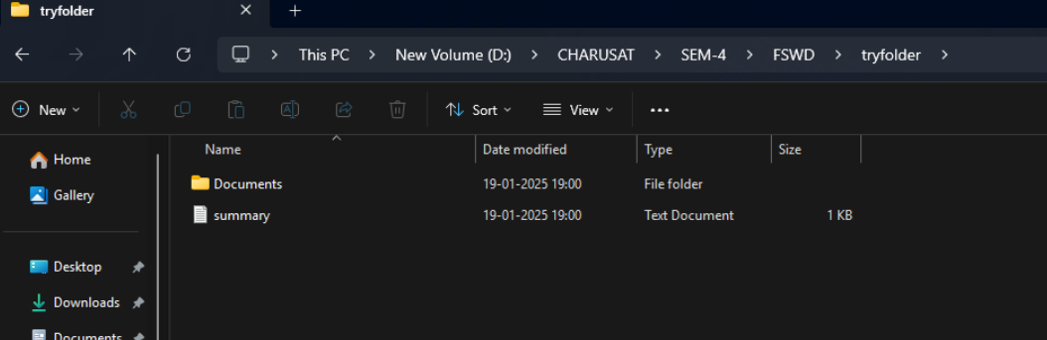

Conclusion: This practical taught us how to create a tool that automatically sorts files into folders based on what type they are (like images or documents). This helps understand how to organize files on a computer automatically.

Practical 6

Project: User Management System

Objective: Create a RESTful API to manage user data without using Express.js.

Tasks:
● Implement the following endpoints using the http module:

● GET /users: Return a list of all users stored in a JSON file.
● POST /users: Accept new user data in the request body and add it to the JSON file.
● DELETE /users/:id: Remove a user by their ID from the JSON file.
● Use the fs module to store and retrieve user data persistently.
● Test the API using Postman or curl.

Screenshots of Code:
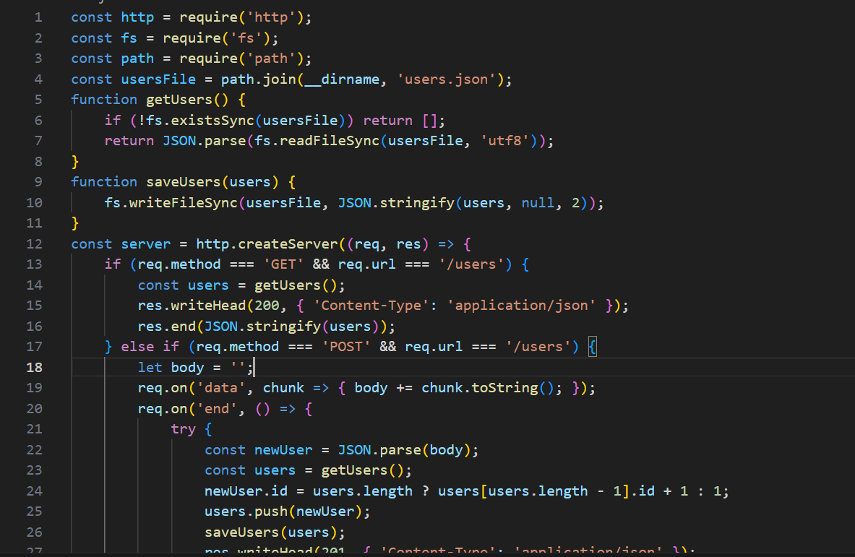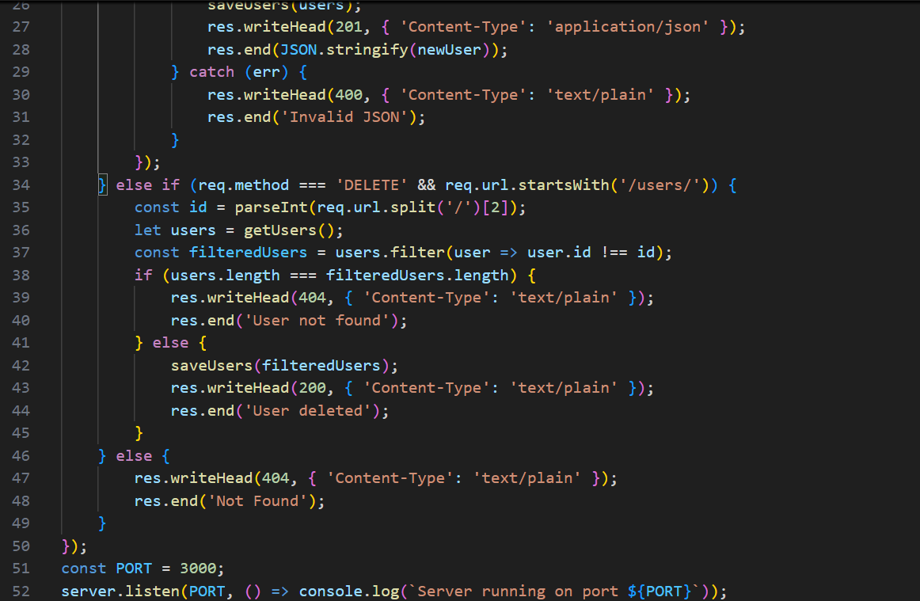
Screenshots of Output:
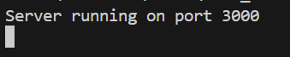
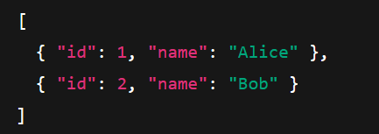

Conclusion: We built a system that can store, show, add, and remove user information. This teaches us how websites manage user data and how to build simple APIs (ways for computers to talk to each other).

Practical 7

Project: Simple Content Delivery Server

Objective: Create a static file server with basic APIs for logging user visits.

Tasks:
● Serve static HTML, CSS, and JS files from a public directory.
● Log every user visit (IP, time) to a visits.log file using middleware.
● Provide an API endpoint (GET /logs) to retrieve the log data as JSON.

Screenshots of Code:
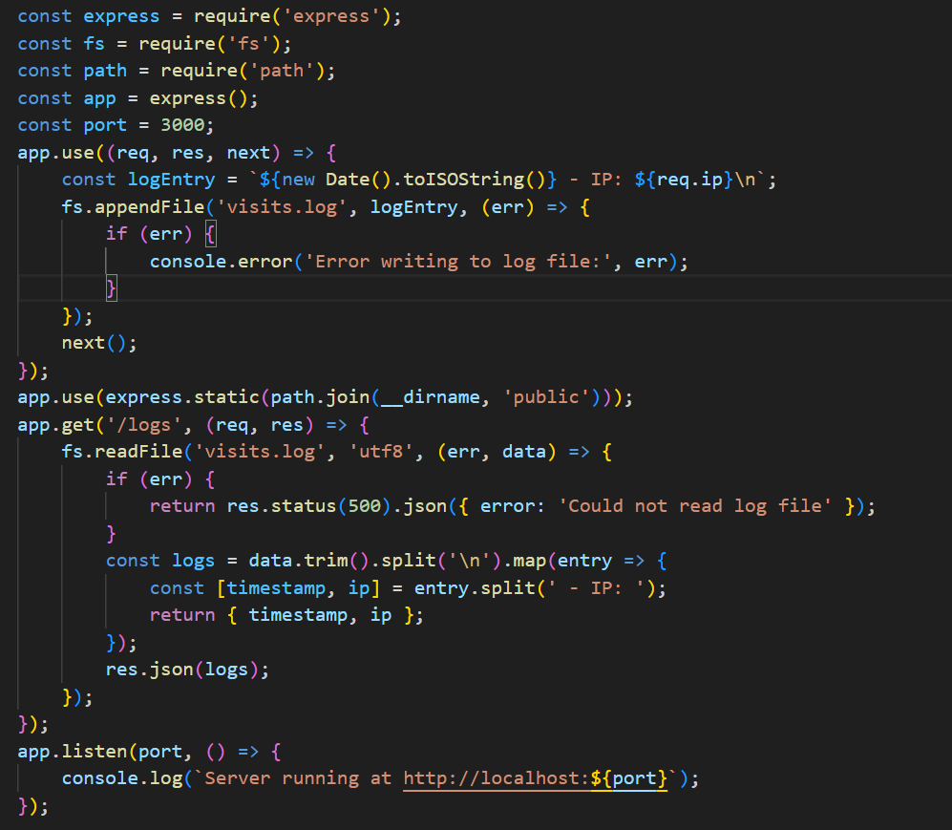
Screenshots of Output:
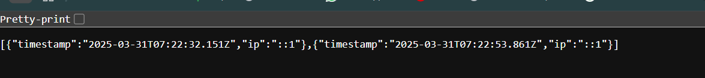

Conclusion: This practical showed us how to create a server that delivers website content and keeps track of who visits. This helps understand how websites track visitors and serve content.

Practical 8

Project: E-Commerce Product Catalog API

Objective: Build an API for managing an e-commerce product catalog.

Tasks:
● GET /products: Return all products.
● GET /products/:id: Fetch a specific product by ID.
● GET /products?category=electronics: Filter products by category.
● Use route parameters and query strings effectively.

Screenshots of Code:
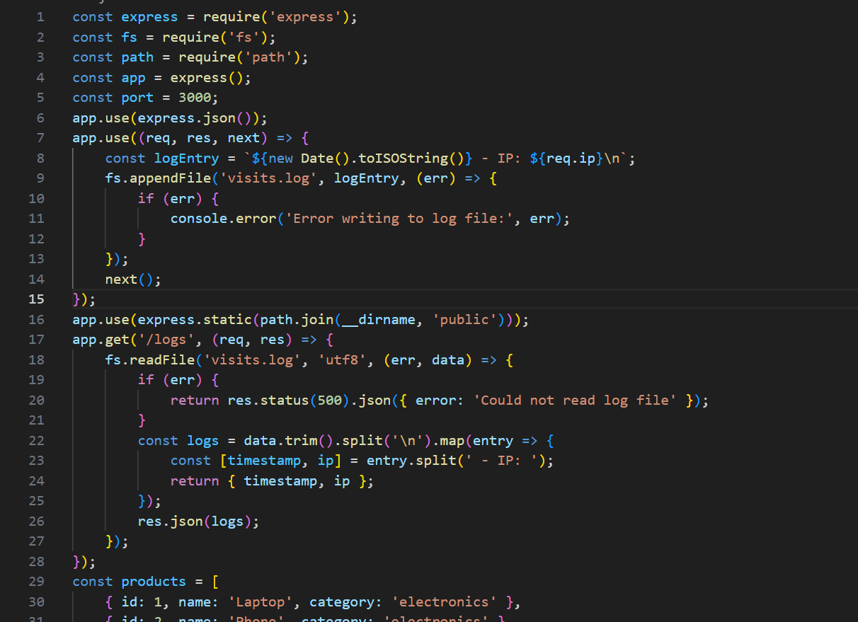
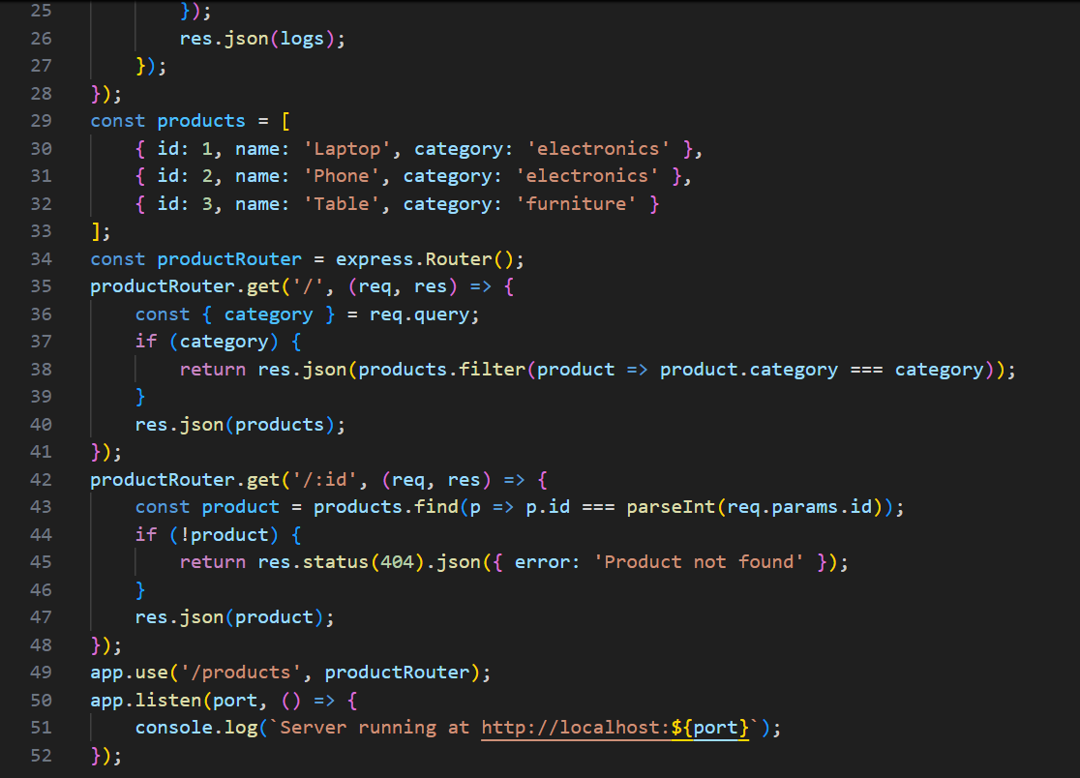
Screenshots of Output:
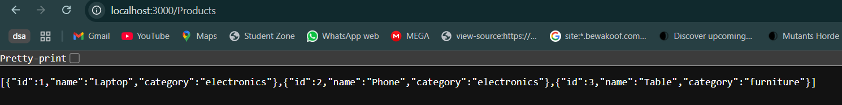
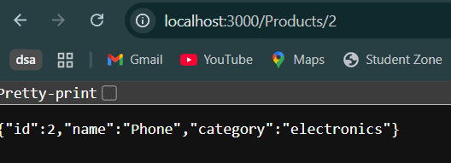
Conclusion: We built an API for an online store that can show all products, find specific products, and filter products by category. This teaches us how online stores organize their product information.
Practical 9

Project: Order Management System

Objective: Create a secure API for managing orders with robust logging, error handling, authentication, and session management.

Tasks:

1. CRUD Operations for Orders
● Implement endpoints:
● POST /orders: Create a new order.
● GET /orders: Retrieve all orders.
● GET /orders/:id: Retrieve a specific order by ID.
● PUT /orders/:id: Update an order by ID.
● DELETE /orders/:id: Delete an order by ID.
● Use in-memory storage or a simple database (e.g., MongoDB with Mongoose) for storing orders.

2. Logging Middleware
● Write a custom middleware function to log:
● HTTP method, URL, and timestamp of each API call.
● Save the logs to a file (server.log) using the fs module.

3. Centralized Error Handling
● Implement a centralized error-handling middleware for:
● Invalid endpoints (404 errors).
● Missing or incorrect data in requests (400 errors).
● Server errors (500 errors).
● Use custom error classes for cleaner error handling.

4. Authentication with JWT
● Add user authentication with login and registration endpoints:
● POST /auth/register: Register a new user.
● POST /auth/login: Authenticate a user and return a JWT token.
● Secure order endpoints so only authenticated users can access them.
● Implement middleware to validate JWT tokens in API requests.

5. Session Management
● Use JWT tokens stored in HTTP-only cookies for session
management.
● Set the cookie on login and remove it on logout:
● POST /auth/logout: Clear the authentication cookie.

6. Bonus Task: Role-Based Access Control
● Assign roles (e.g., admin, user) during user registration.
● Restrict certain endpoints (e.g., DELETE /orders/:id) to admin users.
Screenshots of Code:
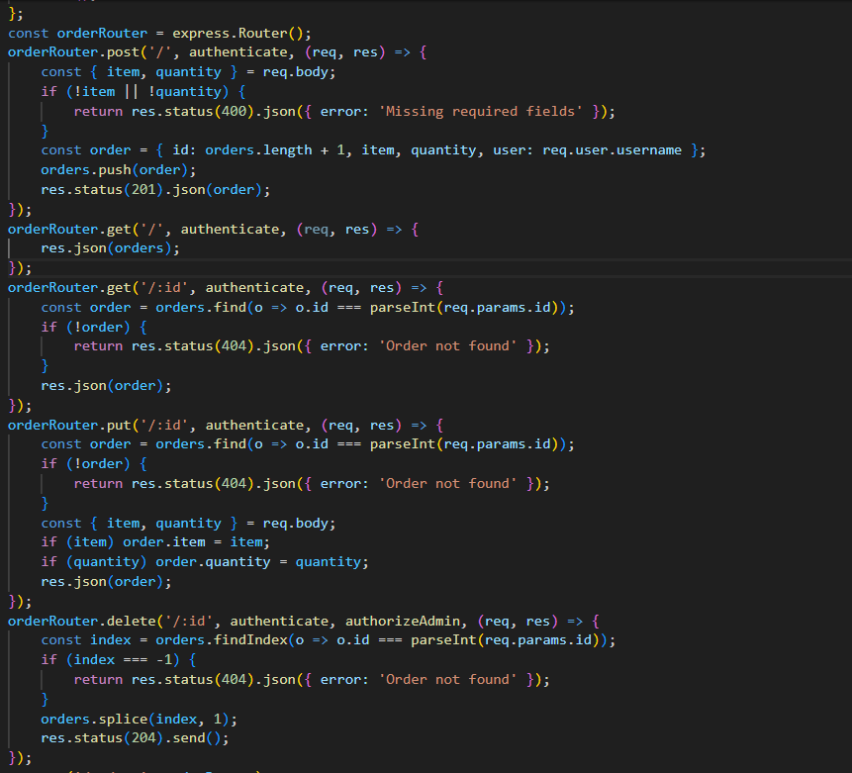

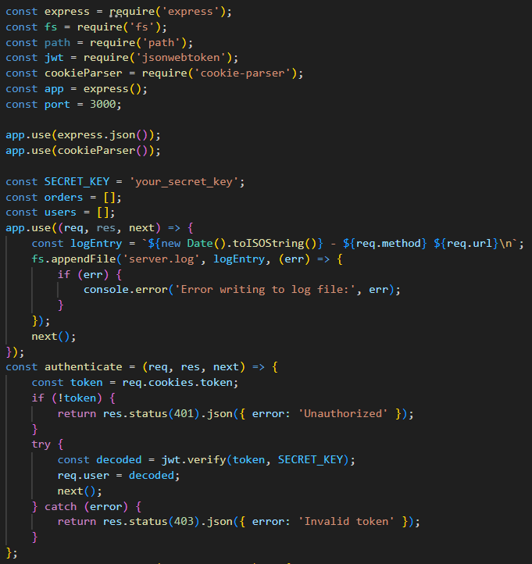
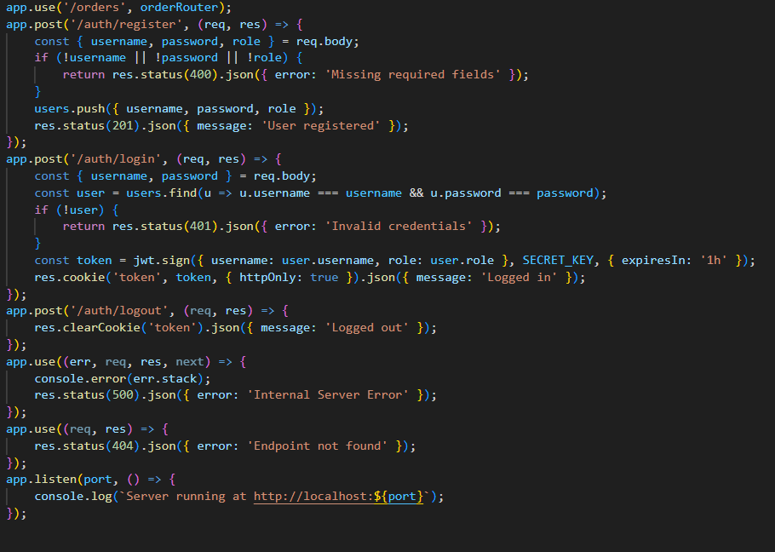

Screenshots of Output:
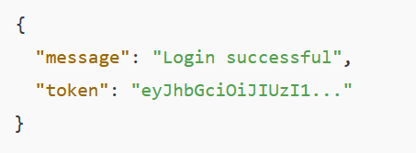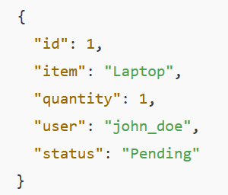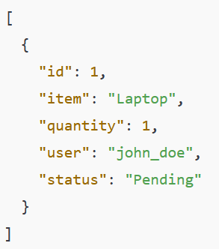
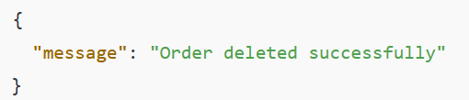
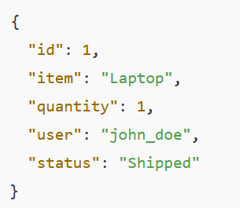

Conclusion: This practical taught us how to create a secure system for managing orders, with user login, error handling, and access control. This helps understand how online shops keep track of orders and ensure only authorized people can see them.

Practical 10

Project: Personal Task Manager
Objective: Build a task management API for creating, updating, and managing tasks.

Tasks:
● CRUD operations for tasks (POST, GET, PUT, DELETE).
● Validate task input data (e.g., title and status fields) using
middleware.
● Persist tasks in a tasks.json file.

Screenshots of Code:
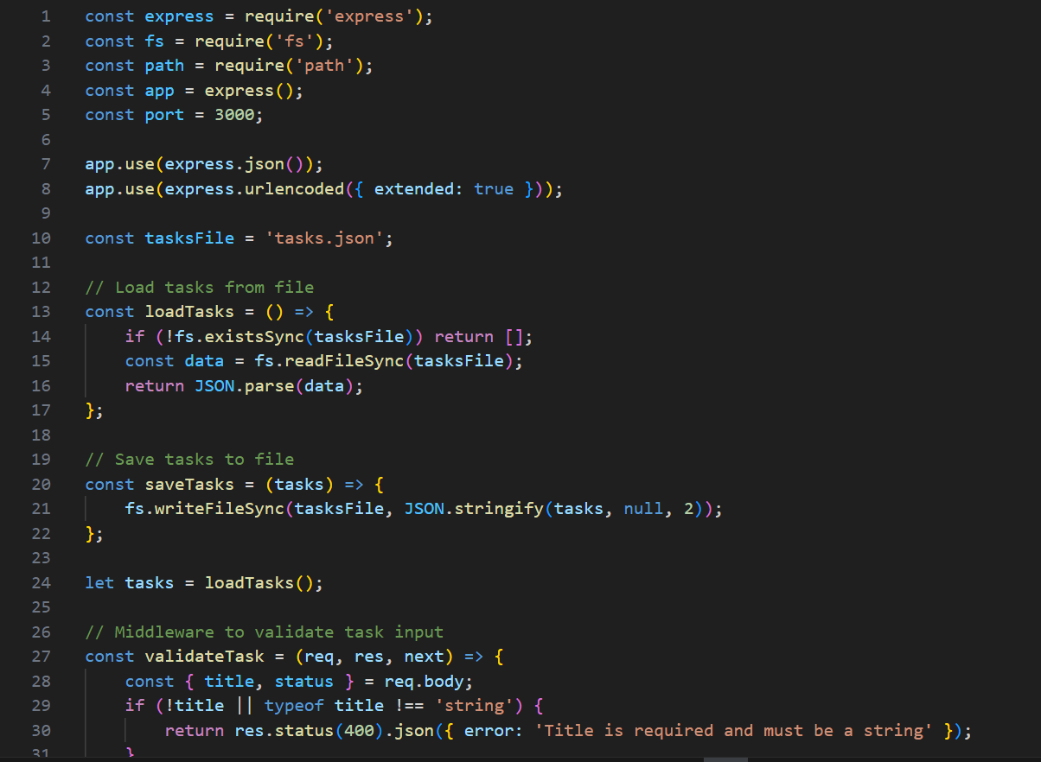
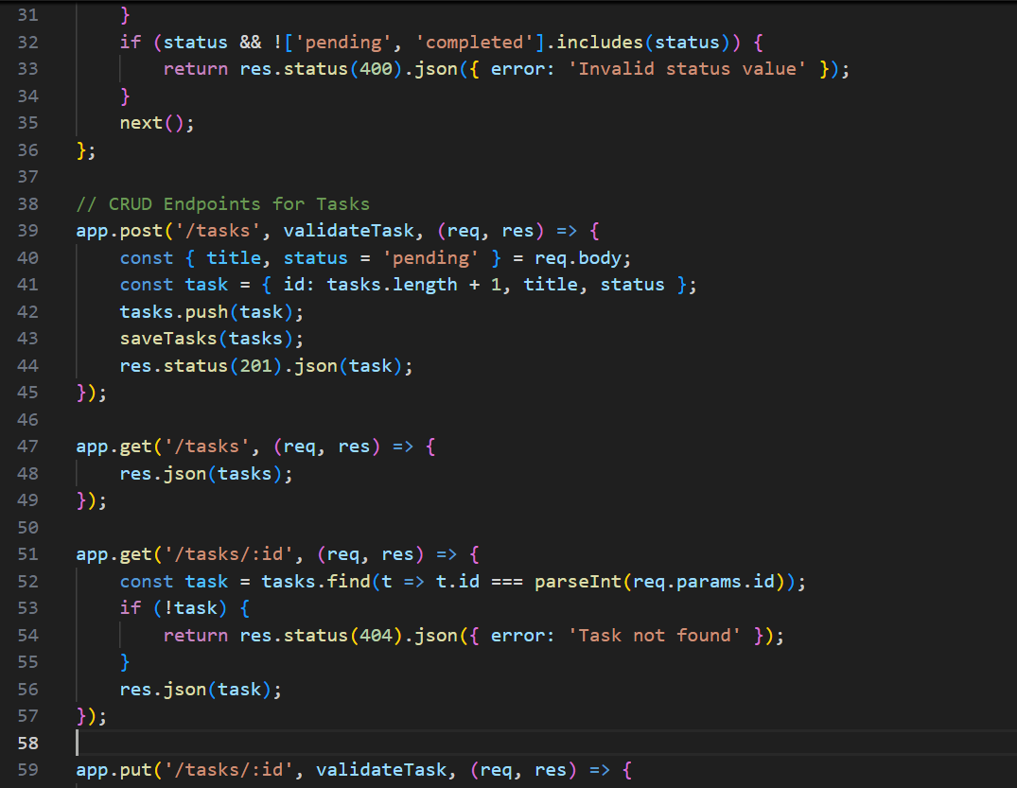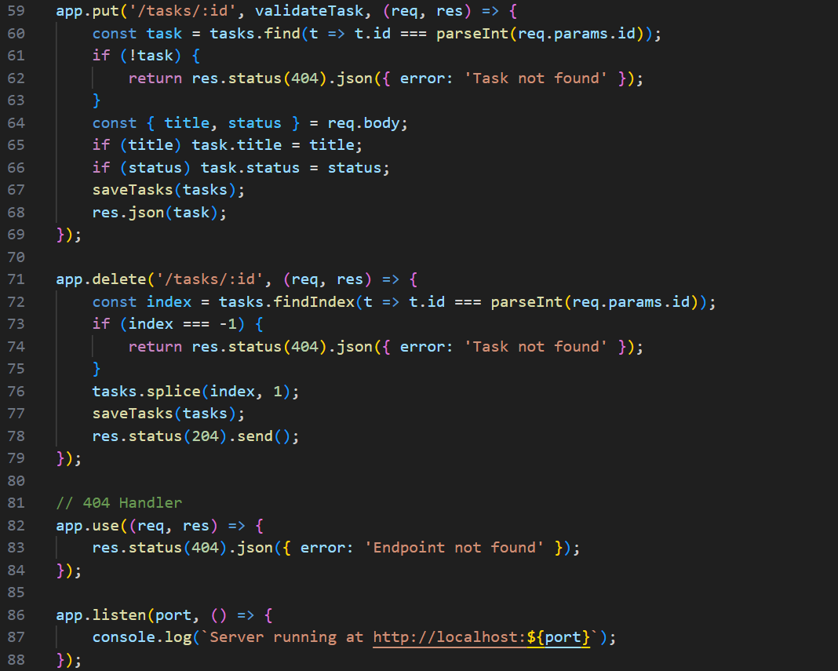

Screenshots of Output:

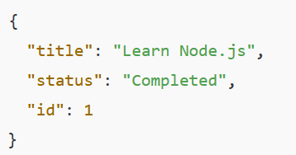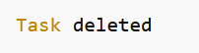

Conclusion: We built an API that helps manage personal tasks, allowing us to create, view, update, and delete tasks. This teaches us how task management apps work behind the scenes.

Practical 11

Project: User Profile Manager
Objective: Set up MongoDB and Mongoose in a Node.js application and create a basic schema to perform simple database operations.
Tasks:
- Install MongoDB locally or create a free cluster on MongoDB Atlas.
- Set up a new Node.js project and install the required dependencies (express, mongoose, dotenv).
- Create a .env file and store your MongoDB connection URI securely.
- Write a connection script in Node.js using Mongoose to connect to MongoDB.
- Define a user schema with fields like name, email, and age.
- Create a simple script to insert a user into the database and log the results in the console.
- Fetch all users from the database and display them in the console.

Screenshots of Code:
Server.js
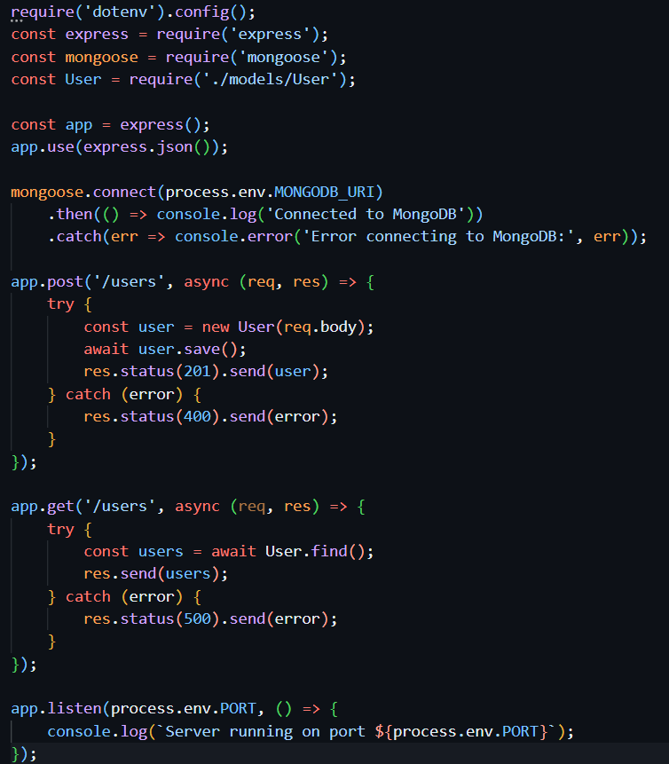

Script/fetchusers.js

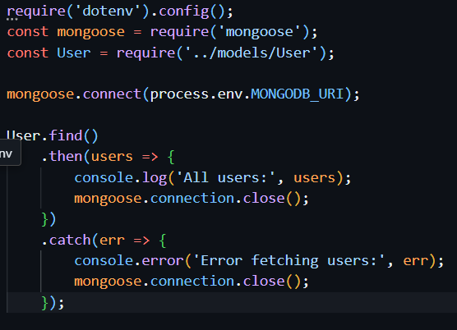

Script/insertusers.js

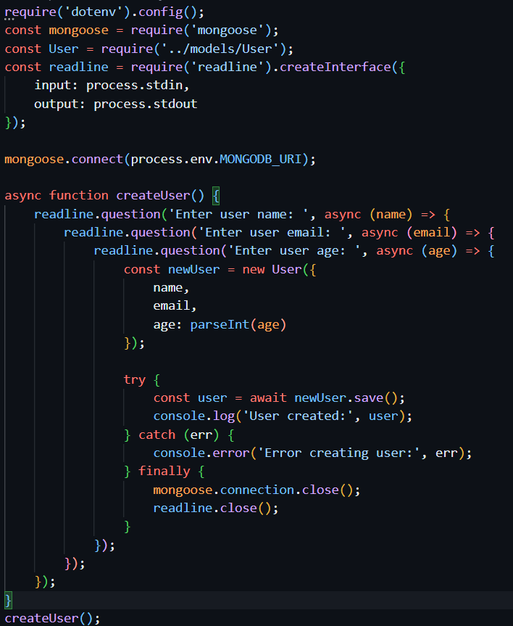models/User.js
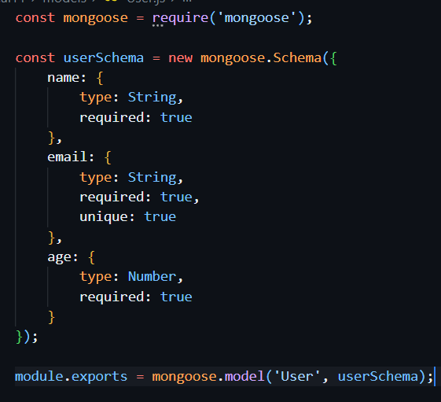
.env

Screenshots of Output:
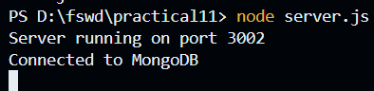

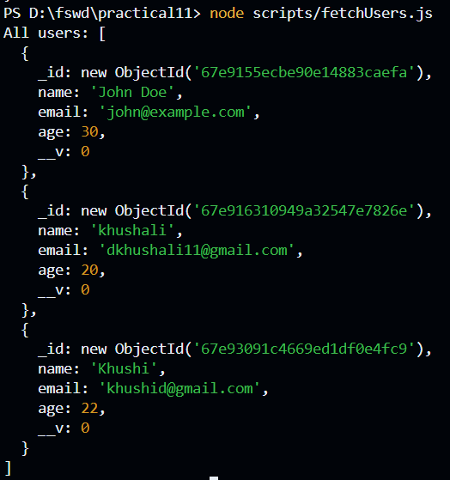

Conclusion: This practical showed us how to connect to a database and store user information. We learned how to add users to the database and retrieve them later. This helps understand how websites store user data.

Practical 12

Project: Task Manager API
Objective: Build a RESTful API with Express and Mongoose to manage tasks in a MongoDB collection.
Tasks:
- Define a Task schema with fields like title, description, status (e.g., "Pending", "Completed"), and dueDate.
- Set up the following API endpoints:
  - POST /tasks: Add a new task to the database.
  - GET /tasks: Retrieve all tasks.
  - GET /tasks/:id: Retrieve a specific task by ID.
  - PUT /tasks/:id: Update task details by ID.
  - DELETE /tasks/:id: Delete a task by ID.
- Test the API endpoints using Postman or Thunder Client.
- Use filters to query tasks based on their status or dueDate.
- Handle basic errors, such as invalid task IDs or missing fields.

Screenshots of Code:

.env
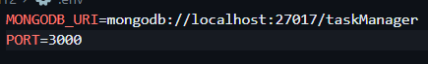

model/task.js
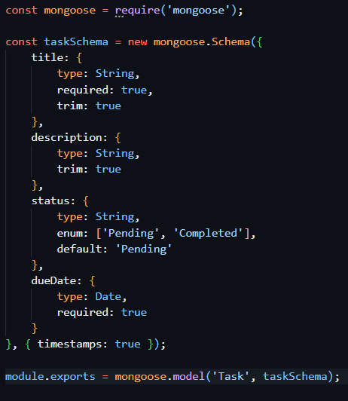
server.js
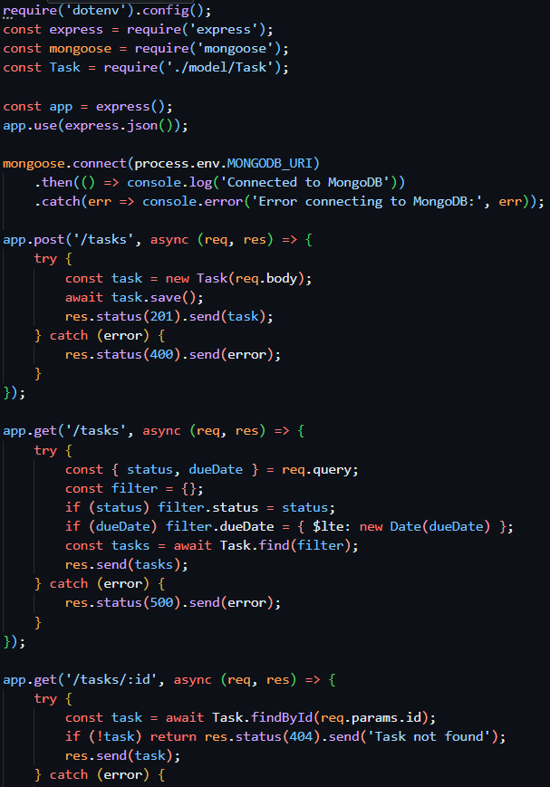
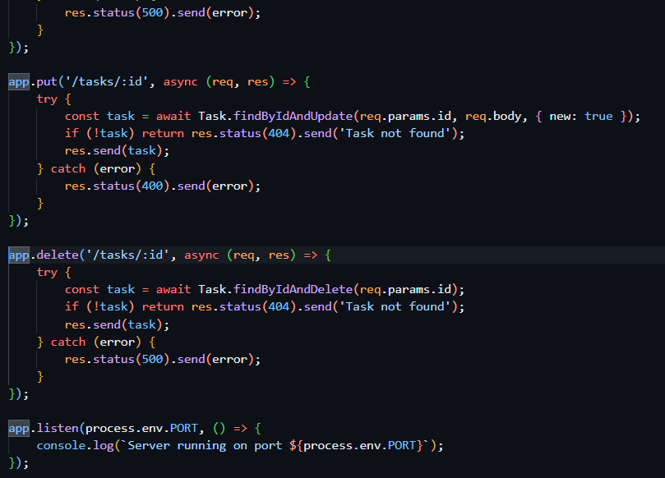

Screenshots of Output:
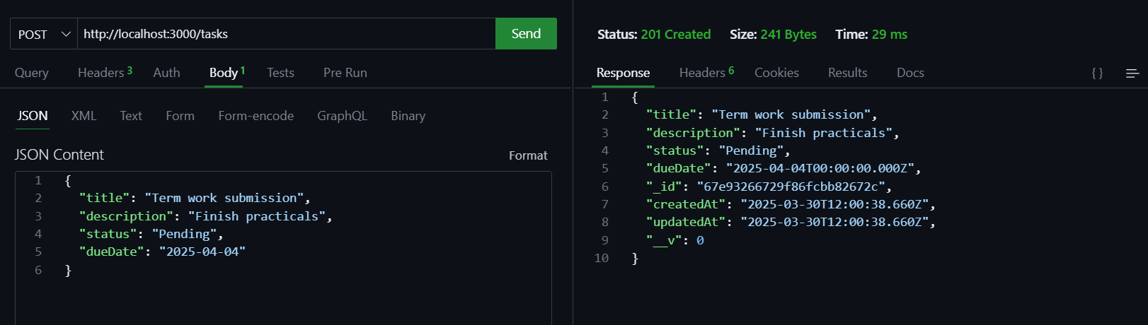
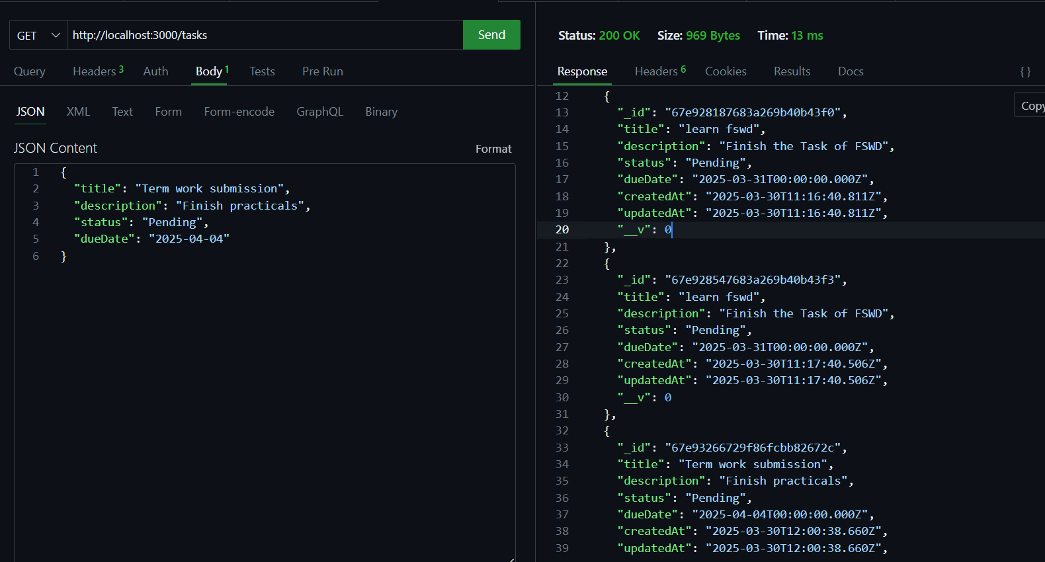
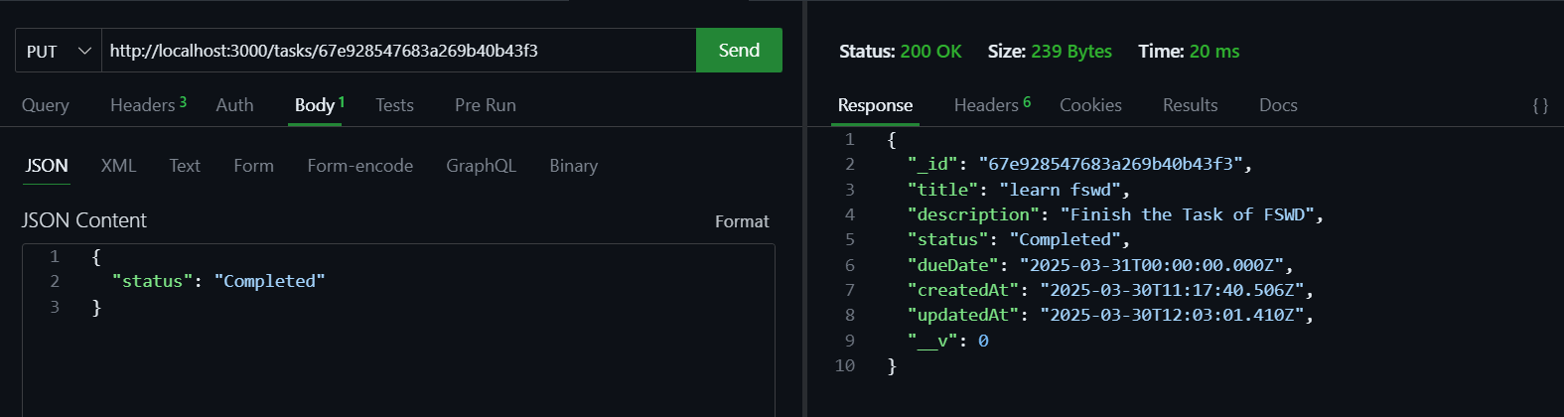
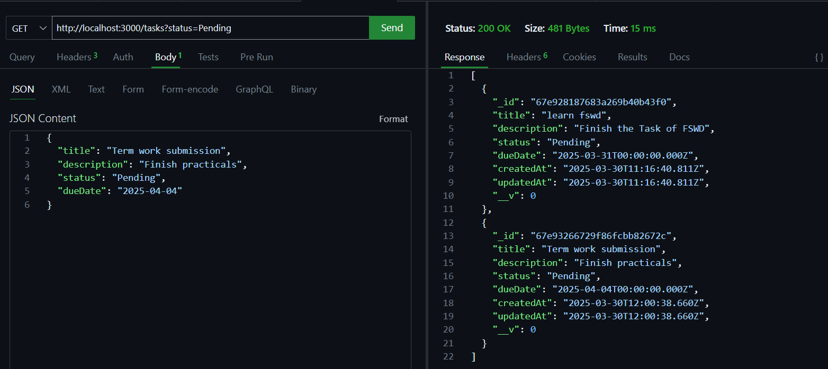
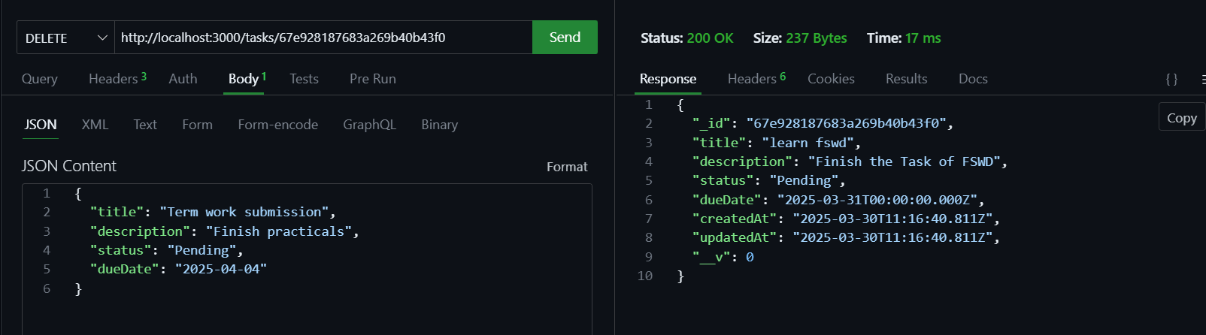

Conclusion: We built a complete system for managing tasks using a database. We can add, view, update, and delete tasks, and even search for specific tasks. This teaches us how task management apps store and organize information.

Practical 13

Project: Blog Application API
Objective: Implement a relational data model to create and manage blog posts with associated authors using Mongoose and Express.
Tasks:
- Define schemas for Author and BlogPost:
  - Author: name, email.
  - BlogPost: title, content, createdAt, author (reference to Author).
- Set up the following API endpoints:
  - POST /authors: Add a new author.
  - POST /blogposts: Add a new blog post and associate it with an author.
  - GET /blogposts: Retrieve all blog posts, including author details (use populate).
  - GET /blogposts/:id: Retrieve a specific blog post by ID with author details.
  - DELETE /blogposts/:id: Delete a blog post by ID.
- Add Mongoose validation to ensure all required fields are provided and correctly formatted (e.g., email validation).
- Handle errors gracefully, such as missing or invalid IDs and validation failures.

Screenshots of Code:
.env
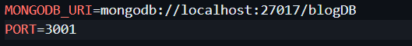
server.js
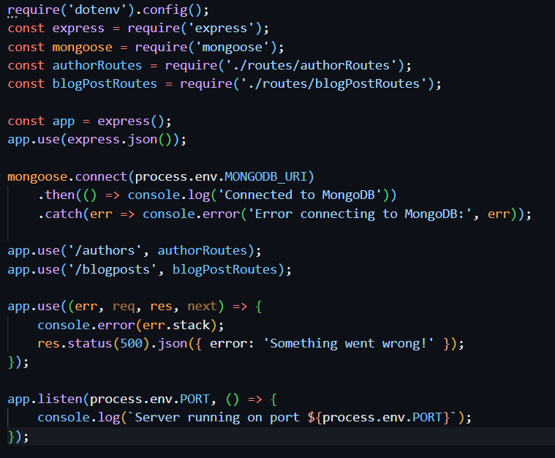
models/Author.js
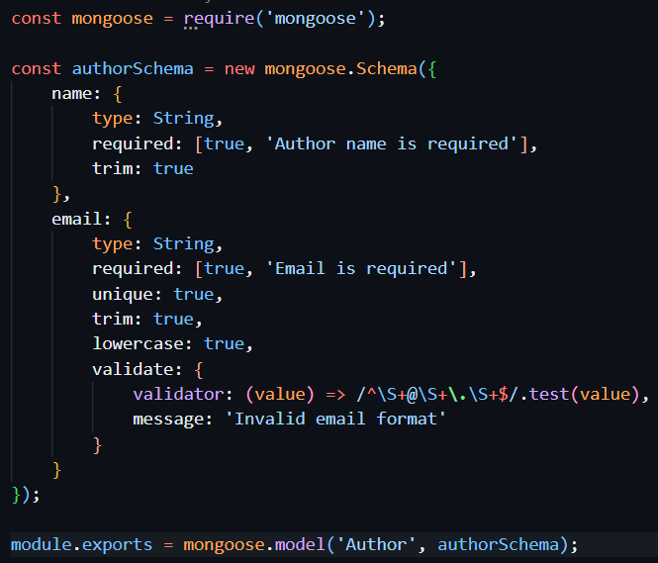
Models/BlogPost.js
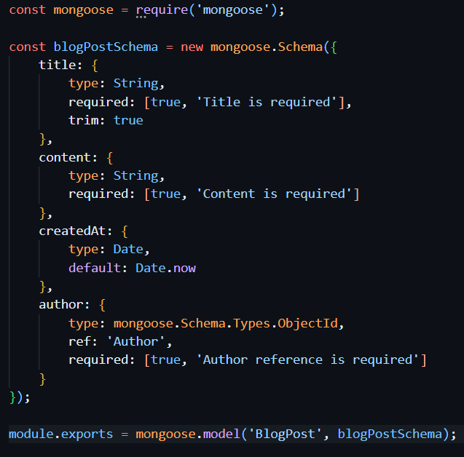
routes/authorRoutes.js
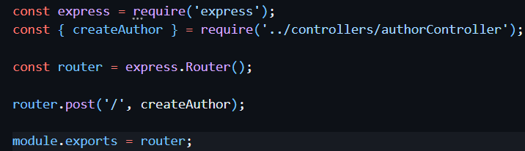
routes/blogpostRoutes.js
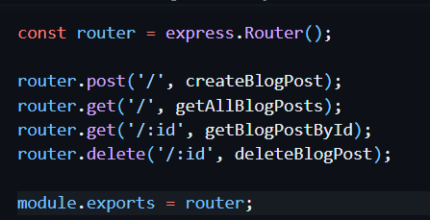
controllers/authorController.js
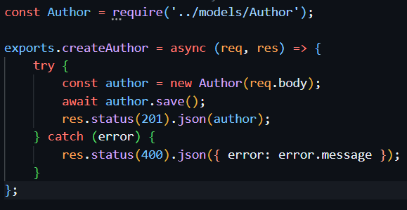
Controllers/blogpostController.js
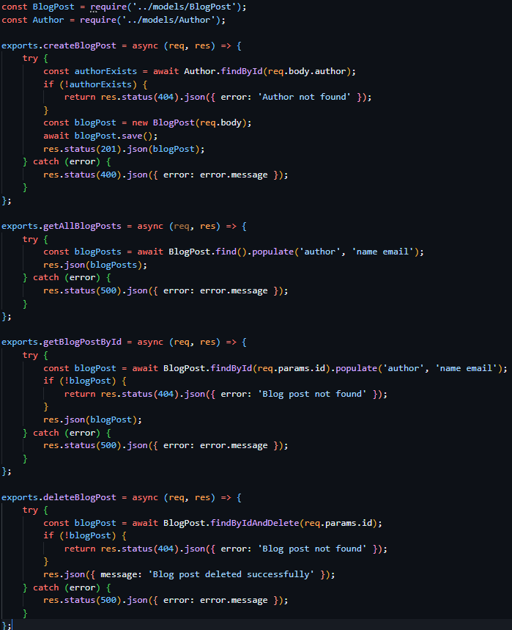

Screenshots of Output:
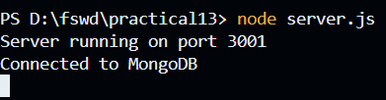
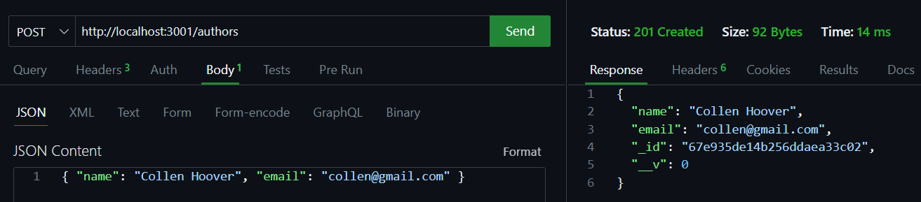
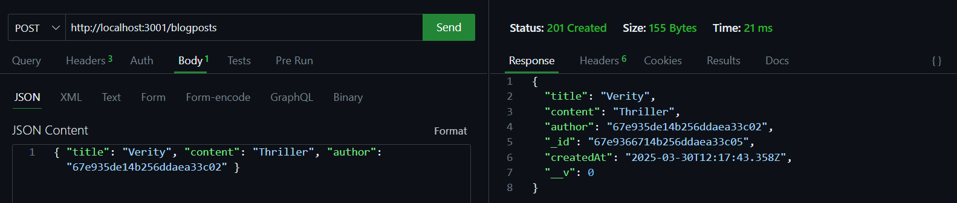
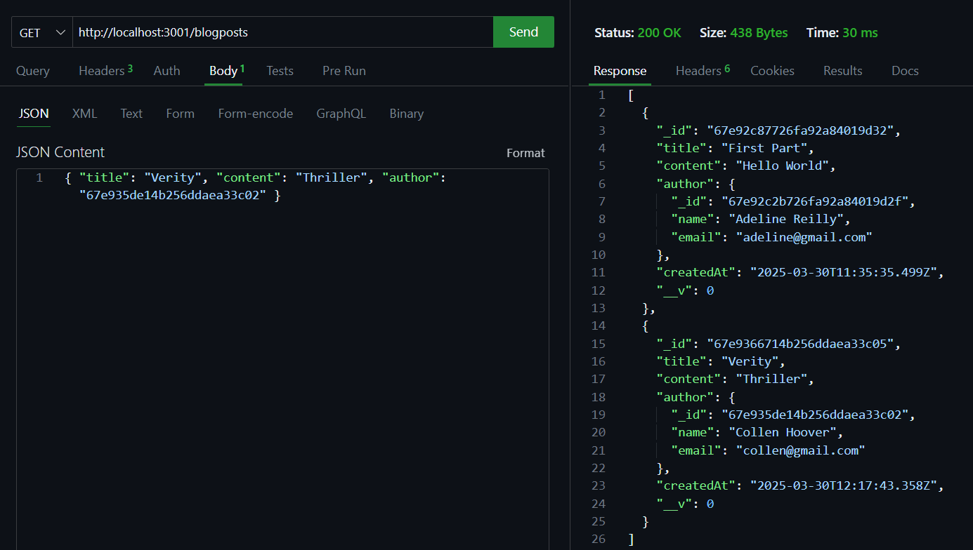
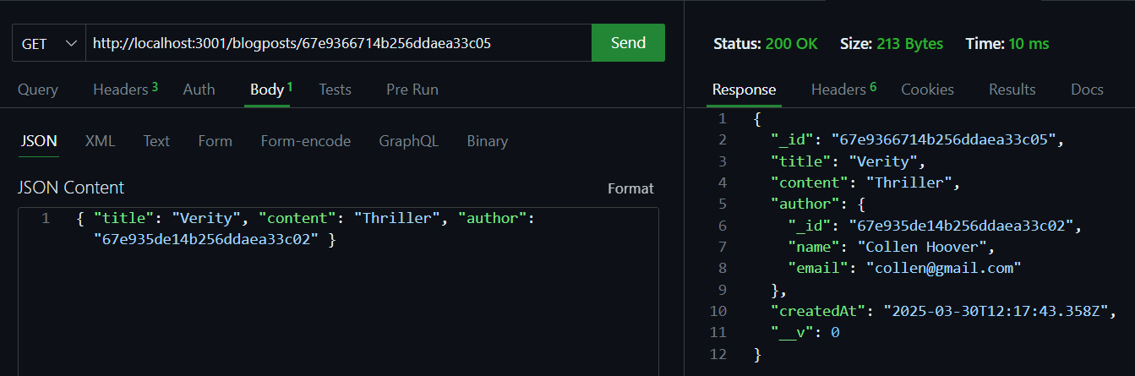
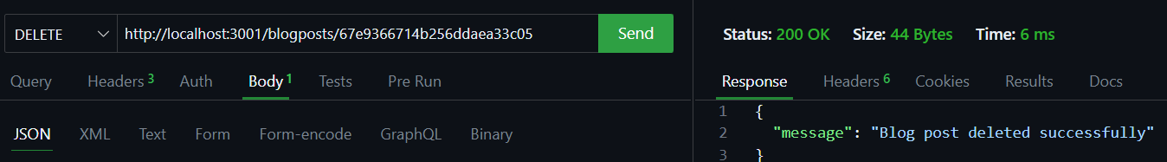

Conclusion: This practical taught us how to create a blog system where authors can write posts. We learned how to connect authors to their blog posts in a database. This helps understand how blogs organize content and authors.

Practical 14

Project: Personal Profile Card
Objective: Learn the basics of React by building reusable components and passing data using props.
Tasks:
- Set up a React project using Vite.
- Create a functional component for a profile card.
- Use props to display a user's name, photo, and a short bio.
- Style the card using basic CSS.

Screenshots of Code: 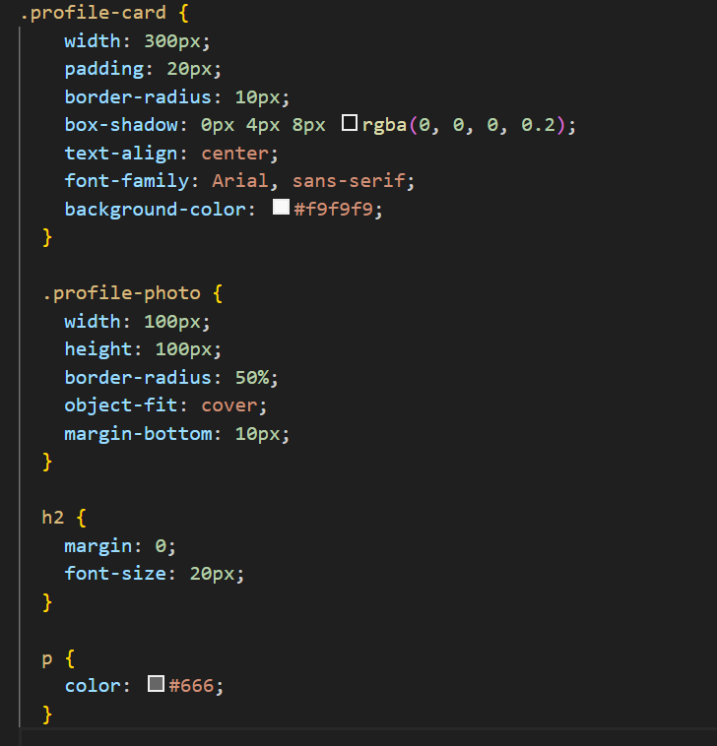

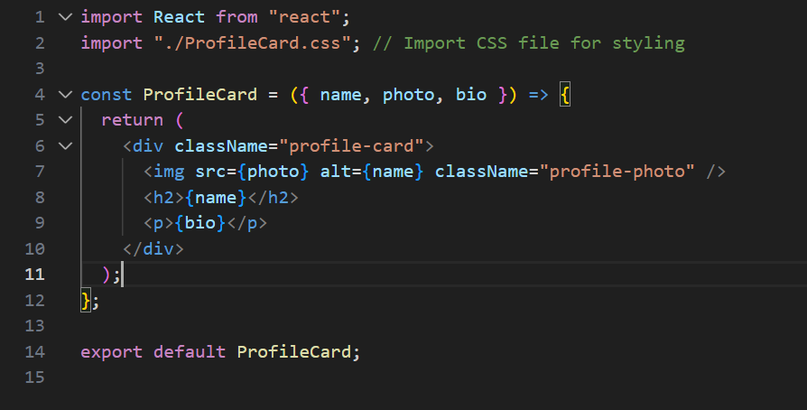
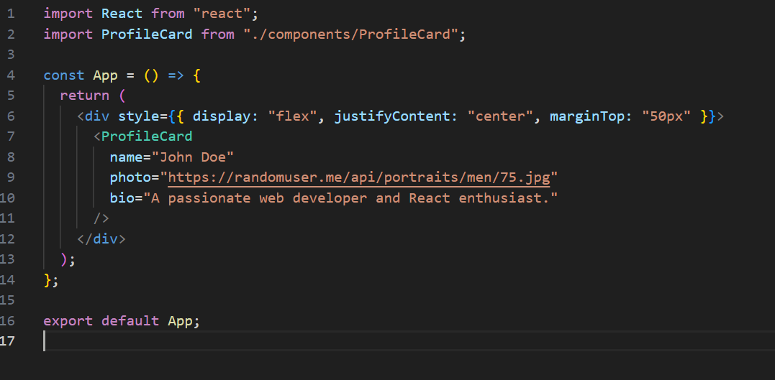

Screenshots of Output :
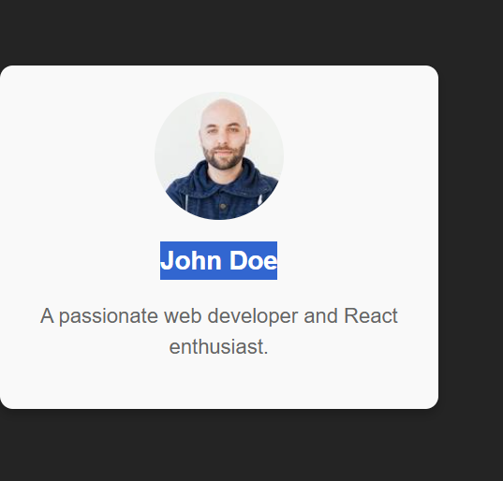

Conclusion: We created a simple profile card using React that shows a person's name, photo, and bio. This teaches us the basics of building user interfaces with React components.

Practical 15

Project: Simple Counter App
Objective: Understand how to manage and update state dynamically in a React application.
Tasks:
- Create a functional component with a state variable for the counter.
- Add buttons to increment, decrement, and reset the counter.
- Display the counter value dynamically on the screen.

Screenshots of Code:
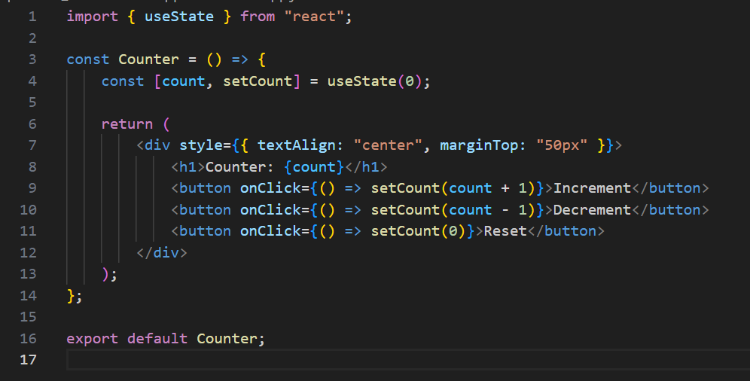
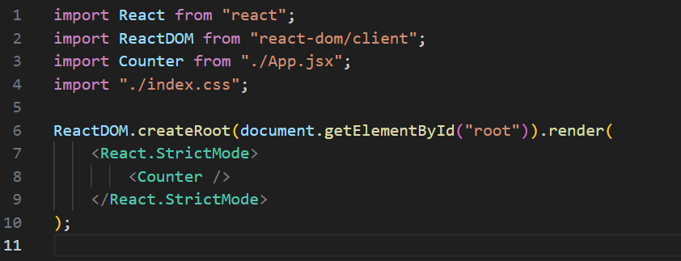

Screenshots of Output :
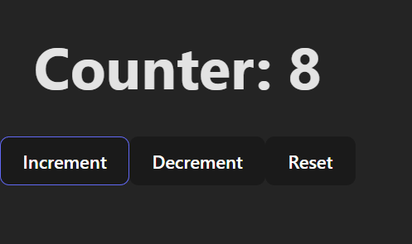

Conclusion: This practical showed us how to create a counter that can be increased, decreased, or reset using React. This helps understand how to make interactive websites that respond to user actions.

Practical 16

Project: To-Do List App
Objective: Learn how to dynamically render and manage a list of items with conditional rendering.
Tasks:
- Create a state variable to store a list of tasks.
- Render the task list dynamically using .map().
- Add functionality to add and remove tasks.
- Display a message when the task list is empty.

Screenshots of Code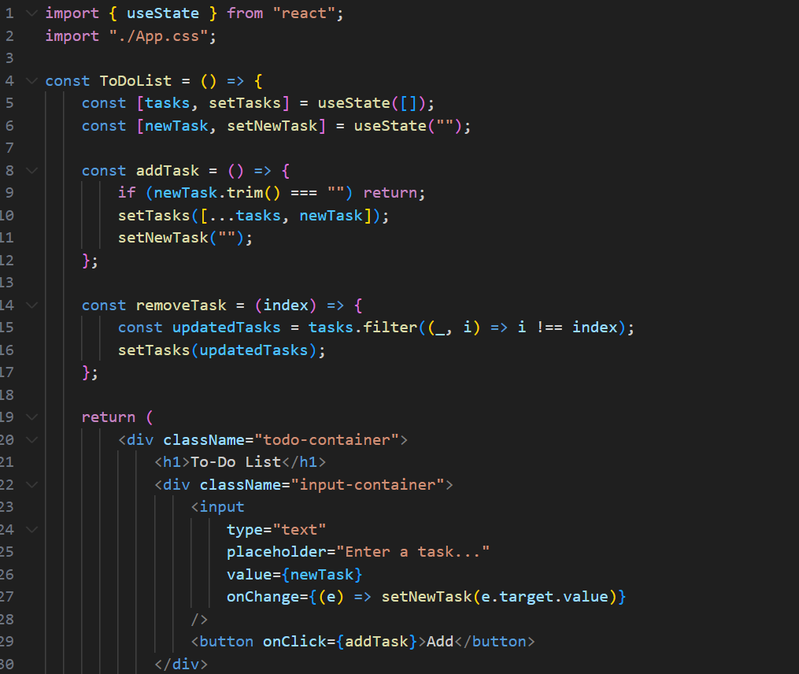:
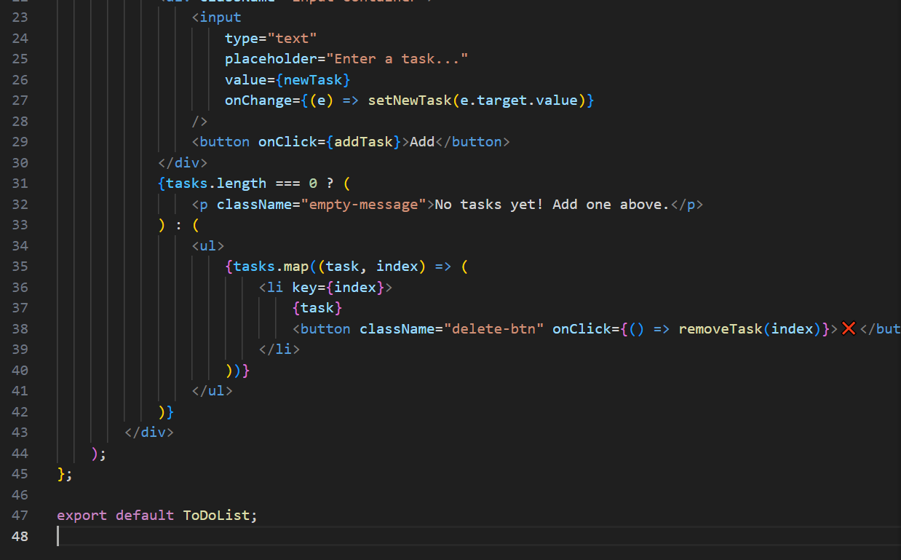

Screenshots of Output :
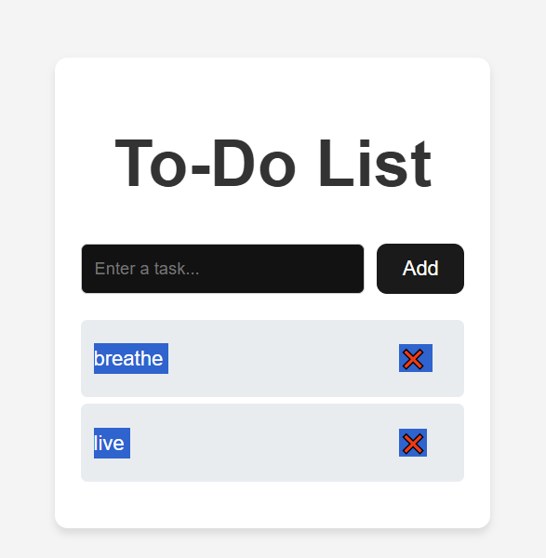

Conclusion: We built a to-do list app where users can add and remove tasks. This teaches us how to create and manage lists of information in React applications.

Practical 17

Project: Feedback Form
Objective: Understand how to handle and validate user input in a React form.
Tasks:
- Create a form with input fields for name, email, and feedback message.
- Use state variables to control the form inputs.
- Validate the inputs (e.g., ensure fields are not empty).
- Display submitted feedback data below the form.

Screenshots of Code: 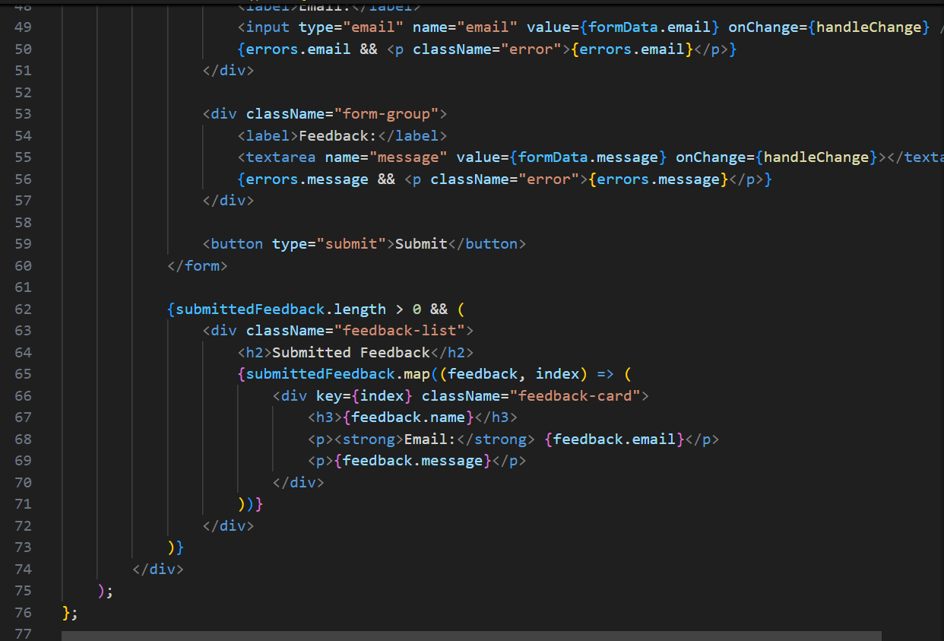

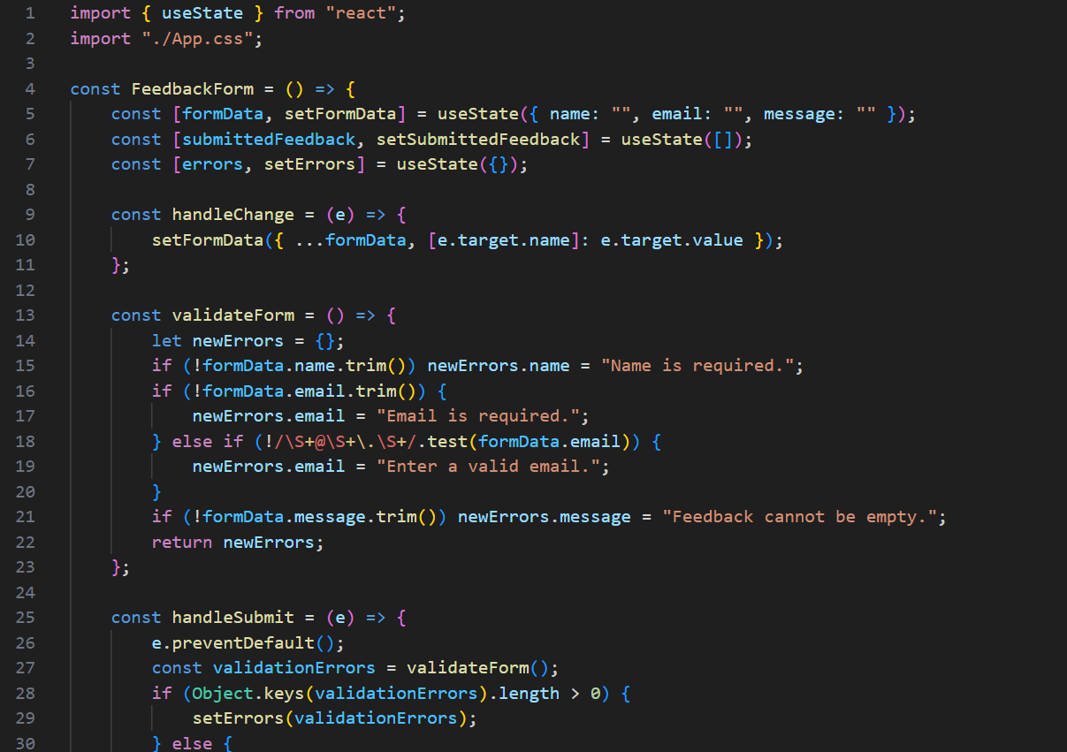
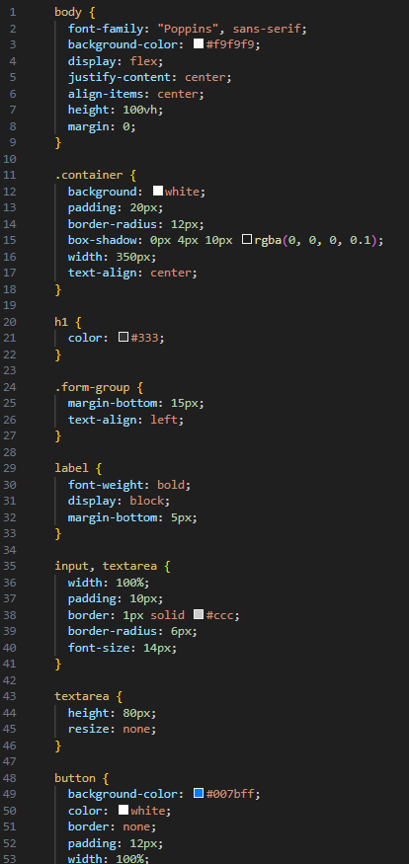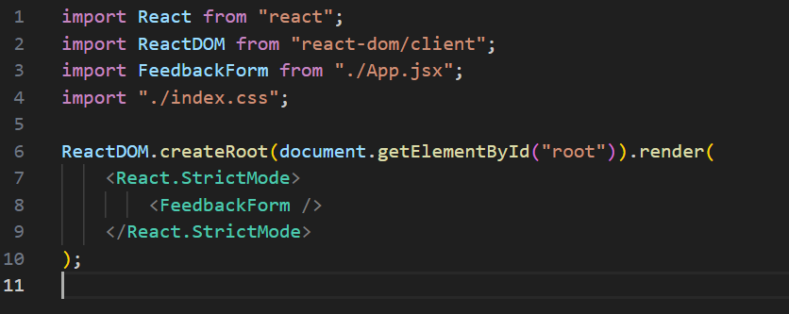

Screenshots of Output :
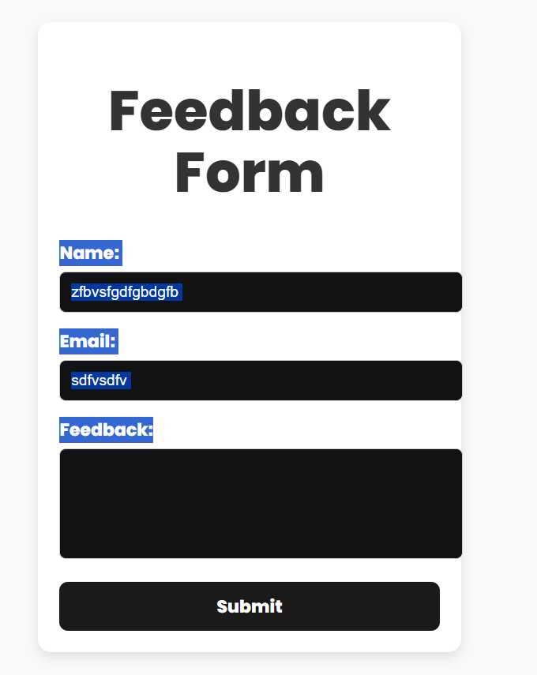
Conclusion: This practical taught us how to create a form that collects user feedback, checks if the information is correct, and shows the submitted feedback. This helps understand how websites collect and validate user input.

Practical 18

Project: Theme Switcher App
Objective: Learn how to use the Context API to manage global state across components.
Tasks:
- Set up a Context Provider to manage theme state.
- Implement a toggle button to switch between light and dark themes.
- Use the theme context to dynamically update the app’s background and text colours.

Screenshots of Code: 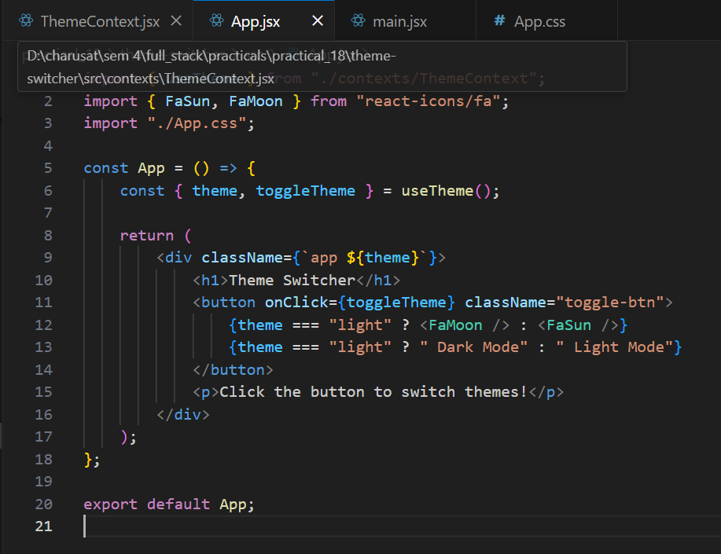

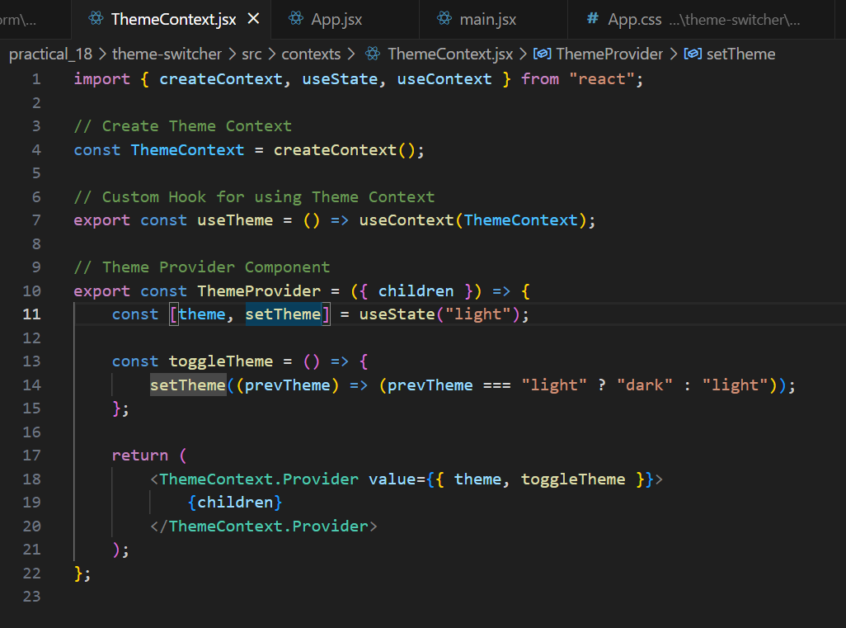
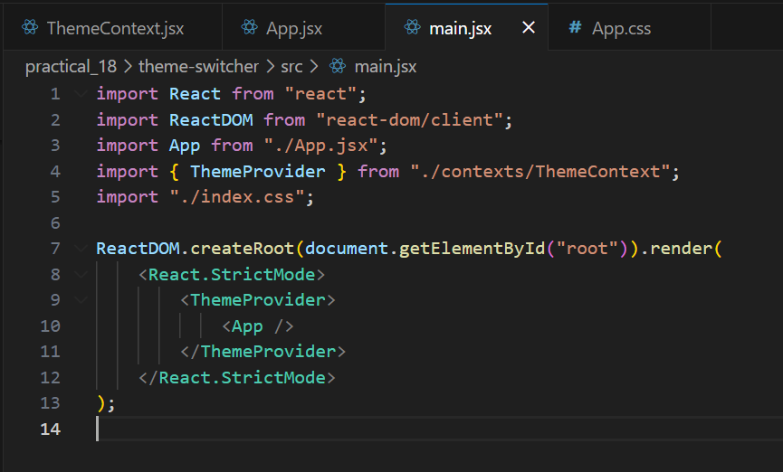

Screenshots of Output :
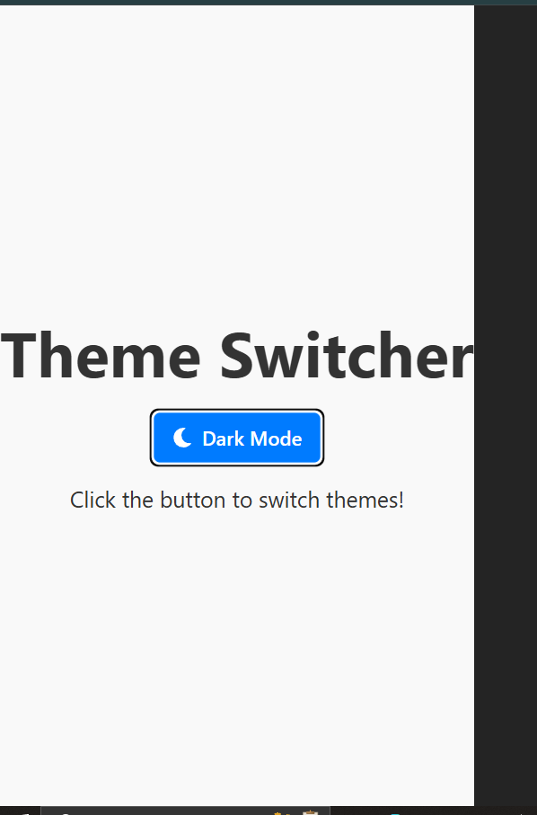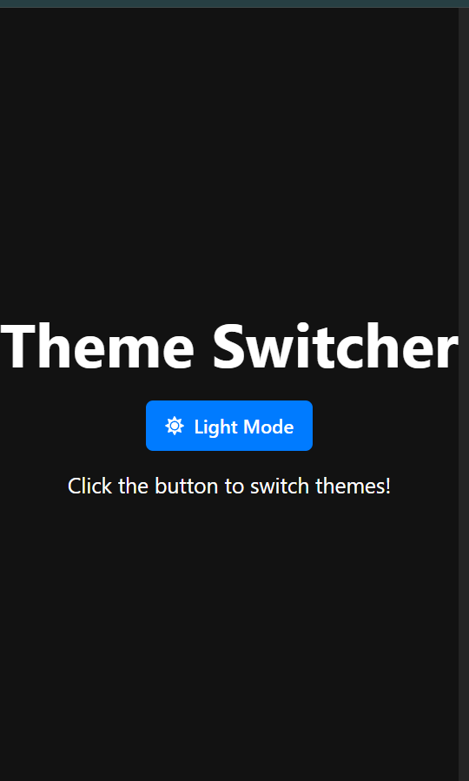

Conclusion: We created an app that can switch between light and dark themes. This teaches us how to share information across different parts of a React application and change how everything looks with one button.

Practical 19

Project: Weather App
Objective: Understand how to use the useEffect hook to fetch and display data from an external API.
Tasks:
- Fetch weather data for a user-input city using an API (e.g., Open Weather Map).
- Display the city name, temperature, and weather conditions.
Update the displayed data when the user searches for a new city.

Screenshots of Code:
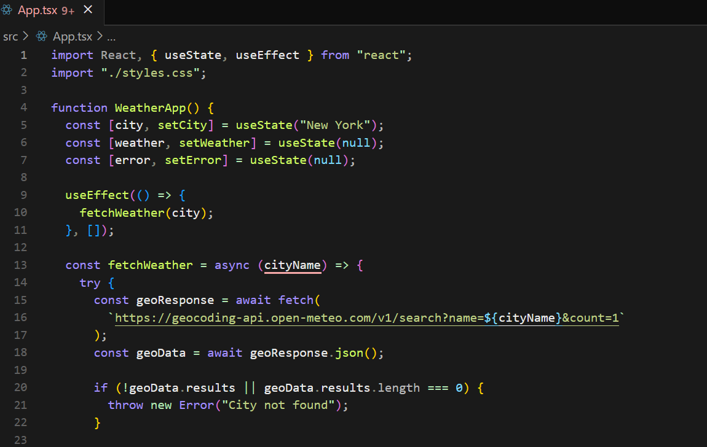

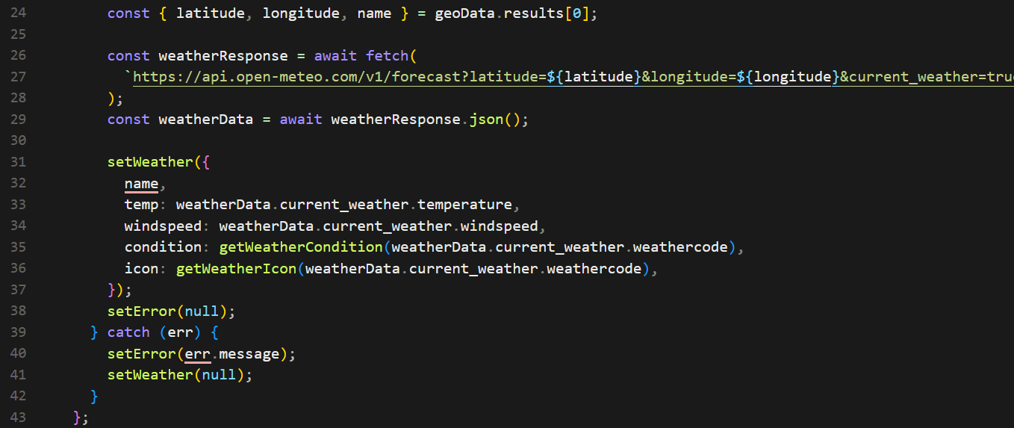
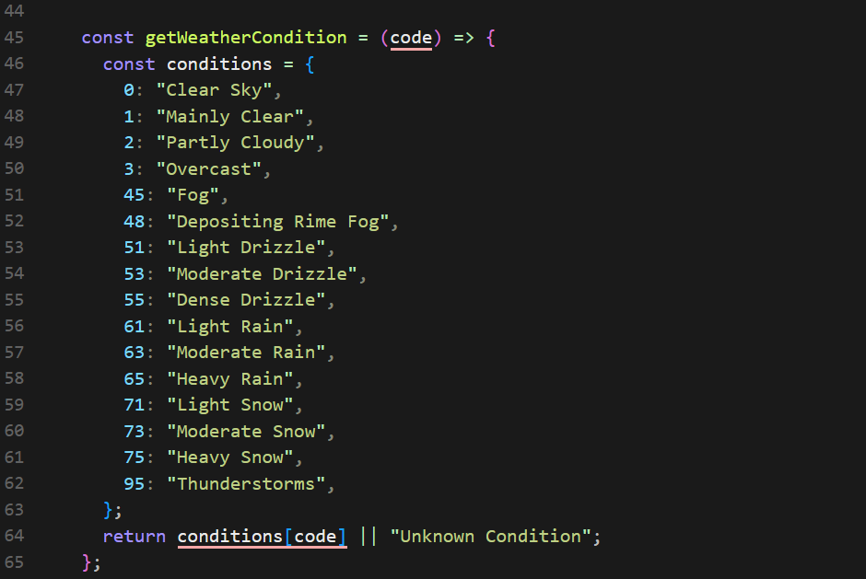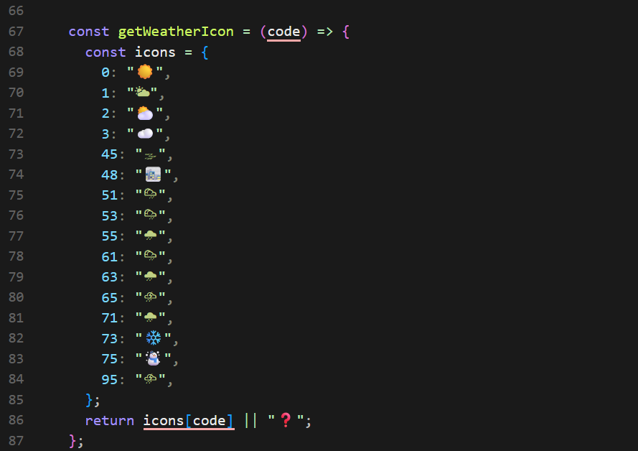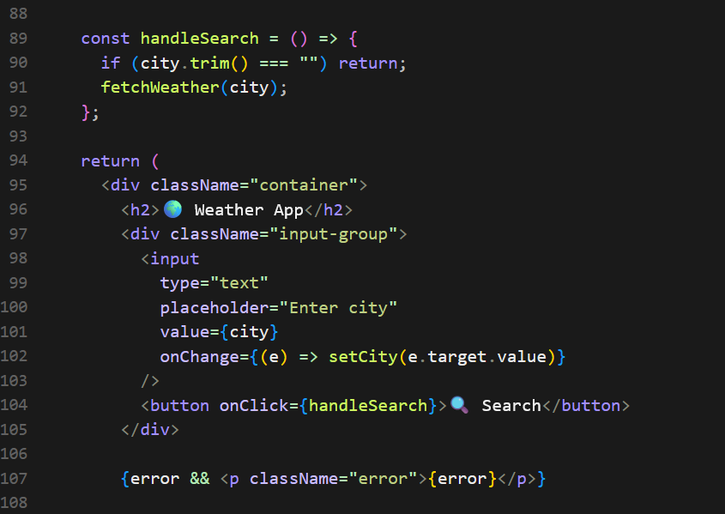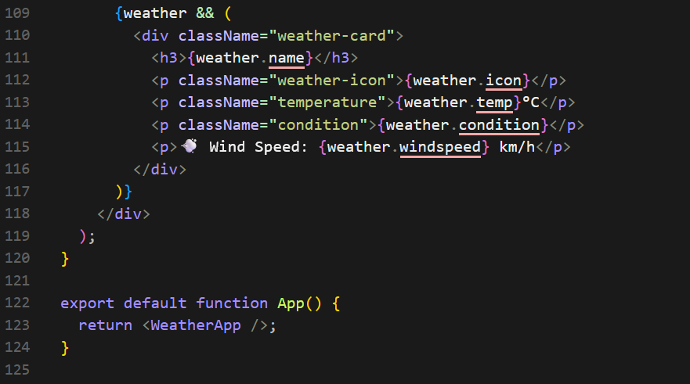

Screenshots of Output :
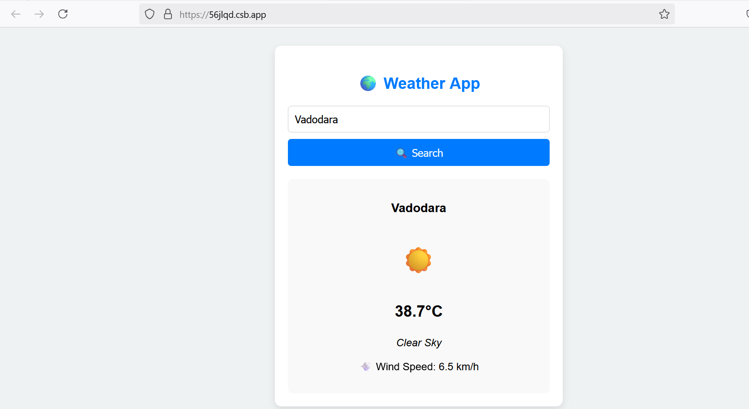

Conclusion: This practical showed us how to create an app that gets weather information from the internet and displays it to users. This helps understand how apps fetch and show real-time data.

Practical 20

Project: Responsive Product Card
Objective: Learn how to style React components using modern CSS techniques.
Tasks:
- Create a product card component with name, price, and description.
- Use CSS Modules to style the card.
- Add responsive styling to adjust layout for different screen sizes.

Screenshots of Code: 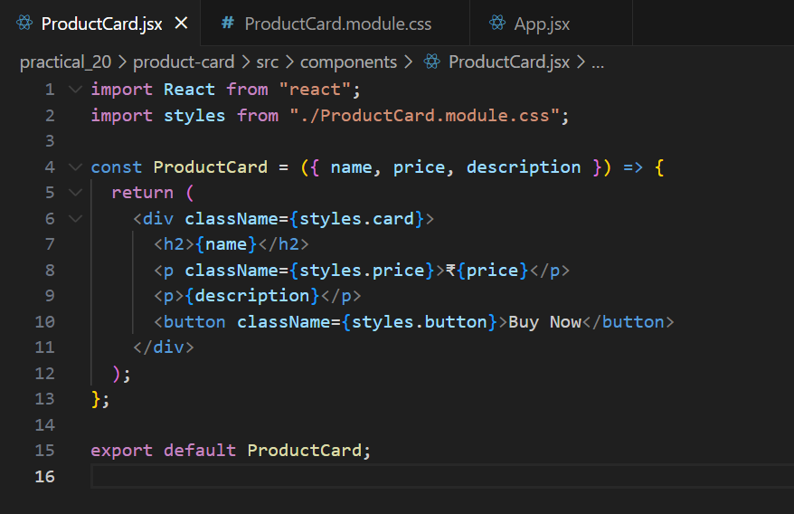
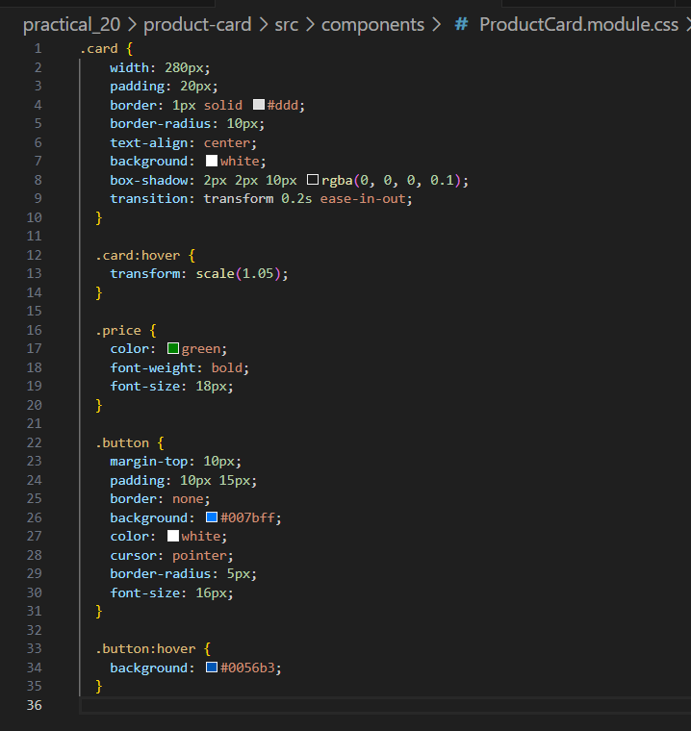

Screenshots of Output:
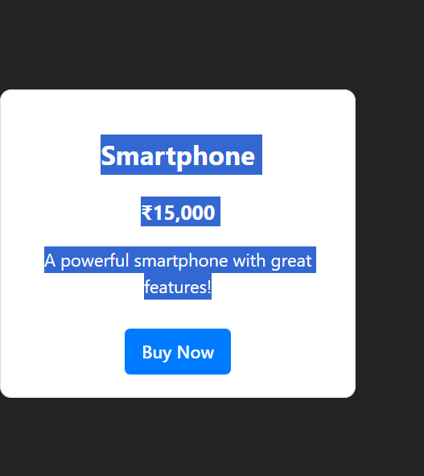

Conclusion: We built a product card that looks good on both big and small screens. This teaches us how to make websites that adapt to different device sizes.

Practical 21

Project: Multi-Page Blog
Objective: Learn to build multi-page applications using React Router.
Tasks:
- Set up routes for a homepage, blog list, and individual blog post pages.
- Use React Router to navigate between pages.
- Display blog post details dynamically based on route parameters.

Screenshots of Code: 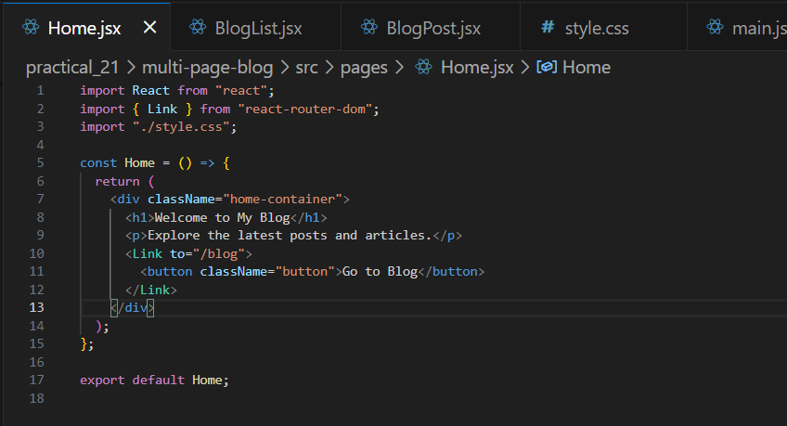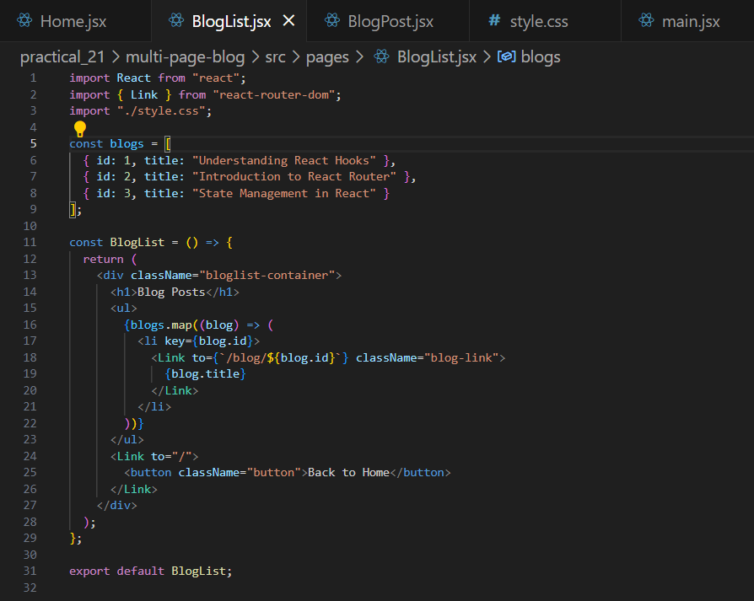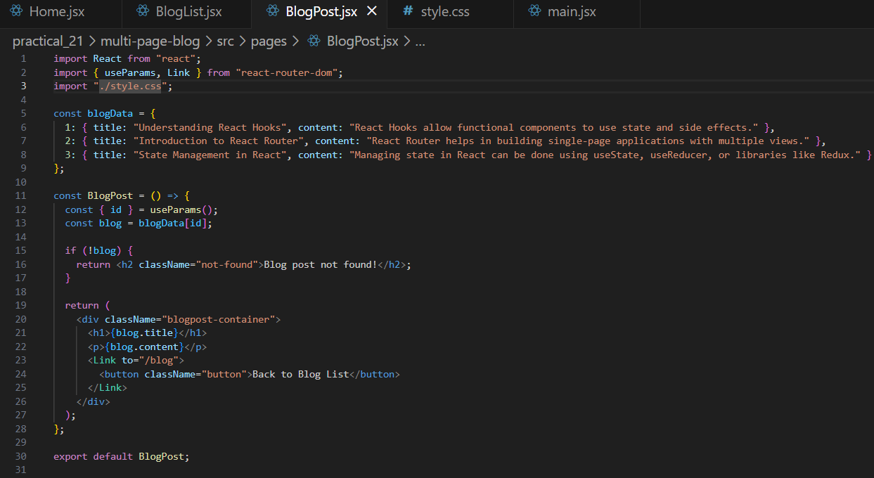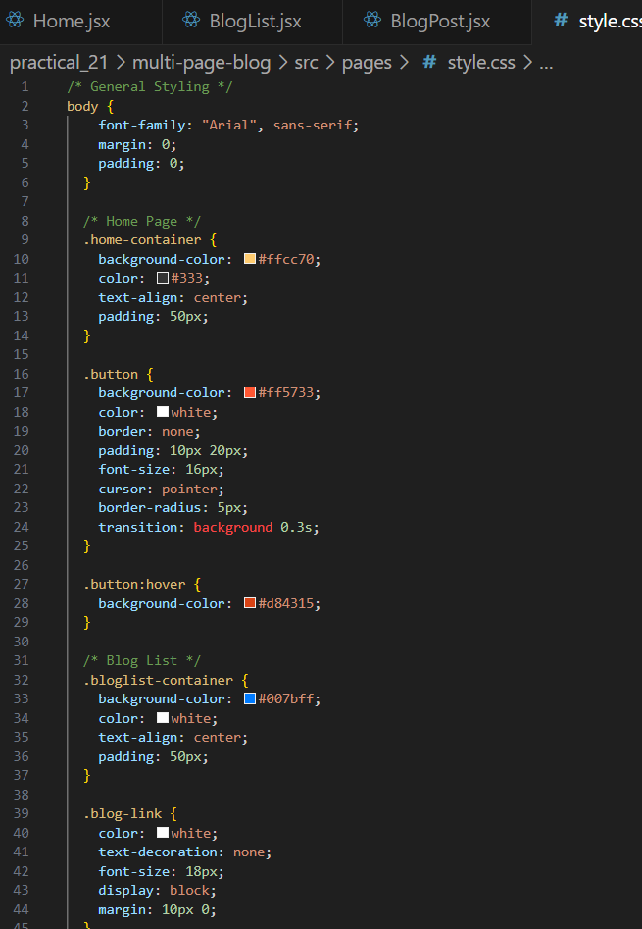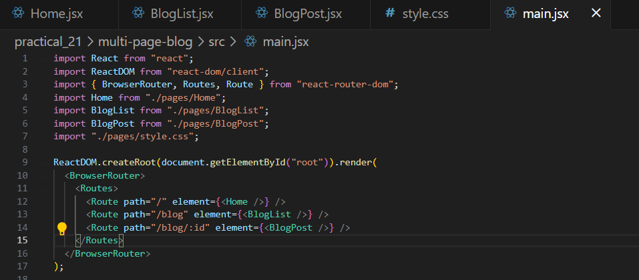

Screenshots of Output: 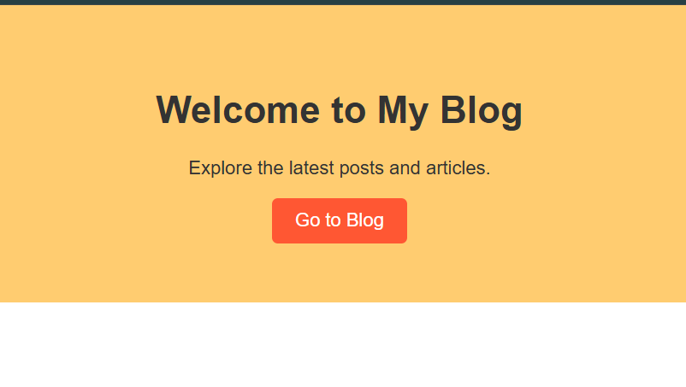
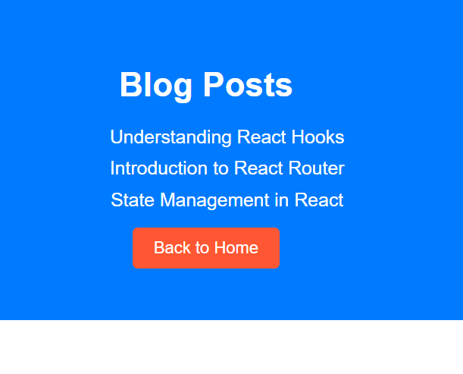
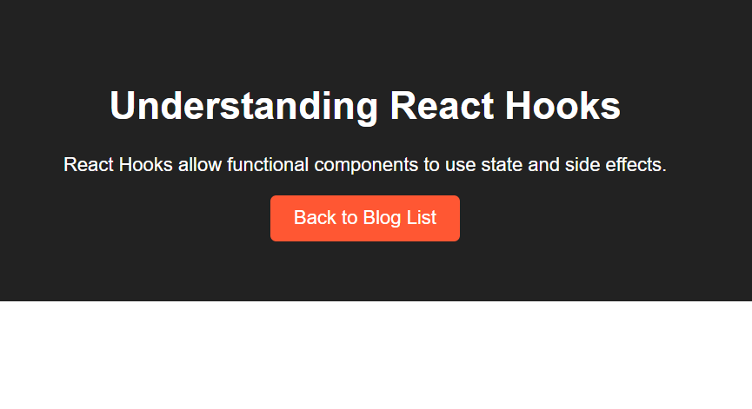
Conclusion: This practical taught us how to create a blog with multiple pages that users can navigate between. This helps understand how to build websites with different sections and pages.
Practical 22

Project: Expense Tracker App
Objective: Learn to manage complex state logic with the useReducer hook.
Tasks:
- Set up a reducer function to manage a list of expenses.
- Add functionality to add and delete expense items.
- Display a summary of total expenses dynamically.

Screenshots of Code :- 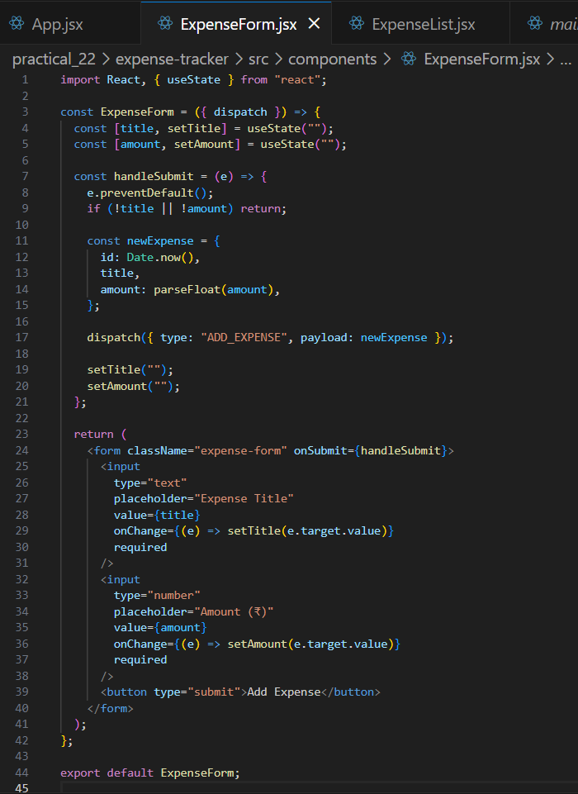
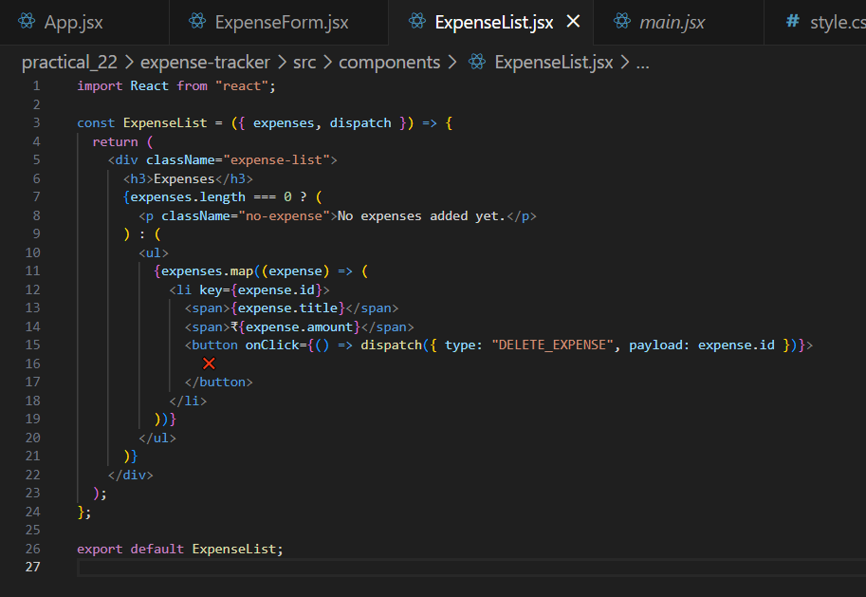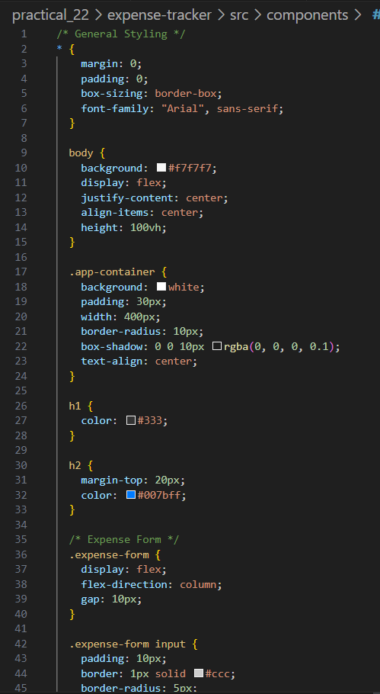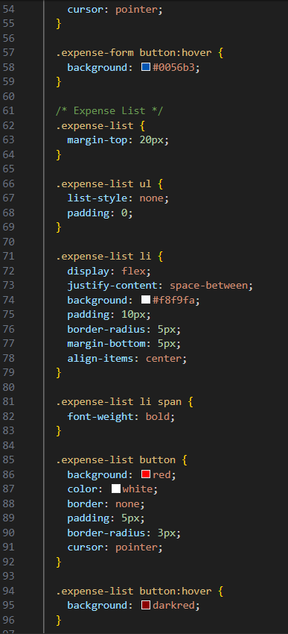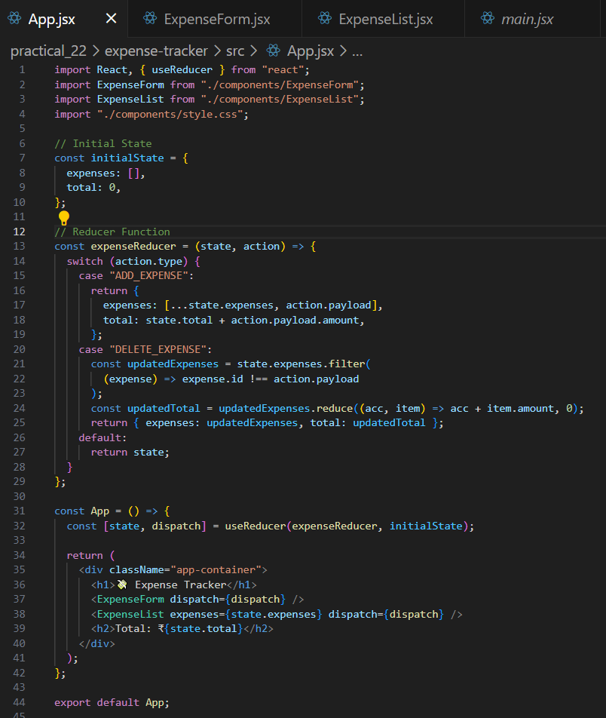

Screenshots of Output: 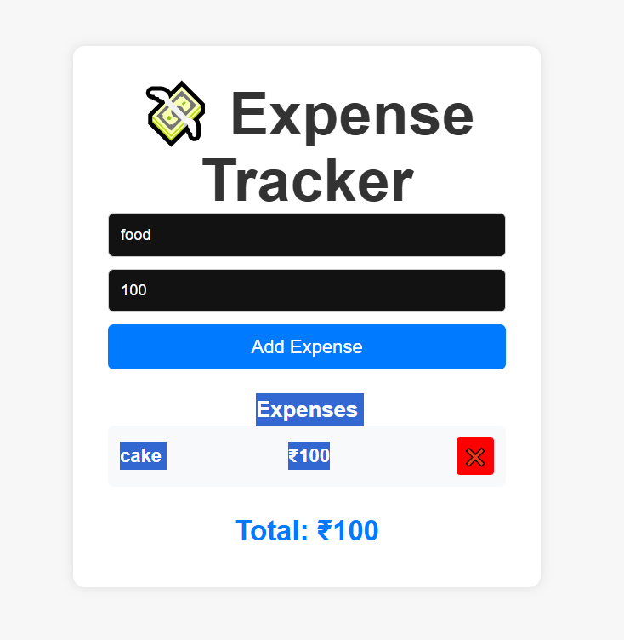

Conclusion: We created an app that helps track expenses, allowing users to add and delete expense items and see the total amount spent. This teaches us how to manage more complex information in React applications.

Practical 23

Project: Testing a Task Manager App
Objective: Test the key features of a "Task Manager" app for managing tasks.
Backend Testing:
- Setup: Use Jest and Super test to test the Node.js backend API.
- Endpoints to Test:
1. POST /tasks: Test if a task is created with valid data.
2. GET /tasks: Test if all tasks are returned.
3. PUT /tasks/:id: Test if a task is updated correctly.
4. DELETE /tasks/:id: Test if a task is deleted by ID.

Screenshots of Code:
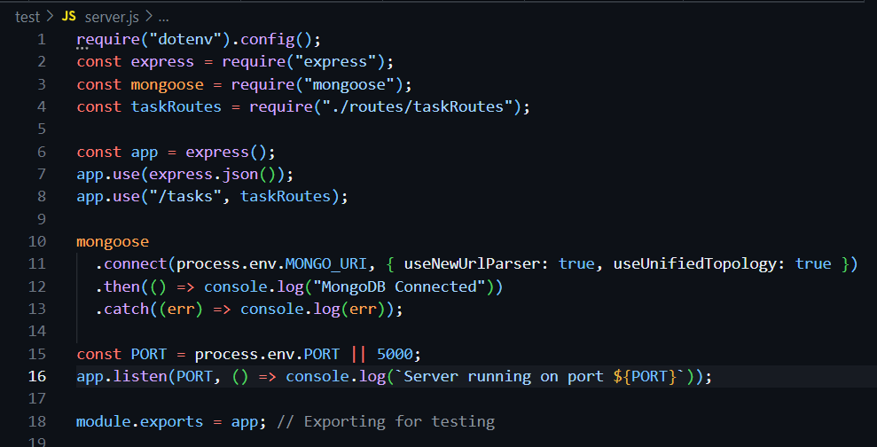
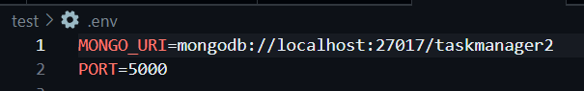
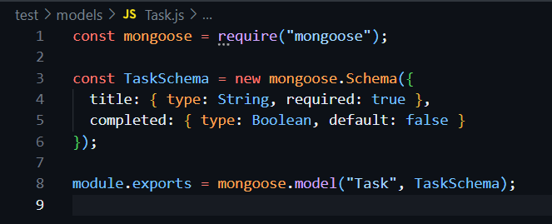
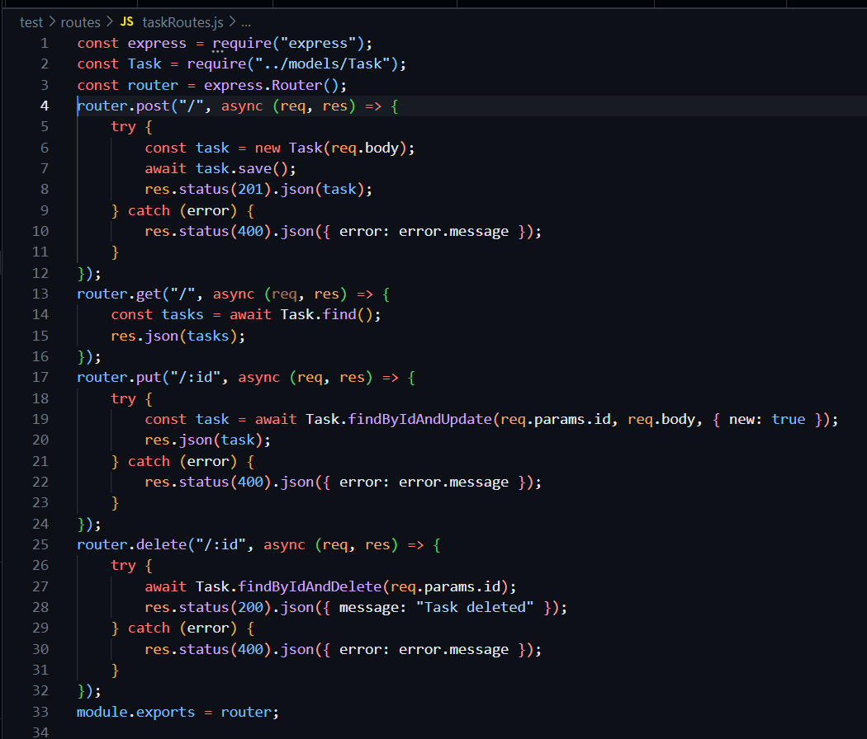
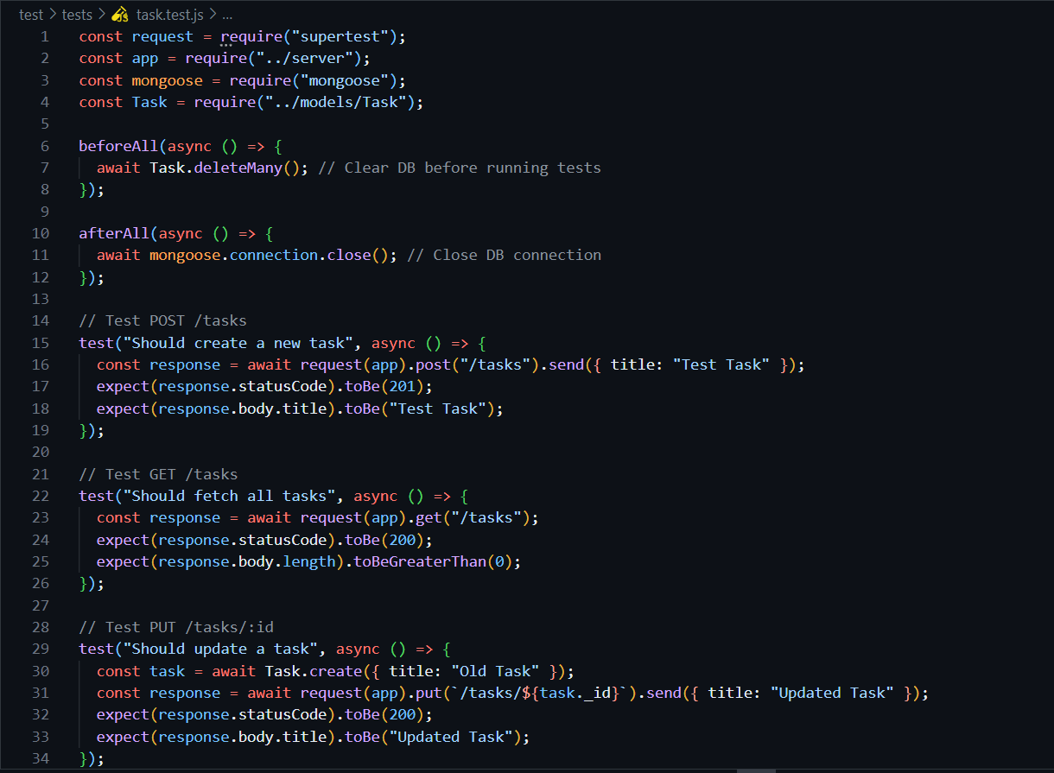
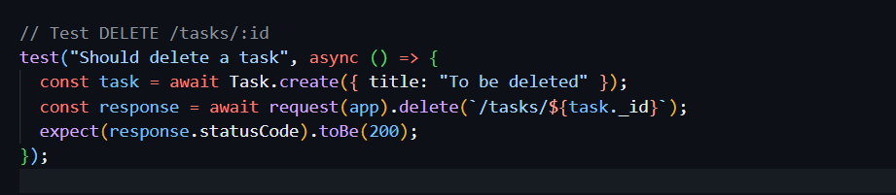

Screenshots of Output:
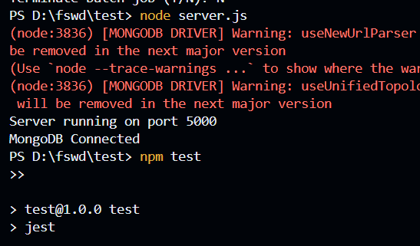
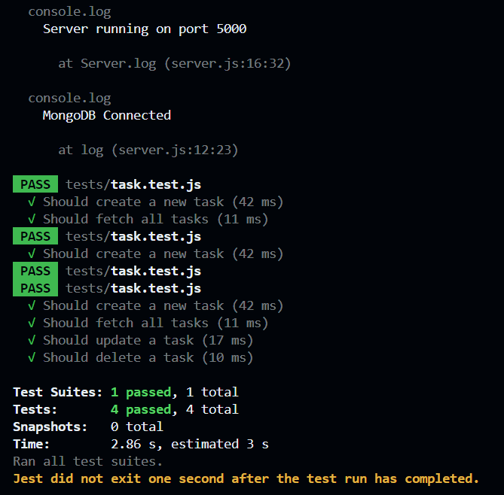

Conclusion: This practical showed us how to test a task manager app to make sure it works correctly. We learned how to check if the app can create, show, update, and delete tasks properly. This helps understand how to make sure software works as expected.

Github Link:
https://github.com/Bobbymkr/Kunj/tree/FSWD-Practicals

