**FYP MANAGEMENT**

A project documentation is submitted to Department of Computer Science and information Technology Ghazi University Dera Ghazi Khan.

**Submitted By**

BABAR ALI

2020-GU-0168

**Submitted To**

Dr:Muhammad Abu Bakar Siddique

Session 2020-2024

**Department of Computer Science & IT**

**Ghazi University, Dera Ghazi Khan**

**2024**

**Final Approval**

This is to certify that we have read this report submitted by BABAR ALI and I judge that this report is of sufficient standard to warrant its acceptance by Ghazi University, Dera Ghazi Khan for the degree of BS (Information Technology).

**Committee:**

**1. External Examiner** _____________________________

Mr. Professor

Department of CS & IT

University

**2. Supervisor** _____________________________

Dr:Muhammad Abu Bakar Siddique

**3. Head of Department** _____________________________

Dr. Hafiz Gulfam Ahmad Umar

Associate Professor

Ghazi University DG Khan

**Acknowledgement**

Allah is very kind, merciful and compassionate. His benevolence and blessings enabled me to accomplish this task.

First, I am very thankful to my parents who encourage me to get admission in this degree which is most demanded now a days. They work hard to fulfil my dreams.

I am thankful to my supervisor and mentor **Dr:Muhammad Abu Bakar Siddique**

who guided me and helped me at each step of the project and enlightened me with his knowledge and ideas.

A project can never be successful without a great supervisor and **Dr:Muhammad Abu Bakar Siddique** is indeed one of the great supervisors. I especially thank him for his great ideas and help in the designing phase of the project.

I express my deep gratefulness to my parents and family for their prayer, honest support, and heartfelt wishes for the accomplishment of my work.

I am greatly obliged to my respected supervisor **Dr:Muhammad Abu Bakar Siddique** that who suggested a very breathtaking and productive idea and supervised and co-operated with my project wholeheartedly.

Finally, my optimum appreciation goes to the Almighty Allah without WHOME, nothing is possible who blessed us with the knowledge and capacity to learn this computer stuff.

We cannot forget our friends in the faculty of Computer Science & Information Technology for their academic interactions and ideas. May Allah bless them and keep them safe. We love you all.

**CHAPTER 1**

**INTRODUCTION**

**CHAPTER 1**

**1.1 Introduction**

The **Final Year Project (FYP)** is a crucial milestone for students in their academic journey. It provides an opportunity for students to apply theoretical knowledge gained throughout their studies to real-world problems. FYPs often involve research, development, and implementation of innovative solutions. The main objective of web-based FYP management systems is to engage all stakeholders (students, supervisors, and evaluators) in a collaborative online environment.

These systems facilitate the exchange of information related to FYPs, making it easier for students to interact with their supervisors and track project progress.

**1.2 System Overview**

These systems facilitate the exchange of information related to FYPs, making it easier for students to interact with their supervisors and track project progress. Supervisors can manage FYP application requests from individual students or groups. Allows supervisors to merge or split teams based on FYP topics. Enhances team management control. Students can submit peer reviews at the end of the FYP. Peers rate each other’s contributions, affecting course scores. Improves efficiency by avoiding manual scheduling errors. Rebuild the FYP Management System with a user-friendly interface.

**1.3 Objectives**

The primary objectives of this project are as follows:

1. Simplify the process of topic selection, team formation, and project tracking.
2. Ensure seamless navigation and accessibility.
3. Develop a module for FYP topic requests and approvals.
4. Enable students to submit their preferred topics online.
5. Allow supervisors to review and allocate topics efficiently.
6. Enhance collaboration within project teams.
7. Cover the entire FYP duration, including progress tracking and final evaluations.

**1.4 Problem Definition**

Traditional paper-based FYP management can be cumbersome and inefficient. Challenges include manual record-keeping, difficulty in accessing project-related information, and delays in communication.

**1.5 Advantages of the Proposed System**

The proposed FYP management System offers several advantages:

**1. Remote Accessibility**: Project managers, students, and supervisors can access the system from anywhere with an internet connection.

No need to be physically present on campus or within specific premises.

Convenient for students who may be off-campus or working remotely.

**2. Efficient Communication**: Web-based systems allow seamless communication among team members, supervisors, and evaluators.

Instant messaging, discussion forums, and notifications enhance collaboration.

3. **Enhanced Collaboration**:

Students can collaborate virtually on project tasks.

Share documents, code, and progress updates.

Facilitates teamwork even when face-to-face meetings are infrequent.

**4. Automated Processes:**

Features like topic allocation, team formation, and presentation scheduling are automated.

Reduces administrative overhead.

Minimizes errors and ensures consistency.

1. **1.6 Chapter Summary**

The web-based FYP management system revolutionizes project management for final-year students. Its advantages include remote accessibility, real-time progress tracking, efficient communication, centralized information storage, enhanced collaboration, and automated processes. Stakeholders benefit from streamlined workflows, transparency, and improved efficiency throughout the FYP journey.

**CHAPTER 2**

**EXISTING SYSTEM**

**CHAPTER 2**

**2.1 Existing System**

In the existing system, all process is manual. Supervisors are assigned manually to the students, and students attend physical meetings to gain information about their projects which is a loss of time. Students submit their proposals to the teachers or committee physically. This is not a good approach.

**2.2 Drawbacks of Existing System**

The drawbacks of the existing irrigation systems include:

**1. Manual Processes and Paperwork:**

Existing systems often involve manual tasks, such as topic allocation and progress tracking. Students and supervisors may need to handle paperwork, leading to inefficiencies. Large volumes of physical documents can accumulate.

**2. Resource Intensive:**

These systems require human resources for maintenance, support, and administration. Manually calculating scores, managing records, and handling queries consume time and effort.

**Limited Role for Higher Officials**:

Existing systems may lack direct involvement from higher authorities or program organizers. Decision-makers may not have real-time insights into project progress.

**Communication Gaps:**

Inefficient communication channels may hinder collaboration. Lack of real-time updates can lead to delays in addressing student concerns.

**2.3 Proposed System**

The web-based FYP management system revolutionizes project management for final-year students. Its advantages include remote accessibility, real-time progress tracking, efficient communication, centralized information storage, enhanced collaboration, and automated processes. Stakeholders benefit from streamlined workflows, transparency, and improved efficiency throughout the FYP journey.

**2.4 Need to Replace Existing System**

The imperative to replace the existing FYP management arises from the need to:

**1. Remote Accessibility**: Project managers, students, and supervisors can access the system from anywhere with an internet connection.

No need to be physically present on campus or within specific premises.

Convenient for students who may be off-campus or working remotely.

**2. Efficient Communication**: Web-based systems allow seamless communication among team members, supervisors, and evaluators.

Instant messaging, discussion forums, and notifications enhance collaboration.

3. **Enhanced Collaboration**:

Students can collaborate virtually on project tasks.

Share documents, code, and progress updates.

Facilitates teamwork even when face-to-face meetings are infrequent.

**4. Automated Processes:**

Features like topic allocation, team formation, and presentation scheduling are automated.

Reduces administrative overhead. Minimizes errors and ensures consistency.

**2.5 Chapter Summary**

The current system relies on manual tasks, paperwork, and physical documents. Requires human resources for maintenance and administration. Decision-makers may lack real-time insights.  Inefficient channels hinder collaboration.

The proposed system aims to streamline FYP management, enhance transparency, and empower stakeholders throughout the FYP journey.

Accessible from anywhere with an internet connection. Monitors project progress in real-time.  Seamless collaboration via instant messaging and notifications.  All FYP data is stored in one place. Reduces administrative overhead and errors.

**CHAPTER 3  
SYSTEM DESIGN**

**3.1 Detailed Description of Proposed System**

Web-based FYP platforms offer a centralized communication channel where students, supervisors, and other stakeholders can collaborate effectively. Features such as discussion forums, messaging, and video conferencing facilitate seamless communication, eliminating the need for lengthy email threads or in-person meetings. With web-based project management tools, supervisors can allocate tasks to students and track their progress in real time. Task lists, milestones, and deadlines help students stay organized and focused, while supervisors can monitor progress and provide timely feedback. Collaborating on documents, code, and other project materials is simplified through web-based platforms. Students can upload files, share resources, and collaborate on documents in real time, ensuring everyone has access to the latest version. Version control features help prevent confusion and ensure changes are tracked accurately.

**3.2 Features of Proposed System**

Key features of the FYP Management System include:

**1. Remote Accessibility**: Project managers, students, and supervisors can access the system from anywhere with an internet connection.

No need to be physically present on campus or within specific premises.

Convenient for students who may be off-campus or working remotely.

**2. Efficient Communication**: Web-based systems allow seamless communication among team members, supervisors, and evaluators.

Instant messaging, discussion forums, and notifications enhance collaboration.

3. **Enhanced Collaboration**:

Students can collaborate virtually on project tasks.

Share documents, code, and progress updates.

Facilitates teamwork even when face-to-face meetings are infrequent.

**4. Automated Processes:**

Features like topic allocation, team formation, and presentation scheduling are automated.

Reduces administrative overhead. Minimizes errors and ensures consistency.

**3.3 Advantages of Proposed System**

The proposed system offers several advantages:

1. **Centralized Collaboration**: The web-based platform provides a centralized hub for all project-related activities, including communication, document sharing, task allocation, and progress tracking. This centralized approach fosters collaboration among students, supervisors, and other stakeholders, regardless of their physical location.
2. **Improved Communication**: Communication is streamlined through features such as discussion forums, messaging, and video conferencing. Students can easily reach out to supervisors for guidance or feedback, while supervisors can provide timely updates and monitor progress effectively. This enhanced communication reduces the likelihood of misunderstandings and ensures everyone is on the same page.
3. **Efficient Task Management**: The platform allows for efficient task allocation and tracking, with supervisors assigning tasks to students and monitoring their progress in real time. Task lists, deadlines, and milestones keep students organized and focused, helping them stay on track with project timelines and objectives.

**3.4 Hurdles to Optimize the Current System**

In the existing system, all process is manual. Supervisors are assigned manually to the students, and students attend physical meetings to gain information about their projects which is a loss of time. Students submit their proposals to the teachers or committee physically. This is not a good approach.

**3.5 Chapter Summary**

The web-based FYP management system revolutionizes project management for final-year students. Its advantages include remote accessibility, real-time progress tracking, efficient communication, centralized information storage, enhanced collaboration, and automated processes. Stakeholders benefit from streamlined workflows, transparency, and improved efficiency throughout the FYP journey.

**CHAPTER 4**

**SOFTWARE PROCESS MODELS**

**CHAPTER 4**

**4.1 Software Process Models**

In the development of the FYP management System, selecting an appropriate software process model is crucial for efficient and systematic progress. The model chosen for this project is the Incremental Model. This iterative approach allows for the gradual development of system functionalities, with each increment building upon the previous one. This model facilitates flexibility, ensuring that adjustments can be made as needed throughout the development process.

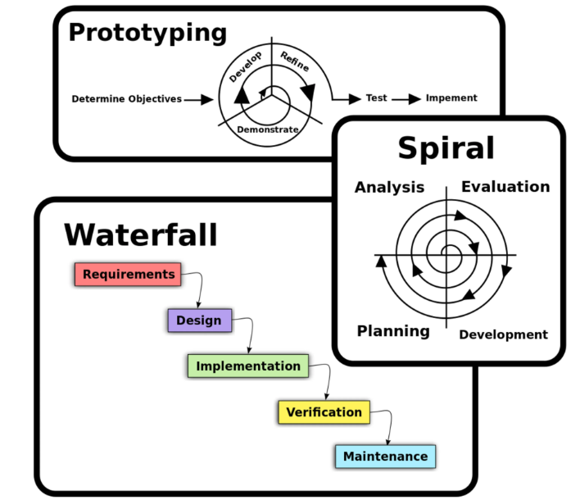

**4.2 Software Requirement Analysis**

The Software Requirement Analysis phase is pivotal in defining the functionalities and specifications of the Smart Irrigation System. Key requirements include:

1. **Real-Time Data Processing:** The system should process sensor data in real-time for accurate decision-making.
2. **User Interface:** An intuitive interface for farmers to monitor and control the system effortlessly.
3. **Actuation Mechanism:** Implementation of an automated actuation system for controlling irrigation valves.
4. **Data Logging:** Storage and retrieval of historical data for analysis and decision support.
5. **Sensor Calibration:** Ensuring precise calibration of sensors to maintain data accuracy.

**4.3 Limitations of Selected Model**

While the Incremental Model offers flexibility and adaptability, it comes with certain limitations. The potential challenges include:

1. **Increased Complexity:** With each increment, the system's complexity may escalate, demanding careful management.
2. **Resource Intensive:** Iterative development may require additional resources, impacting time and budget constraints.
3. **Dependency on Previous Increments:** Modifications to earlier increments may affect subsequent ones, necessitating meticulous planning.

**4.4 Design**

The design phase focuses on translating the system requirements into a structured plan for implementation. This involves:

1. **Architectural Design:** Defining the overall system structure, including the interconnection of components and modules.
2. **Interface Design:** Creating a user-friendly interface for farmers to interact with the system.
3. **Database Design:** Structuring the database for efficient data storage and retrieval.
4. **Algorithm Design:** Developing algorithms for processing sensor data and making irrigation decisions.

**Design Diagram:**

A class diagram is a type of UML (Unified Modeling Language) diagram that represents the structure and relationships of classes in a system or application. It illustrates the classes, attributes, operations, and relationships between them.

